LTP PERFORMANCE EVALUATION BASED ON PHY

CHARACTERISTICS FOR EARTH-MARS SATELLITE

LINKS

Alisher Muratov, B. Eng
Submitted in fulfilment of the requirements for the degree of Master of Science in Electrical and Computer Engineering

School of Engineering and Digital Sciences Department of Electrical and Computer Engineering Nazarbayev University

53 Kabanbay Batyr Avenue, Nur-Sultan, Kazakhstan, 010000

Supervisors: Refik Kizilirmak, Behrouz Maham

March 2025

DECLARATION
I hereby, declare that this manuscript, entitled “LTP performance evaluation based on PHY characteristics for Earth-Mars satellite Links”, is the result of my own work except for quotations and citations which have been duly acknowledged.
I also declare that, to the best of my knowledge and belief, it has not been previously or concurrently submitted, in whole or in part, for any other degree or diploma at Nazarbayev University or any other national or international institution.

---------------------------
Name:
Date:

Abstract
Humanity’s interest in space explorations has increased over the past century, specifically in our closest neighboring planet – Mars. A primary motivation for investigating the red planet is the potential for it to become the first planet, other than Earth, capable of supporting human life in the future. Consequently, significant efforts have been dedicated to building equipment capable of gathering and analyzing data from the planet. To successfully transmit this information, building robust communication frameworks is growing in importance. However, the physical properties of radio waves make transmitting data over the vast distances of space a significant challenge. To successfully transfer data, it is essential to have satellites with high gain antennas, sufficiently powerful amplifiers with high transmission power and advanced telemetry coding. Therefore, one of the objectives of this paper will be designing the physical layer between satellites. Specifically between satellites orbiting Earth, Moon and Mars, creating Earth-Moon-Mars link. This network of satellites is going to deploy the Delay Tolerant Networking (DTN) framework, which is specifically built for connections with high discontinuity, significant delays, and high likelihood of packet loss. DTN has transport layer called Licklider Transmission Protocol (LTP) which is used to transmit information over harsh conditions of space. By continuously retransmitting data when a failure is encountered, LTP achieves high robustness and reduced overhead compared to Transmission Control Protocol (TCP). The main goal of this thesis is to establish an initial connection between Earth and Moon satellites, followed by a connection between the Moon and Mars, using the segment error rate (SER) obtained from physical layer modelling. To obtain SER two various modulation schemes have been implemented. Then, LTP implementation was obtained as the number of segments in the block versus time. The main conclusion is that, to obtain a small SER, modulation of a lower order should be implemented, which diminishes transmission time and increases throughput.
Table of Contents

Abstract 3
List of Abbreviations 6
List of Tables 7
List of Figures 8
List of Publications 9
Chapter 1- Introduction
1.1 Importance of Satellites 10
1.2 Delay Tolerant Networking (DTN) 10
1.3 Establishing Interplanetary Internet 11
1.4 Communication Between Earth and Mars 11
1.5 LTP and Research Objectives 12
1.6 Thesis Outline 13
Chapter 2 - Literature review
2.1 LTP Protocol 14
2.1.1 Difference Between Classical Networks and Space Communication 14
2.1.2 Sources of Delay in Space Communication 14
2.1.3 Economic Constraints on Interplanetary Communication 14
2.1.4 Challenges for Protocol Design in Deep Space Networks 15
2.1.5 LTP Protocol Transmission Modes 15
2.1.6 Segmentation and Transmission Management in LTP 16
2.1.7 Authentication and Reliability Mechanisms in LTP 16
2.2 Earth-Moon Link 17
2.2.1 Architecture of the Satellite Network 17
2.2.2 Role of the Lunar Gateway (GW) in Communication Infrastructure 18
2.3 Radio Frequency Technology 18
2.3.1 Advantages of Radio Frequency Communication 18
2.3.2 RF Communication System Technologies and Techniques 19
2.3.3 Compatibility and Integration with Existing Infrastructure 19
2.4 Earth-Mars communication via Lagrange point 19
2.5 Mars Exploration 20
2.5.1 NASA’s Deep Space Network (DSN) 20
2.5.2 Early Missions and Flybys 20
2.5.3 The Viking Program (1975) 21
2.5.4 Mars Global Surveyor (MGS, 1996) 21
2.5.5 Mars Pathfinder and Sojourner Rover (1996) 22
2.5.6 Mars Exploration Rovers: Spirit and Opportunity (2003) 22
2.5.7 2001 Mars Odyssey 23
2.5.8 Mars Express (2003) 24
2.5.9 Mars Reconnaissance Orbiter (MRO, 2005) 24
2.5.10 Phoenix (2007) and Curiosity (2012) 25
2.5.11 MAVEN (2013) 26
2.5.12 ExoMars (2016) 26
Chapter 3 – Research methodology
3.1 Physical Layer Model Earth-Moon 28
3.2 Physical Layer Model Moon-Mars 31
3.3 Physical Layer Model Moon-L4-Mars 32
3.4 Transport Layer Model – LTP 34
3.5 Performance Evaluation of Earth-Mars link via Moon relay satellite 39
3.6 Performance Evaluation of Earth-Moon-L4-Mars link 44
Chapter 4 – Conclusion and Future work
Bibliography 50

List of Abbreviations
DTN  BP  HDTN  DSG  LTP  SER  DSN  EORP  EOB  GW  RF  FSO  GEO  PAT  LEO  TDRS  PSK  SDR  LGA  HGA  TWTA  FM  GMSK  PCM  CCSDS  EIRP  SNR  FSPL  BPSK  QPSK  BER  CS  RS | Delay Tolerant Networking  Bundle Protocol  High-Rate Delay Tolerant Networking  Deep Space Gateway  Licklider Transmission Protocol  Segment Error Rate  Deep Space Network  End of Red Part  End of Block  Lunar Gateway  Radio Frequency  Free Space Optical  Geostationary Orbit  Pointing and Tracking  Low Earth Orbit  Tracking and Data Relay Satellites  Phase Shift Keying  Software-Defined Radio  Low-Gain Antenna  High-Gain Antenna  Traveling Wave Tube Amplifiers  Frequency Modulation  Gaussian minimum shift keying  Pulse Coded Modulation  Consultative Committee for Space Data Systems  Equivalent Isotropic Radiated Power  Signal-to-Noise Ratio  Free Space Path Loss  Binary Phase Shift Keying  Quadrature Phase Shift Keying  Bit Error Rate  Checkpoint segments  Report Segments

List of Tables
Table 1 Earth-Moon link Architecture 29
Table 2 Satellite Parameters of Mars Reconnaissance Orbiter 31
Table 3 Moon-L4 link characteristics 34
Table 4 L4-Mars link characteristics 34
Table 5 SER values for Earth-Moon-Mars with QPSK 39
Table 6 SER values for Earth-Moon-L4-Mars with QPSK 45

List of Figures
Figure 1: Earth-Moon Link 17
Figure 2: Earth-Mars link via L4 relay satellite 33
Figure 3: First case 37
Figure 4: Second case 38
Figure 5: Third case 38
Figure 6: Earth-Moon LTP protocol 41
Figure 7: Moon-Mars LTP protocol 42
Figure 8: Earth-Moon-Mars LTP protocol 43
Figure 9: Moon L4 LTP protocol 45
Figure 10: L4 Mars LTP protocol 47
Figure 11: Earth – Moon – L4 – Mars LTP protocol 47

List of Publications
[1] - E. Ehile, A. Muratov, and R. C. Kizilirmak, "LTP Performance Evaluation Based on PHY Characteristics for Earth-Moon Satellite Links," in 2024 IEEE 10th Information Technology International Seminar (ITIS), Surabaya, Indonesia, Nov. 2024. doi:10.1109/ITIS64716.2024.10845386.

CHAPTER 1 – Introduction
  - Importance of Satellites
Satellites play a pivotal role in modern communication systems. They are used to transmit data all over the world, and making our life significantly easier. Additionally, they enable communication in remote areas that are difficult to access or lack infrastructure. This bridges the information access gap, enabling people in remote areas to access high-quality content and entertainment. As the quantity of people linked to the internet continues to rise, the role of satellites in communication becomes increasingly important.
The utility of satellites extends well beyond Earth. The interest of humanity in space exploration is increasing every year. Thus, establishing reliable communication is a crucial factor that will enable humans to explore space. A primary challenge in transmitting data in space is the vast distance over which the signal must travel, leading to signal attenuation. Another issue is the microwave background noise of space that can interfere with signal. Also the power of satellites is limited, so it must utilize high gain antennas that are precisely aligned with receiver. To address these challenges Delay Tolerant Networking (DTN) architecture has been proposed [1] [2]. DTN enables data transfer under conditions of high latency, intermittent connectivity, and limited bandwidth. It works where traditional TCP/IP protocols fail.
  - Delay Tolerant Networking (DTN)
The DTN framework utilizes Bundle Protocol (BP), meaning it segments data into bundles. It employs the store-and-forward technique, transmitting data across multiple hops, where they are temporarily stored. Then bundles forwarded when the optimal path becomes available. This provides successful data transfer regardless of technical restriction. To further enhance the bandwidth of DTN, NASA High-Rate Delay Tolerant Networking (HDTN) [3] project has been realized. Furthermore, DTN networks incorporate robust security mechanisms that ensure data confidentiality.
  - Establishing Interplanetary Internet
To enable interplanetary internet, satellites must ensure connectivity at the physical and network layers, as well as robustness at the transport layer. These networks should be capable to withstand signal attenuation and intermittency, which can be further exacerbated by the movement of planets. The first step in building an internet in space is to establish a reliable connection between Earth and the Moon. According to NASA Artemis [4] program this goal is going to be achieved, by providing high speed internet with good traffic [5]. The distance from Earth to Moon is relatively small, and light can travel to one side in about 1 second, therefore setting up highly reliable connection between satellites orbiting them is not a big challenge. Thus DTN approach is capable to handle this connection. Specifically by interconnecting with Deep Space Gateway (DSG), which is going to be a new space station orbiting the Moon. According to NASA’s plans, the DSG will facilitate communication with Earth's surface, lunar missions, and satellites and rovers designed for space exploration [6] [7].
  - Communication Between Earth and Mars
The second step will be building reliable connection between Earth and Mars. Throughout the history of space exploration, humans have explored Mars using rovers. However, according to NASA’s plans, the first humans can visit the red planet in the 2030s [8]. Since distance to Mars is significantly bigger than the distance to Moon, the signal attenuation and probability of intermittency is much higher thus it needs higher gain antennas, larger transmission power and modern coding techniques. While the closest distance to Mars is about 56 million km, the farthest distance can be up to 400 million km. Moreover, there is a phenomenon called Solar Conjunction, which occurs when the Sun is positioned between two planets, blocking the signal from passing between them. It happens approximately every 26 month and lasts about 2 weeks. Even though it is possible to stay unconnected during that rare period with automated rovers, when humans will be on that planet it is essential to overcome this issue. To address that, it is possible to establish connection between Earth and Mars via relay satellites located at Lagrange points, which will guarantee non-stop connection between planets [9].
  - Licklider Transmission Protocol (LTP) and Research Objectives
Important part of transport layer in DTN framework is Licklider Transmission Protocol (LTP). It divides data into blocks, which is further divided into segments and each of them has its own respective number [10]. When a block of data is transmitted, all segments are sent back-to-back, with the last segment serving as a checkpoint. If a loss occurs, a report segment from the receiver indicates it, prompting retransmission. Thus, LTP handles link disruptions, by providing repeated retransmission of lost segments to the receiver. In this paper, an LTP connection will be established between satellites orbiting the Earth and the Moon, as well as between satellites orbiting the Moon and Mars. Thus, an efficiency evaluation of the LTP protocol will be conducted, with a unique focus on the physical characteristics of the satellite network. Furthermore, an analysis of checkpoints and retransmissions has been conducted to enhance the reliability of data transfer in these harsh environments. According to results, obtained Segment Error Rate (SER) in the modelling of physical layer, has non-linear relationship with transmission time. However these losses compensated with LTP, which is specifically designed to solve such problems. There are other papers which also study performance of LTP in satellite networks [11] [12]. Nevertheless, the key distinction of this thesis is that it considers parameters from the physical layer and performs precise error calculations based on these parameters, rather than assuming a prior probability of error.
  - Thesis Outline
First, in chapter 2 a literature review was conducted, providing a detailed description of the LTP protocol and an explanation of the Earth-Moon link, followed by an overview of radio frequency technology. Additionally, the literature review covered Earth-Mars communication via the Lagrange point and concluded with an overview of Mars exploration from a communication perspective. Secondly, in Chapter 3, the Research Methodology section, a study of errors in the Earth-Moon link was conducted, taking into account the properties of the physical layer. A similar study was then carried out for the Moon-Mars link. Using the obtained results from the physical layer, an analysis was further conducted, where the simulation results are presented, to determine the time required for data transmission in the Earth-Moon-Mars link. Finally, in chapter 4 conclusion is provided, with summary of all the thesis.

CHAPTER 2 – Literature review
2.1. LTP protocol
2.1.1. Differences between Classical Networks and Space Communication.
A fundamental distinction exists between classical networks, such as the Internet, and space communication. The primary distinction lies in the round-trip delay, which is influenced by both physical constraints and economic factors.
2.1.2. Sources of Delay in Space Communications
The most evident type of delay caused by natural factors is signal propagation time. For example, the round-trip delay between Earth and Jupiter’s moon Europa ranges from 66 to 100 minutes. A less obvious but more dynamic source of delay is occultation, which occurs when a celestial body obstructs the signal between the transmitter and receiver. Consequently, messages must be queued until transmission can resume. While these delays can be predicted, an additional, less predictable delay exists due to discontinuous transmission support, which is influenced by economic factors.
2.1.3. Economic Constraints on Interplanetary Communication
An interplanetary network requires expensive equipment, such as large antennas, highly sensitive receivers, and powerful transmitters. For most deep-space missions, communication resources are provided by the Deep Space Network (DSN). However, DSN resources are already overloaded and will likely remain so in the near future. As a result, establishing a connection with the DSN requires careful planning and is often strictly limited. Link overloading means that round-trip delay is influenced not only by signal propagation and occultation but also by scheduling and queue management. Data packets may remain in the queue until the next scheduled connection, which could take hours, days, or even weeks. These conditions imply additional constraints on any protocols, developed for deep space communication [13].
2.1.4. Challenges for Protocol Design in Deep-Space Networks
The primary challenge arises from the long round-trip delay, creating a significant time gap between transmitting a data block and receiving the corresponding acknowledgment. Therefore, in LTP protocol all data blocks must be transmitted in parallel. Secondly, to ensure the successful delivery of data blocks, LTP must retain all parts that may require retransmission when there is data loss. To achieve this, the protocol must track which parts of the block have been confirmed as received and which have not. Thirdly, while TCP remains bidirectional, LTP is unidirectional. This design choice is founded on the fact that data streams in space missions are typically unidirectional. Long bidirectional delays make interactive rover control impractical, requiring rovers to operate autonomously with minimal control traffic. In cases where bidirectional interaction is necessary, it is implemented using two unidirectional channels, operating on opposite sides and at different speeds. Lastly, LTP requires a different approach to calculating timeout intervals, as it does not rely on statistical analysis of previous delays, unlike TCP [13].
2.1.5. LTP Protocol Transmission Modes
In LTP, every block is divided into two parts: the red part, whose transmission is guaranteed through retransmissions and acknowledgments, and the green part, which is transmitted only once without acknowledgments or retransmissions, meaning its delivery is not guaranteed. The length of each part can be zero, allowing for three transmission modes. The block can be entirely red, ensuring full delivery guarantee, similar to TCP. It can also be entirely green, functioning like UDP. Additionally, a mixed mode is possible, where part of the data is transmitted with acknowledgment and the rest without. Meanwhile, the red part does not have a higher priority compared to the green part. In LTP, there is no negotiation of network parameters, as occurs in TCP. Instead, the transmitter determines how to send the data, deciding which parts are red and which are green. The receiver simply accepts the data as it was transmitted without participating in any negotiations. However, transmission parameters can be regulated at higher network layers [13].
2.1.6. Segmentation and Transmission Management in LTP
When LTP transmits data, it divides it into segments and queues them, considering segment size restrictions imposed by the network. The final section of the red part is marked as the End of Red Part (EORP), allowing the receiver to recognize that the guaranteed transmission has concluded. This segment serves as a checkpoint and is assigned a unique number. Once the receiver accepts the EORP, it sends a report segment to the transmitter. The final part of the block is labeled with an End of Block (EOB) indicator, helping the receiver determine the total size of the block. LTP is built to operate directly above the data-link layer. Nevertheless, sometimes, it can be used over UDP as well. In all instances, the protocol beneath LTP is known as the local data-link layer. When an opportunity to transmit data arises, LTP takes segments of the block from the queue and sends them to the next network layer, such as UDP/IP, which then delivers them to the receiver. Additionally, a timer starts for the EORP segment. If an acknowledgment does not reach the receiver within the expected time, that segment is automatically retransmitted [13].
2.1.7. Authentication and Reliability Mechanisms in LTP
LTP Authentication is a mechanism for verifying data integrity and ensuring completeness in LTP. It is used to protect transmitted data from losses and potential attacks, particularly in interplanetary communications, where data is transmitted over vast distances and may be vulnerable. If LTP authentication is not used, the channel layer itself must verify data integrity. If a segment is found to be corrupted, it is simply discarded without any attempt to repair or retransmit it. Received segments that were not lost are transmitted to the receiving side. When the LTP on the receiver side accepts the first fragment of a block, it initiates a receiving session and notifies the client service that data transfer has started. If all segments arrive without errors, upon receiving the EORP, the receiver sends a confirmation to the sender indicating that all red parts have been successfully received and then transmits them to the client service. While green parts, are immediately transmitted to the client service as they are received, without waiting for confirmation. Since LTP transmits data in only one direction, reception reports are sent as separate segments rather than being embedded within the data itself, as in TCP. When the receiver accepts the red part of the block, it transmits a report segment to the sender and starts a timer. If confirmation is not received, the report segment is retransmitted. When the sender receives the report segment, it stops the EORP timer, transmits a report acknowledgment, and notifies the customer support that the red part of the block has been successfully dispatched. Once the receiver accepts the acknowledgment, it switches off its own timer, and the transfer of the block is considered complete [13].
2.2. Earth-Moon link
2.2.1. Architecture of the Satellite Network
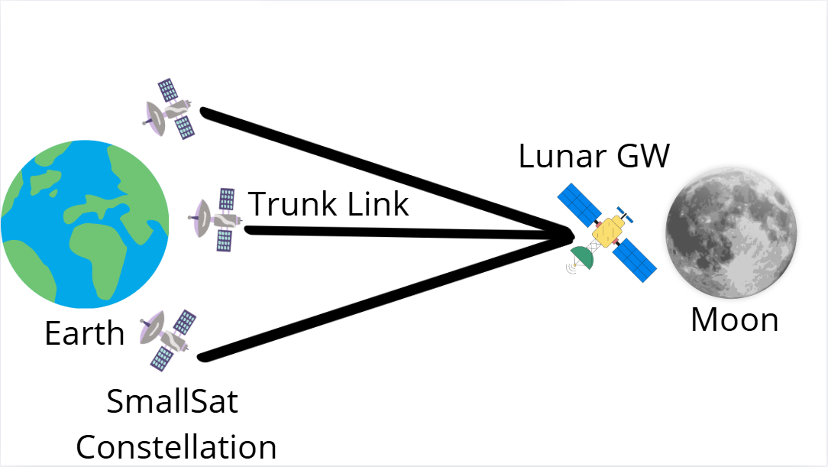
Figure 1. Earth-Moon Link [14]
The overall design of the proposed Earth Moon network is illustrated in Figure 1. It utilizes two mid-point relays: a group of satellites on the terrestrial side and the Lunar Gateway (GW) on the Moon side to facilitate data transfer between Earth and objects on the Moon. The link between a satellite and Earth, as well as the link between GW and lunar objects, is referred to as a proximity channel, while the link between satellites and GW is called a trunk channel. Satellites within the group can exchange data among themselves via cross channels. Both local and trunk channels can switch between radio frequency (RF) and Free Space Optical (FSO) systems, as they are equipped with both types of transmitters. However, in this thesis, only the radio frequency component will be considered [14]. Satellites in geostationary orbit (GEO) provide reliable communication and wide coverage, as they remain fixed relative to Earth and are positioned closer to the Moon and the GW than satellites in higher orbits. This also reduces the requirements for Pointing and Tracking (PAT). However, their use results in increased delays and higher energy consumption. On the other hand, spacecraft in low Earth orbit (LEO) remain closer to Earth, making them more suitable for satellites with limited energy resources [14].
2.2.2. Role of the GW in Communication Infrastructure
NASA's Artemis project incorporates the GW as a crucial element for robust exploration of the moon. Analogous to the International Space Station, the GW is planned to operate as an autonomous communication hub, operating on solar energy while also housing a science lab and a temporary living capsule for astronauts. The Lunar Gateway plays a critical role in relaying signals to the Moon’s surface. Due to its orbital position, direct visibility with Earth will experience minimal obstructions, significantly enhancing connection quality [14].
2.3 Radio Frequency technology
2.3.1. Advantages of RF Communication
The main advantage of RF conveyance is its capability to pass via various atmospheric environments and its less stringent requirements for precise antenna alignment. Modern space network systems, such as NASA's Tracking and Data Relay Satellites (TDRS), use transmitters and receivers in the S-, X-, and Ka-bands, covering frequencies from 2 to 27 GHz. In recent years, the Ka-band (26–40 GHz) has gained significant attention due to its high data transfer rates and increased spectrum access. TDRS satellites operating in the Ka-band have already demonstrated data transfer speeds of up to 800 Mbps [15]. Moreover, the growing adoption of Ka-band applications has led to an increase in the availability of standard equipment on the market, simplifying its implementation.
2.3.2. RF Communication System Technologies and Techniques
Most contemporary and planned space missions use simple modulation and coding frameworks, i.e. Phase Shift Keying (PSK) [16]. In interplanetary communications, simple modulation techniques are generally preferred due to their reliability and robustness against interference. Convolutional coding and Reed-Solomon coding with rates of 1/2, 4/5, and other coding coefficients have demonstrated strong performance [16]. Recent advancements in radio systems, known as Software-Defined Radio (SDR), make it an excellent choice for space exploration. SDR enables the rapid development and adjustment of communication networks by allowing modulation types, frequencies, and other parameters to be easily modified, even after a satellite has been launched. This flexibility is a significant advantage, as engineers can adjust network properties in real-time during the mission [17]. Modern SDR technology is becoming lighter and more compact, and commercially available devices are already designed for small satellites.
2.3.3. Compatibility and Integration with Existing Infrastructure
Lastly, RF technology ensures seamless compatibility with legacy equipment. Since RF technology has been dominant in recent decades, most space systems rely on RF networks for communication. Therefore, any new equipment that needs to connect with older space systems must support RF technology.
2.4 Earth-Mars communication via Lagrange point:
As humanity continues to explore space, ensuring stable and uninterrupted communication with manned spacecraft and automated orbiters is crucial. However, deep-space missions face challenges such as link interruptions caused by physical obstacles—for example, when the Sun, Moon, or other celestial bodies obstruct the signal between the transmitter and receiver. In such cases, link quality can deteriorate significantly [9]. By placing relay satellites at the L4 and L5 Lagrange points, it is possible to maintain uninterrupted and stable communication with Mars, even during solar conjunctions and other periods when a direct connection is difficult or impossible. The key advantage of the L4 and L5 Lagrange points is their exceptional stability within the Earth-Sun system. At these points, the gravitational forces of Earth and the Sun are in equilibrium, allowing satellites to maintain a stable orbit with minimal fuel consumption for positional corrections [9].
2.5 Mars Exploration
2.5.1. NASA’s Deep Space Network (DSN)
This section will describe the history of Mars exploration from a communication perspective. First it is better to note NASA’s DSN, which is a network of satellite that made possible all these projects [25]. DSN is basically a collection of huge antennas with diameter from 34 to 70 meters. In the world in total exist three DNS networks, each of which have several antennas with 34 m diameter and one antenna with 70 m. One center is located in Goldstone, California, USA; second one in Madrid; and the last near Canberra, Australia. Centers are place approximately 120 degrees relative to each other, ensuring continuous communication for all missions beyond Earth. Due to the fact that Earth spins at angular speed of 0.004 deg. per sec, antennas must be highly precise to accurately track and steer toward the space station. The 34-meter antennas are the primary units of the DSN, capable of handling most of NASA's communication links either independently or in groups of two or three. However, for long-distance communications, 70-meter antennas are used. At the present day, DSN remains the most complex and sensitive telecommunication system in the world [18].
2.5.2. Early Missions and Flybys
At the 1964 NASA conducted the initial triumphant mission to Mars – Mariner 4. It was the first spacecraft to transmit images from Mars. Due to the high-gain antenna (HGA) with a diameter of 1,168 cm and the low-gain antenna (LGA) with a diameter of 2,235 cm, a total of 52 million bits of data was received. The signal was transmitted in the S-band, as this frequency allows it to pass through Earth's atmosphere more easily [19]. Until 1971, there were no specific missions to Mars—only spacecraft that flew past the planet. Even this allowed to gather data and send it back to Earth. In 1971, Mariner 9 was launched, becoming the initial spacecraft to orbit Mars. It captured 9,000 photographs and gathered extensive data about Mars' atmosphere. The spacecraft was equipped with an omnidirectional LGA, a parabolic HGA, and a medium-gain cone antenna. Like Mariner 4, Mariner 9 operated in the S-band [20].
2.5.3. The Viking Program (1975)
In 1975, the first successful mission to send both an orbiter and landers simultaneously was the Viking program, which included the Viking 1 and Viking 2 landers. The former operated for 6 years, while the latter operated for four years, conducting various experiments and collecting soil samples. Meanwhile, the orbiter captured 10000 photographs, enabling the development of a global map of Mars. Communication with the orbiter was performed via a 20W broadcaster in the S-band at a frequency of 23 GHz, using two traveling wave tube amplifiers (TWTA). As an experiment, the 84 GHz X-band was also used for downlink, while the 21 GHz S-band was used for uplink. The orbiter was equipped with a 15-meter HGA and a LGA [21]. The lander also established communication via a 20W transmitter in the S-band. It was equipped with an HGA and a fixed omnidirectional LGA, both capable of directly connecting with Earth. The data was stored in a 40 Mbit memory unit [22].
2.5.4. Mars Global Surveyor (MGS, 1996)
In 1996, the Mars Global Surveyor (MGS) was deployed, lasting nine years and becoming the longest-running mission at that time. It provided the highest-resolution images available at the time and contributed to numerous other scientific investigations. Initially, after the spacecraft has been launched it was using LGA, unit it was far enough from Earth to use 15 meters HGA [23]. Data from that antenna was transmitted in the 84 GHz X-band. The uplink speed from Earth to the spacecraft was 500 bps. Due to the transmitter's limited power (25 W), the sole method to receive data on Earth was through the DSN, with a downlink speed of 85.3 kbps [24]. One of the six main instruments on MGS was the Mars Relay (MR). It functioned as a relay, retransmitting signals from landers on the Martian surface to Earth. As a result, the landers did not require large and heavy high-gain antennas (HGA) [25]. The signal from MR was transmitted to Earth at 4371 MHz, a frequency close to the ham radio frequencies, allowing some general radio operators to help in receiving the signal [26]. MR provided a data rate in the radio frequency band ranging from 8 to 128 kbps [27].
2.5.5. Mars Pathfinder and Sojourner Rover (1996)
Also, in 1996, a mission was conducted to launch the Mars Pathfinder lander and its rover, Sojourner. Initially planned to last one month, data transmission continued for about two months. Same as Viking, Pathfinder was equipped with LGA and HGA. Connection with Earth has been conducted in the X-band, which means 84 GHz frequency was used for downlink and 72 GHz for uplink [28]. The HGA on the descent vehicle enabled communication with the 70-meter DSN antenna at a data speed of 55 kbps. The lander's solar panels were powerful enough to support data transmission for 2 to 4 hours every 246 hours, equivalent to one Martian day [29]. Sojourner's internal radio modem worked at a frequency of 4597 MHz with a 25 kHz channel bandwidth. It utilized a type of frequency modulation (FM) known as differential Gaussian minimum shift keying (GMSK). The transmitter's power was only 100 mW, while the maximum data transfer speed reached 96 kbps [30].
2.5.6. Mars Exploration Rovers: Spirit and Opportunity (2003)
The twin exploration vehicles, Opportunity and Spirit, elevated rover missions. Spirit operated for 10 years, covering a distance of 773 km, while Opportunity functioned for 14 years, traveling 4,516 km. The primary purpose of the Mars Exploration Rovers (MER) mission was to launch couple of mobile investigation laboratories on the Mars surface to remotely study geology. As part of the mission, an analysis of the soil was conducted to identify potential traces of past water. For the first time, a microscopic study of geological specimens and a detailed examination of surface conditions were conducted. Apart from scientific tasks, mission aimed to rise interest of society to the space explorations [31]. Rovers were equipped with LGA, receiving commands at speed minimum 78,125 bps, and transmitting at minimum 10bps. The data transfer speed via the steerable HGA was determined by the distance between Mars and Earth. At shorter intervals, the received data rate reached up to 2 kbps, while the transmitted transfer speed peaked at 288 kbps. At the physical layer, the MER rovers had several important parameters. Receiving a signal required 6 W of power, while transmission consumed 12 W. For communication, the incoming frequency from the orbiter to the rover was 4371 MHz. To transmit signals from the rover to the orbiter, two frequencies were used: 4015.85 MHz for connecting with Odyssey and Mars Express, and 4015.29 MHz for connecting with MGS. Rovers implemented Pulse Coded Modulation (PCM). Network speed in the range from 8 to 256 kbps were supported for both incoming and outgoing signals. There was not implemented any coding on the incoming channel, while on the outgoing channel a ½ rate convolutional encoder with a constraint length of 7 was applied. [32].
2.5.7. 2001 Mars Odyssey
In 2001, the Odyssey orbiter was launched. It has been designed to generate a comprehensive diagram of chemical elements and minerals, analyze levels of radiation for future manned expeditions, and seek evidence of Martian water [33]. Additionally, it was utilized as a transmission link to transmit rover and lander data. The Consultative Committee for Space Data Systems (CCSDS) developed the Proximity-1 protocol for space missions [34], enabling communication between rovers, landers, and orbiters from various astronautic organizations. As a result, Mars Odyssey became the primary orbiter to operate with Proximity-1. It is equipped with 15 W power amplifiers and uses 13 meter diameter HGA, medium gain antenna and omnidirectional LGA [35].
2.5.8. Mars Express (2003)
There is global interest in exploring the Mars, and in 2003 the European Space Agency (ESA) deployed project Mars Express. Time necessary to transmit data from Earth to Mars Express orbiter depends on the distance to Mars and can be from four to twenty five minutes. Rate of information transmission on the close interval is 228 kbps, and at the farthest point 57 kbps. The orbiters is equipped with 1.65 meter parabolic antenna and with two LGAs, which is used when two planets close to each other [36]. Same as Odyssey, Mars Express uses Proximity-1 protocol. It handles data transfer speeds up to 128 kbps [35]. Signal transmission to Earth occurs in the X-band at a frequency of 71 GHz, while transmission with the orbiter takes place in the S-band at 21 GHz. The system has a total memory capacity of 12 Gbits [37].
2.5.9. Mars Reconnaissance Orbiter (MRO, 2005)
In 2005, the Mars Reconnaissance Orbiter (MRO) was deployed to investigate the terrain and weather patterns of Mars. Additionally, it serves as a communication relay. MRO is equipped with 160 Gbits of memory and is capable of reaching a data transfer rate of 6 Mbps; however, in practice, the maximum speed reached 45 Mbps. The communication orbiter functions in the X-band at approximately 8 GHz. A one direction signal transmission takes roughly 21 minutes when Mars reaches its farthest point from Earth. At that interval, MRO sends data to a 34-meter antenna at a speed of 600 kbps. When Mars is nearest to Earth, the information transmission rate increases to 26 Mbps for a 34-meter antenna and 35 Mbps for a 70-meter antenna. The average throughput of MRO for each rover is approximately 49 Mbits per Martian day. To communicate with Earth, it uses TWTA with 100 W power and a 3-meter HGA, making its communication channel highly capable. This represents a significant improvement compared to Odyssey and MGS, which had power amplifiers of 15 W and 25 W, respectively. In contrast to MGS and Odyssey, MRO's Equivalent Isotropic Radiated Power (EIRP) of 96 dBm results in a 13–15 dB increase [38]. Additionally, MRO is equipped with the Electra relay module, designed to communicate with other machines on Mars' surface. In general, the relay technology used in orbiters is quite similar, indicating potential for further advancements in this technology. MRO is significantly more advanced than MGS and Odyssey, allowing for a substantial expansion of physical capabilities such as power, size and mass. MRO achieves its maximum data transfer rate in the Ka-band, whereas MGS reaches its highest speed in the UHF-band. This difference is due to the fact that data transfer speed at a specific frequency depends on factors such as antenna diameter, gain coefficient, and transmitter/receiver power. To illustrate the speed of MRO, a simple scenario can be considered. For example, if radio equipment similar to that used on Explorer 1 were used, transmitting an image from Jupiter to Earth via a mobile phone would take 460 times the age of the universe. Performing the same task with Pioneer 2 and 4 would take 600 thousand years. Mariner 9 would complete it in 55 hours, whereas MRO can transmit the image in just 3 minutes [18]. This remarkable speed is the primary reason MRO is used as an orbiter for data transmission via the LTP protocol.
2.5.10. Phoenix (2007) and Curiosity (2012)
To search for water on Mars, the Phoenix mission was developed. It was engineered to land further north than any prior mission, with the goal of determining whether this region could have supported life by investigating the ice and soil [39]. Phoenix reduces price and weight by avoiding an X-band communication framework; instead operates exclusively via a UHF relay link. It is equipped with a UHF transceiver, the CE505, similar to those used in the MER rovers. It connects with Earth mainly via MRO and Odyssey orbiters. The Curiosity rover, also known as the Mars Science Laboratory (MSL), was sent to Mars to look for evidence of previous microbial life. The primary objective of the MSL project is to launch a mobile scientific lab on the Mars’s surface to study the geological composition of the landing site and study radiation levels. Curiosity examines the planet’s surface and investigates Mars' geological properties using advanced microscopic imaging and spectrometry. Rover connects with relay in the UHF-band and with DSN in the X-band [40].
2.5.11. MAVEN (2013)
MAVEN was deployed in November 2013 and achieved Mars in September 2014. The primary goal of the mission is to map electric currents around Mars, as they play a crucial role in atmospheric loss. MAVEN conducts experiments on the upper layers of the atmosphere and ionosphere, recording their current state and measuring the quantity of gas gone to space [41]. Additionally, MAVEN sends information from rovers and landers to Earth via the Electra communication package, which operates in the X-band. It is equipped with a HGA with a diameter of 2 meters. Every 35 days, MAVEN pauses data collection for 5 hours to communicate with Earth. Between these communication sessions, it can store up to 32 Gbits of data in its memory. To track its position, MAVEN uses a LGA [42].
2.5.12. ExoMars (2016)
ExoMars became the first spacecraft developed through collaboration between two space agencies—ESA and Roscosmos. Its primary mission is to study methane and other atmospheric compounds, which have concentrations of less than 1% in Mars' atmosphere and may indirectly indicate possible biological activity. The project was deployed in 2016. ExoMars is composed of two parts: the Trace Gas Orbiter (TGO) and the Entry, Descent, and Landing Demonstrator Module (EDM). While the EDM was furnished with instruments to take direct readings during landing and on the Martian surface, the TGO was designed to observe the atmosphere from orbit.
The TGO is supplied with couple of UHF communication devices, built by NASA in a similar manner to those on the MAVEN satellite, and is used to communicate with rovers and landers. Each transceiver is connected to a dedicated UHF spiral antenna with 6 dBic gain. Communication with Earth is handled by a 65 W system, which includes a 2.2-meter parabolic HGA and three omnidirectional LGA operating in the X-band [43]. The EDM used a UHF transceiver operating at 437.1 MHz for the link from the orbiter to the lander and 401.59 MHz for the link from the lander back to the orbiter. The EDM transceiver had a nominal transmitter power of 48 W and supported data rates ranging from 8 to 64 kbps in the forward channel and from 8 to 1024 kbps in the reverse channel, with optional convolutional coding at a 1/2 rate [43].However, an error occurred during landing: due to an incorrect height assessment, the lander deployed its parachute too early and activated its braking engines for only 3 seconds instead of the intended 30, resulting in a crash. Despite this setback, ESA and Roscosmos are planning the next mission—ExoMars Rover and Surface Platform (RSP). The primary objective of this mission is to land a rover and a Russian lander on the Martian surface in a region with a high probability of detecting organic compounds, particularly those linked to the planet's early history [44].

CHAPTER 3 – RESEARCH METHODOLOGY AND RESULTS
In this thesis, our aim is to evaluate the Earth – Mars link performance, focusing on the packet loss and its impact on transmission time of the block of data. It should be emphasized that, in our study, the transmitter is an Earth orbiter, and the receiver is a Mars orbiter, not the ground stations. We consider two relaying scenarios: one involves a Moon orbiter as a relay, so Earth-Moon-Mars link will be evaluated. The second scenario considers a relay satellite positioned at Lagrange point L4: the Earth-Moon-L4-Mars link will be evaluated.
To achieve our aim, this Section first discusses the selection of the physical layer parameters of the considered links, namely Earth-Moon (Section 3.1), Moon-Mars (Section 3.2), Moon-L4 and L4-Mars (Section 3.3). Next, we incorporate transport layer and introduce the LTP protocol over these links (Section 3.4). After setting the physical and transport layer characteristics, we present the results of the performance evaluation of Earth – Mars networks via Moon orbiter relay (Section 3.5) and via a satellite relay at L4 (Section 3.6). We specifically present the impact of bit errors on segment errors, and subsequently, the effect of segment errors on the overall transmission time of the LTP blocks.
3.1 Physical Layer Model Earth-Moon
Given the substantial distance between Earth and the Moon, the communication link is subject to considerable delays and significant signal losses. As a result, the channel quality and the corresponding Signal-to-Noise Ratio (SNR) are of major concern. In order to integrate physical layer parameters into the evaluation of the transport layer, particularly for the LTP protocol, the physical layer parameters are initially presented.
Table 1 summarizes the Earth-Moon links, both the ones either in service or planned [14]. In the table, satellites in Low Earth Orbit (LEO) transmit RF signals to the Lunar Gateway (GW) at a frequency of 34 GHz in the Ka-band [14]. The important information in this table is in the Eeart-Moon link row, where the frequency is 34 GHz, antenna gain is 45.94 dB, the distance between celestial bodies is 364 thousand km and BPSK-BCH-127-64 modulation is implemented. The distance between satellites depends on their orbit. For instance, satellites in LEO travel at altitudes ranging from approximately 160 to 2000 km above Earth. In the contrary, NASA’s Lunar GW, which is part of Artemis project will be orbiting the Moon at the maximum distance of 450 thousand km above Earth surface and 75 thousand km above Moon. The average distance between the two celestial bodies is 384 thousand km.
After careful evaluation, we select the distance between Earth LEO satellites and the Lunar Gateway, as 364 thousand kilometers, which is a reasonable estimate. The transmit power of our transmitter is selected as 1 dBW which is equivalent to 1.26 W at operating frequency of 34 GHz in the Ka-band [14]. We further chose the antenna gain as 45.94 dB, according to Table 1 as a typical Earth-Moon link. Therefore, it gives the Equivalent Isotropically Radiated Power (EIRP) as 46.94 dbW, which comes as a summation of antenna gain and transmit power. The symmetrical link is assumed for the sake of simplicity.
Link Direction | Device Name | Oper Freq (GHz) | Antenna Diam  (m) | Beam width (deg) | Gain (dB) | Data Rate (Mbps) | Modulation | Distance  (km)
Earth-Moon  Link | LEO UL Tx | 34 | 0.75 | 0.91 | 45.94 | 1 | BPSK-BCH-127-64 | 364465
Earth-Moon  Link | GW UL Rx | 34 | 1.25 | 1.36 | 50.38 | 1 | BPSK-BCH-127-64 | 364465
Earth-Moon  Link | GW UL Tx | 10 | 0.50 | 4.63 | 31.79 | 15 | QPSK | 8729.26
Earth-Moon  Link | Lunar UL Rx | 10 | 0.50 | 4.63 | 31.79 | 15 | QPSK | -

Table 1. Earth-Moon link Architecture [14]
For the communication link spanning 364 thousand km and operating at a frequency of 34 GHz, signal attenuation is calculated using the Free Space Path Loss (FSPL) model, as
$FSPL_{dB}= 20\log_{10}{d_{m}}+ 20\log_{10}{f_{Hz}} – 147.55$
where the FSPL_{dB} is loss in free space (dB), d_{m} is the distance between antennas in meters, f_{Hz} is the operating frequency in Hertz. By substituting the parameters into this formula, the Free Space Path Loss (FSPL) is calculated to be 234.30 dB, yielding a received power of -111.42 dBm. The system's noise density is -174.24 dBm/Hz at 273ºK, which, for a 200 KHz bandwidth, gives a total noise power of -121.23 dBm. Due to the fact that in satellite networks forward error correction (FER) is implemented, coding gain has been assumed which is equal to 1.8 dB. Therefore, the effective Signal-to-Noise Ratio (SNR), which is the sum of SNR and coding gain, is 11.6 dB.
Binary Phase Shift Keying (BPSK) and Quadrature Phase Shift Keying (QPSK) modulation schemes are selected, both operating at a 200 KHz bandwidth. Bit Error Rate (BER) calculated using the following formula:
$$BER = Q(\sqrt{n*SNR})$$
where n = 2 for BPSK, and n = 1 for QPSK. Obtained values of BER are 3.65 × 10⁻⁸ and
7.04 × 10⁻⁵ for BPSK and QPSK respectively.
LTP protocol, in the contrast to conventional TCP does not implement mechanisms of error detection, such as checksums. Instead, to detect errors LTP relies on lower layers, which is usually realized at the link-layer protocols. Thus when an error is encountered, even in one bit, LTP automatically discards the entire segment. Hence, the segment error rate (SER), is obtained using
$SER {= 1- (1 - BER)}^{L}$
where L is the segment size in bits. When L equals to 1000 bits, SER for BPSK and QPSK are 3.65 × 10⁻⁵ and 0.06795 respectively. SER significantly depends on other parameters as well, such as losses incorporated with system implementation, before antenna loss, losses when pointing antenna, noise characteristic of the system, efficiency of antenna. Moreover, the general efficiency of the system may depend on the coding schemes, system temperature, and on the type of hardware that was implemented. These calculations demonstrate approximate evaluation of SER, which is followed by explanation about how SER impacts LTP protocol at the transport layer.
3.2 Physical Layer Model Moon-Mars
In the following, the parameter selection for communication link between Moon and Mars is discussed, since the goal of this thesis is to build multi-hop LTP connection, from Earth to Mars via intermediate relay satellite. The potential Moon-Mars link will be built between Lunar GW and MRO satellite orbiting the Mars and the link is assumed to be symmetrical for the sake of simplicity. The signal is transmitted in RF at Ka band with 32 GHz frequency [45]. The distance between the Moon and Mars is assumed to be approximately equal to the distance between Earth and Mars, as the distance between Earth and Moon is negligible.
Parameter/Orbiter | Mars Reconnaissance Orbiter (MRO)
Frequency Bands | Downlink | Ka band | 32 GHz
Antenna Quantity | 1 X HGA (Tx and Rx) (3 m diameter)
Antenna Gain | HGA | 32 GHz | 56.4 dBi
Antenna Half-Power Beam width | HGA | X band  Ka band | 0.69 deg  0.18 deg
Telemetry Coding | Convolutional (rate ½, constraint length 7),  turbo code, Reed-Solomon
Power Amplifiers | 2 * X band TWTA (100 W)
Command Data Rate | 7.8125, 15.625, 31.25, 62.5, 125, 250, 500, 1000, 2000 bps
Downlink Data Rate | 500 kbps – 6Mbps

Table 2. Satellite Parameters of Mars Reconnaissance Orbiter [45]

The distance between two celestial bodies can range from approximately 55 million kilometers at their closest approach to about 400 million kilometers at their farthest. On average, they are about 225 million kilometers apart and this number will be implemented in our model. In Table 2, the physical layer parameters of MRO are presented. MRO uses 2 traveling wave tube amplifiers (TWTA) each with 100W, which provides in total 200W transmission power. Furthermore, antenna gain at 32 GHz operating frequency is stated as 56.4dB. Therefore, it gives in total of 79.41 dBW EIRP, which is significantly larger than the value for Earth-Moon links. The FSPL equals to 289.6 dB, resulting in -123.79 dBm received power. The temperature of the system is assumed to be 200ºK, which results in -175.59 dBm/Hz system’s noise density. Therefore, for a 200 KHz bandwidth, the total noise power is obtained as -122.58 dBm. According to Table 2, MRO implements convolutional coding (rate 1/2, constraint length 7), turbo coding, and Reed-Solomon telemetry coding, providing a 12 dB coding gain. This results in an effective SNR of 10.79 dB.
We consider BPSK and QPSK modulation schemes both operating at 200 KHz. For 1000 bits, the BERs are 4.78 × 10⁻⁷ and 2.65 × 10⁻⁴ for BPSK and QPSK, respectively. When L equals to 1000 bits, SER for BPSK and QPSK are 4.78 × 10⁻⁴ and 0.2328 respectively.
A significant drawback of sending signal from Moon- Mars is the solar conjunction phenomenon, when the sun is between two planets and the signal can’t reach the destination due to the solar plasma [15]. Solar conjunction between Earth and Mars occurs roughly every 26 months, and it lasts for about 2 weeks, however deterioration of the signal quality can be from 3-4 weeks in total. Even though currently Mars is explored by rovers and they can operate in autopilot mode, meaning they can tolerate the link disruption, in the future, when NASA will send people to the Mars, establishing robust and continuous connection is essential. Therefore in the next section the possibility of building the link between Moon and Mars via relay satellites in the Lagrange points will be considered.
3.3 Physical Layer Model Moon-L4-Mars
Lagrange points are places in space where the total impact of gravitational forces of two large bodies balance the centripetal force of a smaller object, such as satellite. There are five Lagrange points, and only L4 and L5 are stable.
Therefore, by placing the relay satellites at stable Lagrange points [9] that will retransmit the signal can create a distinctive possibility to establish uninterrupted connection with Mars during the solar conjunction. In our work, a single relay satellite is placed at L4 Lagrange point in the Earth-Sun system as depicted in Fig. 2. The distance between Earth and L4 is 1.49 × 10¹¹ m, and from L4 to Mars is 2.5 × 10¹¹ m.
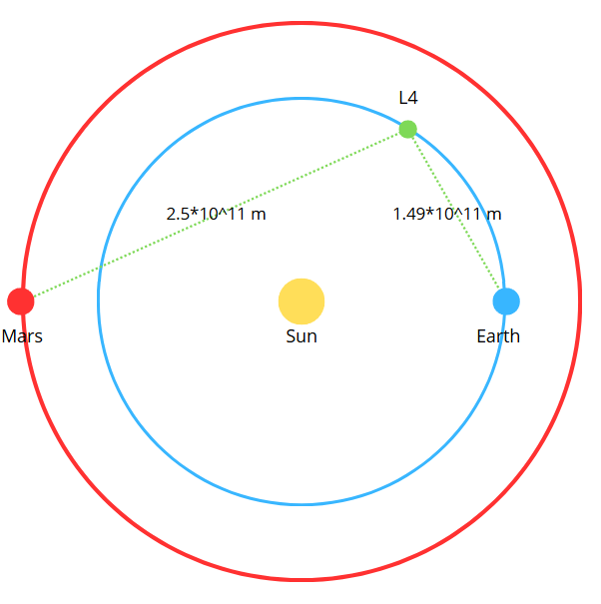
Figure 2. Earth-Mars link via L4 relay satellite [9]
In Table 3, parameters of a sample Moon-L4 link is provided [9]. Operating frequency is 32 GHz in Ka band. Transmitter power for uplink is 73 dBm, while transmitter antenna gain is 47 dBi. Therefore, the total EIRP equals 120 dBm. The FSPL is calculated as 286.02 dB, resulting in -119.02 dBm received power. The temperature of the system is assumed to be 200ºK, which results to -175.59 dBm/Hz system’s noise density. Thus, for a 200 KHz bandwidth, the total noise power is calculated to be -122.58 dBm. According to Table 3, the PCM/PSK modulation type has been implemented, resulting in a 7 dB coding gain. As a result, the effective SNR is 10.56 dB. BPSK and QPSK, functioning at a 200 KHz frequency, have been implemented. For a segment size of 1000 bits, the obtained BER values are 9.11 × 10⁻⁷ and 3.69 × 10⁻⁴, while the SER values are 9.11 × 10⁻⁴ and 0.309 for BPSK and QPSK, respectively.
Parameter | Unit | Value
Parameter | Unit | Uplink | Downlink
Distance | m | $$1.49*{10}^{11}$$ | $$1.49*{10}^{11}$$
Frequency | GHz | 34.2 | 32
Bit Rate | kbits | 120 | 120
FSPL | dB | 295.85 | 295.95
Transmitter Power | dBm | 73 | 56
Modulation Type | - | PCM/PSK | PCM/PSK
Receiver Gain | dBi | 47 | 46.7
Transmitter Gain | dBi | 47 | 46.7
Receiver Power | dBm | -130.85 | -148.55
Table 3. Moon-L4 link characteristics [9]
In Table 4, parameters of a Mars-L4 link is provided [9]. Operating frequency for downlink is 32 GHz. For this thesis, it is assumed that the Mars satellite will be MRO, as it is one of the most powerful satellites. Since a symmetrical link is assumed, the antenna gain for both the transmission and receiving sides should be 56.4 dB, which corresponds to MRO’s antenna gain. According to Table 4, transmitter power is 60 dBm, thus the total EIRP equals to 116.4 dBm. The FSPL equals to 290.5 dB, resulting in -117.71 dBm received power. The temperature of the system is assumed to be 200ºK, which results to -175.59 dBm/Hz system’s noise density. Thus, for a 200 KHz bandwidth, the total noise power is calculated to be -122.58 dBm. The selected modulation type for the link between the satellite at the Lagrange point and the Mars-orbiting satellite is BPSK, which provides a 6 dB coding gain. As a result, the effective SNR is 10.87 dB. The obtained BER values are 3.85 × 10⁻⁷ and 2.37 × 10⁻⁴, while the SER values are 3.85 × 10⁻⁴ and 0.211 for BPSK and QPSK, respectively.
Parameter | Unit | Value
Parameter | Unit | Uplink | Downlink
Distance | m | $$2.5*{10}^{11}$$ | $$2.5*{10}^{11}$$
Frequency | GHz | 34.2 | 32
Bit Rate | kbits | 120 | 120
FSPL | dB | 291.08 | 290.51
Transmitter Power | dBm | 60 | 50
Modulation Type | - | BPSK | BPSK
Receiver Gain | dBi | 47 | 46.7
Transmitter Gain | dBi | 47 | 46.7
Receiver Power | dBm | -139.08 | -149.11
Table 4. L4-Mars link characteristics [9]
3.4 Transport Layer Model – LTP
The primary protocol of DTN networks is LTP, a transport layer protocol specifically designed for space communication. It is well-suited for space exploration and missions to distant planets, as it was designed to operate under conditions of high latency and significant intermittency. Also it is built to operate in environments where maintaining an end-to-end link is challenging. In general LTP operates in the following way:
- First in LTP large data blocks are divided into segments. These segments are then sent back-to-back to the receiver, with lost segments being continuously retransmitted based on indications from the report segment.
- Once all segments have been successfully transmitted, the connection is completed with a report acknowledgment (RA) [46]. If there is a loss of segment in a block, retransmission will be conducted just for that particular segment, not for the entire data block, which diminishes excessive loss of time and resources.
- In addition to regular segments, there are also checkpoint segments (CS) and report segments (RS) [47]. CS contains information about all the transmitted segments. It informs the receiving side whether all segments of the block have been successfully transmitted or if some were lost and require retransmission. The RS is sent from the receiving side to confirm the receipt of segments after analyzing the CS. If the receiving side detects a loss of segments, the RS is sent to the sender, indicating the missing segments, so they can be retransmitted.
- An additional feature of LTP is custody transfer, which allows data to be stored at an intermediate node (such as a satellite or ground station) to ensure continuous delivery. This means that if a connection is lost, there is no need to restart transmission from the source node, as the data can be forwarded from the nearest intermediate node.
The LTP protocol considers each block as consisting of two parts: the red part, which must be reliably transmitted and will be retransmitted if necessary, and the green part, which is sent without a delivery guarantee and does not require retransmission [13]. The length of either part can be zero. This means the entire block can be red, ensuring that data transfer continues until the receiver fully acknowledges the entire block. Otherwise, it can be totally green, meaning that no part of the block is assured or retransmitted. Therefore, LTP at the same time is capable to provide properties, similar to TCP (guaranteed deliver), and UDP (not guaranteed delivery) on a single session [13]. When the block consisting of both red and green parts is transmitted, red parts does not have any priorities or higher urgency compared to the green parts. Red parts will be just reliably transmitted, it might be that without them green part will become useless, such as header of application-layer [13].
The operation of the LTP protocol in the presence of errors differs from the error-free case, and various cases may arise depending on which segment is lost. These cases must be analyzed to develop an accurate simulation of the LTP protocol.
- The first case occurs when one of the transmitted segments, except for the checkpoint, is lost. In this case, the receiver will send a RS containing a list of lost segments, prompting the sender to retransmit them along with the checkpoint.
- The second case occurs when the checkpoint itself is lost, preventing the receiver from acknowledging it and sending an RS. Consequently, the transmitter must wait for the timeout period to expire before retransmitting. This timeout period is equal to the sum of the propagation and transmission times required to send a single segment. Then checkpoint will be retransmitted, and it will receive RS, and finish LTP with acknowledgment.
- The third case is when RS is lost. In this case, checkpoint is successfully transmitted, and receiving side sends RS which is lost. Then, the same time out period as in the second scenario will end, and checkpoint will be retransmitted. It will repeat until report segment successfully transmitted.
Each of these three cases are illustrated in the figures below (Figs 3, 4 and 5). Also combination of these three cases can occur, but this is easy to simulate once the basic scenarios are implemented.
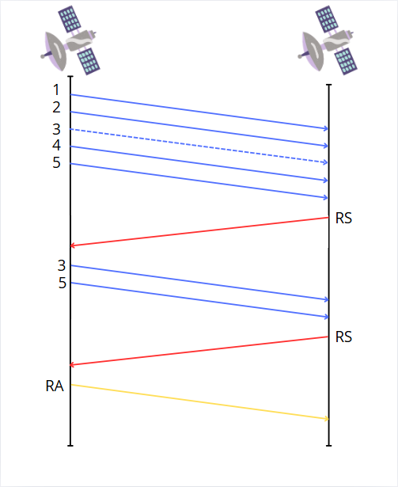

Figure 3. First case
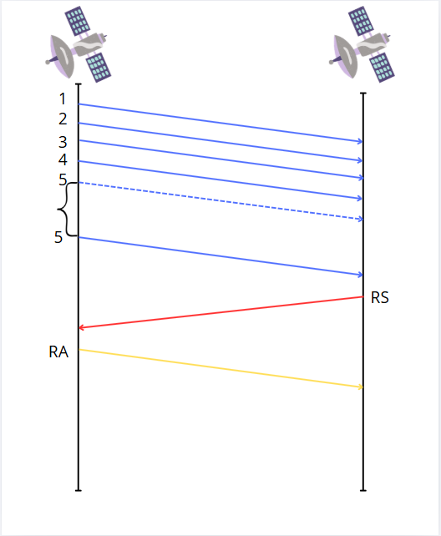

Figure 4. Second case
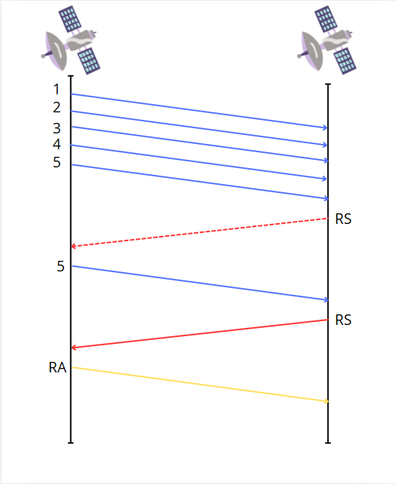

Figure 5. Third case
LTP, depending on mission requirements, can operate in both reliable and unreliable modes [13]. Therefore, if critically important data needs to be transmitted, the reliable mode will be used. Otherwise, when it is important to reduce the load on the system and minimize overhead, less strict approaches can be used. Currently LTP protocol is more frequently being integrated into the Bundle Protocol (BP) as part of the DTN architecture. According to [12], the efficiency of the LTP protocol decreases due to channel asymmetry. In this thesis, it is assumed that the entire data block is transmitted in reliable mode and that the forward and backward channels are symmetric.
3.5. Performance Evaluation of Earth-Mars link via Moon relay satellite
In this section, numerical results of the LTP protocol operating between Earth and Mars via Moon relay satellite is illustrated. For the demonstration purpose, just 1 block of data is transmitted. In the physical layer section, we presented how the Segment Error Rate (SER) has been determined. Below in Table 5 we again summarize the findings.
Link | SER
Earth-Moon | 0.06795
Moon-Mars | 0.2328
Table 5. SER values for Earth-Moon-Mars with QPSK
LTP simulation is inherently based on random losses dictated by SER. We allow losses to occur any of the segment including Data, RS segments during a block transmission. Then, we performed 10,000 numerical trials, and the average block transmission time was calculated, i.e., the time between the first bit of data transmitted and the last bit of CA segment is received. The trials with no error occurrence were also included. The obtained SER value for QPSK modeling between LEO satellites and the Lunar Gateway is 6.795%.
Figure 6 shows the relationship between the number of segments per block and the corresponding transmission time. As found in Figure 6, there is a significant increase in time as the number of segments rises due to the multiple retransmission of the errored segments. However, as the number of segments continues to grow, the corresponding increase in time becomes less pronounced. The slope of the red line decreases as the segment count increases. For the 6.795% error case, there is a sharp rise in time from 5 to 30 segments, but from 30 to 100 segments, the relationship becomes almost linear with a smaller slope. This suggests that at first, an increase in the number of segments results in a substantial rise in time. In contrast, when the number of segments is larger, the corresponding increase in time is significantly smaller. This result can be explained by the properties of the LTP protocol.
When the number of segments per block is increased from 5 to 10 or from 10 to 15, the probability of segment loss rises significantly, requiring retransmission of the lost segments. However, when the number of segments per block increases from 90 to 95, the likelihood of segment loss also increases, but not as drastically. In the next transmission round, there is a high probability that all lost segments will be successfully retransmitted. As the number of segments increases, the likelihood of segment loss grows accordingly. In subsequent retransmission rounds, a higher number of lost segments must be resent, increasing the chance of additional errors and potentially requiring a third round of retransmission. Consequently, as the number of segments increases, there will always be a corresponding increase in transmission time.
In Figure 6, we also present a 0% error line for the Earth-Moon link as a reference. This line has a linear shape due to the incremental increase in transmission time, which is caused by the growing number of transmitted segments per block. Since there are no errors, after transmitting the checkpoint, the transmitter receives the RS and completes the connection with a report acknowledgment (RA). It should be noted that propagation time does not increase as the number of segments grows, since all segments are sent back-to-back. Regardless of the number of segments, only a one-way propagation time dominates, as the time it takes for packets to leave the transmitter is negligible.
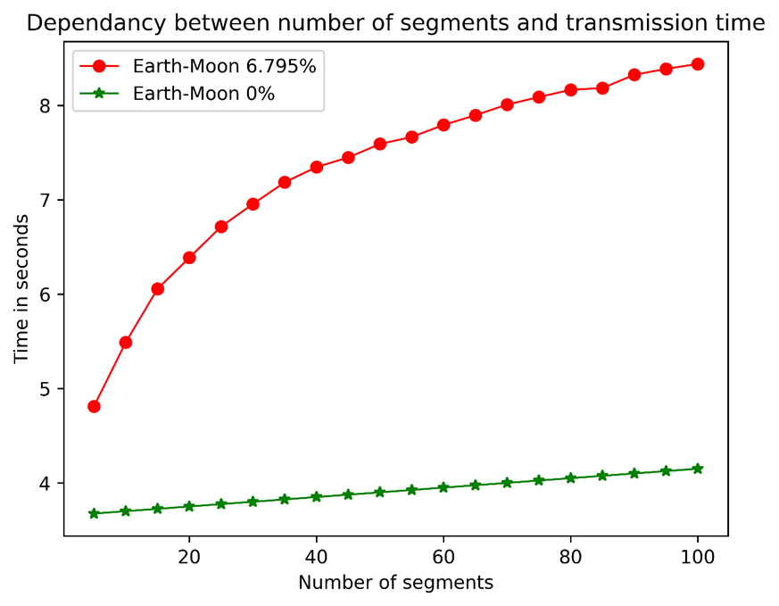
Figure 6. Earth-Moon LTP protocol
In Fig. 7, we present Moon-Mark link performance. For the Moon Mars link in the physical layer part the SER for QPSK has been obtained, which is equal to 23.28%. Implementing the same approach as for the Earth Moon link, dependency between number of segments and transmission time has been plotted in the figure 7. As the reference 0% error case is also demonstrated. The average distance between the planets is assumed– 225 million km, which results in 750 seconds one-way propagation time. Since for LTP to transmit data, it should first transmit all segments, receive RS and transmit report acknowledgment, which is equal to 2250 seconds for three way propagation time. Transmission time also should be considered: for 1 segment, with 1000 bit size and 200 KHz bandwidth, one way transmission time is 0.005 seconds. Thus, transmission time compared to the propagation time is very small and in the figure we can notice just constant line slightly above 2000 seconds. In the contrast, green line indicates time necessary to transmit data with LTP protocol from Moon to Mars with 23.28% error. At first there is sudden rise of time, as number of segments start increasing. After 30 segments, increase of time for the respective increment in segment number, is small and becomes almost constant resulting in linear relationship. In general this line has similar patterns as Earth-Moon link, just with bigger times due to the larger propagation time.
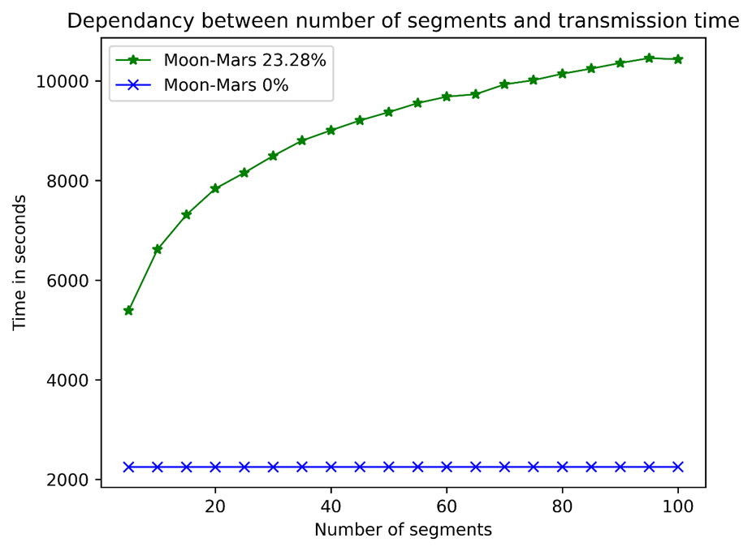
Figure 7. Moon-Mars LTP protocol
In order to transmit the data from Earth to Mars via Moon as relay satellite, initially the block of data is transmitted with LTP protocol from Earth to Moon, which is depicted in the Figure 6. Then when the data is received at the Moon orbiter (e.g. Lunar GW), it starts transmitting with LTP protocol to the satellite orbiting the Mars (e.g., MRO). Therefore, in order to establish multi-hop communication between satellites, it is necessary just to utilize LTP protocol consequently and add the respective time. This result is demonstrated in the Figure 8. Since the time between Earth and Moon is very small compared with Moon and Mars, result of Figure 8 is almost similar to Figure 7. Therefore in order to transmit data from Earth to Mars via relay satellites, for 5 segments it will take more than 5000 seconds, and for 100 segments it will take approximately 10000 seconds.
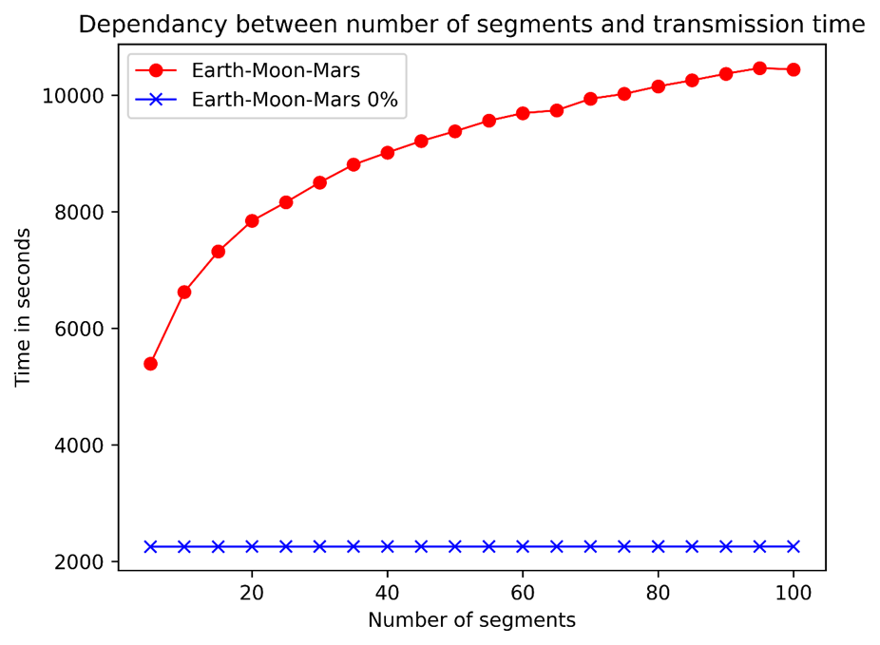
Figure 8. Earth-Moon-Mars LTP protocol
One of the advantages of using the Moon as a relay between Earth and Mars is that the frequency and duration of communication windows become significantly better. This is mainly due to the limited direct line of sight between Earth and Mars orbital devices. Direct visibility between Earth and Mars usually occurs periodically and, per orbit, lasts only several minutes. This is because of the dynamic motion of both planets. For example, the orbital period of a Mars satellite is about two hours, while a satellite in low Earth orbit (LEO) has a period of approximately 90 minutes. Such short windows create disruptions, which reduce the efficiency and reliability of data transmission.
Even though satellites in geostationary Earth orbit (GEO) can provide longer windows due to their fixed position relative to Earth, they still depend on planetary alignment to establish a connection with Mars. Using the Moon as a relay allows us to bypass these restrictions. Thanks to its close distance to Earth and synchronized rotation, the Moon offers nearly constant visibility from Earth. A relay station on the Moon can support stable and continuous communication with Earth, reducing the periods when Earth is not available for connection. This helps increase the frequency and duration of communication windows with Mars.
The line-of-sight window between satellites placed in low Earth and Mars orbits typically lasts from just a few seconds to a few minutes. However, if one satellite is placed in GEO and the other in a high Martian orbit, the duration of the window can extend to 10 to 20 minutes or more. When the Moon is used as a relay, these time intervals can be further increased thanks to the stable intermediate link it provides. As a result, the limitations caused by the orbital motion of the planets are reduced.
Agencies like NASA and ESA do not rely on constant line-of-sight between orbital equipment on Earth and Mars. Instead, they use a combination of solutions: the Deep Space Network for direct Earth–Mars communication, relay satellites in Mars orbit to transmit data from the surface, and scheduled communication windows during favorable planetary alignments. Placing a relay on the Moon strategically expands these systems. It reduces dependence on rare alignments and increases the reliability of the interplanetary communication network by introducing a stable and predictable intermediate node.
Also using the Moon as a relay point simplifies lunar exploration efforts. In addition to enhancing communication between Earth and Mars, this infrastructure could serve as a foundation for future lunar missions. It opens the possibility of establishing a permanent lunar base that could have direct communication with Earth, further advancing space exploration capabilities.
3.6. Performance Evaluation of Earth-Moon-L4-Mars link
A significant drawback of direct routing between Earth and Mars via a relay satellite is that the signal will be blocked during a solar conjunction (see Fig. 2). Therefore, an alternative route should be proposed that takes the Sun’s position into account. Such a route can be established by placing a relay satellite at the L4 Lagrange point, a gravitationally stable location in the Earth-Sun system. Initially, the link is established between Earth and the Moon. The signal is then transmitted from the Moon to the L4 Lagrange point. The distance from the Moon to the L4 point is approximately the same as the distance between Earth and L4, which is 1.49*10**11 m. In the physical layer, the SER for QPSK is calculated to be 30.92%. Table below summarizes SER values.
Link | SER
Earth-Moon | 0.06795
Moon-L4 | 0.309
L4-Mars | 0.211
Table 6. SER values for Earth-Moon-L4-Mars with QPSK
Figure 9 shows the relationship between the number of segments and transmission time between the Moon and L4. Due to the high error rate, nearly one-third of the segments are lost, causing a significant increase in transmission time as the number of segments grows. However, from the 40 segment / block and onward, the slope becomes less steep and transitions to a more linear pattern. The most substantial increase in transmission time occurs between 5 and 10 segments/block. The most substantial increase in transmission time occurs between 5 and 10 segments/block.
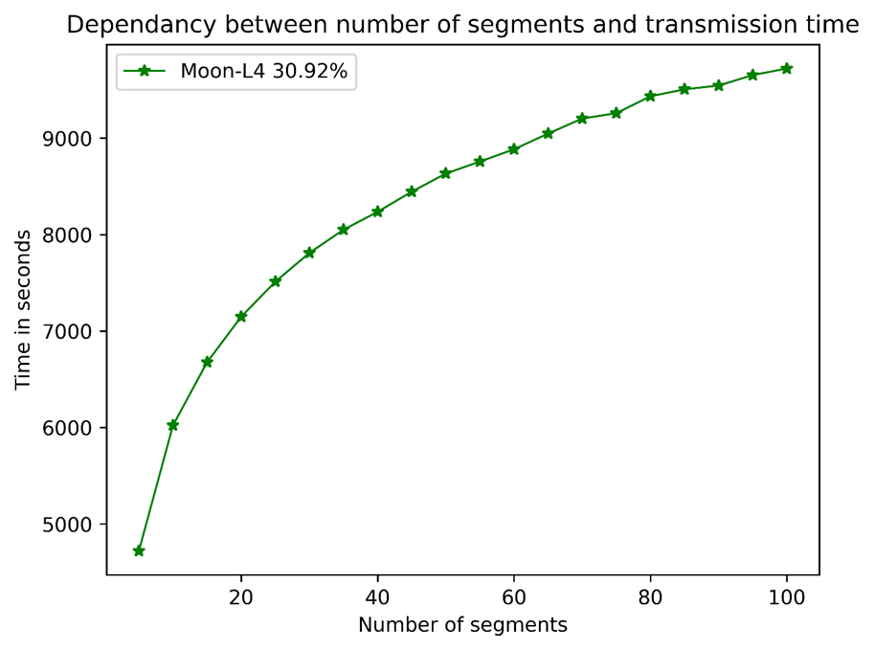
Figure 9. Moon L4 LTP protocol
To transmit data from the Moon to L4, it takes slightly less than 5,000 seconds for 5 segments/block, while for 100 segments/block, the transmission time is approximately 10,000 seconds.
In Fig. 10, the dependency between number of segments/block and the transmission time of the LTP protocol between L4 Lagrange point and Mars with 21.11 % error rate is shown. This value represents SER for QPSK modulation and has been obtained in the physical layer part. The distance between L4 point and Mars is 2.5*10**11 m, so the receiver of the signal will be the MRO satellite orbiting the Mars. It can be observed that till 40 segment/block rise of time for each segment increase is significant, and after that point it becomes less notable.
In order to transmit the data from Earth to Mars via relay satellite at L4 Lagrange point, initially the block of data is transmitted with LTP protocol from Earth to Moon, which is depicted at the Figure 6. Then, when the data is received at the Moon satellite, it starts transmitting with LTP protocol to the satellite at L4 Lagrange point. When L4 satellite completely receives 1 block of data, it will start transmitting it to the MRO satellite orbiting the Mars. Therefore, in order to establish multi-hop communication between satellites, it is necessary just to utilize LTP protocol consequently for each link and add the respective time. This result is demonstrated in the Figure 11. In order to transmit data from Earth-Moon to Mars via relay satellite at L4 Lagrange point, for 5 segments/block it will take more than 10000 seconds, and for 100 segments/block it will take approximately 20000 seconds. The main impact to the transmission time was due to the Moon-L4 link and L4-Mars link, since the distance and respective propagation time is significantly larger than Earth-Moon Link. Therefore, by establishing this connection, between Earth and Mars the Solar conjunction will be avoided, but with the cost of additional increase in time.
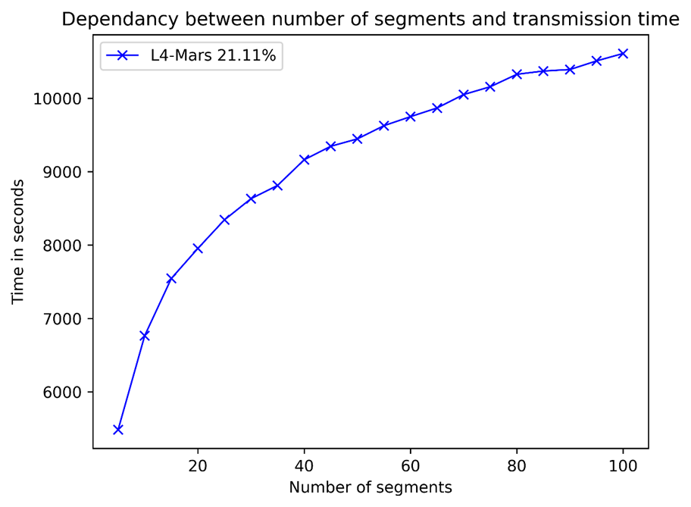
Figure 10. L4 Mars LTP protocol

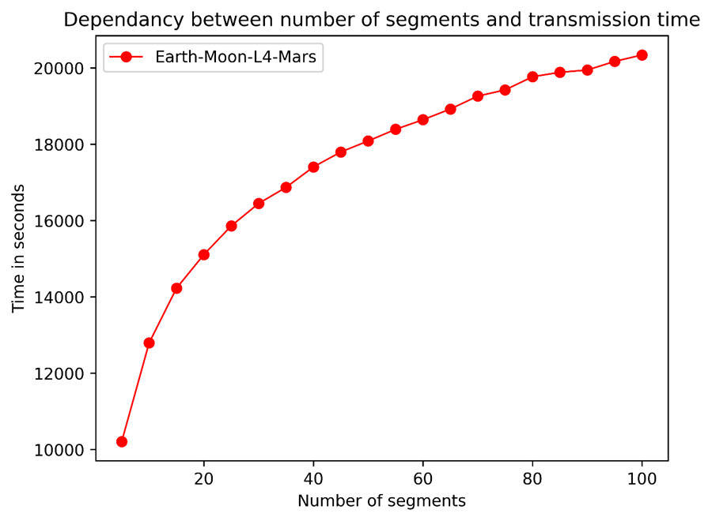
Figure 11. Earth – Moon – L4 – Mars LTP protocol

CHAPTER 4 – Conclusion and future work
In this thesis, the physical and transport layer properties of the Earth-Mars link has been discussed, by utilizing one-way radio frequency signal on the physical layer and LTP protocol at the transport layer. Initially, the physical layer properties of the Earth-Mars link via the Moon were analyzed. By considering various satellite parameters, such as antenna gain, transmission power, and modulation technique, the BER and SER for BPSK and QPSK modulation were determined. The same approach was applied to the Earth-Moon-L4-Mars connection via the L4 Lagrange point. The results from the physical layer modeling, specifically the SER for QPSK modulation, were utilized to simulate the LTP protocol by incorporating a probability of segment loss. The link between Earth and Mars was established via the Moon satellite relay (e.g., Lunar Gateway). While this link can transmit data in a relatively short time, it becomes completely blocked for 3–4 weeks during solar conjunctions. Therefore, an alternative route via the L4 Lagrange point has been proposed. While this route takes longer time to transmit data from Earth to Mars, it ensures a continuous, uninterrupted connection. This thesis analyzes the relationship between physical layer properties and overall transmission time from the source to the destination at the transport layer. Additionally, the impact of varying block sizes on transmission time at the transport layer is illustrated. The interesting characteristics of the LTP protocol has been identified, which is when the segment number in the block is low, i.e. less than 40, increase in segment size leads to significant increase of time. However, when it is more than 40, rise in segment size does not increase time that much. It can be explained by the following property of the LTP protocol. When the block size is small (e.g., 5 segments / block), there is a high likelihood that all segments will be successfully transmitted in the first transmission round. However, increasing the block size to 10, with some probability of segment loss, results in a greater chance of retransmission. In this case, the lost segments are more likely to be successfully retransmitted only in the second transmission round. This explains the sharp increase in transmission time observed between 5 and 10 segments. For larger block sizes (e.g., 70 segments / block), assuming a 10% segment loss rate, approximately 7 segments are expected to be lost. In the second transmission round, it is highly likely that all 7 lost segments will be successfully retransmitted, as the expected number of lost segments in this round would be only 0.7. When the block size increases to 75, it remains likely that all lost segments will be retransmitted in the second round. This explains the reason, as the block size increases, the corresponding increase in transmission time becomes less significant at higher segment counts. Since the LTP protocol simulations were conducted 10,000 times, rare events were averaged out, and the results reflect the typical behavior.

Bibliography/References
[1] C. Caini, P. Cornice, R. Firrincieli, and D. Lacamera, “A dtn approach to satellite communications,” IEEE Journal on Selected Areas in Communications, vol. 26, no. 5, pp. 820–827, 2008.
[2] R. C. Kizilirmak, I. E. Ehile, B. Kabdrashev, and S. Khvan, “Enhancing inter-satellite data relay in dynamic space communication,” in 2024 26th International Conference on Advanced Communications Technology (ICACT), pp. 01–05, IEEE, 2024.
[3] R. Dudukovich, D. Raible, B. Tomko, N. Kortas, E. Schweins berg, T. Basciano, W. Pohlchuck, J. Deaton, J. Nowakowski, and A. Hylton, “Advances in high-rate delay tolerant networking on board the international space station,” in IEEE Space Mission Challenges for Information Technology-IEEE Space Computing Conference (IEEE SMC-IT/SCC), 2024.
[4] NASA, “Lunanet: Empowering Artemis with Communications and Navigation Interoperability.” NASA Humans in Space, 2024. [Online]. Available: urlhttps://www.nasa.gov/humans-in-space/lunanet-empowering artemis-with-communications-and-navigation-interoperability/ [Accessed: 30-Sep-2024].
[5] V. Capuano, F. Basile, C. Botteron, and P.-A. Farine, “Gnss based orbital filter for earth moon transfer orbits,” The Journal of Navigation, vol. 69, no. 4, pp. 745–764, 2016.
[6] U.S. Government Accountability Office, “Polar Security Cutter: DHS Should Clarify Steps and Achieve Design Stability before Moving to Production.” GAO-24-106878, Sept. 2023. [Online]. Available: urlhttps://www.gao.gov/products/gao-24-106878 [Accessed: 30 Sep-2024].
[7] NASA, “Gateway: The Next Step in Human Space Exploration.” NASA Gateway Mission Page, Sept. 2024. [Online]. Available: urlhttps://www.nasa.gov/mission/gateway/ [Accessed: 30-Sep 2024].
[8] N. Drake, “Why we explore Mars- and what decades of missions have revealed,” National Geographic. [Online]. Available: https://web.archive.org/web/20220121050143/https://www. nationalgeographic.com/science/article/mars-exploration-article
[9] S. Manoj, P. Mushahary, and T. R. Rao, "Ka-Band Transmission Link Analysis for Earth-Mars Satellite Communications," in 2024 First International Conference on Innovations in Communications, Electrical and Computer Engineering (ICICEC), 2024, pp. 979-984, doi: 10.1109/ICICEC62498.2024.10808668.
[10] R. Wang, S. C. Burleigh, P. Parikh, C.-J. Lin, and B. Sun, “Licklider transmission protocol (ltp)-based dtn for cislunar communications,” IEEE/ACM Transactions on Networking, vol. 19, no. 2, pp. 359–368, 2010.
[11] R. Lent, “Analysis of the block delivery time of the licklider transmission protocol,” IEEE Transactions on Communications, vol. 67, no. 1, pp. 518–526, 2018.
[12] Y. Zhou, R. Wang, K. Zhao, and S. C. Burleigh, “A study of cross-layer bp/ltp data block size in space vehicle communications over lossy and highly asymmetric channels,” IEEE Transactions on Vehicular Technology, vol. 69, no. 12, pp. 16126–16141, 2020.
[13] S. Burleigh, M. Ramadas, and S. Farrell, "Licklider Transmission Protocol - Motivation," RFC 5325, Network Working Group, Internet Engineering Task Force (IETF), Sep. 2008. [Online]. Available: https://doi.org/10.17487/RFC5325
[14] W. Raza et al., "Towards a Hybrid RF/Optical Lunar Communication System (LunarComm)," arXiv preprint arXiv:2203.15899, Mar. 2022. [Online]. Available: https://arxiv.org/abs/2203.15899
[15] J. Downey, M. Evans, J. Downey, R. Reinhart, and D. Mortensen, Bandwidth-Efficient Communication through 225 MHz Ka-band Relay Satellite Channel. [Online]. Available: https://arc.aiaa.org/doi/abs/10. 2514/6.2016-5737
[16] B. L. Edwards, R. Daddato, K. Schulz, C. Schmidt, J. Hamkins, D. Giggenbach, B. Robinson, L. Braatz, and R. Alliss, “An update on the CCSDS optical communications working group,” in 2017 IEEE International Conference on Space Optical Systems and Applications (ICSOS), 2017, pp. 1–9.
[17] E. Grayver, A. Chin, J. Hsu, S. Stanev, D. Kun and A. Parower, “Software defined radio for small satellites,” 2015 IEEE Aerospace Conference, 2015, pp. 1-9, doi: 10.1109/AERO.2015.7118901.
[18] J. Krywko, “Deep space dial-up: How NASA speeds up its interplanetary communications,” Mar. 2019. [Online]. Available: https://bit.ly/3QVrBjY
[19] G. A. Reiff, R. K. Sloan, and J. N. James, “Mariner 4,” NASA. [On line]. Available: https://web.archive.org/web/20220220154632/https://nssdc.gsfc.nasa.gov/nmc/spacecraft/display.action?id=1964-077A
[20] D. Schneiderman and R. H. Steinbacher, “Mariner 9,” NASA. [Online]. Available: https://web.archive.org/web/20220410004505/https://nssdc.gsfc.nasa.gov/nmc/spacecraft/display.action?id=1971-051A
[21] G. K. Strobel, G. A. Soffen, J. M. Boyce, and J. S. Martin, “Viking 1 orbiter,” NASA. [Online]. Available: https://web.archive.org/web/20220426032142/https://nssdc.gsfc.nasa.gov/nmc/spacecraft/display.action?id=1975-075A
[22] G. K. Strobel, G. A. Soffen, J. M. Boyce, and J. S. Martin, “Viking 1 lander,” NASA. [Online]. Available: https://web.archive.org/web/20220410184029/https://nssdc.gsfc.nasa.gov/nmc/spacecraft/display.action?id=1975-075C
[23] “Mars Global Surveyor,” NASA. [Online]. Available: https://mars. nasa.gov/internal resources/813/
[24] “Keeping in touch,” NASA. [Online]. Available: https://mars.nasa.gov/ mgs/overvu/sc/tele/tele.html
[25] “Mars relay,” NASA. [Online]. Available: https://mars.nasa.gov/mgs/ sci/mr/mr.html
[26] “Participation information,” NASA, 1996. [Online]. Available: https://web.archive.org/web/20210321013412/https://mars.nasa.gov/mgs/sci/mr/mrhome/mrfaq.html
[27] “Mars relay (MR) info,” NASA. [Online]. Available: https://mars.nasa. gov/mgs/scsys/mrtext.html
[28] D. S. Kahan, W. M. Folkner, D. R. Buccino, V. Dehant, S. Le Maistre, A. Rivoldini, T. Van Hoolst, M. Yseboodt, and J. Marty, “Mars precession rate determined from radiometric tracking of the Insight lander,” Planetary and Space Science, vol. 199, p. 105208, 2021. [Online]. Available: https://www.sciencedirect.com/science/article/pii/ S0032063321000477
[29] M. P. Golombek, “The Mars Pathfinder mission,” J. Geophys. Res.: Planets, vol. 102, no. E2, pp. 3953–3965, 1997. [Online]. Available: https://agupubs.onlinelibrary.wiley.com/doi/abs/10.1029/96JE02805
[30] S. Stride, “Microrover radios and antennas,” NASA, Oct 1997. [Online]. Available: https://mars.nasa.gov/MPF/rovercom/ itworks.html#rover-radio
[31] J. R. Taylor, A. Makovsky, A. J. Barbieri, R. H. Tung, P. Estabrook, and A. G. Thomas, “Mars exploration rover telecommunications,” in DESCANSO Design and Performance Summary Series, Oct. 2016. [Online]. Available: https://descanso.jpl.nasa.gov/DPSummary/MER article cmp20051028.pdf
[32] J. Taylor, A. Makovsky, A. Barbieri, R. Tung, P. Estabrook, and A. G. Thomas, Mars Exploration Rover Telecommunications. John Wiley & Sons, Ltd, 2016, ch. 7, pp. 251–358. [Online]. Available: https://onlinelibrary.wiley.com/doi/abs/10.1002/9781119169079.ch7
[33] “Nasa’s Odyssey, studying Mars’ surface,” The Planetary Society, 2018. [Online]. Available: https://web.archive.org/web/20220711004658/ https://www.planetary.org/space-missions/every-mars-mission
[34] “CCSDS 211.0-B-6- Proximity-1 space link protocol-data link layer,” CCSDS Secretariat National Aeronautics and Space Administration, Washington, DC, USA, Jul. 2020.
[35] C. Edwards, Jr., B. Arnold, R. DePaula, G. Kazz, C. Lee, and G. Noreen, “Relay communications strategies for mars exploration through 2020,” Acta Astronautica, vol. 59, no. 1, pp. 310–318, 2006. [Online]. Available: https://www.sciencedirect.com/science/article/pii/ S0094576506000816
[36] “Mars Express,” ESA. [Online]. Available: https://web.archive.org/web/20220709080425/https://www.esa.int/Science Exploration/Space Science/Mars Express/The spacecraft
[37] “Mars Express engineering: Telecoms,” ESA. [Online]. Available: https://web.archive.org/web/20211207094312/https://sci.esa.int/ web/mars-express/-/31034-engineering
[38] C. Edwards and R. DePaula, “Key telecommunications technologies for increasing data return for future Mars exploration,” Acta Astronautica, vol. 61, no. 1, pp. 131–138, 2007. [Online]. Available: https://www.sciencedirect.com/science/article/pii/S0094576507000306
[39] “Mars Phoenix,” NASA, Sep 2019. [Online]. Available: https://web.archive.org/web/20220713194951/https://mars.nasa. gov/mars exploration/missions/phoenix/
[40] “Mars Curiosity rover: Communications with Earth,” NASA, Aug 2019. [Online]. Available: https://web.archive.org/web/ 20220424155307/https://mars.nasa.gov/msl/mission/communications/
[41] “Maven, studying how Mars lost its atmosphere,” The Planetary Society, 2018. [Online]. Available: https://web.archive.org/web/ 20220717140147/https://www.planetary.org/space-missions/maven
[42] “Maven press kit: Exploring Mars’ climate history,” NASA, Nov 2013. [Online]. Available: https://mars.nasa.gov/files/resources/ MAVEN PressKit Final.pdf
[43] “Exomars Trace Gas orbiter (TGO),” ESA. [Online]. Avail able: https://web.archive.org/web/20220707105420/https://exploration. esa.int/web/mars/-/46475-trace-gas-orbiter
[44] “ExoMars 2022,” ESA, Feb 2019. [Online]. Available: https://www.eoportal.org/satellite-missions/exomars-2022# wisdom-water-ice-subsurface-deposit-observation-on-mars-radar
[45] E. Koktas and E. Basar, "Communications for the Planet Mars: Past, Present, and Future," arXiv preprint arXiv:2211.14245, Nov. 2022. [Online]. Available: https://arxiv.org/abs/2211.14245
[46] G. Yang, R. Wang, S. C. Burleigh, and K. Zhao, “Analysis of licklider transmission protocol for reliable file delivery in space vehicle communications with random link interruptions,” IEEE Transactions on Vehicular Technology, vol. 68, no. 4, pp. 3919 3932, 2019.
[47] Z. Shi, S. Peng, Y. Zhou, L. Yang, R. Wang, H. Hu, and K. Zhao, “Study on checkpoint timer optimal setup of licklider transmission protocol,” IEEE Aerospace and Electronic Systems Magazine, vol. 35, no. 5, pp. 4–13, 2020.

