Effect of cocoa flavonoids on lipopolysaccharide-induced reactive oxygen species production in BV-2 microglial cells

Dana Sultanova
Srinivasa Rao Bolla, PI
Syed Hani Abidi, Co-PI
Kamilya Kokabi, Co-PI
March 1, 2026

Abstract
Neuroinflammation mediated by microglial ROS overproduction is one of the mechanisms underlying the pathogenesis of neurodegenerative disorders. Cocoa-derived flavonoids possess antioxidant and anti-inflammatory properties; however, their effect on microglial cells has not been studied. To evaluate whether cocoa extract attenuates LPS-induced ROS production and pro-inflammatory cytokines expression in BV-2 microglial cells. BV-2 cells were pretreated with cocoa extract (3 or 10 μg/ml) or proanthocyanidins (5 or 15 μM), then stimulated with 100 ng/ml LPS. ROS was quantified by a fluorescence assay; cytokine levels were assessed by Western blot and RT-PCR. LPS treatment induced classical amoeboid microglial activation, with high-dose cocoa (10 μg/ml) showing partial preservation of cellular processes. Cocoa pretreatment reduced ROS levels compared to LPS alone (n=1). TNF-α mRNA expression was reduced in a dose-dependent manner; however, protein-level changes were inconclusive and without control normalization (n=1). This study provides preliminary evidence for a potential antioxidant effect of cocoa flavonoids in BV-2 microglial cells. Replication with biological triplicates and cocoa extract composition determination are required to confirm these findings.

Introduction
Neuroinflammation and oxidative stress play one of the main roles in the pathogenesis of neurodegenerative diseases like Alzheimer’s and Parkinson’s. Both processes are mediated by microglia, the resident immune cell of the central nervous system. Microglial cells maintain tissue homeostasis by balancing pro- and anti-inflammatory signaling. When the inflammatory process is triggered, expression of the NF-kB signaling pathway is activated in microglial cells (Hanisch & Kettenmann, 2007; Lim et al., 2018). This drives the production of pro-inflammatory cytokines, such as tumor necrosis factor-α (TNF-α), interleukin-1β (IL-1β), and interleukin-6 (IL-6) (Lim et al., 2018). Contributing to neuronal damage and disease progression. Later, microglial cells start to produce interleukin-10 (IL-10), an anti-inflammatory cytokine, which helps to subside the excessive inflammation (Lim et al., 2018).
Flavonoids are natural compounds present in many plant-based foods, including berries, tea, red wine, and cocoa. They are believed to possess antioxidant properties and the ability to inhibit pro-inflammatory pathways. Epidemiological data links higher dietary flavonoid intake to a 40% risk reduction of developing Parkinson’s in men (Gao et al., 2012). Previous in vitro studies have shown a protective effect of cocoa extract in cardiac and cochlear cell lines. A significant reduction in NF-kB pathway expression, subsequent IL-6 production, and cellular apoptosis were observed in cocoa pretreated cell lines (Ahmed et al., 2022; Del Mar Rivas-Chacón et al., 2022).
The BV-2 cell line is an immortalized mouse microglial cell line that exhibits morphological and functional characteristics of primary microglial cells (Henn et al., 2009). Neuroinflammation can be induced by different pathogens, one of which is lipopolysaccharide (LPS). LPS is a TLR4 agonist that activates NF-kB signaling in microglia and leads to the production of proinflammatory cytokines (Lim et al., 2018). Despite evidence that cocoa flavonoids modulate inflammation in other cell types, their effect on LPS-induced microglial activation remains unexplored.
In this study, we evaluated the effect of cocoa extract on oxidative stress markers in BV-2 microglial cells. We hypothesize that microglia pretreated with cocoa flavonoids will exhibit a reduction in ROS production.

Material and methods

Cocoa extract preparation
The cocoa powder was dissolved in water and infused for 24h in a dark, cold place, then the extract was filtered through a 0.22 μm filter. Before each use, the extract was diluted with Complete Media.

Cell culture and treatment
BV-2 mouse microglial cells were used for the experiments. The cells were grown in complete media (CM): DMEM (Gibco, 11965092), 10% FBS (Capricorn, 12A), 1% antibiotic (Capricorn, PS-B). Cells were seeded in 24-well plates or 6-well plates, depending on the experiment, and treated with low (3 μg/ml) and high (10 μg/ml) concentrations of Cocoa solution for 12 hours, and later with 100 ng/ml LPS (Sigma-Aldrich, 93572420) solution for 18 hours. A positive control group was treated with low (5 μM) and high (15 μM) concentrations of proanthocyanidins derived from grape seed extract (MedChemExpress, HY-N0794) for 12 hours, and then with the same concentration of LPS. The concentrations of LPS (100 ng/ml) (He et al., 2021), cocoa extract (3 and 10 μg/ml) (del Mar Rivas-Chacón et al., 2022), and proanthocyanidins (5 and 15 μM) (Toda et al., 2020) were selected based on previous cell culture studies showing effective immune modulation and antioxidant activity in these ranges without cytotoxicity.

ROS assay
Mouse microglial cells were pretreated with cocoa extract and then with LPS. Induced ROS were detected using Cellular ROS/RNS Detection Assay Kit (Abcam, ab139473). Fluorescence was visualized under a microscope, and the intensity was measured in ImageJ. For each treatment group, three technical replicates were performed, and mean fluorescence values were calculated.

Western Blot
The cells were spun down and washed with PBS once, then lysed on ice using RIPA buffer containing protease inhibitor cocktail (Sigma-Aldrich, R0278). The proteins were separated by SDS gel electrophoresis (BioRad, 4561033). Then, the proteins were transferred to a PVDF membrane and stained with primary antibodies specific to IL-1β (R&D Systems, AF-401-NA), IL-10 (Abcam, ab9736), IL-6 (R&D Systems, AF-406-NA), and TNF-α (R&D Systems, AF-410-NA). A rabbit anti-goat (Abcam, ab6741) antibody was used as a secondary antibody.

Real-time PCR
RNA was purified from the treated cells using the RNeasy Mini Kit (Qiagen, 74104) according to the manufacturer's instructions. RNA integrity was determined by electrophoresis through a bleach-containing agarose gel, protocol described by Aranda et al. (2012). RNA was reverse transcribed into cDNA using PrimeScript™ RT Master Mix (Takara, RR036A) according to the manufacturer's protocol. Primers for PCR were obtained from the local dealership, NCBS Astana. Gene expression was quantified using the comparative CT (2^{-ΔΔCT}) method (Schmittgen & Livak, 2008). The expression was normalized to β-actin, as a housekeeping gene. The experiment was performed in technical triplicates, and mean Ct values were used for calculation. Target genes analyzed included TNF-α and IL-10. Primers for IL-1β and IL-6 were also tested but produced non-specific amplification and were excluded from analysis.

Results

Cell Morphology
Morphological changes in BV-2 cells were evaluated using phase-contrast microscopy after pretreatment with cocoa extract or proanthocyanidins and LPS stimulation (Figure 1). Untreated control cells exhibited a ramified morphology with elongated processes and spindle-shaped cell bodies, which is a characteristic of resting microglia. Following LPS treatment, cells became more amoeboid. The morphology is characterized by retracted processes, rounded cell bodies, and increased granularity. These changes are consistent with classical microglial activation. Cells pretreated with low-dose cocoa extract (C3) had predominantly amoeboid morphology similar to the LPS-treated group. In contrast, high-dose cocoa pretreatment (C10) resulted in cells with intermediate morphological characteristics. These cells had some processes, although they mostly stayed rounded. Groups pretreated with proanthocyanidins (P5 and P15) were very similar to each other and had amoeboid morphology similar to the LPS-treated group.

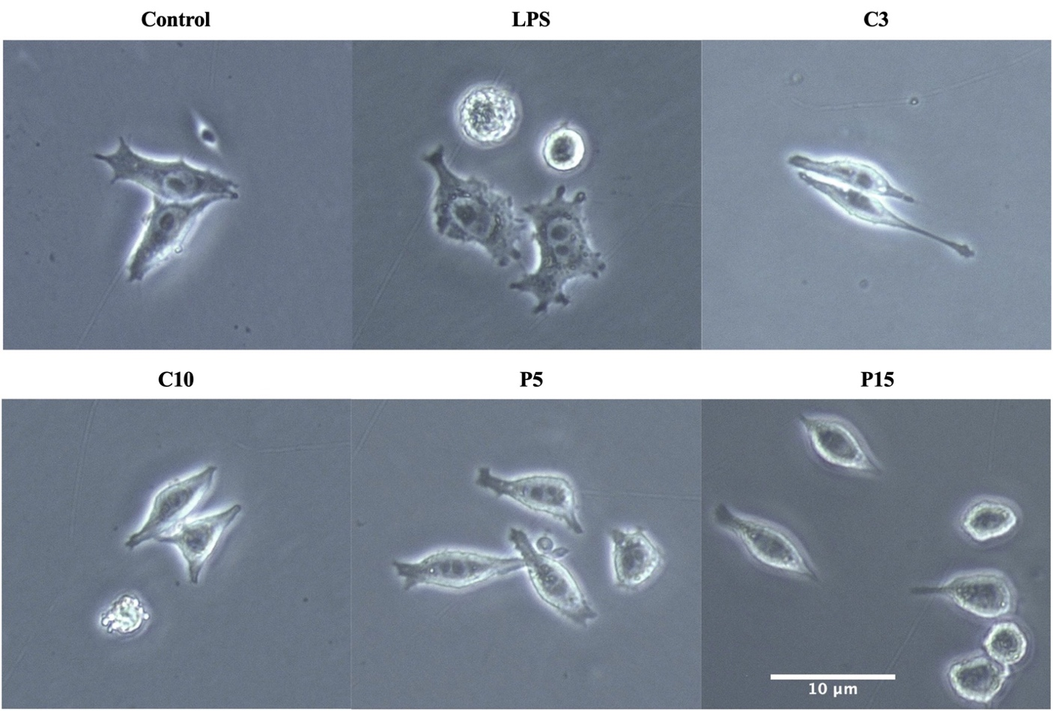
Figure 1. BV-2 microglial cell morphology after pretreatment with cocoa extract or proanthocyanidins and LPS stimulation. Representative phase-contrast microscopy images show cell morphology in untreated Control, LPS-treated (100 ng/ml, 18 hours), and cells pretreated with cocoa extract (C3: 3 μg/ml or C10: 10 μg/ml) or proanthocyanidins (P5: 5 μM or P15: 15 μM) for 12 hours prior to LPS stimulation. Control cells exhibit ramified morphology with extended processes; LPS induces amoeboid activation with rounded cell bodies and retracted processes. Images captured at 20X magnification.

ROS assay
Intracellular ROS production in BV-2 microglial cells was measured following pretreatment with cocoa extract or proanthocyanidins and subsequent treatment with LPS. Figure 2 shows that LPS exposure alone increases mean fluorescence intensity compared to untreated control cells. Pretreatment with cocoa extract with low (C3) and high (C10) concentrations showed a reduction in mean fluorescent intensity compared to the LPS group. Similarly, proanthocyanidins pretreatment showed fluorescence values intermediate between the untreated control and LPS-treated cells. Due to the single-replicate nature of this experiment (n=1), no statistical analysis was performed.
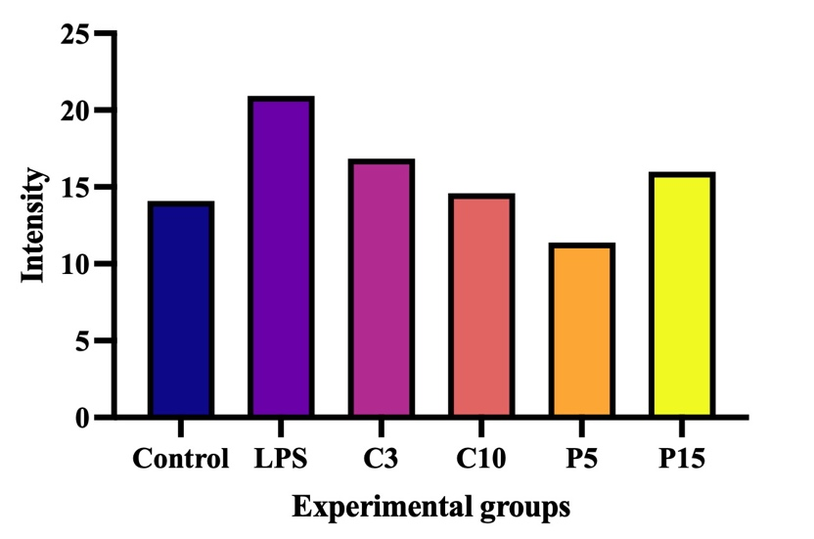
Figure 2. LPS-induced ROS production in BV-2 cells. Mean fluorescence intensity of the Total ROS detection assay is shown. Cells were pretreated with cocoa (C3: 3 μg/ml, C10: 10 μg/ml) or proanthocyanidins (P5: 5 μM, P15: 15 μM) followed by 100 ng/ml LPS. Values represent mean of technical replicates from a single biological replicate (n=1).

Western Blot
The effect of cocoa extract on protein-level expression of proinflammatory cytokines, including TNF-α and IL-1β, was analysed by Western Blot (Figure 3). The band intensity quantification showed that TNF-α expression in the LPS-treated group was lower than in the control group, contrary to the expected results. Pretreatment with cocoa extract increased TNF-α expression, with low concentration (C3) showing the highest intensity peak. In a positive control group, treated with proanthocyanidins, low-dose treatment (P5) showed results comparable to the control group, while the high concentration (P15) group notably reduced TNF-α production. Similar results were observed with IL-1β production. The highest IL-1β expression was observed in the cocoa pretreated groups.
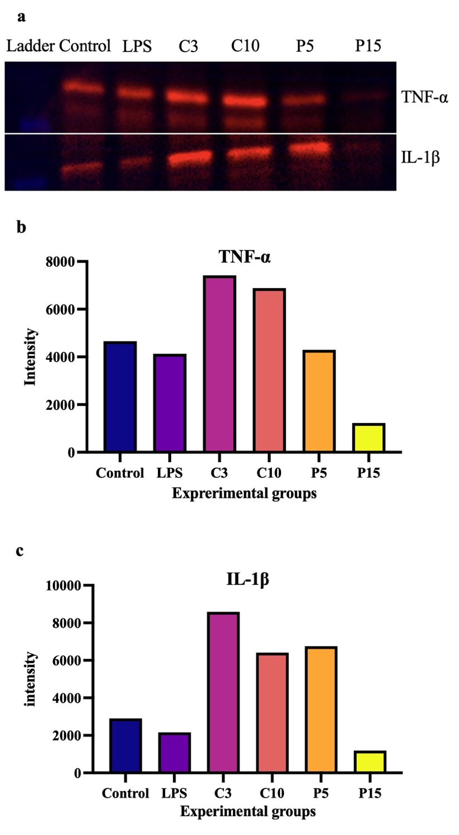
Figure 3. Western blot analysis of TNF-α and IL-1β expression in LPS-stimulated BV-2 cells. (a) Representative blot image. (b-c) Densitometric quantification of TNF-α (b) and IL-1β (c) band intensity. Results are not normalized to a loading control (n=1).

Real-time PCR
RNA integrity was evaluated by agarose gel electrophoresis prior to reverse transcription into cDNA. Two bands corresponding to 28S and 18S rRNA were observed in all samples (Figure 4). The presence of those bands indicates that RNA integrity was preserved in all experimental groups.
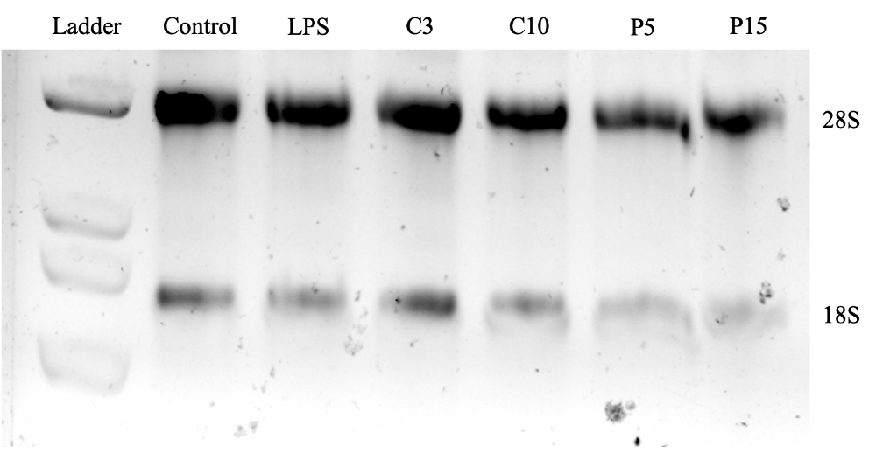
Figure 4. RNA integrity assessment by bleach gel electrophoresis. The presence of 28S and 18S bands confirms sample quality in all experimental groups.
Gene expression levels of pro-inflammatory and anti-inflammatory cytokines were quantified by RT-PCR, normalized to β-actin housekeeping gene, and expressed relative to an untreated control (Figure 5). TNF-α mRNA expression was reduced in LPS-treated cells relative to control group. Pretreatment with cocoa extract resulted in suppression of TNF-α in a dose-dependent manner. The high concentration group (C10) showed the lowest relative expression. Proanthocyanidins pretreatment at low dose (P5) maintained the cytokine expression at the control level, while high dose (P15) resulted in its suppression. IL-10 mRNA expression in LPS-treated cells showed a similar pattern of cytokine reduction. This suppression pattern persisted across all groups.
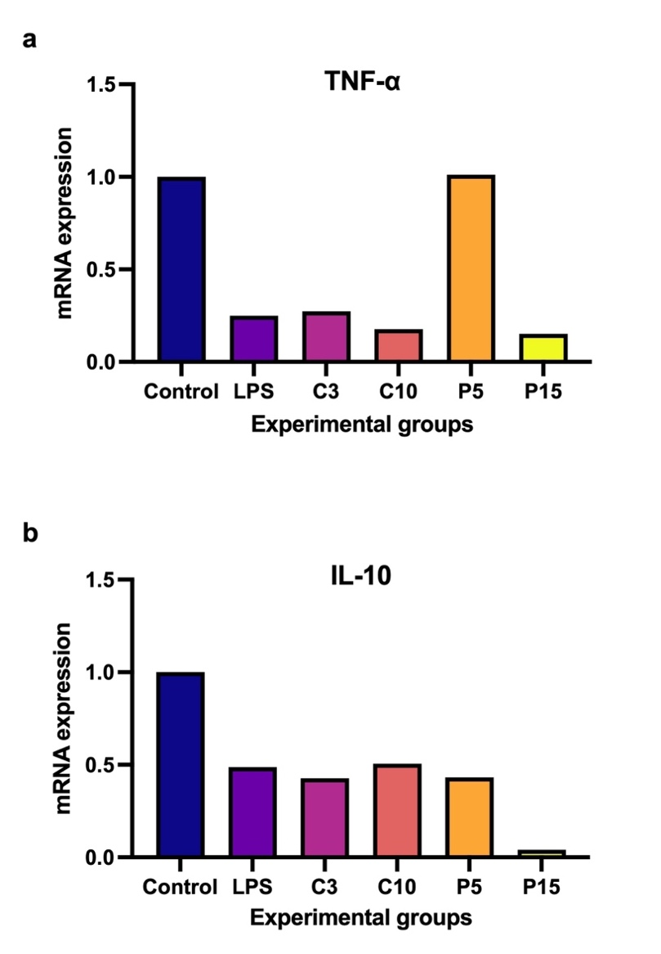
Figure 5. Relative TNF-α (a) and IL-10 (b) mRNA expression. Gene expression was quantified by RT-PCR using the comparative CT method (2^{-ΔΔCT}) (Schmittgen & Livak, 2008), normalized to β-actin as housekeeping gene, and expressed relative to untreated control. Values represent mean of technical triplicates from a single biological replicate (n=1).

Discussion
In this study, the effect of cocoa extract on LPS-induced oxidative stress and inflammatory response in BV-2 microglial cells was studied. The results demonstrate some ROS reduction in cocoa pretreated cells. At the gene level, cocoa pretreatment suppressed TNF-α mRNA expression in a dose-dependent manner, suggesting an anti-inflammatory effect. However, western blot analysis of pro-inflammatory proteins showed results that were inconsistent with RT-PCR data.
Morphological assessment showed LPS induced classical microglial activation, as evidenced by the transition from ramified to amoeboid morphology. This morphological change is a key feature of microglial activation. After LPS stimulation, resting microglia retract their processes and become more rounded (Hanisch and Kettenmann, 2007; He et al., 2021). The induction of these morphological changes by LPS demonstrates that the experimental conditions were sufficient to activate BV-2 cells. Cocoa treatment at the higher concentration (C10, 10 μg/ml) showed a subtle trend towards preservation of cellular processes compared to the LPS-treated group. This might suggest that cocoa extract modulates BV-2 microglial activation. However, this observation is only speculative due to the single nature of the experiment. Therefore, further morphological analysis should be performed.
The ROS fluorescence assay showed that both cocoa extract concentrations (3 μg/ml and 10 μg/ml) reduced mean fluorescence intensity compared to the LPS-treated group. This general trend aligns with earlier in vitro studies and suggests that cocoa flavonoids exhibit antioxidant properties across different cell types. Ahmed et al. (2020) reported that cocoa extract significantly reduced ROS production in cardiomyocytes after ischemia-reperfusion injury. Similarly, del Mar Rivas-Chacón et al. (2022) observed the protective effect of cocoa extract in cochlear cells exposed to oxidative stress. However, any definitive conclusions about the reliability of this effect cannot be made due to the high variability observed in mean fluorescence measurements. To determine if cocoa extract truly has an antioxidant effect in microglia, the experiment needs to be conducted in biological triplicates with technical replicates.
Western blot results for TNF-α and IL-1β protein expression were inconsistent with the expected LPS response and with the RT-PCR findings. The finding that LPS treatment reduced TNF-α and IL-1β band intensities compared to untreated samples contradicts expectations. These findings can be explained by the absence of a loading control, which affected the normalization of the results. Meaning that observed band intensity differences could reflect unequal sample loading rather than true biological changes (Ghosh et al., 2014). Western blot analysis was attempted for IL-10 and IL-6 in addition to TNF-α and IL-1β. However, no detectable bands were observed for IL-10 and IL-6. This could reflect insufficient protein transfer to the membrane or cytokine expression levels below the detection threshold of the assay.
TNF-α mRNA expression was reduced in a dose-dependent manner by cocoa extract pretreatment. This finding is consistent with published reports of flavonoid-mediated suppression of proinflammatory cytokines by inhibiting the NF-kB pathway. Proanthocyanidins, used as a positive control, showed a similar pattern. Low-dose (P5, 5 μM) maintained TNF-α expression near control levels, while high-dose (P15, 15 μM) strongly suppressed TNF-α mRNA. The IL-10 results were more complex. IL-10 is an anti-inflammatory cytokine that is typically upregulated to limit excessive inflammation. In our study, LPS treatment reduced IL-10 expression, which has persisted across all treatment groups. This pattern may suggest a pro-inflammatory microglial state at the 18-hour LPS treatment time point. Time-course experiments in macrophages have shown that the production of pro-inflammatory cytokines, such as TNF-α, happens earlier (peaking at 6-16 hours after LPS stimulation) than production of anti-inflammatory cytokines, such as IL-10 (peaking at 16-24 hours) (Hobbs et al., 2018). This suggests that the anti-inflammatory response in our experiment may not have been activated at the 18-hour time point. The RT-PCR analysis was limited to TNF-α and IL-10 due to technical issues with IL-1β and IL-6 primer sets, which failed to produce specific amplifications.
This study has several important limitations that should be recognized. First, all experiments were performed as a single replicate, due to time and consumable constraints. This makes statistical analysis infeasible. Second, the composition of the cocoa extract used in this study was not determined. The experiments were made under the assumption that the cocoa extract contains antioxidant flavonoids; however, the exact concentration was not determined prior to the experiments. Third, cell viability and cytotoxicity assays were not performed. Therefore, the toxicity of cocoa extract in chosen concentrations was not assessed. Finally, the Western blot findings were not adjusted to a housekeeping protein. Thus, making protein-level quantification unreliable.
In summary, our research showed that cocoa extract affects oxidative and inflammatory responses in BV-2 microglial cells. This is indicated by trends towards ROS reduction and suppression of TNF-α mRNA expression. However, due to significant experimental limitations, the results presented in this report must be considered preliminary and not definitive findings. The Western blot analysis produced results inconsistent with established LPS biology and the RT-PCR data. This was likely due to technical problems, including the absence of loading controls and possible issues with protein transfer or antibody performance. The RT-PCR analysis was incomplete due to primer optimization failures for IL-1β and IL-6. These methodological problems, combined with the single-replicate design, mean that all experiments require complete repetition with proper controls and biological replicates before any conclusions can be drawn about the effects of cocoa flavonoids on microglial inflammation and ROS production.

References
Ahmed, S., Ahmed, N., Rungatscher, A., Linardi, D., Kulsoom, B., Innamorati, G., Meo, S. A., Gebrie, M. A., Mani, R., Merigo, F., Guzzo, F., & Faggian, G. (2020). Cocoa Flavonoids Reduce Inflammation and Oxidative Stress in a Myocardial Ischemia-Reperfusion Experimental Model. Antioxidants, 9(2), 167. https://doi.org/10.3390/antiox9020167
Aranda, P. S., LaJoie, D. M., & Jorcyk, C. L. (2012). Bleach gel: A simple agarose gel for analyzing RNA quality. ELECTROPHORESIS, 33(2), 366–369. https://doi.org/10.1002/elps.201100335
del Mar Rivas-Chacón, L., Yanes-Díaz, J., de Lucas, B., Riestra-Ayora, J.I., Madrid-García, R., Sanz-Fernández, R., Sánchez-Rodríguez, C. (2022). Preventive Effect of Cocoa Flavonoids via Suppression of Oxidative Stress-Induced Apoptosis in Auditory Senescent Cells. Antioxidants, 11(8), 1450. https://doi.org/10.3390/antiox11081450
Gao, X., Cassidy, A., M.A. Schwarzschild, Rimm, E. B., & A. Ascherio. (2012). Habitual intake of dietary flavonoids and risk of Parkinson disease. Neurology, 78(15), 1138–1145. https://doi.org/10.1212/wnl.0b013e31824f7fc4
Ghosh, R., Gilda, J. E., & Gomes, A. V. (2014). The necessity of and strategies for improving confidence in the accuracy of western blots. Expert Review of Proteomics, 11(5), 549–560. https://doi.org/10.1586/14789450.2014.939635
Hanisch, U.-K., & Kettenmann, H. (2007). Microglia: active sensor and versatile effector cells in the normal and pathologic brain. Nature Neuroscience, 10(11), 1387–1394. https://doi.org/10.1038/nn1997
He, Y., Taylor, N., Yao, X., & Bhattacharya, A. (2021). Mouse primary microglia respond differently to LPS and poly(I:C) in vitro. Scientific Reports, 11(1). https://doi.org/10.1038/s41598-021-89777-1
Henn, A. (2009). The suitability of BV2 cells as alternative model system for primary microglia cultures or for animal experiments examining brain inflammation. ALTEX, 83–94. https://doi.org/10.14573/altex.2009.2.83
Hobbs, G. A., Zhou, B., Cox, A. D., & Campbell, S. L. (2018). LPS‐stimulated NF‐κB p65 dynamic response marks the initiation of TNF expression and transition to IL‐10 expression in RAW 264.7 macrophages. Physiological Reports, 6(21), e13914. https://doi.org/10.14814/phy2.13914
Lim, H.-S., Kim, Y. J., Kim, B.-Y., Park, G., & Jeong, S.-J. (2018). The Anti-neuroinflammatory Activity of Tectorigenin Pretreatment via Downregulated NF-κB and ERK/JNK Pathways in BV-2 Microglial and Microglia Inactivation in Mice With Lipopolysaccharide. Frontiers in Pharmacology, 9. https://doi.org/10.3389/fphar.2018.00462
Schmittgen, T. D., & Livak, K. J. (2008). Analyzing real-time PCR data by the comparative CT method. Nature Protocols, 3(6), 1101–1108. https://doi.org/10.1038/nprot.2008.73
Toda, K., Tsukayama, I., Nagasaki, Y., Konoike, Y., Tamenobu, A., Ganeko, N., Ito, H., Kawakami, Y., Takahashi, Y., Miki, Y., Yamamoto, K., Murakami, M., & Suzuki-Yamamoto, T. (2020). Red-kerneled rice proanthocyanidin inhibits arachidonate 5-lipoxygenase and decreases psoriasis-like skin inflammation. Archives of Biochemistry and Biophysics, 689, 108307. https://doi.org/10.1016/j.abb.2020.108307

