Impact of Materials and Resources Factors on the Sustainability of Buildings

Yerzhan Alizhan, B. Eng.

Submitted in fulfillment of the requirements for the degree of Master of Science
in Civil & Environmental Engineering



School of Engineering and Digital Sciences Department of Civil & Environmental Engineering Nazarbayev University

53 Kabanbay Batyr Avenue, Astana, Kazakhstan, 010000

Lead Supervisor: Dr. Abid Nadeem
Co-Supervisor: Dr. Shazim Ali Memon

October 2023

Declaration
I hereby declare that this manuscript, entitled “Impact of Materials and Resources Factors on the Sustainability of Buildings” is the result of my work except for quotations and citations which have been duly acknowledged.
I also declare that, to the best of my knowledge and belief, it has not been previously or concurrently submitted, in whole or in part, for any other degree or diploma at Nazarbayev University or any other national or international institution.

-------------------------------------------
Name: Yerzhan Alizhan
Date: 30.11.2023

Abstract
Currently, the construction industry consumes enormous amounts of energy and emits one-third of total carbon dioxide emissions over the world. Therefore, it is highly essential to decrease the influence of the building sector on the environment. Materials and Resources play a crucial role in the construction process, encompassing the extraction, production, transportation, and disposal of construction materials, which are all associated with energy consumption and emissions. Therefore, this research investigates the influence of Materials and Resources (MR) on building sustainability. The research was undertaken in Kazakhstan's construction sector and is based on a survey of construction professionals with various backgrounds for a typical residential high-rise structure. The research focuses on the materials and resources part of LEED certification and intends to investigate construction professionals' attitudes and understanding of building MR sustainability. Furthermore, the thesis intends to emphasize the need to implement BIM technology to achieve building sustainability.
The methodology of the research is descriptive research and based on a survey that is designed to collect data from construction professionals about their perceptions, knowledge, and understanding of the MR aspect of LEED certification. The survey questions were developed by conducting a comprehensive analysis of various research papers, books, and journals. The various tests were conducted to check the distribution of the results, agreement among respondents, central tendency, validity, and reliability of the survey. The Cronbach’s alpha technique and Shapiro-Wilk test were completed to check the correlation of the items and normal distribution of the survey respectively. The Kendall’s coefficient of concordance and Man-Whitney U statistics checked the agreement among respondents. The Mean Technique, Factor Analysis, and PLS-SEM test helped to check the validity and reliability. Factor analysis also identifies underlying factors or dimensions that explain the patterns of relationships among observed variables and PLS-SEM determines the correlation between survey categories.
In the theoretical model of the survey, 7 main questions were created. According to these questions, 10 various hypotheses were created and 9 of them were supported with the results. Hypothesis 4 (Managing and Maintaining Materials (MMM) Management and Disposal of Construction Waste (MDCW)) was not supported and had a p-value higher than a threshold of 0.05. Moreover, from the results, the highest mean value got sub-questions of component Managing and Maintaining of Materials (MMM). The highest load also was in component MMM and was equal to 0.834 Overall, the theoretical model of the survey was supported by the results and the results were satisfactory.
The results of the research are expected to contribute to the understanding of the impact of MR factors on the sustainability of buildings. The research also provides insights into the perceptions and understanding of construction professionals regarding the sustainability of building materials and resources.

Acknowledgment
I would like to express my sincerest gratitude to Dr. Abid Nadeem and Dr. Shazim Ali Memon for their invaluable guidance, support, and encouragement throughout my thesis research. Their expertise, feedback, and constructive criticism have been instrumental in shaping my ideas and improving the quality of my work.
I would also like to extend my thanks to the faculty and staff of Nazarbayev University, who have provided me with a nurturing academic environment and endless opportunities for personal and professional growth. Their dedication to excellence and commitment to student success have been a constant source of motivation and inspiration.
Finally, I would like to acknowledge the support and encouragement of my family and friends, who have been my pillars of strength throughout this journey. Their unwavering belief in my abilities and unwavering support have been invaluable in helping me to achieve my goals.
Thank you all for your contributions to my success.

List of Abbreviations
AVE Average Variance Extracted
BCA Building and Construction Authority
BIM Building Information Modelling
BREEAM Building Research Establishment Environmental
Assessment Method
CR Composite Reliability
CSR Corporate Social Responsibility
CV Convergent Validity
DV Discriminant Validity
EA Energy and Atmosphere
EEM Energy Efficient Materials
EIA Environmental Impact Assessment
EPD Environmental Product Declaration
HTMT Heterotrait-Monotrait
ID Innovation and Design Process
IEQ Indoor Environmental Quality
ISO International Organization for Standardization
KMO Kaiser-Meyer-Olkin
LEED Leadership in Energy and Environmental Design
MR Materials and Resources
MDCW Management and Disposal of Construction Waste
MMM Managing and Maintaining Materials
MTP Measuring and Tracking of Progress
NEPA National Environmental Policy Act
PLS-SEM Partial Least Squares Path Modeling
RM Recycled Materials
SEM Structural Equation Modeling
SET Staff Education and Training
SRSM Sustainability and Responsibly managed sources
SS Sustainable Sites
USGBC U.S. Green Building Council
WE Water Efficiency
List of Tables
Table 2.1 Materials and Resources Credits 19
Table 2.2 Question Abbreviation 27
Table 3.1 Question division 35
Table 3.2 Hypotheses 35
Table 4.1 Cronbach’s Alpha value 41
Table 4.2 Shapiro-Wilk 43
Table 4.3 Mann-Whitney U test results 44
Table 4.4 Mean score analysis for two groups 46
Table 4.5 Total Mean score value with ranking 47
Table 4.6 Bartlett’s Test of Sphericity and KMO 50
Table 4.7 Factor Loading for each Component 50
Table 4.8 Reliability and validity test 60
Table 4.9 HTMT criterion 61
Table 4.10 Variance level (R² values) 62
Table 4.11 Statistical Significance 62
Table 4.12 Updated Statistical Significance 67
Table 4.13 Updated Reliability and validity test 68
Table A.1 IP, ID and Location of Respondents 84
Table A.2 Position, experience and finished projects 92
Table A.3 Degree, Position of Company and Environmental Actions 100
Table A.4 Questions from SRMS1 – MDCW6 109
Table A.5 Questions from RM1 – EEM1 112
Table A.6 Questions from EEM2 – SET3 116
Table A.7 Questions from SET4 – MTP5 119

List of Figures
Figure 1.1 Difference between BIM Technologies and 2D Modelling 12
Figure 2.1 Comparison of various certification methods (Xu et al., 2018) 17
Figure 4.1 Position of respondents on a construction site 36
Figure 4.2 Experience of respondents on a construction site 37
Figure 4.3 Finished projects by respondents 38
Figure 4.4 Level of education of respondents 39
Figure 4.5 Company type 40
Figure 4.6 Assessment of environmental influence 41
Figure 4.7 Total Variance 52
Figure 4.8A Path Model 58
Figure 4.8B Path Model with calculations 59
Figure 4.9A Updated Model of the Path 66
Figure 4.9B Updated Model of the Path with calculations 67
Figure B.1 Introduction to the survey 123
Figure B.2 Consent to participate 124
Figure B.3 Question 1 125
Figure B.4 Question 2 125
Figure B.5 Question 3 126
Figure B.6 Question 4 126
Figure B.7 Question 5 127
Figure B.8 Question 6 127
Figure B.9 Question 7 128
Figure B.10 Question 8 128
Figure B.11 Question 9 129
Figure B.12 Question 10 130
Figure B.13 Question 11 130
Figure B.14 Question 12 131
Figure B.15 Question 13 132
Figure B.16 Submission of survey 132

Table of Content
Declaration 2
Abstract 3
Acknowledgment 5
List of Abbreviations 6
List of Tables 7
List of Figures 8
Chapter 1 – Introduction 11
1.1 Background 11
1.1.1 Importance of Sustainable Buildings 11
1.1.2 Promoting sustainable building practices. 12
1.2 Problem Statement 13
1.3 Scope and Limitations 13
1.4 Aim and Objectives of the Study 14
1.5 Hypothesis 14
1.6 Structure of the Thesis 15
Chapter 2 - Literature Review 16
2.1 Introduction 16
2.2 LEED certification method 16
2.2.1 LEED: Materials and Resources 18
2.2.2 LEED: Materials and Resources Point Distribution 19
2.3 Critical Review of the Materials and Resources Use in Buildings 22
2.3.1 Assessment and evaluation of the material’s environmental impact used in construction site – Materials Ingredients 22
2.3.2 Sustainably and responsibly managed sources – Sourcing of raw materials 23
2.3.3 Management and disposal of construction waste (MDCW) – Construction and waste management 23
2.3.4 Recycled Materials (RM) – Environmental Product Declarations 24
2.3.5 Managing and maintaining materials (MMM) – Storage and Collection of recyclables 24
2.3.6 Energy Efficient Materials (EEM) - Environmental Product Declarations 24
2.3.7 Staff education and training (SET) – Building Life-Cycle Impact Reduction 25
2.3.8 Measuring and tracking of progress (MTP) – Building Life-Cycle impact reduction 26
2.4 Creation of Survey Questions 27
Chapter 3 - Research Methodology 29
3.1 Introduction 29
3.2 Survey 29
3.2.1 Cronbach’s alpha technique 30
3.2.2 Shapiro-Wilk test 31
3.2.3 Kendall’s coefficient of concordance 32
3.2.4 Mann-Whitney U statistics 32
3.2.5 The mean ranking technique 32
3.2.6 Factor Analysis 33
3.2.7 PLS-SEM 33
3.2.8 Hypotheses 34
Chapter 4 - Results and Discussions 36
4.1 Introduction 36
4.2 The survey results: Demographic questions 36
4.3 Statistical Checks 41
4.3.1 Consistency 41
4.3.2 Normality 42
4.3.3 Response Group Agreement 44
4.3.4 Mean Score Ranking Technique 46
4.4 Factor Analysis 50
4.4.1 Sustainably and Responsibly Managed Sources (SRMS) 52
4.4.2 Management and Disposal of Construction Waste (MDCW) 53
4.4.3 Recycled Materials (RM) 54
4.4.4 Managing and Maintaining Materials (MMM) 54
4.4.5 Energy Efficient Materials (EEM) 55
4.4.6 Staff Education and Training (SET) 56
4.4.7 Measuring and Tracking of Progress (MTP) 57
4.5 SEM Analysis 58
4.5.1 Validity and reliability tests 58
4.5.2 Structural Model Evaluation 62
4.6 Discussions 64
Chapter 5 – Conclusions, Recommendations, and Future Directions 70
5.1 Conclusions 70
5.2 Recommendations 71
5.3 Future Directions 72
References 74
Appendices 84

Chapter 1 – Introduction

1.1 Background
In recent times, the building sector has taken an enormous part not only in every country's economy but also has an impact on the social and environmental aspects. Construction consumes about one-third of the total energy in the world and emits 39% of total carbon dioxide (Remizov et al., 2021). Therefore, it is highly essential to reduce this number as much as possible, otherwise, huge environmental problems may occur.

1.1.1 Importance of Sustainable Buildings
The passive attitude of designers and contractors leads to slow improvement in achieving sustainable buildings (Remizov et al., 2021). However, the developing environmental influence of the buildings is regarded as a cause of creating different environmental rating systems. For example, the most common Leadership in Energy and Environmental Design (LEED) assessment and the Building Research Establishment Environmental Assessment Method (BREEAM) are used to develop building influence on the environment by evaluating new building energy use, water usage, material consumption, etc. There are a lot of other rating systems. For Example, the Singapore Building and Construction Authority (BCA) Green Mark, BREEAM, The Three-Star System established by the Ministry of Construction of China, etc (Wong & Kuan, 2014). However, this research is built on the LEED assessment method as it is one of the most popular ones.
The last version of LEED certification has six main categories: Innovation in Design, Water Efficiency, Indoor Environmental Quality, Materials and Resources, Energy and Atmosphere, and Sustainable Sites. Extra four points can be gained in the Regional Priority category and the other six points are in the Innovation in Design area.
The rapid development of technologies created Building Information Modeling (BIM) programs, which changed the traditional methods of architecture, construction work, and engineering vision of the various building projects. Nowadays, BIM has become one of the integral parts of the developing construction industry (Azhar, 2011). BIM helps to visually render the future building’s design in a 3D model. Moreover, the program can help to estimate the cost of the building and if there is a material change in one part of the building, the cost automatically will be updated. A BIM can appropriately coordinate material ordering, manufacture, and delivery dates for all construction components, saving time (Azhar, 2011).

1.1.2 Promoting sustainable building practices.
The positive impact of the BIM technologies in comparison with the 2D modeling technique can be proved in Figure 1.1. This figure indicates that BIM technology is increasing time efficiency. Despite the fact, that BIM consumes about 50%-80% of the whole time, later this amount gradually decreases and requires less time for documentation and coordination part. BIM can also reduce the building’s environmental impact and make it more sustainable.
In addition, from Figure 1.1 it can be mentioned that the common building strategy requires less investment at the beginning of construction, but this value increases with time until the end of construction when BIM technology needs more investment at the beginning and this amount decreases with time (Vitaly, 2021). Therefore, the use of BIM will help to increase the number of Green Buildings (GBs) in the construction area (Oumbe & Boton, 2020). Moreover, BIM technology is widely used only in 31% of the construction companies in the world (Oumbé & Boton, 2020), which is a really low number. However, almost 46% of companies around the world invest in improving digital skills (Mésároš et al., 2016). BIM technologies are changing the understanding of the common engineering vision, construction work, and architectural methods (Volk et al., 2014). Moreover, research by Azhar et al., (2011) indicates that in BIM-based technologies about 38 credits of LEED Rating in total can be directly adopted.

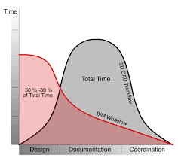
Figure 1.1 Difference between BIM Technologies and 2D Modelling

1.2 Problem Statement
Materials and Resources are essential to the building industry. Therefore, it is highly important to correctly evaluate the impact of Materials and Resources. There are several reasons for this aspect:
1) Building durability and structural integrity are both directly impacted by the materials used. Structures are made of high-quality materials to guarantee their durability, stability, and safety.
2) Energy Efficiency: The building industry is a major energy user. Buildings may minimize energy use and greenhouse gas emissions by utilizing energy-efficient materials and technology. This is especially important in light of the need to reduce the effects of climate change.
3) Environmental Impact: The use of natural resources and the production of garbage are only two examples of how construction operations have a huge negative impact on the environment. The construction industry may reduce its negative environmental effects and support sustainable development by implementing environmentally friendly techniques and sustainable materials.
4) Green Building Certification: Green building certification programs take into account the value of resources and materials in the construction industry. These systems assess and reward structures that adhere to particular sustainability standards, such as the use of eco-friendly materials, resource efficiency, and waste minimization.
Overall, the construction industry relies on materials and resources to ensure structural integrity, promote energy efficiency, reduce environmental effects, and achieve sustainability goals. So, the influence of the Materials and Resources should be properly studied (Ehtesham & Massom, 2018).

1.3 Scope and Limitations
Achieving building sustainability is different for developed and developing countries (Vanegas et al., 1995b). Thus, this paper is narrowed to Astana city, the capital of the developing country Kazakhstan. Moreover, Kazakhstan is one of the fastest-growing countries in Central Asia. In Kazakhstan, the use of renewable energy sources is insufficient, but this country has enormous potential from hydro, biomass, solar, and wind (KAZNIICA, 2017). The weather in Kazakhstan, especially in Astana, is cold. The minimum temperature can reach -51.6 degrees Celsius (Karatayev & Clarke, 2016).
As it is the capital of the developing country, Astana city is sharply growing in all directions. Therefore, it is significant to make most of the new buildings sustainable, so they will not require reconstruction in the far future. Therefore, the research is narrowed to assess the knowledge and experience of construction sector workers in Kazakhstan on building sustainability and the significance of the Materials and Resources (MR) aspect of LEED certification.

1.4 Aim and Objectives of the Study
This study has the following three objectives:
- To evaluate the effectiveness of the MR aspect in optimizing material use and reducing waste in the construction of sustainable buildings in Astana, Kazakhstan
- To indicate the importance and influence of MR aspects to achieve building sustainability in Astana, Kazakhstan
- To investigate the knowledge, in Materials and Resources aspect of LEED certification, of people in the building sector of Kazakhstan
The decision to investigate materials and resource sustainability in this thesis is rooted in the recognition of the construction industry's substantial impact on the environment. As stated earlier, the construction sector is a major contributor to energy consumption and carbon dioxide emissions globally. Within this sector, materials and resources are a fundamental aspect, encompassing the extraction, production, transportation, and disposal of construction materials. These processes inherently involve substantial energy usage and emissions, making them a critical focus area for mitigating the environmental impact of construction.
The thesis aims to comprehensively evaluate the influence and significance of Material and Resources (MR) aspects of LEED Certification on achieving building sustainability in Astana, Kazakhstan

1.5 Hypothesis
Currently, building sustainability in developed countries is becoming one of the main problems. The application of Materials and Resources in LEED certification supports building sustainability. The knowledge of construction sector professionals in the aspect of Materials and Resources can be assessed. Increasing the knowledge of workers at the beginning of the project can help to improve the application of MR in sustainable buildings.

1.6 Structure of the Thesis
The thesis contains 5 Chapters.
Chapter 1: Introduction
The introduction part describes the overview of the thesis and sets the context. It works as a starting point and shows the purpose and importance of the thesis paper.
Chapter 2: Literature Review
The literature review part involves a comprehensive examination and analysis of existing research articles, papers, books, and other relevant sources about the thesis’s topic. The purpose of this section is to provide a summary and evaluation of the existing literature to establish the significance and gaps in the research area.
Chapter 3: Research Methodology
The research Methodology section provides the approach and technique used in the thesis. It outlines the step-by-step process of the researcher to collect the relevant data and analyze it.
Chapter 4: Results and Discussion
The key section of the thesis is the Results and Discussion part. It outlines the findings of the study and explains the meaning and implications of the findings. Overall, the Results section provides objective findings, while the Discussion part shows a subjective analysis.
Chapter 5: Conclusions, Recommendations, and Future Directions
The final component of the thesis is Chapter 5. It summarizes the key findings of the thesis, provides practical suggestions based on the results, and offers future guidance for the thesis.

Chapter 2 - Literature Review

2.1 Introduction
The previous chapter introduced the research and its objectives, while the current chapter explores the background and theoretical foundations that support the research. A comprehensive literature review is conducted, with a specific emphasis on the Materials and Resources component of LEED. Furthermore, this section provides pertinent information to substantiate the various survey questions used in the study.

2.2 LEED certification method
The goal of the voluntary grading system LEED is to establish a precise definition of what a "green building" is by analyzing the sustainability impact from a whole-building perspective during the life cycle of a project (USGBC, 2001). According to the USGBC, LEED was created for the following reasons:
- Promote favorable outcomes for the environment, occupant health, and financial gain.
- Establish a grading system for measuring “Green”
- Decrease “greenwashing” (USGBC, 2002)
“Greenwashing” is a term used to mislead or give false claims about the environmental benefits of the product (USGBC, 2002).
LEED is a graded system. It consists of 64 credit points, and they are divided into 5 environmental impact areas:
- Sustainable Sites (SS)
- Water Efficiency (WE)
- Energy and Atmosphere (EA)
- Materials and Resources (MR)
- Indoor Environmental Quality (IEQ)
- In addition, there are 5 credit points for Innovation and Design Process (ID) activities.
To achieve LEED certification every building must fulfill the requirements of 4 of these areas. To get the LEED certification at least 26 points must be accomplished with all additional prerequisites. The Silver rating is given to the buildings with points between 33 and 38. The Gold and Platinum ratings are given to points from 39 to 51 and 52 to 69 points, respectively.
Document submissions, statement requirements, and some pre-requirements are required for each credit. For example, the LEED process contains the registration of construction projects, submitting the necessary documents, and completing each credit requirement (USGBC, 2002).
The Leadership in Energy and Environmental Design (LEED) certification is one of the well-known rating systems for evaluating the sustainability and environmental performance of buildings. In comparison with other rating systems, LEED certification focuses on the energy performance of the building (Xu et al., 2018).
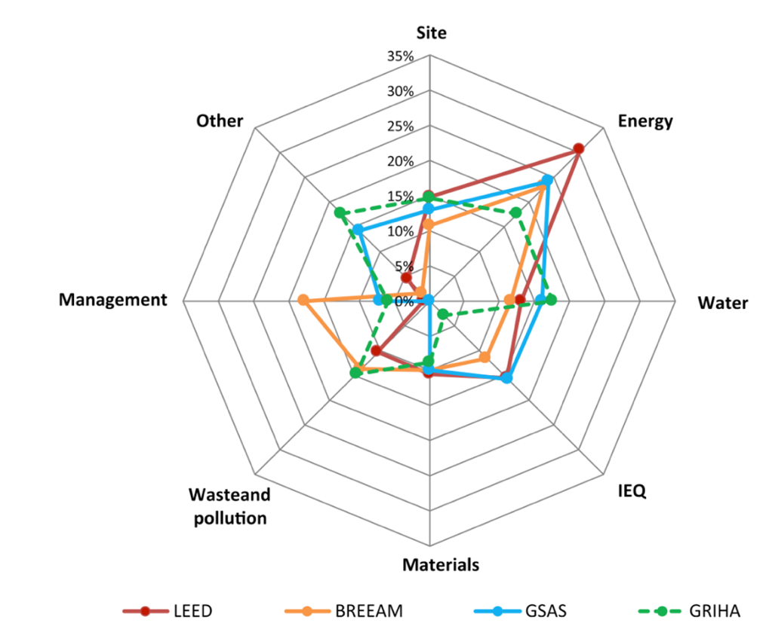

Figure 2.1 Comparison of various certification methods (Xu et al., 2018)
From Figure 2.1 it can be indicated that the LEED certification system has more focus on the aspect of Energy, and it also competes well in other aspects. Since the objective of the thesis is to analyze the influence of the Materials and Resources aspect on the building’s environmental performance, the LEED can be the main rating system for this thesis.
As for now, the total amount of LEED-certified buildings in Astana is 38 construction projects (USGBC, 2022). The Talan Towers is the name of one of the towers. The Ritz-Carlton Hotel occupies the first tower, which is 26 stories tall. The second tower is a 30-story premium building. A three-story platform structure connects the towers. The construction of the 1.05 million-square-foot structure lasted five years. The skyscraper consumes 20% less energy than comparable structures in the city, despite the high winter and summer temperatures in Nur-Sultan, which may drop to -35°C and +40°C, respectively. The structure received certification in 2018 and was put forward for the LEED Core & Shell2009 Gold Rating Level (Tokbolat & Nazipov, 2021).
Another building is the Expo Commercial buildings. The building's area is 342,052 ft² and it was issued certification in 2019. Expo buildings scored 61 out of 110 possible and were nominated to LEED for New Construction 2009 Gold Rating Level (Tokbolat & Nazipov, 2021).

2.2.1 LEED: Materials and Resources
The LEED Materials and Resources category is the primary focus of the thesis work. Construction sites must establish recyclable areas for collection and storage, throughout the design and operation stage to fulfill the demands of the Materials and Resources element. The category also recognizes and promotes the use of certified wood, locally produced eco-friendly products, and quickly renewable resources (that are collected in a 10-year cycle or less). For projects that apply a construction waste management plan and reuse certain amounts for on-site building, a reduced number of by-products is also required. The building's procurement guidelines, which address MR, must be included in the project's environmentally preferable purchasing plan. The policy must be applied to all used products in an industrial area under the site manager's authority (Azhar, 2011).
A solid waste management plan that refers to the streams within the building and the site manager's control should be used. The mercury-containing light must be recycled by handling several MR aspect points. Usage, Life Cycle, and Transparency are the three key MR components overall (Azhar, 2011).
Usage in the MR refers to properly discussing with manufacturers how to maximize social, environmental, and health consequences. The material's total value as well as its benefits and drawbacks may be evaluated using LEED. This section is intended to consider the whole life cycle of the building, from manufacture through material transportation, operations, maintenance, and finally, the end of life (Chen, 2012).
According to a thorough building life-cycle review, the term "life cycle" in the MR refers to the architect and structural engineer, who should collaborate to seek chances to right-size a building's structure to lower the embodied energy of its components. Paying attention to the bay size and slab depth of the building could extend the lifetime of a house by up to 20–30%. This is essential because the embodied influence of the materials increases as structures become more useful (Chen, 2012).
Architects and designers may learn more about the components used in goods and the manufacturing process via environmental and health product declarations, which are referred to as transparency in the MR (EPDs). EPDs describe the production process and the ingredients used, whereas other sources just give information on the producers (Chen, 2012).

2.2.2 LEED: Materials and Resources Point Distribution

Table 2.1 Materials and Resources Credits
Category or Credit Name | Point
Materials and Resources | 13
Storage and collection of recyclables | P
Construction and demolition waste management planning | P
Building Life-Cycle Impact Reduction | 5
Building product disclosure and optimization - environmental product declarations | 2
Building product disclosure and optimization - sourcing of raw materials | 2
Building product disclosure and optimization – Material Ingredients | 2
Construction and demolition waste management | 2
Table 2.1 above introduces the Credits distribution in the Material and Resources aspect of LEED.
LEED Materials and Resources categories:

- Materials and Resources require recycling and building waste management. This may be done by providing easy access for both building residents and trash collectors to centrally located recycling bins located throughout the building. Materials that may be recycled, such as mixed paper, corrugated cardboard, glass, plastics, and metals, should be included. In addition, it is essential to take the necessary precautions to ensure the secure collection, storage, and disposal of hazardous refuse such as batteries, mercury-containing lights, and electronic waste. Create and put into action a plan to manage construction and demolition waste:
- By selecting at least five materials (including structural and nonstructural) that should be diverted, waste diversion targets for the project may be established. A rough estimation of the amount of trash from the entire project.
- Indicate if materials will be mixed or separated and describe the project's intended diversion techniques. Specify the location of the materials' collection and the way the recycling facility will handle the items.
Give a complete report outlining all significant waste streams produced, along with disposal and diversion rates.

- Building Life-Cycle Impact Reduction
It has four main requirements.
Requirement 1. Historic Building Reuse
Reuse a historic building by preserving its framework, exterior, and interior nonstructural components. A structure must be included on a local, state, or federal register of historic places to qualify.
Requirement 2. Renovation of abandoned or Blighted Building
Renovate an abandoned or derelict structure while retaining at least 50% of its exterior and internal components. The building must be renovated at least to the point where it is possible to occupy it productively.
Requirement 3. Building and Materials Reuse
Utilize or salvage materials that are on or off-site. Included are structural components like floors and roof decking, enclosure components like the building's skin or framing, and permanently placed interior components like walls and doors.
Requirement 4. Whole Building Life-Cycle Assessment.
Conduct a life-cycle analysis by ISO 14044 of the International Standards Organization and choose materials and products that show a 10% reduction in impact compared to the reference building. The reference building must be roughly the same size, purpose, and orientation as the intended building, and both must have the same energy performance as specified in the EA Prerequisite, Minimum Energy Performance. By the materials/product selection process, there must be decreases in at least three of the six environmental impact measures (global warming potential, stratospheric ozone depletion potential, acidification, eutrophication, formation of tropospheric ozone, and depletion of nonrenewable energy resources).
- Building product disclosure and optimization - environmental product declarations
There are two requirements:
Requirement 1. Environmental Product Declaration (1 point)
At least 20 different items must either comply with other USGBC-approved EPD frameworks or have an ISO 14044 product-specific statement, an EPD that complies with ISO and reveals impact information, or both.
Requirement 2. Multi-attribute optimization (1 point)
Use products that meet one of the following requirements for at least 50% of the cost of all permanently installed products: (1) third-party certified products with impacts below the industry average for three of the six environmental impacts measures (global warming potential, stratospheric ozone depletion potential, acidification, eutrophication, formation of tropospheric ozone, and depletion of nonrenewable energy resources); or products that meet the requirements for energy efficiency.

- Building product disclosure and optimization - sourcing of raw materials
There are two options:
Option 1. Raw material source and extraction reporting (1 point)
Use at least 20 items from five distinct producers who have published a report on their raw materials that demonstrates ethical extraction techniques.
These reports may combine the manufacturer's self-declarations with data from independent corporate social responsibility (CSR) reports on the effects of raw material extraction. The CSRs must adhere to one of the recognized CSR frameworks, such as the Global Reporting Initiative or the UN Global Compact.
Option 2. Leadership extraction points (1 point)
Use products from one of the following for at least 25% of the total value of permanently installed building products: extended producer responsibility, bio-based materials, wood products that are certified by the Forestry Stewardship Council, materials reuse, recycled content, or a USGBC-approved program.

- Building product disclosure and optimization – Material Ingredients
There are three requirements:
Requirement 1. Material ingredient reporting
Utilize at least 20 products from producers who employ one of the programs listed below to accurately identify the chemical composition of the product to at least 0.1 percent or 1,000 parts per million:
Cradle to Cradle, Manufacturer Inventory, Health Product Declaration, or a USGBC-approved program.
Requirement 2. Material ingredient optimization (1 point)
Use one of the GreenScreen v1.2 Benchmark, Cradle to Cradle Certified, REACH Optimization, or a USGBC-approved program material ingredient optimization paths for at least 25% of the total value of permanently installed building materials.
Requirement 3. Product Manufacturer Supply Chain Optimization (1 point)
Use products for at least 25% of the value of all permanently installed building products, measured by cost, that are sourced from producers who participate in strong, validated safety, health, hazard, and risk programs that list at least 99% of the ingredients, measured by weight, of the product or material. Additionally, the products must come from producers whose safety, health, hazard, and risk management procedures have been independently verified by a third party.

- Construction and demolition waste management
Requirement 1. Diversion (1-2 points)
Divert 50% - 1 point
Divert 75% - 2 points
Divert at least three separate material streams for at least 50% of the total construction and demolition waste stream.
Requirement 2. Reduction of Total Waste Material (2 points)
Limit your trash production to 2.5 pounds per square foot (12.2 kilos per m²).

2.3 Critical Review of the Materials and Resources Use in Buildings
The following aspects of the materials and resources used in buildings can be critically reviewed as follows with LEED MR requirements described in the previous section.

Assessment and evaluation of the material’s environmental impact used in construction site – Materials Ingredients
Depending on the project and the region, environmental impact evaluations for materials used on construction sites may be conducted more often. As per the US Environmental Protection Agency, an environmental impact assessment (EIA) should be completed before the commencement of a project and updated as necessary during the project's progress. In addition, government agencies are required by the National Environmental Policy Act (NEPA) to take the environment into account when making decisions, particularly those regarding building projects.
The frequency of environmental impact assessments for materials used on construction sites can vary depending on the project and location. Additionally, the National Environmental Policy Act (NEPA) requires that federal agencies consider the environmental impact of their actions, including construction projects (US Environmental Protection Agency, 2023).
The International Organization for Standardization (ISO) provides guidelines for environmental impact assessments in construction and related industries through the ISO 14001 standard. This standard recommends that organizations conduct regular reviews of their environmental performance, including the materials used in their construction projects (US Environmental Protection Agency, 2023). To properly evaluate all these criteria, it is pertinent to analyze the usage frequency of EIA.

2.3.2 Sustainably and responsibly managed sources – Sourcing of raw materials
Using certification programs for wood products, such as the Forest Stewardship Council (FSC) (Forest Stewardship Council) or the Program for the Endorsement of Forest Certification (PEFC) (Program for the Endorsement of Forest Certification). These agencies vouch for the origin of wood products from sustainably managed forests.
Putting into practice a sustainable procurement policy that establishes standards for buying goods that are socially and environmentally responsible (Construction Leadership Council).
Verify that resources are supplied from ethical and sustainable sources by conducting supplier audits (Construction Leadership Council).
To reduce waste and the demand for new resources, encourage the use of recycled and reclaimed materials (Construction Leadership Council).

2.3.3 Management and disposal of construction waste (MDCW) – Construction and waste management
Reducing packing and using materials effectively (EPA, 2022).
Reusing resources during construction. For example, crushed concrete can be a foundation for fresh pavement (Whole Building Design Guide, 2022).
Recycling resources like plastic, metal, and wood (Whole Building Design Guide, 2022).
Reusable materials can be bought, sold, or donated for use in other projects (Whole Building Design Guide, 2022).
Burning garbage, although this approach is less advised because it's not eco-friendly (EPA, 2022).
Responsibly removing hazardous material to permitted facilities, such as asbestos, lead, and mercury (Whole Building Design Guide, 2022).

2.3.4 Recycled Materials (RM) – Environmental Product Declarations
Using recycled aggregates, like crushed concrete or asphalt, for the base layers of roads and buildings (Kenai, 2018).
Use of recycled steel and aluminum during construction for structural steel and metal roofs (American Iron and Steel Institute, 2022).
Recycled plastic products can be used as traditional wood in decking, fencing, and other exterior parts of the building (Shiri et al., 2019).
Terrazzo flooring and other decorative surface treatment materials can be exchanged for recycled glass (National Glass Recycling Coalition, n.d.).
Recycled wood can be used in different interior and exterior parts of the building (Bergman, 2010).
Use of recycled brick, stone, and masonry materials in new construction sites (National Concrete Masonry Association, n.d.)

2.3.5 Managing and maintaining materials (MMM) – Storage and Collection of recyclables
Material storage and protection is about the proper storage and protection of materials in the construction area (Domone & Illston, 2010).
Material handling and transportation ask for the efficient and safe movement of materials on the site (Domone & Illston, 2010).
Quality control is about checking the conditions of materials before their usage in construction (Wang et al., 2015).

2.3.6 Energy Efficient Materials (EEM) - Environmental Product Declarations
Insulated concrete forms (ICFs) or spray foam insulation are used to reduce energy loss, which leads to lower use of materials with high insulation values (Kostevšek et al., 2015).
Reduction of heat loss and heat gain in winter and summer, respectively, can be achieved by using energy-efficient windows and doors (Kostevšek et al., 2015).
Reflection of sunlight and reduction of heat gain in summer help to keep the building cooler. It can be achieved by using light-colored roofing materials (Kostevšek et al., 2015).
Skylights and light tubes are examples of daylighting solutions that may be used to cut back on the requirement for artificial lighting throughout the day (Kostevšek et al., 2015).
Using HVAC systems with high energy efficiency ratings, such as Energy Star-certified systems, or systems that use renewable energy sources such as geothermal heat pumps (Kostevšek et al., 2015).
Using low-VOC paints, adhesives, and sealants can improve indoor air quality and reduce the number of harmful chemicals released into the environment (Kostevšek et al., 2015).
Incorporating green roofs or living walls can help insulate the building, reduce heat islands, and improve air quality (Kostevšek et al., 2015).
High energy efficiency rating HVAC systems, like Energy Star-qualified equipment or systems with renewable energy sources (Kostevšek et al., 2015).
Using paints, adhesives, and sealants with low volatile organic compounds (VOCs) can enhance indoor air quality by lowering the number of hazardous chemicals (Kostevšek et al., 2015).
Green roofs or living walls help to enhance air quality and insulate the structure (Kostevšek et al., 2015).

2.3.7 Staff education and training (SET) – Building Life-Cycle Impact Reduction
On-site training: Providing on-site training sessions for staff members can be an effective way to educate them about sustainable materials management practices and allow them to see the practices in action.
Online courses: Providing online courses or webinars can be a convenient and cost-effective way to educate staff about sustainable materials management practices (Koskela & Brown, 2015).
Certifications: Encouraging staff to obtain certifications in sustainable materials management, such as LEED (Leadership in Energy and Environmental Design), can demonstrate a commitment to sustainability and provide staff members with the necessary knowledge and skills to implement sustainable materials management practices (Iqbal et al., 2021).
Site visits: Organizing site visits to other construction sites that have implemented sustainable materials management practices can provide staff members with valuable information and inspiration to implement similar practices on their sites (Iqbal et al., 2021).
Collaboration with industry organizations: Partnering with industry organizations such as the US Green Building Council, the Construction Industry Institute, or other organizations that promote sustainable materials management can provide staff members with access to additional resources and networking opportunities (Amiri et al., 2019).
Implementing a mentorship program: Pairing experienced staff members with new or less experienced staff members can provide hands-on training and support for implementing sustainable materials management practices (Berardi, 2013).
Incorporating sustainable materials management into the performance evaluation process: Making sustainable materials management a fundamental part of the performance assessment procedure can encourage staff members to prioritize and incorporate sustainable practices into their work (Koskela & Brown, 2015).
Incentivizing sustainable behavior: The adoption of sustainable methods may be encouraged by offering rewards to staff employees who show a dedication to sustainable materials management (Amiri et al., 2019).
Incorporating sustainability into job descriptions and requirements: Sustainable personnel may be attracted and retained by including an emphasis on sustainable materials management in job descriptions and requirements (Amiri et al., 2019).
Creating a culture of sustainability: A common knowledge of the significance of sustainable materials management may be created through encouraging openness, open communication, and employee participation in decision-making inside the business. This can also motivate staff members to embrace sustainable practices (Brown, 2016).

2.3.8 Measuring and tracking of progress (MTP) – Building Life-Cycle impact reduction
Material usage tracking is about tracking the number of new materials and recycled resources during construction. It helps to decrease the material usage amount. (Anable, Kelly & O'Malley, n.d.)
Waste management track: Tracking the waste generation in the construction area. It helps to find the huge garbage creation sector, where waste reduction methods can be applied to them. (Anable, Kelly & O'Malley, n.d.)
Carbon footprint tracking: Greenhouse gas emissions must be tracked. It helps to find areas where carbon emissions can be decreased (Onat & Kucukvar, 2020).
Green Building Rating System tracking: LEED or BREEAM progress during construction needs to be tracked. It helps to rate the environmental impact of the building and to implement different ways to succeed in sustainable materials management (Horvath, 2004).

2.4 Creation of Survey Questions
Survey questions were created to assess the knowledge about sustainable development of buildings on the aspect of Materials and Resources of construction sphere professionals. The survey consists of 13 various questions, which are divided into two parts.
The initial part is the demographic questionnaire, which consists of 5 questions. These questions give information about respondents' experience. Questions connected to knowing their role in the construction area, working experience, education level, and the role of their company during construction.
The second part is narrowed to understand the importance of different points of Materials and Resources aspect of the LEED certification method and it is done in the Likert Scale. This part of the questionnaire starts with Question 7. This part was divided into 7 main parts and has the following sub-questions with them, and the respondents should assess the significance of various aspects of construction. Since one of the aims of the research is to investigate the knowledge, in the Materials and Resources aspect of LEED certification, of people in the building sector of Kazakhstan following questions were created based on that. Questions assess the main criteria of the MR aspect, where the points of this part are distributed. Moreover, special abbreviations for the questions of the survey were created and shown in Table 2.2.

Table 2.2 Question Abbreviation
Question  code | Question
Q1 | What is your role on the construction site? - Selected Choice"
Q1.1 | What is your role on the construction site? - Other (Please, specify) - Text"
Q2 | How long have you been working in the construction industry?"
Q3 | How many construction projects have you been involved in?"
Q4 | What is your highest level of education completed?"
Q5 | What is the type of your organization on the construction project? - Selected Choice"
Q5.1 | What is the type of your organization on the construction project? - Other (Please, specify) - Text"
Q6.1 | How often do you assess and evaluate the environmental impact of the materials used on the construction site? - Selected Choice - Before the initiation of a project"
Q6.2 | How often do you assess and evaluate the environmental impact of the materials used on the construction site? - Selected Choice - Updated as necessary throughout the project's development"
Q6.3 | How often do you assess and evaluate the environmental impact of the materials used on the construction site? - Selected Choice - Regular reviews of the environmental performance of materials used in construction projects"
Q6.4 | How often do you assess and evaluate the environmental impact of the materials used on the construction site? - Selected Choice - Any other aspect (Please, State)"
Q6.5 | How often do you assess and evaluate the environmental impact of the materials used on the construction site? - Any other aspect (Please, State) - Text"
SRMS | Sustainably and responsibly managed sources
SRMS1 | Third-party certification systems
SRMS2 | A sustainable procurement policy
SRMS3 | Supplier audits
SRMS4 | Use of recycled and reclaimed materials
MDCW | Management and disposal of construction waste
MDCW1 | Reducing waste at the source
MDCW2 | Reusing materials on site
MDCW3 | Recycling materials
MDCW4 | Donating or selling reusable materials
MDCW5 | Incinerating waste
MDCW6 | Properly disposing of hazardous waste
RM | Recycled materials
RM1 | Using recycled aggregates
RM2 | Incorporating recycled steel and aluminum in building components
RM3 | Using recycled plastic products
RM4 | Incorporating recycled glass in terrazzo flooring and other decorative surface treatments
RM5 | Using reclaimed wood in flooring, paneling, and other interior and exterior building applications
RM6 | Incorporating reclaimed brick, stone, or other masonry materials into new construction or renovation projects
MMM | Managing and maintaining materials
MMM1 | Material storage and protection
MMM2 | Material handling and transportation
MMM3 | Quality control
EEM | Energy efficient materials
EEM1 | High insulation values
EEM2 | Energy-efficient windows and doors
EEM3 | Light-colored roofing materials
EEM4 | Renewable energy sources
EEM5 | Daylighting strategies
EEM6 | HVAC systems
EEM7 | Low-VOC paints, adhesives, and sealants
EEM8 | Green roofs or living walls
SET | Staff education and training
SET1 | On-site training
SET2 | Online courses
SET3 | Organizing site visits to other construction sites that have implemented sustainable materials management practices
SET4 | Collaboration with industry organizations
SET5 | Implementing a mentorship program
SET6 | Incorporating sustainable materials management into the performance evaluation process
SET7 | Incentivizing sustainable behavior, such as providing bonuses or recognition
SET8 | Incorporating sustainability into job descriptions and requirements
SET9 | Creating a culture of sustainability
MTP | Measuring and tracking progress
MTP1 | Material usage tracking
MTP2 | Waste management tracking
MTP3 | Carbon footprint tracking
MTP4 | Cost-benefit analysis
MTP5 | Tracking of the Green Building Rating System

Chapter 3 - Research Methodology

3.1 Introduction
In Chapter 2, the literature review was critically reviewed. This chapter outlines the research methodology and the methods employed to accomplish the purpose and objectives of the study. It encompasses details regarding the data collection process, the analytical tools utilized for analyzing the gathered data, and provides background information on the study participants. The logical research methodology is significant for the research (Fellow and Lui, 2015). Thus, depending on the aims and objectives of the research appropriate research methodology was chosen. The study of Abowitz and Toole, 2010 has shown that reliable and strong results require the experience and knowledge of construction workers. Therefore, in the study only experienced workers were involved.

3.2 Survey
This research also aims to explore the knowledge and attitudes of professionals in the construction sector toward sustainable construction practices in the Materials and Resources aspect of the LEED certification system. This study specifically investigates building professionals' attitudes and opinions concerning the usage of sustainable materials and resources in construction projects. This study uses a descriptive research methodology and a survey to collect data. A survey is an effective method for gathering information on the target population's attitudes, views, and perceptions. The descriptive research approach is suited for this study since it intends to examine building professionals' attitudes and beliefs concerning the usage of sustainable materials and resources in construction projects.
The sample for this study is building professionals, including architects, engineers, project managers, and contractors. The sampling method is purposive sampling, as the target population is defined by specific criteria. Purposive sampling is a non-probability sampling method used to pick research participants based on predetermined criteria or qualities, rather than by chance. Qualitative research studies often use this sampling technique, where the aim is to highlight the experiences, perspectives, and behaviors of a specific group of people (Scribbr, 2021).
The online survey was used as a tool to collect the data on a Qualtrics platform. The survey is done in two languages Russian and English and consists of closed-ended questions and Likert scales to measure the attitudes and perceptions of building professionals towards the use of sustainable materials and resources sustainably in construction projects. The literature and expert opinions were used to develop the questionnaire. Since the survey was distributed online, the electronic addresses of some of the respondents were the same. The reason for this was that people sit on the same construction site and use the same Internet Network.
The survey has 13 questions, and they are divided into two parts. The first part consists of 5 demographic questions. The second part is narrowed to the research area and has 8 questions regarding the Materials and Resources aspect of the LEED certification system.
The online survey questionnaire was distributed through professional networks, online directories, and social media platforms. The respondents were asked to provide informed consent before participating in the study.
This study adhered to ethical principles, including confidentiality and anonymity of the respondents. The purpose of the study and their rights as participants were shown to the respondents. Before taking part in the study, respondents provided informed consent.
The survey data is evaluated with descriptive statistics such as mean, standard deviation, and frequency. The SPSS and Smart PLS programs are used to evaluate the collected data. The results are presented using tables and graphs to illustrate the attitudes and perceptions of building professionals toward the use of sustainable materials and resources in construction projects.

3.2.1 Cronbach’s alpha technique
The thesis shows the Reliability test - Cronbach’s alpha technique. Cronbach's alpha is a statistical method used to measure the internal consistency or reliability of a set of items or questions in a survey or questionnaire (Fellow and Liu, 2015). Higher values of the alpha coefficient indicate more internal consistency or dependability. It runs from 0 to 1 (Santos, 1999). For research purposes, an alpha coefficient of 0.7 or higher is usually regarded as adequate, while one of 0.8 or higher is regarded as good (Cortina, 1993).
Cronbach’s alpha is calculated by (Li, 2003):
 | α = $\frac{\frac{kcov}{var}}{1+\left(k-1\right)cov/var}$ , | (3.1)
Where α - Cronbach’s alpha coefficient value, k - the number of items, 𝑐𝑜𝑣 - the average covariance among the items, 𝑣𝑎𝑟 - the average variance in the items.
The formula can be simplified when the factors are standardized with a common variance:
 | α= $\frac{kr}{1+\left(k-1\right)r }$, | (3.2)
Where 𝑟 - is the average correlation among the items.

3.2.2 Shapiro-Wilk test
The normal distribution of data was tested by the Sharipo-Wilk test.
A statistical technique called the Shapiro-Wilk test may be used to evaluate if a collection of data has a standard normal distribution (Kim, 2015). Test statistics and p-values are calculated. The null hypothesis should be rejected and the conclusion that the data does not follow a normal distribution is drawn if the p-value is less than 0.05 (Hsu et al., 2000; Razali and Wah, 2011).
During the conduction of the Shapiro-Wilk test, the p-value was less than 0.05, the null hypothesis was rejected and the data were not normally distributed. This aided in applying non-parametric tests, such as Kendall’s coefficient of concordance and the Mann-Whitney U test for analyzing the results. The Shapiro-Wilk test statistics (Shapiro, 1965) is defined as,
 | $W=\frac{{(\sum_{i=1}^{n}{a_{i}y_{i})}}^{2}}{{\sum_{i=1}^{n}{(y_{i}-y)}}^{2}}$, | (3.3)

Where y_{i} - the i_{th} order statistics, y – mean.
 | A_{i}= $\frac{m^{t}v^{-1} }{{{(m}^{t}v^{-1}m)}^{1/2}}$, | (3.4)
Where m is - the standard normal distribution, V - the covariance matrix.

3.2.3 Kendall’s coefficient of concordance
Kendall's coefficient of concordance is a statistical measure used to determine the degree of agreement between raters (Kendall and Gibbon, 1990). Kendall's W value can be from 0 to 1, where 1 indicates total agreement among raters and 0 indicates no agreement beyond chance (Siegel and Castellan, 1988)., The null hypothesis is rejected if the p-value is smaller than 0.001. The Formula of Kendall’s W is (Siegel and Castellan, 1988):
 | $$W=\frac{\sum_{i=1}^{n}{\left(R_{n}+R\right)}}{p^{2}\left(n^{3}-n\right)-pT},$$ | (3.5)
Where n is - the number of variables, Ri - is the rating to the i_{th} variable, R - is the Ri’s mean value, p - is the number of respondents, and T - correction variable.

3.2.4 Mann-Whitney U statistics
Mann-Whitney U statistics is a nonparametric test used to compare two independent groups. This test is widely used in statistical analysis when the data is not normally distributed (Darko et al., 2017). Two groups were created by their experience, the first group is people who have working experience of 0-6 years and the second group is people who have worked 6 or more years in the construction sphere.

3.2.5 The mean ranking technique
The mean score ranking technique is a statistical method commonly used to evaluate and rank data based on their average scores (Hwang et al., 2017). When two or more factors have the same mean value, the factor with a lower Standard Deviation value was chosen to be higher (Mao et al., 2015). A lower Standard Deviation means that the difference between raters is not statistically large, and the average is more valid for the majority (Staplehurst and Ragsdell, 2010). The formula for Mean score ranking is:
 | B_{i}=$\frac{\sum_{j=1}^{n}{a_{ij}}}{n},$ | (3.6)
where N - number of raters, 𝑎𝑖𝑗 - the importance of the factor i rated by the respondents j, 𝐵𝑖 - the importance of factor I;

3.2.6 Factor Analysis
The statistical technique used to identify relationships among several variables is called Factor Analysis (FA). (Hair et al., 2006; Field, 2009). There are four main steps in conducting factor analysis:
1. Finding the factors from the study;
2. Simulating the correlation matrix;
3. Rotating each factor;
4. Grouping factors as underlying factors (Chen et al., 2004);
Factor extraction was investigated before applying these steps. Before conducting FA the Kaiser-Meyer-Olkin (KMO) measure of sampling adequacy and Bartlett’s test of sphericity were calculated. The KMO value varies from 0 to 1, and the closer the number to 1, the more factor analysis will provide reliable and clear factors (Field, 2009). The correlation existence is checked by Bartlett’s test.
Factor extraction and factor rotation are the main FA methods. Factor rotation is necessary for evaluating the extracted factors, whereas factor extraction entails locating the underlying factors that contribute to a certain collection of variables. Factor matrix rotation simplifies and enhances factor patterns by transferring variation from early factors to later ones. Factor rotation uses oblique and orthogonal approaches. Varimax, Equamax, and Quartimax presume factor independence, whereas Promax, Oblimin, and Quartimin accept factor correlation (Henson and Roberts, 2006). This study extracted factors using principal component analysis and varimax rotation. Eigenvalues larger than 1 were kept to calculate a factor's variance explanation (Field, 2009). Finally, the factors were grouped based on the common themes that pervade the variables included in the study (Owusu and Chan, 2019).

3.2.7 PLS-SEM
The last test was Structural Equation Modeling (SEM), which statistical technique used to examine the connections of the variables. SEM has two types, and they are the PLS-SEM approach and the covariance-based approach. In this test, the PLS-SEM method was used, because it has greater statistical power in parameter estimations (Hair et al. 2011). Structural model–path analysis and reliability and validity tests are used in PLS-SEM.
Measurements were conducted in the Smart PLS program, where convergent validity (CV) and discriminant validity (DV) were checked. CV was tested by estimating three values, Average Variance Extracted (AVE), Cronbach alpha, and composite reliability (CR). To evaluate the internal consistency dependability of the assessment items, Cronbach alpha, and CR were used. For both Cronbach alpha and CR, a suggested benchmark or criterion of 0.70 is used to evaluate a scale's dependability on internal consistency (Nunnally, 1978). Fornell and Larcker (1981) recommended that several 0.5 for AVE be considered adequate. The Heterotrait-Monotrait (HTMT) measure is calculated to evaluate the DV of the data. Traditional methods like cross-loading and the Fornell-Larcker criterion are abandoned by the HTMT. It is advised to use HTMT numbers below the cutoff point of 0.85. (Henseler et al., 2015).
A structural equation model is developed and evaluated to look at the direction and intensity of correlations among constructs after the measurement model's reliability has been established. The evaluated theory was assessed using the path coefficient. Theoretically, the values of the path coefficients indicate how strongly the external (independent) and endogenous (dependent) variables are correlated. (Hair et al., 2014). The route coefficient values were cross-validated using the bootstrapping method. When determining the distribution of any statistic for a distinct type of distribution, bootstrapping is helpful. (Jack et al., 2001). The findings were virtually guaranteed to be stable because there were 5,000 bootstrap subsamples, and there were as many cases as replies. The model's ability to forecast outcomes and the statistical importance of the correlations were assessed using the variance described (R2) and the p-values of the path estimates, respectively. The t-values for a two-tailed test were significant at significant levels of 1.65 (significant level = 10%), 1.96 (significant level = 5%), and 2.58 (significant level = 1%). (Hair et al., 2014).

3.2.8 Hypotheses
For this study, theoretically, 21 different hypotheses can be created. However, after brainstorming and analyzing the survey questions, some of the hypotheses were redundant and not significant. For example, the correlation of questions in Sustainably and Responsibly Managed Sources (SRMS) with Management and Disposal of Construction Waste (MDCW), questions help to get answers for the managerial part, which is redundant. Therefore, 10 hypotheses were created to assess their correlation with the PLS-SEM technique. Table 3.2 introduces the 10 correlations between questions and explains their hypotheses. First, all the question sets were divided into two subgroups, named Managerial and Technical. They had 3 and 4 sets of questions respectively. Table 3.1 shows the division of constructs into managerial and technical categories.

Table 3.1 Question division
Questions | Category
Sustainably and Responsibly Managed Sources (SRMS) | Managerial
Management and Disposal of Construction Waste (MDCW) | Managerial
Recycled Materials (RM) | Technical
Managing and Maintaining Materials (MMM) | Managerial
Energy Efficient Materials (EEM) | Technical
Staff Education and Training (SET) | Technical
Measuring and Tracking of Progress (MTP) | Managerial

Hypotheses were created in between technical and Managerial aspects.

Table 3.2 Hypotheses
Question influence | Hypothesis
Sustainably and Responsibly Managed Sources (SRMS) Recycled Materials (RM) | H1 – Sustainable management of resources leads to the usage of Recycled Materials.
Sustainably and Responsibly Managed Sources (SRMS) Energy Efficient Materials (EEM) | H2 – Sustainably managed resources directly influence energy-efficient materials.
Management and Disposal of Construction Waste (MMM) Recycled Materials (RM) | H3– Appropriate Management and Disposal of Construction Waste leads to the creation and use of Recycled Materials.
Managing and Maintaining Materials (MMM) Management and Disposal of Construction Waste (MDCW) | H4– Proper material management influences the waste produced in the construction sector.
Managing and Maintaining Materials (MDCW) Measuring and Tracking Progress (MTP) | H5– Managing and Maintaining Materials positively impacts Measuring and Tracking of Progress
Recycled Materials (RM) Energy Efficient Materials (EEM) | H6 – Recycled Materials has a positive impact on Energy Efficient Materials
Staff Education and Training (SET) Management and Disposal of Construction Waste (MDCW) | H7 – Staff Education and Training have a positive impact on the Management and Disposal of Construction Waste
Staff Education and Training (SET) Managing and Maintaining Materials (MMM) | H8 – Staff Education and Training has a positive impact on Managing and Maintaining Materials
Staff Education and Training (SET) Measuring and Tracking of Progress (MTP) | H9 – Staff Education and Training has a positive impact on MTP
Measuring and Tracking of Progress (MTP) Management and Disposal of Construction Waste (MDCW) | H10 – Proper Measuring and Tracking of Progress creates favorable conditions for the development of Management and Disposal of Construction Waste

The hypotheses were created to assess the influence and correlation of survey questions with each other. The survey results will be analyzed by various methods and techniques.

Chapter 4 - Results and Discussions

4.1 Introduction
This chapter shows the information regarding the results of the survey. The respondents were construction sector workers of various construction companies. The results consist of two parts of the data. The first part is about demographic and the second is the main survey. The demographic questions help to identify the experience, position, and role during construction. The main part of the section helps to test the knowledge and understanding of respondents on the MR aspect of LEED certification. Furthermore, the Chapter contains analyses and discussion of each result.

4.2 The survey results: Demographic questions
The first demographic question was narrowed to see what the role of the respondents in the construction area is. Figure 4.1 shows the distribution of roles among the respondents. The most represented role was that of an architect or engineer, accounting for 39 people of the total respondents. Project managers, site managers, and quality control managers were the next most common roles, comprising 19 people. The 23 people of respondents were not employed on a construction site, which could indicate the presence of researchers or academics within the sample. Other roles include carpenters, electricians, plumbers, welders, equipment operators with 7 people, procurement/purchasing officers, materials coordinators with 7 responses, safety officers, environmental managers with 3 people, laborers with 5 people, and supervisors/foremen with 17 people.
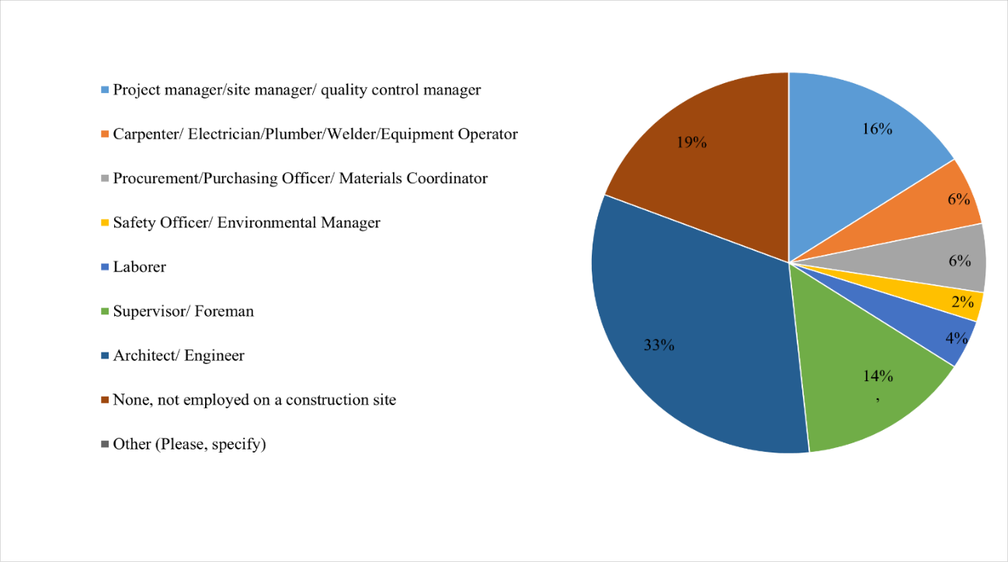

Figure 4.1 Position of respondents on a construction site

The presented Figure 4.2 shows the distribution of respondents based on their years of experience in the construction industry. A total of 119 respondents participated in the study, out of which 53.8% (64 responses) had 0-3 years of experience, 16% (19 responses) had 3-6 years, 9.2% (11 responses) had 6-9 years, and 8.4% (10) had more than 9 years of experience. Furthermore, 12.6% (15) of the respondents reported that they were not working in the construction industry. Finally, the average working experience of the respondents was 3 years.
The findings indicate that the majority of the respondents in this study are relatively new to the construction industry, with 0-3 years of experience. The percentage of respondents with more than 9 years of experience is relatively low (8.4%). The proportion of respondents with mid-level experience (3-6 years and 6-9 years) is also low, accounting for only 25.2% of the total respondents. Even though most of the respondents were lucky with a lack of work experience, the quality of their answers will be checked. Their answer will be compared with the answers of highly qualified respondents, to see if there is any difference in their responses.

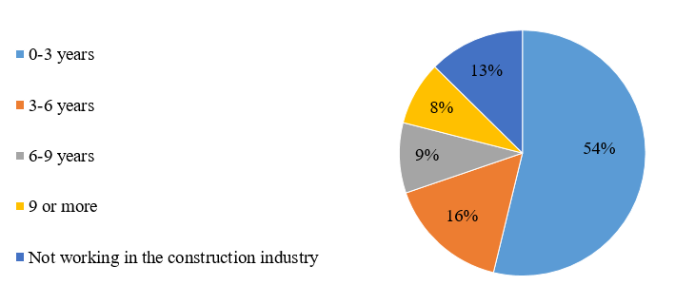

Figure 4.2 Experience of respondents on a construction site

Question number 3 is related to several projects finished by the respondents. The presented Figure 4.3 shows the distribution of respondents based on the number of construction projects they have worked on. A total of 119 respondents participated in the study, out of which 30% (34 responses) have worked on 1-2 projects, 34.5% (41 responses) have worked on 3-5 projects, 13.6% (16 responses) have worked on 6-10 projects, and 10.3% (12 responses) have worked on more than 10 projects. Additionally, 12.6% (15 responses) of the respondents reported that they were not working on a construction project. On average every respondent had finished 4 projects.
It is also interesting to note that a significant percentage of respondents 12.6% (15 responses), reported that they were not working on a construction project. This may be due to the seasonality of the construction industry or a lack of available projects. Alternatively, it may be possible that the respondents were self-employed or working in a related industry but not on construction projects.

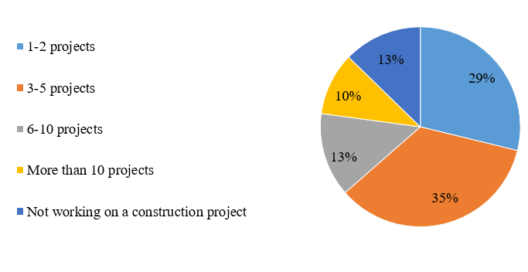

Figure 4.3 Finished projects by respondents

The fourth question is about the education level of respondents. The presented Figure 4.4 provides information about the educational qualifications of the respondents who participated in the study. According to the results of the survey, 65% (77 responses) have a bachelor’s or associate degree, 22.1% (26 responses) have a master’s degree, and only 2.5% (3 responses) have a Doctorate or other advanced degree. Additionally, 9.4% (11 responses) of the respondents have completed high school, and 0.8% (1 response) reported that they have not completed any formal education.
The findings suggest that a significant percentage of the respondents have attained higher education qualifications, with the majority having at least a bachelor’s or associate's degree. This may indicate that the majority of the respondents are professional specialists.

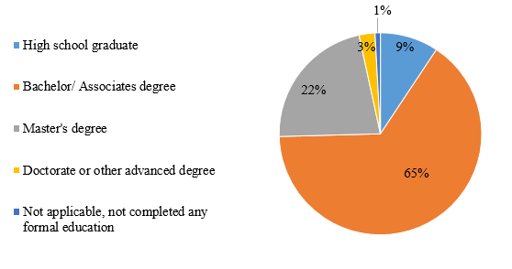

Figure 4.4 Level of education of respondents

The last question is about the respondent's company type. Figure 4.5 shows the role of the company in which the respondents are employed in the construction industry. The majority of the respondents (36.1%, 43 responses) work for a general contractor or construction management firm, while 16.8% (20 responses) work for an owner/developer. Subcontractors/specialty trade contractors represent 13.4% (16 responses) of the respondents, and architectural/engineering firms make up 12.6% (15 responses). Only 1.7% (2 responses) of the respondents work for a government agency, while 19.3% (23 responses) are not currently employed in a construction project.
Overall, understanding the distribution of roles among the companies involved in a construction project is important for effective collaboration and communication among different parties. It can help to collect information from various construction sector companies and positions.

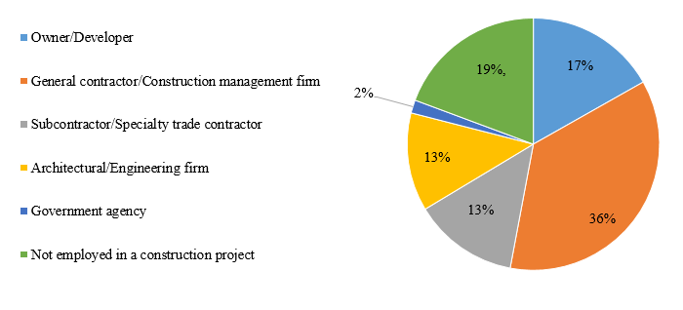

Figure 4.5 Company type

Question 6 identified when the environmental influence of the materials is assessed. The presented Figure 4.6 provides information about the environmental sustainability practices implemented by respondents in the construction industry. According to the results of the survey, 52 reported that they consider environmental sustainability before the initiation of a project. Another 42 respondents reported that they updated their sustainability practices as necessary throughout the project's development.
Furthermore, 19 respondents reported conducting regular reviews of the environmental performance of materials used in construction projects. This suggests that a significant percentage of respondents prioritize the use of environmentally sustainable materials and are actively seeking ways to reduce their environmental impact.
However, only 6 respondents reported any other sustainability practices not covered in the listed categories. This may suggest that there is a need for further research and education on sustainable practices in the construction industry, particularly in areas beyond the commonly known practices.

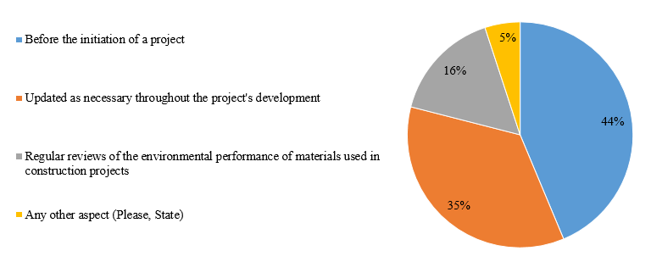

Figure 4.6 Assessment of environmental influence

4.3 Statistical Checks

4.3.1 Consistency
In the first test, Cronbach’s Alpha value was calculated. From Table 4.1 the value total number equals 0.956, which states that this study has a high level of internal consistency. Overall, the value for every question was higher than 0.7, except SRMS, which is also close to 0.7.

Table 4.1 Cronbach’s Alpha value
Questions | Sub-questions | Cronbach’s Alpha value
Questions | Sub-questions | Statistic
Total |  | 0.956
Sustainably and responsibly managed sources (SRMS) | SRMS1 | 0.682
Sustainably and responsibly managed sources (SRMS) | SRMS2 | 0.682
Sustainably and responsibly managed sources (SRMS) | SRMS3 | 0.682
Sustainably and responsibly managed sources (SRMS) | SRMS4 | 0.682
Management and disposal of construction waste (MDCW) | MDCW1 | 0.745
Management and disposal of construction waste (MDCW) | MDCW2 | 0.745
Management and disposal of construction waste (MDCW) | MDCW3 | 0.745
Management and disposal of construction waste (MDCW) | MDCW4 | 0.745
Management and disposal of construction waste (MDCW) | MDCW5 | 0.745
Management and disposal of construction waste (MDCW) | MDCW6 | 0.745
Recycled materials (RM) | RM1 | 0.833
Recycled materials (RM) | RM2 | 0.833
Recycled materials (RM) | RM3 | 0.833
Recycled materials (RM) | RM4 | 0.833
Recycled materials (RM) | RM5 | 0.833
Recycled materials (RM) | RM6 | 0.833
Managing and maintaining materials (MMM) | MMM1 | 0.779
Managing and maintaining materials (MMM) | MMM2 | 0.779
Managing and maintaining materials (MMM) | MMM3 | 0.779
Energy efficient materials (EEM) | EEM1 | 0.829
Energy efficient materials (EEM) | EEM2 | 0.829
Energy efficient materials (EEM) | EEM3 | 0.829
Energy efficient materials (EEM) | EEM4 | 0.829
Energy efficient materials (EEM) | EEM5 | 0.829
Energy efficient materials (EEM) | EEM6 | 0.829
Energy efficient materials (EEM) | EEM7 | 0.829
Energy efficient materials (EEM) | EEM8 | 0.829
Staff education and training (SET) | SET1 | 0.863
Staff education and training (SET) | SET2 | 0.863
Staff education and training (SET) | SET3 | 0.863
Staff education and training (SET) | SET4 | 0.863
Staff education and training (SET) | SET5 | 0.863
Staff education and training (SET) | SET6 | 0.863
Staff education and training (SET) | SET7 | 0.863
Staff education and training (SET) | SET8 | 0.863
Staff education and training (SET) | SET9 | 0.863
Measuring and tracking of progress (MTP) | MTP1 | 0.805
Measuring and tracking of progress (MTP) | MTP2 | 0.805
Measuring and tracking of progress (MTP) | MTP3 | 0.805
Measuring and tracking of progress (MTP) | MTP4 | 0.805
Measuring and tracking of progress (MTP) | MTP5 | 0.805

4.3.2 Normality
The normality test was conducted by the Shapiro-Wilk test, but in Table 4.2 the significance level was smaller than 0.001 and it concludes that the data is not normally distributed. Based on this outcome, Kendall’s coefficient of concordance and the Mann-Whitney U test were applied.

Table 4.2 Shapiro-Wilk
Question | Shapiro-Wilk
Question | Statistic | df | Sig.
SRMS1 | .791 | 119 | <.001
SRMS2 | .804 | 119 | <.001
SRMS3 | .815 | 119 | <.001
SRMS4 | .844 | 119 | <.001
MDCW1 | .749 | 119 | <.001
MDCW2 | .812 | 119 | <.001
MDCW3 | .816 | 119 | <.001
MDCW4 | .867 | 119 | <.001
MDCW5 | .874 | 119 | <.001
MDCW6 | .769 | 119 | <.001
RM1 | .829 | 119 | <.001
RM2 | .829 | 119 | <.001
RM3 | .826 | 119 | <.001
RM4 | .847 | 119 | <.001
RM5 | .843 | 119 | <.001
RM6 | .840 | 119 | <.001
MMM1 | .739 | 119 | <.001
MMM2 | .781 | 119 | <.001
MMM3 | .733 | 119 | <.001
EEM1 | .778 | 119 | <.001
EEM2 | .807 | 119 | <.001
EEM3 | .848 | 119 | <.001
EEM4 | .827 | 119 | <.001
EEM5 | .852 | 119 | <.001
EEM6 | .826 | 119 | <.001
EEM7 | .814 | 119 | <.001
EEM8 | .840 | 119 | <.001
SET1 | .785 | 119 | <.001
SET2 | .843 | 119 | <.001
SET3 | .809 | 119 | <.001
SET4 | .807 | 119 | <.001
SET5 | .850 | 119 | <.001
SET6 | .800 | 119 | <.001
SET7 | .821 | 119 | <.001
SET8 | .803 | 119 | <.001
SET9 | .794 | 119 | <.001
MTP1 | .775 | 119 | <.001
MTP2 | .789 | 119 | <.001
MTP3 | .809 | 119 | <.001
MTP4 | .808 | 119 | <.001
MTP5 | .832 | 117 | <.001

4.3.3 Response Group Agreement
A Kendall’s coefficient test was calculated to measure the agreement among respondents. Kendall’s value was equal to 0.560, and it resulted in a significant difference in the rating of judges.
To conduct the Mann-Whitney U test, respondents were divided into two groups by their experience. The first group is people who worked in the construction sphere for 0 to 6 years and the second group is people with 6 or more years of experience. The results are shown in Table 4.3.

Table 4.3 Mann-Whitney U test results
Question | Mann-Whitney U | Wilcoxon W | Z | Asymp. Sig. (2-tailed) | r
SRMS1 | 845 | 5696 | -1.414 | 0.157 | 0.130
SRMS2 | 928 | 5779 | -0.756 | 0.45 | 0.069
SRMS3 | 855 | 5706 | -1.308 | 0.191 | 0.120
SRMS4 | 1025.5 | 5876.5 | -0.026 | 0.979 | 0.002
MDCW1 | 933 | 1164 | -0.714 | 0.475 | 0.065
MDCW2 | 855 | 1086 | -1.276 | 0.202 | 0.117
MDCW3 | 840.5 | 5691.5 | -1.45 | 0.147 | 0.133
MDCW4 | 1023.5 | 5874.5 | -0.041 | 0.967 | 0.004
MDCW5 | 779 | 1010 | -1.876 | 0.061 | 0.172
MDCW6 | 849 | 1080 | -1.191 | 0.234 | 0.109
RM1 | 978 | 5829 | -0.369 | 0.712 | 0.034
RM2 | 862 | 5713 | -1.28 | 0.2 | 0.117
RM3 | 989.5 | 5840.5 | -0.293 | 0.77 | 0.027
RM4 | 889.5 | 1120.5 | -1.027 | 0.304 | 0.094
RM5 | 1019 | 1250 | -0.074 | 0.941 | 0.007
RM6 | 967.5 | 1198.5 | -0.453 | 0.651 | 0.042
MMM1 | 990 | 1221 | -0.286 | 0.775 | 0.026
MMM2 | 818 | 5669 | -1.555 | 0.12 | 0.143
MMM3 | 975.5 | 1206.5 | -0.417 | 0.677 | 0.038
EEM1 | 1007.5 | 1238.5 | -0.164 | 0.87 | 0.015
EEM2 | 1006.5 | 1237.5 | -0.175 | 0.861 | 0.016
EEM3 | 1017 | 5868 | -0.092 | 0.926 | 0.008
EEM4 | 1015 | 1246 | -0.104 | 0.917 | 0.010
EEM5 | 975.5 | 1206.5 | -0.395 | 0.693 | 0.036
EEM6 | 883 | 1114 | -1.079 | 0.281 | 0.099
EEM7 | 944 | 1175 | -0.629 | 0.53 | 0.058
EEM8 | 817.5 | 5668.5 | -1.572 | 0.116 | 0.144
SET1 | 926 | 5777 | -0.771 | 0.441 | 0.071
SET2 | 950 | 1181 | -0.579 | 0.562 | 0.053
SET3 | 982 | 5833 | -0.359 | 0.719 | 0.033
SET4 | 974.5 | 1205.5 | -0.403 | 0.687 | 0.037
SET5 | 900 | 5751 | -0.964 | 0.335 | 0.088
SET6 | 1008 | 5859 | -0.157 | 0.875 | 0.014
SET7 | 946 | 1177 | -0.608 | 0.543 | 0.056
SET8 | 895 | 5746 | -1.011 | 0.312 | 0.093
SET9 | 889 | 5740 | -1.058 | 0.29 | 0.097
MTP1 | 904.5 | 5755.5 | -0.93 | 0.352 | 0.085
MTP2 | 772 | 5623 | -1.939 | 0.053 | 0.178
MTP3 | 1014.5 | 1245.5 | -0.107 | 0.914 | 0.010
MTP4 | 791.5 | 5642.5 | -1.788 | 0.074 | 0.164
MTP5 | 909.5 | 5565.5 | -0.739 | 0.46 | 0.068

From these results, it can be stated that there is a small difference between the two groups. The significance level for each question is higher than 0.05, which indicates that there is no significant difference between the respondents' answers. Therefore, results suggest that both groups possess similar levels of knowledge and understanding of Materials and Resources. Overall, both groups displayed a relatively high level of understanding of the importance of Materials and Resources in sustainable building practices.
These findings have important implications for both sustainable building practices and education in the field. By recognizing that individuals with less experience possess similar levels of understanding as those with more experience, it is possible to create more inclusive and accessible educational programs that address the needs of a diverse range of learners. Additionally, by emphasizing the benefits of sustainable materials and resources, it has the potential to promote more widespread adoption of sustainable building practices and promote a more sustainable future.

4.3.4 Mean Score Ranking Technique
Table 4.4 and Table 4.5 illustrate the Mean value of the two groups and the total Mean value for each question respectively.

Table 4.4 Mean score analysis for two groups
How long have you been working in the construction sphere? | 0-6 years |  |  | 6 or more
 | Mean | N | Std. Deviation | Mean | N | Std. Deviation
SRMS1 | 4.14 | 98 | 0.92 | 4.4 | 21 | 0.75
SRMS2 | 4.17 | 98 | 0.84 | 4.2 | 21 | 0.62
SRMS3 | 4.14 | 98 | 0.91 | 4 | 21 | 0.95
SRMS4 | 4.02 | 98 | 1.02 | 3.8 | 21 | 0.94
MDCW1 | 4.29 | 98 | 0.84 | 4.5 | 21 | 0.81
MDCW2 | 4.04 | 98 | 0.96 | 4.1 | 21 | 0.97
MDCW3 | 4.23 | 98 | 0.77 | 3.9 | 21 | 0.77
MDCW4 | 3.9 | 96 | 0.96 | 3.7 | 21 | 0.78
MDCW5 | 3.69 | 98 | 1.1 | 3.7 | 21 | 1.35
MDCW6 | 4.21 | 98 | 0.82 | 4.5 | 21 | 0.6
RM1 | 4.03 | 98 | 0.92 | 4.1 | 21 | 0.73
RM2 | 4 | 98 | 1.09 | 3.9 | 21 | 0.7
RM3 | 3.99 | 98 | 1.07 | 4.1 | 21 | 0.86
RM4 | 3.89 | 98 | 1.06 | 3.9 | 21 | 0.7
RM5 | 3.85 | 98 | 1.05 | 3.8 | 21 | 1.03
RM6 | 3.81 | 98 | 1.08 | 4.2 | 21 | 0.7
MMM1 | 4.41 | 98 | 0.76 | 4.4 | 21 | 0.67
MMM2 | 4.32 | 98 | 0.75 | 4.3 | 21 | 0.78
MMM3 | 4.38 | 98 | 0.79 | 4.3 | 21 | 1.01
EEM1 | 4.3 | 98 | 0.72 | 4.3 | 21 | 0.66
EEM2 | 4.17 | 98 | 0.86 | 4.1 | 21 | 1.04
EEM3 | 3.98 | 98 | 0.94 | 3.9 | 21 | 0.89
EEM4 | 4.12 | 98 | 0.88 | 3.8 | 21 | 1.12
EEM5 | 4 | 98 | 0.82 | 3.8 | 21 | 1.08
EEM6 | 3.94 | 98 | 0.98 | 4.3 | 21 | 0.85
EEM7 | 4.07 | 98 | 0.91 | 4.2 | 21 | 0.83
EEM8 | 4 | 98 | 0.99 | 3.8 | 21 | 1.17
SET1 | 4.28 | 98 | 0.76 | 4.4 | 21 | 0.59
SET2 | 3.92 | 98 | 0.95 | 3.8 | 21 | 1.14
SET3 | 4.03 | 98 | 0.96 | 4.3 | 21 | 0.72
SET4 | 4.12 | 98 | 0.9 | 4.1 | 21 | 0.91
SET5 | 3.93 | 98 | 1.01 | 3.7 | 21 | 1.23
SET6 | 4.1 | 98 | 0.87 | 4.3 | 21 | 0.85
SET7 | 4.05 | 98 | 0.84 | 4.3 | 21 | 0.64
SET8 | 4.04 | 98 | 0.97 | 4.2 | 21 | 1.08
SET9 | 4.06 | 98 | 0.94 | 4.2 | 21 | 0.98
MTP1 | 4.28 | 98 | 0.73 | 4.5 | 21 | 0.6
MTP2 | 4.11 | 98 | 0.91 | 4.5 | 21 | 0.6
MTP3 | 4.04 | 98 | 1.09 | 4.1 | 21 | 0.89
MTP4 | 4.12 | 98 | 0.82 | 4.4 | 21 | 0.81
MTP5 | 3.97 | 96 | 1 | 4.1 | 21 | 1.09

Table 4.5 Total Mean score value with ranking
Construct |  | Total
 |  | Mean | Ranks | Std. Deviation
Sustainably and responsibly managed sources (SRMS) | SRMS1 | 4.19 | 9 | 0.90
Sustainably and responsibly managed sources (SRMS) | SRMS2 | 4.18 | 10 | 0.80
Sustainably and responsibly managed sources (SRMS) | SRMS3 | 4.12 | 13 | 0.91
Sustainably and responsibly managed sources (SRMS) | SRMS4 | 3.97 | 23 | 1.00
Management and disposal of construction waste (MDCW) | MDCW1 | 4.33 | 3 | 0.83
Management and disposal of construction waste (MDCW) | MDCW2 | 4.04 | 19 | 0.96
Management and disposal of construction waste (MDCW) | MDCW3 | 4.18 | 10 | 0.78
Management and disposal of construction waste (MDCW) | MDCW4 | 3.86 | 26 | 0.93
Management and disposal of construction waste (MDCW) | MDCW5 | 3.70 | 28 | 1.14
Management and disposal of construction waste (MDCW) | MDCW6 | 4.26 | 8 | 0.79
Recycled materials (RM) | RM1 | 4.05 | 18 | 0.89
Recycled materials (RM) | RM2 | 3.98 | 22 | 1.03
Recycled materials (RM) | RM3 | 4.00 | 20 | 1.03
Recycled materials (RM) | RM4 | 3.89 | 24 | 1.01
Recycled materials (RM) | RM5 | 3.84 | 27 | 1.04
Recycled materials (RM) | RM6 | 3.88 | 25 | 1.03
Managing and maintaining materials (MMM) | MMM1 | 4.40 | 1 | 0.74
Managing and maintaining materials (MMM) | MMM2 | 4.31 | 5 | 0.76
Managing and maintaining materials (MMM) | MMM3 | 4.36 | 2 | 0.83
Energy efficient materials (EEM) | EEM1 | 4.30 | 6 | 0.71
Energy efficient materials (EEM) | EEM2 | 4.16 | 11 | 0.89
Energy efficient materials (EEM) | EEM3 | 3.97 | 23 | 0.93
Energy efficient materials (EEM) | EEM4 | 4.07 | 17 | 0.93
Energy efficient materials (EEM) | EEM5 | 3.97 | 23 | 0.87
Energy efficient materials (EEM) | EEM6 | 4.00 | 20 | 0.97
Energy efficient materials (EEM) | EEM7 | 4.10 | 14 | 0.90
Energy efficient materials (EEM) | EEM8 | 3.97 | 23 | 1.02
Staff education and training (SET) | SET1 | 4.29 | 7 | 0.73
Staff education and training (SET) | SET2 | 3.89 | 24 | 0.98
Staff education and training (SET) | SET3 | 4.08 | 16 | 0.92
Staff education and training (SET) | SET4 | 4.13 | 12 | 0.90
Staff education and training (SET) | SET5 | 3.89 | 24 | 1.05
Staff education and training (SET) | SET6 | 4.13 | 12 | 0.86
Staff education and training (SET) | SET7 | 4.09 | 15 | 0.81
Staff education and training (SET) | SET8 | 4.07 | 17 | 0.99
Staff education and training (SET) | SET9 | 4.08 | 16 | 0.94
Measuring and tracking of progress (MTP) | MTP1 | 4.32 | 4 | 0.71
Measuring and tracking of progress (MTP) | MTP2 | 4.18 | 10 | 0.87
Measuring and tracking of progress (MTP) | MTP3 | 4.05 | 18 | 1.06
Measuring and tracking of progress (MTP) | MTP4 | 4.18 | 10 | 0.82
Measuring and tracking of progress (MTP) | MTP5 | 3.99 | 21 | 1.01

Grouped questions can be assessed by their importance and by assessing their mean value. The most significant point of category 1 is SRMS1, which states “What is the importance of factors to ensure that the materials used on the construction site are sourced from sustainable and responsibly managed sources? - Third-party certification systems”. It had a mean of 4.19. Overall, third-party certification programs are beneficial for the environment because they encourage ethical and sustainable procurement, decrease the environmental effects of resource extraction and manufacturing, and increase supply chain transparency and accountability (Browne,2020).
In the second grouping, the highest mean was in MDCW1 with a mean value of 4.33. It states “What is the importance of following ways to manage and dispose of construction waste on the site to minimize environmental impact? - Reducing waste at the source”. It may decrease the negative effects of building on the environment, save disposal costs, and protect natural resources by decreasing waste at the source (Sustainable Management of Construction and Demolition Materials | US EPA, 2023).
The third category had the highest mean in RM1, and it states “What is the importance of incorporating the use of recycled materials in construction projects? - Using recycled aggregates”. The use of recycled aggregates in building projects may give great benefits, both in terms of the long-term sustainability of the environment and the efficient utilization of the available resources. In conclusion, the use of recycled aggregates in building projects may give a variety of advantages, including those related to the environment, the economy, and society. These benefits include the reduction of waste, the preservation of natural resources, the reduction of energy consumption, and the reduction of cost (Tahmoorian et al., 2017).
MMM1 is classified as the most important question in factor 4. Moreover, it had the highest agreement among respondents with a mean value of 4.40. MMM1 is “What is the importance of the following factors in managing and maintaining materials on the construction site to ensure their long-term durability and sustainability? - Material storage and protection”. Proper storage of construction materials leads to the reduction of loss and waste, which influences not only ecologically but also financially.
In the fifth category, the highest grade was given EEM1 which had a mean of 4.30. It states “What is the importance of ways to ensure that the materials used on the construction site are energy efficient? - Using materials with high insulation values”. Material choice is an essential part of every construction. Therefore, it is highly essential to choose materials that lead to a reduction in energy use (Tettey et al., 2014).
SET1 states “What is the importance of different ways to educate and train your staff on sustainable materials management practices on the construction site? - On-site training” and had the highest mean in factor 6. The educated and trained staff can sufficiently influence the achievement of building sustainability (Vilisova & Mironova, 2021).
In the last category, MTP1 was the most important point with a mean of 4.32. It states “What is the importance of ways to measure and track the progress and success of your sustainable materials management practices on the construction site? - Material usage tracking”. Material usage tracking can help reduce the negative environmental effects of building materials and promote sustainable construction (Taylor,2023).
To sum up, the most important factor with the highest mean value was Managing and Maintaining Materials (Material storage and protection) MMM1 followed by Material storage and protection (Quality control) MMM3. After that goes Management and Disposal of Construction Waste (Reducing waste at the source) MDCW1 with Measuring and Tracking of Progress (Material Usage Tracking) MTP1. The fifth highest mean value had the factor Managing and Maintaining Materials (Materials Handling and Transportation) MMM2. Overall, the factors in the aspect of Managing and Maintaining Materials (MMM) had the highest mean values in comparison with other questions.

4.4 Factor Analysis
A Factor Analysis test was simulated by using principal component analysis and varimax rotation. The lowest factor loading was set to 0.50.
Bartlett’s Test of Sphericity was also conducted to calculate chi-squared statistic that compares the observed correlation matrix to an identity matrix. The chi-squared value was significant and indicated 3485.02 (Table 4.6). Also, Kaiser–Meyer–Olkin (KMO) value checks the suitableness of Factor analysis. The measure was 0.827 and a value higher than 0.800 shows the appropriateness of Factor analysis (Hill, 2011).

Table 4.6 Bartlett’s Test of Sphericity and KMO
KMO |  | 0.827
Bartlett’s Test of Sphericity | Chi-squared | 3485.02
Bartlett’s Test of Sphericity | Significance | <0.001

Nonetheless, in the initial Factor Analysis, four items failed to load. They are Recycling materials (MDCW3), Properly disposing of hazardous waste (MDCW6), Low-VOC paints, adhesives, and sealants (EEM7), and Incorporating sustainable materials management into the performance evaluation process (SET6) and these items were removed from Correlation Matrix. Two variables, Use of recycled and reclaimed materials (SRMS4) and Organizing site visits to other construction sites that have implemented sustainable materials management practices (SET3), were also removed because they were loaded in other components than their underlying component. Hence, 7 different components were loaded. Thus, the theoretical division of questions was similar to the loads, and therefore seven different subgroups were created. Overall, the average factor loading of each component was higher than 0.5 which is above the threshold. However, the total variance of some, which is shown in Figure 4.7, components do not meet the threshold of 60% (25). Components 8,11 and 12 had a variance lower than 50% and Component 13 had almost 56.1% of the total variance, which is marginal. Nevertheless, the eigenvalues of each question set were above 1 and presented in Table 4.7.

Table 4.7 Factor Loading for each Component
Components | 1 | 2 | 3 | 4 | 5 | 6 | 7
SRMS1 | 0.822
SRMS2 | 0.872
SRMS3 | 0.740
Loads Ave. | 0.811
Eigenvalues | 1.62
MDCW1 |  | 0.742
MDCW2 |  | 0.791
MDCW4 |  | 0.672
MDCW5 |  | 0.586
Loads Ave. |  | 0.697
Eigenvalues |  | 1.34
RM1 |  |  | 0.810
RM2 |  |  | 0.807
RM3 |  |  | 0.752
RM4 |  |  | 0.782
RM5 |  |  | 0.811
RM6 |  |  | 0.800
Loads Ave. |  |  | 0.793
Eigenvalue |  |  | 2.16
MMM1 |  |  |  | 0.846
MMM2 |  |  |  | 0.822
MMM3 |  |  |  | 0.833
Loads Ave. |  |  |  | 0.834
Eigenvalue |  |  |  | 1.67
EEM1 |  |  |  |  | 0.726
EEM2 |  |  |  |  | 0.730
EEM3 |  |  |  |  | 0.765
EEM4 |  |  |  |  | 0.617
EEM5 |  |  |  |  | 0.687
EEM6 |  |  |  |  | 0.652
EEM8 |  |  |  |  | 0.546
Loads Ave. |  |  |  |  | 0.675
Eigenvalue |  |  |  |  | 1.58
SET1 |  |  |  |  |  | 0.649
SET2 |  |  |  |  |  | 0.591
SET4 |  |  |  |  |  | 0.811
SET5 |  |  |  |  |  | 0.644
SET7 |  |  |  |  |  | 0.671
SET8 |  |  |  |  |  | 0.744
SET9 |  |  |  |  |  | 0.660
Loads Ave. |  |  |  |  |  | 0.681
Eigenvalue |  |  |  |  |  | 1.71
MTP1 |  |  |  |  |  |  | 0.821
MTP3 |  |  |  |  |  |  | 0.808
MTP4 |  |  |  |  |  |  | 0.633
MTP5 |  |  |  |  |  |  | 0.719
Loads Ave. |  |  |  |  |  |  | 0.745
Eigenvalue |  |  |  |  |  |  | 1.44

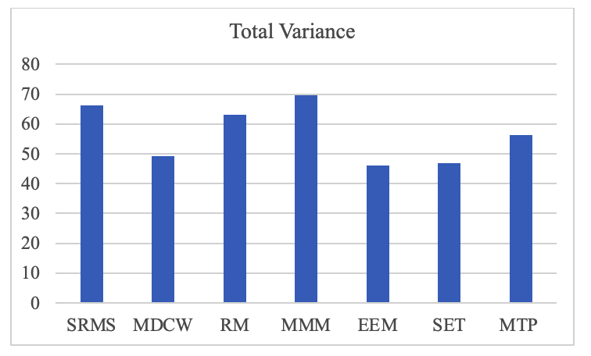

Figure 4.7 Total Variance

4.4.1 Sustainably and Responsibly Managed Sources (SRMS)
This component assesses whether materials used on the construction site are sourced from sustainable and responsibly managed sources. The analysis shows it to consist of three factors, Third-party certification systems (SRMS1), Sustainable procurement policy (SRMS2), and Supplier audits (SRMS3). SRMS component explains 66.1% of the total variance and it has an average factor loading of 0.811. Specifically, the underlying factors of this component are various sources that can be used to improve building sustainability.

Third-party certification systems (SRMS1)
Sources that are sustainably and responsibly maintained are an essential part of building sustainability (Pagan, 2016). LEED-certified building projects must follow environmental rules and employ a suitable proportion of sustainably and responsibly managed resources. Building projects pursuing LEED certification must comply with environmental laws and use a reasonable amount of sustainably and responsibly managed sources (USGBC | U.S. Green Building Council, n.d.).

Sustainable procurement policy (SRMS2) and Supplier audits (SRMS3)
Many multinational firms have pledged to utilize suppliers who have sustainable social and environmental policies, yet suppliers frequently fail to meet the criteria, creating major financial, social, and environmental hazards (Villena, 2020). A sustainable procurement policy incorporates specifications, regulations, and criteria that are compatible with environmental and societal protection(EcoVadis, 2021). Sustainable supply chain procurement requires organizations to reduce waste and promote green purchasing. Environmental, governmental, and social aspects of corporate responsibility are all incorporated into the process of sustainable purchase. Sustainable procurement is the practice of acquiring goods and services for use in a company's supply chain while protecting the environment (What Is Sustainable Procurement? Rheaply, n.d.; Toikka, n.d.; Simfoni, 2022). Therefore, third-party certification, sustainable procurement policies, and supplier audits can minimize the environmental impact of building and create a sustainable development of the construction sphere.

4.4.2 Management and Disposal of Construction Waste (MDCW)
Component 2 highlights the Management and Disposal of Construction Waste (MDCW) on the site to minimize environmental impact and consists of questions MDCW1, MDCW2, MDCW4, and MDCW5. It has an average factor loading of 0.697 and a level of variance was 49.3%. This component is focused on the management and disposal of construction waste. Thus, this is one of the significant sectors in the Materials and Resources aspect of LEED certification.

Reducing waste at the source (MDCW1) and Reusing materials on site (MDCW2)
LEED requires building sites to recycle at least 50% of their resources. Construction waste management plans for LEED-certified buildings must include the kind of materials that will be reused or recycled rather than thrown away, as well as whether these materials will be separated on-site or mixed (LEED Construction Waste Management | Southern Waste & Recycling, 2021). The crucial aspects of MDCW are practicing source reduction of waste, salvaging, recycling, and reusing materials (Sustainable Management of Construction and Demolition Materials | US EPA, 2023).

Donating or selling reusable materials (MDCW4) and Incinerating waste (MDCW5)
The reduction of waste has several positive impacts not only on the environment but also on economic conditions. Construction businesses may lessen waste generation and the number of materials disposed of in landfills, both of which can lessen pollution and preserve natural resources (Creedla, 2019). Furthermore, decreasing trash can assist in reducing disposal costs and saving money on material purchases (StackPath, n.d.). Overall, reducing construction waste has an affirmative influence on the environment and economy.

4.4.3 Recycled Materials (RM)
Component 3 contains questions about Using recycled aggregates (RM1), Incorporating recycled steel and aluminum in building components (RM2), Using recycled plastic products (RM3), Incorporating recycled glass in terrazzo flooring and other decorative surface treatments (RM4), Using reclaimed wood in flooring, paneling, and other interior and exterior building applications (RM5), and Incorporating reclaimed brick, stone, or other masonry materials into new construction or renovation projects (RM6) and evaluates the incorporation of the use of Recycled Materials (RM) in construction projects. It explains the total variance of 63.0% and the average factor loading of 0.793. Particularly, the driving forces behind this component are connected with the use and implementation of recycled materials during construction. The use of sustainable construction aspects like using natural or recycled materials can also impact a building’s sustainability (Kliment, 2020). There are several advantages to using recycled materials in building construction. First, it can help in the conservation of energy and natural resources, as well as the reduction of waste generation and pollution (Treloar, 2003). Second, minimizing the environmental effects of the building sector helps in the achievement of sustainable development (Y. Zhang, 2021). Third, it helps to extend a building's lifespan and decrease water runoff and urban heat islands (Ye, 2009). Finally, recycled materials in building construction assist in achieving sustainable development and reducing the environmental impact of the building and construction sector itself (Ding, 2014).

4.4.4 Managing and Maintaining Materials (MMM)
Managing and Maintaining Materials (MMM) is a fourth component of the study. It has questions about Material storage and protection (MMM1), Material handling and transportation (MMM2), and Quality control (MMM3). This component had the highest total variance of 69.5% and an average factor load of 0.834. It highlights ensuring their long-term durability and sustainability. Proper storage and site practices reduce construction material damage and contamination (Woods, 2019). Efficient material transportation is another significant aspect, which helps to reduce the damage. Thus, the waste and the loss of materials can be reduced. Moreover, efficient management and maintenance of construction materials can not only lead to a successful finish of the project but also lead to the reduction of waste and cause improvement in material procurement in construction (Construction and Rehabilitation of Changla Gali-Makhniyal Road, 2019).

4.4.5 Energy Efficient Materials (EEM)
In this study, Energy Efficient Materials (EEM) became component 5, which assesses the energy efficiency of materials used in construction. It contains questions High insulation values (EEM1), Energy-efficient windows and doors (EEM2), Light-colored roofing materials (EEM3), Renewable energy sources (EEM4), Daylighting strategies (EEM5), HVAC systems (EEM6) and Green roofs or living walls (EEM8). It had a total variance of 46.0% and the average load was equal to 0.675. Specifically, the driving forces behind this component addressed to use of energy-efficient materials during construction.
High insulation values (EEM1), Energy-efficient windows and doors (EEM2), and Light-colored roofing materials (EEM3)
Choosing goods that are LEED-friendly, such as those that are energy-efficient, may contribute to the creation of a building that is both more sustainable and more energy-efficient. Various energy-efficient materials with high insulation values, energy-efficient windows, and doors, green and light-coloured roofing, HVAC system and daylighting strategies, and renewable energy sources can lead to a decrease in energy usage and make the building more sustainable (Woods, 2019). For example, the study of Görman and Johansson, (2019) has shown that the cellulose-based insulation material, used in construction, with a district heating system, can sufficiently decrease the energy usage of the building.

Renewable energy sources (EEM4), Daylighting strategies (EEM5) and HVAC systems (EEM6)
Another example may be found in the article of Punia, (2021) which addresses the use of renewable energy sources such as solar energy to supplement the energy demands of a building. The results found a reduction in the amount of energy that is consumed for the building's heating, cooling, and lighting requirements. Overall, an increase in the number of energy-efficient materials during construction may lead to the sustainable development of buildings.

4.4.6 Staff Education and Training (SET)
Component 6 is about Staff Education and Training (SET), it highlights sustainable materials management practices on the construction site; and consists of questions about On-site training (SET1), Online courses (SET2), Collaboration with industry organizations (SET4), Implementing a mentorship program (SET5), Incentivizing sustainable behavior, such as providing bonuses or recognition (SET7), Incorporating sustainability into job descriptions and requirements (SET8), and Creating a culture of sustainability (SET9). It explains a total variance of 46.9% and has an average load of 0.681.

On-site training (SET1) and Online courses (SET2)
The research of Hajj and Hamani, (2011) revealed that the most frequent measure practiced in minimizing material waste is staff training. The application of various on-site sustainability training impacts not only everyday duty in the industry but also promotes sustainable practices throughout a building's operation (Gurmu, 2019). Educated staff members on the importance of recycling, composting, and waste reduction lead to a significant reduction of the amount of waste it generates and minimizes its impact on the environment.

Implementing a mentorship program (SET5)
Also, building managers can make sure that staff members are knowledgeable about the most recent sustainability practices and technologies and are prepared to implement them successfully by offering ongoing training and education. This can support the long-term effectiveness and relevance of a building's sustainability initiatives as well as the continuous development of the structure's environmental performance.

Incentivizing sustainable behavior, such as providing bonuses or recognition (SET7), Incorporating sustainability into job descriptions and requirements (SET8), and Creating a culture of sustainability (SET9)
Implementation of various bonuses forces workers to make energy-efficient decisions. Moreover, it can lead to the creation of culture on the job, so every worker thinks about different technologies and methods, which can save energy, and materials and reduce waste production Therefore, staff training plays a vital role in improving a building's sustainability. Construction companies can reduce energy use, encourage sustainable behaviors, and guarantee that sustainability initiatives remain effective over time through educating and empowering staff members. This can help both the environment and the long-term health of the building.

4.4.7 Measuring and Tracking of Progress (MTP)
The last component was Measuring and Tracking Progress (MTP). Specifically, the driving factors of this component are the evaluation of various ways of measuring and tracking the progress and success of sustainable materials management practices on the construction site. It consists of Material usage tracking (MTP1), Carbon footprint tracking (MTP3), Cost-benefit analysis (MTP4), and Tracking of the Green Building Rating System (MTP5); which explains a total variance of 56.1% and has an average factor load of 0.745.

Material usage tracking (MTP1), Carbon footprint tracking (MTP3) and Cost-benefit analysis (MTP4)
It is possible to increase the efficiency of building projects by measuring and tracking the material used in construction. MTP may lead to the identification of the performance of pinpoint areas and find out where improvements can be made. Construction waste may be decreased and inefficiencies in the process can be fixed by keeping detailed records of all the materials utilized. The use of sustainable resources and ecologically friendly building methods may both be ensured with the use of tracking material usage. This may contribute to environmental sustainability and waste reduction, which in turn may result in cost savings and increased effectiveness (Gurmu, 2019).
Tracking of the Green Building Rating System (MTP5)
Additionally, measurements of progress in the Green Building Rating System are crucial for confirming the minimum performance standards for buildings set by the USGBC's LEED certification (Tobias, 2021). Overall, MTP can directly affect the performance of the building in the energy usage aspect.

4.5 SEM Analysis

4.5.1 Validity and reliability tests
The measurements model was done in a Smart PLS program. The model of the path is shown in Figure 4.8A. In addition, Figure 4.8B provides the calculations for each components. It shows their factor loads and Cronbach Alpha’s values. The model path was created based on the hypothesis and depending on how the questions are related to each other.
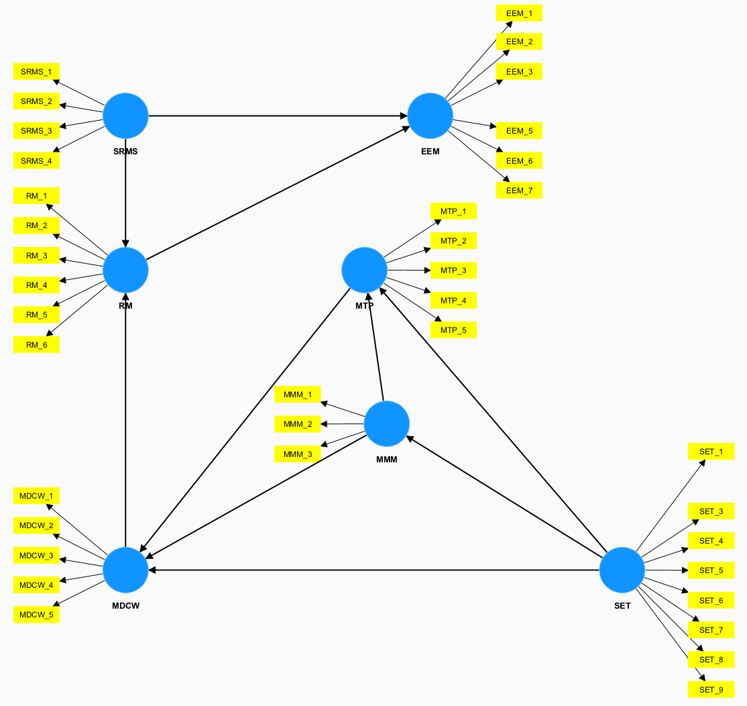

Figure 4.8A Path Model

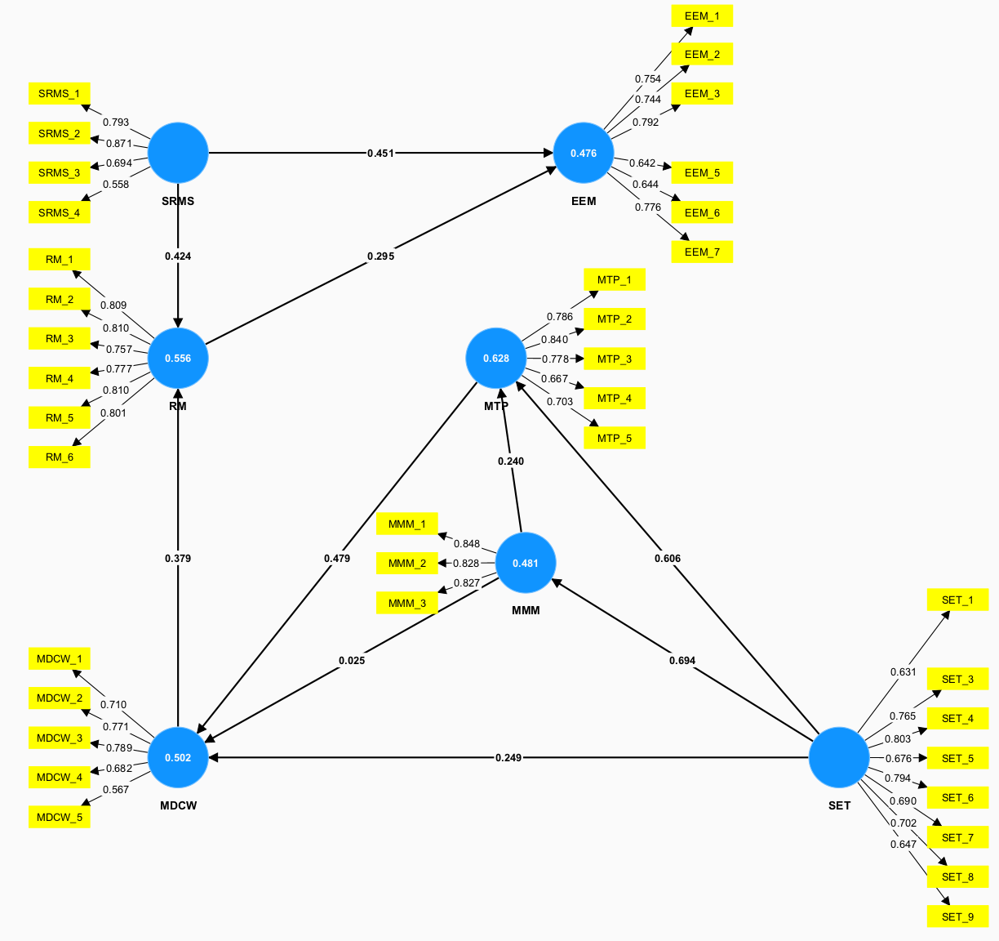

Figure 4.8B Path Model with calculations
The Convergent Validity (CV) was examined by evaluating Cronbach alpha, Composite Reliability (CR), and Average Variance Extracted (AVE). The threshold for Cronbach alpha and CR value was 0.7 and for AVE it is 0.5. This was achieved by removing factors with a load lower than 0.5 (Zaman et al., 2019). The Heterotrait-Monotrait (HTMT) criteria was used to evaluate Discriminant Validity (DV). The values of the HTMT were lower than the threshold, which was set at 0.85 (Henseler et al., 2015). Tables 4.8 and 4.9 provide CV and DV results.

The presented Table 4.8 gives insights into the Reliability and Validity of several constructs, with distinct rows referring to either the overall construct or specific constituents contained by those constructs.
For each build, the factor loadings are also presented. Higher numbers indicate a stronger connection between the item and the construct, and it shows the loading factor of individual items. The internal consistency of the items for each construct is shown by the Cronbach alpha values. For instance, SRMS displays a 0.713 Cronbach's alpha. SRMS's Composite Reliability (CR) score of 0.824, which denotes strong reliability, measures the overall construct consistency.
The AVE (Average Variance Extracted) value is used to evaluate the variance captured by a concept about measurement error; an AVE greater than 0.5 (such as 0.545 for SRMS) is considered good convergent validity.
Overall, the table shows the collection of data in such a way that the factor loadings for the individual items are shown after the overall reliability and validity metrics for each construct.

Table 4.8 Reliability and validity test
Construct | Code | Factor load | Cronbach alpha | CR | AVE
SRMS | SRMS1 | 0.792 | 0.713 | 0.824 | 0.545
 | SRMS2 | 0.869 | - | - | -
 | SRMS3 | 0.685 | - | - | -
 | SRMS4 | 0.572 | - | - | -
MDCW | MDCW1 | 0.710 | 0.748 | 0.832 | 0.501
 | MDCW2 | 0.771 | - | - | -
 | MDCW3 | 0.789 | - | - | -
 | MDCW4 | 0.682 | - | - | -
 | MDCW5 | 0.567 | - | - | -
RM | RM1 | 0.809 | 0.883 | 0.911 | 0.631
 | RM2 | 0.810 | - | - | -
 | RM3 | 0.757 | - | - | -
 | RM4 | 0.777 | - | - | -
 | RM5 | 0.810 | - | - | -
 | RM6 | 0.801 | - | - | -
MMM | MMM1 | 0.848 | 0.783 | 0.873 | 0.696
 | MMM2 | 0.828 | - | - | -
 | MMM3 | 0.827 | - | - | -
EEM | EEM1 | 0.754 | 0.821 | 0.870 | 0.530
 | EEM2 | 0.744 | - | - | -
 | EEM3 | 0.792 | - | - | -
 | EEM5 | 0.642 | - | - | -
 | EEM6 | 0.644 | - | - | -
 | EEM7 | 0.776 | - | - | -
SET | SET1 | 0.631 | 0.863 | 0.893 | 0.513
 | SET3 | 0.765 | - | - | -
 | SET4 | 0.803 | - | - | -
 | SET5 | 0.676 | - | - | -
 | SET6 | 0.794 | - | - | -
 | SET7 | 0.690 | - | - | -
 | SET8 | 0.702 | - | - | -
 | SET9 | 0.647 | - | - | -
MTP | MTP1 | 0.786 | 0.813 | 0.870 | 0.574
 | MTP2 | 0.840 | - | - | -
 | MTP3 | 0.778 | - | - | -
 | MTP4 | 0.667 | - | - | -
 | MTP5 | 0.703 | - | - | -

Table 4.9 HTMT criterion
 | SRMS | MDCW | RM | MMM | EEM | SET | MTP
SRMS
MDCW | 0.957
RM | 0.846 | 0.8358
MMM | 0.592 | 0.649 | 0.422
EEM | 0.837 | 0.833 | 0.701 | 0.921
SET | 0.802 | 0.772 | 0.682 | 0.828 | 0.985
MTP | 0.813 | 0.858 | 0.769 | 0.827 | 0.860 | 0.904

The HTMT values between constructs mainly are below the recommended threshold of 0.85. This suggests that there is no significant overlap between these constructs. Since the values are higher than the recommended threshold of 0.85, it indicates that these constructs measure similar aspects.
Overall, the results of the HTMT test show that there is no significant overlap between constructs. However, to understand the underlying factor structure and to find any potential problems with the assessment of the problematic constructs, more research into the measurement model is advised. To handle any potential overlap between the constructs, this may include looking at the cross-loading of items and utilizing more sophisticated statistical methods and potential issues with discriminant validity between several pairs of constructs.

4.5.2 Structural Model Evaluation
The path coefficients of each direction were investigated by the bootstrapping technique. The model's predictive accuracy was evaluated by the R² value and showed a moderate level of predictive quality and accuracy with the lowest value of 0.476 in Table 4.10 (Hair et al., 2011). The statistical significance of relationships was assessed by p-values. Results are shown in Table 4.11.

Table 4.10 Variance level (R² values)
Construct | R-square
EEM | 0.476
MDCW | 0.502
MMM | 0.481
MTP | 0.628
RM | 0.556

Table 4.11 Statistical Significance
Hypothesis | Path coefficient | t-value | p-value | Inference | Hypothesis
SRMS RM | 0.424 | 2.812 | 0.005 | Supported | H1
SRMS EEM | 0.451 | 3.799 | 0.000 | Supported | H2
MDCW RM | 0.379 | 2.315 | 0.021 | Supported | H3
MMM MDCW | 0.025 | 0.249 | 0.803 | Not supported | H4
MMM MTP | 0.240 | 2.841 | 0.005 | Supported | H5
RM EEM | 0.295 | 2.288 | 0.022 | Supported | H6
SET MDCW | 0.249 | 2.559 | 0.011 | Supported | H7
SET MMM | 0.694 | 10.169 | 0.000 | Supported | H8
SET MTP | 0.606 | 7.659 | 0.000 | Supported | H9
MTP MDCW | 0.479 | 4.301 | 0.000 | Supported | H10

From Table 4.11, two path coefficients were not supported. Path MMM to MDCW had a p-value of 0.769 and path RM to EEM showed a p-value of 0.084, which means that this path’s results were not significant. However, other parts results were significant.
Hypothesis 1
For the path Sustainably and responsibly managed sources (SRMS)🡪 Recycled materials (R) the results were significant ($β=0.424, ρ=0$.005) and H1 “Sustainable management of resources leads to the usage of recycled materials” were supported. Management of waste and recycled materials in construction creates Sustainably and Responsibly Managed Sources (Vandecasteele & van der Sloot, 2011). The protection of natural resources, the reduction of energy consumption, and the preservation of the environment can all be accomplished by recycling construction and demolition waste as energy-efficient and sustainable construction materials (Maurya & Malviya, 2021). Therefore, it is essential to manage material usage and material sources, which directly affect the usage number of Recycled Materials.
Hypothesis 2
H2 “Sustainably managed resources directly influence energy-efficient materials.” also was supported, with a path coefficient of $β=0.451$, and with a significance level of $ρ=0.000$. The utilization of renewable energy technology systems, natural building materials, and energy-efficient design are all essential elements for developing sustainability (Das et al., 2019). Sustainably and responsibly managed sources (SRMS) materials and products should be energy-efficient, to develop the achievement of sustainability.
Hypothesis 3
Path Management and disposal of construction waste (MDCW)🡪 Recycled materials (RM) had similarly significant results ($β=0.379, ρ=0.021$). It states that “Appropriate Management and Disposal of Construction Waste leads to creation and use of Recycled Materials.”. Proper management and disposal of construction waste can increase the number of recycled materials used in construction.
Hypothesis 4
H4 was not supported, and the result was not significant ($β=0.025, ρ=0.803$). The path coefficient for H4 had a value of 0.030. Hypothesis 4 states “Proper material management influences the waste produced in the construction sector.”.
Hypothesis 5
H5, which states “Managing and maintaining materials (MMM) positively impacts Measuring and tracking of progress (MTP)”, had significant results, with path coefficient value $β=0.240$ and with significance level $ρ=0.005$. Appropriate Managing and maintaining materials (MMM) create favorable conditions for the development of Measuring and tracking progress (MTP) (Tissera et al., 2022).
Hypothesis 6
H6 was not supported, and the result was significant ($β=0.295, ρ=0.022$). The path coefficient for H6 had an acceptable value and the significance percentage was lower than 0.05. Hypothesis 6 states “Recycled Materials (RM) has a positive impact on Energy Efficient Materials (EEM)”.

Hypothesis 7
H7 is “Staff education and training (SET) has a positive impact on Management and disposal of construction waste (MDCW)”. It had a path coefficient of $0.249$ and a significance of $ρ=0$.011. Trained construction workers can have a positive impact on waste management. Educated staff members of contractors, with high education and participation in various training on waste management, create proper development of Management and disposal of construction waste (MDCW) (Begum et al., 2009).
Hypothesis 8
The path Staff education and training (SET)🡪 Managing and maintaining materials (MMM) was supported and H8 states “Staff education and training (SET) has a positive impact on Managing and maintaining materials (MMM)”. The results were significant with values $β= 0.695, ρ=0.0$00. Trained personnel have a considerable impact on material management and maintenance on construction sites (Shimamoto, 2013).
Hypothesis 9
H9 which states “Staff education and training (SET) has a positive impact on Measuring and tracking of progress (MTP)” was supported and values were $β=0.606, ρ=0.000.$ The research of Shimamoto, (2013) has shown that the implementation of environmental education and training programs proved to be the most effective method of environmental management.
Hypothesis 10
The last H10 states “Proper Measuring and tracking of progress (MTP) creates favorable conditions for development of Management and disposal of construction waste (MDCW)” and also was supported. It had a path coefficient of $=0.479$ and a significance of $ρ=0$.000. Proper material tracking and control leads to the reduction of construction waste during the whole period of building.

4.6 Discussions
Overall, these statistical analyses provided valuable insights into the reliability, distribution, agreement, differences, and underlying factors of the survey data, and helped to better understand the perspectives and opinions of respondents.
The survey data was analyzed using a variety of statistical tests to assess the reliability of an SPSS program, normality, concordance, and differences in responses. Firstly, the Cronbach alpha coefficient was calculated, which measures the internal consistency of the responses. The results showed a Cronbach alpha value of 0.956, indicating a high level of reliability in survey data.
Secondly, the normality test was conducted by calculation of the Shapiro-Wilk value. The tests illustrated that data was not normally distributed (p < 0.05), indicating a non-normal distribution. Therefore, Kendall's coefficient of concordance was estimated and shown. Our results showed a coefficient value of 0.560, indicating a moderate level of agreement among respondents.
In addition, the Mann-Whitney U test was conducted to estimate whether there were statistically significant differences between the two groups' responses. The findings demonstrated that there was no obvious difference in the two groups' replies (p < 0.05). Moreover, the Mean score ranking technique was also conducted to determine the overall level of agreement or disagreement among respondents. The results showed that the mean score values varied between questions, indicating that respondents had varying levels of agreement or disagreement with different statements.
The FA test was conducted as a factor analysis to identify underlying factors that contributed to the responses to the survey. The results showed that seven underlying factors accounted for most of the variance in the data, indicating that the responses were driven by a few key factors. Furthermore, the standard deviation of the survey responses ranges from 0.7 to 1.1, which indicates that there was a moderate amount of variability in the data. Although the mean values showed an overall indication of agreement and disagreement among raters, there was still some degree of variability in the individual questions and responses.
The last test was SEM analysis on a Smart PLS program. The acceptable level of significance level and t-value for the two-tailed test were 1.65 (significant level = 10%), 1.96 (5%), and 2.58 (1%). The number for the path coefficients was calculated to assess the adequacy of the structure, and the threshold was set to 0.33 to achieve a moderate level (Chin, 1998).
According to the results, the hypothesized relationships between constructs are generally supported by the model, with several significant path coefficients indicating statistical significance between the constructs. For instance, the relationship between MDCW and RM is statistically significant with a path coefficient of 0.379, a t-value of 2.315, and a p-value of 0.021. Similarly, the path coefficients for MMM to MTP (0.240, t=2.841, p=0.005) and MTP to MDCW (0.479, t=4.301, p=0.000) are also significant, providing support for the relationships between these constructs.
The overall results of the analysis provide strong support for the hypothesized relationships between the constructs in the model. Notably, the significant path coefficients indicate that there is a statistically significant association between the variables under consideration. These outcomes underscore the importance of influencing factors to each other within the context of the model.
Conversely, the path coefficient for MMM to MDCW (0.025, t=0.249, p=0.803) is not statistically significant, indicating that the relationship between these constructs is not supported by the data.
Thus, an updated Model of the Path was created and illustrated in Figure 4.9A. In addition, Figure 4.8B provides the calculations for each components. It shows their factor loads and Cronbach Alpha’s values.. Moreover, Table 4.12 provides the updated values and results, which show that all Hypotheses were supported by the results.

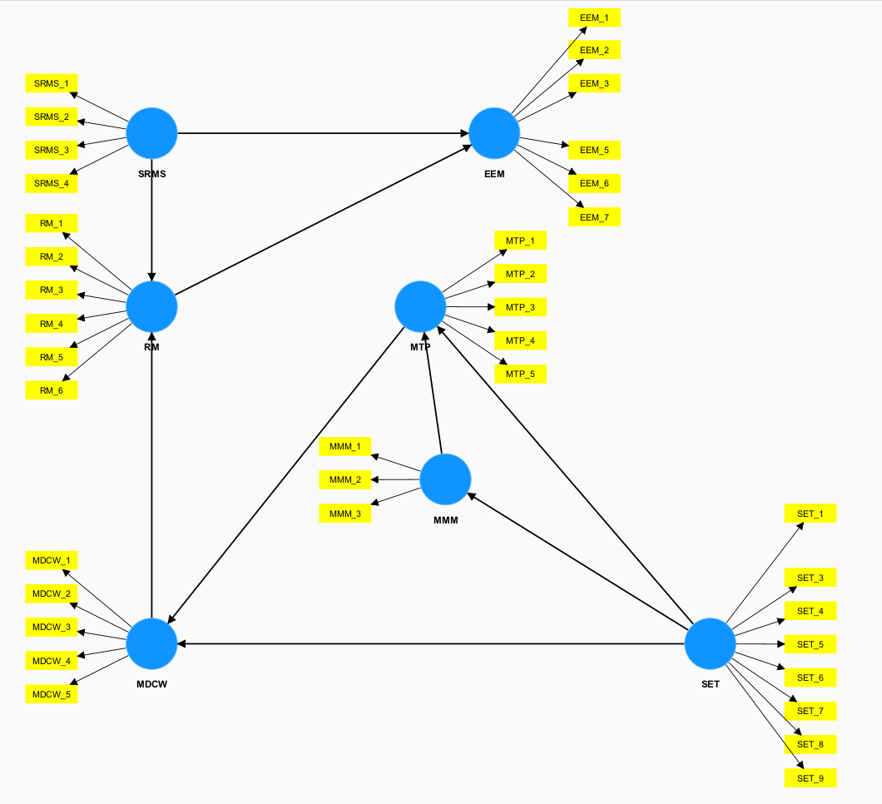

Figure 4.9A Updated Model of the Path

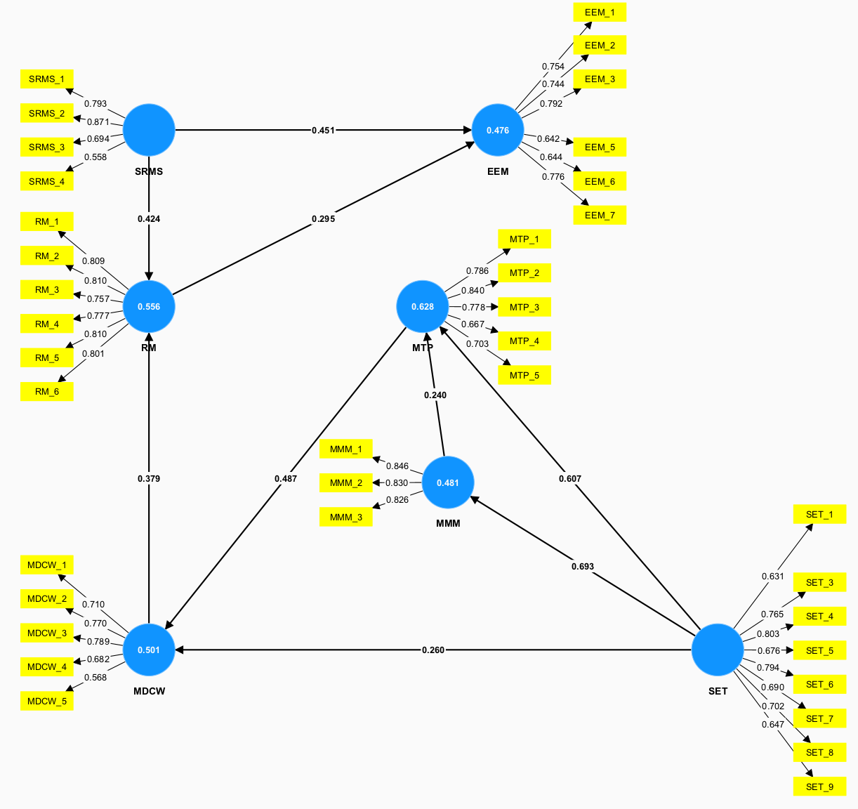

Figure 4.9B Updated Model of the Path with calculations

Table 4.12 Updated Statistical Significance
 | Path coefficient | t-value | p-value | Inference | Hypothesis
SRMS RM | 0.424 | 2.817 | 0.005 | Supported | H1
SRMS EEM | 0.451 | 3.799 | 0.000 | Supported | H2
MDCW RM | 0.379 | 2.328 | 0.020 | Supported | H3
MMM MTP | 0.240 | 2.836 | 0.005 | Supported | H5
RM EEM | 0.295 | 2.289 | 0.022 | Supported | H6
SET MDCW | 0.260 | 2.526 | 0.012 | Supported | H7
SET MMM | 0.693 | 10.144 | 0.000 | Supported | H8
SET MTP | 0.607 | 7.668 | 0.000 | Supported | H9
MTP MDCW | 0.487 | 4.972 | 0.000 | Supported | H10

The presented Table 4.13 gives updated insights into the Reliability and Validity of several constructs, with distinct rows referring to either the overall construct or specific constituents contained by those constructs. Overall, values were the same , but some factor loads were increased.

Table 4.13 Updated Reliability and validity test
Construct | Code | Factor load | Cronbach alpha | CR | AVE
SRMS | SRMS1 | 0.793 | 0.713 | 0.824 | 0.545
 | SRMS2 | 0.871 | - | - | -
 | SRMS3 | 0.694 | - | - | -
 | SRMS4 | 0.558 | - | - | -
MDCW | MDCW1 | 0.710 | 0.748 | 0.832 | 0.501
 | MDCW2 | 0.770 | - | - | -
 | MDCW3 | 0.789 | - | - | -
 | MDCW4 | 0.682 | - | - | -
 | MDCW5 | 0.568 | - | - | -
RM | RM1 | 0.809 | 0.883 | 0.911 | 0.631
 | RM2 | 0.810 | - | - | -
 | RM3 | 0.757 | - | - | -
 | RM4 | 0.777 | - | - | -
 | RM5 | 0.810 | - | - | -
 | RM6 | 0.801 | - | - | -
MMM | MMM1 | 0.846 | 0.783 | 0.873 | 0.696
 | MMM2 | 0.830 | - | - | -
 | MMM3 | 0.826 | - | - | -
EEM | EEM1 | 0.754 | 0.821 | 0.870 | 0.530
 | EEM2 | 0.744 | - | - | -
 | EEM3 | 0.792 | - | - | -
 | EEM5 | 0.642 | - | - | -
 | EEM6 | 0.644 | - | - | -
 | EEM7 | 0.776 | - | - | -
SET | SET1 | 0.631 | 0.863 | 0.893 | 0.513
 | SET3 | 0.765 | - | - | -
 | SET4 | 0.803 | - | - | -
 | SET5 | 0.676 | - | - | -
 | SET6 | 0.794 | - | - | -
 | SET7 | 0.690 | - | - | -
 | SET8 | 0.702 | - | - | -
 | SET9 | 0.647 | - | - | -
MTP | MTP1 | 0.786 | 0.813 | 0.870 | 0.574
 | MTP2 | 0.840 | - | - | -
 | MTP3 | 0.778 | - | - | -
 | MTP4 | 0.667 | - | - | -
 | MTP5 | 0.703 | - | - | -

Overall, the SEM analysis provides support for the theoretical model, highlighting MDCW, MMM, MTP, RM, SET, EEM, and SRMS as important constructs for understanding the relationships among variables in this model. Further research is necessary to explore the factors that might impact the relationships between these constructs and to determine the generalizability of these findings to other settings.

Chapter 5 – Conclusions, Recommendations, and Future Directions

5.1 Conclusions
In conclusion, the construction industry is a significant contributor to global greenhouse gas emissions and resource depletion. Therefore, it is crucial to implement sustainable practices and technologies to minimize the environmental impact of construction activities. The use of sustainable materials and resources is one of the critical factors that can contribute to the sustainability of building projects.
The results of the survey methodology to gather insights into the Materials and Resources aspect of LEED among construction sphere professionals in Kazakhstan. The survey was taken by 119 people and valuable information was gathered. On average, respondents had 3 years of work experience and finished 4 projects. Even though, the answers of less experienced people were compared with highly experienced workers and results did not show any significant difference. So, it can be stated that the collected data information is qualitative. So it can be said that these two groups perceive the impact of materials and resources on sustainability in a similar manner.
Various tests on the results of the survey have proven the correctness of the survey. The various conducted tests checked the distribution of the results, agreement among respondents, central tendency, validity, and reliability of the survey. The Cronbach’s alpha technique, Shapiro-Wilk, Kendall’s coefficient of concordance, Man-Whitney U statistics, Mean Technique, Factor Analysis, and PLS-SEM test results showed the correctness of the survey. For example, 9 out of 10 hypothesized relationships between constructs are generally supported by the model. This thesis provides valuable insights into the current state of sustainable building practices in Kazakhstan and highlights the importance of continued efforts toward a more sustainable future in the construction industry.
Based on the results the following five important factors for the impact of materials and resources on building sustainability can be identified.
1. Material storage and protection (MMM1)
2. Quality control in managing and maintaining the materials (MMM3)
3. Reducing waste at the source (MDCW1)
4. Material usage tracking (MTP1)
5. Material handling and transportation (MMM2)
From the Factors Analysis, it was ascertained that only those factors statistically about their respective categories were included. Based on the results, the Managing and Maintaining Materials (MMM) category with three subcomponents showed the highest load average at 0.834. This was followed by Sustainably and responsibly managed sources (SRMS) with three subcomponents at a load average of 0.811. The next one with the highest load was the Recycled Materials (RM) category with six subcomponents and a value of 0.793.
From the results of PLS-SEM it can be concluded that 9 out of 10 correlations were supported which are as follows:
1. Staff education and training (SET) has the highest influence on the better management and maintenance of materials (MMM) at a path coefficient of 0.694 (Hypothesis 8).
2. Staff education and training (SET) had a positive influence on Measuring and tracking progress (MTP) with a path coefficient of 0.606
3. Measuring and tracking progress (MTP) has a positive influence on the Management and Disposal of construction waste (MDCW). This correlation had the second-highest path coefficient in the PLS-SEM structural model at 0.479.
4. Sustainably and responsibly managed sources (SRMS) have a positive influence on Energy Efficient Materials (EEM) and had a path coefficient of 0.451.
5. The fifth highest influence was in path Sustainably and responsibly managed sources (SRMS) have a positive influence on Recycled materials (RM) and had a path coefficient of 0.424.
In conclusion, all of the objectives were achieved and the impact of Materials and Resource factors on the sustainability of building projects has shown to be significant. The findings of this study support the need for sustainable materials and resources to minimize the environmental impact of construction activities.

5.2 Recommendations
Based on the findings of this study, several recommendations can be made to promote the use of sustainable materials and resources in the projects. Firstly, architects and builders should prioritize the selection of sustainable materials and resources throughout the design and construction process. This can be achieved by conducting a life-cycle analysis of building materials and selecting those with the least environmental impact. Additionally, building owners and developers should incentivize the use of sustainable materials and resources by offering tax credits or other financial incentives.
Finally, policymakers should also play a role in promoting sustainable construction practices. They can incentivize the use of sustainable materials and resources through building codes, regulations, and standards. They can also support research and development initiatives to promote the use of sustainable materials and resources and BIM in building projects.
Overall, the adoption of sustainable materials and resources in building projects can help to minimize the environmental impact of construction activities and promote a more sustainable built environment. The recommendations provided can guide architects, builders, and policymakers in promoting sustainable practices and technologies in the construction industry.

5.3 Future Directions
From the conducted survey results, several recommendations for future improvements can be made.
- The enhancement of the thesis paper can be achieved through the integration of novel inquiries focusing on the Materials and Resources (MR) aspect of LEED certification. By incorporating these additional questions, the thesis can yield significant advancements in terms of MR-related points. Furthermore, conducting further analysis on this particular topic can provide a more comprehensive understanding of its implications.
- To broaden the scope of the survey and conduct a thorough analysis of the influence of LEED certification on the sustainability of buildings, it is advisable to include other components of the certification framework such as Sustainable Sites (SS), Water Efficiency (WE), Energy and Atmosphere (EA), and Indoor Environmental Quality (IEQ). Incorporating these aspects into the survey will not only expand its coverage but also enable a deeper exploration of the multifaceted impact of LEED certification on building sustainability.
- To enhance survey participation rates, it is imperative to extend the outreach efforts to various stakeholders within the construction industry. A comprehensive approach involves targeting construction companies, esteemed professors specializing in construction-related disciplines across different universities, and individuals who possess prior experience working in the construction sector. By diversifying the recipients, it can significantly augment the dataset and capture a broader spectrum of perspectives and insights on the subject matter. Furthermore, this inclusive approach facilitates a comparative analysis of opinions and knowledge among individuals from distinct domains within the construction industry.

References
АО “KAZNIICA”. (2017). BUILDING CLIMATOLOGY. Doi: https://igis.kz/images/snip/stroitelnye-normativy/sp-rk-2.04-01-2017-stroitelnaya- klimatologiya.pdf
Al-Hajj, A. (2011). Material Waste in the UAE Construction Industry: Main Causes and Minimization Practices.
Alkhaddar, R. (2012). Deep learning approach’s effectiveness on sustainability improvement in the UK construction industry.
American Committee of the National Information Model Standard Project Committee. (n.d.). https://www.nibs.org/bimc
American Iron and Steel Institute. (2022). Steel Production Greenhouse Gas Emissions Calculation Methodology Guidelines. In https://www.steel.org/sustainability/. https://www.steel.org/wp-content/uploads/2022/11/AISI-GHG-Emissions-Calculation-Methodology-Guidelines-final-11-3-22.pdf
Amiri, A., Ottelin, J., & Sorvari, J. (2019). Are LEED-Certified Buildings Energy-Efficient in Practice? Sustainability, 11(6), 1672. doi:10.3390/su11061672 Anable, G., Kelly, P. J., & O'Malley, C. (n.d.). Sustainable Materials Management in
Assessment of Construction and Demolition Waste plant management in Spain: in pursuit of sustainability and eco-efficiency. Journal of Cleaner Production, 90, 16–24. https://doi.org/10.1016/j.jclepro.2014.11.067
Azhar, S. (2011). Building Information Modeling (BIM): Trends, Benefits, Risks, and Challenges for the AEC Industry. Leadership and Management in Engineering, 11(3), 241–252. doi:10.1061/(asce)lm.1943-5630.0000127
Azhar, S., Carlton, W. A., Olsen, D., & Ahmad, I. (2011). Building information modelling for sustainable design and LEED® rating analysis. Automation in Construction, 20(2), 217–224. doi:10.1016/j.autcon.2010.09.019
Begum, R. A., Siwar, C., Pereira, J. J., & Jaafar, A. H. (2009). Attitude and behavioural factors in waste management in the construction industry of Malaysia. Resources, conservation and recycling, 53(6), 321-328.
Behaviour, Fourth Edition. CRC Press. https://books.google.com/books/about/Construction_Materials.html?id=cxIocVbGsSAC
Berardi, U. (2013). Sustainable Construction: Green Building Design and Delivery. Intelligent Buildings International, 5(1), 65–66. https://doi.org/10.1080/17508975.2012.756388
Brown, R. D. (2016). Incentivizing sustainable behaviour in the construction industry.
Browne, N. (2020, November). The Effect of LEED-Certification on Multi-Family Residential Rents and Expenses in the District of Columbia. In 113th Annual Conference on Taxation. NTA.
BuildingSMART – 2010 – http://www.buildingsmart-tech.org/
Business Review. https://hbr.org/2020/03/a-more-sustainable-supply-chain
Businesses? Simfoni. https://simfoni.com/procurement-analytics/what-is-sustainable-procurement-and-why-it-is-important-for-businesses/
Chan, A. P., Chan, D. W., Chiang, Y. H., Tang, B. S., Chan, E. H., and Ho, K. S. (2004). Exploring critical success factors for partnering in construction projects. Journal of construction engineering and management, 130(2), 188-198. https://www.researchgate.net/publication/245283659_Exploring_Critical_Success_Factors_for_Partnering_in_Construction_Projects
Chin, W. W. (1998). The partial least squares approach for structural equation modeling. In G. A. Marcoulides (Ed.), Modern methods for business research (pp. 295–336). Lawrence Erlbaum Associates Publishers. https://psycnet.apa.org/record/1998-07269-010
construction : measuring environmental impact using life-cycle inventory analysis. US Forest Service Research and Development. https://www.fs.usda.gov/research/treesearch/37173
Construction. Retrieved from https://www.cibse.org/knowledge/knowledge-items/detail?id=a0q20000008I9J6AAK
Cortina, J. M. (1993). What is coefficient alpha? An examination of theory and applications. Journal of applied psychology, 78(1), 98. https://psycnet.apa.org/record/1993-19965-001
Creed LA. Equitable Economic Development. https://creedla.com/benefits-of-reducing-construction-demolition-waste/
Creedla. (2019, May 14). Benefits of Reducing Construction & Demolition Waste.
Darko, A., Chan, A. P., Owusu-Manu, D. G., and Ameyaw, E. E. (2017). Drivers for implementing green building technologies: An international survey of experts. Journal of Cleaner Production, 145, 386-394. https://eprints.kingston.ac.uk/id/eprint/37331/1/Ameyaw-E-37331-AAM.pdf
Das, P., Chandra, T. S., Kumar, A., & Mahajan, D. (2019). Sustainability Through Energy Efficient Building.
Ding, G. (2014). Life cycle assessment (LCA) of sustainable building materials: an overview. Elsevier eBooks, 38–62. https://doi.org/10.1533/9780857097729.1.38
Djamila, H. ., Rajin, M. ., & Rizalman, A. N. . (2020). Energy Efficiency through Building Envelope in Malaysia and Singapore . Journal of Advanced Research in Fluid Mechanics and Thermal Sciences, 46(1), 96–105. Retrieved from https://www.akademiabaru.com/submit/index.php/arfmts/article/view/2206
Domone, P., & Illston, J. (2010a). Construction Materials: Their Nature and
EcoVadis. (2021, November 22). Определение устойчивых закупок | EcoVadis.
Efficient in Practice? Sustainability, 11(6), 1672. https://doi.org/10.3390/su11061672
Environment and Resources, 29(1), 181–204. https://doi.org/10.1146/annurev.energy.29.062403.102215
Ehtesham, A. and Massom, R. (2018). GREEN BUILDING CONCEPT, RATING SYSTEM AND ITS MANAGEMENT IN CONSTRUCTION PROJECTS IN INDIA. https://doi.org/10.15623/ijret.2018.0708002
Fellows, R. F., and Liu, A. M. (2015). Research methods for construction. John Wiley and Sons. https://www.wiley.com/en-us/Research+Methods+for+Construction%2C+5th+Edition-p-9781119814733
Field, A. (2009). Discovering statistics using IBM SPSS statistics. 3rd edition. Sage Publications, London, UK. https://www.scirp.org/(S(351jmbntvnsjt1aadkposzje))/reference/ReferencesPapers.aspx?ReferenceID=1866193
Fornell, C., and Larcker, D. F. (1981). Evaluating structural equation models with unobservable variables and measurement error. Journal of marketing research, 18(1), 39-50. https://www.jstor.org/stable/3151312
Franklin Associates, Characterization of Municipal Solid Waste: 1998 Update. 1999, U.S. EPA.
General Services Administration – GSA BIM Guide Series 01 - 2007 Online.
global review and supply chain analysis. Renewable & Sustainable Energy Reviews, 124, 109783. https://doi.org/10.1016/j.rser.2020.109783
Gurmu, A. T. (2019). Tools for Measuring Construction Materials Management
Hair, J. F. (1973). Multivariate Data Analysis. Journal of the Royal Statistical Society, 136(1), 101. https://doi.org/10.2307/2344428
Hair, J. F., Black, W. C., Babin, B. J., Anderson, R. E., and Tatham, R. L. (2006). Multivariate data analysis, 7th Edition, Pearson Prentice Hall. Upper Saddle River, NJ. https://books.google.kz/books/about/Multivariate_Data_Analysis.html?id=VvXZnQEACAAJ&redir_esc=y
Hair, J. F., Ringle, C. M., and Sarstedt, M. (2011). PLS-SEM: Indeed a silver bullet. Journal of Marketing theory and Practice, 19(2), 139-152. https://www.researchgate.net/publication/236033273_PLS-SEM_Indeed_a_silver_bullet
Hair, Jr. F., Sarstedt, M., Hopkins, L., and G. Kuppelwieser, V. (2014). Partial least squares structural equation modelling (PLS-SEM) An emerging tool in business research. European Business Review, 26(2), 106-121. https://www.emerald.com/insight/content/doi/10.1108/EBR-10-2013-0128/full/html
Henseler, J., Ringle, C. M., and Sarstedt, M. (2015). A new criterion for assessing discriminant validity in variance-based structural equation modelling. Journal of the academy of marketing science, 43(1), 115-135. https://research.utwente.nl/en/publications/a-new-criterion-for-assessing-discriminant-validity-in-variance-b
Henson, R. K., and Roberts, J. K. (2006). Use of exploratory factor analysis in published research: Common errors and some comment on improved practice. Educational and Psychological measurement, 66(3), 393-416. https://journals.sagepub.com/doi/10.1177/0013164405282485
Hill, Brent Dale. (2011). The sequential Kaiser-Meyer-Olkin procedure as an alternative for determining the number of factors in common-factor analysis: A Monte Carlo simulation. Oklahoma State University ProQuest Dissertations Publishing. https://www.proquest.com/docview/898980750?pq-origsite=gscholar&fromopenview=true
Horvath, A. (2004). Construction Materials and the Environment. Annual Review of
Hsu, A. T., Ho, L., Ho, S., and Hedman, T. (2000). Immediate response of glenohumeral abduction range of motion to a caudally directed translational mobilization: a fresh cadaver simulation. Archives of physical medicine and rehabilitation, 81(11), 1511-1516. https://www.sciencedirect.com/science/article/abs/pii/S0003999300660185
https://books.google.kz/books?hl=ru&lr=&id=x_Rnb9uIiQQC&oi=fnd&pg=PP1&dq=leed+certification&ots=LQ1GKHr7GP&sig=X0a2Tt67drkK-PpNhQ5mngq32wA&redir_esc=y#v=onepage&q=leed%20certification&f=false
https://doi.org/10.1016/b978-0-08-102156-9.00003-1
https://ecovadis.com/ru/glossary/sustainable-procurement/
https://rheaply.com/what-is-sustainable-procurement/
https://sievo.com/blog/sustainable-procurement-part1
Hwang, B. G., Zhao, X., and Yu, G. S. (2016). Risk identification and allocation in underground rail construction joint ventures: contractors’ perspective. Journal of Civil Engineering and Management, 22(6), 758-767. https://www.semanticscholar.org/paper/Risk-identification-and-allocation-in-underground-Hwang-Zhao/bd5543e5f2692362c66fcd6887d8f86d7b9e9ce3
Integrating BIM and LiDAR for Real-Time Construction Quality Control. Journal of Intelligent and Robotic Systems, 79(3–4), 417–432. https://doi.org/10.1007/s10846-014-0116-8
Iqbal, M., Ma, J., Ahmad, N., Hussain, K., & Usmani, M. S. (2021). Promoting
Jack, P., Russell, C., and Bert, B. (2001). Validation of trace-driven simulation models: bootstrap tests. Management Science, 47(11), 1533-1538. https://dl.acm.org/doi/10.5555/2804683.2804690
Journal of Cleaner Production, 135, 766-775. https://www.perplexity.ai/search/3efdf542-6316-445c-a622-d1286cebf0b4?s=u
Kaderzhanov, M., Nurbekova, K., & Ibrayeva, A. (2021). Energy performance of a high-rise building in the continental climate of Kazakhstan. Buildings, 11(12), 633. https://doi.org/10.3390/buildings11120633
Karatayev, M., & Clarke, M. L. (2016). A review of current energy systems and green energy potential in Kazakhstan. Renewable & Sustainable Energy Reviews, 55, 491–504. https://doi.org/10.1016/j.rser.2015.10.078
Kenai, S. (2018). Recycled aggregates. Elsevier EBooks, 79–120.
Kendall, M., and Gibbons, J. D. (1990), Rank Correlation Methods, New York: Oxford University Press. https://www.worldcat.org/title/rank-correlation-methods/oclc/21195423
Kim, T. K. (2015). T test as a parametric statistic. Korean journal of anesthesiology, 68(6), 540. https://pubmed.ncbi.nlm.nih.gov/26634076/
Kliment, D. (2020). Influence of sustainable construction aspects and quality of public space on the price of houses in the Czech Republic.
Kostevšek, A., Klemeš, J. J., Čuček, L., & Petek, J. (2015). Sustainability assessment
Kutlu, L., Tran, K. C., & Tsionas, M. G. (2020). A spatial stochastic frontier model with endogenous frontier and environmental variables. European Journal of Operational Research. doi:10.1016/j.ejor.2020.03.020
LEED Construction Waste Management | Southern Waste & Recycling. (2021, March 4).Southern-waste.
Li, B. (2003). Risk Management of Construction Public-Private Partnerships. PhD Dissertation, Glasgow Caledonian University, Glasgow, Scotland. https://ethos.bl.uk/OrderDetails.do?uin=uk.bl.ethos.270518
Mao, C., Shen, Q., Pan, W., and Ye, K. (2013). Major barriers to off-site construction: the developer’s perspective in China. Journal of Management in Engineering, 31(3), 04014043. https://research.polyu.edu.hk/en/publications/major-barriers-to-off-site-construction-the-developers-perspectiv
Maurya, M. C., & Malviya, D. K. (2021). Recycled C&D waste energy efficient and sustainable construction material. International Journal of Engineering, Science and Technology, 13(1), 119-124.
Mésároš, P., Mesarosova, A., & Behún, M. (2016, November 1). Developing managerial and digital competencies through BIM technologies in the construction industry. International Conference on Emerging eLearning Technologies and Applications. https://doi.org/10.1109/iceta.2016.7802095
National Glass Recycling Coalition. (n.d.). Glass Recycling in Construction. Glass Recycling Coalition (glassrecycles.org)
Norusis, M. (2008). SPSS 16.0 advanced statistical procedures companion. Upper Saddle River, NJ: Prentice Hall. https://dl.acm.org/doi/book/10.5555/1628706
Nunnally, J. C. (1978). Psychometric methods, McGraw-Hill, New York, US. https://books.google.kz/books/about/Psychometric_theory.html?id=WE59AAAAMAAJ&redir_esc=y
of the Locally Integrated Energy Sectors for a Slovenian municipality. Journal of Cleaner Production, 88, 83–89. https://doi.org/10.1016/j.jclepro.2014.04.008
Onat, N. C., & Kucukvar, M. (2020). The carbon footprint of the construction industry: A
Oumbé, R., & Boton, C. (2020, July 1). BIM-Based Cost Management Practices in the Quebec’s Construction Industry. https://doi.org/10.3311/ccc2020-072
Owen, R., & Koskela, L. (2006). AGILE CONSTRUCTION PROJECT MANAGEMENT.
https://www.semanticscholar.org/paper/AGILE-CONSTRUCTION-PROJECT-MANAGEMENT-Owen-Koskela/11db7d28d71c03fd5e4522fc250c04ba52cea611
Owusu, E.K., and Chan, A. P. (2019). Barriers affecting the effective application of anticorruption measures in infrastructure projects: Disparities between developed and developing countries. Journal of Management in Engineering, 35(1), 04018056. https://ascelibrary.org/doi/full/10.1061/%28ASCE%29ME.1943-5479.0000667
Pagan, K. W. (2016). Is There Real Potential of Sustainable City Life? Journal of
Pakistan. (2019). Environmental and Social Impact Assessment and Environmental and Social Management Plan for Construction and Rehabilitation of Changla Gali-Makhniyal Road.
PhDBergman, R. D. (2010). Using reclaimed lumber and wood flooring in
Practices and Predicting Labor Productivity in Multistory Building Projects. Journal of the Construction Division and Management, 145(2). https://doi.org/10.1061/(asce)co.1943-7862.0001611
Prototype Building Models - Building Energy Codes Program - https://www.energycodes.gov/prototype-building-models
Punia, A. (2022). Analysis of the Impact of Passive Design Strategies on Energy Consumption of a Building in Composite Climate Zone.
Razali, N. M., and Wah, Y. B. (2011). Power comparisons of Shapiro-Wilk, Kolmogorov-Smirnov, Villiers and Anderson-darling tests.Journal of statistical modelling and analytics, 2(1), 21-33. https://www.researchgate.net/publication/267205556_Power_Comparisons_of_Shapiro-Wilk_Kolmogorov-Smirnov_Lilliefors_and_Anderson-Darling_Tests
recycled materials for the construction of residential buildings.
Remizov, A., Tukaziban, A., Yelzhanova, Z., Junussova, T., & Karaca, F.
(2021). Adoption of Green Building Assessment Systems to Existing Buildings under Kazakhstani Conditions. Buildings, 11(8), 325. doi:10.3390/buildings11080325
Rodríguez, G., Medina, C., Alegre, F., Asensio, E., & De Rojas, M. S. (2015).
Santos, J. R. A. (1999). Cronbach’s alpha: A tool for assessing the reliability of scales. Journal of extension, 37(2), 1-5. https://www.semanticscholar.org/paper/Cronbach%27s-alpha%3A-a-tool-for-assessing-the-of-Santos-Santos/c0b3d137884bd928193054c61531fd677cff422e
Scribbr. (2021, January 26). Purposive sampling: Definition, types, examples, and more. Scribbr. https://www.scribbr.com/methodology/purposive-sampling/
Shimamoto, K. (2013). Environmental Management and Efficiency.
Shiri, N. D., Krafft, M. S., & Thurm, W. (2019). Plastic lumber product development
Siegel, S., and Castellan, N. J. (1988). Measures of association and their tests of significance. Nonparametric statistics for the behavioral sciences, 224-312. https://psycnet.apa.org/record/1988-97307-000
Simfoni. (2022). What is Sustainable Procurement and Why it is Important for
StackPath. (n.d.). https://www.forconstructionpros.com/sustainability/article/22288658/nielsons-skanska-inc-rethinking-sustainable-strategies-for-construction-waste
Staplehurst, J., and Ragsdell, G. (2010). Knowledge sharing in SMEs: A comparison of two case study organizations. Journal of Knowledge Management Practice, 11(1), 1-16. https://link.springer.com/chapter/10.1007/978-3-642-35879-1_14
sustainable construction through energy-efficient technologies: an analysis of promotional strategies using interpretive structural modelling. International Journal of Environmental Science and Technology, 18(11), 3479–3502. https://doi.org/10.1007/s13762-020-03082-4
Sustainable Management of Construction and Demolition Materials | US EPA. (2023, February 7). US EPA. https://www.epa.gov/smm/sustainable-management-construction-and-demolition-materials
Sustainable Management of Construction and Demolition Materials | US EPA. (2023, February 7). US EPA. https://www.epa.gov/smm/sustainable-management-construction-and-demolition-materials
Tahmoorian, F., Samali, B., & Yeaman, J. (2017). Classification and characterization of recycled construction aggregate (RCA).
Taylor, C., Roy, K., Dani, A. A., Lim, J. B., De Silva, K., & Jones, M. (2023). Delivering Sustainable Housing through Material Choice. Sustainability, 15(4), 3331.
Tettey, U. Y. A., Dodoo, A., & Gustavsson, L. (2014). Effects of different insulation materials on primary energy and CO2 emission of a multi-storey residential building. Energy and Buildings, 82, 369–377. https://doi.org/10.1016/j.enbuild.2014.07.009
Tissera, W. D. A. C., Dahanayake, R., & Edirisinghe, V. (2022). The applicability of regulations for the disposal of construction and demolition waste in Sri Lanka.
Tobias, M. (2021, June 10). Importance of Measurements in the LEED Certification for Buildings. Nery Engineers. https://www.ny-engineers.com/blog/importance-of-measurements-in-the-leed-certification-for-buildings
Toikka, J. (n.d.). What is sustainable procurement and why is it important?
Tokbolat, S., & Nazipov, F. (2021). Investigating the Application of LEED and BREEAM Certification Schemes for Buildings in Kazakhstan. Advances in Sustainability Science and Technology. https://doi.org/10.1007/978-981-15-8775-7_11
Treloar, G. (2003). An analysis of factors influencing waste minimisation and use of
U.S. General Services Administration. (2022). https://www.gsa.gov/real-estate/design-and-construction/3d4d-building-information-modeling
Urban History. https://doi.org/10.1177/0096144216657078
USGBC | U.S. Green Building Council. (n.d.). https://www.usgbc.org/
USGBC, An Introduction to the U.S. Green Building Council and the LEED Green Building Rating System. 2002, U.S. Green Building Council.
USGBC, LEED Materials and Resources. 2001, Washington, DC: U.S. Green Building Council. 280. https://www.usgbc.org/articles/materials-and-resources-leed-v4
USGBC, LEED Reference Guide Version 2.0. 2001, Washington, DC: U.S. Green Building Council. 280.
USGBC. Green Building Cost. in Advanced LEED Training Workshop. 2002. Dearborn, MI: U.S. Green Building Council.
Using commingled waste plastics. AIP Conference Proceedings, 2080(1). https://doi.org/10.1063/1.5092935
Vandecasteele, C., & van der Sloot, H. (2011). Sustainable management of waste and recycled materials in construction. Waste Management, 31(2), 199-200.
Vanegas, J. A., DuBose, J., & Pearce, A. R. (1995, January 1). Sustainable technologies for the building construction industry. ResearchGate. https://www.researchgate.net/profile/Annie_Pearce/publication/228540323_Sustainab%20le_technologies_for_the_building_construction_industry/links/00b7d5267fdd57eefd0%2000000.pdf
Vilisova, A., & Mironova, L. (2021). Theoretical Foundations of Training Students in the Building Information Modeling in the Context of Sustainable Development of the Construction Industry.
Villena, V. H. (2020, November 16). A More Sustainable Supply Chain. Harvard
Vitaly, B. (2021). BIM technologies in construction. https://www.planradar.com/ru/bim- tekhnologii-v-stroitelstve/#8
Volk, R., Stengel, J., & Schultmann, F. (2014). Building Information Modeling (BIM) for existing buildings — Literature review and future needs. Automation in Construction, 38, 109–127. https://doi.org/10.1016/j.autcon.2013.10.023
Wang, J., Sun, W., Shou, W., Wang, X., Wu, C., Chong, H., Liu, Y., & Sun, C. (2015).
What is sustainable procurement? - Rheaply. (n.d.). Rheaply.
Wong, J. K.-W., & Kuan, K.-L. (2014). Implementing “BEAM Plus” for BIM-based sustainability analysis. Automation in Construction, 44, 163–
175. doi:10.1016/j.autcon.2014.04.003
Woods, A. (2019). Green Building 101: Choosing LEED-Friendly products. Albany
Woodworks. https://www.albanywoodworks.com/2018/12/09/green-building-101-how-to-choose-leed-friendly-products/
Xu, C., Hu, X., Tivendale, L., Liu, C., & Hosseini, M. R. (2018). Building information modelling in sustainable design and construction. International Journal of Sustainable Real Estate and Construction Economics, 1(2), 164. https://doi.org/10.1504/ijsrece.2018.10013438
Ye, F. (2009). Laboratory Study on Recycled Building Waste Materials for Road Construction.
Zaman, U., Jabbar, Z., Nawaz, S., and Abbas, M. (2019). Understanding the soft side of software projects: An empirical study on the interactive effects of social skills and political skills on complexity–performance relationship. International Journal of Project Management, 37(3), 444-460. https://www.sciencedirect.com/science/article/pii/S0263786318306379
Zhang, J., Schmidt, K. M., & Li, H. (2016). BIM and Sustainability Education: Incorporating Instructional Needs into Curriculum Planning in CEM Programs Accredited by ACCE. Sustainability, 8(6), 525. https://doi.org/10.3390/su8060525
Zhang, Y. (2021). Application of Industrial Solid Waste in Preparation of Recycled Concrete: A Review.
Zhang, Y., Long, E., Li, Y., & Li, P. (2017). Solar radiation reflective coating material on building envelopes: Heat transfer analysis and cooling energy saving. Energy Exploration & Exploitation, 35(6), 748–766. doi:10.1177/0144598717716285

Appendices
Appendix A

The tables above show the results from the Survey. Table A.1, Table A.2 and Table A.3 give the demographic information about each respondent. Other tables Table A.4, Table A.5, Table A.6 and Table A.7 show the answers of the respondents for each question, where NI means Not Important, LI – Less Important, N – Neutral, I – Important and VI – Very Important.

Table A.1 IP, ID and Location of Respondents
Respondent | IP Address | Response ID | Location Latitude | Location Longitude
1 | 46.34.193.75 | R_2QWfuoqNGN88SM6 | 51.1879 | 71.4332
2 | 87.255.216.85 | R_12upejhIVf61Ud2 | 51.1879 | 71.4332
3 | 46.34.194.70 | R_1MSvuZTU3sepp4R | 51.1879 | 71.4332
4 | 85.117.97.152 | R_3s5rFJ37y8PLzy6 | 43.2638 | 76.9293
5 | 95.82.64.173 | R_wR7VxD7ueOITDLX | 51.1879 | 71.4332
6 | 46.34.194.27 | R_2YfidiuLCltmQWW | 51.1879 | 71.4332
7 | 95.82.118.239 | R_1kSOppacMDyeRLR | 43.2638 | 76.9293
8 | 198.45.118.1 | R_3s6LaM3eR0AQ4IE | 43.2638 | 76.9293
9 | 87.255.216.72 | R_3QLSx5IMG4ciZbQ | 51.1879 | 71.4332
10 | 185.97.114.32 | R_20M5PQV6oBBp8tB | 43.2638 | 76.9293
11 | 87.255.216.84 | R_2CV3ceCrXT1grWd | 51.1879 | 71.4332
12 | 185.19.192.110 | R_2v0pWXdNsgfEM09 | 51.1879 | 71.4332
13 | 185.19.192.110 | R_3JelaRRhMpMYLbZ | 51.1879 | 71.4332
14 | 73.142.214.115 | R_1nN7g1FyqZ8pexY
15 | 87.255.216.87 | R_234qEKIBXqlv5Cf | 51.1879 | 71.4332
16 | 93.170.37.50 | R_1CD84IdcXBKL0LE | 51.1879 | 71.4332
17 | 2.72.113.253 | R_2TXHoyS1MriSbze | 43.2638 | 76.9293
18 | 95.82.119.117 | R_25TvYc4UWDRqKko | 43.2638 | 76.9293
19 | 176.64.24.194 | R_1OBIBvEgYWnLW5r | 43.2638 | 76.9293
20 | 95.141.138.89 | R_1n91JNM8a5l5dc7 | 51.1879 | 71.4332
21 | 95.141.138.89 | R_1NIZheCrW55AlJL | 51.1879 | 71.4332
22 | 37.99.47.195 | R_27ljV9Esmk9nHF3 | 43.2638 | 76.9293
23 | 2.72.162.57 | R_2VkLsbbekTbDFSl | 43.2638 | 76.9293
24 | 5.63.64.78 | R_3FOmGEgGX3ETjT2 | 44.8496 | 65.5155
25 | 95.82.118.124 | R_p3Klcp7wjybf8f7 | 43.2638 | 76.9293
26 | 185.57.73.193 | R_3iqAl4KLvJEBQBi | 43.2638 | 76.9293
27 | 95.161.225.178 | R_2afWVoT5I4gF5DL | 48 | 68
28 | 185.19.192.110 | R_To38G4klaiTjaIp | 51.1879 | 71.4332
29 | 159.65.106.113 | R_3iOPY8xGN81qbA9 | 37.3417 | -121.975
30 | 109.183.216.114 | R_2WI6lU72Alz1LWl | 50.1023 | 14.3568
31 | 176.64.3.50 | R_3oRTROFqMlcEI7i | 43.2638 | 76.9293
32 | 212.96.74.147 | R_1gwP6fjUHOoVU6z | 51.1879 | 71.4332
33 | 212.96.74.147 | R_2lcE3dUMuYyy45H | 51.1879 | 71.4332
34 | 212.96.74.147 | R_3F3aaw5GfZugwJs | 51.1879 | 71.4332
35 | 213.211.125.122 | R_3NQCu20JVL6CLWp | 43.2638 | 76.9293
36 | 91.247.56.196 | R_22WE22CE0Egl7og | 42.869 | 74.5939
37 | 176.64.13.28 | R_3HqnOTx1u53Gl7e | 43.2638 | 76.9293
38 | 2.76.200.184 | R_1rBWD8W1lSK6SXn
39 | 95.82.64.199 | R_1QFOMtjAiI8qqVQ
40 | 5.76.187.71 | R_1mmDiu5n2Pwl3zF
41 | 95.82.126.60 | R_2PtV59PvvuYRKcA
42 | 2.133.189.19 | R_bdW4angwKzLzugN
43 | 89.43.167.181 | R_sBGcwDZvOcVxNYJ
44 | 5.63.64.78 | R_wZyDdPSZpWD5beF
45 | 195.47.220.249 | R_10I5t3o3HzqUFts
46 | 93.170.37.65 | R_3g5RBMmrIh9VkSQ
47 | 188.246.244.69 | R_1EYx3DJdLZgZacN
48 | 91.185.26.179 | R_1f7As7euNfvwAV1
49 | 156.146.59.49 | R_1obTOzhraxgL3Fj
50 | 2.72.61.123 | R_esNbUGsNm4KkMJr
51 | 87.247.28.2 | R_2Y38yoEh9pne8Od | 51.1876 | 71.4491
52 | 87.255.216.85 | R_241Szq7F7t01Opf | 51.1876 | 71.4491
53 | 185.19.192.110 | R_1Qfm1khaGWTc6BE | 51.1876 | 71.4491
54 | 185.19.192.110 | R_2Sk2zigGNFN2XGs | 51.1876 | 71.4491
55 | 185.19.192.110 | R_3jfypYikH0cU2qn | 51.1876 | 71.4491
56 | 185.19.192.110 | R_NUT0Hun8uzZpgWd | 51.1876 | 71.4491
57 | 185.19.192.110 | R_1BnDPobYda4aIAF | 51.1876 | 71.4491
58 | 185.19.192.110 | R_1hSwhyfdSmwO1AX | 51.1876 | 71.4491
59 | 185.19.192.110 | R_12DwhNcDCCfkdAq | 51.1876 | 71.4491
60 | 185.19.192.110 | R_1GNT17yozT8QL3u | 51.1876 | 71.4491
61 | 185.19.192.110 | R_3M5aRqssOk48jXx | 51.1876 | 71.4491
62 | 185.19.192.110 | R_3iKVXHtcRfYaLYU | 51.1876 | 71.4491
63 | 185.19.192.110 | R_2f8lO8LtRoa8Km7 | 51.1876 | 71.4491
64 | 178.91.253.72 | R_2bH4AZb4l7SrL1w | 51.1876 | 71.4491
65 | 178.91.253.88 | R_3lua8sxWB8W34co | 51.1876 | 71.4491
66 | 178.91.253.88 | R_2wL9H7dvShdvEcR | 51.1876 | 71.4491
67 | 178.91.253.72 | R_3HBlsCQXfqlTW5y | 51.1876 | 71.4491
68 | 82.84.102.103 | R_29v6QKdRqfS0l9o | 45.5819 | 9.2683
69 | 185.48.148.187 | R_3foUczapEtYOTDE | 51.1876 | 71.4491
70 | 185.48.148.187 | R_QalkOW6hfxSCNTr | 51.1876 | 71.4491
71 | 147.161.185.28 | R_3LjT1C8l8FcPAnT | 48.8323 | 2.4075
72 | 147.161.185.28 | R_85DClWaKssEsU6d | 48.8323 | 2.4075
73 | 87.255.216.72 | R_1GUkKCJ8fldNEXz | 51.1876 | 71.4491
74 | 185.48.148.184 | R_3szBVjlokkek3W9 | 51.1876 | 71.4491
75 | 87.255.216.87 | R_1lmaXigBKbbmS4T | 51.1876 | 71.4491
76 | 87.255.216.74 | R_29rYoAZVg3swwGH | 51.1876 | 71.4491
77 | 185.48.148.187 | R_DM0tH35WeaaqODT | 51.1876 | 71.4491
78 | 165.225.207.44 | R_30emiLTilRbmvPV | 52.2296 | 21.0067
79 | 165.225.207.44 | R_12KXETE1KBxRZ4J | 52.2296 | 21.0067
80 | 185.48.148.187 | R_3e3lACfu6Z07Mss | 51.1876 | 71.4491
81 | 165.225.207.44 | R_yDUe7fjyTQBOIMN | 52.2296 | 21.0067
82 | 193.6.168.247 | R_21oe5zErZFhZq3f | 47.5232 | 21.6334
83 | 185.48.148.172 | R_1LHfyoiE1YaZVmV | 51.1876 | 71.4491
84 | 5.34.127.175 | R_3JL9zmCnEWQ654O | 51.1876 | 71.4491
85 | 5.34.127.175 | R_3KJY22uREMXbEJn | 51.1876 | 71.4491
86 | 46.34.192.144 | R_YXMVVq6wVb3sFQl | 51.1876 | 71.4491
87 | 87.255.216.86 | R_2bJc3Jf8yYFcbUC | 51.1876 | 71.4491
88 | 46.34.192.144 | R_UnZKelMSpVt3A4x | 51.1876 | 71.4491
89 | 87.255.216.86 | R_3NIO8eTw2IiurwG | 51.1876 | 71.4491
90 | 87.255.216.86 | R_3Eh7Wrn9G5ctOjC | 51.1876 | 71.4491
91 | 46.34.192.144 | R_wUjR6FCWwiFFB7P | 51.1876 | 71.4491
92 | 192.112.253.22 | R_5vhCG5VH94K0ZPj | 40.7957 | -77.8618
93 | 192.112.253.22 | R_10H0ZrgP6oCrUus | 40.7957 | -77.8618
94 | 192.112.253.22 | R_31R9pLZowPQdlX4 | 40.7957 | -77.8618
95 | 192.112.253.22 | R_2S8oB3U3ZzdXUze | 40.7957 | -77.8618
96 | 192.112.253.22 | R_dmPomDr74984u9r | 40.7957 | -77.8618
97 | 192.112.253.22 | R_2D8D1sKvVtAGUXq | 40.7957 | -77.8618
98 | 2.134.106.94 | R_3MoMPMQpkBNwsQX | 50.2797 | 57.2072
99 | 178.91.253.74 | R_2Piox5E9Be4yhYu | 51.1876 | 71.4491
100 | 87.255.216.72 | R_2c2dNH47fEyuWGz | 51.1876 | 71.4491
101 | 87.247.28.2 | R_0P1zw5YCBzt4erL | 51.1876 | 71.4491
102 | 87.255.216.86 | R_3jdu4bpw4fpfyao | 51.1876 | 71.4491
103 | 178.90.252.117 | R_3gY699XDSW11qSZ | 47.1169 | 51.8853
104 | 82.84.100.147 | R_3PySvUvntEFJUV8 | 45.6135 | 9.2381
105 | 2.79.238.211 | R_zZ27wnZjFpyJMml | 47.1169 | 51.8853
106 | 5.34.69.247 | R_3M6G5qFRBuaGKm9 | 42.2994 | 69.606
107 | 37.161.64.232 | R_bHJG2eIrYAhFFtf | 43.1479 | 12.1097
108 | 46.34.193.75 | R_1pPPTZS8Kafe6c8 | 51.1879 | 71.4332
109 | 87.255.216.88 | R_2y1tzAHQZLMLx8h | 51.1879 | 71.4332
110 | 91.246.84.98 | R_25o2Y4gSWAnDxbr | 51.1879 | 71.4332
111 | 46.36.144.171 | R_1n2OfMKgDZB6Hz7 | 42.2994 | 69.606
112 | 5.104.235.34 | R_1pATf2vzxnJ9u9l | 51.1879 | 71.4332
113 | 5.104.235.34 | R_1E06sCg8oT40HOs | 51.1879 | 71.4332
114 | 87.255.216.73 | R_7U3pyYtUkVkNV4d | 51.1879 | 71.4332
115 | 185.48.148.173 | R_22Dm7i2WuvhaITA | 51.1879 | 71.4332
116 | 67.22.29.10 | R_2ziLFWpW1kZgyW3 | 40.7957 | -77.8618
117 | 87.255.216.84 | R_51EVbKFdwdITstz | 51.1879 | 71.4332
118 | 87.255.216.103 | R_2YrdryljuBR6gUS | 51.1876 | 71.4491
119 | 87.255.216.74 | R_4GYH7yMGaXNMsql | 51.1876 | 71.4491

Table A.2 Position, experience and finished projects
Respondent | Q1 | Q2 | Q3
1 | Project Manager, Head of the site | 3-6 years | 1-2 projects
2 | None, not employed on a construction site | 0-3 years | Not working on construction projects.
3 | None, not employed on a construction site | 0-3 years | 1-2 projects
4 | Project Manager, Head of the site | 0-3 years | 3-5 projects
5 | Supervisor/Foreman | 0-3 years | 1-2 projects
6 | None, not employed on a construction site | Not working in the construction industry. | Not working on construction projects.
7 | Supervisor/Foreman | 0-3 years | 3-5 projects
8 | Architect/ Engineer | 0-3 years | 6-10 projects
9 | Architect/ Engineer | Not working in the construction industry. | Not working on construction projects.
10 | Architect/ Engineer | 0-3 years | 1-2 projects
11 | Project Manager, Head of the site | 6-9 years | 6-10 projects
12 | Architect/ Engineer | 0-3 years | 3-5 projects
13 | Other (Please note) | 3-6 years | Not working on construction projects.
14
15 | Safety Officer/ENIironmental Manager | 3-6 years | 3-5 projects
16 | Architect/ Engineer | 0-3 years | 3-5 projects
17 | Carpenter / Electrician / Plumber / Welder / Equipment Operator | 6-9 years | 3-5 projects
18 | Handyman | 0-3 years | 1-2 projects
19 | Architect/ Engineer | 3-6 years | 3-5 projects
20 | None, not employed on a construction site | Not working in the construction industry. | Not working on construction projects.
21 | Architect/ Engineer | 0-3 years | 3-5 projects
22 | None, not employed on a construction site | Not working in the construction industry. | Not working on construction projects.
23 | Handyman | 0-3 years | 3-5 projects
24 | None, not employed on a construction site | Not working in the construction industry. | Not working on construction projects.
25 | Project Manager, Head of the site | 9 или больше | More than 10
26 | Other (Please note) | 9 или больше | 1-2 projects
27 | None, not employed on a construction site | Not working in the construction industry. | Not working on construction projects.
28 | Architect/ Engineer | 0-3 years | 3-5 projects
29 | Other (Please note) | 0-3 years | More than 10
30 | Carpenter / Electrician / Plumber / Welder / Equipment Operator | 9 или больше | More than 10
31 | Architect/ Engineer | Not working in the construction industry. | Not working on construction projects.
32 | Architect/ Engineer | 0-3 years | 6-10 projects
33 | Project Manager, Head of the site | 0-3 years | 3-5 projects
34 | Project Manager, Head of the site | 3-6 years | Not working on construction projects.
35 | Architect/ Engineer | Not working in the construction industry. | Not working on construction projects.
36 | Architect/ Engineer | 0-3 years | Not working on construction projects.
37 | Architect/ Engineer | 9 или больше | Not working on construction projects.
38 | Project Manager, Head of the site | 0-3 years | More than 10
39 | Other (Please note) | 0-3 years | More than 10
40 | None, not employed on a construction site | Not working in the construction industry. | Not working on construction projects.
41 | None, not employed on a construction site | Not working in the construction industry. | Not working on construction projects.
42 | Project Manager, Head of the site | Not working in the construction industry. | Not working on construction projects.
43 | Other (Please note) | 0-3 years | 1-2 projects
44
45
46
47 | None, not employed on a construction site | Not working in the construction industry. | Not working on construction projects.
48 | None, not employed on a construction site | Not working in the construction industry. | Not working on construction projects.
49
50
51 | Architect/ Engineer | 0-3 years | 1-2 projects
52 | None, not employed on a construction site | Not working in the construction industry. | Not working on construction projects.
53 | Project Manager, Head of the site | 0-3 years | 1-2 projects
54 | Architect/ Engineer | 0-3 years | 1-2 projects
55 | Architect/ Engineer | 3-6 years | 6-10 projects
56 | Architect/ Engineer | 0-3 years | 3-5 projects
57 | Supervisor/Foreman | 3-6 years | 3-5 projects
58 | Architect/ Engineer | 3-6 years | 3-5 projects
59 | Architect/ Engineer | 0-3 years | 1-2 projects
60 | Purchasing Officer/Purchasing Officer/Materials Coordinator | 3-6 years | 3-5 projects
61 | Project Manager, Head of the site | 9 или больше | More than 10
62 | Architect/ Engineer | 0-3 years | 1-2 projects
63 | Architect/ Engineer | 0-3 years | 1-2 projects
64 | Architect/ Engineer | 0-3 years | 1-2 projects
65 | Architect/ Engineer | 0-3 years | 1-2 projects
66 | Project Manager, Head of the site | 6-9 years | 6-10 projects
67 | Architect/ Engineer | 0-3 years | 1-2 projects
68 | Architect/ Engineer | 0-3 years | 1-2 projects
69 | Supervisor/Foreman | 6-9 years | 6-10 projects
70 | Architect/ Engineer | 6-9 years | 3-5 projects
71 | Handyman | 0-3 years | 1-2 projects
72 | Purchasing Officer/Purchasing Officer/Materials Coordinator | 3-6 years | 3-5 projects
73 | None, not employed on a construction site | 0-3 years | Not working on construction projects.
74 | None, not employed on a construction site | 0-3 years | 1-2 projects
75 | Safety Officer/ENIironmental Manager | 9 или больше | 6-10 projects
76 | Handyman | 0-3 years | 3-5 projects
77 | Carpenter / Electrician / Plumber / Welder / Equipment Operator | 6-9 years | 3-5 projects
78 | Project Manager, Head of the site | 6-9 years | More than 10
79 | Project Manager, Head of the site | 3-6 years | More than 10
80 | Purchasing Officer/Purchasing Officer/Materials Coordinator | 6-9 years | 3-5 projects
81 | Architect/ Engineer | 3-6 years | 3-5 projects
82 | None, not employed on a construction site | Not working in the construction industry. | Not working on construction projects.
83 | Handyman | 0-3 years | 1-2 projects
84 | Supervisor/Foreman | 0-3 years | 1-2 projects
85 | Purchasing Officer/Purchasing Officer/Materials Coordinator | 0-3 years | 1-2 projects
86 | Architect/ Engineer | 0-3 years | 3-5 projects
87 | Purchasing Officer/Purchasing Officer/Materials Coordinator | 6-9 years | 6-10 projects
88 | Supervisor/Foreman | 0-3 years | 6-10 projects
89 | Supervisor/Foreman | 3-6 years | 3-5 projects
90 | Project Manager, Head of the site | 9 или больше | More than 10
91 | Purchasing Officer/Purchasing Officer/Materials Coordinator | 0-3 years | More than 10
92 | Architect/ Engineer | 0-3 years | 1-2 projects
93 | Supervisor/Foreman | 0-3 years | 1-2 projects
94 | Safety Officer/ENIironmental Manager | 0-3 years | 3-5 projects
95 | Supervisor/Foreman | 0-3 years | 3-5 projects
96 | Carpenter / Electrician / Plumber / Welder / Equipment Operator | 3-6 years | 3-5 projects
97 | Supervisor/Foreman | 0-3 years | 3-5 projects
98 | None, not employed on a construction site | Not working in the construction industry. | Not working on construction projects.
99 | Supervisor/Foreman | 3-6 years | 3-5 projects
100 | None, not employed on a construction site | Not working in the construction industry. | Not working on construction projects.
101 | Architect/ Engineer | 0-3 years | 3-5 projects
102 | Carpenter / Electrician / Plumber / Welder / Equipment Operator | 3-6 years | 3-5 projects
103 | None, not employed on a construction site | Not working in the construction industry. | Not working on construction projects.
104 | Architect/ Engineer | 0-3 years | 1-2 projects
105 | Architect/ Engineer | 0-3 years | 3-5 projects
106 | Architect/ Engineer | 0-3 years | 3-5 projects
107 | None, not employed on a construction site | 0-3 years | 1-2 projects
108 | None, not employed on a construction site | 0-3 years | 1-2 projects
109 | Carpenter/ Electrician/Plumber/Welder/Equipment Operator/ | 0-3 years | 1-2 projects
110 | Architect/ Engineer | 0-3 years | 3-5 projects
111 | Project manager/site manager/ quality control manager | 0-3 years | 3-5 projects
112 | Supervisor/ Foreman | 3-6 years | 3-5 projects
113 | Architect/ Engineer | 9 or more | More than 10
114 | Carpenter/ Electrician/Plumber/Welder/Equipment Operator/ | 0-3 years | 3-5 projects
115 | Project manager/site manager/ quality control manager | 9 or more | More than 10
116 | Architect/ Engineer | 0-3 years | Not working on construction projects.
117 | Architect/ Engineer | 3-6 years | 6-10 projects
118 | None, not employed on a construction site | Not working in the construction industry. | Not working on construction projects.
119 | None, not employed on a construction site | Not working in the construction industry. | Not working on construction projects.

Table A.3 Degree, Position of Company and Environmental Actions
Respondent | Q4 | Q5 | Q6
1 | Bachelor/Associate degree | Subcontractor/Specialty trade contractor | Before the initiation of a project
2 | Bachelor/Associate degree | Not employed in a construction project
3 | Bachelor/Associate degree | Not employed in a construction project
4 | Bachelor/Associate degree | General contractor/Construction management firm | Before the initiation of a project
5 | Masters degree | General contractor/Construction management firm | Before the initiation of a project
6 | Bachelor/Associate degree | Not employed in a construction project | Regular reviews of the environmental performance of materials used in construction projects
7 | Masters degree | Architectural/Engineering Firm/Specialty Trade Contractor | Updated as necessary throughout the project's development
8 | Masters degree | Subcontractor/Specialty trade contractor | Regular reviews of the environmental performance of materials used in construction projects
9 | Masters degree | Not employed in a construction project | For any other, please specify
10 | Bachelor/Associate degree | Architectural/Engineering Firm/Specialty Trade Contractor | Updated as necessary throughout the project's development
11 | Masters degree | General contractor/Construction management firm | Before the initiation of a project
12 | Bachelor/Associate degree | General contractor/Construction management firm | Regular reviews of the environmental performance of materials used in construction projects
13 | Bachelor/Associate degree | General contractor/Construction management firm | Before the initiation of a project
14
15 | Masters degree | General contractor/Construction management firm | Before the initiation of a project
16 | Bachelor/Associate degree | Architectural/Engineering Firm/Specialty Trade Contractor | Before the initiation of a project
17 | Masters degree | General contractor/Construction management firm | Updated as necessary throughout the project's development
18 | Bachelor/Associate degree | General contractor/Construction management firm | Before the initiation of a project
19 | Bachelor/Associate degree | Architectural/Engineering Firm/Specialty Trade Contractor | Updated as necessary throughout the project's development
20 | Bachelor/Associate degree | Not employed in a construction project | For any other, please specify
21 | Bachelor/Associate degree | Architectural/Engineering Firm/Specialty Trade Contractor | Before the initiation of a project
22 | Masters degree | Not employed in a construction project | Regular reviews of the environmental performance of materials used in construction projects
23 | Bachelor/Associate degree | Architectural/Engineering Firm/Specialty Trade Contractor | Updated as necessary throughout the project's development
24 | Masters degree | Not employed in a construction project | Before the initiation of a project
25 | PhD degree | Owner/Developer | Regular reviews of the environmental performance of materials used in construction projects
26 | Masters degree | Owner/Developer | Updated as necessary throughout the project's development
27 | Bachelor/Associate degree | Not employed in a construction project | Before the initiation of a project
28 | Bachelor/Associate degree | General contractor/Construction management firm
29 | Masters degree | Not employed in a construction project | Before the initiation of a project
30 | PhD degree | ГосуYesрстIеNNое агеNтстIо | Regular reviews of the environmental performance of materials used in construction projects
31 | High school graduate | Not employed in a construction project | Regular reviews of the environmental performance of materials used in construction projects
32 | Masters degree | Subcontractor/Specialty trade contractor | Before the initiation of a project
33 | Bachelor/Associate degree | General contractor/Construction management firm | Before the initiation of a project
34 | Masters degree | ГосуYesрстIеNNое агеNтстIо | Regular reviews of the environmental performance of materials used in construction projects
35 | Masters degree | Not employed in a construction project | Updated as necessary throughout the project's development
36 | High school graduate | Not employed in a construction project | Before the initiation of a project
37 | Bachelor/Associate degree | Subcontractor/Specialty trade contractor
38 | Bachelor/Associate degree | Not employed in a construction project
39 | Masters degree | Owner/Developer
40 | Bachelor/Associate degree | Not employed in a construction project
41 | Bachelor/Associate degree | Not employed in a construction project
42 | Masters degree | Not employed in a construction project
43 | Bachelor/Associate degree | General contractor/Construction management firm
44
45
46
47 | Bachelor/Associate degree | Not employed in a construction project
48 | Bachelor/Associate degree | General contractor/Construction management firm
49
50
51 | Bachelor/Associate degree | General contractor/Construction management firm | Updated as necessary throughout the project's development
52 | Masters degree | Not employed in a construction project | Before the initiation of a project
53 | Masters degree | Owner/Developer | Updated as necessary throughout the project's development
54 |  | General contractor/Construction management firm | Updated as necessary throughout the project's development
55 | Bachelor/Associate degree | General contractor/Construction management firm | Regular reviews of the environmental performance of materials used in construction projects
56 | Bachelor/Associate degree | General contractor/Construction management firm | Before the initiation of a project
57 | Bachelor/Associate degree | General contractor/Construction management firm | Updated as necessary throughout the project's development
58 | Bachelor/Associate degree | Owner/Developer | Before the initiation of a project
59 | Bachelor/Associate degree | General contractor/Construction management firm | Updated as necessary throughout the project's development
60 | Masters degree | Owner/Developer | Updated as necessary throughout the project's development
61 | PhD degree | Owner/Developer | Updated as necessary throughout the project's development
62 | Bachelor/Associate degree | Owner/Developer | Updated as necessary throughout the project's development
63 | Bachelor/Associate degree | Owner/Developer | Updated as necessary throughout the project's development
64 | Bachelor/Associate degree | General contractor/Construction management firm | Updated as necessary throughout the project's development
65 | Bachelor/Associate degree | General contractor/Construction management firm | Before the initiation of a project
66 | Masters degree | General contractor/Construction management firm | Regular reviews of the environmental performance of materials used in construction projects
67 | Bachelor/Associate degree | General contractor/Construction management firm | Regular reviews of the environmental performance of materials used in construction projects
68 | Masters degree | Architectural/Engineering Firm/Specialty Trade Contractor | Regular reviews of the environmental performance of materials used in construction projects
69 | Bachelor/Associate degree | Subcontractor/Specialty trade contractor | Regular reviews of the environmental performance of materials used in construction projects
70 | Masters degree | General contractor/Construction management firm | Regular reviews of the environmental performance of materials used in construction projects
71 | High school graduate | Subcontractor/Specialty trade contractor | Before the initiation of a project
72 | Bachelor/Associate degree | General contractor/Construction management firm | Before the initiation of a project
73 | Bachelor/Associate degree | Not employed in a construction project | Regular reviews of the environmental performance of materials used in construction projects
74 | Masters degree | Not employed in a construction project | Before the initiation of a project
75 | Masters degree | Owner/Developer | Updated as necessary throughout the project's development
76 | Bachelor/Associate degree | Architectural/Engineering Firm/Specialty Trade Contractor | Before the initiation of a project
77 | High school graduate | Subcontractor/Specialty trade contractor | Regular reviews of the environmental performance of materials used in construction projects
78 | High school graduate | Owner/Developer | Before the initiation of a project
79 | High school graduate | Owner/Developer | Before the initiation of a project
80 | Masters degree | Subcontractor/Specialty trade contractor | Updated as necessary throughout the project's development
81 | Bachelor/Associate degree | Architectural/Engineering Firm/Specialty Trade Contractor | Before the initiation of a project
82 | High school graduate | Not employed in a construction project | Updated as necessary throughout the project's development
83 | Bachelor/Associate degree | Subcontractor/Specialty trade contractor | Before the initiation of a project
84 | Bachelor/Associate degree | General contractor/Construction management firm | Updated as necessary throughout the project's development
85 | Bachelor/Associate degree | General contractor/Construction management firm | Before the initiation of a project
86 | Bachelor/Associate degree | General contractor/Construction management firm | Updated as necessary throughout the project's development
87 | Bachelor/Associate degree | Subcontractor/Specialty trade contractor | Before the initiation of a project
88 | Bachelor/Associate degree | General contractor/Construction management firm | Before the initiation of a project
89 | High school graduate | Architectural/Engineering Firm/Specialty Trade Contractor | Updated as necessary throughout the project's development
90 | Masters degree | Owner/Developer | Regular reviews of the environmental performance of materials used in construction projects
91 | Bachelor/Associate degree | General contractor/Construction management firm | Regular reviews of the environmental performance of materials used in construction projects
92 | Bachelor/Associate degree | Architectural/Engineering Firm/Specialty Trade Contractor | Updated as necessary throughout the project's development
93 | Bachelor/Associate degree | General contractor/Construction management firm | Before the initiation of a project
94 | Bachelor/Associate degree | Subcontractor/Specialty trade contractor | Before the initiation of a project
95 | Bachelor/Associate degree | General contractor/Construction management firm | Updated as necessary throughout the project's development
96 | Bachelor/Associate degree | Subcontractor/Specialty trade contractor | Regular reviews of the environmental performance of materials used in construction projects
97 | Bachelor/Associate degree | Owner/Developer | Before the initiation of a project
98 | Bachelor/Associate degree | Other (Please note) | Before the initiation of a project
99 | Bachelor/Associate degree | General contractor/Construction management firm | Updated as necessary throughout the project's development
100 | Bachelor/Associate degree | Not employed in a construction project | Before the initiation of a project
101 | Bachelor/Associate degree | General contractor/Construction management firm | Before the initiation of a project
102 | Bachelor/Associate degree | Architectural/Engineering Firm/Specialty Trade Contractor | Before the initiation of a project
103 | Masters degree | Not employed in a construction project | Before the initiation of a project
104 | Bachelor/Associate degree | General contractor/Construction management firm | Updated as necessary throughout the project's development
105 | Bachelor/Associate degree | Subcontractor/Specialty trade contractor | Updated as necessary throughout the project's development
106 | Bachelor/Associate degree | Subcontractor/Specialty trade contractor | Updated as necessary throughout the project's development
107 | Bachelor/Associate degree | Architectural/Engineering firm | Updated as necessary throughout the project's development
108 | Bachelor/Associate degree | General contractor/Construction management firm
109 | Bachelor/Associate degree | General contractor/Construction management firm
110 | Bachelor/Associate degree | General contractor/Construction management firm | Before the initiation of a project
111 | Bachelor/Associate degree | Owner/Developer | Before the initiation of a project
112 | Bachelor/Associate degree | General contractor/Construction management firm | Before the initiation of a project
113 | Not applicable, not completed any formal education. | Owner/Developer | Before the initiation of a project
114 | Bachelor/Associate degree | Subcontractor/Specialty trade contractor | Before the initiation of a project
115 | High school graduate | Owner/Developer | Before the initiation of a project
116 | Bachelor/Associate degree | General contractor/Construction management firm
117 | Master's degree | Subcontractor/Specialty trade contractor | Updated as necessary throughout the project's development
118 | High school graduate | Not employed in a construction project | Updated as necessary throughout the project's development
119 | Bachelor/Associate degree | Not employed in a construction project | Before the initiation of a project

Table A.4 Questions from SRMS1 – MDCW6
Respondent | SRMS1 | SRMS2 | SRMS3 | SRMS4 | MDCW1 | MDCW2 | MDCW3 | MDCW  4 | MDCW  5 | MDCW  6
1 | I | N | I | I | I | I | I | I | I | I
2 | VI | VI | VI | VI | VI | VI | VI | VI | N | VI
3 | N | N | N | I | I | N | VI | I | N | VI
4 | VI | VI | VI | VI | VI | VI | VI | VI | VI | VI
5 | I | N | N | LI | N | LI | N | LI | I | I
6 | N | I | VI | VI | LI | N | N | N | N | VI
7 | LI | I | I | N | N | N | N | N | N | N
8 | I | VI | VI | I | I | I | VI | I | I | I
9 | VI | VI | I | VI | VI | VI | VI | VI | NI
10 | I | I | I | N | VI | I | LI | NI | NI | N
11 | VI | I | N | I | VI | VI | N | N | VI | VI
12 | I | I | I | N | VI | I | I | N | LI | VI
13 | N | I | VI | VI | VI | VI | I | I | I | I
14
15 | VI | I | N | VI | VI | LI | I | N | VI | VI
16 | VI | VI | VI | NI | LI | VI | VI | VI | VI | VI
17 | N |  |  |  | LI | N | LI
18 | VI | VI | VI | N | VI | VI | VI | I | I | I
19 | I | I | I | I | I | I | I | I | I | I
20 | N | I | I | I | I | LI | I | I | LI | VI
21 | I | VI | VI | VI | VI | I | VI | I | I | VI
22 | VI | VI | VI | VI | VI | VI | VI | VI | VI | VI
23 | I | I | N | N | I | I | I | I | N | I
24 | I | I | I | I | I | I | I | I | I | I
25 | VI | VI | VI | VI | VI | VI | VI | VI | VI | VI
26 | VI | I | VI | LI | LI | LI | N | I | N | VI
27 | VI | I | I | LI | VI | VI | VI | VI | NI | VI
28 | VI | I | VI | N | N | N | I | VI | N | VI
29 | VI |  |  |  | VI
30 | VI | VI | VI | N | VI | VI | I | N | I | VI
31 | I | I | I | I | I | I | I | I | I | I
32 | VI | I | VI | I | VI | I | VI | N | VI | VI
33 | VI | N | I | LI | VI | I | I | VI | VI | I
34 | VI | VI | VI | VI | VI | VI | I | I | I | I
35 | VI | VI | VI | N | VI | I | VI | VI | VI | VI
36 | VI | VI | I | N | VI | N | VI | I | VI | VI
37 | VI | VI | VI | N | VI | VI | VI | N | VI | VI
38 | I | I | I | I | VI | VI | VI | VI | N | N
39 | I | I | I | I | VI | VI | VI | VI | N | N
40 | I | I | I | I | VI | VI | VI | VI | N | N
41 | I | I | I | VI | VI | VI | VI | N | N | N
42 | I | I | I | I | VI | VI | VI | VI | N | N
43
44
45 | I | I | I | I | VI | VI | VI | VI | N | N
46
47
48 | I | I | I | I | VI | VI | VI | VI | N | N
49
50
51 | I | I | VI | N | VI | N | N | I | NI | I
52 | I | I | VI | VI | VI | VI | I | I | I | I
53 | I | I | I | I | VI | VI | VI | VI | VI | VI
54 | VI | I | VI | LI | I | I | VI | LI | I | LI
55 | I | I | VI | VI | I | VI | VI | VI | I | VI
56 | I | I | VI | LI | I | I | I | LI | VI | VI
57 | N | N | N | N | VI | I | N | N | N | N
58 | I | I | I | I | VI | VI | VI | VI | N | N
59 | I | I | N | N | VI | N | I | I | LI | I
60 | N | VI | NI | VI | I | I | N | N | I | I
61 | VI | VI | VI | VI | VI | VI | VI | VI | VI | VI
62 | VI | I | N | I | VI | I | N | I | VI | VI
63 | VI | I | VI | N | VI | I | VI | I | LI | NI
64 | I | I | I | I | I | I | I | I | I | I
65 | VI | VI | VI | VI | VI | VI | VI | VI | VI | VI
66 | VI | VI | VI | VI | VI | VI | VI | VI | VI | VI
67 | N | N | N | N | N | N | N | N | N | N
68 | I | I | I | I | I | I | I | I | N | VI
69 | VI | I | N | N | VI | VI | VI | N | LI | I
70 | I | VI | N | I | VI | I | I | N | N | VI
71 | I | I | I | I | I | I | I | I | I | I
72 | I | I | I | I | I | I | I | I | I | I
73 | VI | VI | VI | VI | VI | I | VI | VI | N | VI
74 | VI | VI | I | I | I | VI | VI | VI | I | VI
75 | VI | I | N | VI | VI | I | VI | N | I | VI
76 | VI | VI | VI | VI | VI | VI | I | I | I | I
77 | VI | I | I | VI | VI | I | N | N | I | N
78 | VI | VI | VI | VI | VI | VI | VI | VI | VI | VI
79 | VI | N | LI | I | I | VI | I | N | VI | I
80 | N | N | N | N | N | N | N | N | N | N
81 | VI | I | N | N | I | N | N | N | I | VI
82 | VI | I | N | VI | VI | I | VI | N | N | VI
83 | I | I | I | I | I | I | I | I | I | I
84 | I | VI | I | I | I | I | I | N | N | VI
85 | I | VI | VI | I | I | N | VI | I | N | I
86 | I | I | I | I | I | I | I | LI | LI | I
87 | VI | I | N | VI | VI | I | I | N | N | N
88 | I | I | I | N | I | I | I | N | N | I
89 | N | N | N | N | N | N | I | I | VI | I
90 | VI | NI | NI | VI | VI | NI | N | I | VI | VI
91 | I | VI | VI | N | VI | I | N | N | VI | VI
92 | I | I | I | I | I | I | VI | I | I | I
93 | I | I | I | N | I | I | VI | I | N | I
94 | I | I | I | I | I | I | I | I | I | I
95 | I | I | VI | I | I | I | N | I | VI | I
96 | N | I | I | I | I | I | I | N | N | I
97 | I | I | N | VI | I | N | I | I | I | I
98 | VI | VI | VI | VI | VI | VI | VI | VI | VI | VI
99 | VI | VI | VI | VI | VI | VI | VI | VI | VI | VI
100 | VI | VI | I | I | VI | VI | VI | VI | VI | VI
101 | I | VI | VI | N | VI | VI | N | N | N | VI
102 | I | VI | VI | VI | VI | VI | I | VI | VI | VI
103 | VI | VI |  |  | VI | VI
104 | VI | VI | I | VI | VI | I | I | I | N | I
105 | LI | N | I | LI | I | I | I | VI | N | VI
106 | I | VI | I | VI | I | VI | I | I | I | I
107 | N | N | I | LI | I | N | I | I | N | I
108 | I | I | I | I | I | I | VI | VI | VI | I
109 | I |  | VI | VI | N | VI | I | LI | NI | VI
110 | N | N | N | N | N | LI | N | I | N | I
111 | VI | VI | VI | VI | I | VI | VI | VI | VI | I
112 | VI |  |  |  | I | VI | I | I | I | I
113 | I | VI | VI | VI | VI | I | VI | VI | VI | VI
114 | VI | VI | VI | VI | VI | VI | VI | VI | VI | VI
115 | VI | VI | VI | VI | VI | VI | VI | I | N | I
116 | N | I | I | I | VI | I | I | N | LI | I
117 | I | VI | N | I | VI | I | VI | I | VI | N
118 | NI | LI | LI | I | LI | NI | N | LI | LI | LI
119 | VI | I | VI | VI | VI | I | I | N | N | I

Table A.5 Questions from RM1 – EEM1
Respondent | RM1 | RM2 | RM3 | RM4 | RM5 | RM6 | MMM1 | MMM2 | MMM3 | EEM1
1 | I | I | I | I | I | I | I | I | I | I
2 | VI | VI | VI | VI | VI | VI | VI | VI | VI | VI
3 | I | N | N | I | I | I | VI | VI | VI | I
4 | VI | VI | VI | VI | VI | VI | VI | VI | VI | VI
5 | N | I | N | LI | N | LI | VI | VI | VI | I
6 | N | N | N | N | N | N | N | N | N | N
7 | N | N | N | N | N | N | I | VI | VI | I
8 | I | I | I | I | I | I | I | I | I | I
9 | VI | VI | VI | VI | VI | VI | VI | I | VI | I
10 | I | N | N | LI | I | N | VI | N | I | I
11 | VI | I | VI | I | N | VI | VI | N | VI | VI
12 | N | LI | I | I | I | VI | VI | VI | VI | VI
13 | N | N |  | N | N | N | I | I | I | N
14
15 | VI | VI | VI | I | I |  | VI | N |  | I
16 | VI | VI | I | I | I | I | VI | I | I | I
17 | I | LI | N | I | I | VI | VI | VI | LI | VI
18 | I | I | I | N | N | I | VI | VI | VI | VI
19 | I | I | I | I | I | I | I | I | I | I
20 | N | N | N | N | N | N | N | N | N | N
21 | VI | VI | VI | VI | I | I | I | VI | VI | VI
22 | I | I | N | N | LI | N | VI | VI | VI | VI
23 | N | I | N | N | N | N | N | N | N | N
24 | I | I | I | I | I | I | I | I | I | I
25 | VI | VI | VI | VI | VI | VI | VI | VI | VI | VI
26 | I | N | N | N | NI | N | VI | VI | VI | VI
27 | N | I | N | N | N | N | VI | VI | VI | VI
28 | I | N | I | LI | I | NI | VI | VI | VI | I
29 | VI | VI | VI | VI | VI | VI | VI | VI |  | VI
30 | VI | VI | VI | I | N | LI | VI | VI | VI | VI
31 | I | I | I | I | I | I | I | I | I | I
32 | VI | I | VI | VI | VI | I | VI | VI | VI | VI
33 | VI | VI | I | I | VI | VI | VI | I | VI | VI
34 | VI | VI | VI | N | I | I | VI | I | VI | VI
35 | VI | VI | VI | VI | VI | VI
36 | I | N | VI | LI | NI | LI | I | N | I | N
37 | VI | VI | VI | VI | VI | VI | VI | VI | VI | VI
38 | N | N | VI | VI | I | I | I | I | I | VI
39 | N | N | VI | VI | I | I | I | I | I | VI
40 | N | N | VI | VI | I | I | I | I | I | VI
41 | N | VI | VI | I | I | I | I | I | VI | VI
42 | N | N | VI | VI | I | I | I | I | I | VI
43
44
45 | N | N | VI | VI | I | I | I | I | I | VI
46
47
48 | N | N | VI | VI | I | I | I | I | I | VI
49
50
51 | VI | LI | VI | I | VI | VI | VI | I | NI | I
52 | VI | VI | VI | VI | I | I | VI | VI | VI | VI
53 | I | I | I | VI | VI | I | VI | I | VI | VI
54 | VI | VI | N | VI | VI | I | I | VI | N | I
55 | I | VI | N | I | VI | N | VI | VI | I | VI
56 | I | LI | I | I | LI | I | VI | VI | LI | VI
57 | N | N | N | N | N | N | I | I | I | I
58 | N | N | VI | VI | I | I | I | I | I | VI
59 | I | VI | I | LI | VI | I | I | VI | I | I
60 | N | N | VI | VI | I | VI | VI | VI | VI | I
61 | I | I | VI | VI | VI | VI | VI | VI | VI | VI
62 | VI | I | LI | VI | I | VI | N | I | VI | I
63 | I | VI | I | LI | I | N | I | VI | I | I
64 | I | I | I | I | I | I | I | I | I | I
65 | VI | VI | VI | VI | VI | VI | I | I | I | VI
66 | VI | VI | VI | VI | VI | VI | VI | VI | VI | VI
67 | N | N | N | N | N | N | N | N | N | N
68 | I | I | I | I | I | I | I | I | I | VI
69 | VI | I | VI | I | N | LI | VI | VI | VI | VI
70 | VI | I | N | I | VI | I |  |  |  | VI
71 | I | I | I | I | I | I | I | I | I | I
72 | I | I | I | I | I | I | I | I | I | I
73 | VI | VI | VI | VI | VI | VI | VI | VI | VI | VI
74 | VI | VI | VI | I | I | VI | VI | VI | VI | VI
75 | VI | I | VI | VI | N | I | VI | I | I | VI
76 | I | I | I | I | I | I | I | N | I | I
77 | VI | I | N | N | N | N | N | N | N | I
78 | I | I | VI | I | I | VI | I | VI | VI | I
79 | I | N | I | VI | I | VI | I | VI | I | I
80 | N | N | N | N | N | N | N | N | N | N
81 | N | I | I | I | VI | VI | I | I | N | N
82 | N | VI | I | I | I | N | VI | VI | VI | N
83 | I | I | I | I | I | I | I | I | I | I
84 | N | N | I | I | I | N | VI | VI | VI | I
85 | I | N | VI | VI | I | N | I | I | N | I
86 | N | N | I | I | N | I | I | I | I | I
87 | N | VI | VI | VI | I | VI | I | N | I | VI
88 | I | I | I | N | N | I | I | I | VI | VI
89 | VI | I | N | N | I | I | VI | I | VI | VI
90 | VI | N | I | N | LI | I | LI | N | VI | VI
91 | N | I | VI | N | VI | I | I | VI | I | VI
92 | I | VI | VI | I | I | VI | I | I | I | I
93 | I | VI | VI | I | N | I | I | I | VI | VI
94 |  | I | VI | I | I | I | N | I | I | I
95 | I | VI | I | VI | I | N | I | VI | I | I
96 | N | I | I | I | N | I | N | I | I | N
97 | I | I | I | I | N | I | I | I | I | I
98 | VI | VI | VI | VI | VI | VI | VI | VI | VI | VI
99 | VI | VI | VI | VI | VI | VI | VI | VI | VI | VI
100 | VI | VI | I | I | I | VI | VI | I | VI | N
101 | I | N | N | N | N | VI | VI | VI | VI | VI
102 | VI | VI | VI | VI | VI | VI | VI | VI | VI | VI
103 | VI | VI | VI | VI |  |  | VI |  |  | VI
104 | I | I | I | I | VI | I | I | I | I | I
105 | NI | NI | NI | NI | NI | NI | VI | VI | I | I
106 | I | VI | I | N | VI | I | I | I | I | I
107 | N | I | N | I | I | I | VI | VI | VI | I
108 | I | I | VI | I | VI | I | VI | I | VI | I
109 | N | NI | NI | VI | N | NI | VI | VI | VI | VI
110 | N | N | N | N | N | N | I | I | VI | I
111 | VI | I | VI |  |  |  | I | VI | VI | VI
112 | I | VI | VI | VI | VI | VI | I | I | VI | I
113 | I | VI | VI | VI | I | I | VI | VI | VI | I
114 | VI | VI | VI | VI | VI | VI | VI | VI | VI | VI
115 | VI | VI | LI | VI | VI | VI | VI | I | VI | I
116 | I | I | I | I | N | I | VI | VI | VI | I
117 | VI | VI | I | N | I | VI | VI | N | I | VI
118 | LI | LI | LI | NI | NI | LI | LI | LI | LI | LI
119 | VI | VI | VI | I | N | N | VI | VI | VI | VI

Table A.6 Questions from EEM2 – SET3
Respondent | EEM2 | EEM3 | EEM4 | EEM5 | EEM6 | EEM7 | EEM8 | SET1 | SET2 | SET3
1 | I | I |  | I | I | I | I | I | I | I
2 | VI | VI | VI | VI | VI | VI | N | VI | LI | VI
3 | N | N | N | I | I | I | I | I | I | N
4 | VI | VI | VI | VI | VI | VI | VI | VI | VI | VI
5 | VI | N | N | N | I | N | I | N | N | N
6 | N | N | N | N | N | N | N | N | N | N
7 | N | N | N | N | N | N | N | I | N | VI
8 | I | I | I | I | I | I | I | I | I | I
9 | VI | N | VI | I | VI | N | VI | I | N | I
10 | VI | I | I | I | LI | N | LI | I | N | N
11 | I | N |  | LI | I | VI | LI | I | NI | I
12 | VI | I | N | VI | I | VI | N | VI | I | VI
13 | N | I | I | N | N | I | N | N | I | N
14
15 | I | I | I | N | VI | VI | VI | VI | N | VI
16 | I |  | I | I | I | N | N | I | I | I
17 | VI | VI | VI | N | I | LI | NI | I | NI | LI
18 | VI | I | N | N | VI | I | I | VI | VI | VI
19 | I | I | I | I | I | I | I | I | I | I
20 | N | N | N | N | N | N | N | N | N | N
21 | VI | VI | VI | VI | VI | VI | I | VI | I | VI
22 | VI | VI | VI | VI | VI | VI | VI | VI | N | I
23 | N | N | N | N | N | N | N | N | N | N
24 | I | I | I | I | I | I | I | I | I | I
25 | VI | VI | VI | VI | VI | VI | VI | VI | VI | VI
26 | VI | LI | LI | N | N | VI | I | VI | VI | VI
27 | VI | VI | VI | VI | VI | VI | LI | I | I | I
28 | I | N | I | VI | N | I | LI | VI | N | I
29 | VI | VI | VI | VI | VI | VI | VI | VI | VI | VI
30 | VI | VI | I | I | VI | I | N | VI | I | VI
31 | I | I | I | I | I | I | I | I | I | I
32 | I | VI | LI | I | VI | VI | VI | VI | I | VI
33 | VI | VI | VI | I | VI | VI | VI | VI | VI | NI
34 | N | VI | N | NI | I | VI | VI | VI | VI | N
35
36 | N | N | VI | N | I | VI | LI | I | N | VI
37 | VI | VI | VI | VI | N | VI | VI | VI | N | VI
38 | VI | I | I | I | VI | VI | I | I | VI | VI
39 | VI | I | I | I | VI | VI | I | I | VI | VI
40 | VI | I | I | I | VI | VI | I | I | VI | VI
41 | I | I | I | VI | VI | I | I | VI | VI | VI
42 | VI | I | I | I | VI | VI | I | I | VI | VI
43
44
45 | VI | I | I | I | VI | VI | I | I | VI | VI
46
47
48 | VI | I | I | I | VI | VI | I | I | VI | VI
49
50
51 | LI | I | VI | LI | VI | I | LI | I | VI | I
52 | VI | VI | VI | I | I | I | I | VI | VI | VI
53 | I | VI | I | VI | I | VI | VI | VI | VI | VI
54 | LI | I | N | I | VI | I | VI | I | I | I
55 | N | N | VI | VI | VI | I | I | I | I | I
56 | VI | LI | I | I | NI | I | VI | I | I | LI
57 | N | I | N | N | N | N | I | I | I | N
58 | VI | I | I | I | VI | VI | I | I | VI | VI
59 | N | N | I | I | LI | VI | VI | I | VI | VI
60 | I | I | I | I | I | VI | VI | VI | I | I
61 | VI | VI | VI | VI | VI | VI | VI | I | I | VI
62 | I | I | N | VI | I | N | VI | VI | NI | I
63 | VI | I | N | LI |  |  |  | I | VI | LI
64 | I | I | I | I | I | I | I | I | I | I
65 | N | LI | N | I | I | I | I | I | I | I
66 | VI | VI | VI | VI | VI | VI | VI | VI | VI | VI
67 | N | N | N | N | N | N | N | N | N | N
68 | VI | N | VI | VI | VI | I | VI | VI | N | VI
69 | N | I | I | I | I | LI | LI | VI | NI | N
70 | LI | I |  | I | VI | I | VI | VI | I | N
71 | I | I | I | I | I | I | I | I | I | I
72 | I | I | I | I | I | I | I | I | I | I
73 | VI | I | VI | VI | VI | VI | I | VI | I | VI
74 | VI | I | VI | VI | VI | I | I | VI | VI | VI
75 | N | I | VI | I | LI | LI | N | VI | LI | N
76 | N | I | I | I | I | I | I | I | I | N
77 | I | VI | I | I | N | I | I | VI | VI | I
78 | VI | I | VI | I | VI | I | VI | I | I | I
79 | N | N | LI | VI | I | I | VI | I | I | VI
80 | N | N | N | N | N |  |  | N | N | N
81 | N | LI | I | I | I | LI | I | I | N | I
82 | VI | N | VI | VI | N | VI | VI | I | N | VI
83 | I | I | I | I | I | I | I | I | I | I
84 | I | N | N | I | I | N | N | I | N | I
85 | N | I | N | N | I | N | N | VI | VI | I
86 | I | I | I | N | N | I | LI | I | LI | I
87 | I | N | LI |  | I | VI | VI | VI | I | I
88 | VI | VI | LI | LI | LI | I | LI | I | I | I
89 | I | N | N | N | I | I | VI | I | I | N
90 | I | LI | N | N | I | I | VI | VI | I | N
91 | VI | VI | LI | N | I | VI | LI | I | N | VI
92 | I | I | I | I | I | I | I | I | I | VI
93 | VI | N | I | I | I | I | VI | I | N | I
94 | I | I | VI | I | I | I | I | I | I | I
95 | I | I | VI | I | I | N | I | I | I | VI
96 | I | I | I | I | I | VI | N | I | I | N
97 | N | I | I | N | I | I | N | I | I | N
98 | VI | VI | VI | VI | VI | VI | VI | VI | VI | VI
99 | VI | VI | VI | VI | VI | VI | VI | VI | VI | VI
100 | N | N | VI | VI | VI | VI | VI | VI | VI | I
101 | VI | VI | N | N | N | VI | N | VI | N | VI
102 | VI | VI | VI | VI | VI | VI | VI | VI | I | I
103 |  |  |  |  |  |  |  | VI
104 | I | I | I | I | I | I | VI | I | N | I
105 | N | N | VI | N | I | N | N | I | I | I
106 | I | I | I | I | I | I | I | I | I | I
107 | VI | I | N | I | VI | I | I | N | I | I
108 | I | I | I | I | I | VI | VI | VI | VI | VI
109 | VI | VI | VI | VI | VI | VI | VI | VI | I | VI
110 | I | N | VI | N | I | N | N | N | N | I
111 | VI | VI | I | VI | N | VI | I | I | I | I
112 | VI | I | VI | I | VI | I | I | VI | VI | I
113 | VI | VI | I | VI | I | VI | VI | VI | VI | VI
114 | VI | VI | VI | VI | VI | VI | VI | VI | VI | VI
115 | VI | VI | VI | N | LI | I | VI | LI | VI | I
116 | VI | I | VI | VI | VI | VI | I | VI | I | VI
117 | VI | VI | VI | I | N | I | VI | VI | VI | I
118 | LI | NI | LI | N | NI | NI | LI | N | LI | NI
119 |  | VI | VI | VI | VI | I | N | VI | VI | VI

Table A.7 Questions from SET4 – MTP5
Respondent | SET4 | SET5 | SET6 | SET7 | SET8 | SET9 | MTP1 | MTP2 | MTP3 | MTP4 | MTP5
1 | I | I | I | I | I | I | I | I | I | I | I
2 | VI | I | VI | VI | VI | VI | VI | VI | VI | VI | VI
3 | I | N | I | N | I | I | I | VI | VI | VI | I
4 | VI | VI | VI | VI | VI | VI | VI | VI | VI | VI | VI
5 | I | I | N | N | I | I | I | N | N | I | N
6 | N | N | N | N | N | N | N | N | N | I | I
7 | I | N | N | N |  |  | VI | N | N | VI | N
8 | I | I | I | I | I | I | I | VI | VI | I | I
9 | I | I | I | I | I | I | I | I | I | I | VI
10 | I | N | LI | I | VI | N | I | N | N | VI | NI
11 | LI | LI | I | I | I | I | VI | I | I | I | VI
12 | VI | VI | VI | VI | I | I | I | I | N | VI | LI
13 | N | N | N | N | N | N | I | VI | VI | VI | VI
14
15 | VI | LI | I | VI | I | VI | VI | VI | VI | VI | VI
16 | I | I | I | I | I | I | I | I | I | N | N
17 | LI | N | N | I | LI | LI | N | LI | N | LI | LI
18 | I | N | I | N | I | VI | VI | VI | VI | VI | I
19 | I | I | I | I | I | I | I | I | I | I | I
20 | N | N | N | N | N | N | N | N | N | N | N
21 | VI | VI | VI | VI | VI | I | VI | I | VI | VI | VI
22 | I | I | VI | I | I | N | VI | VI | VI | VI | VI
23 | N | N | N | N | N | N | N | N | N | N | N
24 | I | I | I | I | I | I | I | I | I | I | I
25 | VI | VI | VI | VI | VI | VI | VI | VI | VI | VI | VI
26 |  | VI | VI | VI | VI | N | VI | VI | LI | VI | VI
27 | I | VI | VI | I | VI | I | VI | VI | VI | VI | VI
28 | I | I | I | VI | I | I | I | I | VI | I | N
29 | VI | VI | VI | VI | VI | VI | VI | VI | VI | VI | VI
30 | I | N | VI | VI | I | I | VI | VI | VI | VI | I
31 | I | I | I | I | I | I | I | I | I | I | I
32 | VI | VI | VI | VI | I | N | VI | I | VI | I | I
33 | VI | VI | VI | I | I | I | VI | VI | VI | N | VI
34 | VI | LI | I | I | VI | VI | VI | N | VI | VI | VI
35
36 | I | N | N | VI | I | NI | N | I | VI | I | N
37 | VI | VI | VI | VI | VI | VI | VI | VI | VI | VI | VI
38 | VI | VI | I | I | N | N | I | I | VI | VI | VI
39 | VI | VI | I | I | N | N | I | I | VI | VI | VI
40 | VI | VI | I | I | N | N | I | I | VI | VI | VI
41 | VI | I | I | N | N | I | I | VI | VI | VI | Yes
42 | VI | VI | I | I | N | N | I | I | VI | VI | VI
43
44
45 | VI | VI | I | I | N | N | I | I | VI | VI | VI
46
47
48 | VI | VI | I | I | N | N | I | I | VI | VI | VI
49
50
51 | LI | NI | VI | I | NI | VI | VI | I | I | VI | VI
52 | VI | VI | I | I | I | I | VI | VI | VI | I | I
53 | I | I | VI | I | VI | I | VI | I | VI | I | VI
54 | LI | VI | I | NI | LI | I | I | I | LI | I | VI
55 | VI | I | VI | N | VI | N | I | N | N | N | VI
56 | I | LI | I | I | LI | I | I | I | VI | VI | LI
57 | N | I | I | LI | N | LI | N | I | N | I | LI
58 | VI | VI | I | I | N | N | I | I | VI | VI | VI
59 | I | VI | VI | LI | LI | VI | I | VI | LI | I | I
60 | VI | I | VI | I | VI | I | VI | VI | VI | VI | VI
61 | VI | VI | I | I | VI | VI | I | VI | I | I | I
62 | VI | LI | LI | I | I | NI | I | I | VI | I | N
63 | I | LI | I | I | NI | I | I | I | N | VI | I
64 | I | I | I | I | I | I | I | I | I | I | I
65 | N | N | I | N | I | VI | I | I | I | I | I
66 | VI | VI | VI | VI | VI | VI | VI | VI | VI | VI | VI
67 | N | N | N | N | N | N | N | N | N | N | N
68 | VI | I | I | VI | I | I | I | I | VI | N | VI
69 | N | LI | I | I | N | I | VI | I | LI | I | VI
70 | I | VI | VI | I | I | I | I | I | LI | LI | I
71 | I | I | I | I | I | I | I | I | I | I | I
72 | I | I | I | VI | I | I | I | VI | N | I | N
73 | VI | VI | VI | VI | VI | VI | VI | VI | VI | VI | VI
74 | VI | VI | VI | VI | VI | VI | VI | I | VI | VI | VI
75 | I | I | VI | VI | LI | N | VI | I | N | LI | VI
76 | VI | VI | VI | VI | VI | I | I | I | I | I | I
77 |  | N | I | VI | I | I | I | I | N | I | VI
78 | VI | I | VI | I | VI | I | I | VI | I | I | VI
79 | I | N | I | VI | I | VI | I | VI | I | VI | I
80 | N | N | N | N | N | N | N | N | N | N | N
81 | I | I | N | I | LI | I | I | VI | VI | VI | LI
82 | VI | I | I | VI | VI | VI | VI | VI | VI | VI | VI
83 | VI | N | VI | I | N | I | VI | VI | VI | I | VI
84 | N | VI | I | N | I | I | I | N | I | VI | N
85 | I | VI | I | I | I | VI | I | VI | I | N | I
86 | I | I | I | I | I | I | I | N | N | I
87 | VI | VI | VI | I | I | N | VI | I | N | N | N
88 | VI | VI | VI | VI | VI | I | VI | VI | I | VI | LI
89 | N | N | LI | LI | N | N | VI | I | N | N | N
90 | N | N | N | N | VI | VI | VI | N | N | I | LI
91 | VI | N | VI | VI | VI | VI | VI | I | I | I | LI
92 | N | I | I | N | I | I | I | I | I | N | I
93 | VI | I | I | I | N | I | N | N | I | I | I
94 | I | VI | I | I | I | I | I | VI | VI | N | I
95 | I | I | I | I | I | VI | I | VI | VI | I | I
96 | N | N | I | I | I | I | I | I | I | I | N
97 | N | I | I | I | I | VI | I | N | I | N | I
98 | VI | VI | VI | VI | VI | VI | VI | VI | VI
99 | VI | VI | VI | VI | VI | VI | VI | VI | VI | VI | VI
100 | VI | I | I | I | VI | N | I | I | I | VI | VI
101 | VI | VI | VI | VI | VI | VI | VI | VI | VI | VI | N
102 | VI | VI | I | VI | VI | VI | VI | VI | VI | VI | VI
103 |  |  |  |  |  |  | VI
104 | I | I | I | I | VI | VI | I | VI | VI | VI | I
105 | I | LI | N | I |  |  | N | I | NI | VI | N
106 | I | I | I | I | I | I | I | I | I | I | I
107 | I | I | I | I | I | VI | I | I | I | I | I
108 | VI | VI | VI | VI | VI | I | VI | VI | VI | VI | VI
109 | VI | VI | VI | VI | LI | N | VI | LI | I | I | LI
110 | VI | I | I | I | I | I | I | I | N | I | I
111 | N | VI | VI | VI | VI | VI | VI | I | VI | I | I
112 | VI | I | I | I | VI | I | VI | VI | VI | I | I
113 | I | LI | N | I | VI | VI | I | I | VI | I | VI
114 | VI | VI | VI | VI | VI | VI | VI | VI | VI | VI | VI
115 | I | VI | VI | N | VI | VI | VI | VI | VI | I | I
116 | I | I | I | I | VI | VI | VI | VI | I | VI | VI
117 | VI | I | VI | VI | VI | VI | VI | I | N | N | I
118 | NI | NI | NI | N | LI | NI | LI | NI | NI | LI | LI
119 | I | I | I | I | I | VI | I | VI | I | VI | VI

Appendix B

The figures below show the survey consent form used for the survey and the survey questions.

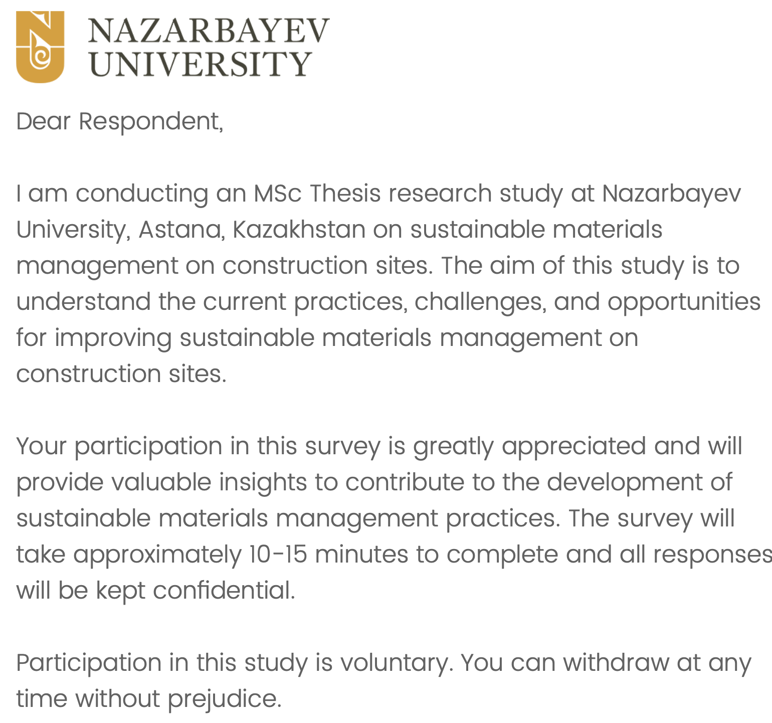

Figure B.1 Introduction to the survey

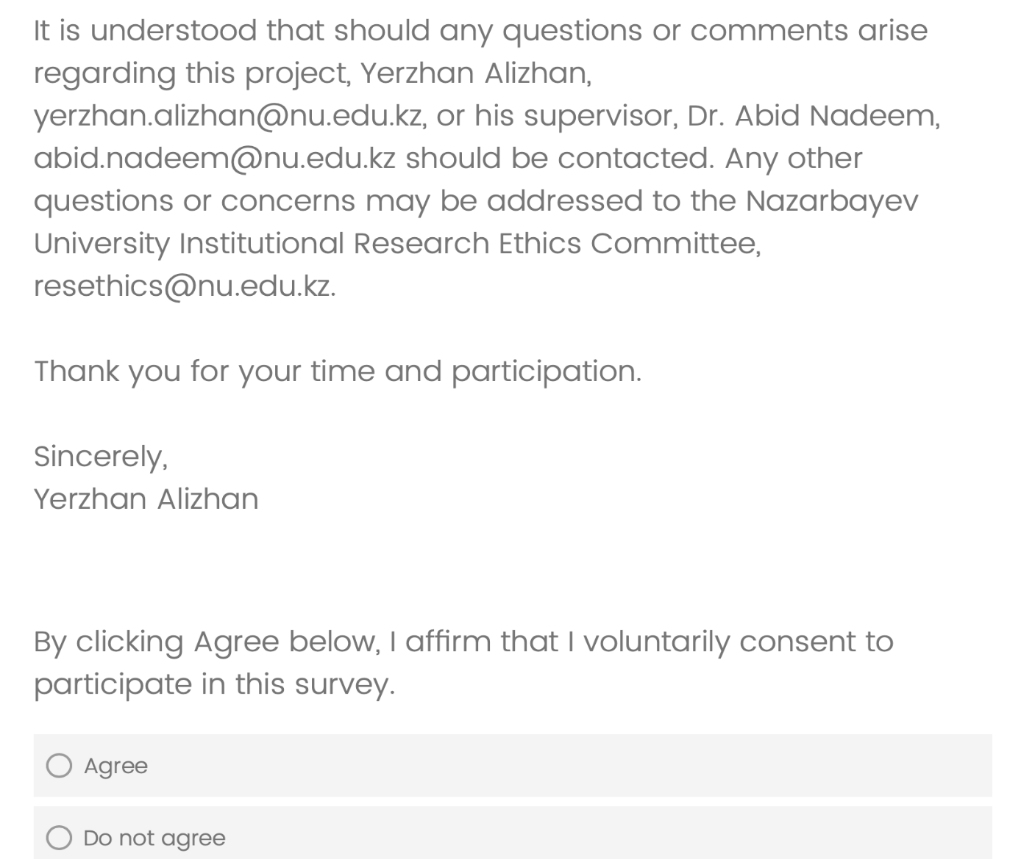

Figure B.2 Consent to participate

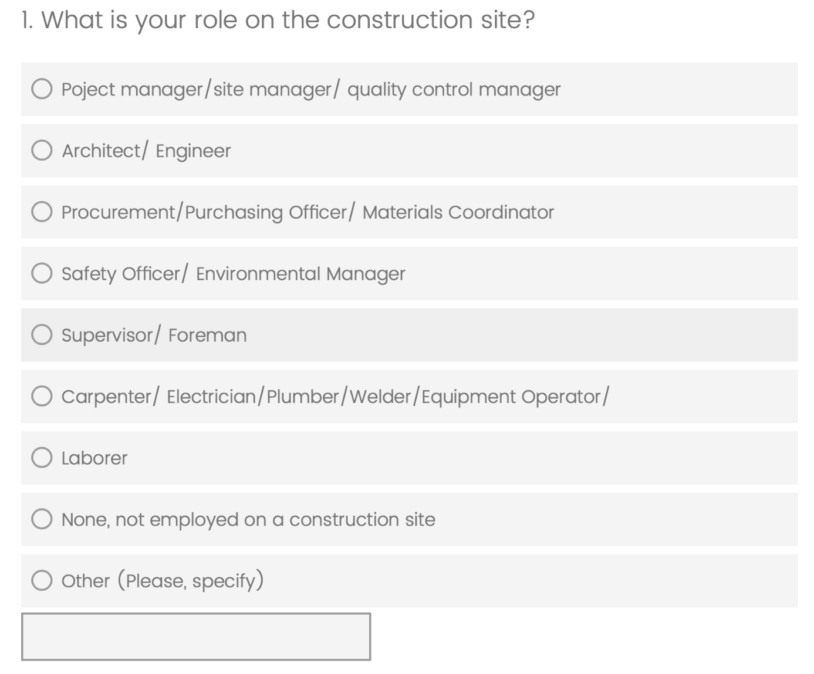

Figure B.3 Question 1


Figure B.4 Question 2

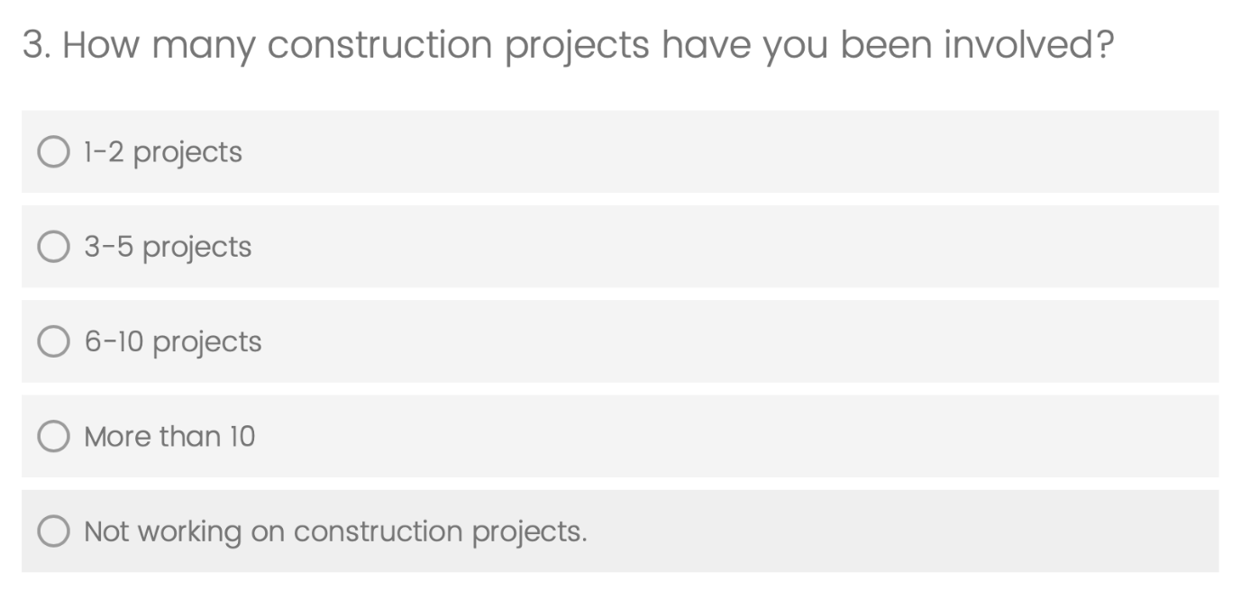

Figure B.5 Question 3

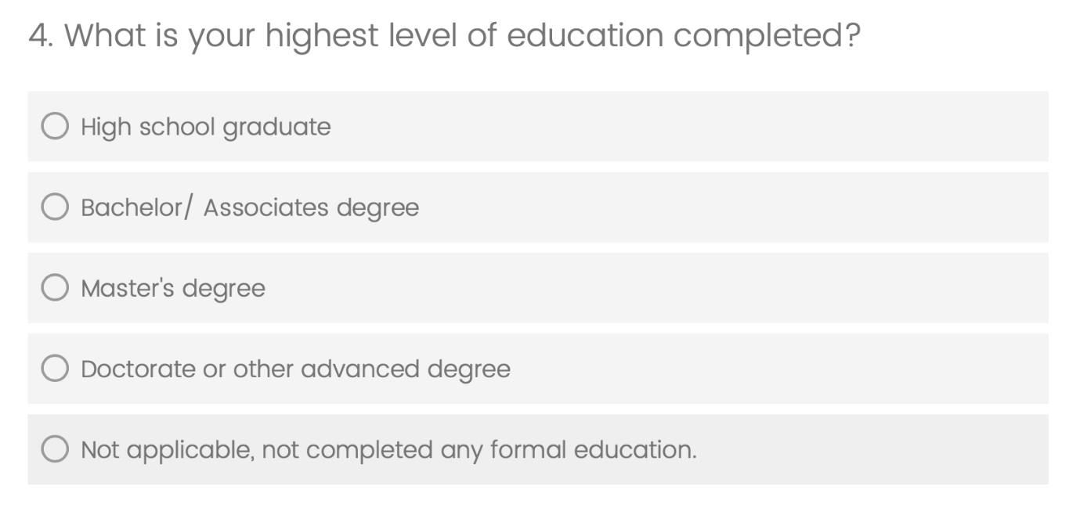

Figure B.6 Question 4



Figure B.7 Question 5

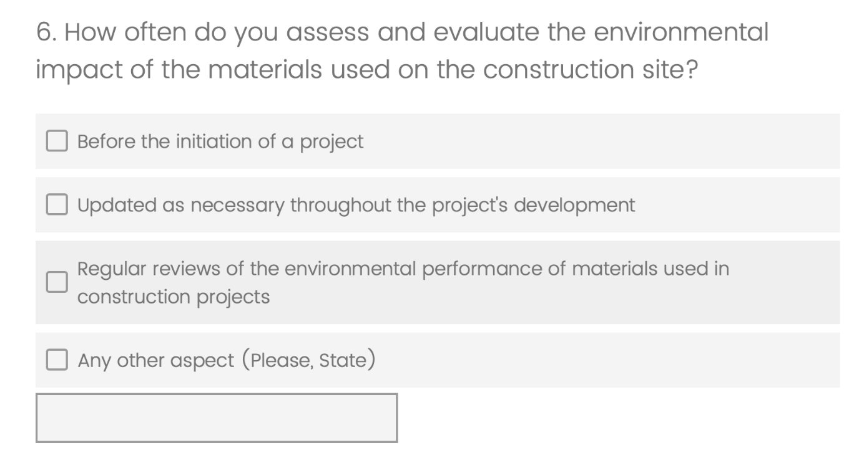

Figure B.8 Question 6

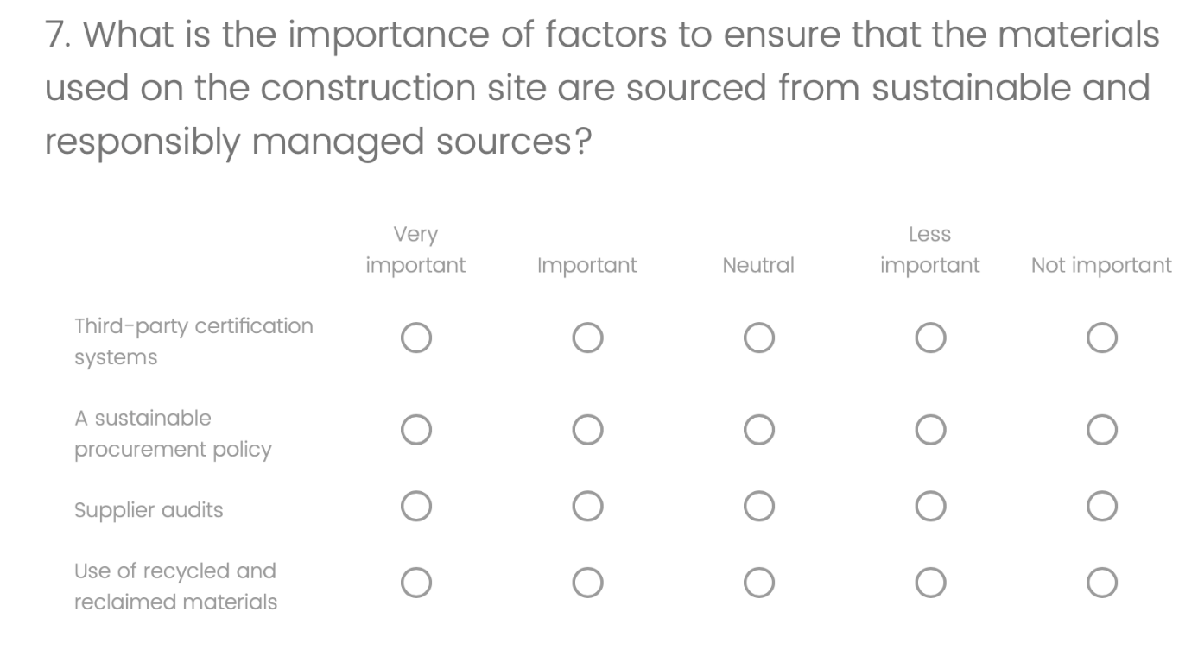

Figure B.9 Question 7

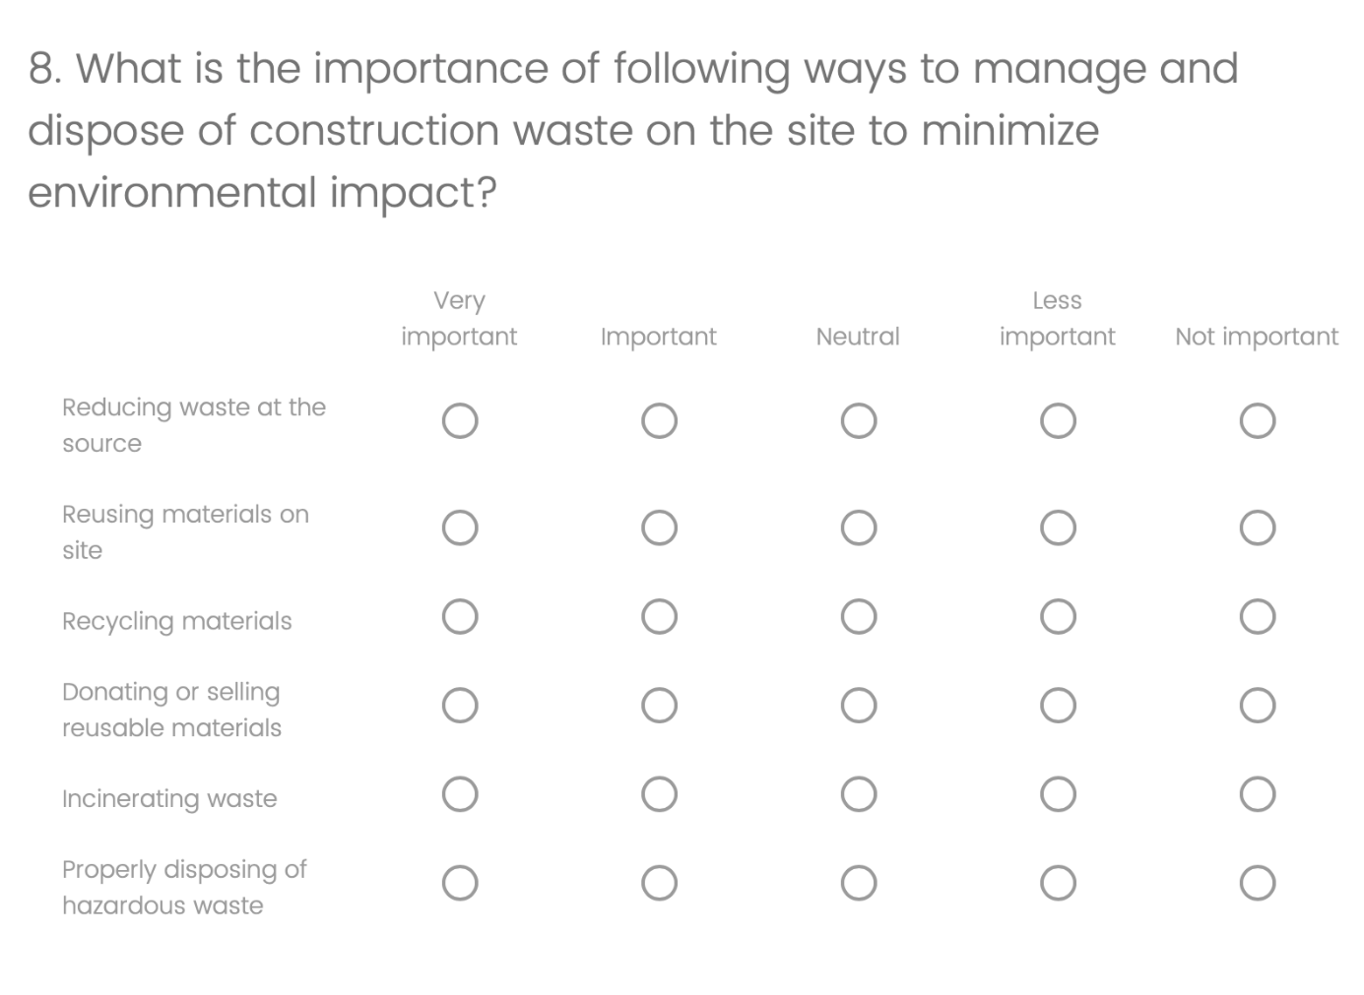

Figure B.10 Question 8

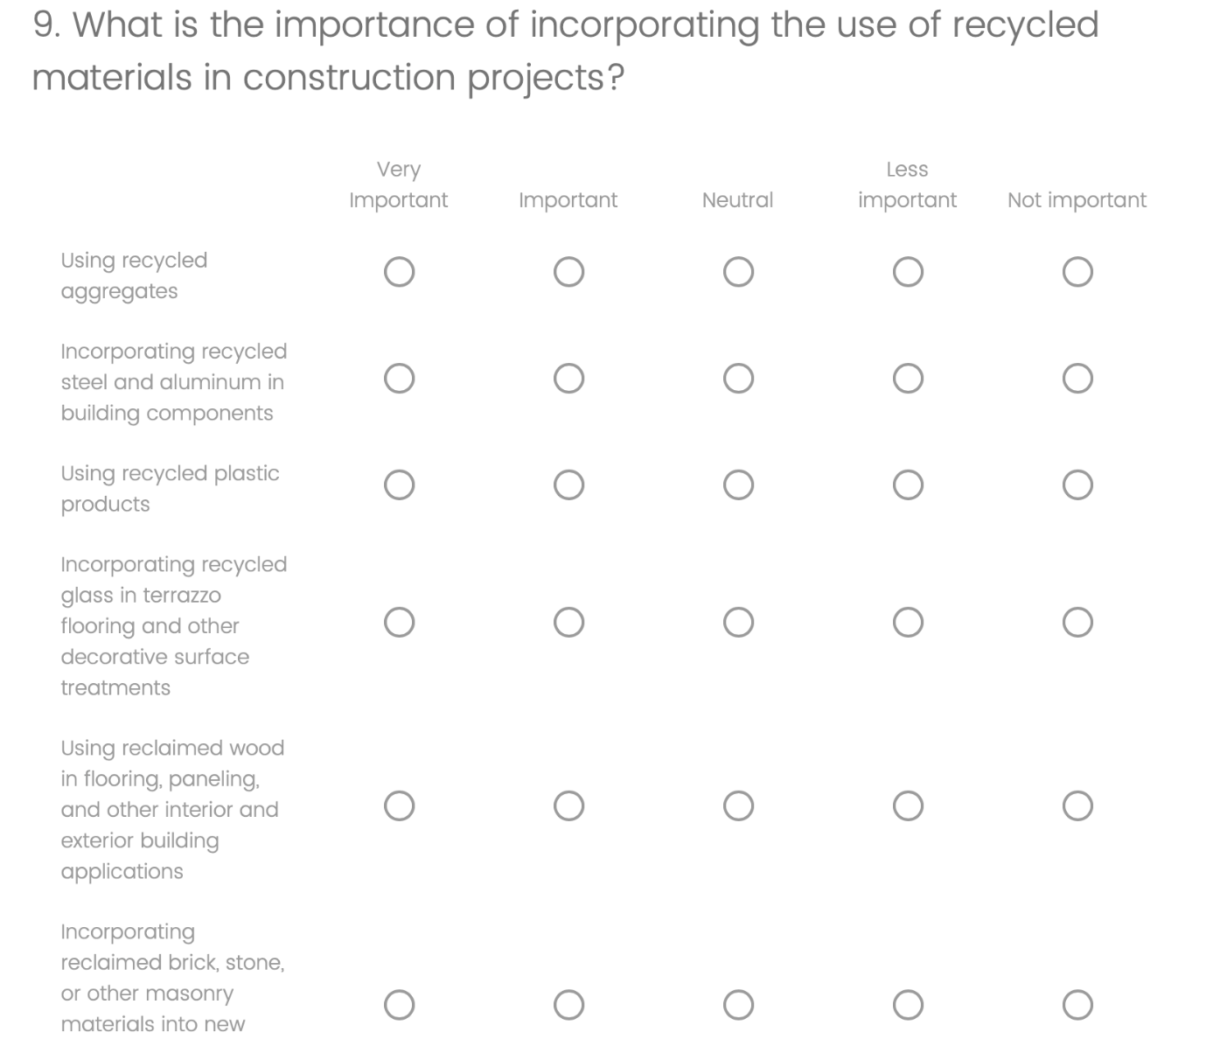

Figure B.11 Question 9

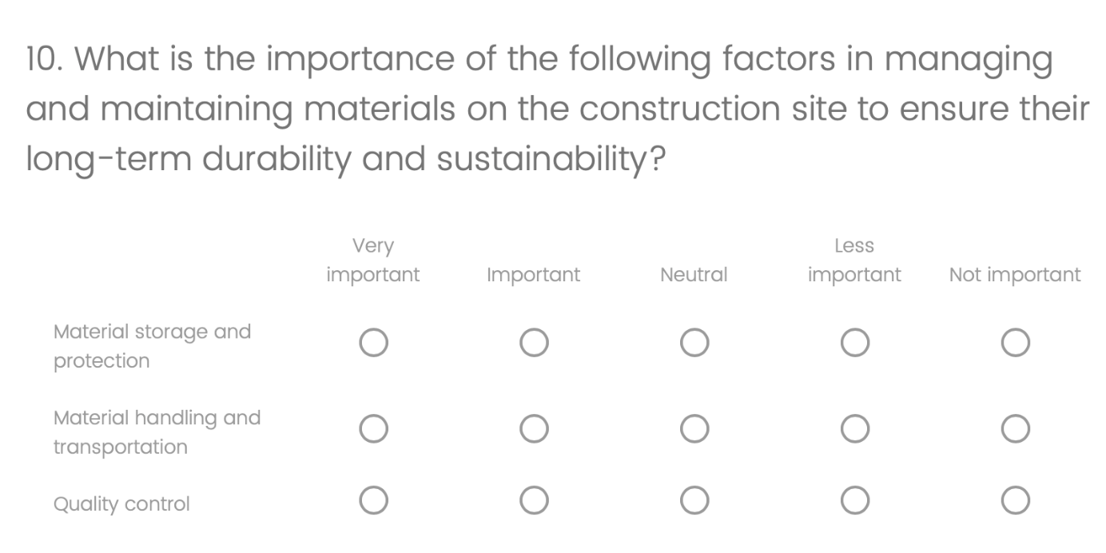

Figure B.12 Question 10
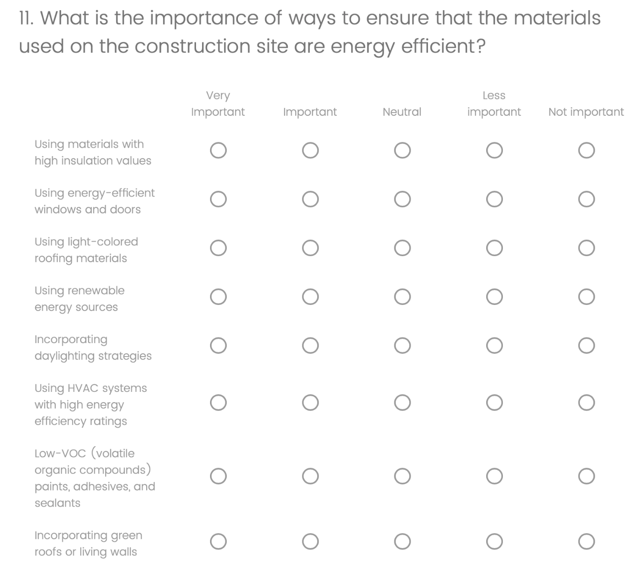

Figure B.13 Question 11

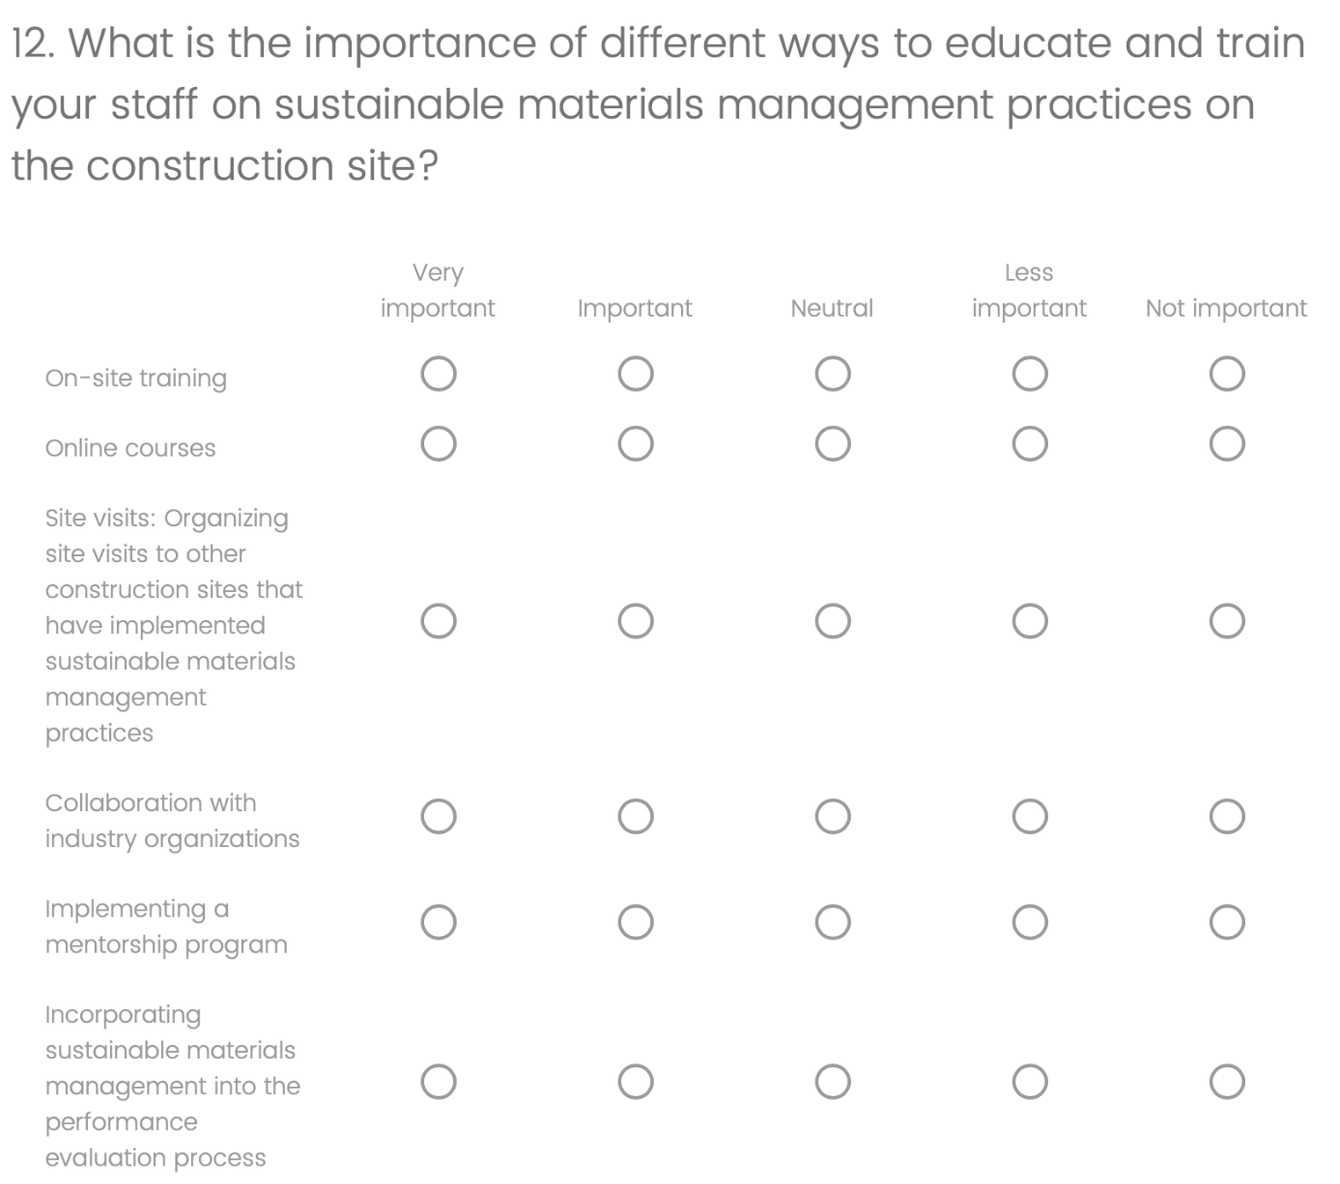


Figure B.14 Question 12

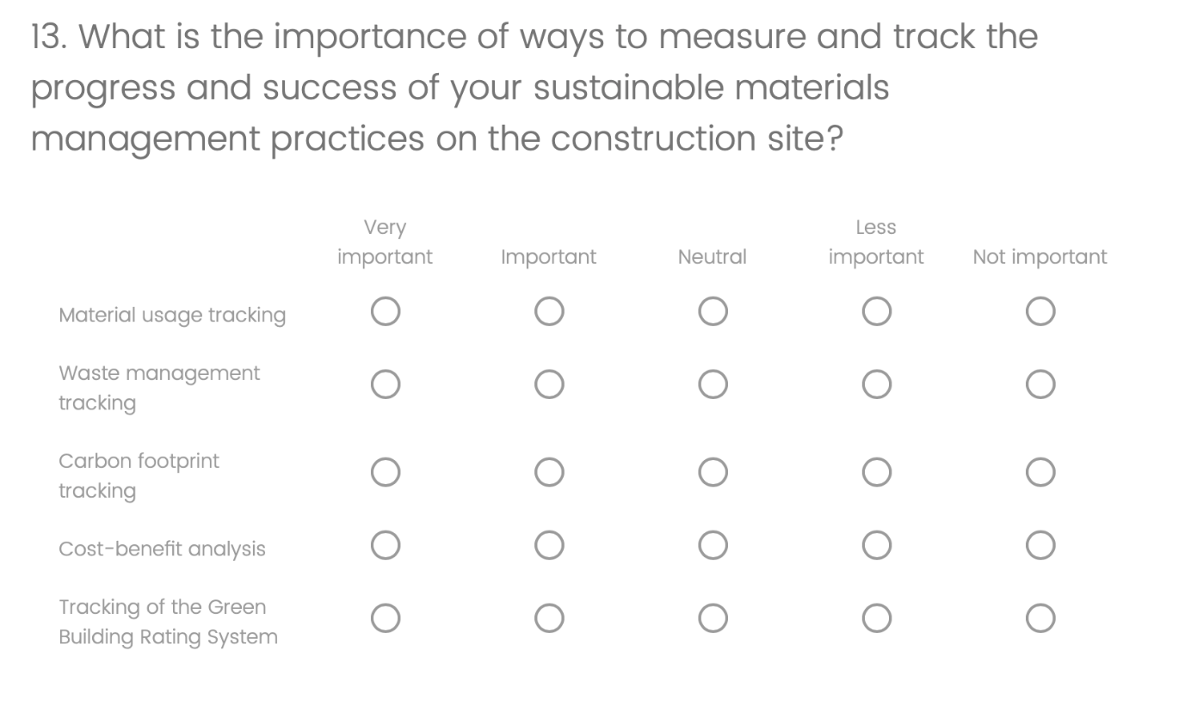

Figure B.15 Question 13



Figure B.16 Submission of survey

