Synthesis of PS/Cu MOF Nanofibers for the Adsorption of Lead (II) Cation from an Aqueous Solution
Ayazhan Kuben
CHEM 489
Directed Research II
Supervisor: Mannix Balanay

1. Introduction
Environmental contamination, notably water pollution, has gained significant focus in recent years due to its profound impact on humans and other living organisms. Besides striving to decrease the release of pollutants, it is essential to devise efficient methods for eliminating present pollutants like heavy metal ions and organic dyes from the used water (Shi, 2018). Even though they are typically found in small amounts, heavy metals such as Zn, Pb, Cd, Fe, Cu, Hg, and Ni are considered the most harmful and common substances in wastewater. Because the body cannot metabolize these heavy metals, they build up in soft tissues and pose a health risk to people (Chai, 2021). Lead is one of the most toxic and common metals in wastewater, with a permissible level of 0.10 mg/L (Simate, 2016). Lead is not degradable and causes many diseases, such as mental retardation, sensor neural deafness, and liver, kidney, and intestinal damage (Simate, 2016).
Many methods have been proposed to remove heavy metal ions from aqueous media, including solvent extraction, coagulation, ion exchange, chemical precipitation, membrane filtration, and other technologies (Chai, 2021). Because of its versatility in design and operation, the adsorption method stands out among the others. It also dramatically impacts the toxicity, biological activity, and movement of heavy metals in wastewater (Shi, 2018). Traditionally, the wastewater industries have employed adsorbents such as activated carbon, coal, natural oxide, and zeolites for water treatment.
MOFs are infinite structures constructed from metal ions/clusters and organic ligands connected via coordination interactions (Zhao, 2014). These substances are renowned as inorganic polymers, boasting unique chemical and physical properties. They find widespread application in gas separation, PEC, drug delivery, sensing, and adsorption (Shi, 2018). Recently, the interest in metal-organic frameworks (MOFs) has significantly increased due to their use as adsorbents for the removal of pollutants. During the removal, these pollutants are accommodated on the empty sites in the pores of MOFs. Their structural morphology, including pore characteristics (size, shape, and surface area) can be adjusted depending on reaction conditions (Wei, 2019). The MOF materials' nanoscale size makes it difficult to gather and recycle them in real-world applications. Thus, nanoporous materials, such as polymers, are added to the MOF substrates (Wei, 2019). Electrospinning is an effective method for synthesizing these polymer nanofibers that can serve as an efficient and low-resistance filter material (Liu, 2020).
This study is going to synthesize copper MOFs using organic ligands, biphenyl-4,4-dicarboxylic acid (BDC) and benzene-1,4-dicarboxylic acid (BTC), to further prepare polystyrene (PS) nanofiber-supported metal-organic frameworks (MOF) by electrospinning. The resulting nanofiber materials will be analyzed for the lead cation (Pb²⁺) adsorption efficiency from an aqueous solution.
2. Experimental Section
2.1. Materials
Polystyrene, Dimethylformamide [DMF anhydrous, 99%, Aldrich], Copper nitrate trihydrate crystalized [Cu(NO3)2·3H2O, >97%, Sigma-Aldrich], Zinc nitrate hexahydrate [Zn(NO3)2·6H2O], terephthalic acid 98% [Aldrich], trimesic acid, Ethanol [C₂H₅OH], DI.
2.2. Preparation of Samples for Analysis
2.2.1. Synthesis of Cu-BDC, Cu-BTC, Cu-BCA MOF powders
First, 0.84 g of terephthalic acid was dissolved in 24 mL DMF to get solution A. 1.75 g of Cu(NO3)2∙3H2O was dissolved in 2 mL ultrapure deionized water to get solution B. Then, solution A was added to solution B drop by drop on a magnetic stirrer until a homogeneous solution was obtained. The resultant homogeneous solution was poured into a 100 mL cleaned Teflon reactor and kept in a muffle furnace at 120°C for 15h. Finally, the obtained light blue suspension was filtered and separated using a centrifugation technique at 3500 rpm for 15 mins and washed with water and ethanol, 2 times each. The prepared Cu-BDC MOF powder was dried in a vacuum oven at 50°C for 6 hours. The Cu-BTC MOF was synthesized using the same procedures but 1.063 g of trimesic acid was used. Cu-BC MOF was prepared by a 1:1 ratio of two ligands: 0.42 g of terephthalic acid and 0.53g of trimesic acid. Prepared MOFs were characterized by SEM, EDS, and FTIR.
2.2.2. Synthesis of PS-supported Cu MOF nanofibers by electrospinning
80 mg of Cu-BDC MOF nanoparticles was added to 10 mL DMF and stirred at room temperature for 4 hours. 1.5 g of PS was dissolved in that mixture and stirred at room temperature for 24 hours. Then, the polymer solution was loaded into a 10 mL plastic syringe with a stainless needle (22G, inner diameter: 0.41 mm). After that, in an electrospinning machine, a high positive (+ve) terminal voltage of 20 kV was connected to a syringe needle. The tip-to-collector distance was 20 cm and the aluminum foil was used to collect the nanofiber. The flow rate of introducing the polymer solution was set to 0.6 mL/h. After electrospinning, until all the solution was used, a very fine PS/Cu-BDC MOF electrospun nanofibers were collected. They were dried at 60°C in a vacuum oven overnight to remove the residual DMF. PS/Cu-BTC MOF and PS/Cu-BCA MOF nanofibers were synthesized using the same procedures. The characterization of fibers was done by Scanning Electron Microscopy (SEM), Energy Dispersive X-ray spectroscopy (EDS), and FT-IR.
2.3. Adsorption Procedure
2.3.1 Preparation of Lead (II) Solution
1000 ppm stock solution of Pb(II) ion was prepared by dissolving 1.6 g of lead nitrate [Pb(NO₃)₂] in 1L of deionized water. A 100-ppm standard solution of Pb(II) ion was made by taking 50 mL from the stock solution and diluting it with ultrapure deionized water up to a mark in a 500 mL measuring flask.
2.3.2 Adsorbent dose reactions
Clean conical flasks, numbered from 1 to 4 were taken, and 50 mL of 50 ppm lead ion solution was added to each flask. Then, different amounts of PS/Cu-BDC MOF nanofiber (s) were added to each flask (0.05g, 0.1g, 0.15g, 0.2g). Flasks were stirred at 600 rpm for 30 minutes on a magnetic stirrer. Reaction contents were filtrated to remove the adsorbent and the filtrates were analyzed by ICP-MS for concentration determination of Pb (II) ions. The same procedures were done with PS/Cu-BTC and PS/Cu-BC MOF nanofibers to evaluate the capacity to adsorb lead ions from an aqueous solution. In the case of copper MOF powders, the same approach was applied, except the reactant solution was stirred at 250 rpm and centrifuged for at 3500 rpm 15 mins to remove the adsorbent powder before ICP-MS analysis.
2.3.2 Contact time reactions
Clean conical flasks marked, numbered from 1 to 6 were taken, and 50 mL of 50 ppm lead ion solution and 70 mg of PS/Cu-BDC MOF nanofibers were added to each flask. Flasks were stirred at 200 rpm for 5,10,15,20,25, and 30 mins on a magnetic stirrer. After stirring, the reaction contents were filtrated through filter paper and decanted to remove the adsorbent. Finally, filtrates were subjected to ICP- MS analysis for concentration determination of Pb (II) ions. The same methods were repeated with PS/Cu-BTC and Cu-BC MOF nanofibers.
3. Results and Discussion
3.1. Characterization of MOFs and nanofibers
The images from the Scanning Electron Microscopy (SEM) in Figure 1 (a) depict the crystal topography of Cu-BDC MOFs, which consist of rod-shaped clustered structures. The crystal structure has an uneven, porous surface with some cracks. The second image (b) shows the structure of Cu-BTC MOF powder that contains cubic crystals with uneven octahedral geometry. The divided cracks on the surface are present as well. The Cu-BCA MOF image (c) demonstrates the characteristics of both previous MOFs. The rod-shaped Cu-BDC MOFs embedded on the surface of bigger Cu-BTC MOF crystals can be observed.
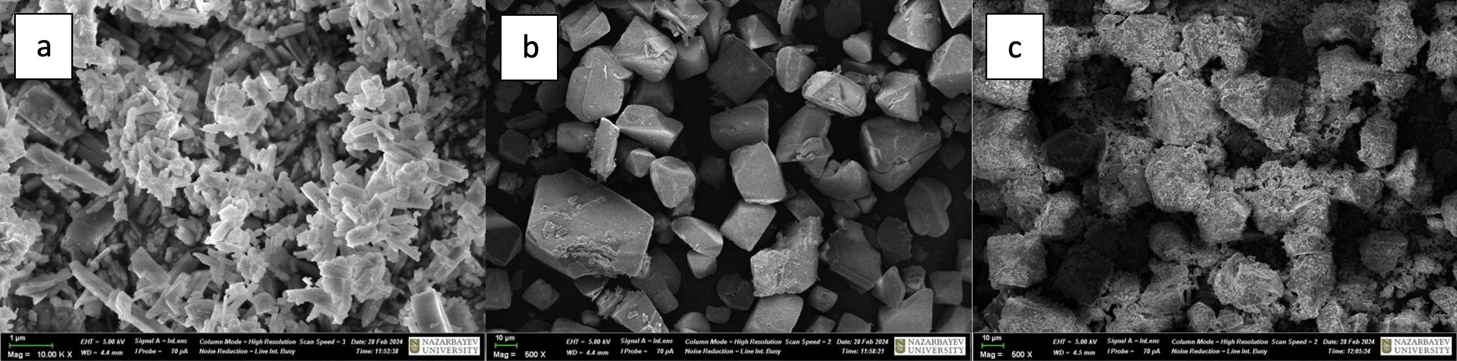
Figure 1. SEM images of (a) Cu-BDC MOF (b) Cu-BTC MOF (c) Cu-BCA MOF powders
The prepared nanofibers were also characterized by SEM and their morphology is shown in Figure 2. In images a, c, and e, bead-like structures were observed in all three nanofibers, demonstrating the incorporation of MOF nanoparticles into PS. These patchy areas give strength to the nanofiber networks. The diameter of nanofibers ranged from 130 to 370 nm.
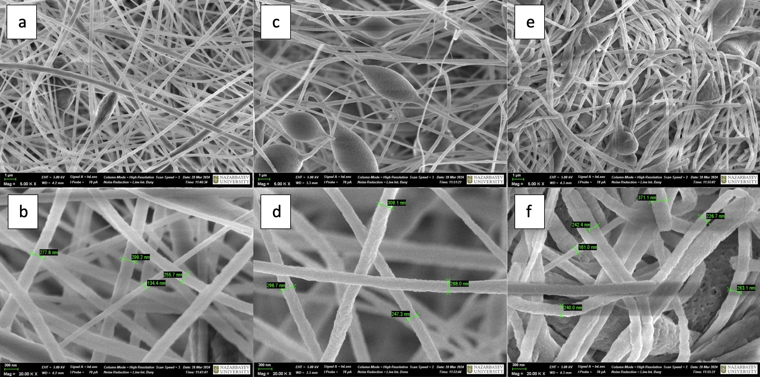
Figure 2. SEM images of (a)(b) PS/Cu-BDC; (c)(d) PS/Cu-BTC; (e)(f) PS/Cu-BCA MOF nanofibers
The elemental composition of Cu-BDC MOF powders was determined by EDS analysis as shown in Figure 3. The graphs depict the presence of copper, carbon, and oxygen in both MOF and NF materials. The difference between the two EDS spectra is that the PS/Cu-BDC nanofiber (b) has greater peak intensity in carbon than the MOF powder (a), indicating the presence of polystyrene. The EDS results of other MOF powders and nanofibers are analogous [Appendices 1 and 2].
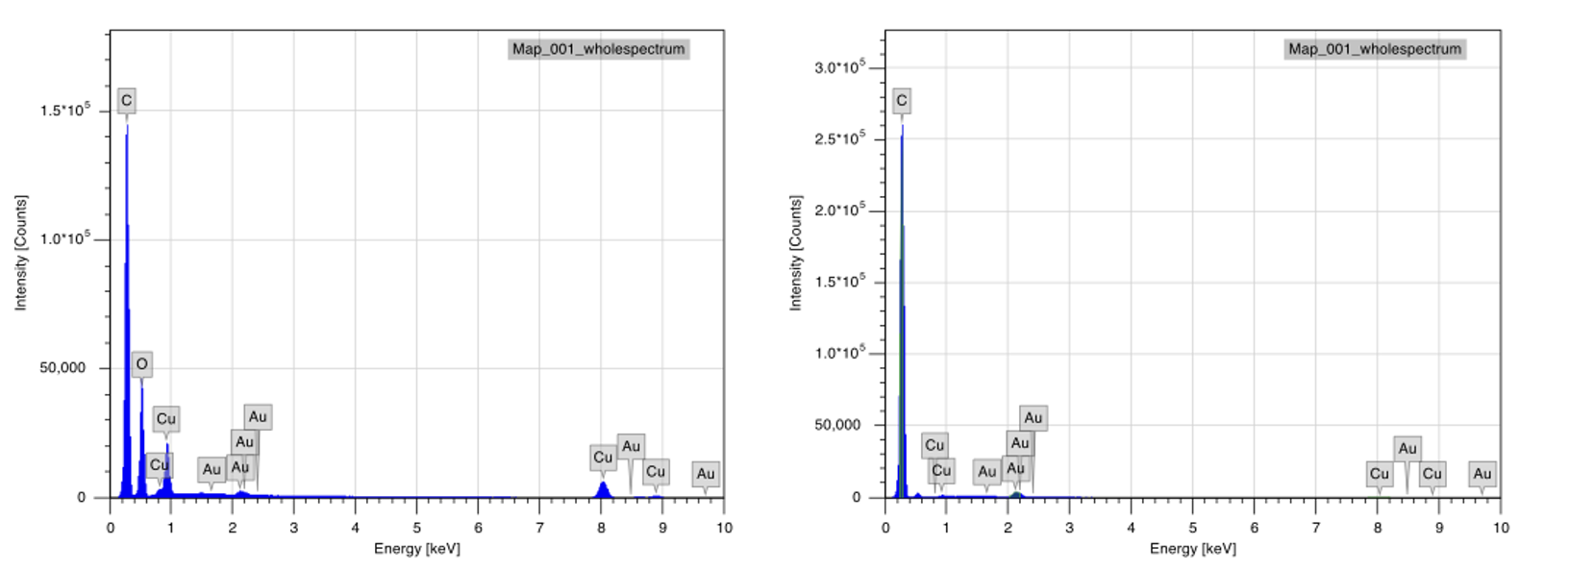
a
b
Figure 3. EDS results of (a) Cu-BDC MOF and (b) PS/Cu-BDC MOF NF
Figure 4 shows the FTIR spectra of three Cu MOFs to check for the presence of functional groups. The bands around 490 cm⁻¹ and 726 cm⁻¹ are attributed to the bending and stretching vibrations of Cu–O. Major peaks of Cu-BDC MOF at 3612 cm⁻¹ and 1500 cm⁻¹ correspond to the carboxylic acid group's O-H stretching and bending vibrations. The absorption band of the aryl group is observed at 1562 cm⁻¹, which indicates the aromatic C=C stretch on the benzene ring. The intense peak at 1385 cm⁻¹ is due to C-C bond vibration, and the sharp peak at 918 cm⁻¹ shows a stretching vibration of the C-O bond in Cu-BDC MOF. In the case of Cu-BTC MOF, where trimesic acid was used as a ligand, the broad peak between 2860 cm⁻¹ and 3000 cm⁻¹ indicates the presence of O-H stretching in the BTC ligand. Bands at 1635 cm⁻¹ and 1374 cm⁻¹ are observed and ascribed to asymmetrical and symmetrical C=O stretching. The peak corresponding to surface adsorbed water in the Cu-BTC MOF is at 3675 cm⁻¹. Also, in Figure 4, we can see that the Cu-BCA MOF spectrum matches well with the peaks of Cu-BDC and Cu-BTC MOFs, as it contains the 1:1 ratio by mass of both ligands. The results are consistent with the previous research (Ajpi, 2023).
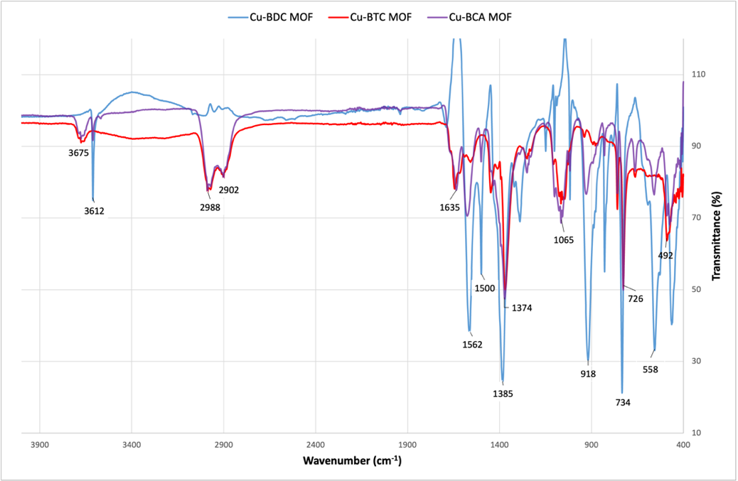
Figure 4. FTIR spectra of Cu-BDC, Cu-BTC, Cu-BCA MOFs
The PS-supported Cu MOF nanofibers were also characterized by FT-IR as shown in Figure 5. All nanofibers showed similar results and had all the characteristic bands of pure PS. The sharp peaks at 693 cm⁻¹ and 752 cm⁻¹ were assigned to the C=C bending vibration in the benzene ring of polystyrene. C-H stretching vibrations were observed as a cluster of peaks at 2919, 3025, and 3060 cm⁻¹ wavelengths. A band at 3670 cm⁻¹ indicates the presence of -OH groups of ligands in the nanofiber structure. The obtained FTIR spectra match the previous research results (Liu, 2020).
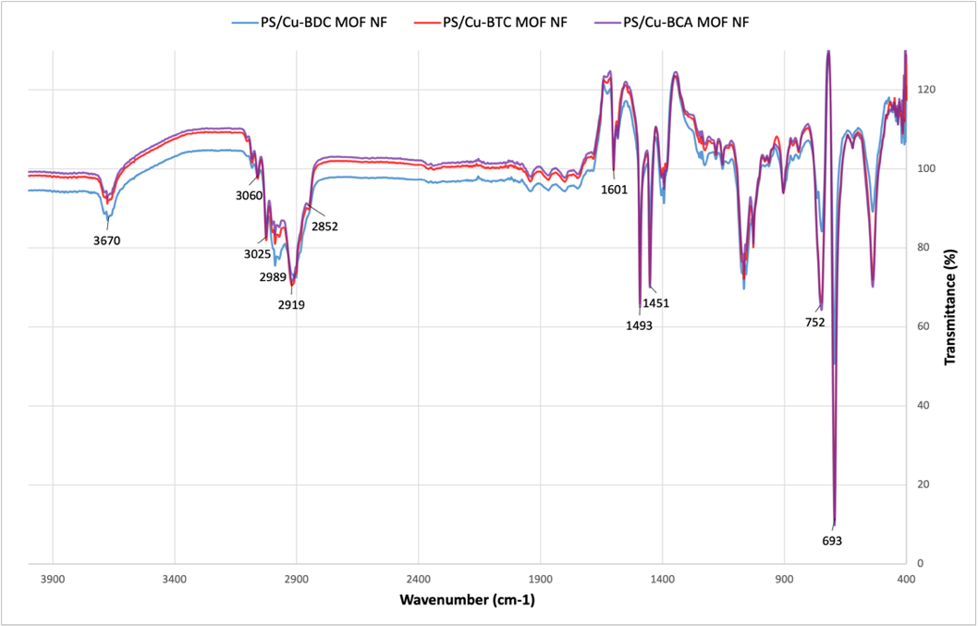
Figure 5. FTIR spectra of three PS-supported Cu MOF nanofibers
Based on the results of FTIR, EDS, and SEM analyses, it can be confirmed that the Cu MOFs and PS/Cu MOF nanofibers have been successfully synthesized.
3.2. The effect of the adsorbent dose
The effects of the dose of nanofibers and MOFs on the adsorption of Pb(II) ion are shown by the concentration of the remaining ion concentration in Figures 6 and 7, respectively. Generally, upon the reaction of 100 ppm Pb(II) solution with NFs, the concentration of the lead ion decreases when the dose of all three nanofibers increases as shown in Fig. 6. This result is most prominent in the case of PS/Cu-BTC MOF nanofiber. This reduction in concentration indicates better adsorption. The reason for this can be ascribed to the accumulation of nanoparticles or to the concentration gradient when accumulated sorbates start to move away from the sorbent. The maximum adsorption of the lead ion was observed when 0.1g of PS/Cu-BDC MOF NF, 0.05g of PS/Cu-BTC MOF NF, and 0.1g of PS/Cu-BCA MOF NF were used. Overall, the PS/Cu-BCA MOF nanofiber demonstrates the lowest ion concentrations after the reactions than the other two nanofibers. This better adsorption can be attributed to the presence of two ligands in the structure, allowing the better accumulation of lead ions.
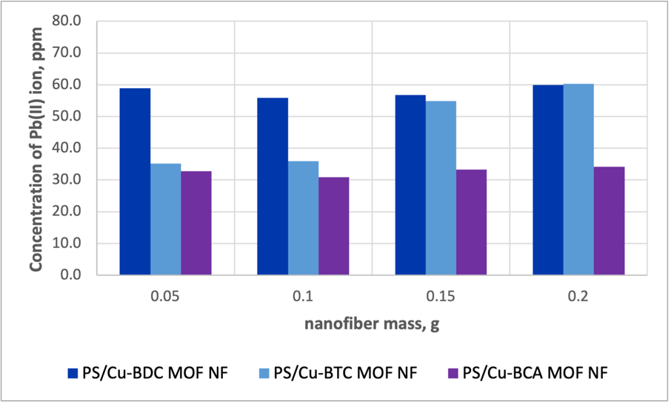
Figure 6. The effect of the NF adsorbent dose
The removal of the lead ion is 2 or 3 times better with use of the MOF powders than their corresponding nanofibers. For example, in Fig. 7, the ion concentration for 0.05g of Cu-BDC MOF is 20 ppm, while the value for the PS/ Cu-BDC MOF nanofiber is almost 60 ppm. Such difference might be due to the hydrophobic nature of the polystyrene, which makes it hard for the ions to accommodate the pores of MOFs. Unlike with nanofibers, the concentration slightly decreases as the Cu-BDC MOF mass increases. However, there is no clear trend with the adsorption capacity of Cu-BTC MOFs when their mass changes. The maximum adsorption was observed when 0.15 g of Cu-BDC and 0.2g of Cu-BTC MOFs were used. The Cu-BCA MOF results were not displayed due to the shortage of the powder produced.
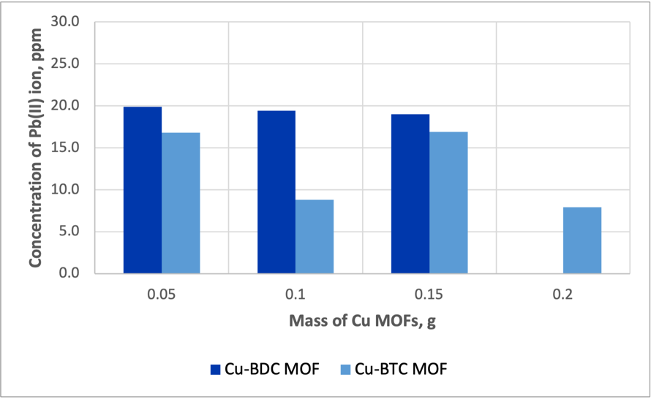
Figure 7. The effect of the MOF adsorbent dose
3.3 The effect of the contact time
The effective contact time for the removal of lead cations was studied with three different MOFs and depicted in Fig.8. The concentration of the Pb(II) decreased as the adsorption time increased. The better removal was observed when more time was given to adsorption of the pollutant by the nanofiber structure. There is no such clear tendency with PS/Cu-BCA NF due to the errors occurred during ICP-MS analysis, so the results are not reliable. Overall, PS/Cu-BTC and PS/Cu-BCA MOF nanofibers demonstrate better removal ranging the Pb(II) concentration from 35 ppm to 23 ppm.
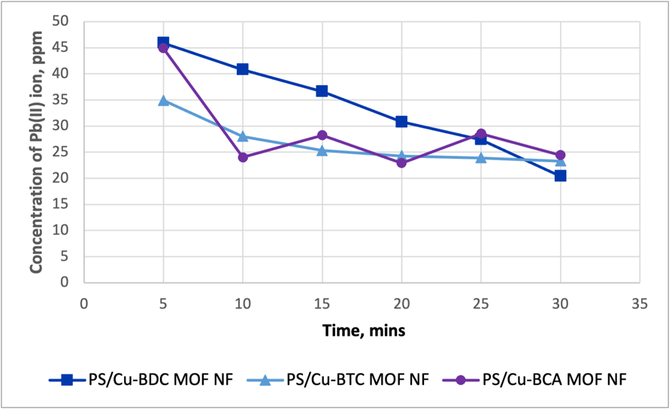
Figure 8. The effect of the contact time for Pb(II) ion removal
4. Conclusion
In conclusion, the Cu MOFs and PS/Cu MOF nanofibers were successfully synthesized according to the SEM, FTIR, and EDS analyses results. Generally, upon the reaction of 100 ppm Pb(II) solution with NFs, the lead cation removal efficiency was increased when the adsorbent dose increased. The maximum adsorptions were observed at 0.05 g for PS/Cu-BTC NF and 0.1 g for the other two nanofibers. Among three nanofiber structures, the best removal was detected with the PS/Cu-BCA MOF NF. The adsorption efficiency of Cu MOFs was 2-3 times better than their corresponding NFs. Additionally, the better removal was shown when more time was given to the adsorption of the pollutant by the nanofiber material.
The limitations of the research include the low yield production of MOFs, which caused the incomplete results in some experiments. Also, very high spinning rate was required during adsorbent dose and contact time reactions. The hydrophobic nature of polystyrene might have caused difficulties during initiation of these reactions.
In the future, this study can be improved by trying new ligands and metal centers when constructing MOFs. The selectivity and the adsorption capacity can also be analyzed by increasing the scope of the experiments and reactants used.
5. References
Ajpi, C., Leiva, N., Lundblad, A., Lindbergh, G., & Cabrera, S. Synthesis and spectroscopic characterization of Fe3+-BDC metal-organic framework as material for lithium-ion batteries. Journal of Molecular Structure. 2023, 1272, 134127. https://doi.org/10.1016/j.molstruc.2022.134127
Chai, W. S., Cheun, J. Y., Kumar, P. S., Mubashir, M., Majeed, Z., Banat, F., ... & Show, P. L. A review of conventional and novel materials towards heavy metal adsorption in wastewater treatment application. Journal of Cleaner Production. 2021, 296, 126589. DOI: https://doi.org/10.1016/j.jclepro.2021.126589
Liu, F., Chen, Y., Shao, W., Yue, W., Li, M., Liao, X., ... & He, J. Preparation of polystyrene nanofiber-supported metal-organic framework with formaldehyde adsorption properties. Journal of Fiber Science and Technology. 2020, 76(1), 43-49. DOI: https://doi.org/10.2115/fiberst.2020-0005
Shi, Z., Xu, C., Guan, H., Li, L., Fan, L., Wang, Y., ... & Zhang, R. Magnetic metal organic frameworks (MOFs) composite for removal of lead and malachite green in wastewater. Colloids and Surfaces A: Physicochemical and Engineering Aspects. 2018, 539, 382-390. DOI: https://doi.org/10.1016/j.colsurfa.2017.12.043
Simate, G. S., Maledi, N., Ochieng, A., Ndlovu, S., Zhang, J., & Walubita, L. F. Coal-based adsorbents for water and wastewater treatment. Journal of Environmental Chemical Engineering. 2016, 4(2), 2291-2312. DOI: https://doi.org/10.1016/j.jece.2016.03.051
Wei, N., Zheng, X., Ou, H., Yu, P., Li, Q., & Feng, S. Fabrication of an amine-modified ZIF-8@ GO membrane for high-efficiency adsorption of copper ions. New Journal of Chemistry. 2019, 43(14), 5603-5610. DOI: 10.1039/C8NJ06521G
Zhao, X. L., & Sun, W. Y. The organic ligands with mixed N-/O-donors used in the construction of functional metal-organic frameworks. CrystEngComm. 2014, 16(16), 3247-3258. DOI: 10.1039/C3CE41791C

Appendices
Appendix 1
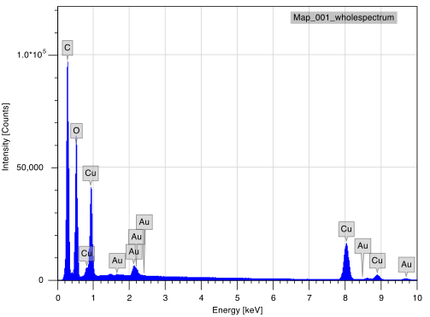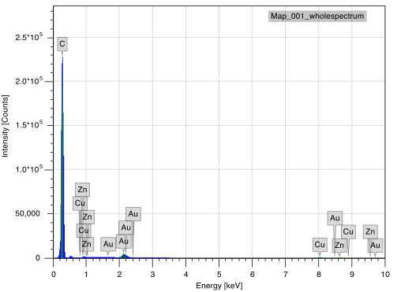
EDS results of (a) Cu-BTC MOF and (b) PS/Cu-BTC MOF NF
Appendix 2
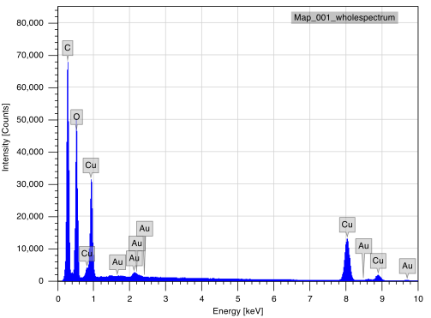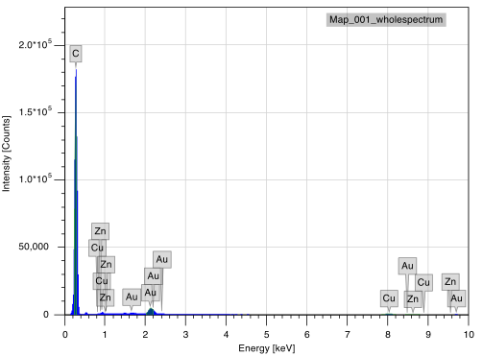
EDS results of (a) Cu-BCA MOF and (b) PS/Cu-BCA MOF NF

