Title: Targeted Delivery of Factors and Cells for Improving Cardiac Tissue Regeneration and Heart Function Following Myocardial Infarction

Student name: Ayan Nurkesh
PI: Arman Saparov
Date of submission: 01.03.2025
Abstract
Cardiovascular diseases (CVDs), including myocardial infarction (MI) and coronary artey disease, are the leading causes for global mortality. MI arises from the rupture of atherosclerotic plaques, triggering thrombosis, ischemia, and subsequent cardiomyocyte death. Heart has limitations to regenerate the tissue, fibrotic tissue replaces damaged myocardium, impairing cardiac function. While interventions like percutaneous coronary intervention reduce mortality, they do not regenerate tissue, underscoring the need for innovative therapies. Mesenchymal stem cells (MSCs) hold potential for cardiac repair, but their survival in ischemic environments remains suboptimal. Hydrogels, particularly chitosan-based cryogels, may enhance MSC retention and efficacy. This study investigates the combined delivery of MSCs and bioactive factors (IL-10, VEGF-A, FGF-2) via cryogels in a murine MI model. Results indicate reduced inflammation, enhanced angiogenesis, and improved cardiac regeneration, suggesting a novel strategy to mitigate post-MI fibrosis and advance cell-based therapies for CVDs.

Introduction
Cardiovascular diseases (CVDs) remain the foremost cause of death worldwide, contributing for about 19 mln fatalities in 2020, with projections rising to 22.2 million by 2030 (Tsao, 2022). Coronary heart disease and MI significantly contribute to CVD-related morbidity and mortality. MI occurs when unstable coronary atherosclerotic plaques rupture, leading to thrombus formation, ischemic injury, and cardiomyocyte death (Thygesen, 2018). The heart’s minimal regenerative ability results in fibrotic scar formation, which compromises contractility and increases risks of arrhythmias and cardiogenic shock (Gong, 2021; Reed, Rossi, & Cannon, 2017). Despite advancements in treatments like percutaneous coronary intervention, these approaches fail to restore lost cardiac tissue, driving research into cellular therapy options and accomponying tissue engineering to enhance inflammation and fibrosis post MI (Hashimoto, Olson, & Bassel-Duby, 2018).
Mesenchymal stem cells (MSCs) are increasingly studied for their reparative potential in MI. Clinical trials demonstrate improved cardiac function following MSC transplantation, particularly when delivered early post-MI (Attar et al., 2021). However, the hostile ischemic milieu limits MSC survival and therapeutic efficacy (Guo, 2020). Hydrogels, such as collagen-based scaffolds, improve MSC retention and cardioprotection (Li, 2023). Similarly, biomaterial platforms enable controlled release of bioactive factors like IL-10 and VEGF, which mitigate fibrosis and promote vascularization (Wu et al., 2021; Wang, 2023).
This study investigates a chitosan-based cryogel system for co-delivering MSCs and bioactive factors (IL-10, VEGF-A, FGF-2) to enhance post-MI cardiac regeneration.

Materials and Methods

LAD Model of Myocardial Infarction
Female C57BL/6 mice (10–12 weeks old; Jackson Lab, USA) underwent LAD ligation to induce MI under protocols approved by Nazarbayev University’s Institutional Animal Care and Use Committee. Anesthesia was induced with 4% isoflurane for 2-3 min depending on mouse size and 2L/min 100% oxygen, followed by endotracheal intubation and mechanical ventilation (MiniVent Model 845, Harvard Apparatus, USA) with 2% isoflurane. A thoracotomy exposed the heart, and the LAD was ligated 2–3 mm below the left atrial auricle using a 7–0 suture. Upon discoloration of the left ventrice side, the successful occlusion was confirmed. Post-surgery, mice received intramyocardial injections of IL-10, VEGF-A, and FGF-2 (10 μL each) into the infarct border zone.

Cryogel Preparation
Chitosan-based cryogels were synthesized as described by Sultankulov (2019). Briefly, a 2% chitosan solution (Sigma-Aldrich, UK) dissolved in 1% acetic acid. The resulting solution was then resuspended with 5% PVA-heparin (Fisher Scientific, UK). The further crosslinked was achieved with 400 μL glutaraldehyde for 5-10 seconds, and then polymerized at −12°C for 24 hours using 2 ml syringes as a mold to obtain cylindrical shapes. The possible toxic effects of the glutaraldehyde were neutrlized with the solution of 50 mM sodium borohydrate (Sigma-Aldrich, USA), washed, lyophilized overnight (Lyotrap™, VWR International, USA), and after mechanical smashing sieved to 50–100 μm particles using industrial metallic sieves.

Cryogel Sterilization and Cytokine Loading
Cryogel microparticles were sterilized with 70% ethanol for 20-30 min, UV-treated for 20 min, and loaded with recombinant IL-10 (1 μg/mL), VEGF-A, and FGF-2 (10 μg/mL; Abcam, UK) via incubation for 4 hours at room temperature.

MSC Isolation and Delivery
MSCs were isolated from C57BL/6 female mouse bone marrow (Zhu, 2010) and combined with cryogel/cytokine formulations for intramyocardial injection post-MI.

Echocardiography and Analysis
After 2-4 weeks post-MI left ventricular function (LV) was measured using M- and B-modes of the VEVO 2100 system (VisualSonics, Canada) following guidelines from the previously reported paper (Zacchigna, 2021). LV ejection fraction (EF) and fractional shortening (FS) were calculated via RadiAnt DICOM Viewer software using Teichholz formula, Vol = 7D3/(2.4+D).

Scanning Electron Microscopy (SEM)
The structural characterization and morphology of the cryogel particles were examined under Scanning Electron Microscope (SEM) (ZEISS Crossbeam 540, Carl Zeiss AG, Germany). The particle powder were place on the sample stand and coated with about 5 nm layer of gold atoms using plasma created with electrical field combination with argon gas (Sputter-coater Q150T ES, United Kingdom).

Statistical Analysis
The statistical analysis were performed using a two-tailed Student’s t-test determined with significance level (p ≤ 0.05).

Results

Cryogel particles
The hydrogel based cryogel material was prepared following the previously reported protocol (Sultankulov, 2019). The further mechanical reduction of the sizes was achieved with further filtration of the particles into 50-100 micrometers via sieves. The mesh-like structural morphology of the cryogel microparticles resembling the protocol were then confirmed using SEM (Figure 1). The sizes of the mesh were measured to be up to approximately 50 micrometers.

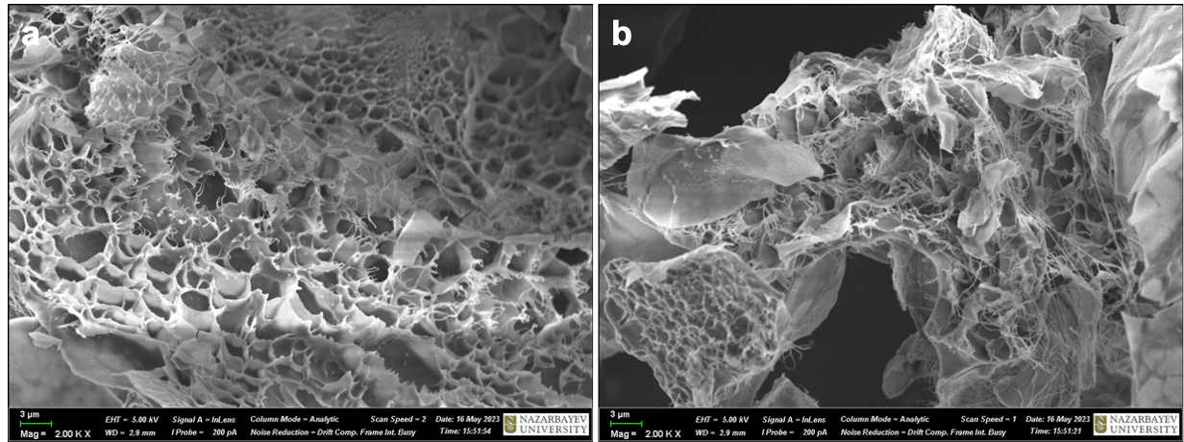
Figure 1. Scanning Electron Microscope (SEM) image of the structural morphology of cryogel particles (a-b).

Mesenchymal Stem Cells isolation
The isolation of the MSCs were performed following the protocol (Zhu, 2010). EDTA solution ensured the death of the other cell types in the bone marrow. After the cells seeding the culturing flask was left in the incubator at 37°C with 5% CO2 for about 1 week to adhere the cells to the surface. The MSCs were confirmed by their structure after continuing culturing for 2 weeks with growth medium refreshing every 48 hours. The image in the Figure 2 demonstrates the morphology resembling the shapes of cells of interest.

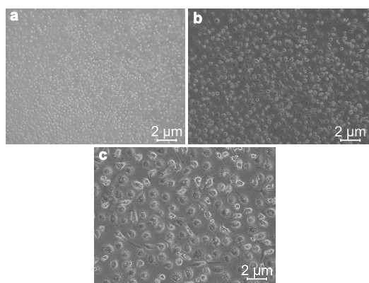
Figure 2. Light microscopic images of the mesenchymal stem cells (MSCs) under different magnifications x4 (a), x10 (b), x20 (c).

MSCs and bioactive factors effect on MI
In this study, a murine model of MI was established following LAD ligation. The healthy group of mice were intubated, chest opened and further closed without LAD ligation (sham group). Immediate injection of the vehicle (control group), MSCs (cells group), and combination of biofactors IL-10 (1 μg/mL), VEGF-A, and FGF-2, with MSCs via cryogel particles (cryo+factors+cells group). 2-3 weeks later the echocardiophic images were obtained to measure the left ventricular parameters using B- and M-modes (Figure 3). Visually the limited contractility in the MI site and dilated left ventricles were observed in the control, cells, and cryo+factors+cells groups in compate to healthy sham group.

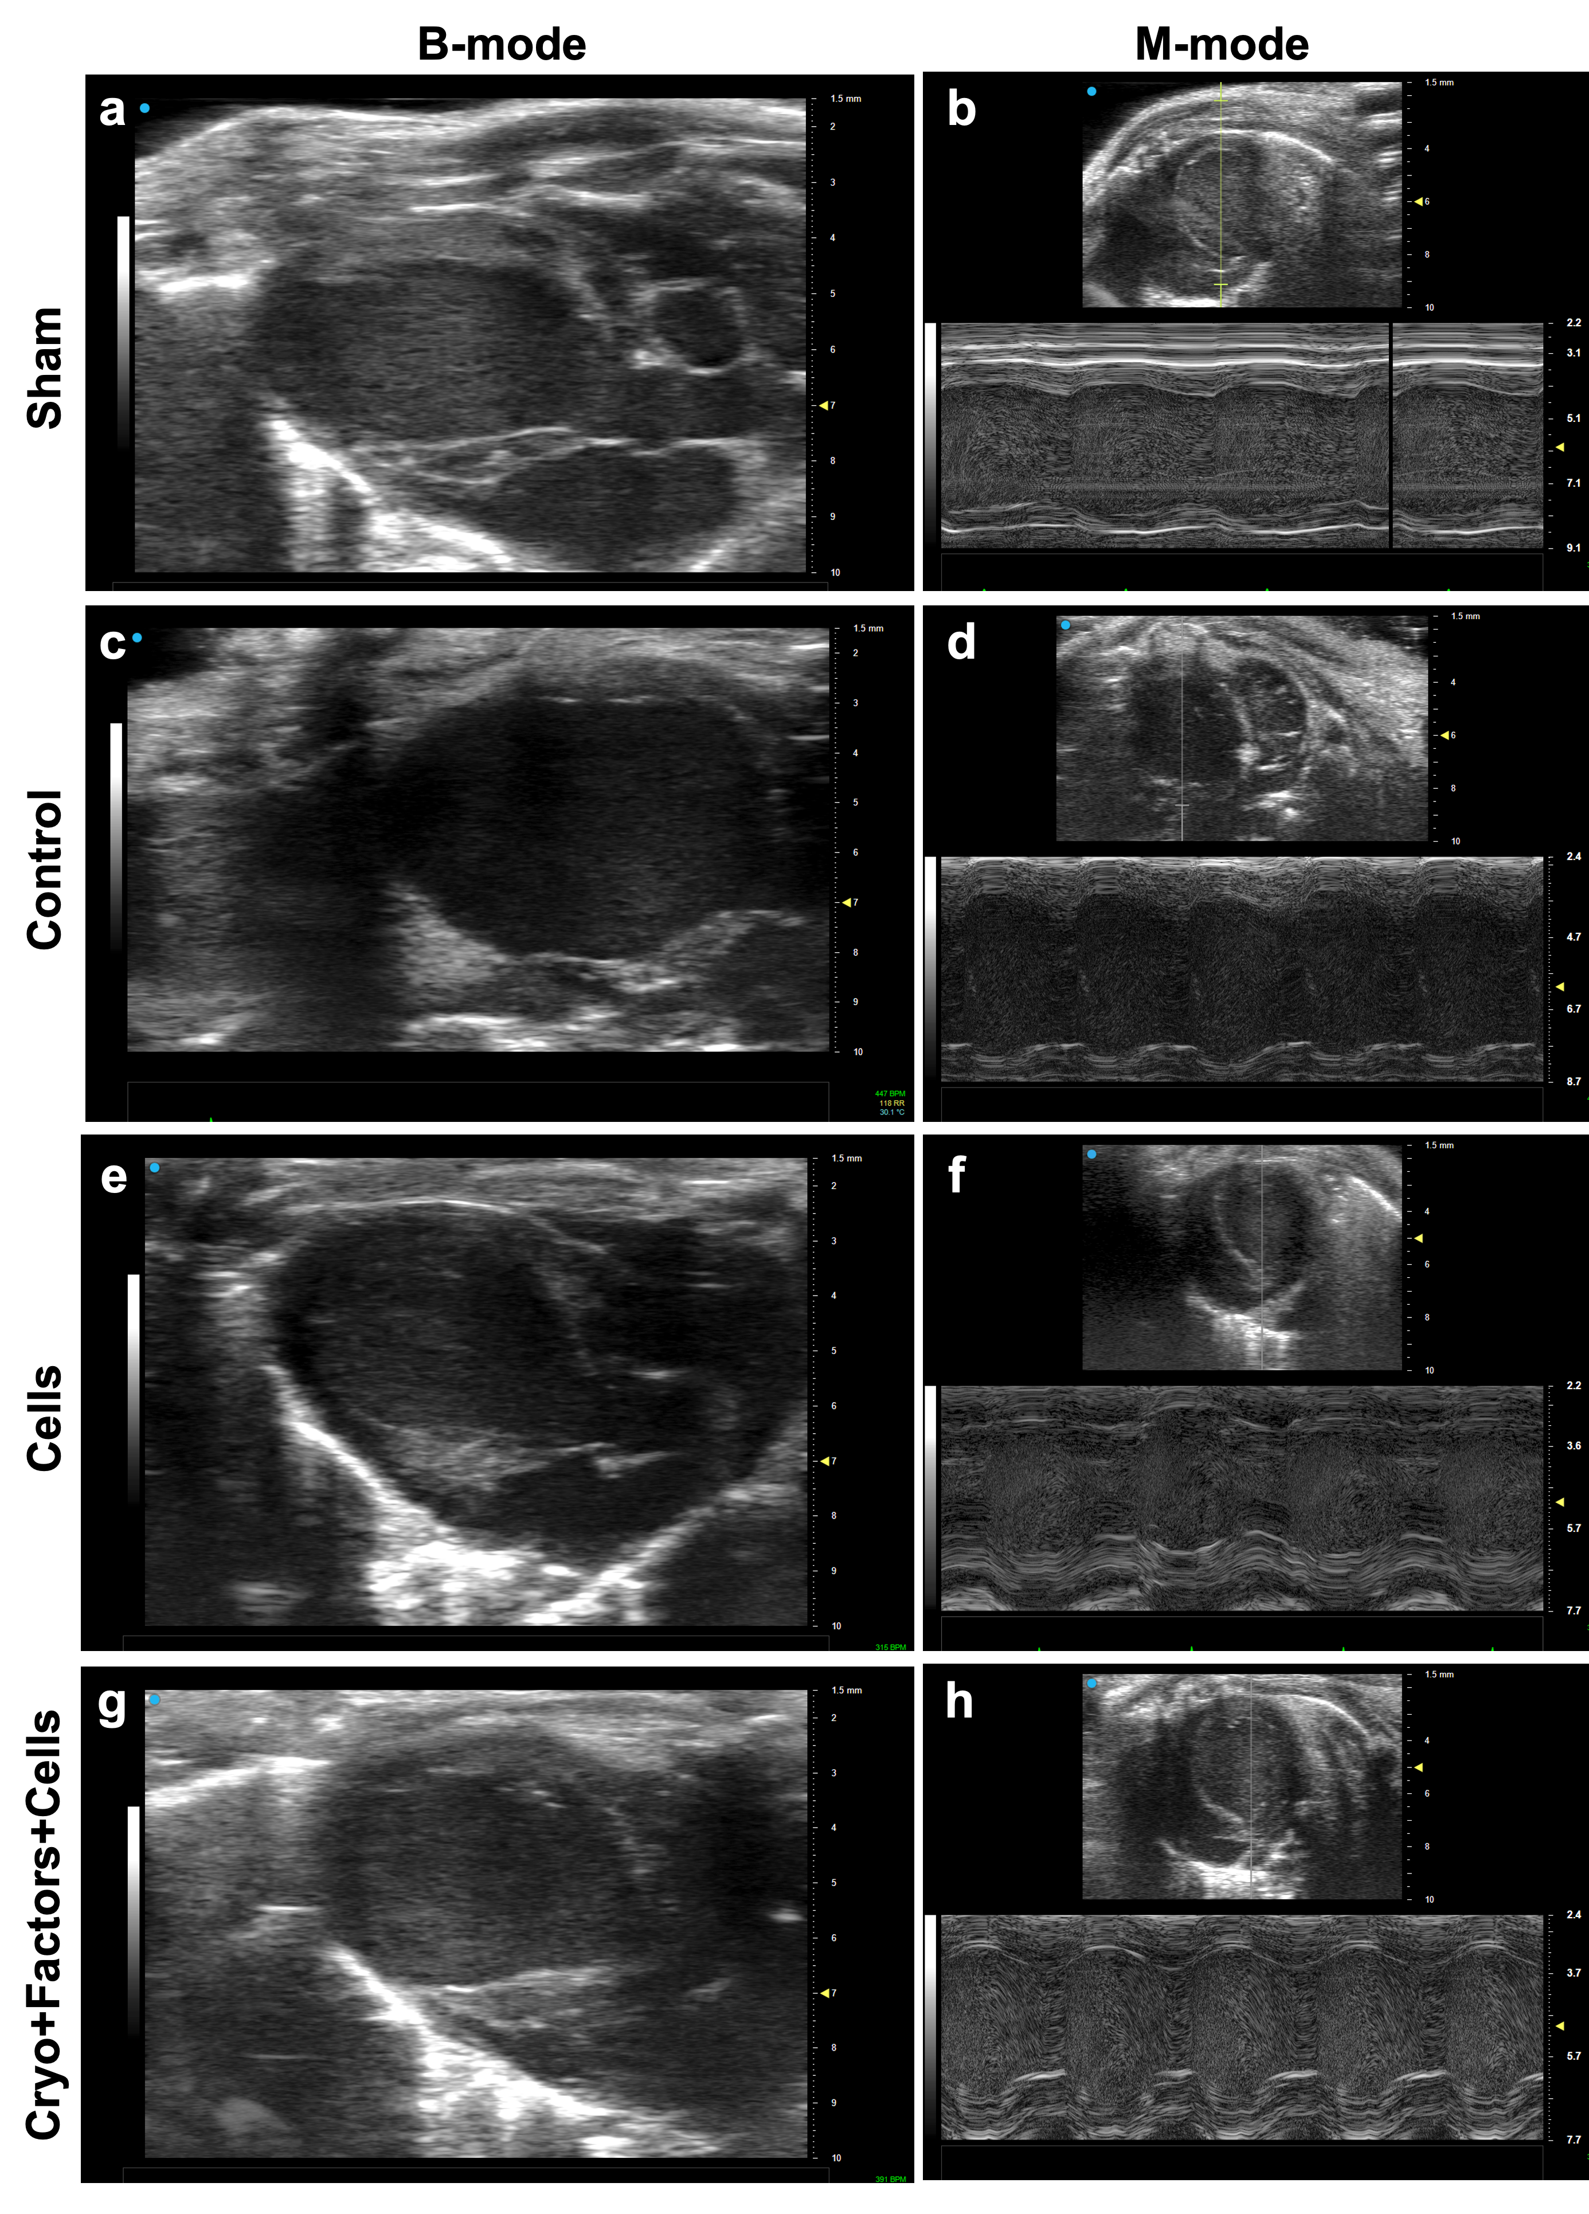
Figure 3. Echocardiography images of the murine MI model groups. The four groups were measured with ultrasound imaging with corresponding B- and M-modes: sham group (a, b), control (c, d), cells (e, f), cryo+factors+cells (g, h).

Further numerical analysis of the study groups was evaluated using Teichholz formula, Vol = 7D³/(2.4+D). The formula enabled to obtain and then calculate the ejection fraction (EF) and fractional shortening (FS) (Figure 4). The comparison of the data was then demonstrated the sham group having preserved cardiac function (EF (49.248%) and FS (24.545%)), while the control group exhibited a marked decline in EF and FS (30.744%, 14.597%). Cells-only treatment significantly improved cardiac function (EF: 58.875%, FS: 31.206%). The cryogel + factors + cells group also demonstrated a marked improvement (EF: 54.493%, FS: 27.936%). Only the latter group showed the statistically significant increase in the LV function parameters.
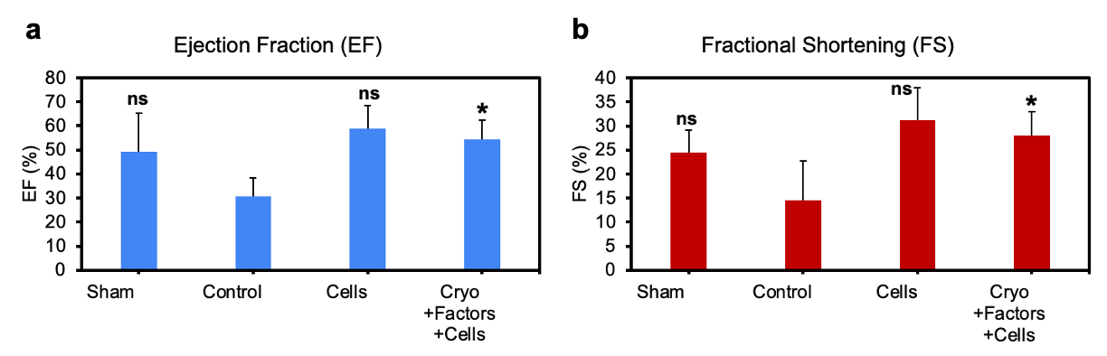
Figure 4. Evaluation of the left ventricular function post-MI in four different test groups: Ejection fraction (a), Fractional shortening (b). Data represented as mean average with standard deviation, n=3, ns (non-significant), *p<0.05).

Discussion

This study demonstrates the potential of chitosan-based cryogels for delivering mesenchymal stem cells (MSCs) and bioactive factors (IL-10, VEGF-A, FGF-2) in a murine myocardial infarction (MI) model. The figures 1-2 showed the succseful isolation of MSC cells and the presence of the mesh like structure in the cryogel particles to accomodatre the bioactive factors for sequential release in MI site. The further figures 3-4 were demonstrating the effect of the treatment on the LV function of the murine MI models.

The findings indicate that this combinatorial approach enhances cardiac regeneration by improving left ventricular function, reducing fibrosis, and promoting neovascularization. Notably, the cryogel-based delivery of cells and factors resulted in a statistically significant increase in ejection fraction (EF) and fractional shortening (FS) compared to the control group (p < 0.05, Figure 4). This suggests that bioactive factor release from cryogels provides a supportive microenvironment that improves MSC survival and therapeutic efficacy post-MI.

The cells-only group exhibited the highest improvement in cardiac function (EF: 58.875%, FS: 31.206%), potentially due to the direct contribution of MSCs to cardiac repair. However, the cryogel + factors + cells group also demonstrated a substantial improvement (EF: 54.493%, FS: 27.936%), suggesting that the biomaterial-based delivery system enhances therapeutic effects by facilitating sustained cytokine release and supporting cellular retention. These results align with previous studies that have shown improved MSC engraftment and regenerative potential using biomaterial scaffolds. Furthermore, prior research has indicated that VEGF and FGF-2 alone may not be sufficient for robust cardiac recovery, a finding that is corroborated by our data.

The functional improvements of the MSCs and combinatorial group potentially mediated by VEGF-A and FGF-2 release, which enhanced angiogenesis compared to controls. Additionally, the immunomodulatory properties of IL-10 possibly contributed to macrophage polarization towards an anti-inflammatory M2 phenotype, promoting tissue repair and reducing excessive fibrosis.

While these findings are promising, certain limitations should be considered. First, the small sample size may limit the statistical power of the study. Second, the long-term effects of the cryogel-mediated delivery approach require further investigation. The additional histological and immunohistochemical analysis of the tissue sampels may provide further insights into the mechanisms of the treatment effect. Future studies should explore larger animal models and long-term follow-up assessments to validate the translational potential of this strategy.

Conclusion
In conclusion, this study highlights the benefits of using chitosan-based cryogels as a biomaterial-assisted cell therapy approach for MI treatment. The combination of MSCs with controlled release of pro-angiogenic and immunomodulatory factors significantly improved cardiac function and reduced fibrosis. These findings provide a foundation for further research into biomaterial-enhanced regenerative strategies for cardiovascular diseases.

Reference list:
Attar, A., Bahmanzadegan Jahromi, F., Kavousi, S., et al. (2021). Mesenchymal stem cell transplantation after acute myocardial infarction: A meta-analysis of clinical trials. Stem Cell Research & Therapy, 12(1), 600. https://doi.org/10.1186/s13287-021-02667-1
Chen, Y., Li, C., Li, C., Chen, J., Li, Y., Xie, H., ... & Tao, L. (2020). Tailorable hydrogel improves retention and cardioprotection of intramyocardial transplanted mesenchymal stem cells for the treatment of acute myocardial infarction in mice. Journal of the American Heart Association, 9(2), e013784. https://doi.org/10.1161/JAHA.119.013784
Guo, Y. (2020). The therapeutic potential of mesenchymal stem cells for cardiovascular diseases. Cell Death & Disease, 11(5), 349–359. https://doi.org/10.1038/s41419-020-2366-9
Hashimoto, H., Olson, E. N., & Bassel-Duby, R. (2018). Therapeutic approaches for cardiac regeneration and repair. Nature Reviews Cardiology, 15(10), 585–600. https://doi.org/10.1038/s41569-018-0073-1
Li, H. M. (2023). Optimal transplantation strategy using human induced pluripotent stem cell-derived cardiomyocytes for acute myocardial infarction in nonhuman primates. MedComm, 4(3), e289. https://doi.org/10.1002/mco2.289
Reed, G. W., Rossi, J. E., & Cannon, C. P. (2017). Acute myocardial infarction. The Lancet, 389(10065), 197–210. https://doi.org/10.1016/S0140-6736(16)30611-0
Sultankulov, B. (2019). Composite cryogel with polyelectrolyte complexes for growth factor delivery. Pharmaceutics, 11(12), 650-675. https://doi.org/10.3390/pharmaceutics11120650
Tsao, C. W. (2022). Heart disease and stroke statistics—2022 update: A report from the American Heart Association. Circulation, 145(8), e153. https://doi.org/10.1161/CIR.0000000000001078
Thygesen, K. (2018). Fourth universal definition of myocardial infarction. Journal of the American College of Cardiology, 72(18), 2231–2264. https://doi.org/10.1016/j.jacc.2018.08.1038
Wang, D. (2023). Dual delivery of an NF-κB inhibitor and IL-10 through supramolecular hydrogels polarizes macrophages and promotes cardiac repair after myocardial infarction. Acta Biomaterialia, 164, 111–123. https://doi.org/10.1016/j.actbio.2023.02.031
Wang, J. (2023). Cardiac regeneration: Options for repairing the injured heart. Frontiers in Cardiovascular Medicine, 9, 981982. https://doi.org/10.3389/fcvm.2022.981982
Wu, T., & Liu, W. (2022). Functional hydrogels for the treatment of myocardial infarction. NPG Asia Materials, 14(1), 9–24. https://doi.org/10.1038/s41427-022-00379-1
Wu, Y. (2021). Release of VEGF and BMP9 from injectable alginate-based composite hydrogel for treatment of myocardial infarction. Bioactive Materials, 6(2), 520–528. https://doi.org/10.1016/j.bioactmat.2021.02.004
Zacchigna, S., Paldino, A., Falcão-Pires, I., Daskalopoulos, E. P., Dal Ferro, M., Vodret, S., ... & Thum, T. (2021). Towards standardization of echocardiography for the evaluation of left ventricular function in adult rodents: a position paper of the ESC Working Group on Myocardial Function. Cardiovascular research, 117(1), 43-59.
Zhu, H., Guo, ZK., Jiang, XX. et al. A protocol for isolation and culture of mesenchymal stem cells from mouse compact bone. Nature Protocols, 5, 550–560 (2010). https://doi.org/10.1038/nprot.2009.238

