The synthesis of carbazole-based dye as a potential sensitizer for DSSCs application

Introduction
Solar cell technology has advanced significantly as a result of the pressing need for renewable energy. Even though conventional mono- and polycrystalline silicon and inorganic solar cells are effective at turning sunlight into power, their use of hazardous chemicals like silicon tetrachloride and trichlorosilane, together with their expensive manufacturing costs, poses environmental dangers. Perovskite solar cells (PSCs), dye-sensitized solar cells (DSSCs), and organic photovoltaics (OPVs) are examples of new-generation solar cells that have been created to address these problems. Because of its low power potential in both indoor and outdoor settings, DSSCs in particular have gained attention as viable options for powering a wide range of electronic devices.^{1, 2} In a period of 1991 to 2020, DSSCs have developed significantly in efficiency from 7.1% to 20.98% with a Ru(II) pyridyl complex dye and metal-free organic dye.³
The ability to increase the flexibility and efficiency of DSSCs via a variety of techniques, including design modification, integration on diverse substrates, and adaptive manufacturing techniques, draws researchers and creates commercialization opportunities.
Transparent conductive oxide glass (TCO) coated with Pt, an electrolyte, and a dye-sensitized mesoporous photoanode (dye-anchored nanocrystalline titanium dioxide film, or TiO2) make up DSSCs. When sunlight is absorbed by a sensitizer that is fixed to the semiconductor's surface, electrons are excited from the highest occupied molecular orbital (HOMO) to the lowest unoccupied molecular orbital (LUMO). The energized electrons then move via an external electrical circuit from the conductive band to the counter electrode through electron diffusion.
After, when the electrolyte regenerates the oxidized dye and then reduces on the surface of the counter electrode, a photoelectric cycle is finished.^{1, 2}
The perfect performance of every component is necessary for a solar cell to function effectively. Sensitizers in DSSCs must, first and foremost, be able to absorb light rapidly, maintain their chemical stability, withstand deterioration, adhere effectively to semiconductor films, and regenerate from the electrolyte. As a result, the counter electrode needs to be robust and extremely catalytic. Despite its shortcomings, traditional Pt remains the most effective since substitutes such carbon-based materials and transition metal compounds are difficult to quantify. Lastly, while maintaining stability over time, the electrolyte must convey electrical charge and replenish the sensitizer.^{1, 4}
Organic dyes suitable for application as sensitizers for inorganic semiconductors such as titanium dioxide (TiO2) and zinc oxide (ZnO)⁵ in dye-sensitized solar cells (DSSCs) have received immense attention in recent years due to the possibility that they could serve as low cost consumer power generation equipment in the near future. Performance of DSSCs fabricated using the organic dyes are largely dependent on their electronic and structural characteristics.⁶⁻¹³ The absorption properties and the frontier orbital energies affect the charge generation and collection efficiency in the devices. Broader and intense charge transfer absorption of the dyes is beneficial for the charge generation, while the LUMO level higher than the conduction band energy of the semiconductor is essential to thermodynamically drive the charge injection.¹⁰ It has been recently found that the recombination of injected electrons with the oxidized dye or the triiodide ions (I₃⁻) in electrolyte severely diminishes the photocurrent density. Several structural modifications such as introduction of alkyl chains, bridged bianchoring architecture, and so forth have been identified to retard the recombination reactions and contribute to the hike in short-circuit current (JSC) and open circuit voltage (VOC) of the devices. Despite the sincere efforts by chemists in the design of new organic dyes, the DSSCs fabricated using the organic dyes are inferior to those derived from organometallic ruthenium complexes. The reason for the poor performance of organic dyes, despite possessing a high molar extinction coefficient for the charge transfer transition, is unclear.¹³ To unravel this puzzle, more studies on the structure−property relationship of metal-free organic dyes are necessary. Carbazole-based organic materials have been widely employed as active ingredients in electronic devices such as organic light-emitting diodes (OLEDs) and DSSCs due to their unique charge-transporting properties and pronounced thermal stability.
Carbazole is an attractive building block as it offers many nuclear sites for functional group incorporation.^{14, 15} For instance, many carbazole derivatives with functional chromophores attached via C-2, C-3, C-6, C-7, and N-9 have been reported for application in organic light-emitting diodes and photovoltaic devices. Particularly, in the dyes serving as sensitizers in DSSCs, carbazole has been used either as a peripheral donor or as a π-linker. Due to the presence of electron-rich amine functionality, carbazole can easily donate electrons; however, the cation radical formed after the removal of the electron is quite unstable owing to the large structural reorganization associated with the oxidation.¹⁶ Substitution of electron-releasing groups, on the contrary, on the carbazole nucleus can enhance the donor strength of the carbazole.^{17, 18}

Experimental Procedure
(a) 3,6-diiodocarbazole

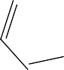

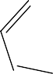


Carbazole (10 g, 119.6 mmol) was dissolved in boiling glacial acetic acid (175 mL) under argon atmosphere, and then potassium iodide (13.25 g, 159.6 mmol) was added. The solution was cooled, and ground potassium iodate (19.25 g, 179.9 mmol) was slowly added in a small portion. The resulting mixture was heated under reflux until it acquired a clear straw-colored tint. After this time, the hot solution was decanted from the undissolved potassium iodate and was cooled to 45 °C. The resulting precipitate was filtered, and the crude product was recrystallized from methanol (100 mL) to afford a straw color solid.¹⁹ (24.25 g, 96.73%)
(b) 3,6-diiodo-N-hexylcarbazole

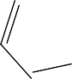

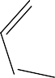



To a solution of (a) (5g, 11.9 mmol) in DMF (25 mL) were added a catalytic amount of sodium tert-butoxide (1.1 g, 11.8 mmol). The reaction mixture was vigorously stirred for 5 min., 201.2 and 1-bromohexyl (1.65 mL, 11.8 mmol) was added. The resulting mixture was stirred at room temperature for 12h. After this time, the mixture was extracted with ethyl acetate. The combined organic layers were dried under anhydrous Na2SO4 and filtered. After removing the solvent under reduced pressure, the crude product was purified by flash column chromatography (silica gel, hexane), affording a white solid.¹⁹ (4.59g, 76.72%)

(c) 3-iodo-6-(9H-carbazol-9-yl)-9-hexylcarbazole

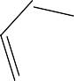

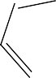

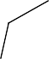
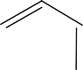


A mixture of (b) (1.06 g, 2 mmol), carbazole (0.3 g, 1.8 mmol), 1,10-phenantroline (54 mg,
0.3 mmol), K2CO3 (0.38 g, 2.86 mmol), and CuI (28.6 mg, 0.15 mmol) in 3 ml of anhydrous DMF was heated under reflux for 30h under nitrogen atmosphere. After this time, the mixture was cooled, diluted with CH2Cl2, and filtered. The filtrate was concentrated under reduced pressure. The crude product was purified by column chromatography (silica gel, hexane/dichloromethane, 10:1→5:1 v/v) to give c as a white solid.¹⁹ (431.3 mg, 39.90% yield).
(d) 4-ethynylbenzaldehyde
In a 250 mL three-necked flask, methyl 4-iodobenzaldehyde (1 g, 4.30 mmol), CuI (40.97 mg, 0.215 mmol), and Pd(PPh3)2Cl2 (90.55 mg, 0.129 mmol) were dissolved in THF (4 mL) and Et3N (21 mL) under nitrogen. Then, triisopropylsilyl acetylene (0.9 mL, 4.73 mmol) was added. After stirring at 60°C for 18 h, the solvent was removed under reduced pressure, then KOH (188.81 mg, 1.68 mmol), a few drops of methanol and 1.5 mL THF were mixed in and stirred for 1 hour at room temperature. Next, the organic layer was extracted with CH2Cl2 and dried over Na2SO4. After removing the solvent under reduced pressure, the residue was purified on a silica gel column with ethyl acetate: hexane 20:80 to obtain a yellow powder.²⁰ (336 mg, 60%)

(e) 4-((9-hexyl-9H-[3,9'-bicarbazol]-6-yl)ethynyl)cyclohexa-1,5-dienecarbaldehyde
A solution of compound (c) (151.87 mg, 0.28 mmol) in 2 ml degassed THF and TEA (3:1 v/v) was bubbled with nitrogen and stirred for 10 minutes. After this time, PdCl2(PPh3)4 (14.04 mg, 0.02 mmol, 8%-mol) and CuI (3.81 mg, 0.02 mmol, 8%-mol) were added, and the resulting mixture was bubbled with nitrogen for another 10 minutes. 4-ethynylcyclohexa-1,5-diene-1-carbaldehyde (d) (40.12 mg, 0.34 mmol, 1.2 eq) in 2 mL THF was then injected through the septum, and the mixture was stirred at 60 °C for 24h under an argon atmosphere. After this time, the reaction mixture was filtered, and the filtrate was evaporated under reduced pressure. The residue was purified by column chromatography.¹⁹ ( 45 mg, 30%)

(f) (2-cyano-2-(4-((9-hexyl-9H-[3,9'-bicarbazol]-6-yl)ethynyl)cyclohexa-1,5-dien-1-yl)acetic acid
The compound (e) (17 mg, 0.04 mmol), 2-cyanoacetic acid (5 mg, 0.06 mmol), ammonium acetate (2.3 mg, 0.03 mmol), and acetic acid (0.6 mL) were mixed and refluxed for 24h. The resulting red precipitate was filtered and washed several times with water and dried. It was crystallized from a dichloromethane/hexane mixture to obtain the analytically pure sample. Yellow solid.
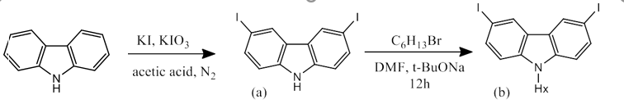
Scheme 1. The synthesis root of the dye sensitizer.

Results and Discussion
The purity of the obtained product was evaluated using 1H and 13C NMR. As a result of the research, the novel D-π-A-architected dye sensitizer was designed and synthesized. Step by step results are presented below.
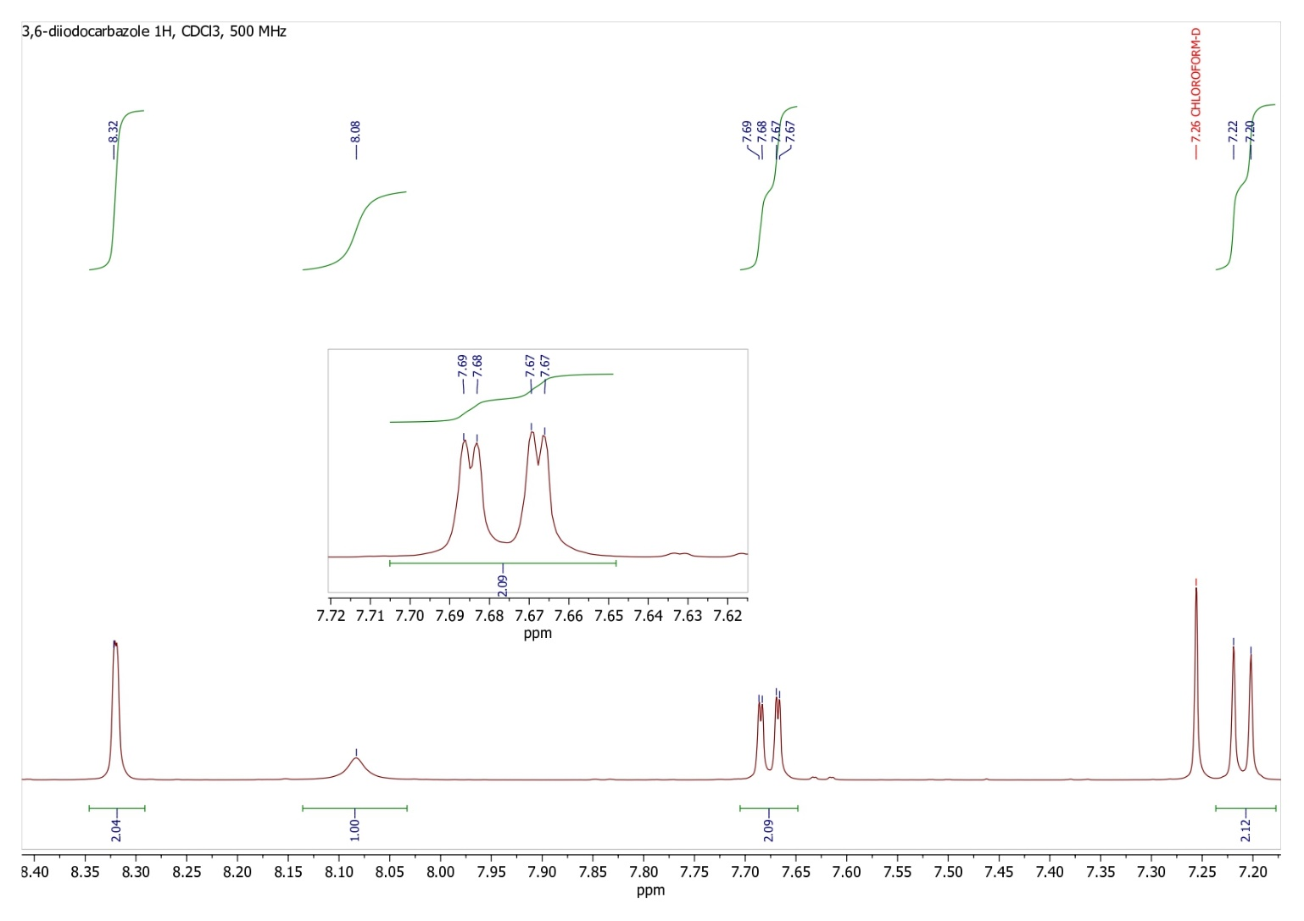Figure 1. The 1H NMR spectrum of (a) 3,6-diiodocarbazole.
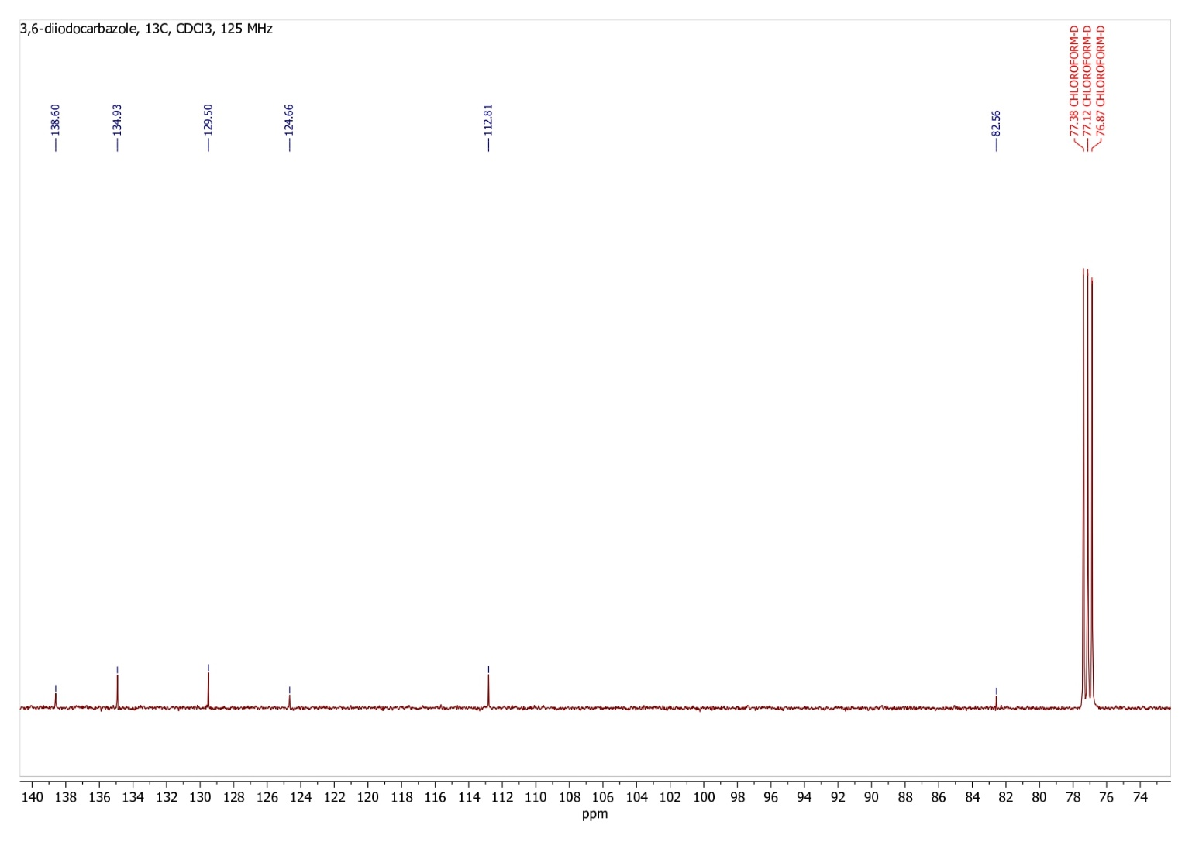
Figure 2. The 13C NMR spectrum of (a) 3,6-diiodocarbazole.
The first step is a halogenation reaction of carbazole at the 3,6 positions. Iodine was used for that purpose, because iodine is a good leaving group and modification at the positions can be easily and variously manipulated. Additionally, modification through the 3,6-positions boosts the electron donor ability. Incorporation of 3,6-diiodocarbazole as a dendritic donor unit both improves the molar extinction coefficients of the absorption and suppresses the charge recombination with electrolyte.²¹ The 1H, 13C NMR results matched with literature data.¹⁹ 1H NMR (500 MHz, CDCl3): δ 8.32 (s, 2H), 8.07 (br s, 1H), 7.68 (dd, J1 = 8.5, J2 = 1.2 Hz, 2H), 7.21 (d, J = 8.5 Hz, 2H). 13C NMR (125 MHz, CDCl3): δ 138.42, 134.76, 129.21, 123.44, 112.60, 82.48. The 1H, 13C NMR spectra are represented above (Figures 1 and 2).
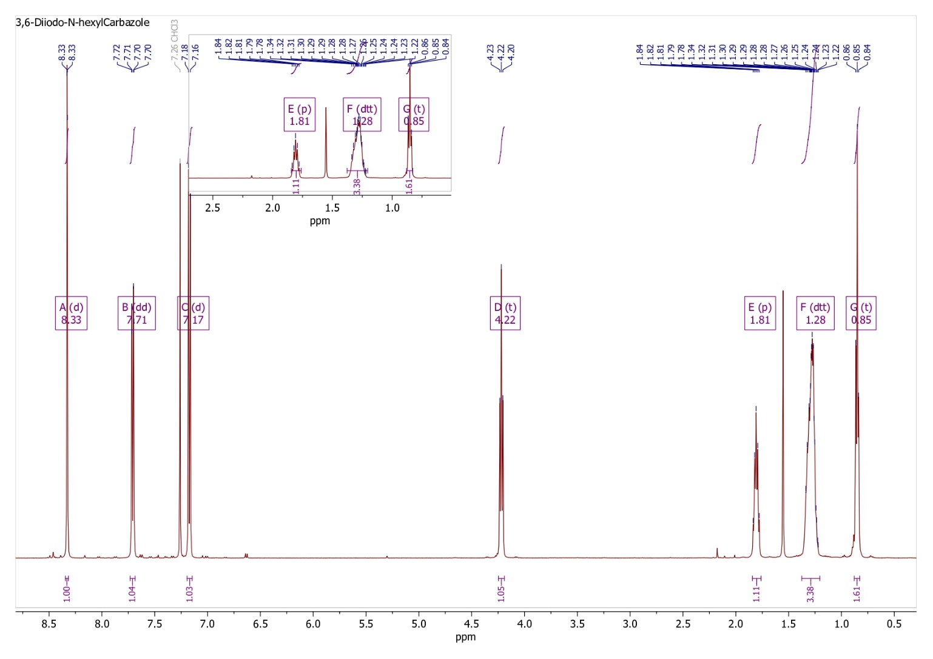Figure 3. The 1H NMR spectrum of (b) 3,6-diiodo-N-hexylcarbazole

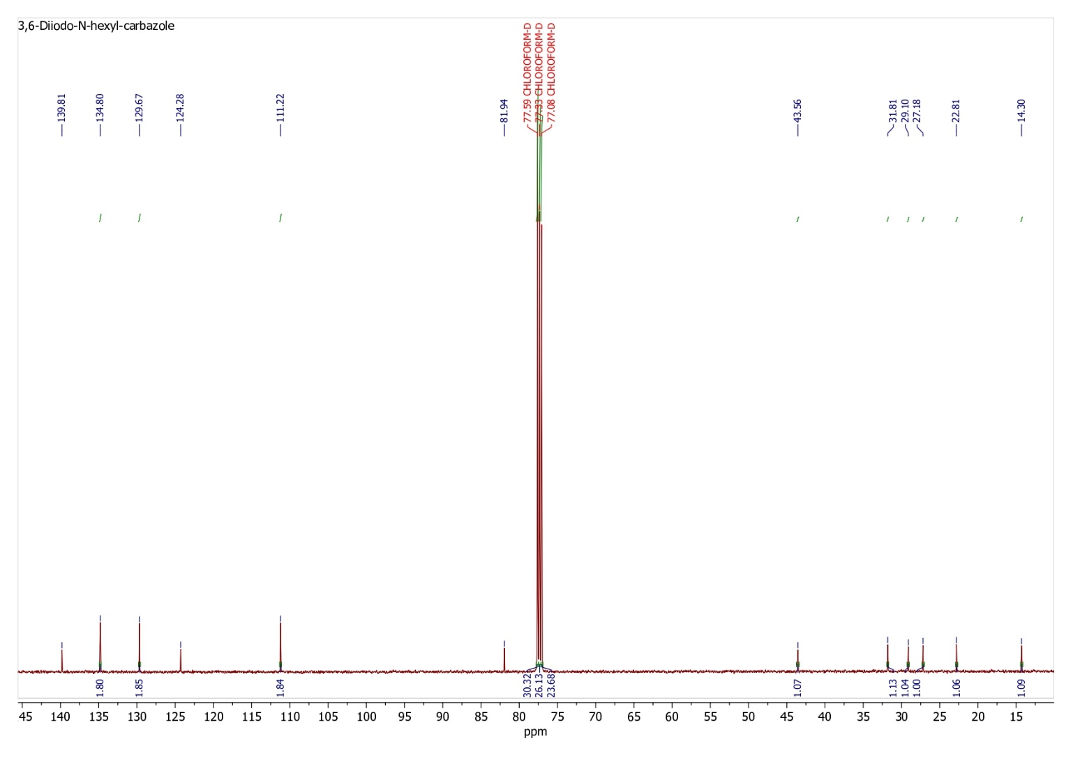
Figure 4. The 13C NMR spectrum of (b) 3,6-diiodo-N-hexylcarbazole
After, the 3,6-diiodocarbazole was alkylated at the 9-N position. Introducing the hexyl chain enhances the molar extinction coefficients of these dyes in the visible absorption band and prevents dye aggregation on the semiconductor, contributing to an increase in the short-circuit current, improving the charge recombination and solubility through back electron transfer.²²
The 1H, 13C NMR results matched with literature data.¹⁹ 1H NMR (500MHz, CDCl3): δ 8.32 (d, J = 1.6, 2H), 7.71 (dd, J1 = 8.6 Hz, J2 = 1.5 Hz, 2H), 7.16 (d, J = 8.6 Hz, 2H), 4.21 (t, J = 7.1 Hz, 2H), 1.84-1.75 (m, 2H), 1.33-1.18 (m,10H), 0.85 (t, J = 7.1 Hz, 3H). 13C NMR (125 MHz, CDCl3): δ 139.50, 134.50,129.36, 123.97, 110.89, 81.60, 43.26, 31.77, 29.30, 29.12, 28.83, 27.21, 22.58,14.02. The 1H, 13C NMR spectra are represented above (Figures 3 and 4).
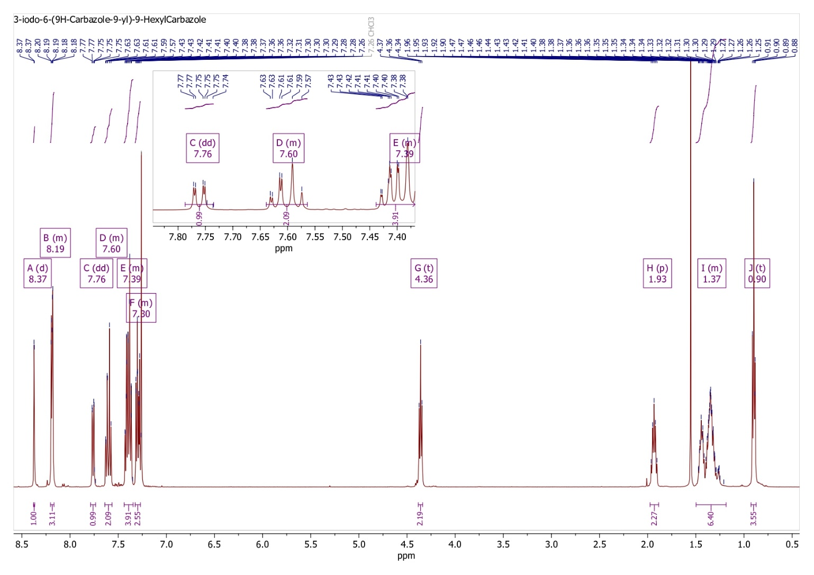
Figure 5. The 1H NMR spectrum of (c) 3-iodo-6-(9H-carbazol-9-yl)-9-hexylcarbazole

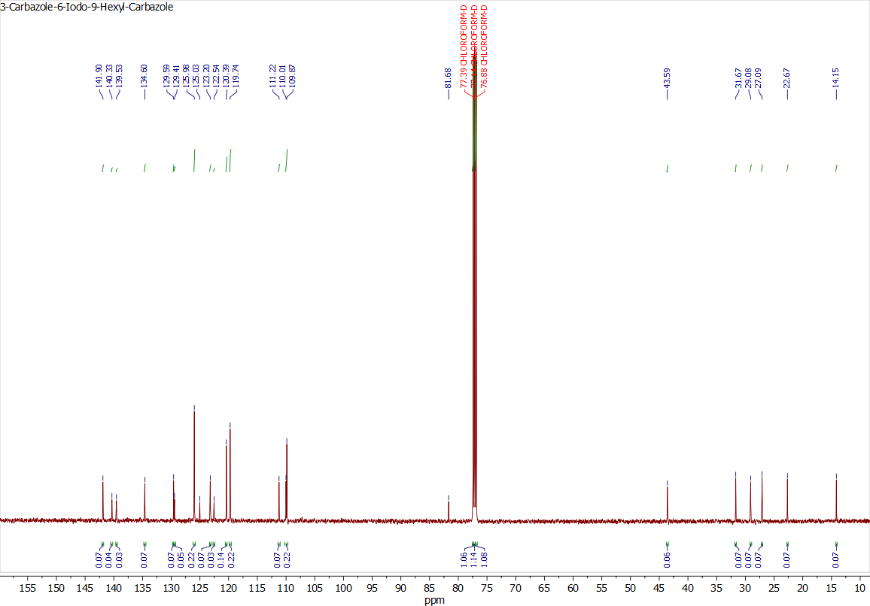
Figure 6. 13C NMR spectrum of (c) 3-iodo-6-(9H-carbazol-9-yl)-9-hexylcarbazole
Carbazole was added at the 6th position of 3,6-diiodo-9-hexylcarbazole, and a Donor-π compound was formed. Carbazole is a donor, and N-alkylated carbazole is a π-bridge. Bicarbazolyl moiety proves to be a stronger donating part than a single carbazolyl group, providing lower ionization potential and superior thermal and electrochemical stability. Additionally, the usage of an alkylated twisted bicarbazolyl moiety prevents the molecules from crystallizing²³.
The 1H, 13C NMR results matched with literature data.¹⁹ 1H NMR (500 MHz, CDCl₃): δ 8.37 (d, J = 1.6 Hz, 1H), 8.21-8.15 (m, 3H), 7.76 (dd, J1 = 8.6 Hz, J2 = S7 1.7 Hz, 1H), 7.65-7.55 (m, 2H), 7.45-7.34 (m, 4H), 7.33-7.26 (m, 3H), 4.36 (t, J = 7.3 Hz, 2H), 2.03-1.86 (m, 2H), 1.47-1.18 (m, 10H), 0.88 (t, J = 6.9 Hz, 3H). 13C NMR (125 MHz, CDCl3): δ 141.90, 140.29, 139.50, 134.57, 129.55, 129.42, 125.94, 125.68, 125.04, 123.21, 122.50, 120.38, 119.72, 119.66, 111.16, 109.97, 109.84, 81.67, 43.26, 31.78, 29.30, 29.11, 28.82, 27.21, 22.60, 14.01. The 1H, 13C NMR spectra are represented above (Figures 5 and 6).

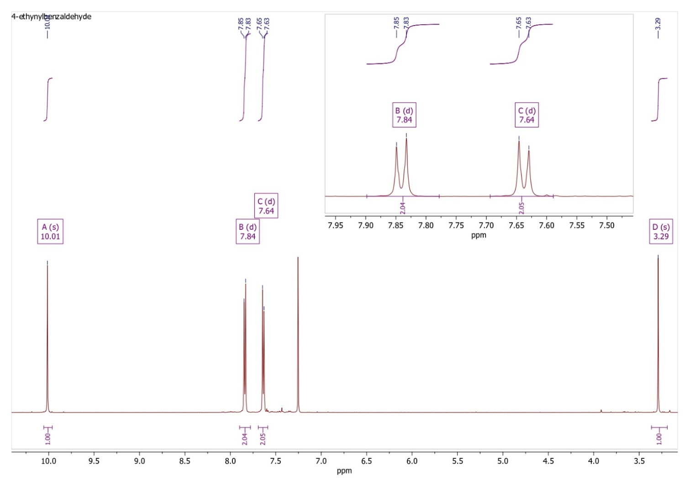
Figure 7. The 1H NMR spectrum of (d) 4-ethynylcyclohexa-1,5-diene-1-carbaldehyde
The 1H, 13C NMR results matched with literature data.²⁰ 1H NMR (500 MHz, CDCl₃) δ 10.01 (s, 1H), 7.84 (d, J = 8.1 Hz, 2H), 7.64 (d, J = 8.1 Hz, 2H), 3.29 (s, 1H). The 1H NMR spectrum is presented above (Figure 7).

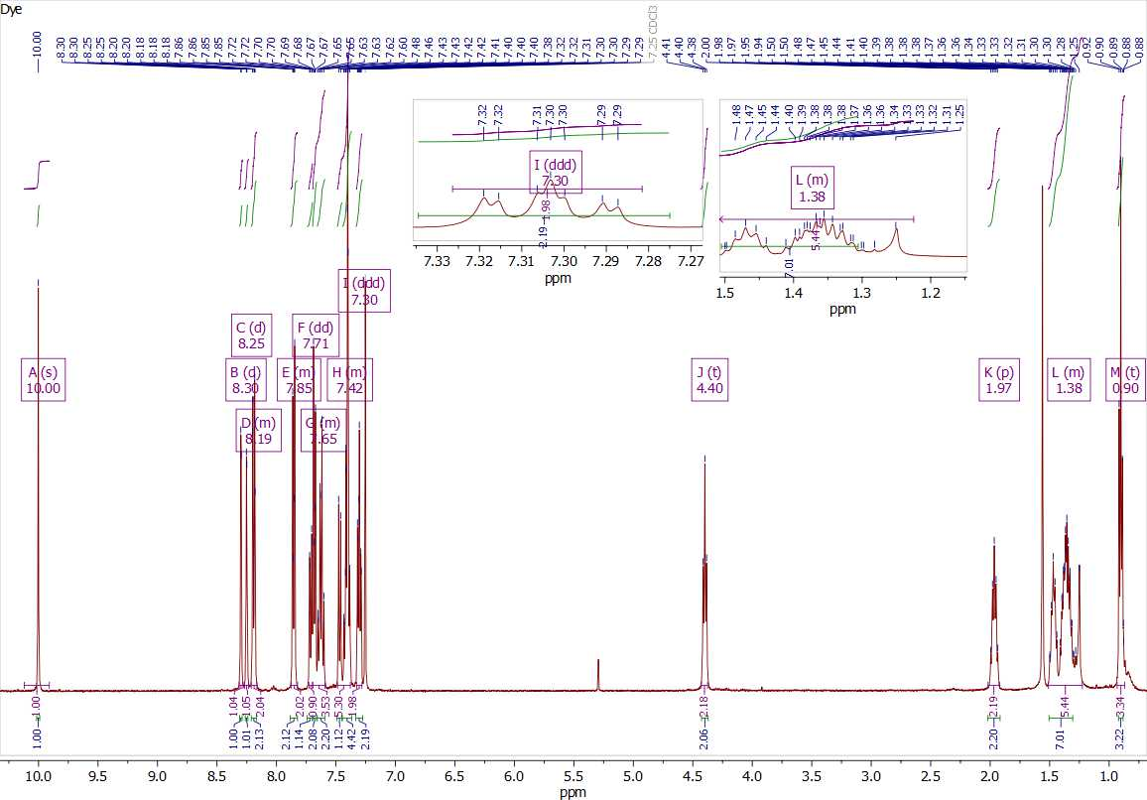Figure 8. The 1H NMR spectrum of (e) 4-((9-hexyl-9H-[3,9'-bicarbazol]-6-yl)ethynyl)cyclohexa-1,5-dienecarbaldehyde
With Sonogashira cross-coupling, the acceptor group was introduced into the dye structure. So, benzaldehyde was attached through the triple bond. The triple bond can result in energy-gap shrinking and enhanced skeleton coplanarity. By increasing the distance between the donor and acceptor and reducing the steric interaction, the introduction of the triple bond generally lowers the torsion angle. Additionally, the distance between the HOMO and LUMO spatial distributions can be widened by the triple-bond insertion.²⁴
1H NMR (500 MHz, CDCl₃) δ 10.00 (s, 1H), 8.30 (d, J = 8.1 Hz, 2H), 8.25 (d, J = 8.1 Hz, 2H), 7.71 (dd, J1 = 8.5 Hz, J2 = 1.5 Hz, 1H), 7.65 (m, 2H), 7.42 (m, 5H), 7.30 (ddd, J1 = 7.9 Hz, J2 = 5.6 Hz, J3 = 2.5 Hz, 2H), 4.40 (t, J = 7.2Hz, 2H), 1.97 (p, 2H), 1.38 (m, 7H), 0.90 (t, J = 6.7 Hz, 3H). The 1H NMR spectrum is presented above (Figure 8).
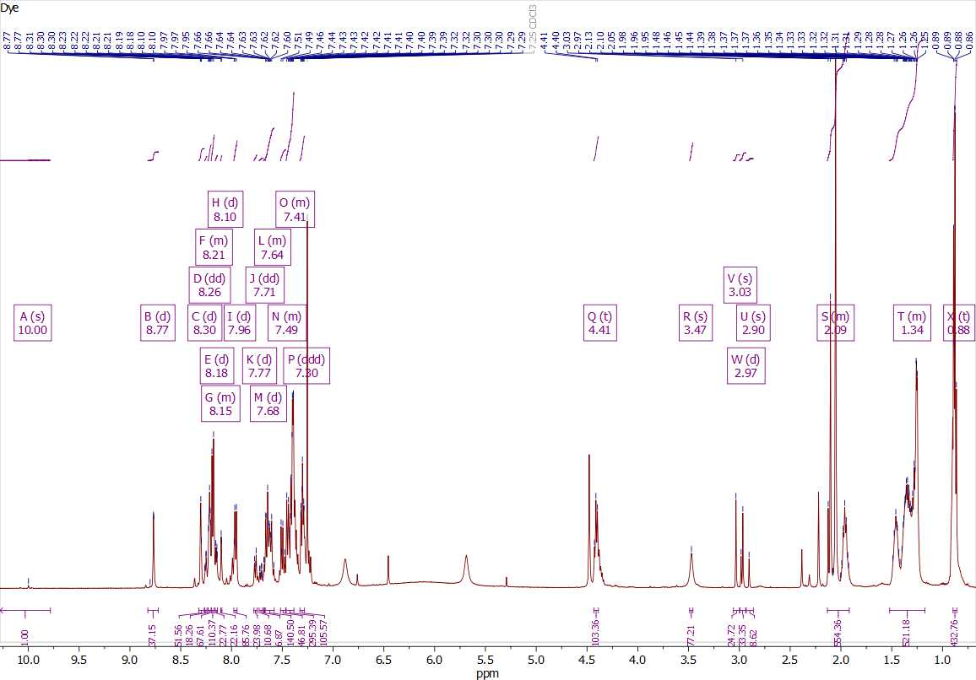
Figure 9. The 1H NMR spectrum of (f) (2-cyano-2-(4-((9-hexyl-9H-[3,9'-bicarbazol]-6-yl)ethynyl) cyclohexa-1,5-dien-1-yl)acetic acid
Finally, cyanoacrylic acid was added to the aldehyde as an anchoring group. This modification results into more red-shifted absorption, more efficient charge transfer, higher PCE (power conversion efficiency), forming not a monodentate, but a bidentate linkage with the TiO₂ cluster, leading to higher J_{SC}, V_{OC}, and FF. ²⁵
1H NMR (500 MHz, CDCl3): δ 10.00 (s, ), 8.77, 8.30, 8.26 (dd, J1 = 5.1 Hz, J2 = 1.4 Hz, 2H), 8.21, 8.18 (d, J = 7.7 Hz, 2H), 8.15, 8.10, 7.96, 7.77, 7.71 (dd, J1 = 8.5 Hz, J2 = 1.5 Hz, 1H), 7.68 (d, ), 7.64 (m, 2H), 7.49 (m, 2H), 7.41 (m, 5H), 7.30 (ddd, J1 = 7.9 Hz, J2 = 5.6 Hz, J3 = 2.5 Hz, 2H), 4.41 (t, J = 7.2Hz, ), 3.47 (s, ), 3.03 (s, ), 2.97 (d, ), 2.90 (s, ), 2.09 (m, 2H), 1.34 (m, 10H), 0.88 (t, J = 6.7 Hz, 3H). The 1H NMR spectrum is presented above (Figure 9).
Study limitations
The designed carbazole-based dye shows the potential features in application as a sensitizer in DSSCs, but several limitations are still present in the research. First of all, the low yield of the reactions poses a problem that might hinder reproducibility and scalability. Secondly, the photovoltaic properties, such as PCE, IPCE (incident photon-to-current efficiency), and long-term operational stability under illumination of the dye, should be assessed. Next, the physical properties under operational conditions should be evaluated, such as thermal stability, photostability, and resistance to degradation. In future perspectives, the other modifications can be introduced, such as 2,7 positioning, various acceptor and anchoring groups, that will improve compatibility with the TiO₂ cluster and maximize the ratio of charge injection efficiency to light gathering.
Conclusion
The new carbazole-based dye was successfully synthesized and demonstrated promising features for sensitizer application in DSSCs. Characterization by 1H, 13C NMR confirmed the successful stepwise synthesis. The several modifications in dye structure resulted in improved features: as 3,6-positioning enhances electron donation, a bicarbazolyl core improves thermal and electrochemical stability, and a cyanoacrylic acid anchoring group accomplishes stronger binding with TiO₂, triple bond between donor and acceptor groups enhanced coplanarity and a narrowed energy gap, introduced a greater spatial separation of frontier molecular orbitals. These molecular features are designed to enhance light absorption, facilitate efficient charge transfer, and minimize recombination losses, increasing parameters such as short-circuit current (J_{SC}) and open-circuit voltage (V_{OC}). However, future work is required to evaluate the sensitizer’s performance in DSSC cells and to optimize parameters such as dye concentration and soaking time. Additionally, theoretical calculations, DFT analysis of the compound, electrochemical investigations, and more in-depth photophysical studies will be essential to fully understand the structure–property relationships.
Acknowledgements: This research was supported by the Laboratory of Functional Materials and Computational Chemistry (FMC2) and supervised by Professor Mannix P. Balanay.

Reference list
(1) Devadiga, D.; Selvakumar, M.; Shetty, P.; Sridhar Santosh, M.; Chandrabose, R. S.; Karazhanov, S. Recent developments in metal-free organic sensitizers derived from carbazole, triphenylamine, and phenothiazine for dye-sensitized solar cells. International Journal of Energy Research 2021, 45 (5), 6584-6643. DOI: https://doi.org/10.1002/er.6348.
(2) Kumar, D.; Wong, K.-T. Organic dianchor dyes for dye-sensitized solar cells. Materials Today Energy 2017, 5, 243-279. DOI: https://doi.org/10.1016/j.mtener.2017.05.007.
(3) Chandra Sil, M.; Chen, L.-S.; Lai, C.-W.; Lee, Y.-H.; Chang, C.-C.; Chen, C.-M. Enhancement of power conversion efficiency of dye-sensitized solar cells for indoor applications by using a highly responsive organic dye and tailoring the thickness of photoactive layer. Journal of Power Sources 2020, 479, 229095. DOI: https://doi.org/10.1016/j.jpowsour.2020.229095.
(4) Elsherbiny, D.; Yildirim, E.; El-Essawy, F.; Abdel-Megied, A.; El-Shafei, A. Structure-property relationships: Influence of number of anchoring groups in triphenylamine-carbazole motifs on light harvesting and photovoltaic performance for dye-sensitized solar cells. Dyes and Pigments 2017, 147, 491-504. DOI: https://doi.org/10.1016/j.dyepig.2017.08.022.
(5) Ahmad, S.; Guillén, E.; Kavan, L.; Grätzel, M.; Nazeeruddin, M. K. Metal free sensitizer and catalyst for dye sensitized solar cells. Energy & Environmental Science 2013, 6 (12), 3439-3466, 10.1039/C3EE41888J. DOI: 10.1039/C3EE41888J.
(6) Wu, Y.; Zhu, W. Organic sensitizers from D–π–A to D–A–π–A: effect of the internal electron-withdrawing units on molecular absorption, energy levels and photovoltaic performances. Chemical Society Reviews 2013, 42 (5), 2039-2058, 10.1039/C2CS35346F. DOI: 10.1039/C2CS35346F.
(7) Haid, S.; Marszalek, M.; Mishra, A.; Wielopolski, M.; Teuscher, J.; Moser, J.-E.; Humphry-Baker, R.; Zakeeruddin, S. M.; Grätzel, M.; Bäuerle, P. Significant Improvement of Dye-Sensitized Solar Cell Performance by Small Structural Modification in π-Conjugated Donor–Acceptor Dyes. Advanced Functional Materials 2012, 22 (6), 1291-1302. DOI: https://doi.org/10.1002/adfm.201102519.
(8) Yen, Y.-S.; Chou, H.-H.; Chen, Y.-C.; Hsu, C.-Y.; Lin, J. T. Recent developments in molecule-based organic materials for dye-sensitized solar cells. Journal of Materials Chemistry 2012, 22 (18), 8734-8747, 10.1039/C2JM30362K. DOI: 10.1039/C2JM30362K.
(9) Kim, B.-G.; Chung, K.; Kim, J. Molecular Design Principle of All-organic Dyes for Dye-Sensitized Solar Cells. Chemistry – A European Journal 2013, 19 (17), 5220-5230. DOI: https://doi.org/10.1002/chem.201204343.
(10) Mishra, A.; Fischer, M. K. R.; Bäuerle, P. Metal-Free Organic Dyes for Dye-Sensitized Solar Cells: From Structure: Property Relationships to Design Rules. Angewandte Chemie International Edition 2009, 48 (14), 2474-2499. DOI: https://doi.org/10.1002/anie.200804709.
(11) Ooyama, Y.; Harima, Y. Photophysical and Electrochemical Properties, and Molecular Structures of Organic Dyes for Dye-Sensitized Solar Cells. ChemPhysChem 2012, 13 (18), 4032-4080. DOI: https://doi.org/10.1002/cphc.201200218.
(12) Liang, M.; Chen, J. Arylamine organic dyes for dye-sensitized solar cells. Chemical Society Reviews 2013, 42 (8), 3453-3488, 10.1039/C3CS35372A. DOI: 10.1039/C3CS35372A.
(13) Hagfeldt, A.; Boschloo, G.; Sun, L.; Kloo, L.; Pettersson, H. Dye-Sensitized Solar Cells. Chemical Reviews 2010, 110 (11), 6595-6663. DOI: 10.1021/cr900356p.
(14) Wang, H.-Y.; Liu, F.; Xie, L.-H.; Tang, C.; Peng, B.; Huang, W.; Wei, W. Topological Arrangement of Fluorenyl-Substituted Carbazole Triads and Starbursts: Synthesis and Optoelectronic Properties. The Journal of Physical Chemistry C 2011, 115 (14), 6961-6967. DOI: 10.1021/jp200433e.
(15) Huang, H.; Fu, Q.; Pan, B.; Zhuang, S.; Wang, L.; Chen, J.; Ma, D.; Yang, C. Butterfly-Shaped Tetrasubstituted Carbazole Derivatives as a New Class of Hosts for Highly Efficient Solution-Processable Green Phosphorescent Organic Light-Emitting Diodes. Organic Letters 2012, 14 (18), 4786-4789. DOI: 10.1021/ol3020286.
(16) Brunner, K.; van Dijken, A.; Börner, H.; Bastiaansen, J. J. A. M.; Kiggen, N. M. M.; Langeveld, B. M. W. Carbazole Compounds as Host Materials for Triplet Emitters in Organic Light-Emitting Diodes: Tuning the HOMO Level without Influencing the Triplet Energy in Small Molecules. Journal of the American Chemical Society 2004, 126 (19), 6035-6042. DOI: 10.1021/ja049883a.
(17) Teng, C.; Yang, X.; Li, S.; Cheng, M.; Hagfeldt, A.; Wu, L.-z.; Sun, L. Tuning the HOMO Energy Levels of Organic Dyes for Dye-Sensitized Solar Cells Based on Br−/Br3− Electrolytes. Chemistry – A European Journal 2010, 16 (44), 13127-13138. DOI: https://doi.org/10.1002/chem.201000460.
(18) Lee, W.; Cho, N.; Kwon, J.; Ko, J.; Hong, J.-I. New Organic Dye Based on a 3,6-Disubstituted Carbazole Donor for Efficient Dye-Sensitized Solar Cells. Chemistry – An Asian Journal 2012, 7 (2), 343-350. DOI: https://doi.org/10.1002/asia.201100661.
(19) Rams-Baron, M.; Jedrzejowska, A.; Jurkiewicz, K.; Matussek, M.; Ngai, K. L.; Paluch, M. Broadband Dielectric Study of Sizable Molecular Glass Formers: Relationship Between Local Structure and Dynamics. The Journal of Physical Chemistry Letters 2021, 12 (1), 245-249. DOI: 10.1021/acs.jpclett.0c03377.
(20) Feng, Y.-S.; Xie, C.-Q.; Qiao, W.-L.; Xu, H.-J. Palladium-Catalyzed Trifluoroethylation of Terminal Alkynes with 1,1,1-Trifluoro-2-iodoethane. Organic Letters 2013, 15 (4), 936-939. DOI: 10.1021/ol400099h.
(21) Tan, L.-L.; Xie, L.-J.; Shen, Y.; Liu, J.-M.; Xiao, L.-M.; Kuang, D.-B.; Su, C.-Y. Novel organic dyes incorporating a carbazole or dendritic 3,6-diiodocarbazole unit for efficient dye-sensitized solar cells. Dyes and Pigments 2014, 100, 269-277. DOI: https://doi.org/10.1016/j.dyepig.2013.09.025.
(22) Huang, J.-F.; Liu, J.-M.; Tan, L.-L.; Chen, Y.-F.; Shen, Y.; Xiao, L.-M.; Kuang, D.-B.; Su, C.-Y. Novel carbazole based sensitizers for efficient dye-sensitized solar cells: Role of the hexyl chain. Dyes and Pigments 2015, 114, 18-23. DOI: https://doi.org/10.1016/j.dyepig.2014.10.022.
(23) Kukhta, N. A.; Volyniuk, D.; Grazulevicius, J. V.; Juska, G. Effect of the Nature of the Core on the Properties of the Star-Shaped Compounds Containing Bicarbazolyl Moieties. The Journal of Physical Chemistry C 2016, 120 (2), 1208-1217. DOI: 10.1021/acs.jpcc.5b10570.
(24) Mu, Y.; Dong, G.; Dong, X.; Zhang, M. Thienochrysenocarbazole-Based Dyes for Solar Cell: A Theoretical Investigation of the Tethering-Position-Related Influence of Triple-Bond on the Electronic and Optical Properties. ChemistrySelect 2018, 3 (41), 11579-11584. DOI: https://doi.org/10.1002/slct.201802746.
(25) Sharma, S. J.; Prasad, J.; Soni, S. S.; Sekar, N. The impact of anchoring groups on the efficiency of dye-sensitized solar cells: 2-Cyanoacrylic acid vs. ethyl 2-cyanoacrylate. Journal of Photochemistry and Photobiology A: Chemistry 2023, 444, 114915. DOI: https://doi.org/10.1016/j.jphotochem.2023.114915.

