Languages in Use: How Background
and Context Shape Multilingual Language Preference

Yerke Dulatbek
Department of Languages, Linguistics and Literature, Nazarbayev University
WLL 499: Capstone II
Course Instructor: Amanda Murphy
Academic Adviser: Marilyn Plumlee
30 April, 2026

Table of Contents
Abstract 4
Introduction 6
Research Questions 8
Literature Review 9
I. Key Concepts of Translanguaging Studies 9
II. Code-switching: Structural and Psycholinguistics Perspective 10
III. Multilingualism and language ideology in Kazakhstan 14
Methods 20
Results 23
Discussion 44
Conclusion 49
References 51
Appendix A 56
Appendix B 56

Abstract
This capstone project researches how multilingual speakers in Kazakhstan distribute Kazakh, Russian, and English across different communicative contexts, along with how linguistic background and educational environment shape these preferences. I argue that particular language choice in a given situation is not random and can be explained by two major factors: the household language and the language of schooling. Each of the background factors influence the language choices depending on the different situations, contexts and environments.
The project is situated within research on multilingualism and translanguaging. As Kazakhstan offers a unique sociolinguistic environment where most of the young people are able to speak in 3 languages, Kazakh-Russian-English, it is an ideal setting to study how multilinguals distribute their language choices in real life. Translanguaging is especially relevant here as it sees the ability to speak in different languages not as the switching between separate languages, but as naturally blending all languages into one flexible communication style; something that Kazakhstanis do effortlessly every day. This makes Kazakhstan not just an interesting case, but a uniquely fitting one for understanding how multilingual language choice is shaped by background, history, and context.
The main theoretical framework that produced a research foundation was ‘Adaptive Control Hypothesis’ proposed by Green and Abutalebi (2013). The core idea behind it is that brain’s language control system adapts to the communicative contexts the speakers are in. The present study tested whether this adaptive logic holds in a trilingual setting, and the findings suggest that it does.
The primary data for this research come from an online questionnaire distributed to multilingual students and alumni of Nazarbayev University aged 18 - 25. The information about demographic background, family language, educational history, language proficiency, and situational language choice were collected. A total of 75 complete responses were analyzed using descriptive statistics and cross-tabulation in Qualtrics Stats iQ to identify patterns between language background and present-day language preferences.
One example of the cross-tabulation analysis is the influence of participants’ childhood language and school language of instruction on their current preferred language choice in a given context. It was found that household language background significantly influences multilingual language preferences, but educational environments, especially the language of instruction in primary school, often have an even stronger effect on language dominance in adulthood. For instance, the participants’ language choice when they stay alone and just think was mostly influenced by their primary and middle school language instructions. That is, languages used during schooling and peer interaction tend to become dominant in social contexts, even when they are not the speaker’s first language or the language, they heard the most as children.
The key findings include that although 76% of participants reported Kazakh as their first language, Russian appears more frequently in social and emotional communication, such as retelling stories or expressing strong emotions. In contrast, Kazakh remains strongly associated with family interaction, respect toward elders, and expressions of national identity. Meanwhile, English is primarily used in academic settings because of its role as the main language of instruction at NU and as the language frequently used on social media for content.
Overall, the value of this research lies in showing that multilingual language choice is related to the contexts in which languages were lived and learned. In other words, our ability to alternate between languages is not a weakness, but a remarkable skill of adaptability.

Introduction
Being multilingual is about living with several voices in your head, each tied to different identities, emotions and contexts you might have ever experienced. In recent years, there has been growing interest in how multilinguals shift not only between languages, but also in how these shifts actually happen in the brain which holds various pragmatics, syntax, sounds and even phonology components of different languages.
Correspondingly, the idea for this research project came from my personal experience as a bilingual growing up in Kazakhstan in the 2000s. I am from a fully native Kazakh-speaking family, I went to a Kazakh kindergarten and have always been surrounded by only Kazakh-speaking people in my household. However, though my first language was Kazakh, for 13 years Russian has been the most comfortable language for me. I thought that the fact that I went to the Russian primary and secondary schools might be a reason for it, but then, I shifted to full Kazakh school (with English class instruction in technical classes, such as physics, chemistry, math, biology) and my comfortable language slightly changed to more Kazakh. Interestingly, I barely could express my opinion and even didn’t understand the class textbooks when I just changed my language of learning, but after school graduation I mostly spoke Kazakh and felt more confident and comfortable with it. For now, I like to use Kazakh in everyday life, I speak mostly in Kazakh with my family, try to use Kazakh with strangers (such as customer services) and in social media. But when it comes to arguing, explaining my viewpoint, both in speaking and writing, I prefer to use Russian.
I realised that such linguistic capacity might reflect not only the ability of speaking, but can be evident in deeper psycholinguistics states, explaining how speakers coordinate their language choice with particular emotion, identity, and situation. According to Aliaskar (2024), most of the bilinguals in Kazakhstan prefer to use Kazakh in their daily, casual life, but when it comes to emphasising important deadlines, information or technical terms, people switch to Russian. While the causes of this pattern require further investigation, I hypothesise that it might be related to the period of intensive Russification during the 1970s - 1990s, prior to Kazakhstan’s independence from the Soviet Union. This historical part that affected Kazakhstan' s current linguistic state will be extensively discussed in the literature review, but it is worth mentioning that Kazakh was never a language of innovations or technology (more being literal and daily) which possibly affected these results. Further, from the perspective of language dominance, it was indicated higher reported proficiency in Russian (94%) compared to Kazakh (74%). To elaborate, Russian remains more common in urban areas, particularly when discussing technical topics or in professional settings, and Kazakh is used predominantly as a language of cultural, domestic, and rural contexts (Aliaskar, 2024). Taken together, these factors suggest that code-switching in Kazakhstan is not random but is rather influenced from a complex historical interaction of Kazakh with Russian.
Given this linguistic heritage, this study is especially relevant to Kazakhstan’s linguistic environment because the educational system requires the acquisition of Kazakh, Russian, and English. As a result, most people under the age of 30 possess relatively high proficiency in all three languages. The effect is even more evident at Nazarbayev University, where English is the primary language of instruction and academic life. In such an environment, multilingualism became a big study of how young speakers are able to constantly navigate three typologically unrelated languages in a natural and even syntactically coherent way. All in all, effortless multilingualism ability makes Kazakhstan an ideal research subject for examining how multilinguals flexibly coordinate their linguistic systems and how these processes are shaped in their brain while especially producing spontaneous speech.
The project is particularly inspired by the Green and Abutalebi (2013) bilingual study, specifically their ‘Adaptive Control Hypothesis’. The authors propose that bilinguals’ language control system adapts depending on how they use their languages in daily life. According to the Adaptive Control Hypothesis, it was found that bilinguals can manage their languages in three different contexts: single-language, dual-language, and dense code-switching contexts. In a single-language context, each language is used in separate environments (e.g., one language at home and another at work), requiring speakers to maintain the target language. In a dual-language context, both languages are used within the same environment but typically with different speakers. To note, this context requires frequent language switching and increased cognitive control. In contrast, dense code-switching contexts involve freely mixing the languages in one utterance. Overall, it was found that bilingual language control is adaptive, meaning the brain adjusts the language choices according to how frequently and in what situations bilinguals use their languages.
However, these theoretical frameworks and measurement tools have largely been developed and tested with bilingual populations. Therefore, in this research project I aim to test the Adaptive Control Hypothesis to examine whether similar context-dependent patterns of language use can also be observed among multilingual speakers. This is particularly essential for understanding how and why multilingual speakers navigate language choice in our multilingual community.

Research Questions
The main motivation behind this project is to understand how multilinguals’ linguistic and educational background affect their language choice in daily life. Following this, I have developed several research questions of the study:
- How do multilingual speakers in Kazakhstan distribute Kazakh, Russian, and English across different communicative contexts, such as daily interaction, academic discussion, emotional expression, and argumentation?
- How do family language practices and languages of instruction influence language choice later in life?
- To what extent does language choice vary depending on situational and emotional context, rather than remaining stable across domains?

Literature Review
In this literature review I will first introduce the core theories related to the field of translanguaging, a concept that is widely present in a Kazakhstani multilingual society, then I will highlight basic concepts of code-switching phenomenon, broadly examining its psycholinguistic and language processing perspectives. Further, I will synthesise the research on the multilingualism context of Kazakhstan and briefly discuss current language policies in the educational system of Kazakhstan as it is the main driver of multilingualism.

Key Concepts of Translanguaging Studies
In a globalised world, there is a high demand to study multilingual individuals who use more than two languages in their everyday lives. In the past, knowing multiple languages was associated with constant hesitations during speaking and having cognitive pressure because of the constant choice between the languages in the mind (Schwieter, 2024); now, there is an innovative concept of translanguaging.
Translanguaging studies view multilingualism not as the separate use of distinct language systems, but as the dynamic synthesis of all the linguistic features of one language with the features of another, as well as the individuals’ background and history (Vogel & García, 2017). This perspective emphasizes how speakers flexibly draw on all their linguistic resources to make meaning, manage emotions, perform identities, and respond to different social and cognitive demands. Rather than treating language choice as a simple switch between bounded languages, translanguaging highlights the fluid, context-sensitive, and creative nature of multilingual communication.

Code-switching: Structural and Psycholinguistics Perspective
While the above-mentioned hypotheses explain why multilingual competence develops across languages, the following section focuses on how multilingual speakers operationalise this competence through code-switching in real-time speech.
In general, there is ongoing scholarly debate as to whether the concept of translanguaging can replace traditional understandings of code-switching and code-mixing (Vogel & García, 2017). However, empirical and theoretical work suggests that these concepts are better understood as complementary rather than mutually exclusive. Goodman and Tastanbek (2020), for instance, argue that while translanguaging offers a holistic, heteroglossic view of multilingual language use, insights from code-switching research remain analytically valuable, particularly in describing observable structural patterns and interactional functions of language alternation. Drawing on classroom-based evidence from multilingual educational contexts, Goodman and Tastanbek (2020) show that teachers and learners often engage in practices that can be described simultaneously as code-switching at the surface level and translanguaging at the cognitive and ideological level. For example, teachers may strategically alternate between named languages to scaffold understanding of academic content, while learners flexibly draw on their full linguistic repertoires for meaning-making and identity negotiation. Such findings illustrate that code-switching can capture how languages are alternated in interaction, whereas translanguaging provides a broader framework for understanding why and with what cognitive resources multilingual speakers mobilize their languages. Therefore, in this paper, code-switching is another central concept that needs to be introduced in discussion of multilingualism.
Theoretically, code-switching is the change of the languages in one utterance (Goldbrick et al., 2016; Mabule, 2015). That is, code-switching allows unique lexical usage when speakers can use different languages in one conversation. Mabule (2015) highlights that in an increasingly globalised world where international interactions and conversations became a norm, being able to use multiple languages and effortlessly insert elements from one language to the semantics and syntactics of another is not surprising. Given the case, understanding code-switching is crucial for interpreting how multilingual speakers manage their linguistic resources, construct meaning, and navigate social relationships in their daily life. Such an understanding also highlights that code-switching is not a sign of poor linguistic competency but rather a unique communicative strategy that reflects ones’ cognitive flexibility, identity negotiation, and ability to linguistically situate himself/herself to particular situational contexts.
Practically, as was extensively mentioned, when multilinguals code-switch within the sentence, they can use multiple languages in one sentence and/or insert particular elements of one language to the structure of another. Muysken (2000) divided these practices into three different processes, particularly, the methods of insertion, alternation and congruent lexicalization. As the author elaborates, alternation happens when a speaker switches between a word or a phrase in one sentence which is considered to be a “classic” code-switching. Insertion, in turn, is when a speaker inserts (adds) one word from one language into the syntactic, grammatical frame of another. It can be perceived as borrowing from one language (Myers-Scotton, 1993 as cited in Muysken, 2000) or, simply, as a method of filling the lexical gap when one cannot recall the word in one language (Kuzyk, 2019). Finally, congruent lexicalization happens when the speaker combines lexical items from both languages which have shared grammatical structure. However, Muysken (2000) highlights that this process was originally used to describe style-shifting and dialect variation within one language rather than typical multilingual interaction, making it less directly relevant to the present study. Therefore, in this paper I will primarily focus on insertion and alternation.
From a psycholinguistics perspective, code-switching is considered to happen not intentionally but rather triggered by mental processes in bilingual speech production (Riehl, 2005). That is, in our mind code-switching happens because of the specific trigger words that are similar to the items in the other languages, which produces active alternation. This view is extensively studied in the code-switching area as the triggering hypothesis (Broersma & De Bot, 2006). At this point, Clyne (2003, as cited in Broersma & Bot, 2006) introduced 3 types of triggers, specifically cognates (words that have similar form and meaning in two and more languages), bilingual homophones (words that sound similar, but have different meanings) and proper nouns. For instance, in one conversation a speaker asks in Kazakh, Val’s pa? (‘Is it a waltz?’), which is the word (val’s ‘waltz’) that exists in both Kazakh and Russian (cognate). Though the speaker used this word inserting it in a whole Kazakh sentence, the next speaker responded with the Russian word vypusknoj (‘prom’), and then continued her quotation in Russian (Mukanova, 2024). Mukanova (2024) suggests that since the word val’s is used in both languages, the other speaker may have shifted her language frame, which led her to switch to Russian within the reported speech. Similarly, Costa et al. (2000) provided an experiment on Catalan-Spanish bilinguals where participants were asked to name a picture with the cognate words (such as gato ‘cat’ in Spanish and gat ‘cat’ in Catalan) and non-cognates (such as, perro ‘dog’ in Spanish and gos ‘dog’ in Catalan). Consequently, the results showed that cognate words were produced faster than non-cognates, as activation of a cognate in one language facilitated access to its equivalent in the other language. It was further found that bilinguals activate lexical and phonological information in both languages, but only the targeted language’s words are considered for the final speech production (Costa et al., 2000; Green, 2017)​​. At this point Green (2018) introduces a Competitive Queuing (CQ) model which might explain how multilinguals manage to “block” one language and control such a cognitively complex task of synthesising lexical and syntactic inventors of multiple languages. First is the planning layer when, as was proposed by the scholars above, the brain activates all the utterances in all the known languages and then the first word that was actively activated is processed quicker. Hence, during the second layer, choice layer, the item that was activated first “wins” and speaker pronounces the word. Interestingly, this process happens infinitively during the speech, i.e. once you would pronounce one word, the layerings happen further. So, as Green (2018) concludes, it is not necessary to plan a whole sentence, because planning and speaking happens simultaneously. These findings overall might possibly explain the working engine behind multilinguals’ ability to choose the right language during the conversation and their ability to adjust their language to official and non-official situations.
Hence, this cross-language co-activation aligns with a broader theoretical distinction in bilingual processing, specifically language-selective and non-selective models. According to Schwieter (2024), the language-selective view assumes that activating one language suppresses the others, whereas the non-selective view argues that bilinguals maintain a single integrated lexical system in which multiple languages are activated simultaneously. Empirical findings consistently support the non-selective view, that is, when one language is activated, the others are automatically activated as well. In Kazakhstan's case, this can actually explain the bilinguals’ ability to use Russian and Kazakh in one sentence which is nationally even called speaking a “shala-Kazakh” (lit. speaking in half-Kazakh).
A more controlled example of non-selective activation comes from developmental research showing that children also draw on multiple languages simultaneously. One specific example reported in a detailed diary study shows that children sometimes insert a word from one language while speaking in another simply because they momentarily lack the appropriate vocabulary. For instance, a child produced the mixed phrase un petit bird after forgetting the French word oiseau (‘bird’) (Genesee, 2008: 22). Such cases demonstrate that multilinguals' brains can automatically recall all the languages and even serve as a gap-filling strategy, allowing to maintain communicative flow. Rather than signalling deficiency, this form of mixing supports linguistic development and facilitates more effective communication.
Taken together, the structural and psycholinguistic perspectives on code-switching show that multilingual speech is driven by far more than surface-level alternation between languages. Structural models, such as insertion, alternation, or, less relevant here, congruent lexicalization explain how multilinguals combine linguistic elements and reveal that multilingual mixing follows systematic patterns rather than random switching. At the same time, psycholinguistic evidence demonstrates why such switching occurs. Specifically, findings on cognates, lexical activation, and triggering mechanisms show that multilingual speakers do not fully deactivate one language when using another. Instead, their lexical and phonological systems are jointly activated which explains the complex nature of multilinguals’ language processing and their frequent code-switching patterns.

Multilingualism and language ideology in Kazakhstan
Kazakhstan has one of the most unique linguistic phenomena where most of the population are bilinguals who can freely speak Kazakh and Russian and even additional languages. To note, by the beginning of 2025 the Bureau of National Statistics (2025) revealed that there are over 130 ethnicities living in Kazakhstan. Accordingly, it was identified that there are 126 types of bilingualism among Kazakhstanis such as Kazakh - Russian, Uyghur - Russian, German - Russian, Kazakh - English and many more (Khassanov, 1989, as cited in Ibrayeva et al., 2025). However, it is worth mentioning that this unusually rich linguistic landscape did not appear because of Kazakhstan's current globalisation models or active tourism, it was rather shaped by a long history of political and cultural influences. Particularly, the legacy of the Soviet Union played a central role in constructing Kazakhstan as the multi-ethnic and linguistically tolerant country it became now.
During the Soviet period (1920 - 1991), Russian was institutionalized as the primary language of administration, education, science and communication between minority ethnicities (including Kazakh) across the republics of the USSR. Although Kazakh was officially stated as a national language by the First President of the Republic of Kazakhstan, after gaining its independence in 1991, USSR language policy still had a great influence. For instance, the Kazakh language experienced a steady decline in its public use, especially in urban centers, where many Kazakh families became Russian-speaking by default (Baiteliyeva, 2011). As a result, by the near end of the Soviet Union's existence, a large proportion of minority groups, including Kazakhs became bilingual in Kazakh and Russian, while many Slavic groups spoke only Russian. This linguistic asymmetry created a unique sociolinguistic landscape which led to the current status of Kazakh being associated more with ethnic identity and rural life, while Russian held prestige in education, high-status employment and scientific discourse that was discussed in the Introduction part.
Upon independence in 1991, politicians of the newly-independent Kazakhstan had a linguistic dilemma (Smagulova, 2008). On the one hand, the Kazakh language is the reflection of the native culture and heritage, but on the other hand, historically, Kazakhstan has always been multiethnic and needed to maintain good relations with Russia and other minority groups. Thus, Kazakhstan allowed a bilingual ideology that allows Kazakh, Russian and minority languages in academia, schools, politics and work (Smagulova, 2008). Accordingly, in the mid-2000s, Kazakhstan established a new phase of language policy development with First President Nazarbayev’s introduction of the “Trinity of Languages” initiative, which positioned Kazakh, Russian and English as the central linguistic components of national multilingual identity. As Rakhymbayeva (2022) highlights, this policy positioned Kazakh as the unifying language of nationhood, Russian as a necessary regional lingua franca and English as the language of global integration and competitiveness. The President further aimed to develop the new initiative and introduced the State Program for Development and Use of Languages (in 2011 - 2020), establishing particular goals, which were increasing the proportion of citizens fluent in Kazakh to 95%, in Russian to 90%, and in English to 20% by 2020 (Baiteliyeva, 2011). It can be seen that these reforms and insertion of multilingualism ideology on a state level demonstrate that multilingualism did not just spontaneously emerge, but it was a strategically implemented policy in a national planning level.
Practically, the trinity reform is actively observed in the educational system of Kazakhstan institutions. Specifically, nowadays, most of the state and private schools in Kazakhstan teach humanities in Kazakh and Russian, while STEM courses are increasingly taught in English (Belova, 2017). Furthermore, Kazakhstani educational institutions experienced a great innovation in the system where by 2016, trilingual instruction had spread beyond elite institutions such as Kazakh-Turkish lyceums and Nazarbayev Intellectual Schools to 117 comprehensive schools and 33 specialized schools for gifted children. The government further reinforced this shift by investing in multilingual teacher training, increasing credit requirements for foreign languages in the national curriculum, and offering well-paid workforces for multilingual teachers at schools (Baiteliyeva, 2011). In higher education, the trinity policy seems to be observed even more concisely and organized. Take for example, my current study that investigates multilinguals of Nazarbayev University (NU). As Sadulova et al. (2025) note, NU was established as an English-medium university that has strong partnership with top international universities, including UCL, Duke University, Carnegie Mellon University, etc. Besides, there is also the Bolashak Scholarship Program that funds thousands of Kazakhstani researchers studying abroad to gain international experience and acquire new English skills since 1993 (Rakhymbayeva, 2022; Sadulova er al., 2025).
Indeed, the nation that has such innovative and globalised language policies will strongly represent itself in the global arena. However, there is another side of the coin that gradually lowers preservation and usage of our heritage language, Kazakh. As Aliaskar (2024) notes, though promotion of trinity languages embraces Kazakhstan as a multilingual state with unique national identity, there is still a question about the effectiveness of bilingual education systems, cognitive development and language proficiency of Kazakhstanis. From the language dominance point, the author sees a gap, saying that uneven distribution of Kazakh and Russian usage and importance causes unequal opportunities that are brought to smaller cities in comparison with major cities, such as Astana and Almaty. That is, referring back to the claim, in rural areas people prefer more Kazakh and might lack Russian proficiency which is highly needed in the urban cities, especially the capital city Astana and the biggest city of the country Almaty. Hence, lack of knowledge in Russian is often seen as not prestigious and makes the person be perceived as uneducated and auylbai (lit. negative use of being from a rural area (in Kazakh auyl), meaning being retarded). Furthermore, from a linguistic perspective, the influence of Russian language notably worsens a “pure” (initial state of) Kazakh. Ibrayeva et al. (2025) found out that most of the Kazakh-Russian bilinguals make grammatical mistakes while speaking in Kazakh. For instance, there are sentences (1) and (2) [see below] which Ibrayeva et al. (2025, p. 795) provided to show how Russian’ free word order structure influences Kazakh’ strict structure where the predicate clause [qonaq kelmejdі] is supposed to be preceded by the main clause like in sentence (2). Similarly, there were grammatical mistakes made by the respondents in interrogative sentence production which can be seen in sentences (3) and (4) (Ibrayeva et al., 2025, p. 795). The issue is that it became natural even for natives to use WH-question construction first like in Russian (3), but in fact the question particle should be at the end of the sentence, (4). From a morphological perspective, it was found that students code-switch combining Russian and English elements with Kazakh suffixes. To illustrate, Kurmanova et al. (2023, p. 151) provided a research on students’ daily conversation and found such words like ostanovkadan (ostanovka ‘bus stop’ in Russian and -dan Ablative case in Kazakh, ‘from the bus stop’) or zvondañdarsh (zvon ‘call’ in Russian, -dañ derivational suffix that actually don’t exist in Kazakh but here probably just acts as a bridge between Russian stem and Kazakh suffixes, -dar plurality marker in Kazakh and -sh mood marker in Kazakh, ‘call me please’) and laiktaryń (laik ‘like’ in English, -tar plurality marker in Kazakh, -yñ possessive 2SG in Kazakh, ‘your likes).
Moreover, another common pattern is the mix of Russian suffix -skii to Kazakh elements to produce adjectives, e.g. sharshağanskii (sharsha ‘be tired’ in Kazakh, -ğan participle marker in Kazakh and -skii adjective derivational suffix in Russian) (Kurmanova et al., 2023, p. 152). These findings show that Russian and English words actually become loanwords in their daily Kazakh speech, where the morphology of one language is embedded to the other to produce new meanings.
(1) Men ojla-j-myn qonaq kel-mej-dі
I think-prst-1sg guest come-neg.conv-pst
‘I think a guest will not come.’
(2) Men qonaq kel-mej-dі de-p
I guest come- neg.conv-pst cop-conv
ojla-j-myn
think-prst-1sg
‘I think a quest will not come.’
(3) Sіz zertte-dі-nіz ba osy mәsele-nі
You research-pst-2sg q this issue-acc
‘Did you research this issue?’
(4) Sіz osy mәsele-nі zertte-dі-nіz ba
You this issue-acc research-pst-2pl q
‘Did you research this issue?’
Overall, though multilingualism in Kazakhstan is a widespread phenomena that emerged from its sociolinguistic and historical background, it brings both benefits and challenges. On the one hand, the multilingual nature of our nation brings world-level opportunities and opens the horizons. On the other hand, it may create difficulties when one language is much stronger than the other, especially in school or daily life and significantly influence the national language, Kazakh, risking its originality and pure form.
It is worth mentioning though that Kazakh-Russian bilinguals’ often usage of code-switching has a name of being Shala-Kazakhs (half-Kazakhs). As was also noted by Foster (2017), if globally code-switching is seen as the interesting linguistic skill that most of the bi- and multilinguals share, being Shala-Kazakh in Kazakhstan, this practice is sometimes perceived as undermining the purity of the Kazakh language. However, in this paper, this sociocultural interpretation is not the primary focus of investigation.

Methods
To examine how linguistic, demographic and educational background influences multilingual students’ processing of their languages, I employed an online questionnaire. Generally, the questionnaire asked for participants’ demographic history, language background, exposure to languages, and language choices in different situations.
Participants
The participants of the proposed study were volunteer multilingual students of Nazarbayev University, representing diverse regional and linguistic backgrounds. The expected age range of the sample was approximately 18 - 25 years old, where all the current students and alumni of the university were welcome to participate. The reason for designing the research as multilingualism and not bilingualism is directly related to the subjects of the study who primarily know more than 2 languages. Thus, to ensure consideration of all possible factors that might influence the final results, the concept of "multilingualism" was chosen. Referring back to the participants, a total of 114 participants were recruited for the online questionnaire. Since gender is not expected to be a meaningful variable for the aims of this study, participants of all genders were included. The questionnaire was conducted in three languages to allow full acceptability, through the university’s corporate email system as well as through online platforms frequently used by NU students, such as Telegram channels and student community groups.
Materials
The online questionnaire consists of nine sections, each related to a specific aspect of multilingual experience and language use. Significant attention was paid to the participants’ demographic history and linguistic environment, particularly household dominant language and languages of school instruction, as these are hypothetically primary drivers of the overall exposure to each of the three languages. That is, participants were asked about their birthplace, regions they lived in, family language practices, and education history, again, for the purpose of understanding how individual language preferences and proficiencies were developed. Furthermore, it was designed to capture not only participants’ linguistic histories but also their emotional and situational language choices. For this, they were given a set of contextual and emotional situations and asked to choose the most related language they would use in that situation.
Procedure
The recruited participants completed an online questionnaire created using NU Qualtrics. The questionnaire contained instructions and an informed consent form ensuring the confidentiality of the obtained information and the voluntary nature of the participation at any stage of the study. The moment participants started the survey, they were asked to provide their personal information such as age, gender, region of origin, and as any living place information can influence exposure to different languages, this is followed by questions about their history of any mobility.
The next sections were focused on childhood and family language background where participants chose which languages were spoken in their household, in what language did their parents speak with each other and with the participants themselves. From a psycholinguistics perspective, these questions might possibly show if participants had any early biases or inclines to a specific language as children.

Participants then answered questions about their educational background, including languages of instruction in primary, middle, and high school, as well as the type of school they attended (to recall, we have special schools with trinity model education which might affect the variety of results). This section is also designed to capture how academic environments shape language proficiency and dominance patterns in Kazakhstan.
The questionnaire continues with three interrelated sections on exposure to Kazakh, Russian, and English. For this part, participants were asked to rate their proficiency, skill level across speaking, listening, reading, and writing (0 - 10 scale), frequency of use, and the contexts or emotions in which they prefer the language. These sections are helpful to track a systematic comparison across the three languages.
The following section is related to language use across social contexts, where participants were asked to estimate the percentage of Kazakh, Russian, and English used with family, friends, groupmates, colleagues, and on social media. These questions provide insight into how multilingual speakers distribute their languages across different realms of daily life.
Next, participants completed the cross-language usage test, situational questions asking which language they would typically use in contexts such as meeting new people, arguing, discussing academic topics, calming someone, or expressing personal opinions. These situational choices help identify emotional and cognitive preferences in real communication.
As a concluding section, participants were asked to assess their attitudes toward code-switching and multilingual behaviour on a Likert scale. This will help to see how multilinguals feel about their ability to actually code-switch and process the languages simultaneously.
Data analysis
The collected questionnaire data was analysed using Qualtrics Stats iQ, which provides built-in tools for descriptive statistics, cross-tabulation, and visualisation. Given that this project is about identifying language choice patterns, descriptive and comparative analysis will be used.
First, descriptive statistics were used to summarise participants’ demographic and linguistic profiles. That is, frequencies and percentages were calculated for categorical variables such as region of origin, language(s) spoken at home, language(s) spoken with childhood friends, and language(s) of instruction at different educational stages. These findings are for providing an overview of the multilingual background of the whole sample and show differences in language exposure and competence.
Second, to address research questions related to the multilinguals' distribution of three languages in given contexts, cross-tabulation analysis was used. At this point, the answers of each Kazakh-Russian-English proficiency level responder were related to the languages they chose in the given emotional and contextual situations. Similarly, to answer the second research question about the influence of the educational environment and the home environment on language choice in different contextual situations, a cross-tabulation method was conducted. To expand, participants’ family language practices and languages of instruction at different educational stages (primary, secondary, and high school) were related separately to their language preferences across contexts such as daily interaction, academic discussion, emotional expression, and argumentation. Likewise, a cross-tabulation among three variables was conducted, i.e. the answers for participants’ household language preferences, their languages of instruction in education stages, both were related together to their current language preferences as adults with friends, family, work colleagues and in social media to see which one influences more.
Additionally, responses from the Likert-scale attitude items related to code-switching were analysed using mean scores and distribution plots. These items assess participants’ attitudes toward mixing languages, perceived ease of switching, and emotional comfort with multilingual speech.

Results
Personal Background of Respondents
As explained above, the online questionnaire was taken by 114 NU students and alumni participants, but after filtering for completed questionnaires, 75 complete responses were analyzed. There were 59 female (79%) and 16 male responders (21%). Geographically, the distribution is as follows: South Kazakhstanis (41%), North Kazakhstan (19%), West Kazakhstan (17%), Central Kazakhstan (13%) and East Kazakhstan (9%). Although the demographic distribution is less balanced than initially expected, the representation across regions remains sufficient for exploratory analysis. Importantly, most of the participants spent a significant amount of years in the region (medium = 18 years) where they were born, with only four of them having diverse relocating histories (region-to-region and country-to-country); 1 participant moved from South Kazakhstan to Central Kazakhstan, 1 moved from North Kazakhstan to South Kazakhstan, from South Kazakhstan to Central Kazakhstan and East Kazakhstan to Central Kazakhstan. Furthermore, five participants have lived abroad (in England, Italy, Turkey, China and Russia (this person also lived in Finland). Nevertheless, now 81% of the participants live in Astana, 5% in Almaty and 13% in other places within Kazakhstan.
Family and Childhood Language
76% of participants indicated Kazakh as their first acquired language, 20% Russian and the remaining chose English for their first acquired language. Participants’ family language environments showed 84% Kazakh-dominant cases, 44% Russian and only 13% of them indicated having mixed Kazakh - Russian bilingual family environments. Overall, the majority of the participants indicated Kazakh as their household language that is used between the parents and in parent-child relationships. However, the difference between the household and peer interaction languages approximately doubled, suggesting that the influence of Russian becomes more pronounced over time through peer interaction. That is, while Kazakh dominates in family settings, Russian is used much more frequently in communication with peers.
Educational Background
In this section, participants were asked to indicate the language(s) of instruction at different levels of schooling. For these questions, it is assumed that participants reported the primary language of instruction used by their institution and additionally selected other languages if they were introduced at later educational stages.
So, about 85% of participants started to attend Kazakh schools, 32% Russian-medium and approximately 7% English schools. In middle school the proportion stayed consistent with some rising in Russian choice (being 41%) and English (9%), suggesting that some of the participants experienced incorporation of academic Russian and English while still studying at Kazakh-medium schools. However, during high school Russian and English had significant changes, rising to about 45% and 65%, respectively. As discussed in the literature review, Kazakhstan’s education policy promotes trilingual education as a normative model, in which Kazakh and Russian are typically introduced from early schooling, while English is incorporated at later stages, so these changes are supposedly evidence of this. Notably, about 33% of participants graduated from Nazarbayev Intellectual Schools (NIS) and 30% from Bilim-Innovation Lyceums (BIL, who also study Turkish), who have more frequent usage of English as the language of class instructions than those from public schools ( 29% of the sample). This distribution suggests that English was introduced at a broadly similar educational stage across participants; however, students from public schools may have had less intensive exposure to English compared to those from NIS and BIL, which will be seen later during the cross-tabulation analysis.
Exposure to Languages
Participants were asked to self-rate their proficiency levels in Kazakh, Russian and
English, as well as to select in which emotional and situational contexts they use these languages the most.
Kazakh language exposure
Overall, it was revealed that 64% of the sample know Kazakh on a native-like level. Among these participants, nearly 54% use Kazakh in most daily situations, 35% use the language often during the day and only 2% prefer using Kazakh only occasionally. In contrast, those who are beginner-level in Kazakh (5% of the participants) use Kazakh either occasionally (3.5% of beginners) or even not at all (2% of the beginners).
Figure 1, below shows the usage of Kazakh in different situational contexts among participants with varying proficiency levels. Almost 96% of Kazakh native-proficiency level responders use Kazakh at home with their families, 90% use it with friends and 58% on social media. Its usage significantly dropped in work and university settings, where only 27% and 15% of natives use it, respectively. The latter finding is largely unsurprising given that the sample consists primarily of Nazarbayev University students, where English serves as the primary language of instruction.
A similar distribution is observed with advanced level proficiency holders. In contrast, beginners use Kazakh much less frequently, with only one of the four beginners using it at home, during university classes and with friends. Overall, these findings suggest that Kazakh functions primarily as a language of household and peer interaction within this multilingual sample.
Figure 1

Participants’ usage of the language in different situational contexts in relation with their proficiency level in Kazakh
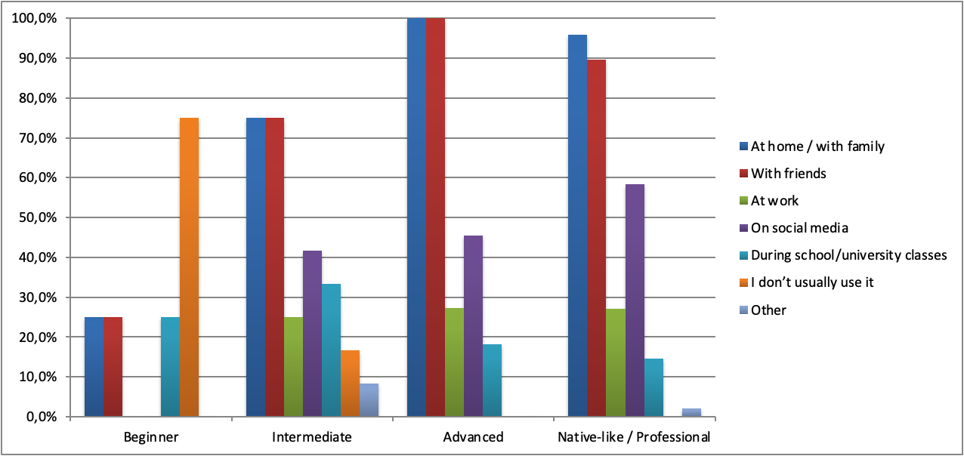
Next, participants were asked to choose emotional contexts in which they prefer using Kazakh. Figure 2, below reveals that native-like proficiency level responders mostly choose Kazakh to show respect while talking with elders ( 87.5% of participants), during humorous conversations (79%) and almost the same amount of participants use it with close friends and to express their national identity (73% and 75%, respectively). From the psycholinguistics perspective, it was interestingly found that only about 44%, less than the majority, choose Kazakh as their “inner” language, i.e. the language they use for thinking. Furthermore, about 15% of native speakers do not associate Kazakh with the given contexts, such as humorous conversations, talking with elders, argumentation, or discussing serious topics, which is quite interesting to investigate. Kazakh advanced and intermediate-level participants mostly choose Kazakh for showing respect to elders and to express their national identity, and least often in emotional contexts, particularly while thinking and being emotional. Lastly, most beginners do not connect Kazakh with any given contexts; however, some beginners do use it to express their national identity (2 of the 5 respondents).
Figure 2

Participants’ usage of the language in different emotional contexts in relation with their proficiency level in Kazakh
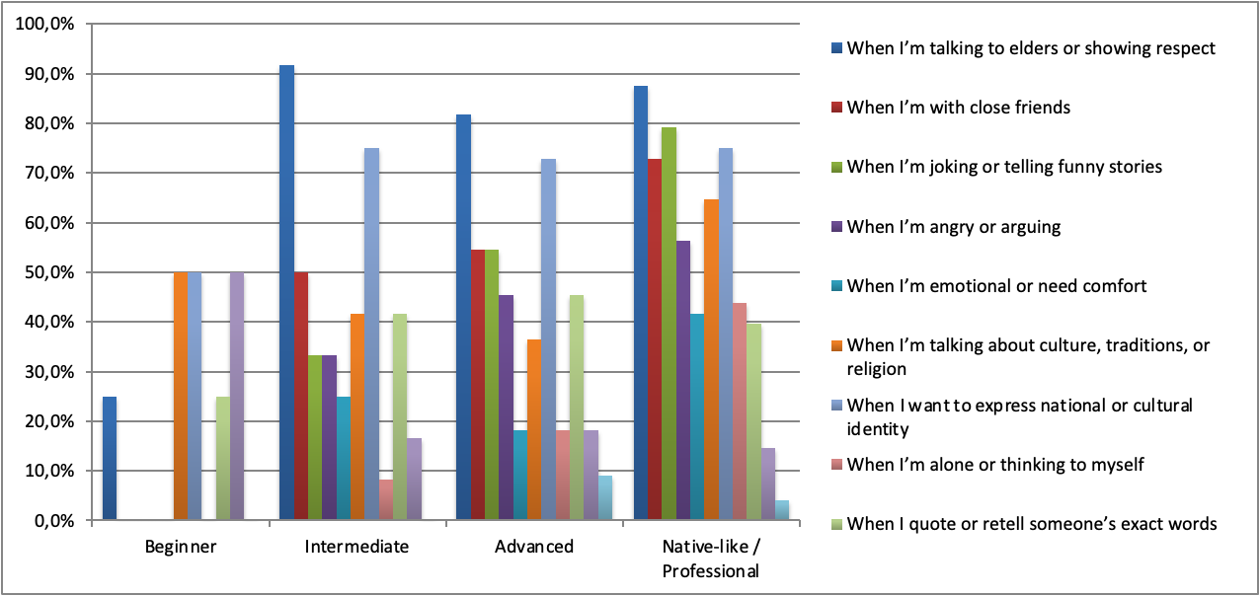
To conclude, Kazakh for all multilinguals is the language of national identity which is mostly used at home, with elders and families. Natives prefer using Kazakh in most of the situations; with friends, while being emotional, joyful or even while being angry. However, as proficiency decreases, the use of Kazakh across different contexts also declines.
Russian language exposure
In comparison with Kazakh, a greater proportion of participants reported advanced-level proficiency in Russian (50%) and native-like proficiency (41%). Notably, Russian showed no beginner-levels, whereas, to recall, there were 5% of Kazakh-beginners. Among the native-like speakers, the majority choose to use Russian all the time (almost 49%); advanced speakers prefer to use it a little bit less frequently, though still often in most daily situations (50%). Interestingly, while intermediate Kazakh speakers report only occasional use of the language, 17% of intermediate Russian speakers, representing the lowest proficiency level recorded for Russian, still choose to use it frequently across most daily situations. At this point, this can support Baiteliyeva’s (2011) findings that because of Russification policies during the USSR, Russian is still being highly used in our country.
The Figure 3 below reveals, native-like speakers of Russian mostly choose this language as the language they use on social media (almost 84%), with friends (77%) and quite the same at home (61%) and at work (58%). As for advanced users, Russian is also the language of communicating with friends, social media and work. Participants with less proficiency level tend to use Russian mostly at work, during university classes or social media. Overall, this might be a broad assumption but according to my results, Russian for Kazakhstani multilinguals is the language that most of the people know, thus is mostly used in a social context (e.g., intermediates try to use it even if they might lack proficiency) rather than with someone with closer ties (such as family and friends).

Figure 3.

Participants’ usage of the language in different situational contexts in relation with their proficiency level in Russian
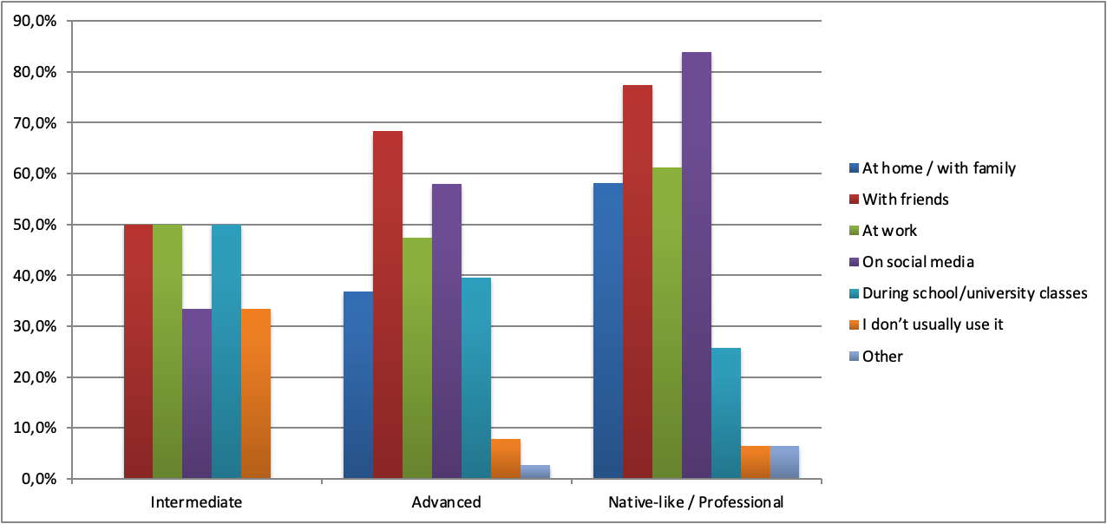
Turning to the language preference in emotional contexts, and compared to the Kazakh usage distribution (as shown in Figure 4 below), Russian functions more like an “emotional” language. Most Russian native-like responders identified Russian as their “inner” language that they use while thinking and as their close friend's interaction language (54%). It is also the language choice for expressing emotions, anger and retelling someone’s stories (cross-social language) for them (about 45%). The least choice was, obviously, for expressing national identity (only 3%).
Interestingly, advanced level responders mostly choose using Russian to retell someone’s stories (about 53%). This findings supports the Ibrayeva et al. (2025) findings that Kazakh-Russian bilinguals tend to mix these two languages, incorporating the grammatical rules of one language to another. To explain, I suppose that narrative retelling and humor are often more automatized in the language associated with informal socialization which causes multilinguals to switch to the language they feel more comfortable in (though for this, it needs to be researched if advanced Russian respondents are also that good in Kazakh). Nevertheless, next distributions are as follows: advanced-Russian participants prefer using Russian when they want to express their anger (47%) and equally the same during funny conversations and as their “inner” language of thinking (32%). Lastly, less proficiency level holders choose Russian equally for retelling someone’s exact words and not associating Russian with any given emotions (50%), suggesting that the relationship between proficiency in a language and its usage is closely interconnected.
Figure 4.

Participants’ usage of the language in different emotional contexts in relation with their proficiency level in Russian
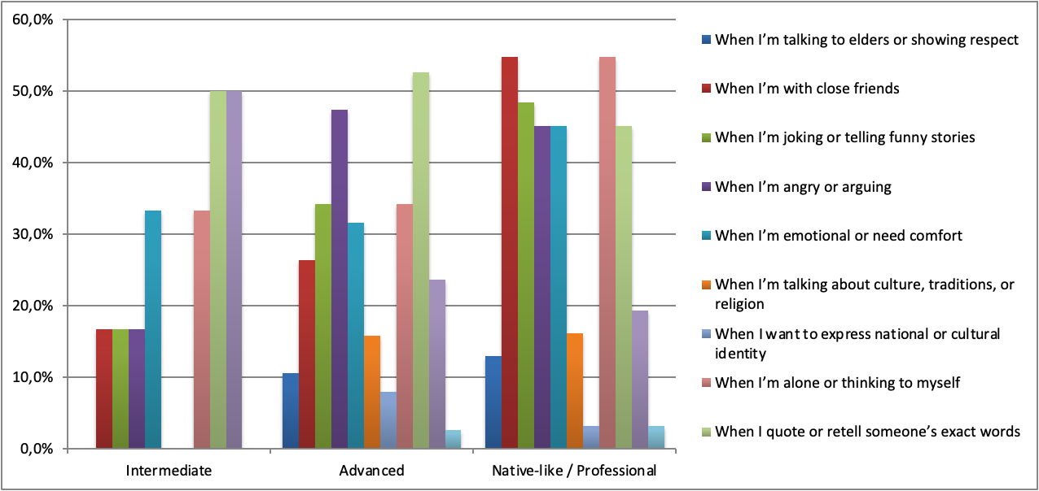
To conclude, the multilingual sample of this research is supposedly bold Kazakh-Russian bilinguals who systematically navigate between the languages. If a multilingual speaker is confident in Russian, they are more likely to use it in social contexts, particularly in interactions involving a wider audience which, in turn, reinforces Russian as the socially recognized and pragmatically unmarked language in such settings.
English language exposure
The last, third language that was considered in this multilingual research project, is English. To recall, the sample were NU students and alumni whose university instruction level is/was English. Accordingly, the majority of participants reported advanced-level proficiency in English (83%), followed by intermediate (9%), native-like (7%), and beginner (1%) levels. In line with this, native-like and advanced level participants selected to use the language often, in most daily situations (80% and 43% of the sample, respectively).
Situationally, Figure 5 shows that advanced level responders (the majority of the overall research sample), use English during school/university classes the most (almost 90%) and on social media (74%). Somewhat lower, though still significant, is the choice of using English at work (43.5%) and with friends (34%). The same ranking of the usage is resulted in native-like and intermediate responders. Accordingly, the least English is chosen at home with family. All in all, as was introduced in the literature review, English in Kazakhstan is significantly introduced as part of the trinity model of education, so English is mostly used in educational settings. Likewise, considering worldwide recognition of English, Kazakhstani multilinguals are also highly using it in social media and with peers in close interactions.
Figure 5.

Participants’ usage of the language in different situational contexts in relation with their proficiency level in English
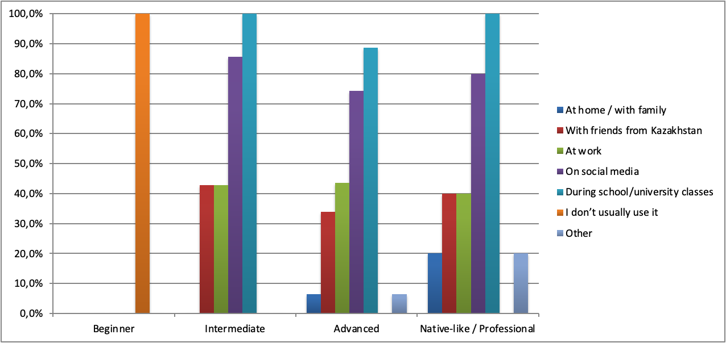
As evident from Figure 6 below, advanced English speakers showed the highest usage while humorous conversations (45%), thinking to themselves (42%), and seeking emotional comfort (41%); intermediate and native-like speakers showed moderately similar distribution. Conversely, English was rarely used when showing respect to elders (3%) or expressing national identity (16%). At the same time, beginner speakers had a single prominent spike in English use when communicating with close friends, the highest recorded across all groups in that category. Across all proficiency levels, English was consistently least used in contexts tied to national identity and elder respect, while informal contexts such as joking and thinking remained among the most common domains for English use.
Figure 6.

Participants’ usage of the language in different emotional contexts in relation with their proficiency level in English
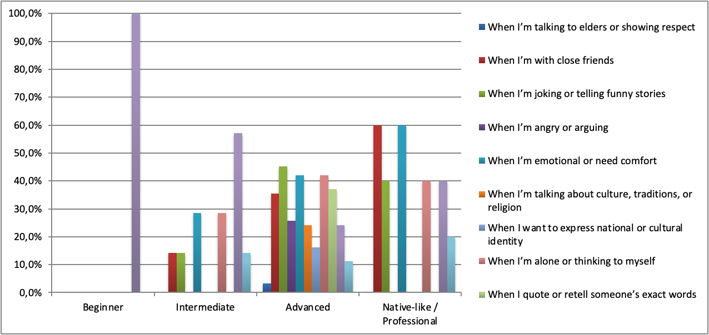
All in all, the findings suggest that English is used as a communication tool for educational purposes, as well as for globally oriented purposes such as communicating in social media and peer interaction. Compared to Kazakh and Russian, multilingual participants of this research prefer using English in internationally oriented contexts rather than in daily personal interactions.
Cross-tabulation Variations
In this part of the Results, to answer RQ2 and RQ3 I conducted the cross-tabulation analysis to see the influence of different variables on the multilinguals’ language preferences in different contexts. The Table 1 below shows the categorisation of six different situational contexts, which presumably could show the participants’ language choices in spontaneous, unexpected settings.
The public contexts include questions about which language participants would prefer using while starting a conversation with strangers and while asking help from strangers, both at a public place. The cognitive contexts are more related to expressive purposes, which include participants’ language choice for arguing and for talking about academic topics. The last category, emotional contexts (or better to say, for personal purposes), where participants were asked to choose the language they prefer for using to calm someone and the language they feel themselves more like “them”.
To note, for the analysis, the questions were written according to the numbering that is presented in Table 1, such as Q1, Q2 and etc., instead of the whole sentences.
Table 1.

Situational questions and their context categories
Public/Transactional contexts | Cognitive/Expressive contexts | Emotional/Identity contexts
Q1: Language you start with when you meet someone new at a public place. | Q3: Language you use for arguing or emphasizing your opinion strongly. | Q5: Language you use for calming or comforting someone.
Q2: Language you start with when you need to ask for help or information. | Q4: Language you use for talking about academic or "serious" topics (study, work, politics). | Q6: Language that feels like the most “you” (or in which you feel like you can express yourself most freely)

Results for RQ2: Household language vs. School language of instruction influence on adult’ language choices
As introduced in the Introduction, one of the research hypotheses is that individual backgrounds play an important role in current language choices across different situations. Thus, to answer for RQ2, I have analyzed the influence of household language and school language of instruction (SLoI) on the participants’ language choice in the contexts given in Table 1 above. Similarly, to examine the extent to which each background factor influences these choices, a regression model was conducted.
Each statistical visualisation of the results for the cross-tabulations is presented in Appendix A to avoid excessive information. Therefore, in the following sections, the findings are presented in written form only.
The influence of household language to the language choices in different situations
Public settings
For Q1 (the language participants initiate with when meeting someone new at a public place), Kazakh was the most frequently chosen language overall, selected by 32 participants compared to 14 who chose Russian. Those who chose Kazakh were nearly 87% from Kazakh-dominant households (KH), almost 28% from Russian-dominant households (RH), and only 15% were from mixed-language households. However, an interesting finding is that among the 14 participants who chose Russian in the same situation, 71% also came from Kazakh-dominant households. This may suggest that while early household exposure strongly shapes preference for Kazakh, Russian as well functions as a socially adaptive language in public interactions, even among those raised in Kazakh-dominant environments.
There was a nearly the same distribution of language choice of Kazakh and Russian for asking strangers for help (Q2). However, here Russian was chosen by a slightly larger group (30 participants) than Kazakh (28 participants). Among those who chose Kazakh for asking for help were 89% from Kazakh-dominant households, about 43% from Russian-dominant ones and the remaining are from bilingual households. The Russians were chosen by 80% KH and by 47% RH.
Cognitive settings
For Q3 (the language participants prefer when arguing or emphasizing their opinion), Russian was chosen by the largest group of 33 participants. Interestingly, among those who chose Russian for arguing, 69.7% came from Kazakh-dominant households. That is, majority of participants raised in Kazakh-speaking homes still preferred Russian when arguing. However, there is an interesting finding that among the 31 participants who chose Kazakh for argumentation, 100% came from Kazakh-dominant households, showing a much stronger alignment between household background and language choice. The English group was the smallest with only 9 respondents, where 77.8% again came from Kazakh-dominant households.
Obviously for RQ4 (language used when discussing academic or serious topics), English was the most common choice with 28 participants, followed by Russian (30 participants) and Kazakh (16 participants). 75% of those who chose English came from Kazakh-dominant households and they still prefer English for academic contexts. Among those who chose Russian for academic purposes, 83.3% came from KH and 60% also reported Russian as a childhood household language, suggesting stronger continuity between household and academic language for this group. Lastly, Kazakh as the least chosen one showed that 16 who selected it came from Kazakh-dominant households, importantly indicating that choosing Kazakh academically requires strong household grounding in the language.
Emotional settings
Responses for the language that comes naturally when comforting someone (Q5) were quite various. So, Russian was chosen by 22 participants, Kazakh by 19, and English by only 6. Of those who chose Russian, 68% reported Russian as a childhood household language and 63% reported KH; Kazakh was chosen by 100% Kazakh-dominant households and only 20% by RH. The "Depends on the person" group was mostly from Kazakh-dominant households (96%), but 43% of them also had Russian as a household language.
For the last question Q6, the language that feels most "you", Kazakh was the most chosen with 40 participants, followed by Russian (23), English (9), and Other (3; they indicated Kazakh-Russian bilingualism). Among those who chose Kazakh, 97.5% came from Kazakh-dominant households, making this the strongest household-to-language alignment in the entire dataset. Among those who chose Russian as their identity language, 69.6% reported Russian as a childhood household language, though, interestingly, 56.5% also came from Kazakh-dominant homes. The English identity group (9 respondents) all came from Kazakh-dominant households, suggesting that those who are from KH prefer choosing Kazakh and English for this case.
The influence of school language of instruction on the language choices in different situations
Primary School
In public settings, Kazakh was the dominant choice across all school language groups. Among those who attended Russian-medium primary schools and chose Russian for public interaction (Q1), 80% came from Kazakh-medium primary schools, and among those who chose Kazakh, 82.1% also attended Kazakh-medium primary schools. For argumentation (Q3), Kazakh-medium primary attendees chose Kazakh at 100%, while Russian-medium attendees also showed a strong Kazakh preference at 72.7%. For academic discussion (Q4), even among Russian-medium primary attendees, 73.3% chose Kazakh, and English-medium primary attendees chose it at 89.3%. For comforting (Q5), Kazakh-medium schoolers chose Kazakh at 94.7%, while Russian-medium attendees were more split between Kazakh (72.7%) and Russian (59.1%). For identity (Q6), Kazakh-medium attendees chose Kazakh at 97.5%, while Russian-medium attendees showed a more mixed pattern with 65.2% choosing Kazakh.
Middle School
The middle school pattern was broadly similar to primary school. In public settings, Kazakh remained the dominant choice, with Kazakh-medium school attendees choosing it at 87% when meeting someone new (Q1) and 82% for asking help (Q2). Russian-medium middle school attendees showed slightly lower Kazakh preference at 83.3% for Q1. For academic discussion (Q4), Kazakh-medium attendees chose Kazakh at 100%, English-medium at nearly 93%, and Russian-medium at 73%. For comforting someone (Q5), Kazakh-medium attendees again strongly chose Kazakh at 94.7%, while Russian-medium attendees were more divided at 77% Kazakh and 59% Russian. For identity (Q6), Kazakh-medium middle school attendees chose Kazakh at 97.5% and English-medium at almost 89%, while Russian-medium showed a lower rate at 69%.
High School
At the high school level, the pattern remained consistently with the Kazakh dominance, though with some variation. To elaborate, Kazakh-medium high school attendees chose Kazakh for public interaction (Q1) at the rate of 84%; English-medium at 62.5%, and Russian-medium at 71.4%. For academic discussion (Q4), Kazakh-medium attendees chose Kazakh at 94%, English-medium at 85%, and Russian-medium at 76%. For argumentation (Q3), Kazakh-medium attendees chose Kazakh at 93%, English-medium at 77%, and Russian-medium at 75%. For comforting someone (Q5), Kazakh remained dominant across all groups, with Kazakh-medium at 89.5%, and Russian-medium at 68.2%. For identity (Q6), Kazakh-medium attendees chose Kazakh as the most comfortable language for themselves at 92.5%, English-medium at 88.9%, and Russian-medium at 65.2%.
Regression Analysis
Now to see which particular background influences the language choice varieties the most, a regression analysis was conducted using Qualtrics Stats iQ. For this analysis, the answers for household language, school languages of instruction and 6 categorical contexts (given in Table 1) were related to each other. The wellness of the results were checked by the R-squared variables. Simply, R-squared shows how much of the participants' language choices can be explained by the background factors. For instance, an R-squared of 12.6% means that only about 13 out of every 100 participants' language choices in public can be predicted from knowing their household language and school background. The remaining roughly 87% of the variation in language choice is explained by other possible factors that were not considered in this project, e.g. peer influence, personal preference, or the specific situation. Values below 0.2 (20%) indicate a low fit, and values above 0.2 indicate a moderate fit.
Public settings
For Q1 (meeting someone new in public), the R-squared was 12.6%, meaning that household language and school language together can only partially explain why participants choose a particular language in this context. However, still, primary school language of instruction was the strongest driver of choosing the language in a given situation of Q1, followed by middle school language, and household language. To elaborate, Kazakh had the highest relative importance (30%) and was chosen by 85% of participants, suggesting that attending a Kazakh-medium primary school is the strongest predictor of choosing Kazakh when meeting strangers. However, again, these predictors were not statistically significant, meaning the results are not for bold conclusions.
Next, for Q2 (asking for help in public), the R-squared was 1.9%, meaning that background factors alone are very poor predictors of language choice in this situation. This actually shows the nature of the situation, i.e. since asking for help is a more spontaneous, context-dependent decision it is harder to predict exactly what background history might drive the person to choose one language or another in that situation.
Argumentative settings
For Q3 (language for arguing), the model explained a moderate proportion of variance (R-squared = 24.8%), making this the best-explained variable among all the situational contexts. In other words, for this research, background factors are more relevant in predicting argumentative language choice than in public or emotional contexts. To explain further, middle school language of instruction was the main driver of choosing a particular language for arguing, being at 93% relative importance. This may suggest that middle school is a particularly formative period for the language people feel most comfortable using in emotionally intense situations like arguing.
Academic settings
For Q4 (language for academic discussion), the model explained a low proportion of variance, where R-squared is 12.1%. Still, Middle school language was the primary driver at 58% relative importance, and household language was secondary at 42%. The most striking results was for Kazakh which was chosen by 87% of participants. The relatively balanced contribution of both middle school and household language here suggests that academic language preference is shaped by both early home exposure and later school socialization.
Emotional comforting context
For Q5 (language for comforting someone), the model, again, explained a low proportion of variance ( R-squared = 7.3%). Household language was by far the primary driver at 85% relative importance, with middle school language playing only a minor role (remaining 15%). I suppose while making an intuitive prediction, the reason for that lies in the fact that emotionally intimate acts, the language of the home, where early emotional bonds are formed, is likely to feel most natural. Kazakh had the highest relative importance at 67% and was reported by 84% of participants.
Identity context
For Q6 (the language that feels most "you"), the R-squared showed the highest value, being 32.3%, suggesting that background factors are most relevant when it comes to predicting identity language. This makes sense, as the language one identifies with most deeply is likely to be strongly tied to early life experiences at home and school. So, household language was the primary driver at 73% relative importance, and middle school language was secondary at 27%. Importantly, having Russian as a household language was the only statistically significant predictor across all six regression models (p < 0.05), with a relative importance of 34%. This means that being raised in a Russian-speaking household is the strongest and most statistically reliable predictor of choosing Russian as one's identity language.
Results for RQ3: Language choice distribution across different situational domains
Change of language choice according to different situations
To examine whether multilinguals’ language choices vary depending on situational and emotional context or whether they remain stable across communicative domains, a five series of cross-tabulations were conducted across six pairs of situational questions. (See Table 1, above.)
The idea for this research method is to see if the language choices would stay consistent in different situations. Table 2, below presents a summary of the key findings of the language distribution across domains. The variable pairs were selected based on two criteria. First, some pairs were chosen to compare contexts where the regression model showed contrasting levels of explanatory drivers. For instance, Q1 (public interaction, R-squared = 12.6%) was paired with Q5 (comforting, R-squared = 7.3%) to see whether participants who initiate in one language in a low-predictability public situation would maintain that same language in an equally unpredictable emotional situation. Second, other pairs were chosen out of personal research interest in seeing how language choice shifts between related domains. To specify, it was my personal interest to see whether the language someone uses for arguing (Q3) connects to the language they feel most themselves in (Q6), or whether academic language (Q4) aligns with identity language (Q6).
Statistically, Appendix B shows the detailed findings for each variable relationship.
Table 2. Summary of cross-tabulation results across situational context pairs
The variables being related | Contexts Compared | Overall results | P-value
Q1 × Q5 | Public vs. Emotional | Participants do not use the same language in public and when comforting someone | 0.575
Q1 × Q3 | Public vs. Expressive | Participants who speak Kazakh in public frequently switch to Russian when arguing | 0.703
Q2 × Q4 | Public vs. Cognitive | Russian speakers in public shift to English in academic contexts | 0.189
Q3 × Q6 | Expressive vs. Identity | The language you argue in is strongly tied to the language you feel most yourself in | 0.0000787
Q4 × Q6 | Cognitive vs. Identity | Kazakh identity speakers do not consistently choose Kazakh academically | 0.0469
The first variables being related examined whether participants who initiate interaction in a particular language in public settings (Q1) maintain that same language when comforting someone emotionally (Q5). It was found that among participants who reported starting with Kazakh in public, only 45.5% also chose Kazakh for emotional comfort, while 33.3% shifted to Russian and 33.3% to English (similar distributional pattern was for Russian). This pattern supports the Adaptive Control Hypothesis, showing that multilinguals’ first language choice in an uncertain setting and emotional language choice operate independently from one another. Thus, even within the same speaker, the language choice varies depending on the situation.
Similar language choice adaptability and unpredictability happened with Q1 x Q3 and Q2 x Q4 cross-tabulation. That is, when observing the relationship between public interaction language and argumentative language it was revealed that participants who initiate in Kazakh in public showed notable shifting when arguing, with 38.9% switching to Russian despite having started in Kazakh. Similarly, the relation between language choice in a public place and academic language preference revealed that participants who use Russian in public tend to shift toward English in academic contexts (44.8%), suggesting that Russian, despite being widely spoken, does not extend naturally into academic domains for this sample. Taken together, it can be seen that multilinguals’ language preferences are closely connected to specific contexts. Moreover, these results can be evident in that as was revealed in the Languages Exposure parts, each language for Kazakshtani multilinguals already have their assigned context of usage (that is, Kazakh for household, Russian for public and English for academic interactions).
However, there are some relations that showed statistically significant connections. Particularly, the relationship between argumentative language and identity language showed that the most comfortable language is more likely to be used in emotionally intense situations (like arguing). For instance, participants who prefer Russian for argumentation chose Russian as the language they feel most themselves in (76%), and those who argue in Kazakh predominantly identified with Kazakh as their identity language (62.8%). This strong relationship aligns with psycholinguistic perspectives on language dominance proposing that cognitively demanding tasks tend to be performed in the language which are internalized the most. Similarly, a statistically significant relationship was found between academic language preference and identity language (though this result should be interpreted with caution as Qualtrics warned that some cells contained insufficient data points). Nevertheless, a statistical percentage showed that participants who feel most themselves in Russian predominantly chose Russian for “serious” and academic discussion (52%), and English identity speakers showed a strong preference for English (55.6%). Interestingly, Kazakh identity speakers were less consistent, with only 39.5% selecting Kazakh for such contexts, the remainder dividing between Russian and English. It can be interpreted that though Kazakh functions as a strong personal and cultural identity language, it does not consistently extend into academic domains.
All in all, multilingual language choice is best understood as a dynamic, context-driven decision, which will be further elaborated in relation to the Adaptive Control Hypothesis in the Discussion section.

Discussion
RQ1: How multilinguals distribute the three languages in different life domains?
The main takeaway from results that can be brought to answer the first research question is that multilinguals of the current sample do not use the languages randomly. Kazakh, Russian, and English, each has a particular role and “assigned” environments.
Among native Kazakh speakers, Kazakh is used by 96% with family, 90% used it with friends, and 87.5% chose it when talking to elders, but the usage dropped significantly the moment the setting became more formal. To recall, only 15% of native speakers chose Kazakh for using it during university classes. Considering the decades of Soviet-era language policy that effectively kept Kazakh out of formal, professional, and academic spaces (Baiteliyeva, 2011; Aliaskar, 2024), this pattern shows that Kazakh native speakers are still experiencing the marks of national Russification.
In contrast, Russian took place as the language of socialisation and emotional expression. Native Russian speakers identified it as the language they think in (54%), the language they use when angry (45%), and the language they naturally reach for when retelling stories or during humorous conversations with friends. The statistics from the RQ2 even show that speakers from Kazakh-dominant households frequently shifted to Russian in public and social settings, meaning that Russian functions as a kind of socially acceptable language as they choose it to fall back on when they are unsure who they are talking to or what register is appropriate.
Lastly, English turned out to have a more predictable role, being used in educational settings (90%) and on social media (74%). Very few participants connected English to emotional or identity-based contexts, only 3% used it with elders, and 16% associated it with national identity. Recalling back to the research sample who were NU students and alumni, the English context distribution is not particularly surprising. However, it is worth mentioning that during high school more participants indicated the English school language of instruction, so, probably because of this the second usage happened to be ‘on social media’. Moreover, as Rakhymbayeva (2022) describes, English in Kazakhstan was designed through the "Trinity of Languages" policy, so it can be a tool for the younger generation to compete in a global arena, and that is essentially what it remains for the current generation.
Overall, it can be concluded that Kazakh is mostly used in family ties and in expressing the national, personal identity. Consequently, Russian belongs to social interaction and emotional expression, while English belongs to education and the internet. These findings provide great evidence for the Adaptive Control Hypothesis (Green & Abutalebi, 2013), proving that bilinguals (in this case, multilinguals) do not use their languages randomly but adapt their language choices to the recurring patterns and demands of different communicative situations.
RQ2: How family and school languages shape the language choices in adulthood
For this research question, it was generally found that both, the language that participants were the most surrounded with during childhood and the language they were studied, do influence the languages they choose in spontaneous conversations and situations. As participants were given three categories of situations, conversation in a public setting, academic setting and for personal purposes, the background factors were found to have varying degrees of influence depending on the context.
To begin, household language was the strongest driver of language choice in emotionally personal contexts. For the question of which language feels most "you" (Q6), household background accounted for 73% of the explanatory power in the regression model, and the overall R-squared of 32.3% was the highest recorded across all six contexts. In other words, the language spoken at home during childhood is the one that most strongly shapes the language a person identifies himself/herself with as an adult. For instance, among those who chose Kazakh as their identity language, 97% came from KH and those who have grown up in a Russian-speaking household reliably predicted (p-value < 0.005) choosing Russian as one's identity language in adulthood. This can greatly be an evidence of Cummins's (1979) Interdependence Hypothesis that says that the first language of the home is the foundation on which later linguistic and cognitive development is built, and the language that tends to feel the most emotionally authentic throughout life.
The second background factor, the language of school instruction, showed interestingly various results. It should be mentioned that SLoI consisted of three variables, particularly primary, middle and high schools, where primary and middle school languages kept consistently the dominant language of instruction (which was Kazakh). Nevertheless, middle school emerged predominantly as the most driving variable for language choice among all these three educational stages. To expand, for the argumentative context (Q3), which was the best-predicted situation overall (R-squared = 24.8%), middle school language of instruction was the dominant driver at 93% relative importance. It suggests that the language in which people first learn to argue, debate, and defend a point of view tends to stick with them as the preferred language for high-stakes, cognitively demanding expression later in life.
Overall, considering the results that were presented, it can be said that household languages are mostly dominant in emotional and personal contexts. If the person was raised in KH, it is most likely that they will choose Kazakh when they would calm someone (85% of the fit), ask for help (69%) and to identify themselves (73%). Conversely, school language drives public and cognitive contexts, so it was 93% fit for the language participants would choose for arguing, 82% for meeting someone new and 58% for discussing academic topics.
However, it is important to mention that for most of the six situational contexts, the regression models explained less than 20% of the variation in participants' language choices. That is, while household and school background do matter, most of what drives a person's language choice in any given moment cannot be predicted from their background alone. Other factors that were not considered in this project, such as peer influence, personality, the language of the person they are talking to, and the specific social dynamics of the situation all play important roles that this study was not designed to capture. This finding is actually consistent with Lai and O'Brien's (2020) conclusion that in multilingual societies, self-reported language background and engagement in different language contexts do not reliably predict actual language switching behaviour. It is a reminder that language use is fundamentally a live, responsive, social and spontaneous activity rather than something fixed for all domains.
RQ3: Does language choice shift across domains, or stays consistent?
Simply, this research question aims to investigate if the Kazakhstani multilinguals stay consistent in their language choices in different situations. Considering the constant prone to code-switching of our participants, the answer for this research question confirms the shifting of the languages.
The clearest example of this was the statistical finding between public language and emotional language. Among participants who reported starting a conversation in Kazakh with a stranger (Q1), only 45% also chose Kazakh when asked to comfort someone emotionally (Q5). It simply means that the language you open with when you meet someone new is not the same language that comes naturally when you are trying to console a friend. A similar shift was visible in the public-versus-argumentative pairing. Those who initiated in Kazakh in a public setting switched to Russian for arguing at a rate of nearly 39%, showing that even if you will be a strong Kazakh speaker it is more likely for you to use Russian in opinion-expression and confrontation. Again, this possibly related to Russian's historical role as the language of formal debate, journalism, and official discourse in Kazakhstan. Meanwhile, participants who used Russian in public shifted toward English in academic contexts (44.8%), meaning that Russian does not naturally extend into the academic domain for such an English-medium-university sample.
The fact that multilinguals often shift between the languages can actually be evident of the psycholinguistic nature of knowing various languages. As was discussed in literature review, when multilinguals start to use their languages, all the languages in the brain are activated, i.e. non-selective activation model proposed by Schwieter (2024). All the pairs that showed shifting can be evident of this. However, there was one statistically significant link between the variables, namely the language used for arguing (Q3) and the language that feels most "you" (Q6), which shows stability of the language choice. Simply, participants who argued in Russian identified with Russian as their personal language 76% of the time; those who argued in Kazakh identified with Kazakh 62.8% of the time. This makes intuitive sense from a psycholinguistic perspective that as argumentation requires the most cognitively demanding communicative acts, such as quick access to vocabulary, the ability to construct complex sentences under pressure, and the fluency to hold a train of thought, people tend to do this best in the language they are most deeply embedded in.
To conclude, Kazakhstani multilinguals do not make one language per one context or setting. The languages are shifted, adapted, and recalibrated depending on who participants are talking to, what they are trying to express, and how cognitively or emotionally demanding the situation is. It can be said that the language shifting is not a sign of linguistic instability or confusion, but rather, as the psycholinguistic evidence suggests, it is the natural outcome of having multiple fully activated language systems available at any moment.

Conclusion
This study was designed to understand how multilingual speakers in Kazakhstan navigate the three primary languages, Kazakh, Russian and English. This included investigating what drives the language choices in different situations and understanding in what domains the languages are mostly used within. Firstly, it was found that each languages has their assigned environments, namely, Kazakh is the language of home and identity, Russian is the socially flexible language of public and emotional life, and English is the language of education and digital spaces. Secondly, household language proved to be the stronger predictor of personal and emotional language choices, while school languages of instruction were the dominant drivers of argumentative expression. Together, these findings suggest that who you are linguistically as an adult is shaped by a combination of where you grew up, where you were schooled, and what each situation demands of you in the moment.
However, considering the time limitation and my current level of education, several limitations should be acknowledged for future research. Significantly, the sample was drawn exclusively from Nazarbayev University students, which limits generalisability to the broader Kazakhstani population. Also, the study relied entirely on self-reported preferences rather than naturalistic speech data. That is why, it would be beneficial for the future research to conduct interviews, collect spoken data, build a larger and more regionally and gender-balanced sample, and record real conversations rather than relying on self-reported preferences alone. Consequently, as there was a lack of qualitative data, it was challenging to reflect on the questionnaire question. Apparently, some questions had inconsistent and wrong answer choice variations which created further problems during the analysis. For instance, the question related to the participants' household language had a ‘check all that apply’ function so people could choose Kazakh, Russian and mixed options separately, as well as indicate both Kazakh and Russian, making it confusing to see if participants had bilingual or totally one-langauged environments.
Despite these limitations, this study offers meaningful evidence that the Adaptive Control Hypothesis extends to trilingual contexts, that individual background can enormously affect the languages that the one would feel himself/herself the most comfortable with. Moreover, the research provides extensive evidence of the current state of the Kazakh language in such a multilingual society.

References
Aliaskar, A. S. (2024). Challenges of bilingualism: Code-switching and language dominance in the context of Kazakhstan. Bulletin of the Eurasian Humanities Institute, 2, 7 - 15. https://doi.org/10.55808/1999-4214.2024-2.01
Baiteliyeva, Z. (2011). Multilingualism in Kazakhstan and problems of teaching the Kazakh language [Unpublished master’s thesis]. Nazarbayev University School of Sciences and Humanities.
Belova, X. (2017). Learners’ Language Use in Communication in a Multilingual Learning Environment [Unpublished master’s thesis]. Nazarbayev University School of Sciences and Humanities.
Broersma, M., & De Bot, K. (2006). Triggered code-switching: A corpus-based evaluation of the original triggering hypothesis and a new alternative. Bilingualism: Language and Cognition, 9(1), 1 - 13. https://psycnet.apa.org/doi/10.1017/S1366728905002348
Bureau of National Statistics of the Agency for Strategic Planning and Reforms of the Republic of Kazakhstan.(2025, March 27). Population of the Republic of Kazakhstan by individual ethnic groups and age groups (at the beginning of 2025). https://stat.gov.kz/en/industries/social-statistics/demography/publications/337150/
Clyne, M. G. (2003). Dynamics of language contact: English and immigrant languages. Cambridge University Press.
Costa, A., A. Colomé, A., & Caramazza. (2000), 21 (2). Lexical access in speech production: The bilingual case. Psicológica 21. 403 - 437. http://www.redalyc.org/articulo.oa?id=16921211
Cummins, J. (1979). Linguistic interdependence and the educational development of bilingual children. Review of Educational Research, 49(2), 222 - 251. https://doi.org/10.3102/00346543049002222
Foster, M. (2017). Imagining the Shala-Kazakh: Codeswitching and satire in Post-Soviet Kazakhstan [Published master’s thesis]. The University of Texas at Austin.
Genesee, F. (2008). Bilingual first language acquisition: Evidence from Montreal. Diversité Urbaine, 9 - 26. https://doi.org/10.7202/019559ar
Goodman, B. A., & Tastanbek, S. (2020). Making space for translanguaging in higher education: A case study of multilingual pedagogies. TESOL Quarterly, 54(1), 129 - 154. https://doi.org/10.1002/tesq.571
Green, D. W. (2018). Language control and code-switching. Languages, 3(2), 1 - 16 https://doi.org/10.3390/languages3020008
Green, D., & Abutalebi, J. (2013). Language control in bilinguals: The adaptive control hypothesis. Journal of Cognitive Psychology, 25(5), 515–530. https://doi.org/10.1080/20445911.2013.796377
Goldrick, M., Putnam, M., & Schwarz, L. (2016). Coactivation in bilingual grammars: A computational account of code mixing. Bilingualism: Language and Cognition, 19(5), 857–876. https://doi.org/10.1017/S1366728915000802
Ibrayeva, Z., Nabiyeva, G., Aldasheva, K., Rivers, W. P., Dossanova, A., & Bainiyeva, K. (2025). Bilingualism in Kazakhstan: Linguistic challenges and error patterns in Kazakh speech. Forum for Linguistic Studies, 7(9), 1–12. https://journals.bilpubgroup.com/index.php/fls
Kurmanova, B. Zh., Utegenova, A., Sultaniyazova, I. S., Khassanov, G. K., Almagambetova, N. A., & Abdigazi, S. Kh. (2023). Multilingual practices in the students’ microcommunity. International Journal of Society, Culture & Language, 11(1), 146 - 159. https://doi.org/10.22034/ijscl.2022.1978443.2862
Kuzyk, O., Friend, M., Sewerdija, V., Zesiger, P., & Poulin-Dubois, D. (2020). Are there cognitive benefits of code-switching in bilingual children? A longitudinal study. Bilingualism: Language and Cognition, 23(3), 542 - 553. https://doi.org/10.1017/S1366728918001207
Lai, G., & O'Brien, B. A. (2020). Examining language switching and cognitive control through the Adaptive Control Hypothesis. Frontiers in Psychology, 11, 1 - 21. https://doi.org/10.3389/fpsyg.2020.01171
Mabule, D. R. (2015). What is this? Is it code switching, code mixing or language alternating? Journal of Educational and Social Research, 5(1), 339–350. https://doi.org/10.5901/jesr.2015.v5n1p339
Mukanova, K. (2025). To switch or not to switch: Functions of code-switching in Kazakh direct reported speech [Unpublished Captone Project]. Nazarbayev University School of Sciences and Humanities. https://nur.nu.edu.kz/handle/123456789/8452
Mulaudzi, I. C., Makhwathana, R. M., & Nndwamato, N. M. (2026). Unlocking language potential: How mother tongue shapes English acquisition in rural Grade 1 classrooms of South Africa. Forum for Linguistic Studies, 8(1), 1–17. https://doi.org/10.30564/fls.v8i1.12390
Muysken, P. (2000). Bilingual speech: A typology of code-mixing. Cambridge: Cambridge University Press.
Rakhymbayeva, N. (2022). Language choice and language ideologies among Kazakhstani students: The status of kazakh in the context of multilingual education [Upublished mater’s thesis. Nazarbayev University School of Sciences and Humanities.
Riehl, C. M. (2005). Code-switching in bilinguals: Impacts of mental processes and language awareness. In J. Cohen (Ed.). Proceedings of the 4th International Symposium on Bilingualism (pp. 1945-1959). Cascadilla Press. http://www.lingref.com/isb/4/151ISB4.PDF
Sadulova, Z., Karimsakova, B., Yessenova, K., Kamarova, N., Kurmanova, B., Smagulova, K., Karagulova, B., & Amangaziyeva, M. (2025). Bilingualism and multilingualism in Kazakhstan: Sociolinguistic and educational perspectives. Forum for Linguistic Studies, 7(7), 1–11. https://journals.bilpubgroup.com/index.php/fls
Schwieter, J. W. (2024). Bilingual language processing. In Oxford Research Encyclopedia of Linguistics. 1- 23 10.1093/acrefore/9780199384655.013.370
Smagulova, J. (2008). Language policies of kazakhization and their influence on language attitudes and use. International Journal of Bilingual Education and Bilingualism, 11 (3&4), 440–475. http://dx.doi.org/10.1080/13670050802148798
Vogel, S., & García, O. (2017). Translanguaging. In Oxford Research Encyclopedia of Education. Oxford University . https://doi.org/10.1093/acrefore/9780190264093.013.181
Zharkynbekova, S. (2018). On the formation of socio-cultural identity of ethno-lingual processes in Kazakhstan. In WUT2018: IX International Conference “Word, Utterance, Text: Cognitive, Pragmatic and Cultural Aspects”. The European Proceedings of Social & Behavioural Sciences. 407 - 415 https://www.europeanproceedings.com/article/10.15405/epsbs.2018.04.02.58

Appendix A
Cross-tabulation Results for Household Language and School Langugae of Instructions influence on the laguage choices

https://drive.google.com/drive/folders/1CyF7EQq0kMayELzXk-IDXOpcwDYSHdQd?usp=sharing
Link 1A. Findings for RQ2

Appendix B
Chi-Squared Test Results for Situational Language Choice Cross-Tabulations

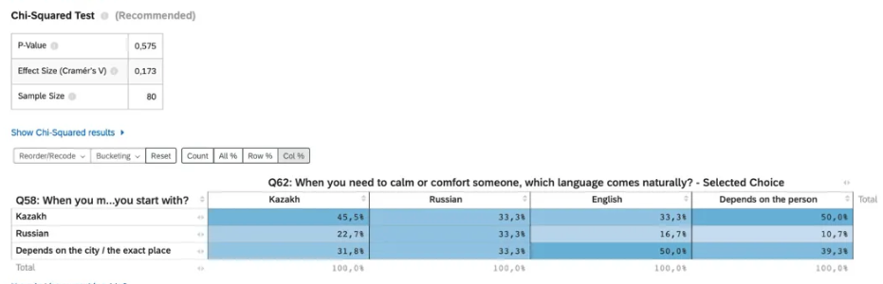
Table B1. Q1 × Q5: Public vs. Emotional Context

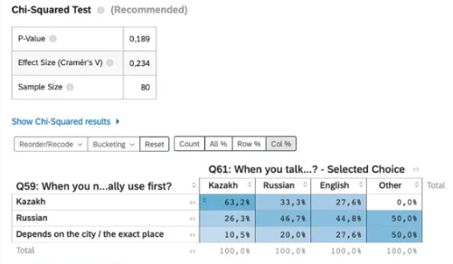
Table B2. Q1 × Q3: Public vs. Expressive Context
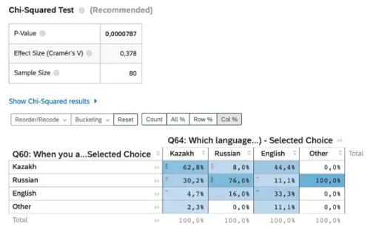
Table B3. Q2 × Q4: Public vs. Academic Context
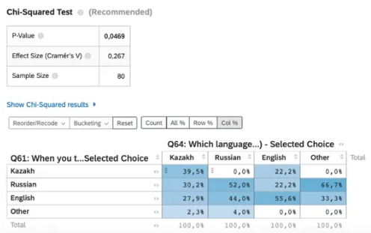
Table B4. Q4 × Q6: Academic vs. Identity Context
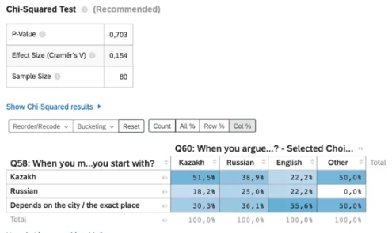
Table B5. Q3 × Q6: Expressive vs. Identity Context

