

COMPUTATIONAL ANALYSIS AND CLASSIFICATION OF VITAMIN D RECEPTOR LIGANDS

SEIDALIYEVA ADELIYA

A THESIS SUBMITTED
FOR THE DEGREE OF MASTER OF LIFE SCIENCES, DEPARTMENT OF BIOLOGY, SCHOOL OF SCIENCES AND HUMANITIES, NAZARBAYEV UNIVERSITY

2026


Student
Adeliya Seidaliyeva 13/04/2026

Student’s Supervisor/Advisor
Ferdinand Molnár 13/04/2026

DECLARATION

I hereby declare that the thesis is my original work and it has been written by me in its entirety. I have duly acknowledged all the sources of information which have been used in the thesis. This thesis has also not been submitted for any degree in any university previously.

ACKNOWLEDGEMENTS

I would like to express my sincere gratitude to my supervisor, Ferdinand Molnár, for his guidance, support, and valuable advice throughout the course of this work.
I am deeply grateful to my parents and friends for their kindness, motivation, and emotional support, which helped me throughout this period.
I would also like to thank my classmates from the Life Sciences program for their support, shared experiences, and encouragement throughout this academic journey.

LIST OF TABLES

- Table 1. Structure and description of variables in the curated VDR ligand dataset.

- Table 2. Distribution of Lipinski’s and Veber’s rule violations.

- Table 3. Compliance with individual drug-likeness criteria.

- Table 4. Kruskal–Wallis test for differences in NP-score among structural categories.

- Table 5. Dunn’s post hoc pairwise comparisons of NP-score among structural categories following the Kruskal–Wallis test.

- Table 6. Pairwise Tanimoto similarity statistics for the VDR ligand dataset across different fingerprint representations.

- Table 7. Intra-category structural compactness based on Tanimoto distance across fingerprint representations.

- Table 8. Clustering performance metrics for VDR ligands across fingerprint types and similarity thresholds.

- Table A1. Shapiro–Wilk normality test for NP-score within each structural category.

- Table A2. Levene’s test for homogeneity of variance of NP-score across structural categories.

LIST OF FIGURES AND ILLUSTRATIONS

- Figure 1. Molecular basis of vitamin D signaling.
- Figure 2. Structure of 1α,25(OH)₂D₃ and its most prominent analogues.
- Figure 3. Distribution of VDR ligands across structural categories.
- Figure 4. Distribution of physicochemical descriptors of VDR ligands. (a) MW, (b) TPSA, (c) Heavy Atoms, (d) LogP, (e) HBA, (f) HBD, (g) Number of RotB, (h) Number of rings and (i) Number of stereo centers.
- Figure 5. Natural product–likeness profiles of VDR ligands.
- Figure 6. t-SNE projections of the chemical space of the VDR ligand library colored by category for four molecular fingerprint types: (a) ECFP4, (b) ECFP6, (c) AtomPair, and (d) RDKit topological.
- Figure 7. UMAP projections of the chemical space of the VDR ligand library colored by compound category for four molecular fingerprint types: (a) ECFP4, (b) ECFP6, (c) AtomPair, and (d) RDKit topological.
- Figure 8. Kernel density estimation plots showing the distribution of physicochemical descriptors of VDR ligands across structural categories: (a) logP, (b) Heavy Atoms, (c) HBA, (d) HBD, (e) MW, (f) TPSA, and (g) number of RotB.
- Figure 9. Distribution of physicochemical descriptors across structural categories of the VDR ligand library, presented as boxplots. (a) logP, (b) Heavy Atoms, (c) HBA, (d) HBD, (e) MW, (f) TPSA, and (g) number of RotB.

ABBREVIATIONS

ARI | Adjusted Rand Index
DBD | DNA-binding domain
ECFP | Extended Connectivity Fingerprint
HBA | Hydrogen bond acceptors
HBD | Hydrogen bond donors
InChI | International Chemical Identifier
KDE | Kernel density estimation
LBD | Ligand-binding domain
LogP | Lipophilicity coefficient
MW | Molecular weight
NMI | Normalized Mutual Information
NP-likeness | Natural product-likeness
PCA | Principal component analysis
RXR | Retinoid X receptor
SMILES | Simplified Molecular Input Line Entry System
TPSA | Topological polar surface area
t-SNE | t-distributed stochastic neighbor embedding
UMAP | Uniform Manifold Approximation and Projection
UV-B | Ultraviolet B radiation
VDR | Vitamin D receptor
VDREs | Vitamin D response elements

TABLE OF CONTENTS

DECLARATION II
ACKNOWLEDGEMENTS III
LIST OF TABLES IV
LIST OF FIGURES AND ILLUSTRATIONS V
ABBREVIATIONS VI
ABSTRACT 1
1. INTRODUCTION 2
1.1 Biological significance of vitamin D signaling in human health 2
1.2 Vitamin D receptor as a molecular target 2
1.3 Structural diversity and functional complexity of VDR ligands 4
1.4 Role of computational and chemoinformatics approaches in VDR ligand research 5
2. AIMS OF THE THESIS PROJECT 7
3. MATERIALS AND METHODS 8
3.1 Ligand structure preparation and standardization 8
3.2 Calculation and validation of physico-chemical descriptors 8
3.3 Evaluation of natural product–likeness 9
3.4 Molecular Fingerprints 10
3.5. Similarity analysis, structural diversity and clustering of VDR ligands 10
3.5.1. Similarity analysis 10
3.5.2 Clustering analysis 11
3.6 Physicochemical property analysis across structural categories 12
4. RESULTS 13
4.1. Curation and general characterization of the VDR ligand dataset 13
4.2. Molecular property profiling of VDR ligands 14
4.2.1 Physicochemical descriptor distribution 14
4.2.3 Natural product–likeness analysis 16
4.3. Similarity, clustering, and chemical space organization of VDR ligands 18
4.3.1 Fingerprint-based similarity analysis 18
4.3.2 Clustering patterns of VDR ligands 19
4.3.3 Visualization of chemical space 20
4.4. Association between structural classes, clusters, and biological annotation 22
5. DISCUSSION 26
6. CONCLUSION 28
REFERENCES 29
Appendix 33

Nazarbayev University, School of Sciences and Humanities, Department of Biology Master´s Degree Program in Life Sciences
Adeliya Seidaliyeva: Computational Analysis and Classification of Vitamin D Receptor Ligands
Master of Science thesis; 41 pages, 2 appendixes
Supervisor: Assoc. Professor Ferdinand Molnár, PhD, Department of Biology, School of Sciences and Humanities, Nazarbayev University
13. 04. 2026
Keywords: vitamin D receptor, VDR ligands, chemoinformatics, molecular fingerprints, clustering, chemical space, natural product-likeness, physicochemical descriptors

ABSTRACT
The vitamin D receptor (VDR) is a ligand-dependent nuclear transcription factor that plays a key role in regulating calcium homeostasis, immune processes, and cellular differentiation, and is a recognized target in drug development. Despite the large number of described VDR ligands, so far there has been no standardized collection with computational annotation suitable for system analysis. In this work, a curated dataset was formed and characterized, including 962 VDR ligands divided into four structural categories: analogues, metabolites, hybrid compounds and non-secosteroidal compounds, digitized based on the Maestro and Seoane catalog. A comprehensive chemoinformatic approach was used for the analysis, including the calculation of physico-chemical descriptors, the index of similarity to natural compounds, as well as four types of molecular fingerprints. Next, similarity analysis, clustering using the Butina algorithm, and visualization of the chemical space using t-SNE and UMAP methods were performed. The results showed that the studied set occupies a relatively compact and predominantly lipophilic chemical space, largely determined by the common secosteroid framework. At the same time, non-secosteroidal ligands are clearly separated on the projections of the chemical space, which confirms their belonging to a structurally distinct chemotype. The formed data set and the proposed multi-level analytical approach. In addition, the analyzed data set based on various types of molecular fingerprints forms a reproducible basis for further modeling the activity of VDR ligands, studying the structure–activity relationship, and rationally designing new analogues.

INTRODUCTION

Biological significance of vitamin D signaling in human health
Vitamin D is a fat-soluble secosteroid that acts as a precursor to the hormonal signaling system, which is important for human physiology [1]. Although vitamin D can come from food and dietary supplements, its main source in humans is endogenous synthesis in the skin under the influence of ultraviolet B radiation (UVB) [2]. After sequential hydroxylation in the liver and kidneys, vitamin D is converted to its biologically active form, 1α,25-dihydroxyvitamin D₃ (1,25(OH)₂D₃, calcitriol), which implements its effects mainly through binding to the vitamin D receptor (VDR) [1].
Vitamin D signaling is necessary for normal bone mineralization, absorption of calcium in the intestine and its reabsorption in the kidneys. Disruption of at least one of these processes leads to the development of well-known diseases such as rickets and osteomalacia [3]. It is also worth noting that vitamin D is involved not only in classical bone effects, but also affects immune responses, processes of cell proliferation, differentiation and apoptosis [4].
In recent years, there has been an increasing number of studies confirming the relationship between vitamin D signaling pathway deficiency and an increased risk of developing chronic diseases, including autoimmune pathologies, cardiovascular diseases, and certain types of malignancies [5]. These observations are supported by molecular studies showing that vitamin D regulates the expression of genes involved in inflammation, immune tolerance, and cell cycle control. Thus, vitamin D is currently considered as a hormone with a wide spectrum of action involved in the systemic regulation of physiological processes, and not only as a factor of mineral metabolism.

Vitamin D receptor as a molecular target
The vitamin D receptor is a key molecular target of the vitamin D signaling pathway and functions as a ligand-dependent transcription factor of the nuclear receptor family. Through binding to the active form of vitamin D, 1α,25-dihydroxyvitamin D₃, VDR transmits a hormonal signal to the gene expression regulation system. VDR expression is found not only in classical target tissues associated with calcium-phosphate metabolism, but also in keratinocytes, dermal fibroblasts, immune cells, and a number of other cell types, reflecting the broad physiological spectrum of vitamin D action [6,7].
Structurally, the VDR has a modular organization and includes an N-terminal domain, a highly conserved DNA binding domain (DBD), a hinge region, and a ligand binding domain (LBD) [8]. DBD contains two zinc fingers: the first provides specific recognition of vitamin D response elements (VDRE) in DNA, while the second is involved in the formation of a heterodimer with retinoid X receptor (RXR). LBD, in turn, contains a ligand-binding pocket and an AF-2 activation surface. The latter is formed mainly by H3, H4, and H12 helices, and ligand binding stabilizes the position of helix 12 and thereby creates conditions for the recruitment of coactivators. As shown in Figure 1, the functional activity of VDR is determined by the coordination of four interrelated processes: binding to DNA, ligand binding, heterodimerization with RXR, and interaction with coactivators [9].
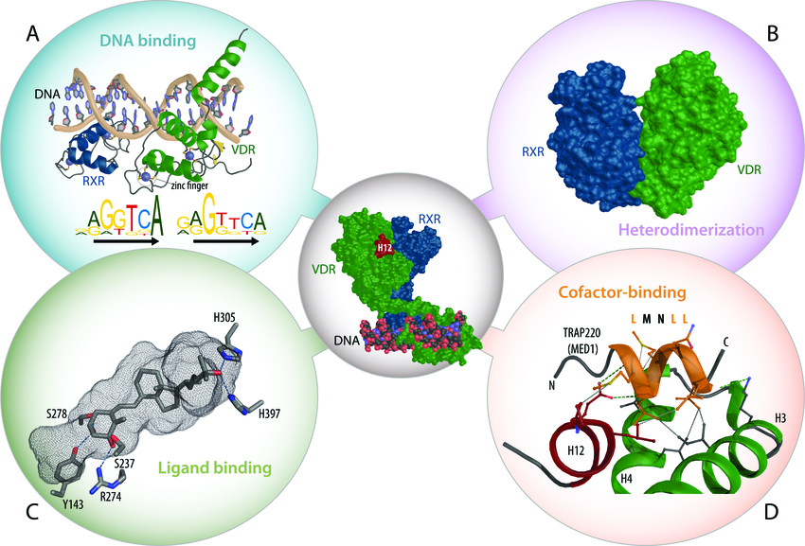
Figure 1. Molecular basis of vitamin D signaling [3]

Of particular importance is the hinge region, which should not be described as just a "flexible area" between DBD and LBD. Structural data show that in VDR, this region performs a spatially organizing function: as part of the RXR–VDR–DNA complex, the hinge region has a pronounced spiral character, connects the DBD associated with the 3'-site of the response to the LBD located at the 5'-end of the response element, and holds the receptor complex in an open conformation, available for binding coregulators [10]. Additional mutational data confirm that the hinge region acts as a linker of a strictly defined length: the removal of only five amino acids in its C-terminal part already significantly reduces the transcriptional activity of the VDR, which indicates its functional role as a structural spacer element rather than a passive connector [11].
Genomic studies show that VDR regulates a wide range of target genes, with the specific response profile depending on the cell type, chromatin environment, ligand availability, and composition of coregulatory complexes [6,7]. Therefore, VDR should be considered not only as a receptor for vitamin D, but also as a context-dependent molecular platform in which the structural organization is directly related to the functional output of the signal [9].

1.3 Structural diversity and functional complexity of VDR ligands
VDR ligands are a structurally heterogeneous group of compounds. In addition to the natural hormone 1α,25-dihydroxyvitamin D₃ (calcitriol), these include its metabolites, numerous synthetic analogues, hybrid structures, and non-secosteroidal ligands [12]. As can be seen in Figure 2, the main directions of chemical modification affect the A-ring, CD fragment and side chain of the molecule, those areas that most determine the binding to the receptor and the biological response [9].
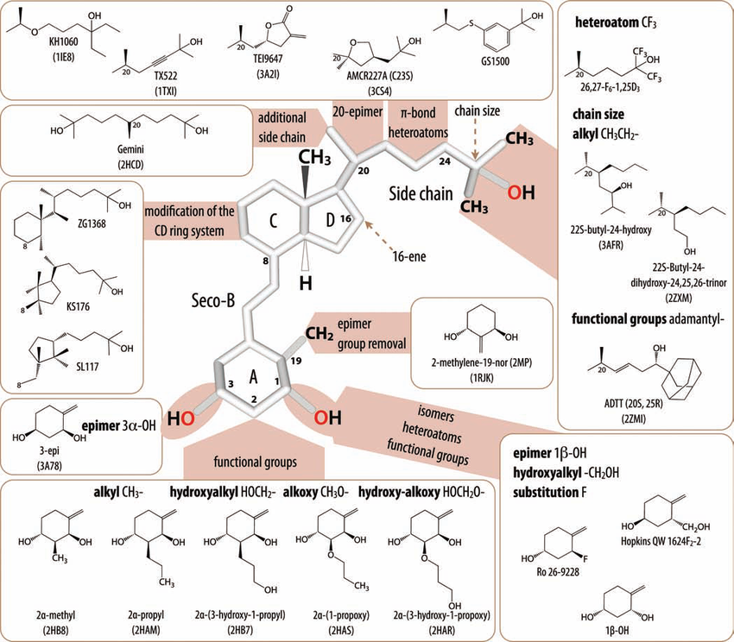
Figure 2. Structure of 1α ,25(OH)₂D₃ and its most prominent analogues [13]

Even small changes in the structure of VDR ligands can lead to noticeable functional differences. The side chain modifications, introduction of heteroatoms, fluorine, additional double or triple bonds, as well as epimerization of individual centers can change the configuration of the ligand–receptor complex and affect transcriptional activity [9]. Also, such changes have been used to produce compounds with higher activity, increased metabolic stability, or reduced calcemic effect [14].
The functional complexity of VDR ligands is related not only to their ability to bind to the receptor, but also to the conformational changes they induce after binding. Different ligands differently stabilize the ligand-binding domain of the VDR and the AF-2 region, which is necessary for interaction with coactivators [9]. Structural studies have shown that the exact positioning and stabilization of helix 12 are critical determinants of receptor activation state [15]. Moreover, individual vitamin D analogues recruit VDR coactivators differently and the selectivity of analog action is determined not only by affinity to the receptor, but also by the tissue context, metabolism, and regulatory interactions [16,17].
Non-secosteroidal VDR ligands create an additional level of diversity. Non-secosteroidal modulators can exhibit tissue selectivity and reduced calcemic effect [18], and the derivatives of lithocholic acid are also able to selectively activate VDR [19]. Thus, VDR ligands should be considered not as a single class of molecules, but as a wide range of compounds in which structural differences are directly related to differences in biological activity, selectivity, and pharmacological profile.

1.4 Role of computational and chemoinformatics approaches in VDR ligand research
The structural diversity of ligands requires computational analysis to identify features that determine agonistic or antagonistic activity [20]. The conversion of molecules into string machine readable formats such as simplified molecular input line entry system (SMILES) or using standardized chemical identifiers for instance InChI provides structured data storage and mapping. Physicochemical descriptors, like molecular weight (MW), lipophilicity coefficient (logP), topological polar surface area (TPSA), and hydrogen bond donors (HBD) and acceptors (HBA) are used to evaluate pharmacokinetic properties [5]. Chemical structure fingerprints such as Morgan/ECFP or MACCS made it possible to identify common structural relations and can be used to perform clustering for identifying structural similarities [20,21]. Various visualization methods such as principal component analysis (PCA), t-distributed stochastic neighbor embedding (t-SNE), uniform manifold approximation and projection (UMAP) and Kernel density estimation (KDE) help with dimensional reduction and provide distribution of various properties [22]. Docking, molecular dynamics and machine learning expand the understanding of the interaction of VDR with its ligands and increase the accuracy of predictions [23,24].
Despite the large number of publications, most VDR ligands studies are descriptive in nature and do not provide standardized databases. For example, Maestro and Seoane catalogued 1,778 ligands but did not create an accessible digital database [12]. The lack of unified SMILES/InChI and incomplete information about their physicochemical properties limit large scale comparative analysis. Even modern research, such as the classification of VDR agonists and antagonists using machine learning uses limited datasets [20]. Systematic clustering and visualization of the chemical space of ligands remain rare, despite the proven effectiveness of these methods [22].
A unified computing framework is needed for the organization, analysis, and visualization of VDR ligands. Standardization of structures, calculation of descriptors, and application of clustering methods allows systematic mapping into the chemical space and ensure reproducibility of the results.

AIMS OF THE THESIS PROJECT
It is reasonable to assume that the chemical space of VDR ligands may be organized into distinct structural clusters reflecting their underlying physicochemical diversity. Compounds sharing similar molecular fingerprint patterns are likely to exhibit comparable physicochemical properties, which could be associated with related receptor binding modes and, potentially, similar biological activity profiles.
This study contains the following aims:
Aim 1. To extract and digitize ligand structures reported in Maestro and Seoane, converting them into standardized computational representations (SMILES and InChI).
Aim 2. To calculate the key physico-chemical properties of all ligands using RDKit, compare them with PubChem records, and establish the correspondence between calculated and reported values.
Aim 3. To classify VDR ligands through chemical fingerprint-based clustering and to analyze and visualize their structural diversity and property distribution using similarity measures and KDE.

MATERIALS AND METHODS

3.1 Ligand structure preparation and standardization
The set of ligands was formed based on the review work by Maestro and Seoane, which included 1778 VDR ligands, from which a subsample of 962 compounds was selected for this study, converted to a standardized digital format.
The remaining 766 compounds were excluded because the corresponding original CDX files, particularly for structures reported between 2014 and 2022, were not available, whereas 50 failed conversion into structurally reliable digital representations suitable for further analysis.
Original ligand structures were provided as ChemDraw Ultra CDX files by Prof. Miguel Maestro. Each structure was manually checked and adjusted to consider the bond orders, geometric (E/Z) and stereochemical (R/S) configurations. After curation, the structures were saved in the MOL V3000 format and converted to isomeric SMILES using the Open Babel GUI while preserving stereochemical information. The correctness of SMILES was additionally verified through PubChem by visually comparing structures.
For further standardization, an RDKit-based Python script was used, in which based on SMILES, InChI and InChIKey were generated. The final data set was exported in CSV format and used for subsequent descriptor calculation and chemoinformatic analysis.

3.2 Calculation and validation of physico-chemical descriptors
Physicochemical descriptors were calculated for the curated set of 962 vitamin D receptor ligands after structural standardization. All calculations were performed in Python within the Anaconda environment using the RDKit cheminformatics library. Prior to descriptor calculation, SMILES strings were parsed into RDKit molecular objects.
For each validated ligand, a set of key physicochemical descriptors was calculated, including MW, logP, TPSA, HBD, HBA, RotB, ring count, and formal molecular charge. These parameters were computed using standard RDKit modules, including Descriptors, Crippen, Lipinski, and rdMolDescriptors.
In addition to continuous descriptor values, rule-based drug-likeness criteria were encoded as Boolean variables. Lipinski’s Rule of Five was evaluated using the thresholds MW ≤ 500 Da, logP ≤ 5, HBD ≤ 5, and HBA ≤ 10. Veber criteria were assessed using RotB ≤ 10 and TPSA ≤ 140 Å². This approach enabled rapid identification of compounds that satisfied or violated commonly used oral bioavailability guidelines.
A comparative assessment of the physico-chemical characteristics calculated using RDKit and those available in PubChem was also carried out. However, 423 compounds from the curated dataset could not be obtained in PubChem. This limited recoverability probably reflects the incomplete representation of highly specialized VDR ligands in public chemical databases. For the subset of compounds that were successfully identified, the descriptor values corresponded to the results obtained using RDKit, which confirms the correctness of the structure and computational workflow used in this study.

3.3 Evaluation of natural product–likeness
The natural product–likeness (NP-likeness) for all VDR ligands was evaluated based on standardized SMILES representations using the npscorer module in the Python/RDKit environment. A CSV file containing the connection identifiers and corresponding SMILES strings was used as input data. Before calculation, each SMILES string was transformed into an RDKit molecular object. A pre-trained model was used for the calculation publicnp.model.gz based on a piecemeal statistical approach.
For each valid NP-likeness molecule, the score was calculated using the scoreMolWConfidence function, which returned two parameters: the NP_score value and the NP_confidence indicator. The NP_score value was determined as the sum of the contributions of fragments found in the training model, normalized by the number of atoms in the molecule:
$NP_score_{raw}=\frac{∑f_{i}}{N_{atoms}}$ (1)
Where $f_{i}$ is contribution of a separate fragment, and​ $N_{atoms}$ is number of atoms in a molecule. For values above +4 or below -4, a logarithmic correction was applied, and the final score returned in the range from -5 to +5. Higher positive values indicated a greater similarity of the structure with natural compounds, while negative values indicated a more pronounced synthetic character of the molecule.
The confidence indicator was calculated using the formula:
$NP_confidence=\frac{N_{found}}{N_{all}}$ (2)
Where ​$N_{found}$ is number of fragments of the molecule represented in the training model, and ​ $N_{all}$ is total number of fragments detected. The NP_confidence value ranged from 0 to 1, where higher values indicated a better representation of fragments of this structure in the training model. The obtained parameters were stored as separate NP_score and NP_confidence variables for subsequent analysis.

3.4 Molecular Fingerprints
Molecular fingerprints are vector-based digital representations of chemical structures, in which a molecule is encoded as a set of binary features. Such representations are widely used in cheminformatics for structural similarity assessment, compound clustering, and chemical space analysis. In this study, molecular fingerprints were used as 2D structural descriptors of VDR ligands.
All calculations were performed in Python using the RDKit library based on standardized SMILES representations. For each valid molecule, four types of binary fingerprints of length 2048 bits were generated: ECFP4, ECFP6, RDKit topological fingerprints, and Atom Pair fingerprints.
Circular fingerprints of the ECFP (Extended Connectivity Fingerprint) type were calculated using the Morgan algorithm with radius of 2 and 3, respectively. These fingerprints encode local atomic environments, with ECFP4 capturing closer structural features and ECFP6 incorporating more distant molecular regions, providing a more detailed representation. RDKit topological fingerprints were generated based on paths in the molecular graph and describe the overall 2D topology of the structure. Atom Pair fingerprints encode pairs of atoms defined by their types and topological distance, capturing the relative arrangement of distant structural elements.

3.5. Similarity analysis, structural diversity and clustering of VDR ligands

3.5.1. Similarity analysis
Pairwise structural similarity between VDR ligands was evaluated using binary molecular fingerprints calculated for each compound. The analysis was performed separately for each fingerprint type to account for differences in structural encoding.
Similarity between compounds was calculated using the Tanimoto coefficient:
$T=\frac{c}{a+b-c}$ (3)
where a and b are the numbers of active bits in the fingerprints of two molecules, and c is the number of shared active bits. The coefficient ranges from 0 (no overlap) to 1 (identical fingerprints).
For each fingerprint type, full pairwise similarity matrices ($T$) and corresponding distance matrices were constructed, where distance was defined as:
$D=1-T$ (4)
The distribution of pairwise Tanimoto similarities was summarized using mean, median, standard deviation, and minimum/maximum values. In addition, the fractions of similar (T ≥ 0.70), highly similar (T ≥ 0.85), and dissimilar (T ≤ 0.30) compound pairs were calculated to assess structural diversity. These metrics were computed separately for each fingerprint type.

3.5.2 Clustering analysis
Compound grouping was carried out using the Butina clustering algorithm implemented in rdkit.ML.Cluster.Butina. For each clustering configuration, the total number of clusters, largest cluster size, number and fraction of singletons, and mean and median cluster size were calculated. Cluster composition was further evaluated by assigning the dominant structural category to each cluster and calculating cluster purity:
$Purity=\frac{1}{N}\sum_{k=1}^{K}{}{max⁡}_{j}(n_{kj})$ (5)
where N is the total number of compounds, K is the number of clusters, and n_{kj} is the number of compounds of category j in cluster k. Higher purity values indicate greater cluster homogeneity with respect to structural categories.
Agreement between clustering results and predefined compound categories was assessed using the Adjusted Rand Index (ARI) and Normalized Mutual Information (NMI). In addition, the silhouette score was calculated from the precomputed Tanimoto distance matrix as an internal measure of cluster compactness and separation:
$s(i)=\frac{b(i)-a(i)}{max⁡(a(i),b(i))}$ (6)
where a(i)is the mean distance from compound $i$to other members of the same cluster, and b(i) is the minimum mean distance to the nearest neighboring cluster. Silhouette analysis was performed only when the number of clusters was greater than 1 and smaller than the total number of compounds.
The clustering results were also used to generate cluster composition tables, cluster size distributions, and chemical space visualizations colored by cluster labels in t-SNE and UMAP projections.

3.6 Physicochemical property analysis across structural categories
To assess the relationship between structural classes, clustering results, and physicochemical properties, distribution analysis of key molecular descriptors was performed across predefined compound categories (metabolites, analogs, hybrids, and non-secosteroidal ligands).
For each descriptor (MW, logP, TPSA, HBA, HBD, RotB, number of rings, number of heavy atoms, and number of stereocenters), distributions were visualized using KDE. KDE provides a non-parametric estimate of the probability density function and allows smooth comparison of descriptor distributions between categories without assuming a specific underlying distribution. KDE curves were computed using Gaussian kernels and normalized to ensure comparability across groups.
To complement KDE visualization, boxplots were generated to summarize central tendencies (median) and dispersion (interquartile range), as well as to identify outliers within each category. This combined approach enabled both qualitative and semi-quantitative comparison of descriptor distributions.
The association between structural classes and clustering results was further evaluated by comparing descriptor distributions within clusters and across categories, allowing assessment of whether structurally defined clusters correspond to distinct physicochemical profiles.

RESULTS

4.1. Curation and general characterization of the VDR ligand dataset
After curation and standardization, the final dataset of vitamin D receptor ligands included 962 compounds. A unified set of variables was formed for each compound, including structural identifiers, ligand category, physico-chemical descriptors, drug-likeness criteria, and natural product-likeness parameters (Table 1).
As shown in Table 1, the dataset structure included standard forms of molecular representation (SMILES, InChI, InChIKey), the categorical affiliation of the compound, as well as the main molecular characteristics: molecular weight, number of heavy atoms, logP, TPSA, HBD, HBA, number of rotatable bonds, rings and stereocenters. Additionally, binary variables were included in the dataset, reflecting compliance with Lipinski's rule and Veber criteria, as well as natural product–likeness and confidence indicators.
Table 1. Structure and description of variables in the curated VDR ligand dataset.
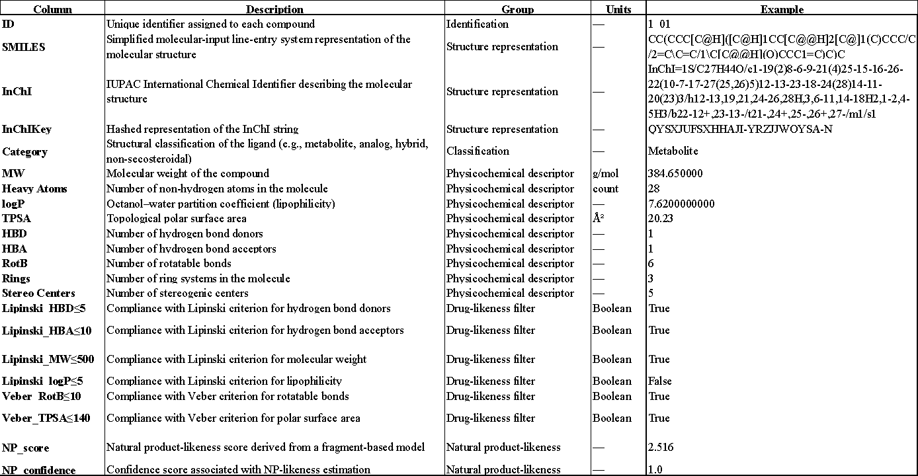

The distribution of compounds by structural categories is shown in Figure 3. The largest share was made up of analogues - 720 compounds. Significantly smaller groups included metabolites (125), hybrid compounds (63), and non-secosteroidal ligands (54).
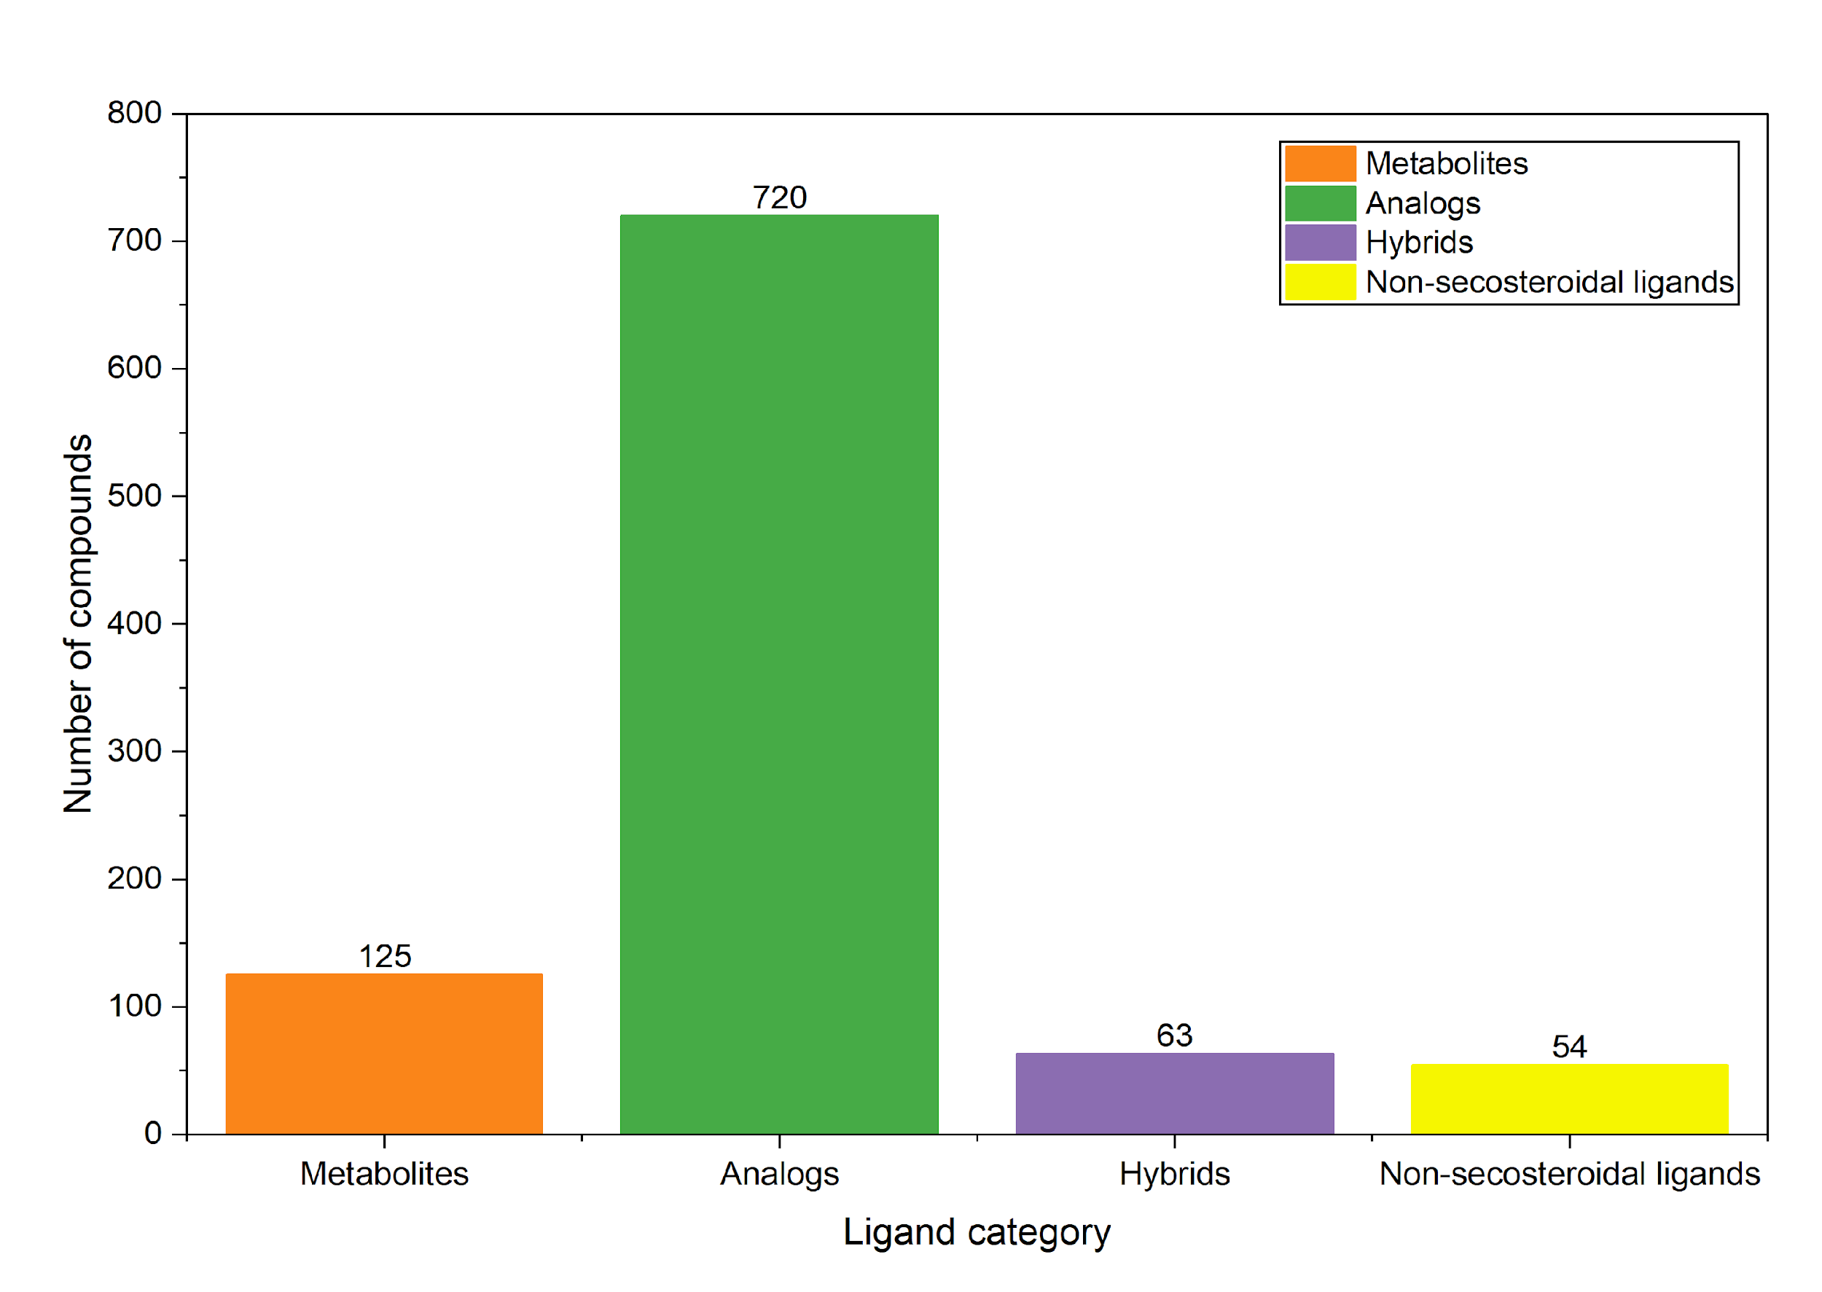
Figure 3. Distribution of VDR ligands across structural categories.

4.2. Molecular property profiling of VDR ligands

4.2.1 Physicochemical descriptor distribution
In the previous step, molecular structures were converted from MOL format to isomeric SMILES format using Open Babel, with preservation of stereochemical information. The resulting SMILES strings were compiled into a CSV file containing two essential fields, a ligand ID and corresponding SMILES representation. This CSV file served as the input for all subsequent descriptor calculations in RDKit. Out of the curated dataset, 423 compounds were not found in PubChem, whereas for the retrieved subset, the physicochemical descriptors were consistent with those, calculated using RDKit.
As shown in Figure 4, the physicochemical descriptors of VDR ligands exhibit relatively narrow and unimodal distributions, indicating a compact chemical space. MW is centered around 450 Da, while the number of heavy atoms shows a consistent distribution near 30–35 atoms, reflecting a conserved structural core.
Lipophilicity is predominantly distributed around 5-6, confirming the hydrophobic nature of the compounds. TPSA values are mainly concentrated near 60–70 Å², and both HBD and HBA display low and narrow distributions, consistent with limited polarity. In contrast, rotatable bonds and stereo centers show broader distributions, indicating variability in molecular flexibility and stereochemical complexity. The number of rings is tightly centered around 3-4, supporting the presence of common cyclic scaffolds.
a)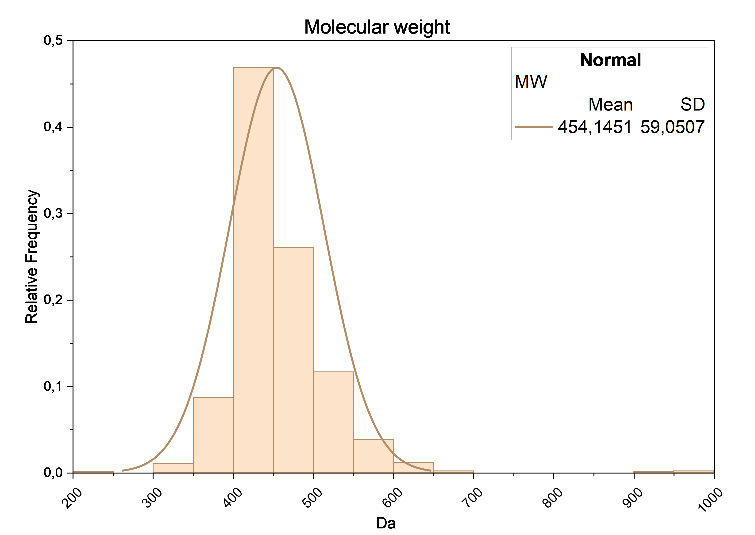b)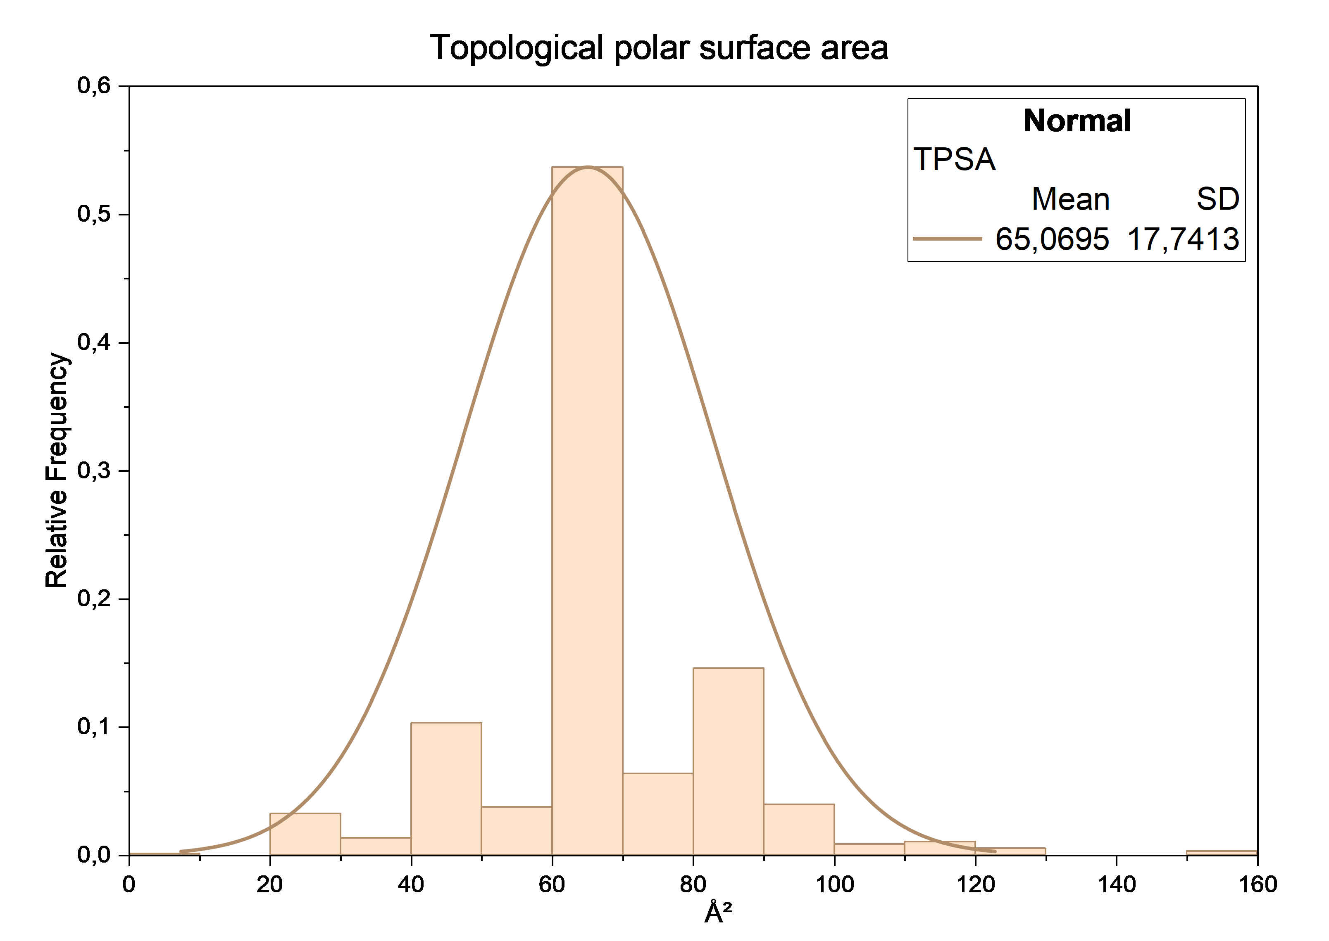c)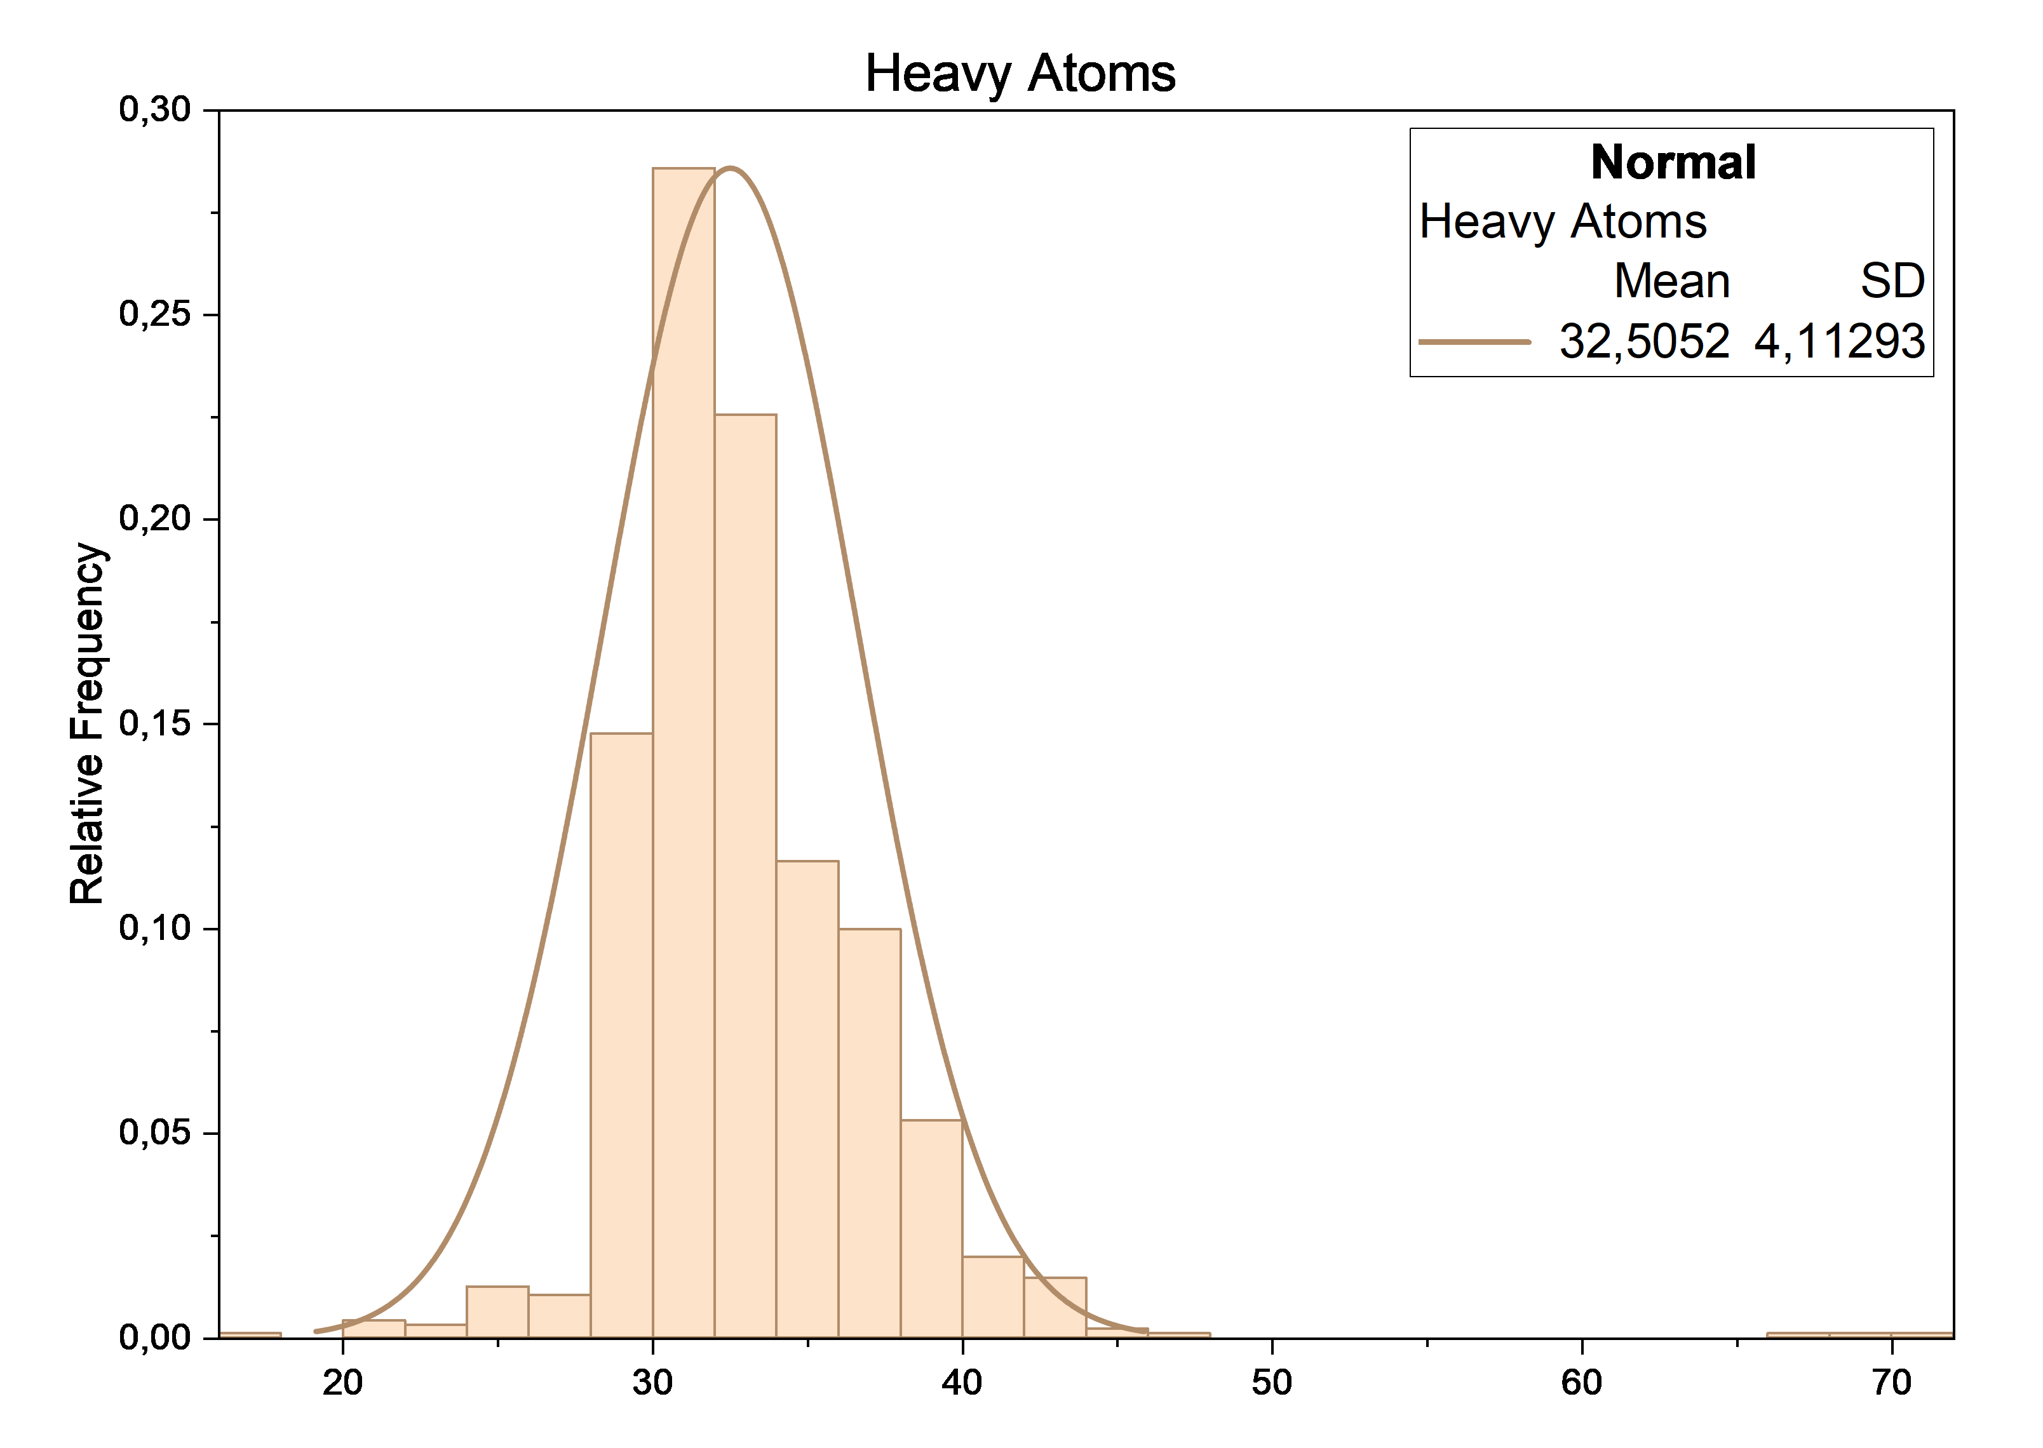d)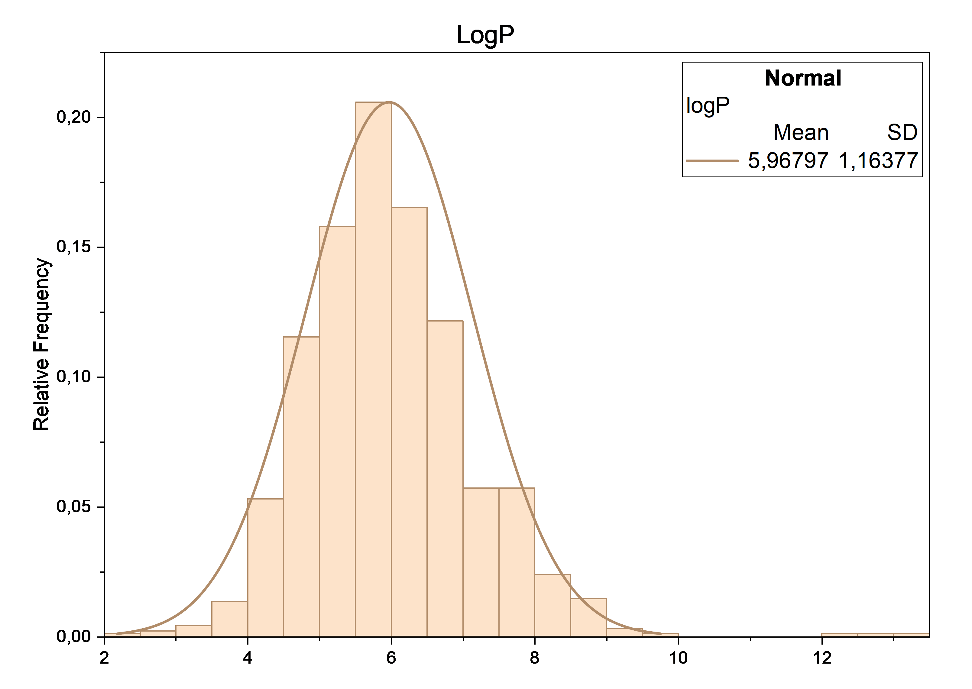e)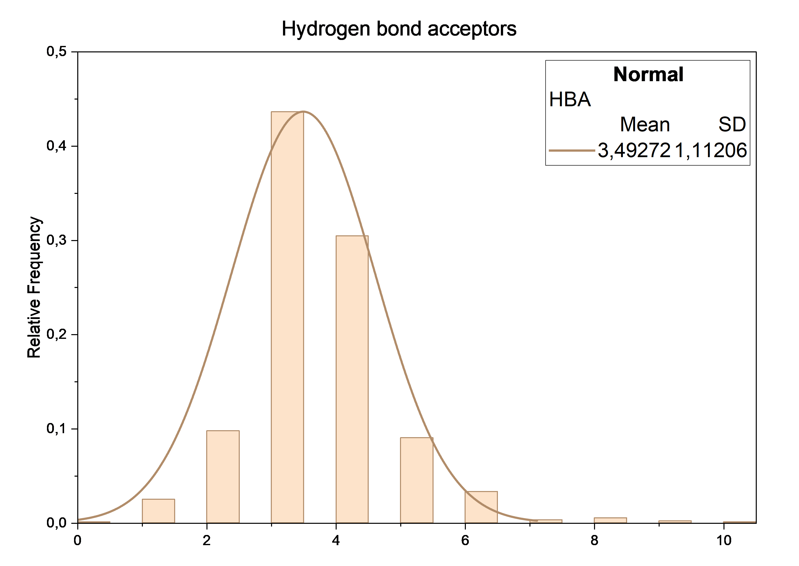f)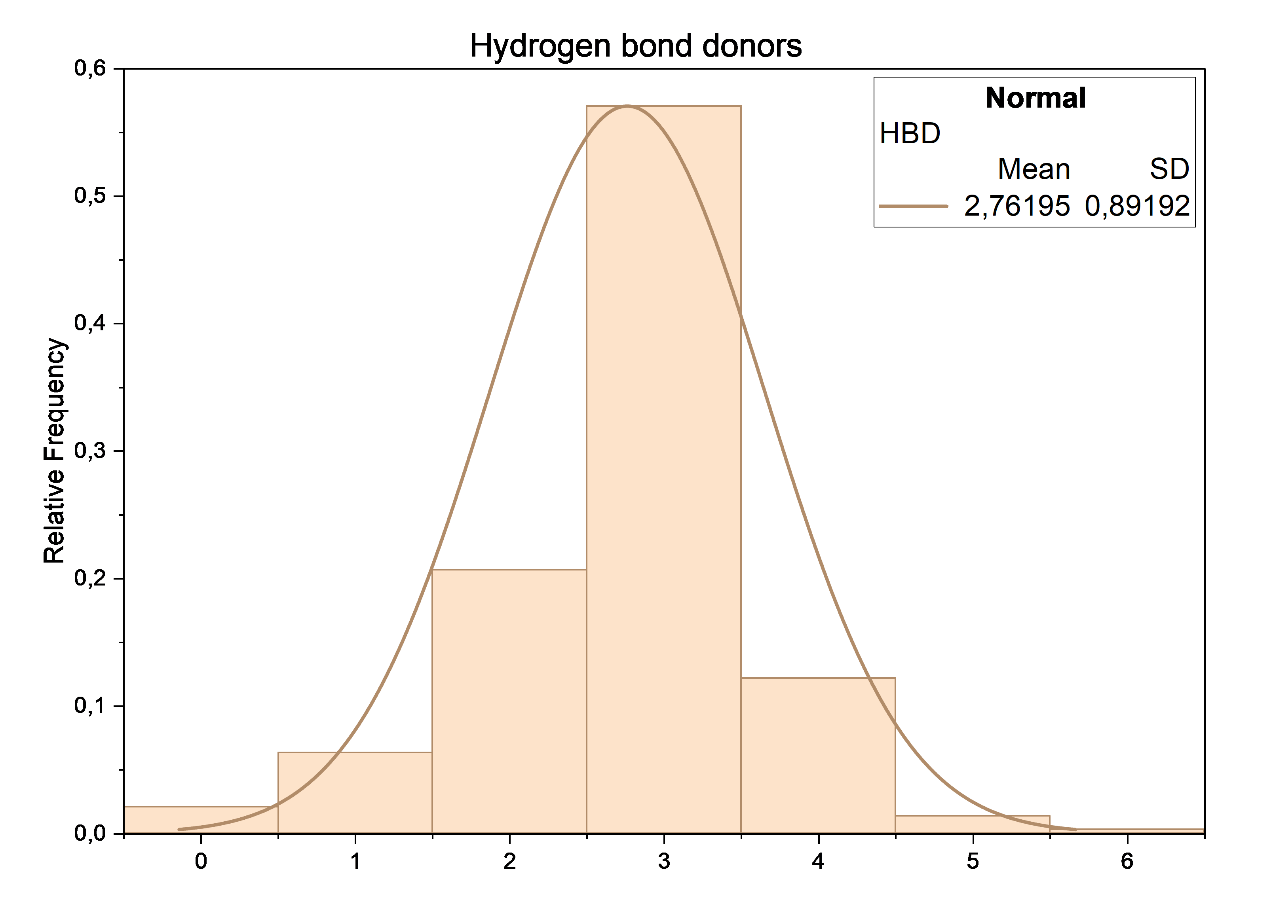g)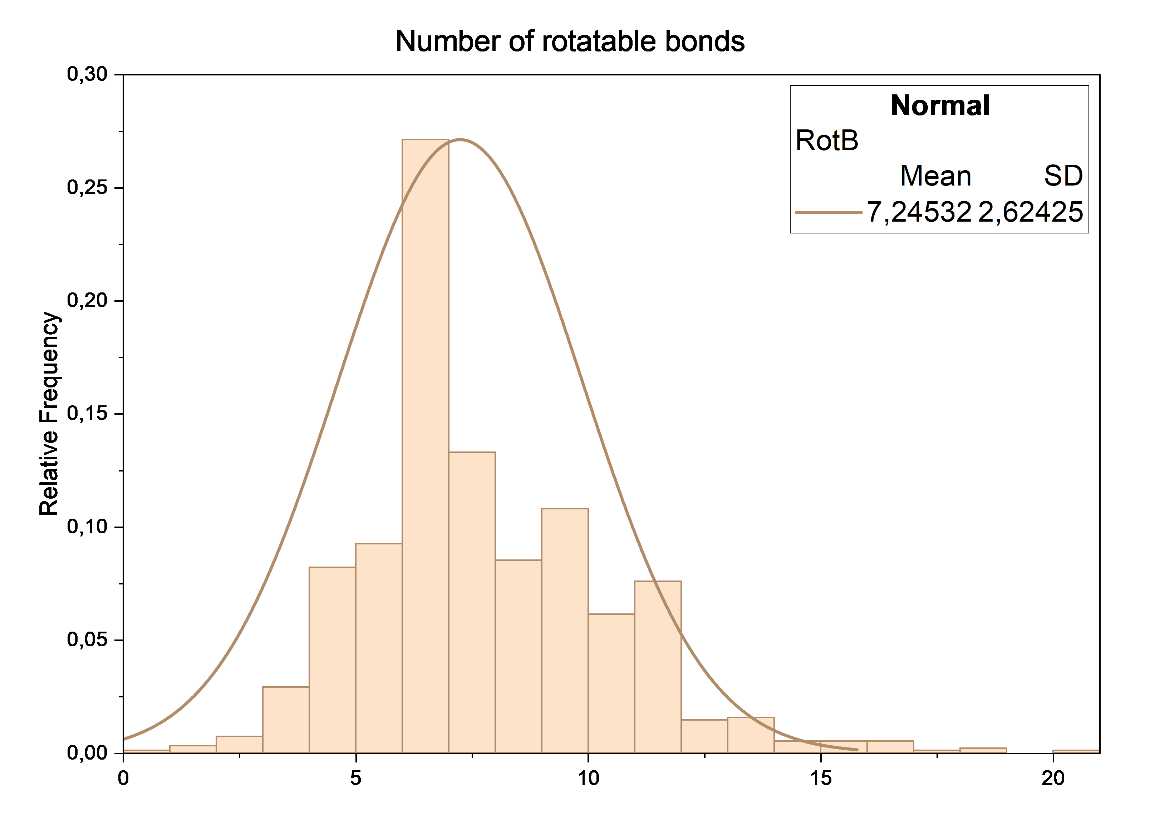h)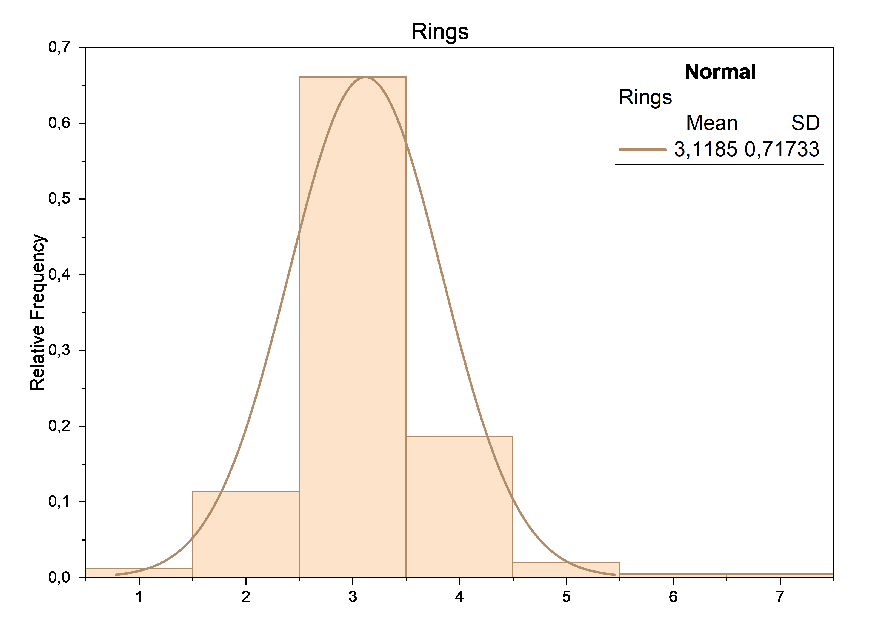i)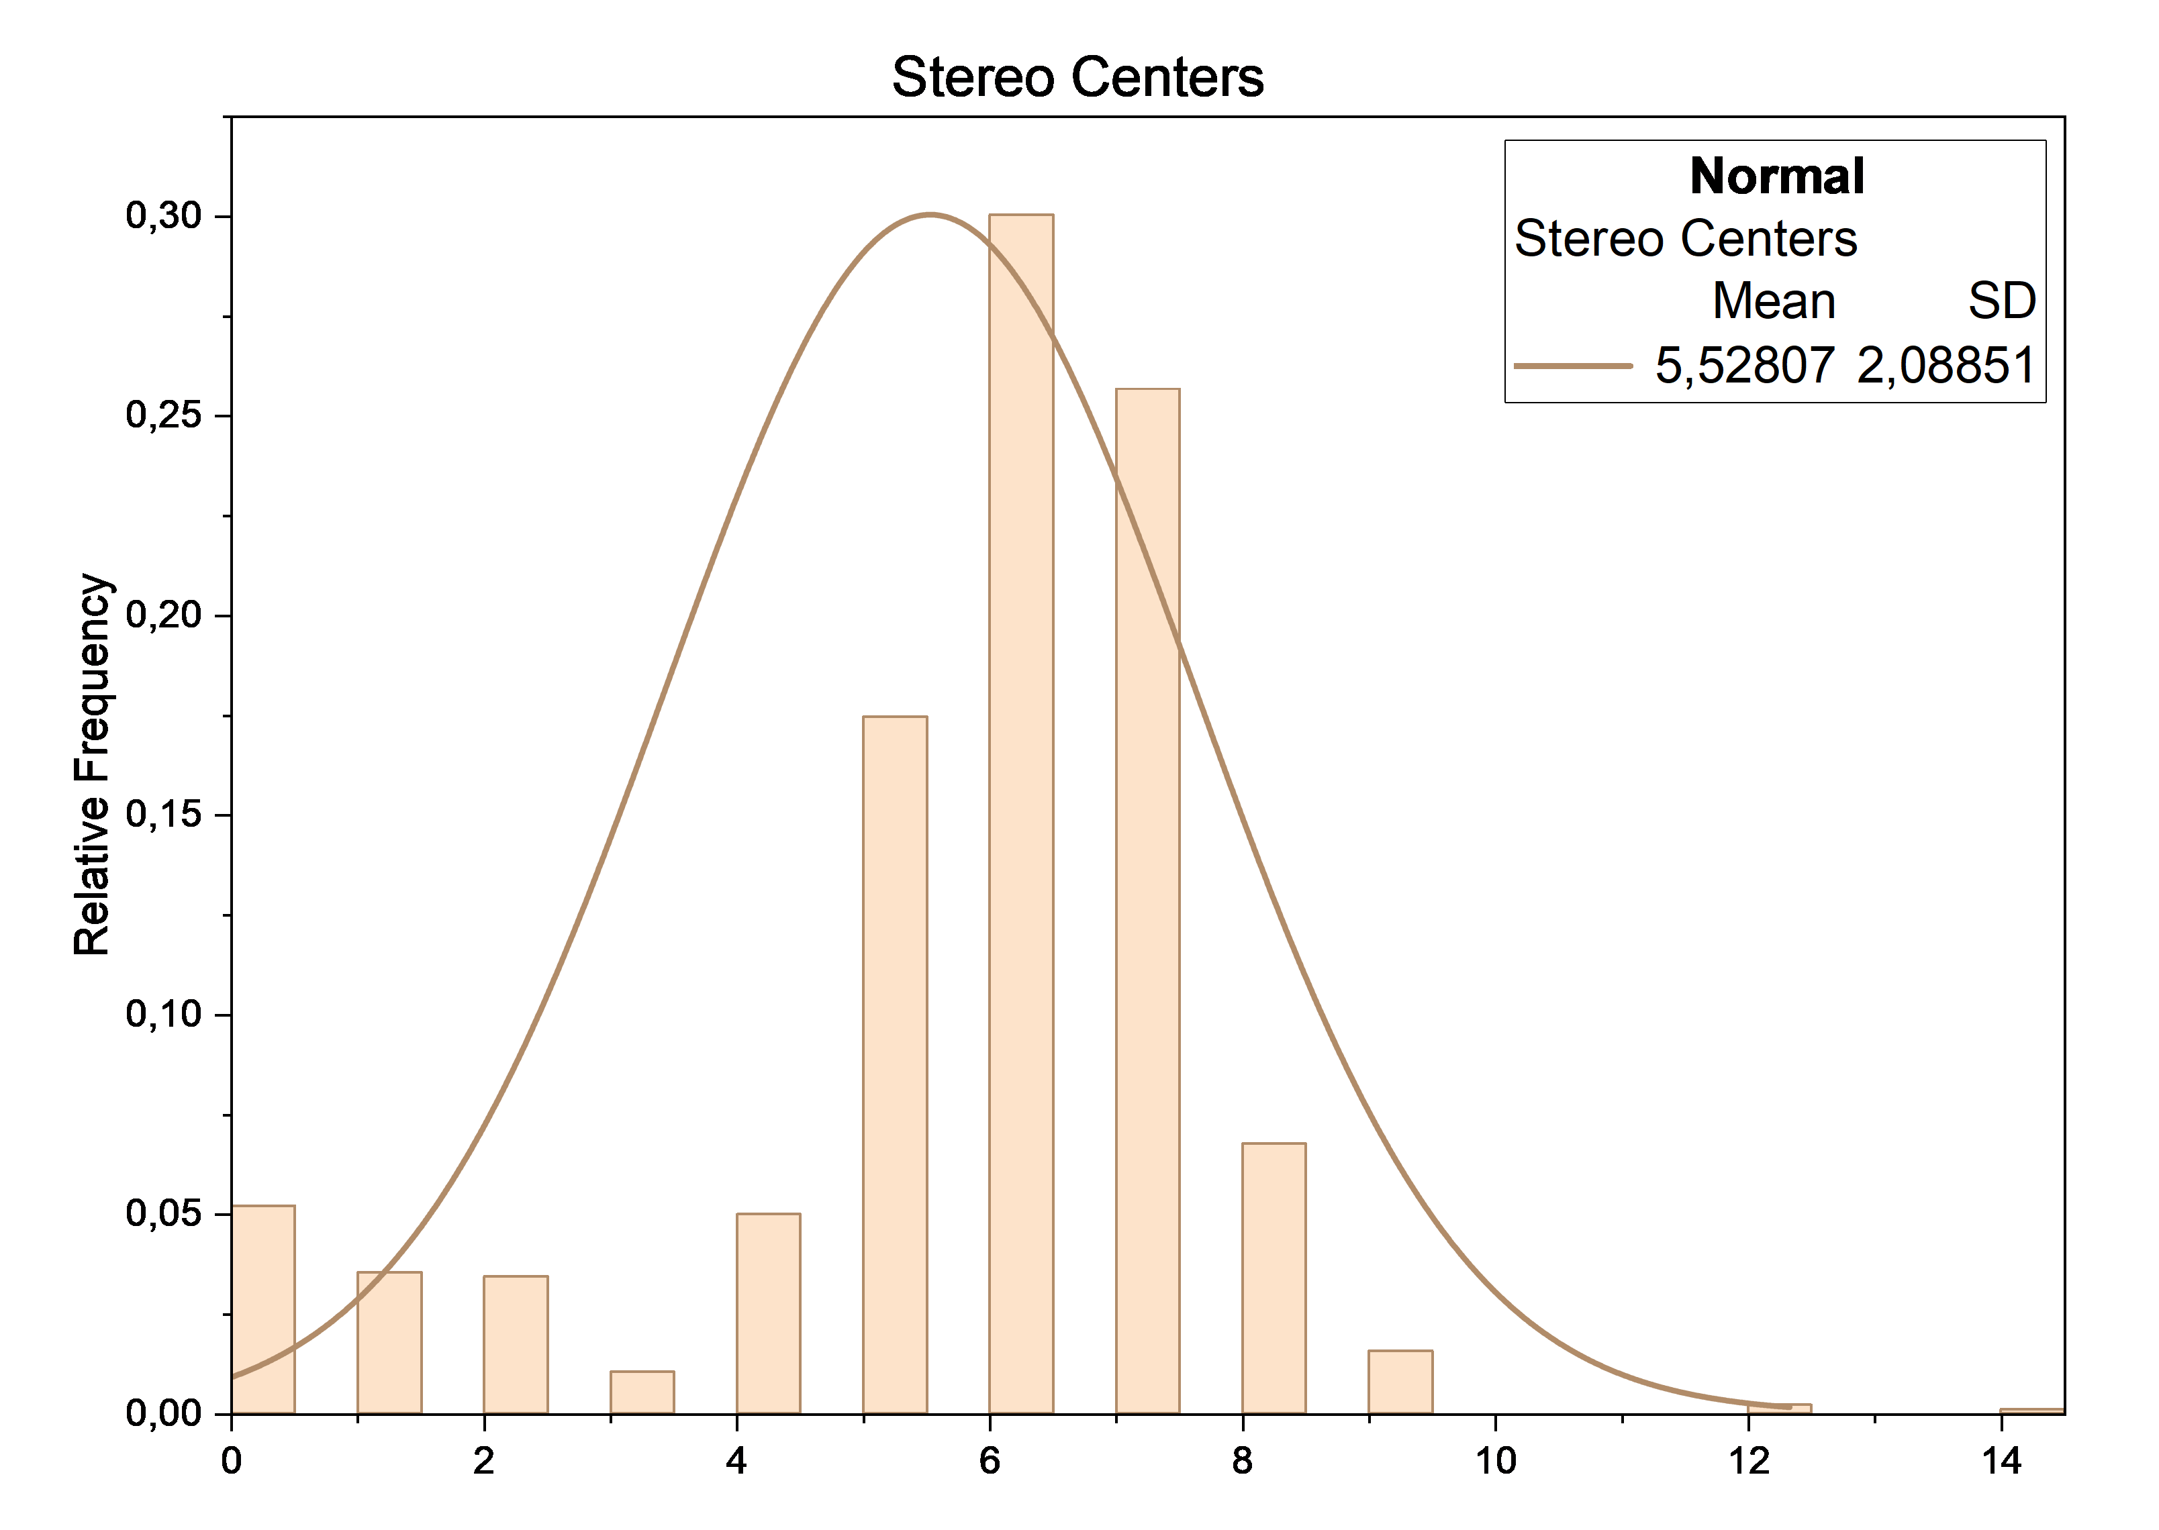
Figure 4. Distribution of physicochemical descriptors of VDR ligands.
(a) MW, (b) TPSA, (c) Heavy Atoms, (d) LogP, (e) HBA, (f) HBD, (g) Number of RotB, (h) Number of rings and (i) Number of stereo centers

4.2.2 Drug-likeness assessment
The drug-likeness assessment showed that most VDR ligands were characterized by a limited number of violations of the Lipinski’s rule and generally high compliance with the Veber criteria.
According to Lipinski's rule, 176 compounds (18.3%) had no violations, 630 (65.49%) had one violation, 153 (15.9%) had two violations, and 3 (0.31%) had three violations. According to Veber criteria, 841 compounds (87.42%) had no violations, 118 (12.27%) had one violation, and 0.31% had two violations (Table 2).
Table 2. Distribution of Lipinski’s and Veber’s rule violations.
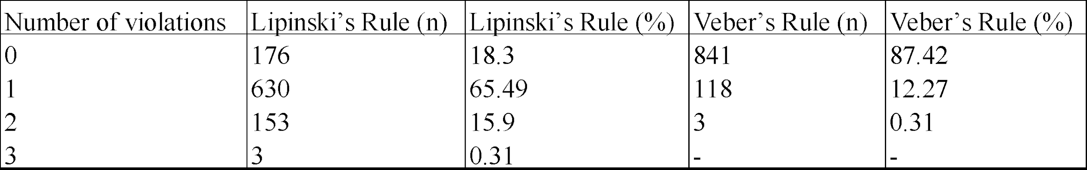

Among the individual criteria, the Lipinski_logP parameter < 5 was most often violated: only 185 compounds (19.23%) met it, while 777 (80.77%) it was exceeded. 797 compounds (82.85%) met the Lipinski_MW < 500 criterion, while 165 (17.15%) did not. The remaining parameters were performed for most compounds: 100% for Lipinski_HBA ≤ 10, 99.69% for Lipinski_HBD ≤ 5, 87.42% - Veber_RotB ≤ 10 and 99.69% for Veber_TPSA ≤ 140 (Table 3).
In general, the dataset of VDR ligands was characterized by preferential compliance with the criteria of drug-likeness, while the main source of violations was increased lipophilicity.
Table 3. Compliance with individual drug-likeness criteria.
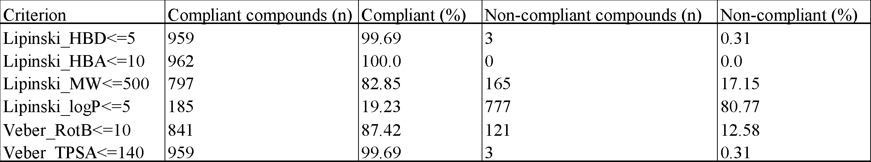

4.2.3 Natural product–likeness analysis
Analysis of the NP-likeness index distribution revealed clear differences among the categories of VDR ligands in Figure 5. The highest mean NP-score values were observed for metabolites, at approximately 2.29, reflecting their natural origin. The analogues also showed relatively high mean NP-scores, close to 2.00, although with a broader distribution. Hybrid compounds show an intermediate profile, with a mean NP-score of 1.48, indicating a partial loss of natural-product-like structural features. In contrast, non-secosteroidal ligands were characterized by the lowest mean NP-score, at 0.35 and the greatest variability, suggesting a pronounced deviation from naturally similar chemical patterns.
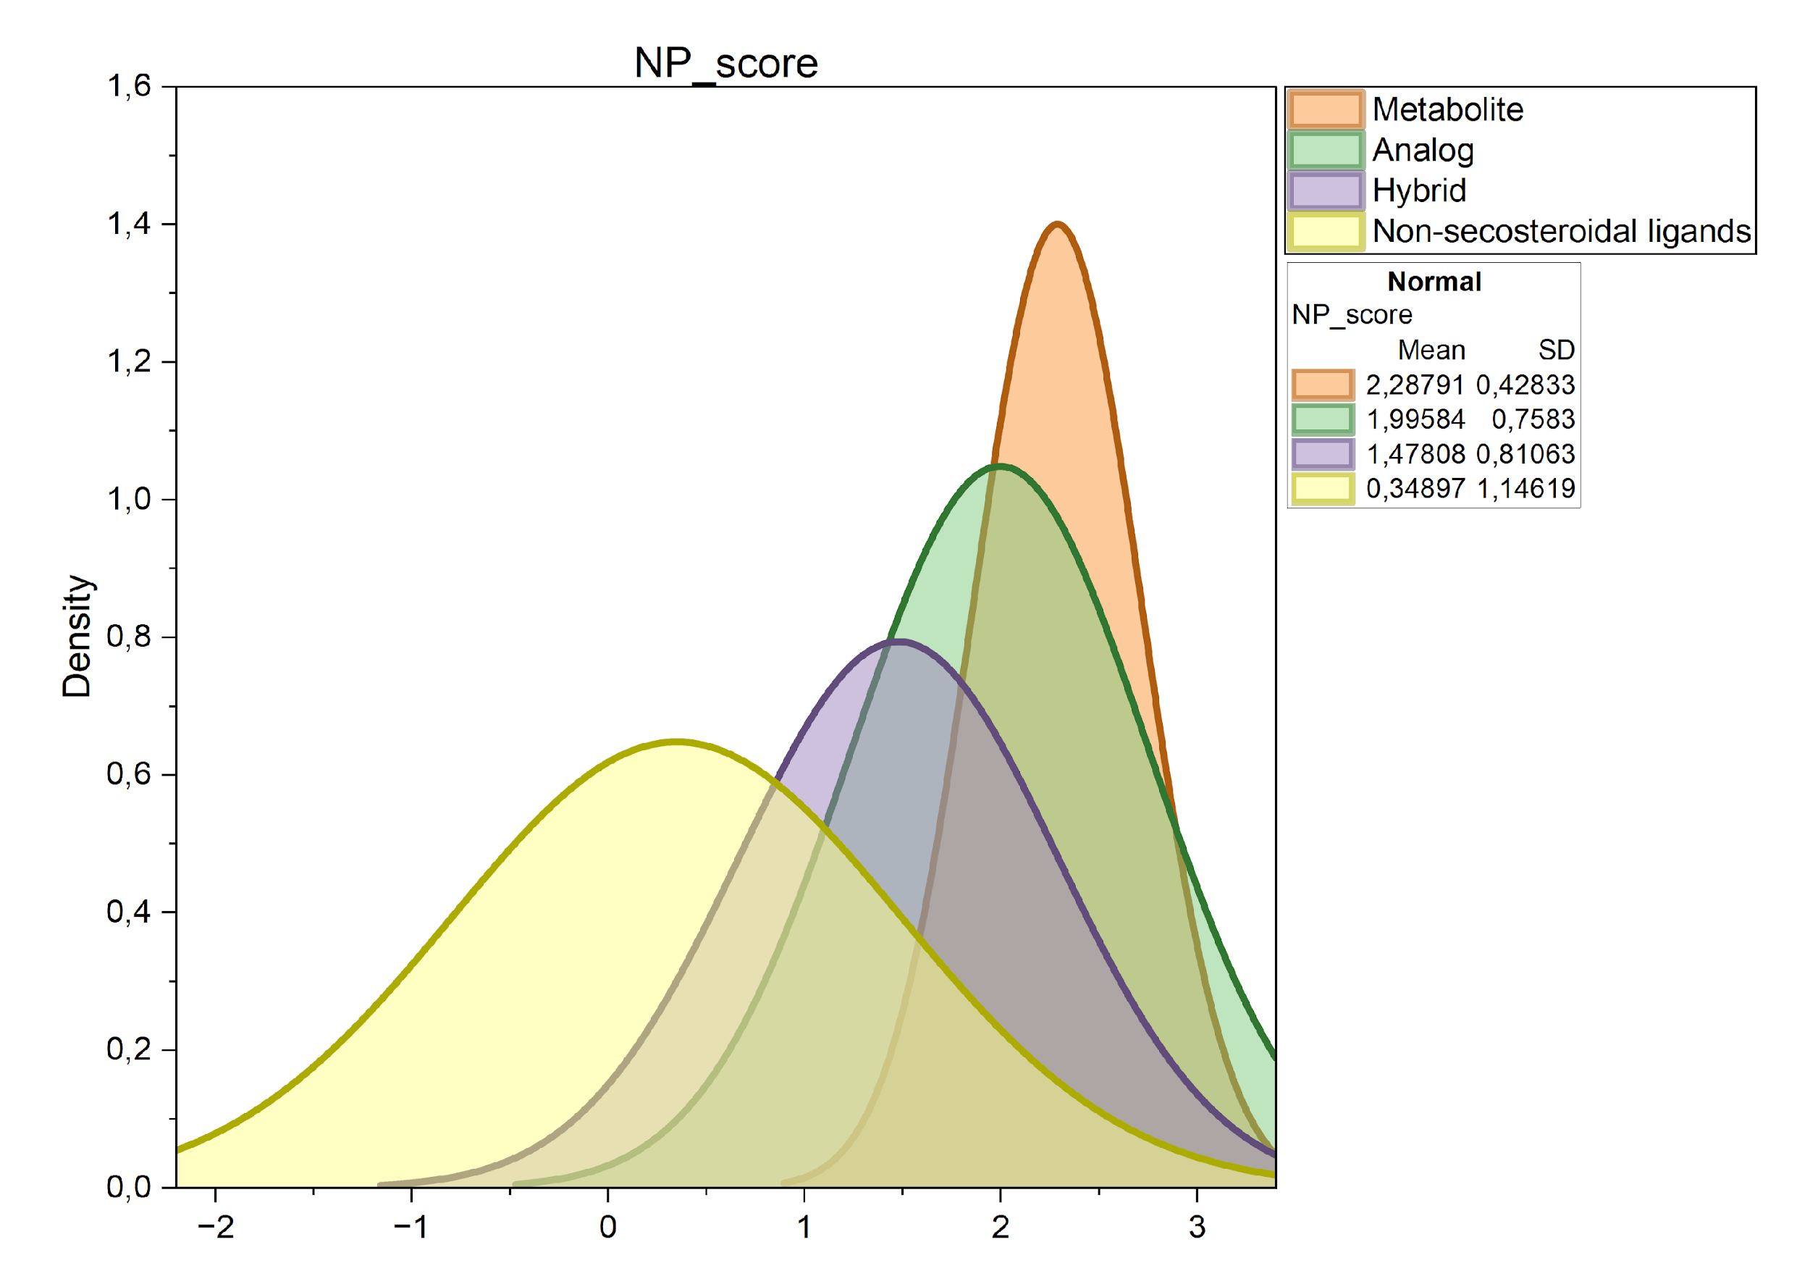
Figure 5. Natural product–likeness profiles of VDR ligands.

These differences were confirmed by non-parametric statistical analysis. As summarized in Table 4, the Kruskal–Wallis test showed a highly significant difference in NP-score distributions among the four ligand categories, χ²(3) = 128.0, p = 1.17 × 10⁻²⁷, with a moderate effect size 0.131. This result indicates that the observed variation in NP-likeness across structural classes was not random but reflected systematic differences in the degree to which each category retained natural-product-like chemical features.
Table 4. Kruskal–Wallis test for differences in NP-score among structural categories.

Pairwise comparisons further clarified the relationships between the categories. As shown in Table 5, post hoc Dunn’s test demonstrated that all category pairs differed significantly. Metabolites showed significantly higher NP-scores than analogues (p = 1.34 × 10⁻⁴), hybrids (p = 3.29 × 10⁻¹³), and non-secosteroidal ligands (p = 1.70 × 10⁻²¹). Analogues also differed significantly from hybrids (p = 1.56 × 10⁻⁸) and from non-secosteroidal ligands (p = 1.28 × 10⁻¹⁶). Although the difference between hybrids and non-secosteroidal ligands was comparatively smaller, it remained statistically significant (p = 2.13 × 10⁻²), indicating that these two classes also occupy distinct positions along the NP-likeness continuum.
In general, there is a decrease in NP-likeness from metabolites to non-secosteroid ligands, reflecting an increase in the degree of structural modification and synthetic optimization of compounds.
Table 5. Dunn’s post hoc pairwise comparisons of NP-score among structural categories following the Kruskal–Wallis test.
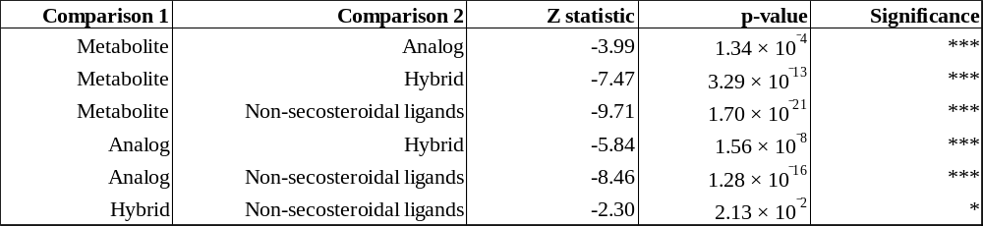

4.3. Similarity, clustering, and chemical space organization of VDR ligands

4.3.1 Fingerprint-based similarity analysis
Pairwise Tanimoto similarity values showed that the degree of structural similarity within the VDR ligand dataset depended strongly on the fingerprint type used. In Table 6 the highest mean and median similarity values were obtained for RDKit topological fingerprints, indicating greater overall topological relatedness of the compounds under this representation. Atom pair fingerprints also yielded relatively high similarity values, whereas ECFP4 and especially ECFP6 were characterized by lower mean and median values.
The largest proportion of highly similar pairs, with Tanimoto similarity of at least 0.70 and at least 0.85, was observed for RDKit topological fingerprints. For atom pair fingerprints, this proportion was noticeably lower, while for ECFP4 and ECFP6 it remained minimal. In contrast, the highest proportion of weakly similar pairs, with Tanimoto similarity not exceeding 0.30, was identified for ECFP6, followed by ECFP4, reflecting the greater sensitivity of circular fingerprints to local structural differences.
Overall, RDKit topological fingerprints and atom pair fingerprints described the dataset as more compact in terms of chemical similarity, whereas ECFP-based representations revealed a more pronounced structural heterogeneity among VDR ligands.
Table 6. Pairwise Tanimoto similarity statistics for the VDR ligand dataset across different fingerprint representations.
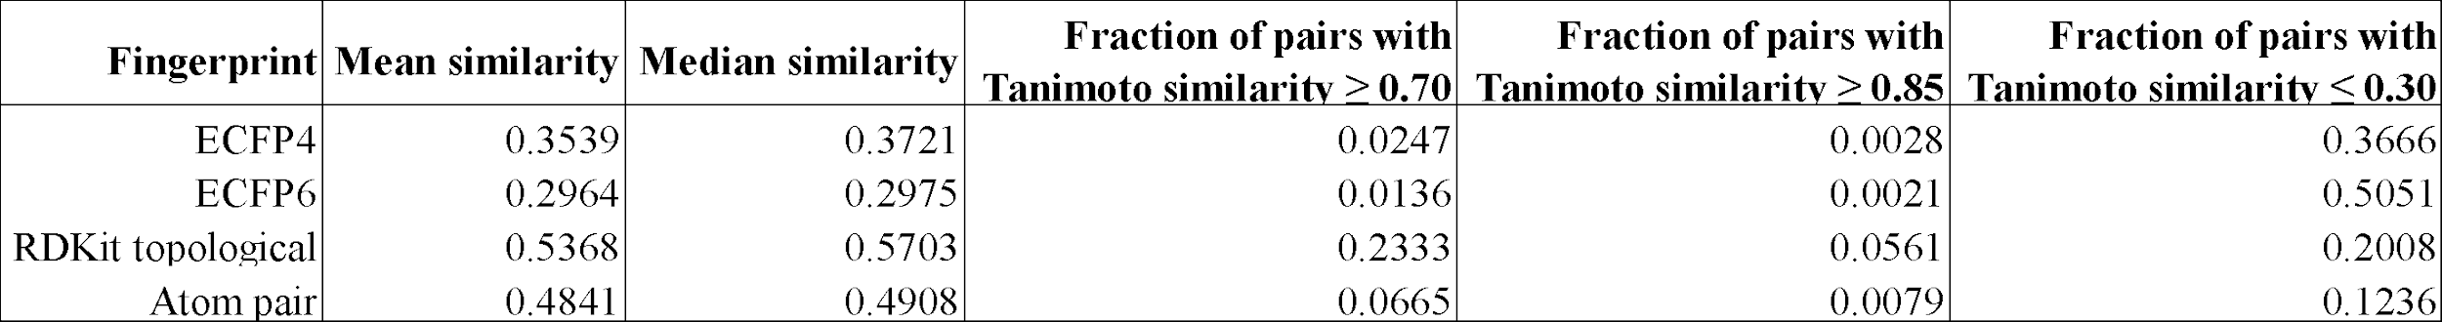

4.3.2 Clustering patterns of VDR ligands
The analysis of intra-category distances (Table 7) revealed that the degree of structural compactness strongly depends on the type of fingerprint used. The lowest distance values were observed for metabolites, particularly with RDKit topological fingerprints, indicating their high structural homogeneity. In contrast, non-secosteroidal ligands exhibited the highest distance values across all fingerprint representations, reflecting pronounced structural heterogeneity. Analogs and hybrids occupied an intermediate position.

Table 7. Intra-category structural compactness based on Tanimoto distance across fingerprint representations.
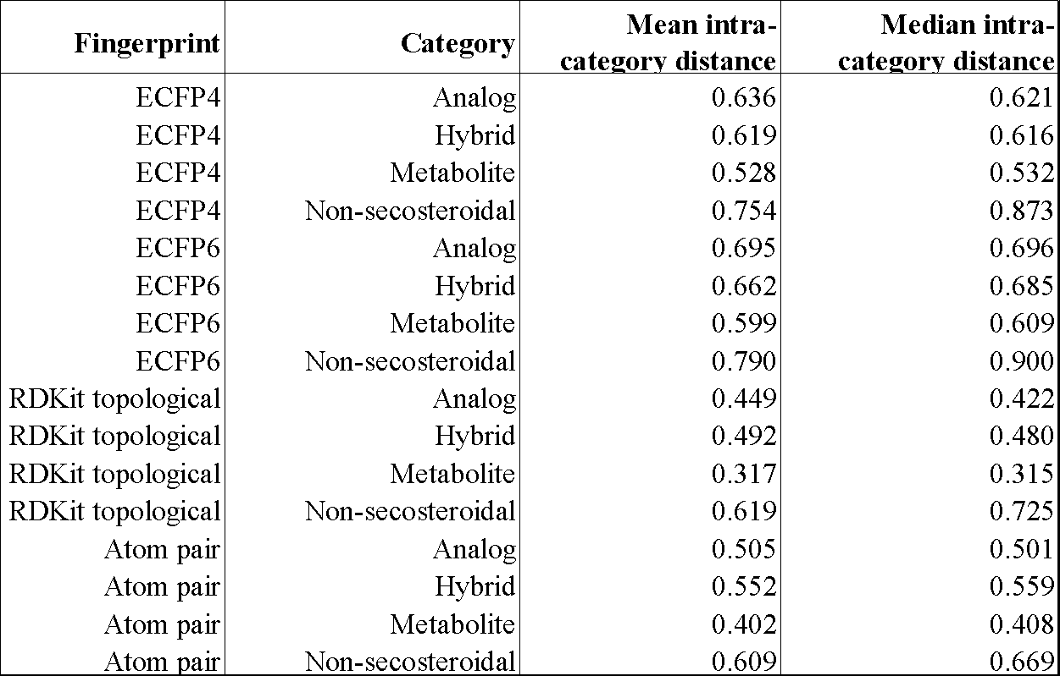

The results of clustering (Table 8) demonstrated that increasing the similarity threshold leads to a higher number of clusters and an increased number of singletons, while simultaneously reducing the size of the largest cluster. The highest purity values were observed at higher similarity thresholds. However, this was accompanied by a decrease in agreement between clusters and the original categorization, as evidenced by consistently low ARI and NMI values across all fingerprint types. In addition, the silhouette scores remained uniformly low (0.085–0.479), indicating poor internal cluster separation even under the best-performing conditions.
Among the evaluated representations, RDKit topological and Atom pair fingerprints provided the most effective separation of chemical space, whereas ECFP-based representations resulted in a larger number of small and fragmented clusters. Overall, the clustering analysis revealed substantial structural heterogeneity within the VDR ligand dataset and a limited correspondence between structural clusters and the predefined ligand categories.
Table 8. Clustering performance metrics for VDR ligands across fingerprint types and similarity thresholds.
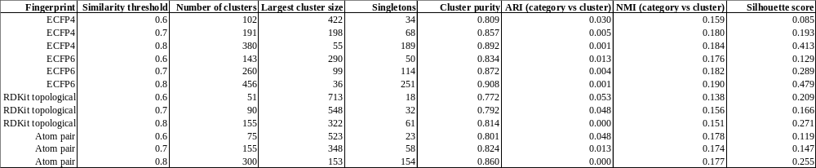

4.3.3 Visualization of chemical space
In Figure 6, t-SNE visualization revealed fingerprint-dependent differences in category separation. ECFP4 showed the clearest cluster structure, with non-secosteroidal ligands forming a fully isolated group and hybrids appearing in several partly separated subgroups, while metabolites were largely embedded within the analog clusters. ECFP6 produced a similar but more fragmented pattern, with a greater number of small and dispersed subgroups.
In the AtomPair projection, analogs formed a denser central cluster, whereas hybrids and non-secosteroidal ligands remained relatively well separated. In contrast, the RDKit topological projection showed the weakest category separation, with substantial mixing of analogs, metabolites, and hybrids, although non-secosteroidal ligands still tended to occupy a distinct region.
UMAP (Figure 7) largely confirmed the t-SNE patterns but produced more compact and discrete groupings. ECFP4 again showed the clearest separation, with well-defined analog subgroups, an isolated non-secosteroidal cluster, and a distinct hybrid cluster. ECFP6 displayed a more fragmented organization with smaller and more distant analog clusters. AtomPair resulted in elongated clusters distributed diagonally across the space, with non-secosteroidal ligands remaining clearly isolated. RDKit topological fingerprints produced the least structured projection, with broad scattering of compounds and strong overlap between categories.
a)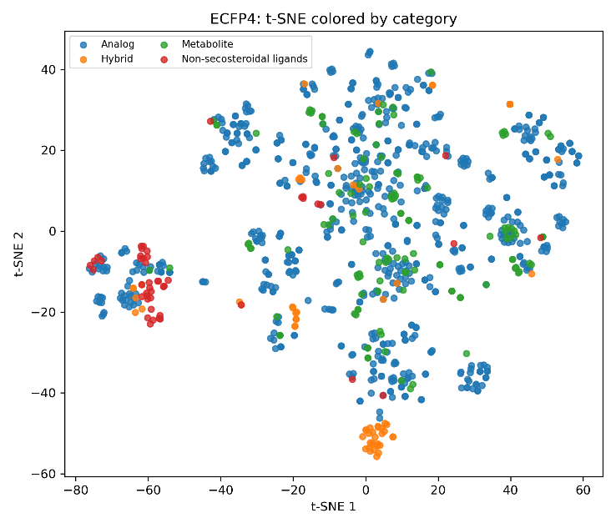b)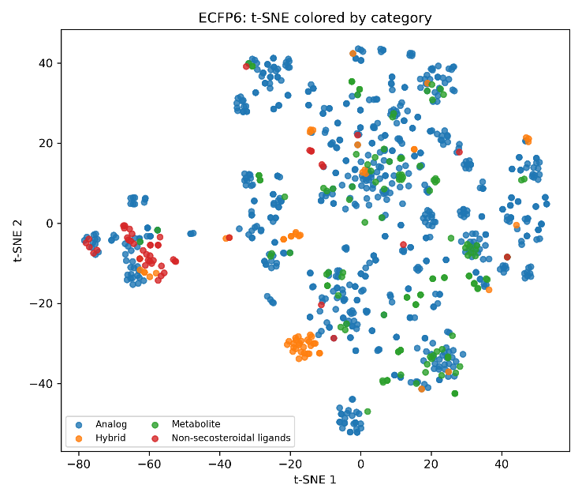
c)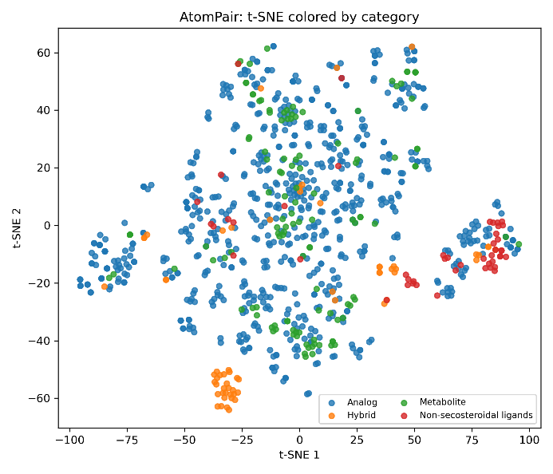d)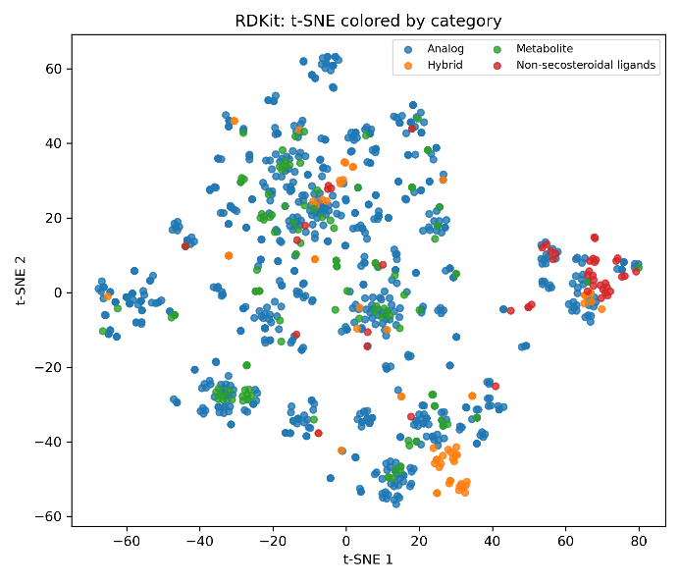
Figure 6. t-SNE projections of the chemical space of the VDR ligand library colored by category for four molecular fingerprint types: (a) ECFP4, (b) ECFP6, (c) AtomPair, and (d) RDKit topological.

a)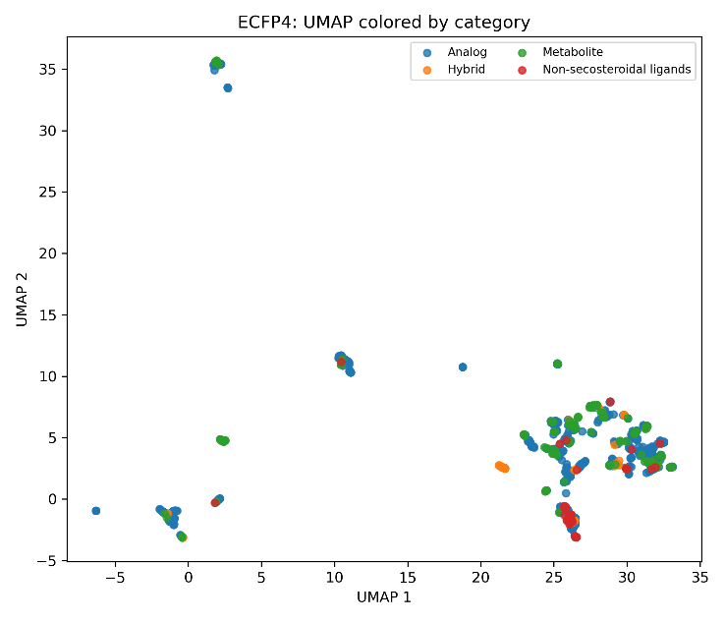b)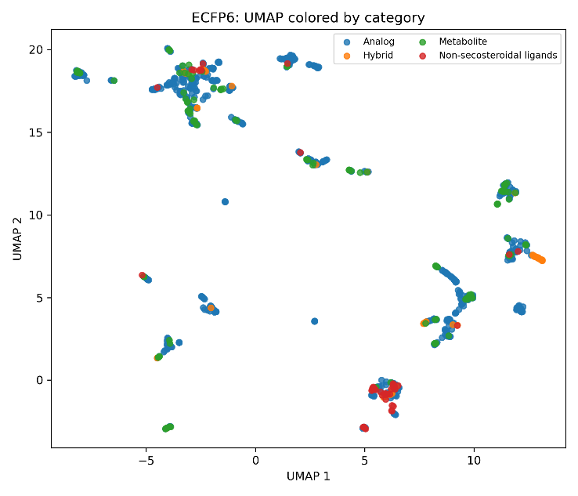
c)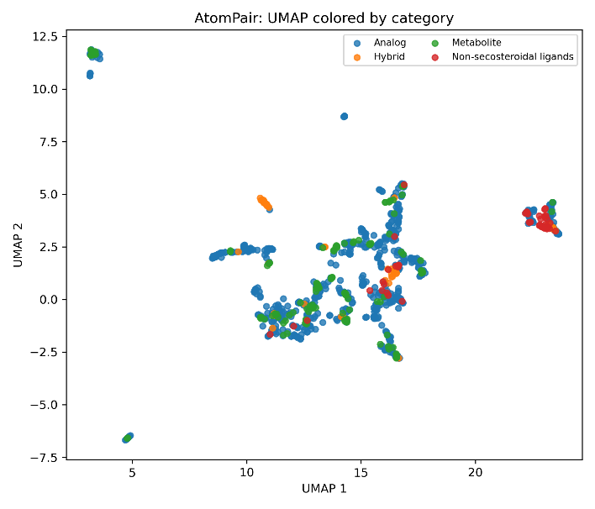d)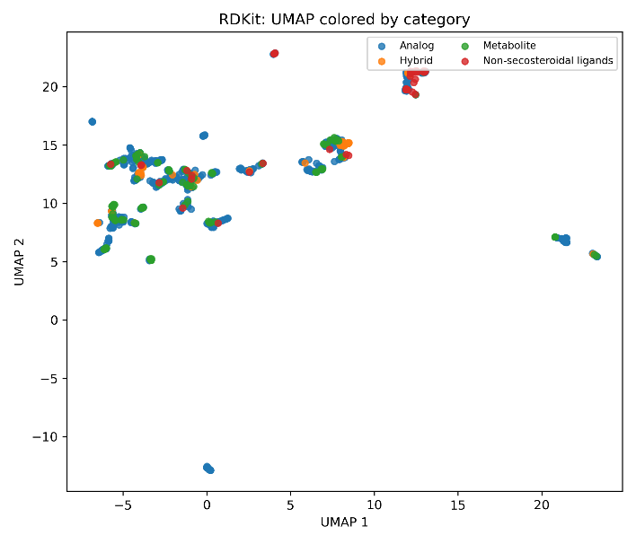
Figure 7. UMAP projections of the chemical space of the VDR ligand library colored by compound category for four molecular fingerprint types: (a) ECFP4, (b) ECFP6, (c) AtomPair, and (d) RDKit topological.

4.4. Association between structural classes, clusters, and biological annotation
Analysis of seven physicochemical descriptors showed that analogs, metabolites, and hybrids largely occupied overlapping property ranges typical of steroid-like compounds, whereas non-secosteroidal ligands were consistently more diverse. The clearest differences were observed for logP, number of heavy atoms, rotatable bonds, and TPSA, where non-secosteroidal ligands displayed broader distributions and more extreme values. Metabolites were distinguished by higher polarity and wider HBA, HBD, and TPSA distributions, consistent with the presence of additional oxygen-containing groups. Hybrids generally showed compact distributions, while analogs exhibited the greatest within-category variability.
a)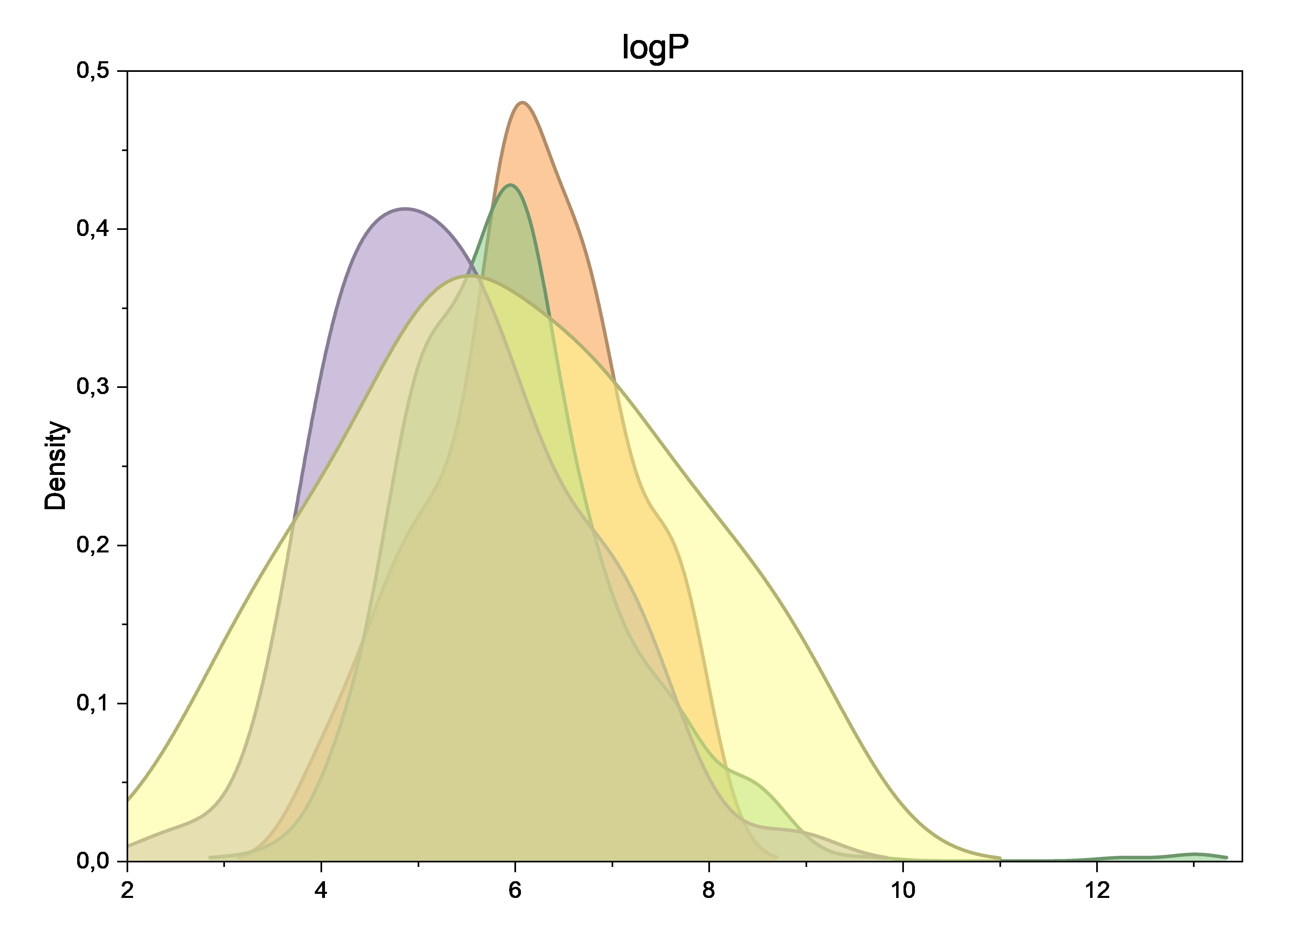 b)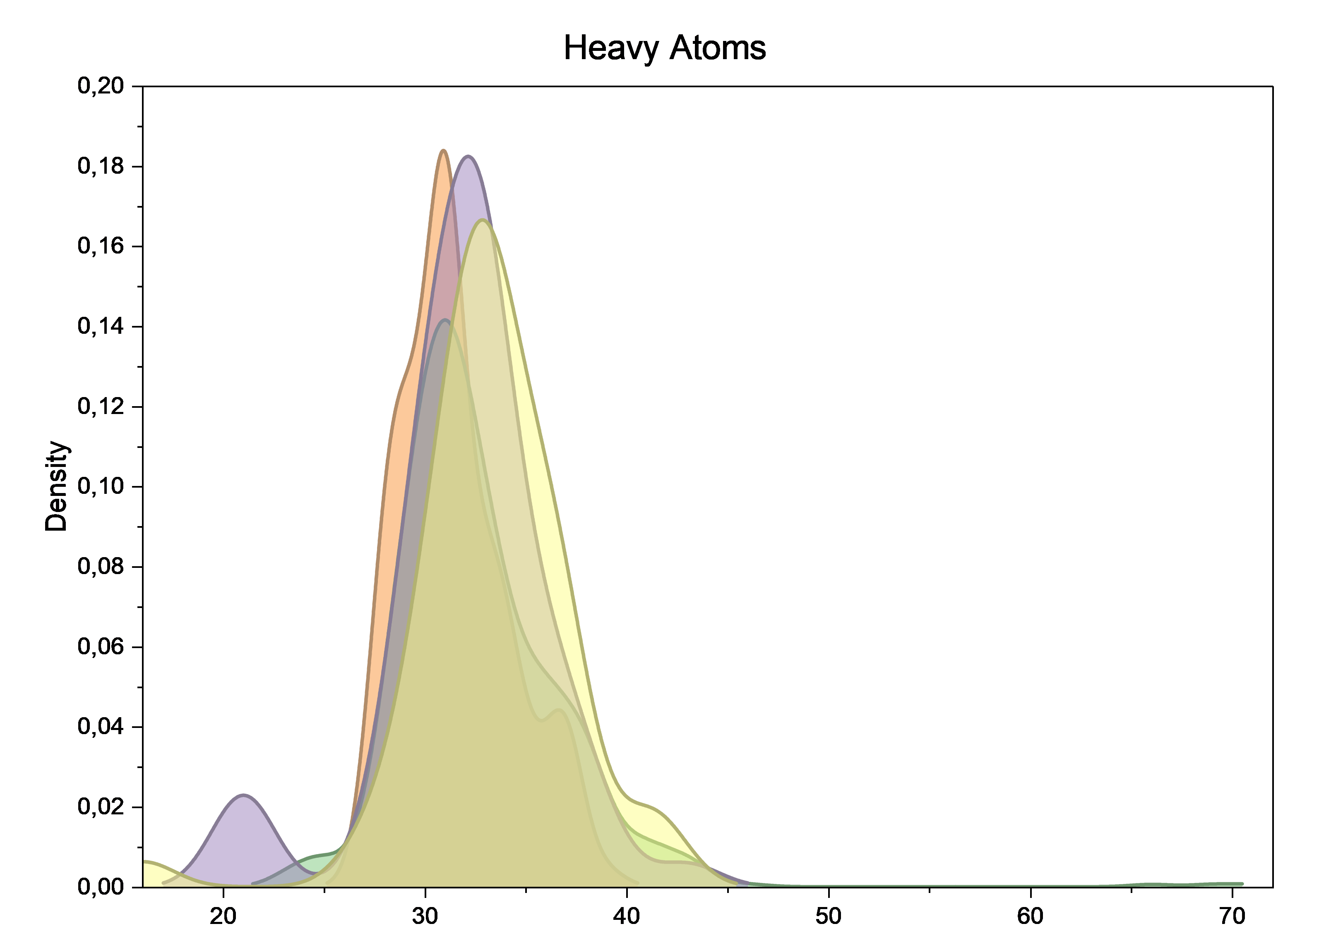
c) 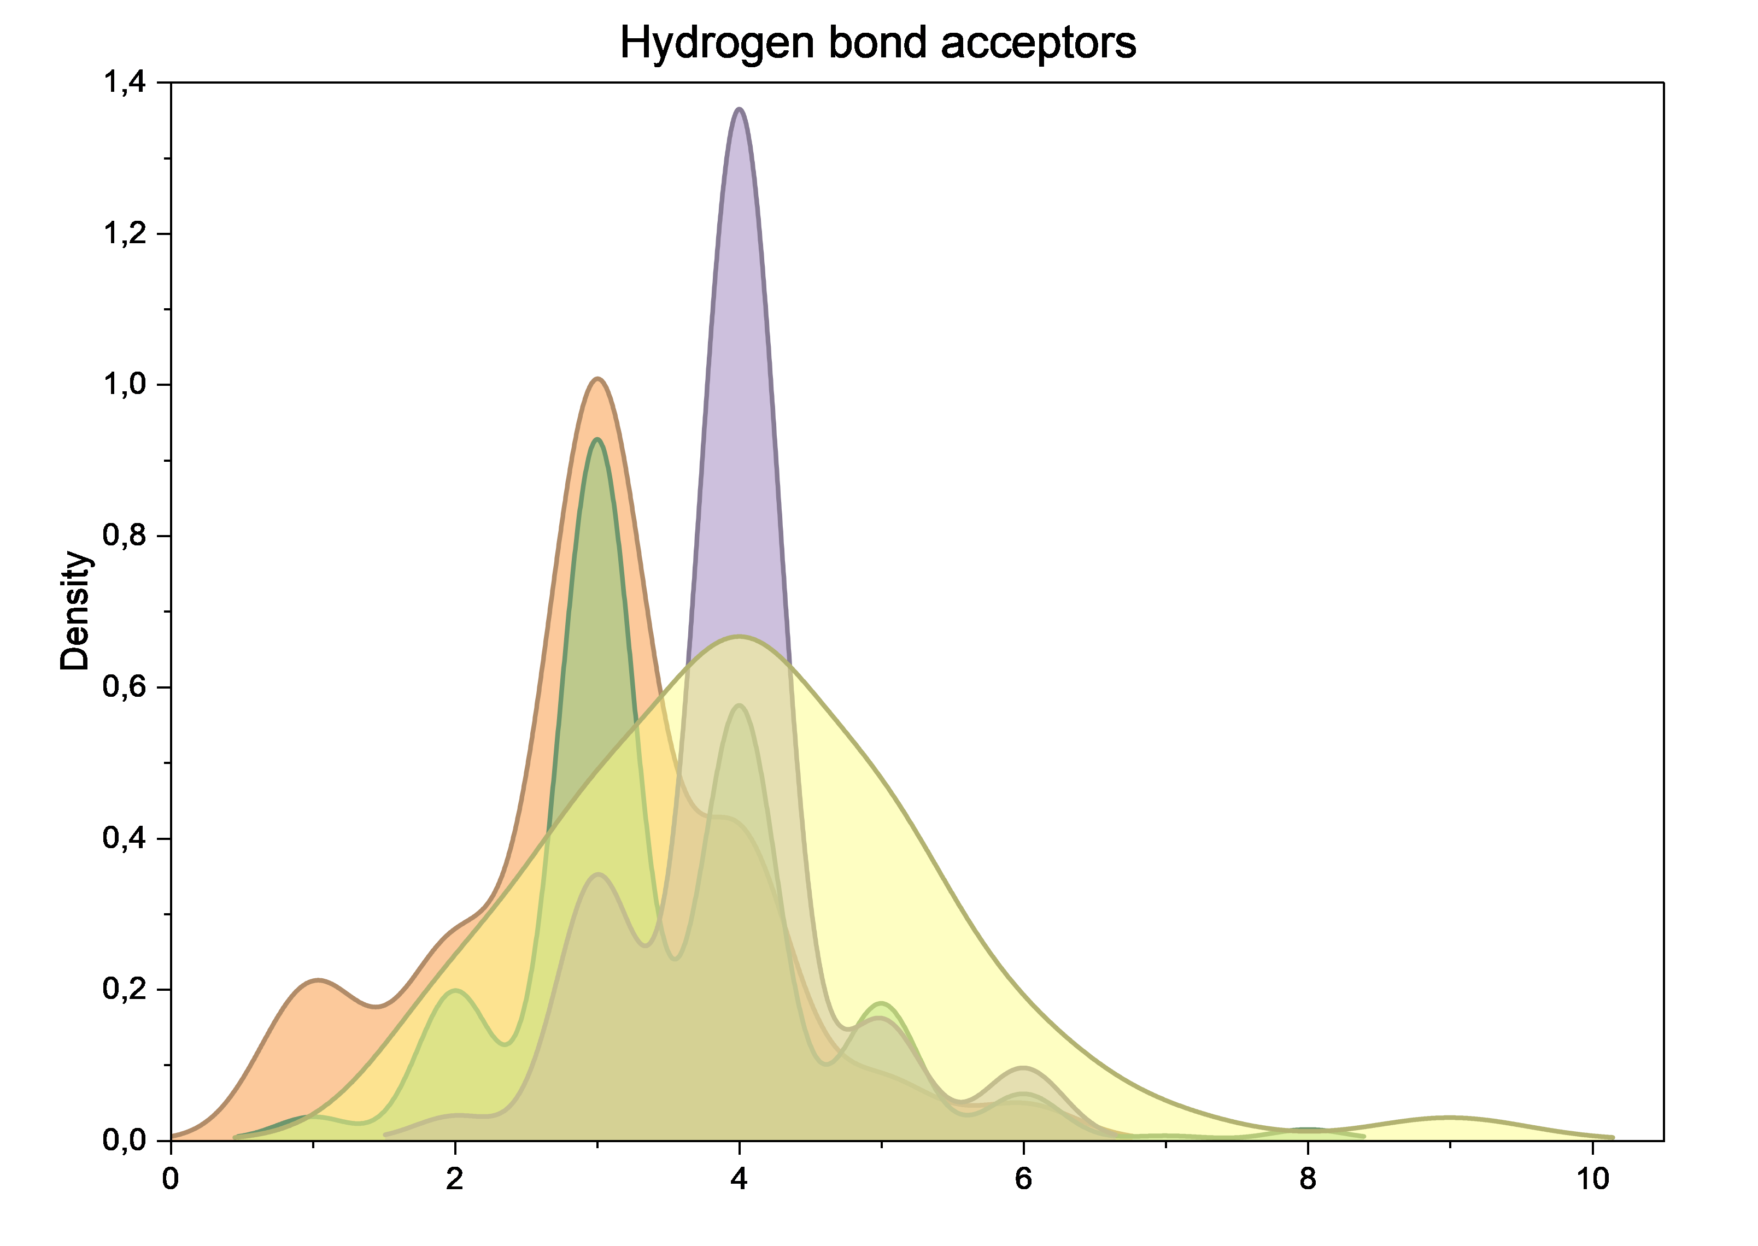 d)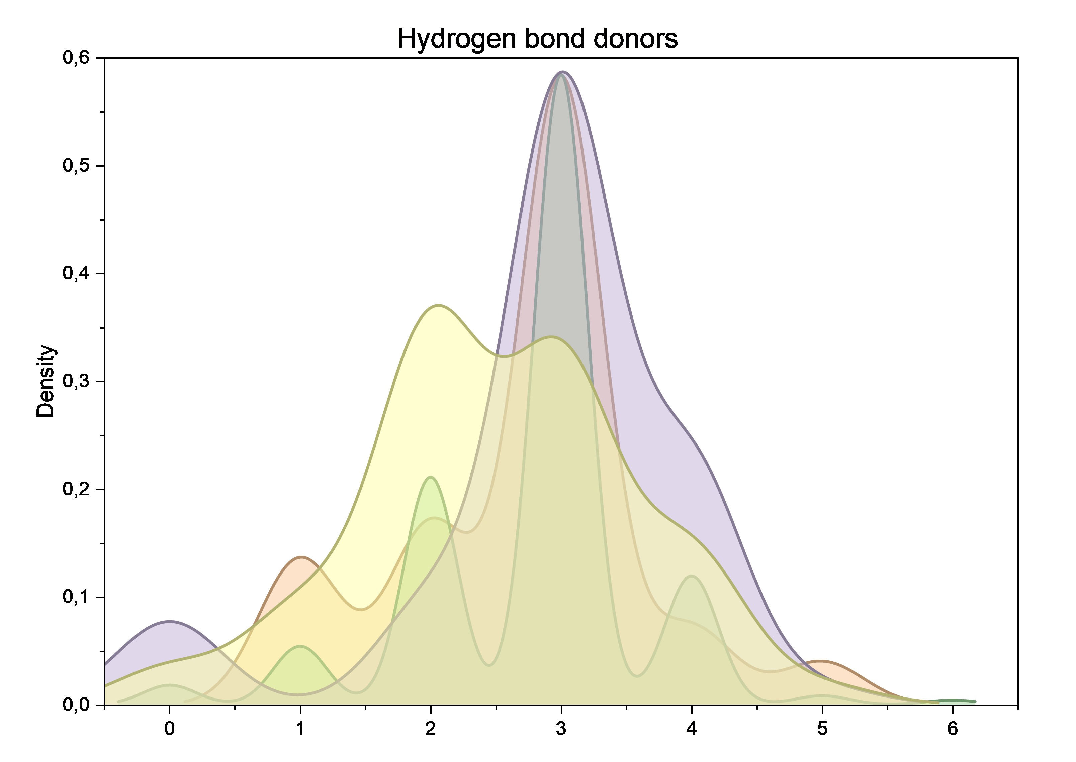
e) 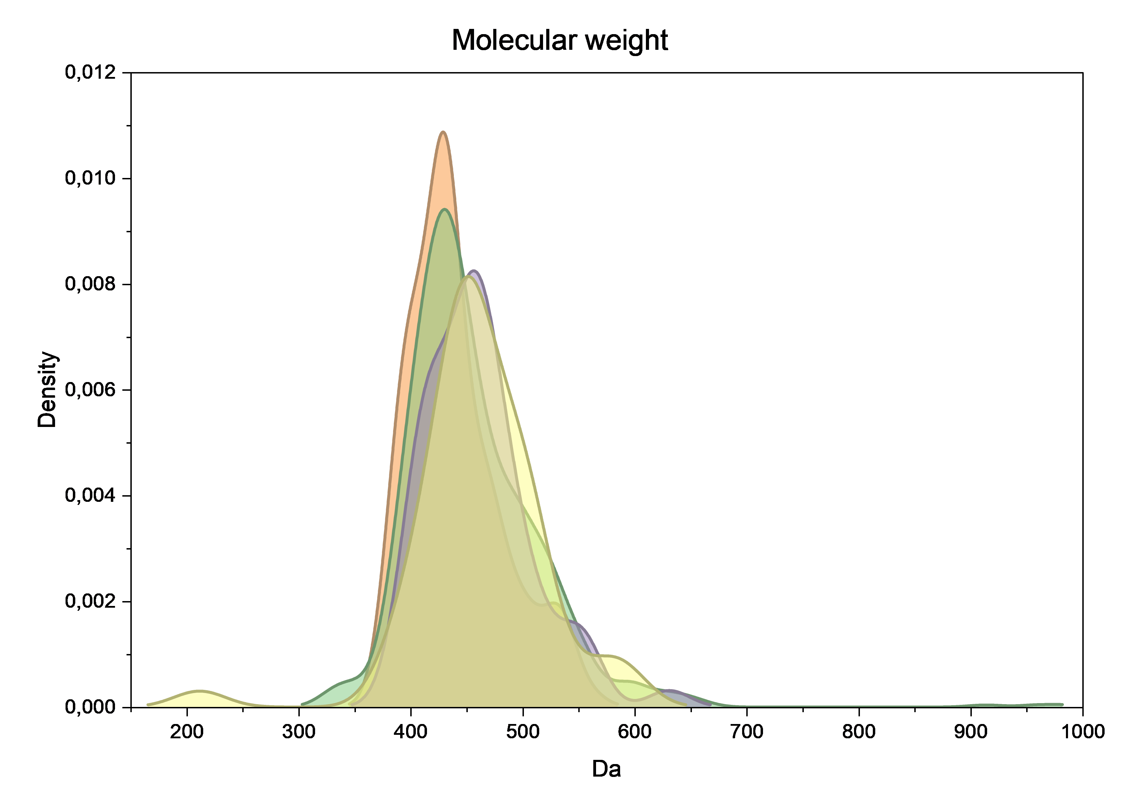 f) 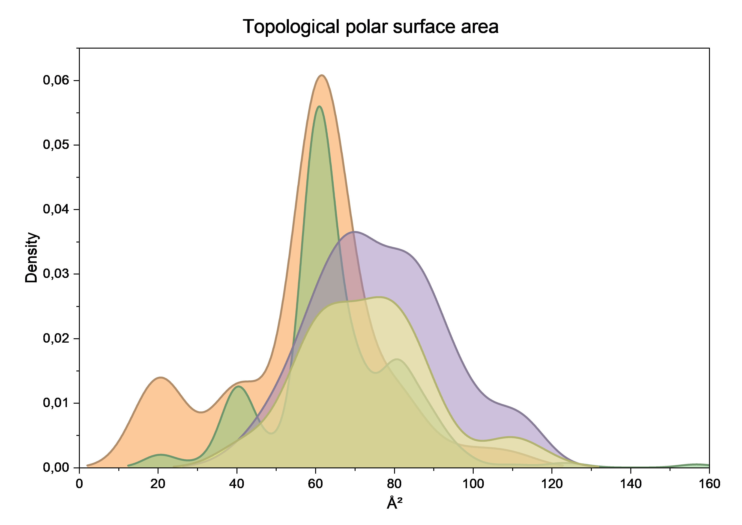
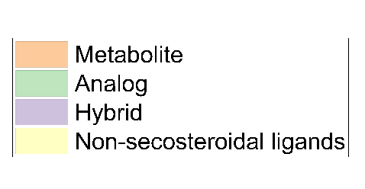
g)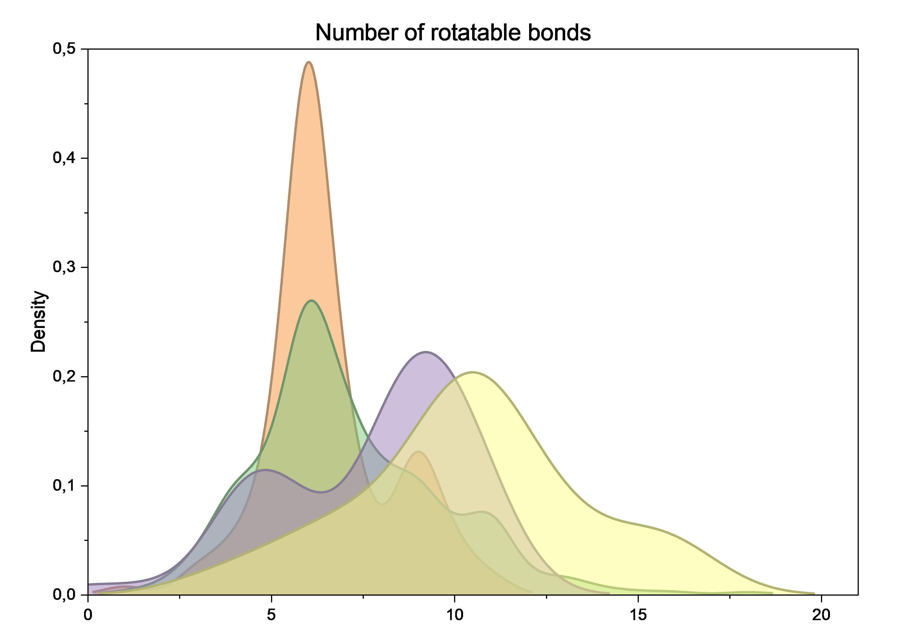
Figure 8. Kernel density estimation plots showing the distribution of physicochemical descriptors of VDR ligands across structural categories: (a) logP, (b) Heavy Atoms, (c) HBA, (d) HBD, (e) MW, (f) TPSA, and (g) number of RotB.
Boxplot analysis confirmed that median descriptor values were often similar across categories, whereas the main differences were related to dispersion and outliers. Analogs showed the highest heterogeneity, likely reflecting the broad structural diversity of this largest class, while hybrids were the most homogeneous. Overall, the descriptor profiles supported the clustering results, indicating partial overlap among steroid-based categories and a clear physicochemical separation of non-secosteroidal ligands.
a)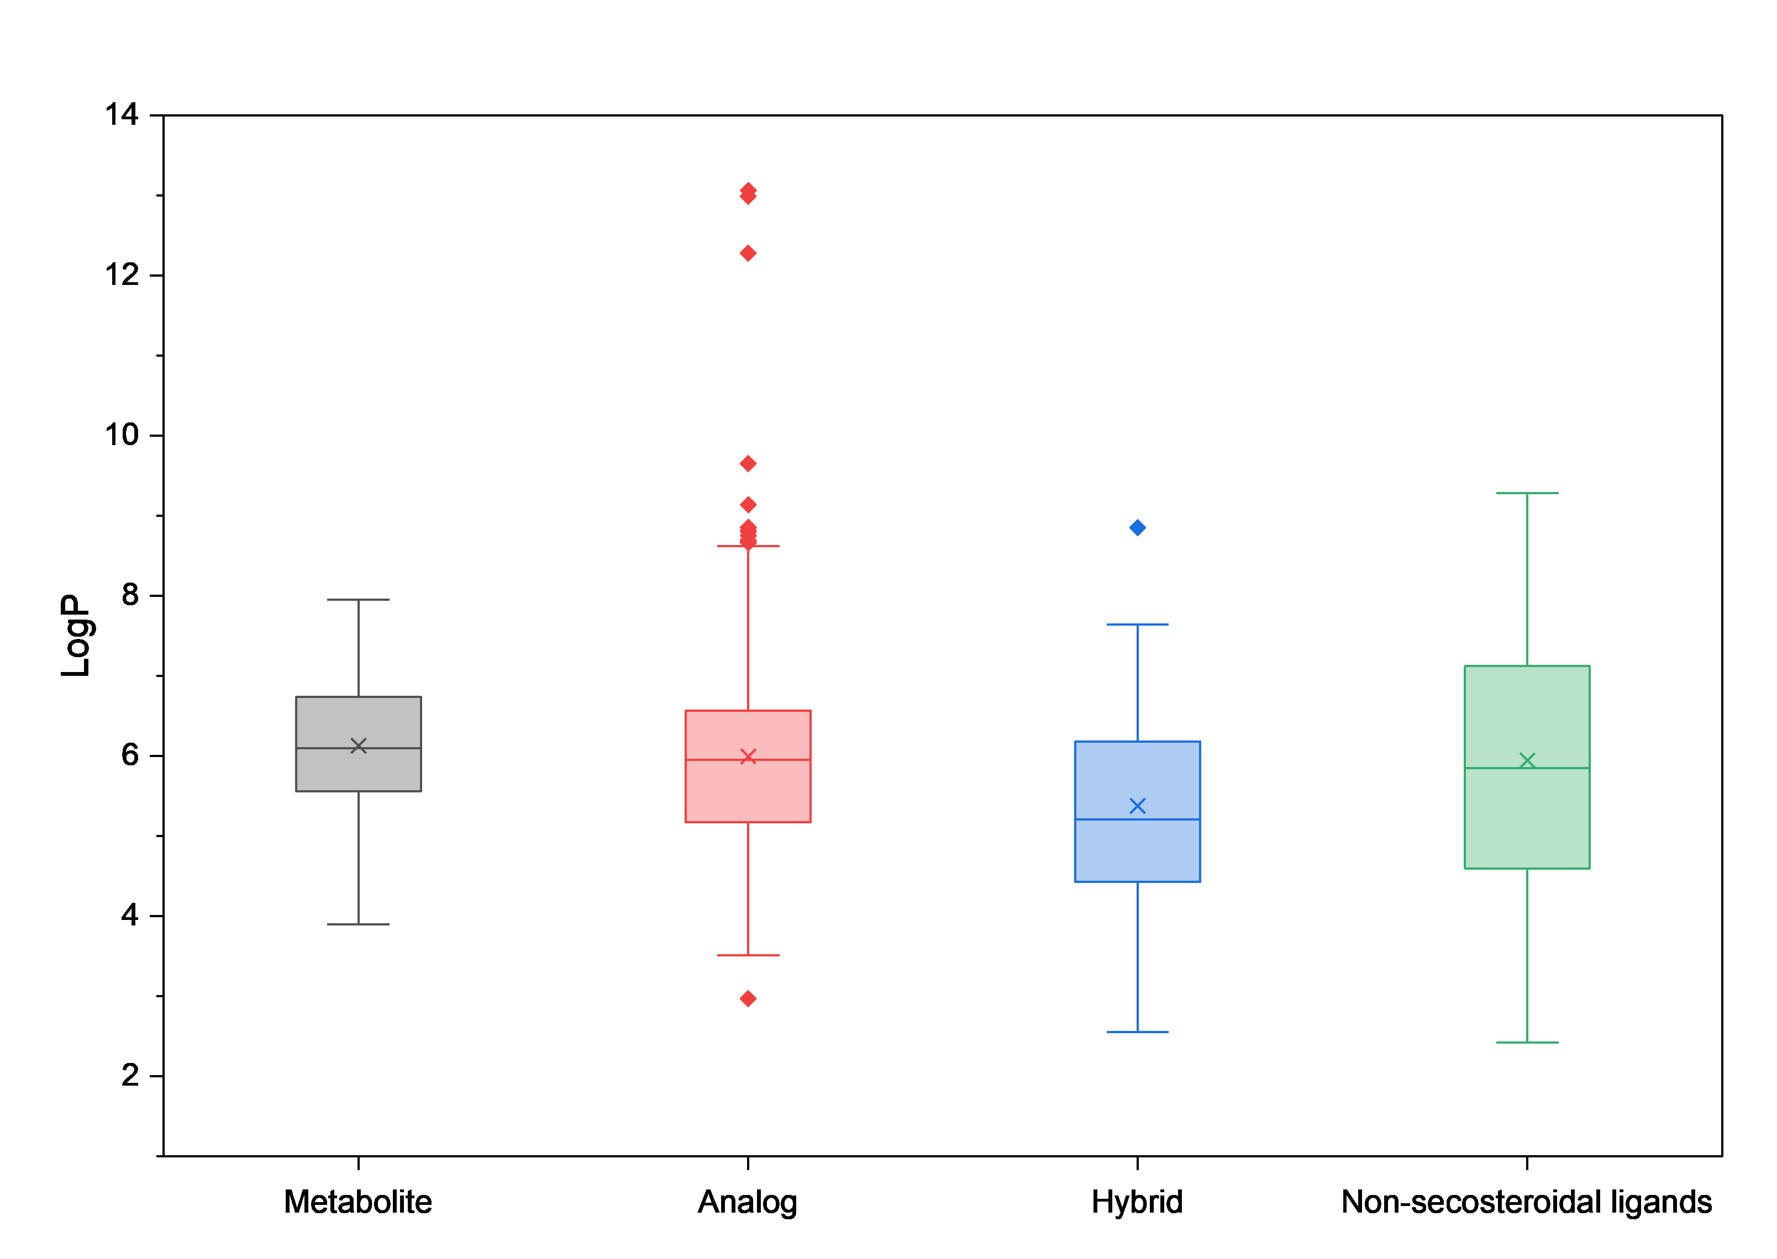b)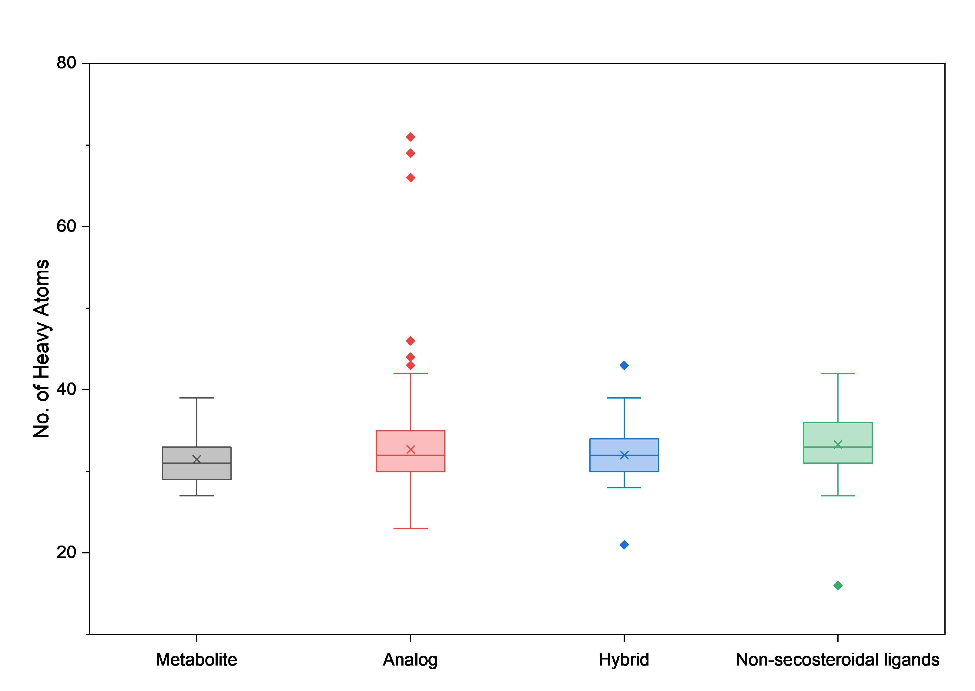
c)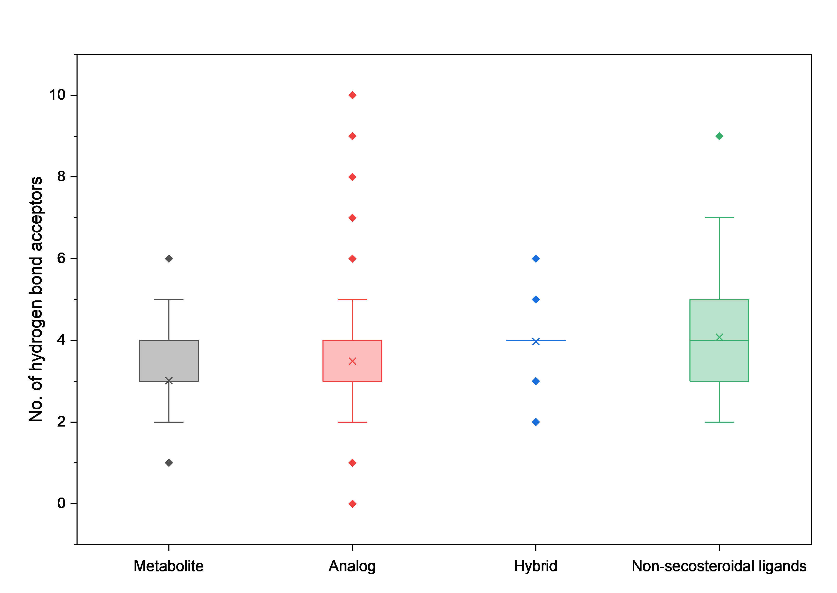d) e) f)
g) 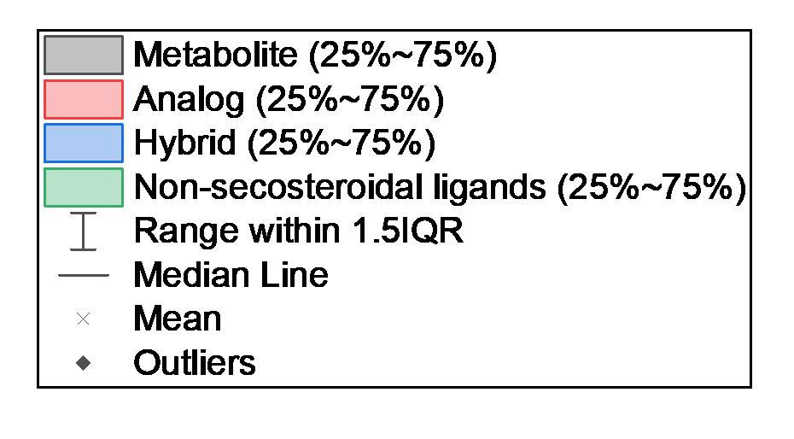
Figure 9. Distribution of physicochemical descriptors across structural categories of the VDR ligand library, presented as boxplots.
(a) logP, (b) Heavy Atoms, (c) HBA, (d) HBD, (e) MW, (f) TPSA, and (g) number of RotB.

DISCUSSION
The descriptor profile shows that the formed set of VDR ligands occupies a chemically consistent, but not classically drug-like space. The narrow distributions of MW, the number of rings, HBA, HBD, as well as TPSA indicate that most compounds retain proximity to a common steroid-like framework. At the same time, the frequent violation of the Lipinsky threshold value of logP reflects not the disadvantages of data selection, but the inherent hydrophobicity of VDR ligands [9,25]. This is consistent with the lipophilic nature of the VDR binding pocket and the limited applicability of the rules of oral "drug-likeness" to steroid nuclear receptor ligands [26]. In this case, compliance with the Veber criteria is more informative, since it demonstrates that, despite the high logP, most compounds retain an acceptable level of polarity and flexibility [27]. However, the analysis of descriptors alone does not allow distinguishing between favorable and unfavorable combinations of properties, since there is no data on biological activity and selectivity.
NP-likeness results serve as an internal verification of the correctness of the structural classification. The monotonous decrease in values from metabolites to analogues, hybrids, and non-secosteroidal ligands reflects a gradual shift from the biosynthetically typical chemical space. This pattern is chemically expected, since metabolites retain a fragmented composition of endogenous vitamin D derivatives, while synthetic analogues and especially non-secosteroidal ligands are gradually moving away from the architecture of natural compounds. At the same time, the NP-score should not be interpreted as an indicator of biological "quality", as it reflects the origin of the structure and the degree of its modification, rather than affinity to the receptor or effectiveness [28]. Its role in this analysis is confirmatory, not predictive.
The most significant result is the dependence of the similarity score on the type of molecular fingerprints. The topological fingerprints of RDKit describe the library as relatively compact, whereas ECFP4 and especially ECFP6 reveal significantly greater heterogeneity. This is not a contradiction but a direct consequence of descriptor design. Path-based fingerprints emphasize overall topology and therefore smooth over many local substitutions, whereas circular fingerprints capture local atomic environments and are more sensitive to the kinds of changes that dominate VDR analog chemistry, including side-chain remodeling, heteroatom replacement, and local stereochemical variation [29]. A clearer division of categories when using ECFP4 in t-SNE and UMAP indicates that the main source of diversity in the set is precisely local substructural variations, rather than differences in the overall framework [21].
Clustering results should be interpreted based on this observation. An increase in the similarity threshold leads to an increase in the "purity" of clusters, but at the same time to their fragmentation, an increase in the number of single connections and a decrease in cluster sizes. This means that highly homogeneous groups do exist, but they represent local regions rather than large chemotypes. Low values of ARI and NMI do not indicate inefficiency of Butina algorithm, but show that the initial categories (metabolites, analogues, hybrids, non-secosteroidal ligands) do not coincide with the structural classes determined by fingerprints. These categories partially reflect the origin and history of compound development, whereas unsupervised clustering captures direct structural proximity [29,30]. Their weak correspondence is thus an informative result.
This interpretation is supported by projections of the chemical space and the categorization of descriptors. Non-secosteroidal ligands consistently occupy a separate region and exhibit broader distributions in lipophilicity, number of heavy atoms, rotating bonds, and TPSA, indicating that they belong to an independent chemotype. At the same time, metabolites, analogues, and hybrids significantly overlap both in low-dimensional projections and in physico-chemical characteristics. This overlap indicates that modifications of the secosteroid framework increase local diversity, but do not form clearly separated global chemotypes. Therefore, the most promising direction for the search for structurally new VDR modulators is not a further variation of the classical framework, but the study of a poorly represented field of non-secosteroidal compounds.
The main limitation of this study is the use of exclusively two-dimensional representations of molecules. In addition, the comparison with PubChem data was limited by the database coverage: 423 out of 962 compounds were not found, which narrowed the analysis to a subset of the data. In the absence of integrated annotations of biological activity and three-dimensional receptor-oriented analysis, this work makes it possible to describe the structural organization of the library but does not make it possible to determine which clusters correspond to different pharmacological effects [9, 31].

CONCLUSION
In this work, a standardized computational dataset was formed, including 962 VDR ligands, and it was shown that their chemical space is compact but internally diverse, largely determined by the secosteroid framework. An analysis of the physico-chemical properties confirmed that the dominant characteristic is increased lipophilicity, which is consistent with the geometry of the VDR binding pocket. The values of the NP-likeness decreased monotonously from metabolites to non-secosteroidal ligands, which quantitatively confirms the proposed structural classification. Multifactorial analysis using different types of molecular fingerprints showed that ECFP-based representations better reflect structural heterogeneity compared to topological fingerprints, while ECFP4 provided the clearest separation of categories when visualizing chemical space. Clustering using Butina's algorithm demonstrated that traditional categories of ligands reflect the history of their development to a greater extent than their actual structural proximity, whereas non-secosteroidal ligands stand out as a truly independent and insufficiently studied chemotype. The main limitation of the study is the lack of annotations of biological activity, which does not allow us to directly establish the structure–activity relationship. The integration of quantitative data on biological activity is a key area for further research within the framework of the proposed approach.

REFERENCES
[1] M.F. Holick, Vitamin D Deficiency, N. Engl. J. Med. 357 (2007) 266–281. https://doi.org/10.1056/NEJMra070553.
[2] T. Khanna, R. Shraim, M. Zarkovic, M. van Weele, J. van Geffen, L. Zgaga, Comprehensive Analysis of Seasonal and Geographical Variation in UVB Radiation Relevant for Vitamin D Production in Europe, Nutrients. 14 (2022) 5189. https://doi.org/10.3390/nu14235189.
[3] C. Carlberg, F. Molnár, Vitamin D receptor signaling and its therapeutic implications: Genome-wide and structural view, Can. J. Physiol. Pharmacol. 93 (2015) 311–318. https://doi.org/10.1139/cjpp-2014-0383.
[4] H. Wang, W. Chen, D. Li, X. Yin, X. Zhang, N. Olsen, S.G. Zheng, Vitamin D and Chronic Diseases, Aging Dis. 8 (2017) 346. https://doi.org/10.14336/AD.2016.1021.
[5] R. Patel, Nandini, H. Kharkwal, M. Saha, M. Sankaranarayanan, S. Sharma, S. Chander, Recent Advancements Towards the Use of Vitamin D Isoforms and the Development of Their Synthetic Analogues as New Therapeutics, Biomedicines. 13 (2025) 1002. https://doi.org/10.3390/biomedicines13041002.
[6] J.W. Pike, M.B. Meyer, S.-M. Lee, M. Onal, N.A. Benkusky, The vitamin D receptor: contemporary genomic approaches reveal new basic and translational insights, J. Clin. Invest. 127 (2017) 1146–1154. https://doi.org/10.1172/JCI88887.
[7] C. Carlberg, Vitamin D and Its Target Genes, Nutrients. 14 (2022) 1354. https://doi.org/10.3390/nu14071354.
[8] N. Rochel, F. Molnár, Structural aspects of Vitamin D endocrinology, Mol. Cell. Endocrinol. 453 (2017) 22–35. https://doi.org/10.1016/j.mce.2017.02.046.
[9] N. Rochel, Vitamin D and Its Receptor from a Structural Perspective, Nutrients. 14 (2022) 2847. https://doi.org/10.3390/nu14142847.
[10] I. Orlov, N. Rochel, D. Moras, B.P. Klaholz, Structure of the full human RXR/VDR nuclear receptor heterodimer complex with its DR3 target DNA, EMBO J. 31 (2012) 291–300. https://doi.org/10.1038/emboj.2011.445.
[11] P.L. Shaffer, D.P. McDonnell, D.T. Gewirth, Characterization of Transcriptional Activation and DNA-Binding Functions in the Hinge Region of the Vitamin D Receptor, Biochemistry. 44 (2005) 2678–2685. https://doi.org/10.1021/bi0477182.
[12] M.A. Maestro, S. Seoane, The Centennial Collection of VDR Ligands: Metabolites, Analogs, Hybrids and Non-Secosteroidal Ligands, Nutrients. 14 (2022) 4927. https://doi.org/10.3390/nu14224927.
[13] C. Carlberg, F. Molnar, Current Status of Vitamin D Signaling and Its Therapeutic Applications, Curr. Top. Med. Chem. 12 (2012) 528–547. https://doi.org/10.2174/156802612799436623.
[14] M.A. Maestro, F. Molnár, C. Carlberg, Vitamin D and Its Synthetic Analogs, J. Med. Chem. 62 (2019) 6854–6875. https://doi.org/10.1021/acs.jmedchem.9b00208.
[15] A.Y. Belorusova, S. Chalhoub, D. Rovito, N. Rochel, Structural Analysis of VDR Complex with ZK168281 Antagonist, J. Med. Chem. 63 (2020) 9457–9463. https://doi.org/10.1021/acs.jmedchem.0c00656.
[16] L.L. Issa, G.M. Leong, R.L. Sutherland, J.A. Eisman, Vitamin D Analogue-Specific Recruitment of Vitamin D Receptor Coactivators, J. Bone Miner. Res. 17 (2002) 879–890. https://doi.org/10.1359/jbmr.2002.17.5.879.
[17] R. Bouillon, L. Verlinden, G. Eelen, P. De Clercq, M. Vandewalle, C. Mathieu, A. Verstuyf, Mechanisms for the selective action of Vitamin D analogs, J. Steroid Biochem. Mol. Biol. 97 (2005) 21–30. https://doi.org/10.1016/j.jsbmb.2005.06.013.
[18] Y. Ma, Identification and characterization of noncalcemic, tissue-selective, nonsecosteroidal vitamin D receptor modulators, J. Clin. Invest. 116 (2006) 892–904. https://doi.org/10.1172/JCI25901.
[19] R. Adachi, Y. Honma, H. Masuno, K. Kawana, I. Shimomura, S. Yamada, M. Makishima, Selective activation of vitamin D receptor by lithocholic acid acetate, a bile acid derivative, J. Lipid Res. 46 (2005) 46–57. https://doi.org/10.1194/jlr.M400294-JLR200.
[20] S. Nagamani, L. Jaiswal, G.N. Sastry, Deciphering the importance of MD descriptors in designing Vitamin D Receptor agonists and antagonists using machine learning, J. Mol. Graph. Model. 118 (2023) 108346. https://doi.org/10.1016/j.jmgm.2022.108346.
[21] D. Rogers, M. Hahn, Extended-Connectivity Fingerprints, J. Chem. Inf. Model. 50 (2010) 742–754. https://doi.org/10.1021/ci100050t.
[22] S. Sosnin, Chemical space visual navigation in the era of deep learning and Big Data, Drug Discov. Today. 30 (2025) 104392. https://doi.org/10.1016/j.drudis.2025.104392.
[23] R. Otero, S. Seoane, R. Sigüeiro, A.Y. Belorusova, M.A. Maestro, R. Pérez-Fernández, N. Rochel, A. Mouriño, Carborane-based design of a potent vitamin D receptor agonist, Chem. Sci. 7 (2016) 1033–1037. https://doi.org/10.1039/C5SC03084F.
[24] J.M. Jayaraj, E. Reteti, C. Kesavan, K. Muthusamy, Structural insights on vitamin D receptor and screening of new potent agonist molecules: structure and ligand-based approach, J. Biomol. Struct. Dyn. 39 (2021) 4148–4159. https://doi.org/10.1080/07391102.2020.1775122.
[25] C.A. Lipinski, Lead- and drug-like compounds: the rule-of-five revolution, Drug Discov. Today Technol. 1 (2004) 337–341. https://doi.org/10.1016/j.ddtec.2004.11.007.
[26] T.P. Burris, L.A. Solt, Y. Wang, C. Crumbley, S. Banerjee, K. Griffett, T. Lundasen, T. Hughes, D.J. Kojetin, Nuclear Receptors and Their Selective Pharmacologic Modulators, Pharmacol. Rev. 65 (2013) 710–778. https://doi.org/10.1124/pr.112.006833.
[27] D.F. Veber, S.R. Johnson, H.-Y. Cheng, B.R. Smith, K.W. Ward, K.D. Kopple, Molecular Properties That Influence the Oral Bioavailability of Drug Candidates, J. Med. Chem. 45 (2002) 2615–2623. https://doi.org/10.1021/jm020017n.
[28] P. Ertl, S. Roggo, A. Schuffenhauer, Natural Product-likeness Score and Its Application for Prioritization of Compound Libraries, J. Chem. Inf. Model. 48 (2008) 68–74. https://doi.org/10.1021/ci700286x.
[29] K. López-Pérez, J.F. Avellaneda-Tamayo, L. Chen, E. López-López, K.E. Juárez-Mercado, J.L. Medina-Franco, R.A. Miranda-Quintana, Molecular similarity: Theory, applications, and perspectives, Artif. Intell. Chem. 2 (2024) 100077. https://doi.org/10.1016/j.aichem.2024.100077.
[30] D. Butina, Unsupervised Data Base Clustering Based on Daylight’s Fingerprint and Tanimoto Similarity: A Fast and Automated Way To Cluster Small and Large Data Sets, J. Chem. Inf. Comput. Sci. 39 (1999) 747–750. https://doi.org/10.1021/ci9803381.
[31] H. Masuno, T. Ikura, D. Morizono, I. Orita, S. Yamada, M. Shimizu, N. Ito, Crystal structures of complexes of vitamin D receptor ligand-binding domain with lithocholic acid derivatives, J. Lipid Res. 54 (2013) 2206–2213. https://doi.org/10.1194/jlr.M038307.

Appendix

Table A1. Shapiro–Wilk normality test for NP-score within each structural category
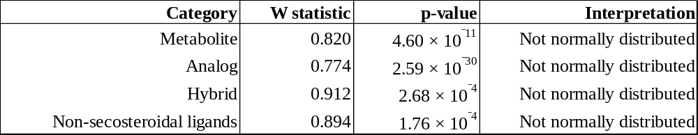

Table A2. Levene’s test for homogeneity of variance of NP-score across structural categories

