Analysis of physical activity-associated gene expression network in muscle cell line model

Student name: Albina Zharylgap

Syed Hani Abidi, PI
Syed Ali, Co-PI
Date of submission: 01.03.2026

Abstract:
Physical activity has been shown to induce the expression of a wide range of genes, thereby altering the function of the musculoskeletal system. The changes often occur through genetic and epigenetic alterations occurring in the coding and promoter regions of different genes, respectively, and can alter (increase or decrease) the expression of different genes. Although several studies have analyzed genetic changes in response to short-term physical activity, the differences in gene expression associated with long-term physical activity as compared to physical inactivity (sedentary lifestyle) are poorly understood. This study aims to analyze gene expression network that is differentially expressed in physically active individuals compared to sedentary individuals, within a muscle cell line model.

Introduction:
Physical activity is proven to have a positive effect on both physical and mental health, making it an indicator of a healthy daily life (Kumar, 2017). It has been shown to induce the expression of a wide range of genes, which can alter the function of the musculoskeletal system. As an adaptation mechanism to endurance exercise, mitochondria number and size increase in skeletal muscle and it is regulated by PGC-1ɑ (Yan, 2012). Akt, GSK-3β, and mTOR serve as important indicators of muscle hypertrophy, following resistance training (Leger, 2006). Our previous research on transcriptomic datasets has shown the seven most differentially expressed genes (DEGs) among elite athletes and sedentary individuals (Table 1).
No | Gene | Gene symbol | Function in human organism
1 | Activating Transcription Factor 3 | ATF3 | Modulation of homeostatic response to stress signals in skeletal muscle after acute exercise (Verdejo et al., 2018)
2 | MYC Proto-Oncogene | MYC | Regulation of skeletal muscle protein synthesis (Edman et al., 2024)
3 | Nuclear Factor, Interleukin 3 Regulated | NFIL3 | The transcriptional regulation of several gene families involved in circadian physiology of skeletal muscle (Martin et al., 2025)
4 | Nuclear Receptor Subfamily 4, Group A, member 2 | NR4A2 | Involvement in mitochondrial biogenesis and function (Mok et al., 2024)
5 | Nuclear Receptor Subfamily 4, Group A, member 3 | NR4A3 | Regulation of glucose metabolism and protein synthesis in skeletal muscle (Smith et al., 2025)
6 | Solute Carrier Family 2 Member 3/GLUT3 | SLC2A3 | Glucose uptake in neurons (Ziegler et al., 2020)
7 | Suppressor of Cytokine Signaling 3 | SOCS3 | Mediates muscle atrophy through protein synthesis and degradation modulation (Ji., et al., 2022)
Table 1. DEGs and their function
Our STRING analysis showed that the seven DEGs are inter-connected, with ATF3 exhibiting the highest degree of connectivity to other genes and may be acting as the hub gene in the network (Figure 1).

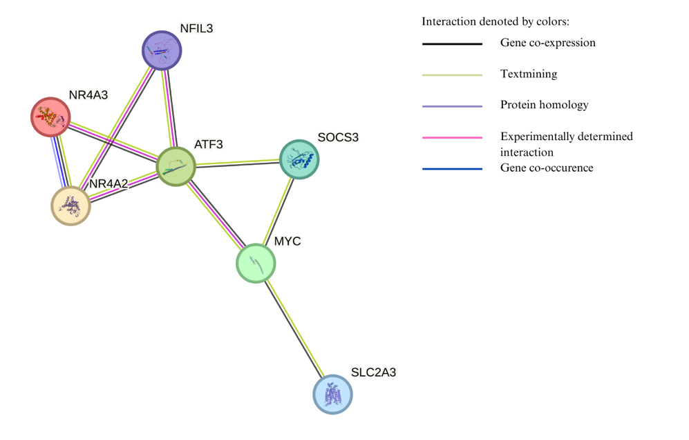
Figure 1. The protein-protein interaction network.
Since Denk and colleagues (2015) established tamoxifen as an agent that induces ATF3 upregulation, in this study it was used to alter ATF3 expression. The overall aim of the present study was to investigate the relationship between alterations in the mRNA expression of ATF3 and the six abovementioned genes in muscle cell line model.

Methods:
Cell line and culture
Human rhabdomyosarcoma (RD) cells were used as the model muscle cells in this study. RD cells are large, multinucleated, spindle-shaped cells (McAllister et al., 1969) and were isolated from an embryonic rhabdomyosarcoma of a 7-year-old female. RD cells are often utilized in rhabdomyosarcoma research (Hinson et al., 2013), are a model for skeletal muscle research (Wu, 1993) and therefore, can bring valuable results as a skeletal muscle model to explore gene alterations.
Human embryonal rhabdomyosarcoma RD cell line was obtained from American Type Culture Collection (ATCC, Manassas, VA, USA). The cell line was cultured in Dulbecco’s Modified Eagle Medium (DMEM, Sigma-Aldrich, St. Louis, MO, USA) supplemented with 10% fetal bovine serum (FBS, Gibco, Thermo Fisher Scientific, Waltham, MA, USA), 1% Penicillin/Streptomycin solution (Sigma-Aldrich, St. Louis, MO, USA) and maintained at 37°C with 5% CO₂ in T-75 flask.
Cell harvesting and tamoxifen treatment
Cells were and harvested from the T-75 flasks by adding 3 mL of 1X phosphate-buffered saline (PBS, Gibco, Thermo Fisher Scientific) and 3 mL of 1X Trypsin-EDTA (Gibco, Thermo Fisher Scientific) to the T-75 flask and incubating at 37°C with 5% CO₂. For neutralization of trypsin, 3 mL of DMEM with 10% FBS (Sigma-Aldrich, St. Louis, MO, USA) was added. Subsequently, cells were sub-cultured in a 6-well plate. To induce changes in ATF3 expression, cells were treated with 20 μM of tamoxifen and assessed at two timepoints (24 hours and 48 hours). Here, cells treated with 2 mL of DMSO 1% + 2 mL of DMEM as a control.
Morphological analysis
At each timepoint, cells were evaluated for morphological changes using inverted microscope (Carl Zeiss Microscopy, GmbH, Germany). Snapshots of cells were recorded using ZEN 2.6 blue edition (Zeiss, Germany) at 24 hours and 48 hours. Qualitative morphological analysis was performed based on following characteristics: cell shape, size, density, detachment and apoptosis.
RNA extraction and cDNA conversion:
The RNA from tamoxifen-treated cells at 24 and 48 hours was extracted using the Monarch® Total RNA Miniprep Kit (New England Biolabs, Ipswich, MA, US), following the manufacturer’s instructions. RNA was converted to cDNA using RevertAid First Strand cDNA Synthesis Kit (Thermo Fisher Scientific). RNA purity and integrity were determined using a Nanodrop ONEC (Thermo Scientific).
Real Time-qPCR
The cDNA was utilized in RT-qPCR (QuantStudio™ 6 Flex, Thermo Fisher Scientific) experiments. Each PCR reaction mixture consisted of Maxima SYBR Green/ROX qPCR Master Mix 2X (Thermo Fisher Scientific) 4 μL, Forward primer 0.5 μL, Reverse primer 0.5 μL, Template cDNA 1 μL and nuclease free-water 4 μL. The concentrations of primers (Table 2) were less than 500 ng/μL and 300 pmol/ μL, respectively. Gene-specific primers were obtained from Nazarbayev University (NU, Astana, Kazakhstan). Each PCR was performed using the following conditions: 2 minutes at 50° C, 10 minutes at 95° C, 15 seconds at 95° C, 1 minute at 60° C, 15 seconds at 95° C. Each sample was analyzed in duplicate with non-template control (NTC). In short,

Table 2. Gene-specific primers used in this study
Primer | Sequences
ATF3-Forward | 5’-CCTCTGCGCTGGAATCAGTC-3’
ATF3-Reverse | 3’-TTCTTTCTCGTCGCCTCTTTTT-5’
MYC-Forward | 5’-GGCTCCTGGCAAAAGGTCA-3’
MYC-Reverse | 3’-CTGCGTAGTTGTGCTGATGT-5’
NFIL3-Forward | 5’-CTGCTTTAACGGAAGTGTCAGA-3’
NFIL3-Reverse | 3’-TTCCTCCGACATGCAGAAGAT-5’
NR4A2-Forward | 5’-GCACTCCGGGTCGGTTTAC-3’
NR4A2-Reverse | 3’-GCCACGTAGTTCTGGTGGAA-5’
NR4A3-Forward | 5’-GGTCGTCTGCCTTCCAAAC-3’
NR4A3-Reverse | 3’-GCTCGGACAAGGGCATTCA-5’
SLC2A3-Forward | 5’-GCTGGGCATCGTTGTTGGA
SLC2A3-Reverse | 3’-GCACTTTGTAGGATAGCAGGAAG-5’
SOCS3-Forward | 5’-CCTGCGCCTCAAGACCTTC-3’
SOCS3-Reverse | 3’-GTCACTGCGCTCCAGTAGAA-5’
RPL13A-Forward | 5’-CTCAAGGTGTTTGACGGCATCC-3’
RPL13A- Reverse | 3’-TACTTCCAGCCAACCTCGTGAG-5’

Statistical analysis:
To identify the expression of shortlisted genes, the Delta CT/fold change method (Rao et al., 2013) was applied in Microsoft Excel software (Microsoft Corporation, Redmond, Washington, USA).
We used the Spearman correlation test to determine the correlation between gene expressions using GraphPad Prism 10 (Dotmatics, Boston, MA, USA). For all analyses, a p<0.05 will be considered statistically significant.
Results:
Morphological Analysis
The RD cells were examined with a phase-contrast microscope (Carl Zeiss Microscopy) at 10x magnification. Cell shape and size across tamoxifen-treated and control cells did not differ, and both groups of cells at the 48-hour timepoint showed a doubling in confluency (Figure 2). Cells were elongated, maintained spindle-shaped morphology, and adherent in both drug-treated and control cells. Detachment and apoptotic signs were slightly prominent in cells treated with tamoxifen at 48 hours compared to vehicle control and drug-treated at 24 hours.
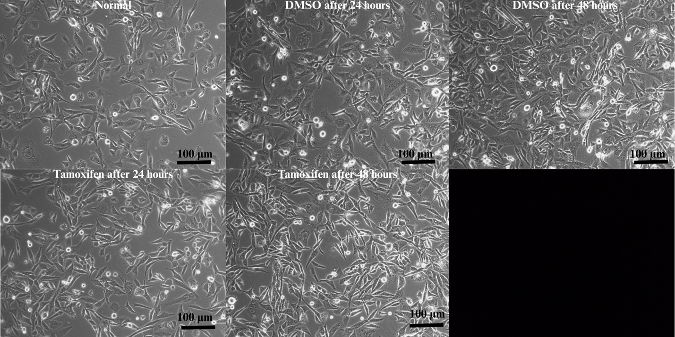
Figure 2. RD cells treated with DMSO 1% and tamoxifen 20 μM at 24 and 48 hours
Time-dependent effect of tamoxifen on expression of DEGs. The normal group is represented by cells that were cultured in DMEM at 0 hours.
Gene expression analysis
In RD cells, treated or untreated with tamoxifen 20 μM for 24 and 48 hours, the change in gene expression was assessed for ATF3, MYC, NFIL3, NR4A2, NR4A3, SLC2A3, SOCS3 by RT-qPCR (2^{-ΔΔCt} method) (Figure 3).
As shown in Figure 3, the relative gene expression of ATF3 had a 2.9 and 1.9-fold decrease for 24 and 48 hours, respectively, compared to the control group. The expression of MYC increased after tamoxifen treatment; at 24 hours it increased 1.5-fold, at 48 hours 3.8-fold. The mRNA level of NFIL3, in contrast, decreases over time: at 24 hours increases 4-fold, whereas at 48 hours decreased to 2.3-fold. RT-qPCR demonstrated downregulation of NR4A2 in both experimental groups compared to control: 24- and 48-hours treatment with tamoxifen led to 1-fold decrease. Meanwhile, NR4A3 was downregulated to 1.2-fold at 24 hours, while upregulated to 1.3-fold at 48 hours. The expression rate of SLC2A3 significantly reduced by at 48 hours compared to 24 hours (2.37-fold at 24 hours to -1.3-fold at 48 hours). At last, SOCS3 was upregulated at 24 hours 1.5-fold and 1.2-fold at 48 hours.

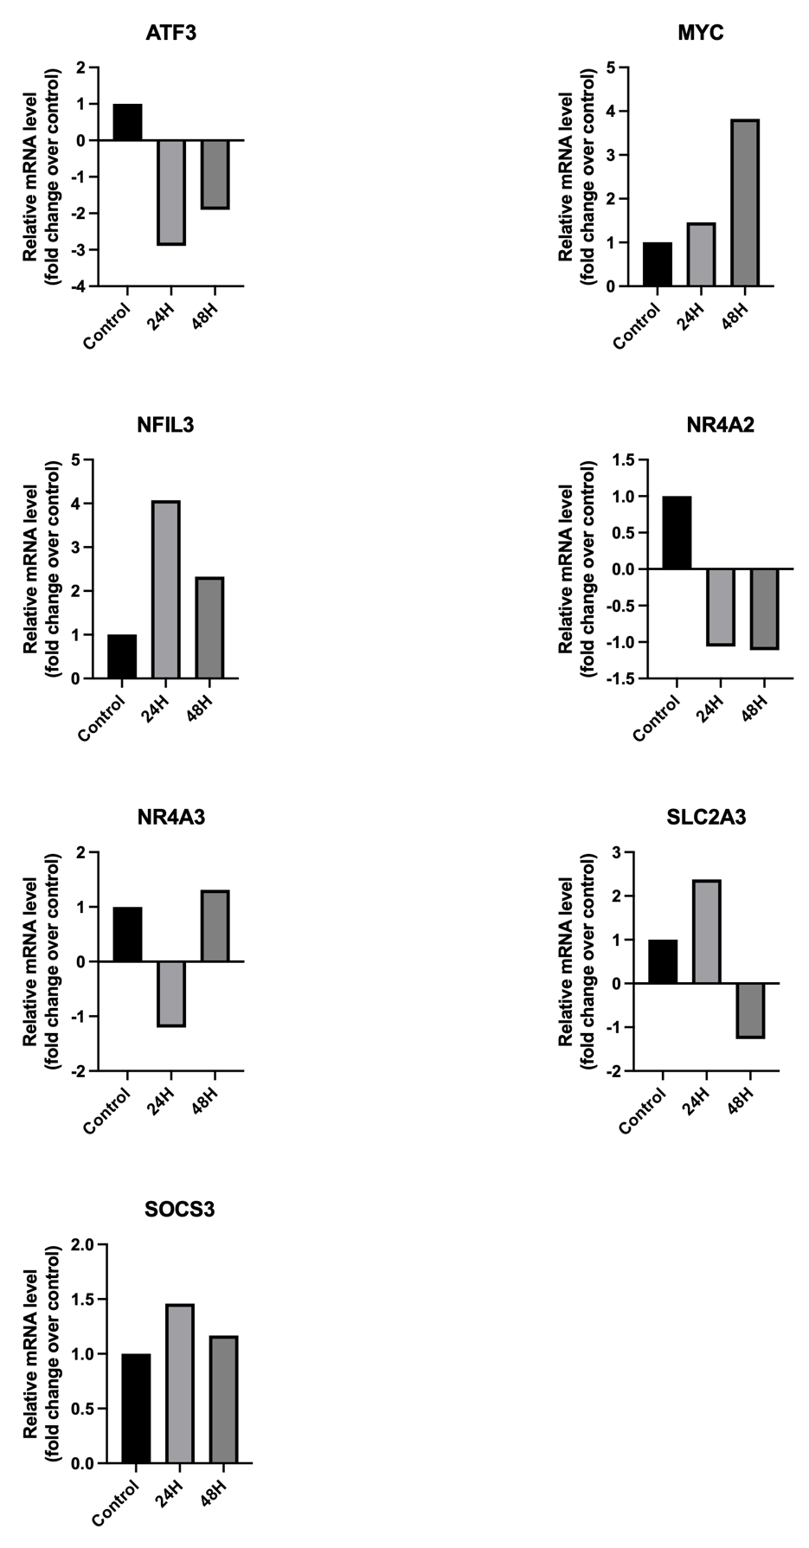
Figure 3. Gene expression by RT-qPCR. Analysis of gene expression of ATF3, MYC, NFIL3, NR4A2, NR4A3, SLC2A3, SOCS3 in RD cells treated with 20 μM of tamoxifen for 24 and 48 hours. Bar charts show the relative mRNA level, normalized to housekeeping gene RPL13A, compared to control (untreated cells).

Correlation analysis
Spearman correlation analysis showed the expression of NFIL3, NR4A2, and NR4A3 to be positively correlated with ATF3 expression (r ≥ 0.4) (Figure 4). In contrast, mRNA expression of MYC and SLC2A3 was negatively correlated with ATF3 (r ≤ -0.4), and SOCS3 showed no correlation with ATF3.
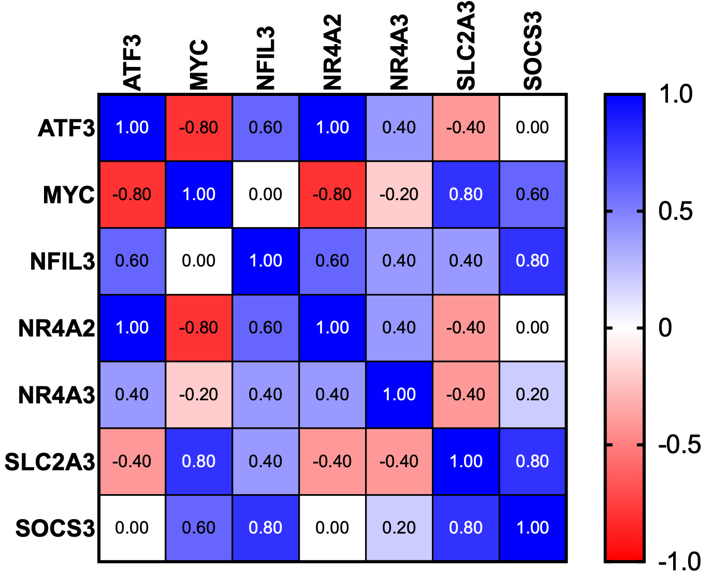
Figure 4. Correlation matrix plot showing the correlation coefficients for the level of expression of pairs of genes. Blue color illustrates genes displaying positive correlations, and red denotes genes showing negative correlations.
Discussion
In this work, time dependent effect of tamoxifen on a rhabdomyosarcoma (RD) cell line was tested; morphological changes, difference in the gene expression and correlation between sets of genes were evaluated.
The investigation made by our researchers led to a necessity for exploring the connection between DEGs, using STRING analysis, which is a powerful tool that is based on current evidence and allows to predict possible interactions between genes (Szklarczyk, 2025). According to it, ATF3 was hypothesized to be the hub gene.
After treatment with tamoxifen, no significant apoptotic effect in cells was observed and confluency increased significantly at 48 h. While confluency increased significantly, rounding of cells elevated slightly at 48 h compared to 24 h.
In the present study, exposure to tamoxifen led to a reduction in ATF3 mRNA expression at both 24 and 48 hours. Nevertheless, comparison between the two time points revealed 1-fold decrease in ATF3 expression levels. In contrast, the previous reports demonstrated upregulation of ATF3 following treatment with tamoxifen in breast cancer cell lines (MCF7 and T47D), various cells of central and peripheral nervous system of a mice model, (Borgoni et al., 2020; Denk et al., 2015), cardiac cells (Li et al., 2017). Such discrepancy could be attributed to differences in cell type, as previous studies were conducted in breast cancer, neural and cardiac cells. Moreover, mRNA expression of MYC was increased following tamoxifen treatment in both groups of cells (24 and 48 hours) in this study and this finding is consistent with previous studies. Tamoxifen had upregulating effect on c-MYC in breast cancer cells (Kang et al., 1996) and angiomyolipoma cells (Yu et al., 2004). In this study, NFIL3 upregulation was greater in tamoxifen treated cells at 24 hours than in cells at 48 hours, while Alamholo and Tarinejad (2025) identified NFIL3 to be downregulated in tamoxifen-resistant breast cancer cells. This finding may suggest that NFIL3 may play a role in the early cellular response to tamoxifen, while its downregulation could contribute to the establishment of resistance in cells. NR4A2 was downregulated in both groups, while Ashraf et al. (2022) showed that tamoxifen induces upregulation of NR4A2 in cardiac cells in mice. After treatment with tamoxifen, cells at 24 hours showed a downregulation of NR4A3, while at 48 hours it was upregulated. Kim et al. (2021) reported expression of NR4A3 did not differ between tamoxifen-sensitive MCF7 cells and tamoxifen-resistant TamR cells. In this study SLC2A3 was downregulated in cells at 24 hours, while upregulated at 48 hours. Li and colleagues (2026) identified SLC2A3 to be activated in tamoxifen-resistant breast cancer cells. As it was mentioned before, the difference in findings could be attributed to variation in cell line models and conditions. In RD cells treated with tamoxifen at 24 and 48 hours the expression of SOCS3 was upregulated. This finding is consistent with previous report (Mirzaei et al., 2022) showing SOCS3 was overexpressed in breast cancer cells treated with tamoxifen. Despite variations in cellular background, the consistent upregulation suggests that SOCS3 activation may represent a common cellular response to treatment.
ATF3 has also shown to have a functional link with MYC (Tamura et al., 2005); downregulated together with NR4A3 in rats with overuse jumping (Shi et al., 2023); identified with NR4A2 as two key hub genes in knee osteoarthritis (Xu et al., 2024); regulates transcription of Il12b which could also be coregulated by NFIL3 (Kobayashi et al., 2011). Also, Luo and colleagues (2024) confirmed that ATF3 binds to the SOCS3 promoter, thereby verifying a direct regulatory link. Although ATF3 is not connected to SLC2A3 directly in the proposed network, Xiang et al. (2023) identified SLC2A3 and ATF3 as two of the three hub genes involved in rheumatoid arthritis and ferroptosis. Combined, this evidence suggests ATF3 to be the “central” gene in the network and its expression induces an effect on the expression of this list of genes.
According to Figure 4, NR4A2 demonstrated the strongest positive correlation with ATF3 expression among the genes analyzed (r=1). Although there are no reports available on the correlation in expression between this pair of genes in a muscle cell line following tamoxifen treatment, our finding highlights the need for further investigation into the underlying mechanism of ATF3 regulation of NR4A2.
In conclusion, tamoxifen induced the downregulation of ATF3 in RD cells and its expression was correlated with DEGs. Spearman correlation analysis established that the strongest correlation of ATF3 expression was with NR4A2.
The experiment in this study was conducted once; therefore, the findings should be interpreted with caution and require validation in independent experiments.

Reference List:
Alamholo, M., & Tarinejad, A. (2025). Molecular mechanisms underlying tamoxifen resistance in breast cancer MCF-7 cell line using transcriptomic and bioinformatics approaches. Discover Applied Sciences, 7(10), 1131.

Ashraf, S., Taegtmeyer, H., & Harmancey, R. (2022). Prolonged cardiac NR4A2 activation causes dilated cardiomyopathy in mice. Basic Research in Cardiology, 117(1), 33.

Bodine, S. C., Stitt, T. N., Gonzalez, M., Kline, W. O., Stover, G. L., Bauerlein, R., ... & Yancopoulos, G. D. (2001). Akt/mTOR pathway is a crucial regulator of skeletal muscle hypertrophy and can prevent muscle atrophy in vivo. Nature cell biology, 3(11), 1014-1019. https://doi.org/10.1038/ncb1101-1014

Borgoni, S., Sofyalı, E., Soleimani, M., Wilhelm, H., Müller-Decker, K., Will, R., Noronha, A., Beumers, L., Verschure, P. J., Yarden, Y., Magnani, L., Van Kampen, A. H., Moerland, P. D., & Wiemann, S. (2020). Time-Resolved Profiling Reveals ATF3 as a Novel Mediator of Endocrine Resistance in Breast Cancer. Cancers, 12(10), 2918. https://doi.org/10.3390/cancers12102918

Denk, F., Ramer, L. M., Erskine, E. L. K. S., et al. (2015). Tamoxifen induces cellular stress in the nervous system by inhibiting cholesterol synthesis. Acta Neuropathologica Communications, 3, 74. https://doi.org/10.1186/s40478-015-0255-6

Duchateau, J., Stragier, S., Baudry, S., & Carpentier, A. (2021). Strength training: in search of optimal strategies to maximize neuromuscular performance. Exercise and sport sciences reviews, 49(1), 2-14. DOI: 10.1249/JES.0000000000000234

Edman, S., Jones Iii, R. G., Jannig, P. R., Fernandez-Gonzalo, R., Norrbom, J., Thomas, N. T., Khadgi, S., Koopmans, P. J., Morena, F., Chambers, T. L., Peterson, C. S., Scott, L. N., Greene, N. P., Figueiredo, V. C., Fry, C. S., Zhengye, L., Lanner, J. T., Wen, Y., Alkner, B., Murach, K. A., … von Walden, F. (2024). The 24-hour molecular landscape after exercise in humans reveals MYC is sufficient for muscle growth. EMBO reports, 25(12), 5810–5837. https://doi.org/10.1038/s44319-024-00299-z

Fernández-Verdejo, R., Vanwynsberghe, A. M., Essaghir, A., Demoulin, J. B., Hai, T., Deldicque, L., & Francaux, M. (2017). Activating transcription factor 3 attenuates chemokine and cytokine expression in mouse skeletal muscle after exercise and facilitates molecular adaptation to endurance training. FASEB journal: official publication of the Federation of American Societies for Experimental Biology, 31(2), 840–851. https://doi.org/10.1096/fj.201600987R

Green, H. J., Ballantyne, C. S., MacDougall, J. D., Tarnopolsky, M. A., & Schertzer, J. D. (2003). Adaptations in human muscle sarcoplasmic reticulum to prolonged submaximal training. Journal of applied physiology, 94(5), 2034-2042

Hinson, A. R., Jones, R., Crose, L. E., Belyea, B., Barr, F. G., & Linardic, C. M. (2013). Human Rhabdomyosarcoma Cell Lines for Rhabdomyosarcoma Research: Utility and Pitfalls. Frontiers in Oncology, 3, 52039. https://doi.org/10.3389/fonc.2013.00183

Ji, Y., Li, M., Chang, M., Liu, R., Qiu, J., Wang, K., Deng, C., Shen, Y., Zhu, J., Wang, W., Xu, L., & Sun, H. (2022). Inflammation: Roles in Skeletal Muscle Atrophy. Antioxidants, 11(9), 1686. https://doi.org/10.3390/antiox11091686

Kang, Y., Cortina, R., & Perry, R. R. (1996). Role of c-myc in Tamoxifen-Induced Apoptosis in Estrogen-Independent Breast Cancer Cells. JNCI: Journal of the National Cancer Institute, 88(5), 279-284. https://doi.org/10.1093/jnci/88.5.279

Kim, Y. C., Kim, C. Y., Oh, J. H., & Kim, M. H. (2021). NR4A1 Regulates Tamoxifen Resistance by Suppressing ERK Signaling in ER-Positive Breast Cancer. Cells, 10(7), 1633. https://doi.org/10.3390/cells10071633

Kobayashi, T., Matsuoka, K., Sheikh, S. Z., Elloumi, H. Z., Kamada, N., Hisamatsu, T., Hansen, J. J., Doty, K. R., Pope, S. D., Smale, S. T., Hibi, T., Rothman, P. B., Kashiwada, M., & Plevy, S. E. (2011). NFIL3 Is a Regulator of IL-12 p40 in Macrophages and Mucosal Immunity. The Journal of Immunology, 186(8), 4649-4655. https://doi.org/10.4049/jimmunol.1003888

Kumar, R. (2017). The benefits of physical activity and exercise for health. Research review International journal of multidisciplinary, 2(2), 2455-3085.

Li, Y., Li, Z., Zhang, C., Li, P., Wu, Y., Wang, C., Lau, W. B., Ma, X.-L., & Du, J. (2017). Cardiac fibroblast-specific activating transcription factor 3 protects against heart failure by suppressing MAP2K3-p38 signaling. Circulation, 135(21), 2041–2057. https://doi.org/10.1161/CIRCULATIONAHA.116.024599

Li, Y., Tang, J., Wu, X., & Zhang, H. (2026). Solute carrier family 2 member 3: A central mediator in aerobic glycolysis contributing to tumor malignant progression. International Journal of Cancer, 158(6), 1437-1449.

Martin, R. A., Viggars, M. R., & Esser, K. A. (2023). Metabolism and exercise: the skeletal muscle clock takes centre stage. Nature reviews. Endocrinology, 19(5), 272–284. https://doi.org/10.1038/s41574-023-00805-8
McAllister, R. M., Melnyk, J., Finklestein, J. Z., Adams Jr, E. C., & Gardner, M. B. (1969). Cultivation in vitro of cells derived from a human rhabdomyosarcoma. Cancer, 24(3), 520-526.

Mirzaei, M., Sheikholeslami, S. A., Jalili, A., Bereimipour, A., Sharbati, S., Kaveh, V., & Salari, S. (2022). Investigating the molecular mechanisms of Tamoxifen on the EMT pathway among patients with breast cancer. Journal of medicine and life, 15(6), 835.

Mok, J., Park, J. H., Yeom, S. C., & Park, J. (2024). PROKR1–CREB–NR4A2 axis for oxidative muscle fiber specification and improvement of metabolic function. Proceedings of the National Academy of Sciences, 121(4), e2308960121. https://doi.org/10.1073/pnas.2308960121

Nitert, M. D., Dayeh, T., Volkov, P., Elgzyri, T., Hall, E., Nilsson, E., ... & Ling, C. (2012). Impact of an exercise intervention on DNA methylation in skeletal muscle from first-degree relatives of patients with type 2 diabetes. Diabetes, 61(12), 3322-3332.

Léger, B., Cartoni, R., Praz, M., Lamon, S., Dériaz, O., Crettenand, A., ... & Russell, A. P. (2006). Akt signalling through GSK‐3β, mTOR and Foxo1 is involved in human skeletal muscle hypertrophy and atrophy. The Journal of physiology, 576(3), 923-933.

Rao, X., Huang, X., Zhou, Z., & Lin, X. (2013). An improvement of the 2ˆ(–delta delta CT) method for quantitative real-time polymerase chain reaction data analysis. Biostatistics, Bioinformatics and Biomathematics, 3(3), 71. https://pmc.ncbi.nlm.nih.gov/articles/PMC4280562/

Shi, X., Wang, Y., Liu, H., & Han, R. (2023). Targeting Hub Genes Involved in Muscle Injury Induced by Jumping Load Based on Transcriptomics. DNA and Cell Biology. https://doi.org/10.1089_dna.2022.0285

Smith, J. A., Gabriel, B. M., Brady, A. J., Abdelmoez, A. M., Savikj, M., Wright, S. C., Koutsilieri, S., Barrès, R., Lauschke, V. M., Krook, A., Zierath, J. R., & Pillon, N. J. (2025). Inactivity-induced NR4A3 downregulation in human skeletal muscle affects glucose metabolism and translation: Insights from in vitro analysis. Molecular Metabolism, 99, 102200. https://doi.org/10.1016/j.molmet.2025.102200

Stitt, T. N., Drujan, D., Clarke, B. A., Panaro, F., Timofeyva, Y., Kline, W. O., Gonzalez, M., Yancopoulos, G. D., Glass, D. J. (2004). The Igf-1/PI3K/Akt pathway prevents expression of muscle atrophy-induced ubiquitin ligases by inhibiting Foxo transcription factors. Molecular Cell, 14, 395–403.

Szklarczyk, D., Nastou, K., Koutrouli, M., Kirsch, R., Mehryary, F., Hachilif, R., Hu, D., Peluso, M. E., Huang, Q., Fang, T., Doncheva, N. T., Pyysalo, S., Bork, P., Jensen, L. J., & Von Mering, C. (2025). The STRING database in 2025: Protein networks with directionality of regulation. Nucleic Acids Research, 53(D1), D730-D737. https://doi.org/10.1093/nar/gkae1113

Tamura, K., Hua, B., Adachi, S., Guney, I., Kawauchi, J., Morioka, M., Tamamori-Adachi, M., Tanaka, Y., Nakabeppu, Y., Sunamori, M., Sedivy, J. M., & Kitajima, S. (2005). Stress response gene ATF3 is a target of c-myc in serum-induced cell proliferation. The EMBO Journal, 24(14), 2590. https://doi.org/10.1038/sj.emboj.7600742
Wu, J. T., Astill, M., Lloyd, C., & Salmon, V. C. (1993). Rhabdomyosarcoma cell line can be used for the isolation of soluble acetylcholine receptor and for assaying blocking and modulating autoantibodies. Journal of clinical laboratory analysis, 7(1), 11–18. https://doi.org/10.1002/jcla.1860070104

Xiang, J., Chen, H., Lin, Z., Chen, J., & Luo, L. (2023). Identification and experimental validation of ferroptosis-related gene SLC2A3 is involved in rheumatoid arthritis. European Journal of Pharmacology, 943, 175568. https://doi.org/10.1016/j.ejphar.2023.175568

Xu, L., Ma, J., Zhou, C., Shen, Z., Zhu, K., Wu, X., Chen, Y., Chen, T., & Lin, X. (2024). Identification of key hub genes in knee osteoarthritis through integrated bioinformatics analysis. Scientific Reports, 14(1), 22437. https://doi.org/10.1038/s41598-024-73188-z

Yan, Z., Lira, V. A., & Greene, N. P. (2012). Exercise training-induced regulation of mitochondrial quality. Exercise and sport sciences reviews, 40(3), 159.

Yu, J., Astrinidis, A., Howard, S., & Henske, E. P. (2004). Estradiol and tamoxifen stimulate LAM-associated angiomyolipoma cell growth and activate both genomic and nongenomic signaling pathways. American Journal of Physiology-Lung Cellular and Molecular Physiology. https://doi.org/286L694

Ziegler, G. C., Almos, P., McNeill, R. V., Jansch, C., & Lesch, K. P. (2020). Cellular effects and clinical implications of SLC2A3 copy number variation. Journal of Cellular Physiology, 235(12), 9021-9036.

