Passenger railway transportation: Train delays between Astana and Almaty
by
Altynay Kozhayeva, Alikhan Yermekov, Temirlan Nurtazin

Supervisor
Professor Vladimir Kozlov

Master’s Project
Paper submitted in partial fulfillment of the
Degree of Master of Public Administration

Graduate School of Public Policy
Nazarbayev University

Astana, Kazakhstan
December 28, 2025

ABSTRACT
Kazakhstan has a comprehensive railway network that covers the country, linking many of the railways characterize one of the largest sectors in transport that link large cities in Kazakhstan, and are crucial in the Astana-Almaty, whereby more than two million people are carried annually in it, and which deals with the heavy freight traffic. Unluckily, this route is characterized by a high level of train delays: 69 instances of more than six-hour delay and total delay till the year 2023 amount to over 412 hours. Climatic factors have impacted negatively on the reputation of KTZ, passenger satisfaction levels and economic rationality because the delays were caused by infrastructure and operational difficulties.
This study aims to establish the root cause of such delays and to recommend possible actions on how to enhance performance in the railway system are the scopes of this study. The Astana -Almaty railroad is aged at approximately 57 percent and mechanical breakdowns and security issues are frequent. The major portion of the railway linking Astana to Almaty is old, and, as a result, there is a high rate of mechanical problems and security concerns. The results show that the railway infrastructure on this route is mostly old and thus and thus experiences frequent mechanical failures and safety issues that are further complicated by the fact that there is lack of efficiency of operations in the route such as underfunding of maintenance and poor resource allocation. As the lack of maintenance financing and resource misdistribution are also increasing operational disruption.
Other disruptions are caused by extreme weather like snowstorms and high temperatures where the infrastructure suffers and the operations are slack due to the systemic issues. The analysis provides some recommendations concerning the way of addressing these challenges. Enhancing reliability involves infrastructure upgrading such as; track, signaling and maintenance. The paper finds that the modernization of infrastructure, improved operational planning, and communication with passengers are the key to decreasing delays and regaining the system reliability. The implementation of advanced preventive maintenance systems is the way to decrease the number of breakdowns and timely repairs. The operational aspects that need to be improved are the flow of resources planning and delay reporting. The unpredictable weather necessitates the infrastructure to be resistant to the climate such as the transportation of the containers in heat resistant tracks and the prevention of floods. Passenger-focused measures such as the frequent real time updates, improved communication even during delays and the improved onboard facilities will likely lead to the decreased dissatisfaction, as well as the decreased trust. Deutsche Bahn and other worldwide railway leaders can cooperate with KTZ to assist in modernization of its business by sharing the best practices and experience. Delays by the infrastructure and operational issues, climatic factors have had negative impacts on the image of the KTZ.
Lastly, it is important to restore the reliability and efficiency of the Astana-Almaty railway so that the transport infrastructure and economic sustainability of Kazakhstan can be enhanced. Such suggestions will not only reduce the delays and enhance passenger satisfaction, but will also restore the confidence of the people on KTZ and make the railway a means of development of the country. These pressures require hard work and a firm hand through the policies, railway authors and the foreign partners so as to make the railway system in Kazakhstan to possess the much needed long term sustainability and competitiveness. It is important to enhance the efficiency of the Astana-Almaty railway, which can guarantee the sustainability of the transport infrastructure of Kazakhstan, its economic sustainability, and increased confidence in the national railway network among its population.

Table of Contents
Abstract .............................................................................................................................. 1
- Introduction .................................................................................................................. 5
1.1 Background of the Study ................................................................................................... 5
1.2 Problem Statement .......................................................................................................... 7
1.3 Purpose of the Research ................................................................................................. 7
1.4 Research Questions ........................................................................................................ 8
- Literature Review ....................................................................................................... 8
2.1 Challenges in Kazakhstan’s Railway System ................................................................... 8
2.2 Infrastructure and Maintenance Challenges in Kazakhstan ............................................. 9
2.2.1 Operational Inefficiency of Kazakhstan Temir Zholy (KTZ) ...................................... 11
2.2.2 Infrastructure Deterioration and Capacity Constraints .................................................. 11
2.2.3 Weather and Climate Change ......................................................................................... 12
2.3 Insights from International Practices and Digitalization ................................................... 13
2.4 Digital Transformation to Enhance Schedule Precision .................................................... 13
2.5 Theoretical Framework ..................................................................................................... 15
- Methodology ............................................................................................................. 17
3.1 Research Design and Data ................................................................................................ 17
3.2 Analytical Methods .......................................................................................................... 17
3.3 Data Preparation and Processing ...................................................................................... 19
3.4 Ethical Considerations ..................................................................................................... 19
- Research findings ........................................................................................................20
4.1 Systemic Scale and Distribution of Delays........................................................................ 20
4.2 Temporal Patterns and Seasonality.................................................................................... 20
4.3 Pareto Concentration of Delay Causes............................................................................... 20
4.4 Spatial Lock-in and Directional Asymmetry...................................................................... 21
4.5 Train-Specific Concentration and Sensitivity..................................................................... 21
4.6 Intra-Week Variation and Load Accumulation................................................................. 21
4.7 . Predictability Limits and Systemic Diagnosis.................................................................. 22
4.8 Passenger survey results ................................................................................................... 22
4.8.1 Descriptive Statistics of the Sample ...................................................................... 22
4.8.2 Delay experience and perceived causes .............................................................. 23
4.8.3 Impact of delays on passengers………………………………........................... 24
4.8.4 Perceived frequency of delays ............................................................................ 24
4.8.5 Passenger priorities for service improvement………………............................. 24
4.8.6 Regression Analysis............................................................................................. 25
5. Discussion .......................................................................................................................... 26
Conclusions ............................................................................................................................ 27
6.1 Research Summary ........................................................................................................... 27
6.2 Key findings …….............................................................................................................. 28
6.3 Policy Implications ........................................................................................................... 28
6.4 Limitation of the study ...................................................................................................... 29
6.5 Directions for Future research .......................................................................................... 29
References ............................................................................................................................... 30
Appendix A .............................................................................................................................. 33
Appendix B .............................................................................................................................. 42

Introduction

Rail transport remains a special place to many people in the present-day world where train travel and automobiles are the major form of transport. The railway plays a significant role in connecting the massive territories and large cities in Kazakhstan like Astana and Almaty. It makes transportation easier to millions of people who are able to enjoy the environment and have more comfortable means of travelling. Although using the train is an attractive idea, the quality of transit between Astana and Almaty is increasingly becoming delayed. Few minutes or hours of these delays have caused passengers to get angry and cast doubts on the effectiveness of the national railway system. The Astana-Almaty path route delays have been a major challenge to Kazakhstan Temir Zholy (KTZ), the state railway company. Such delays annoy passengers, interfere with the timetables of freight, and ruin the confidence that people have in KTZ. It has not improved over the last years, with total delays amounting to 86 hours in 2022, and to 412 hours in 2023, among others, some trains had had to wait longer than 6 hours at a time (Mironova, 2024). This increasing problem has not only led to unhappiness by the passengers, but has also affected the freight activities leading to inefficiencies which permeate the rail network. Old infrastructure, operation problems, weather among others contribute to such delays. These concerns need to be dealt with in order to enhance passenger comfort and railway economic sustainability. KTZ, legislators and other stakeholders have to work together in order to solve these issues and enhance the effectiveness and reliability of rail transport in Kazakhstan. This study intends to state the main reasons which result in train delays between Astana and Almaty and give effective steps towards making this train more punctual and efficient. The study aims to reinstate the trust of people in the railway system of Kazakhstan and enhance the infrastructure of transportation by evaluating the reasons and offering evidence-based reforms. The bibliography regarding the railway travel has positioned the necessity of reliability and punctuality of offering excellent services to goods operators and passengers.

1.1 Background of the study
The Kazakhstan Railway Company is called Kazakhstan Temir Zholy Kazakhstan Temir Zholy (KTZ) and deals with the management of the railway infrastructure in this country, having some serious problems with its work. The state of the tracks and the rolling stock is the task of the depots of KTZ, but due to constant shortages of finances, equipment, and personnel, it is impossible to offer adequate maintenance and repair in time. Moreover, train breakdowns increase train time, freight transportation increases congestion with longer wait times, and delay maintenance virtually instigates a procession of operational failures, which adds to the ineffectiveness of the process.
Moreover, the financial and regulatory constraints that are imposed by the Kazakh government do not allow KTZ to modernize the infrastructure. Nevertheless, the persistent improvement has eluded the processes of modernization and international partnership based on overall deficiency of resources and bureaucratic barriers. The policies by the government on the financing, modernization and the partnership between governments and the private sector are important in shaping the structurality of the modern day financial infrastructure of the railway where governments mostly offer solutions as temporary as opposed to long-term and profitable investments.
In light of these issues, it is necessary to examine the causes of train delays at the Astana-Almaty railway and find possible viable solutions to enhance the effectiveness and promptness of practice. By quantifying the existing-latent inefficiencies, infrastructure deterioration, environmental impacts and policy setbacks a clearer picture of the underlying problems will be provided. To find a solution to the above problems, this research paper was carried out to investigate the chance of operating at optimum efficiency. This research aimed at assessing the railway performance system through the development of a recommendation tool, which encompassed the quantitative and qualitative data collection tools to aid in the development of plans to enhance the train operations and minimise time overruns.
The paper concentrates on the social and managerial sciences contributing factors that cause delays rather than numerous academic articles that consider railway projects in a systems perspective, which only include technical and operational factors. Hence, this study will take into account the multidimensional perspective in reference to the problems encountered by employees of the KTZ, the quantification of the various government policies that influenced the railway transportation, as well as the experience of the passengers who suffer the most as a result of delays. The ultimate aim of the study will be to provide theoretical and practical recommendations on how to improve the state of the railway network in Kazakhstan to raise the reliability of the Astana-Almaty line to meet passenger and freight transit needs.

1.2 Problem statement
Delays in trains between Astana and Almaty have evolved into significant issues of operation at this firm KTZ. Such delays contribute to the inefficiency of both people and cargo transportation, which negatively affect the liability of the railway system and the harm of the reputation of KTZ. On this note, a dialogue between the deputy of Majilis Islam Sunkar and the Minister of Transport Marat Karabayev indicated that there were several issues within the railway sector in Kazakhstan (Mironova, 2024).
The delay time in 2022 was a total of 86 hours with 15 occasions in which the train took over 6 hours to arrive. As of 2023, the total time of delays had reached 412 hours, and 69 instances of over 6-hour delays had taken place, 45 thousand passengers who spend more than 6 hours standing on the train at the mainline railroad networks had not received a meal, and the maintenance level of the mainline railroad networks was quite high (57/100) (Mironova, 2024).
Moreover, delays have the effect of ripple affecting the national and international rail system, and further complicate the logistics planning of the businesses. It is necessary to understand the underlying causes of these delays so that they can come up with solutions that will enhance the performance and customer satisfaction of KTZ as a whole.

1.3 Purpose of research
The general aim of the research is to establish the causes of the train delays within the route between Astana and Almaty and also to offer real-world evidence-based solutions that will minimize these delays. In this study, the operational problems, infrastructure and external factors (e.g., weather) of KTZ will be considered to come up with viable recommendations that can enhance timeliness and efficiency of rail services. It will also discuss how these difficulties can be overcome by using highly-developed technologies like predictive maintenance and real-time scheduling systems.

1.4 Research questions
● What factors contribute to train delays between Astana and Almaty?
● How do KTZ’s operational strategies and infrastructure constraints affect train punctuality?
● What technological and management steps can KTZ take to reduce train delays?

Literature Review

2.1 Challenges in Kazakhstan's Railway System
The railway network in Kazakhstan is an important element of the transportation of people and products in the country by being the main way of linking the large cities such as Astana and Almaty. Nevertheless, current research and official records show that the issue of constant train delays is a systemic issue, which adversely influences the reliability of the services and the trust of the population in rail transportation.
The studies of railway performance highlight that the long and frequent delays cause much dissatisfaction with the passengers and decrease the perception of the efficiency of transport infrastructure (Mironova, 2024). Applying the country of Kazakhstan in context, the empirical evidence indicates that summative delays on the AstanaAlmaty corridor are substantial, and more tickets are refunded and passenger service to the repeated waiting lines remains unfulfilled. These results indicate that there are structural inefficiencies and not individual operational incidences. The literature has mentioned a number of inter-connected causes of delays in railways among them being the old infrastructure, inefficiency in operations, and unfavorable climatic conditions. The existing literature on rail systems in transitional and geographically large countries highlights that the lack of investment in maintenance, the inability to coordinate the work of the operational units, and the impact of extreme weather events tend to cause repeated disruptions (Hansen & Pachl, 2014). In Kazakhstan, these issues are augmented by lengthy rail-way distances as well as massive volumes of traffic on major corridors like that of Astana to Almaty.
On the whole, the literature reviewed indicates that delays in the railway system of Kazakhstan are a multidimensional issue that should be solved by a combination of solutions that will take care of the infrastructure.

2.2 Problems in the Maintenance of the Infrastructure and the Railways in Kazakhstan
The study by Lidén (2015) emphasizes that although much scholarly interest is usually devoted to operational optimization, the issue of infrastructure maintenance is relatively under-researched, yet it is at its core, as it is one of the key factors that help to avoid disruptions. In a similar way, Budai et al. (2006) differentiate between standard maintenance tasks and major renewal projects and point out that delays are more probable in cases when the maintenance plan is not well organized concerning the train operations. Poor scheduling of maintenance windows may diminish the capacity of a network and cause chain effect disruptions on busy routes.
The factors that make the problems associated with infrastructure challenges more problematic in the context of Kazakhstan include long rail distances, significant amounts of traffic, and the lack of flexibility in organizing the conduct of maintenance activities. Authoritative estimations have revealed that current repair activities and speed limits on some parts of the network have limited capacity and negatively impacted time schedule compliance. AstanaAlmaty corridor, which is one of the busiest ones, is especially susceptible to restrictions.
The literature also indicates that the lack of investment in infrastructure renovation and the inability to use a complex monitoring system can lead to the continuation of delays caused by maintenance. The adoption of predictive systems of maintenance and the focus on the specific upgrades in infrastructure is observed to be the effective methods of enhancing reliability and reducing service interruptions. These results highlight the need to invest in railways over the long term and to plan the maintenance of the railway in Kazakhstan.
An important element of railway network management is the effective scheduling of maintenance and repair activities. In the Netherlands, a two-stage approach to developing a four-week maintenance schedule has been implemented, in which work zones on main lines are closed to traffic only once per night, while changes to train timetables remain within acceptable limits for operators. This scheduling framework has been recognized by staff as safe and manageable and has been in continuous use since 2000, demonstrating clear benefits for track worker safety and the overall organization of railway operations (Van Zante-de Fokkert et al., 2007).
The operational inefficiency of KTZ was clearly recognized as a problem in the evaluation.
Service delays in state-owned railway companies have been found in the literature to be caused by operational inefficiency. The literature on the topic of enterprises operated by the state suggests that bad corporate governance, a low efficiency of resource distribution, and the lack of financial responsibility frequently contribute to the negative operational results and the deterioration of the quality of provided services. Such difficulties are especially common among big vertically integrated rail operators, operating passenger and freight services.
The extant literature and official audit reports in the case of Kazakhstan Temir Zholy (KTZ) suggest that managerial and financial inefficiencies within managerial and financial operations are still persisting and impact negatively on the overall performance. Researchers point out that economic and financial instability, as well as inadequate allocation of capital, negatively affect the capability of rail operators to invest in infrastructure renewal, upkeep, and modernization of its services, thus, contributing to the chances of delays and operational inconvenience.
It is also indicated in the literature that the lack of coordination between passenger and freight operations may contribute to the increased level of scheduling conflicts and decrease the flexibility of networks. Together with inflexible planning frameworks and a lack of monitoring of performance, these inefficiencies may result in system-wide delays, instead of localized operational breakdowns.
The experience of other countries shows that the enhancement of state-owned railways operational efficiency can be achieved by introducing the principles of transparency in the government body, increased financial control, and performance-based management. It has been emphasized through research that the collaboration with the established foreign operators and the implementation of the latest logistics and planning practices can help to enhance the reliability and the operational resilience. The insights would be especially applicable in the case of KTZ, where it is necessary to resolve the issue of governance and management inefficiencies to achieve better punctuality and rebuild the faith of the people in the rail transportation system.

2.2.1 Operational Inefficiency of KTZ
One of the main causes of rail delays is the inefficient management of Kazakhstan Temir Jolly (KTZ). The state-owned railroad company faces significant challenges due to poor management, financial instability, and credit risk issues; in October 2023, former Kazakhstan Prime Minister and Chairman of the Supreme Audit Council Arikhan Smailov reported that KTZ had entered the “red zone” of credit risk, indicating serious financial instability (Zakon .kz, 2023). These financial problems are compounded by inefficiencies in passenger and cargo scheduling.
An audit of 23 facilities worth KZT 3 trillion revealed financial violations amounting to KZT 29 billion and inefficient budget planning amounting to KZT 168 billion. The audit reported economic losses and lost profits totaling KZT 307 billion; five cases were turned over to law enforcement and 117 administrative actions were initiated (Zakon.kz, 2023).
To address these inefficiencies, KTZ's management was transferred to Deutsche Bahn, one of Europe's largest railroad operators with expertise in logistics, planning, and modern management. The negative economic value added (EVA) figures for several years for KTZ indicate that its investments are not bringing sufficient returns. It indicates that it is not delivering, with a low return on invested capital (ROIC) of 0.05 in 2019 (Yerdavletova et al.) Such financial and managerial inefficiencies highlight poor capital allocation, which leads to losses rather than value creation.

2.2.2 Infrastructure Deterioration and Capacity Constraints
Ongoing maintenance and upgrades are necessary for the rail system to remain efficient; KTZ is facing reduced track capacity due to ongoing maintenance and repair work. In some areas, such as Karaganda, temporary speed restrictions have been imposed to rehabilitate the line, further affecting schedule adherence.
Deteriorating infrastructure is the main cause of frequent delays. The heavily used Astana-Almaty line faces significant disruption due to aging infrastructure; a study by Hansen and Pachl (2014) identified infrastructure failure, outdated technology, and management inefficiencies as the main causes of train delays. In Kazakhstan, harsh winters and extreme heat further complicate maintenance work, and according to Budai et al. (2006), railroad maintenance can be categorized into routine maintenance (nightly inspections and repairs) and large-scale projects requiring extended outages. In Kazakhstan, maintenance delays are often prolonged, disrupting operations and reducing efficiency. Implementing a real-time monitoring system and improving investment strategies are essential to minimize operational disruptions.

2.2.3 Weather and Climate Change
The weather conditions are generally accepted in literature as an important external factor influencing the reliability of railways and their operation. Rail operations have been demonstrated to be interrupted by such extreme weather conditions as heavy snowfall, heat waves, strong winds, and intense precipitation, which damage the infrastructure, weaken its stability, and increase the risk of equipment malfunction (Doscher, 2019).
These problems are further intensified by climate change that intensifies the occurrence and severity of extreme weather occurrences. Climate adaptation in the transport sector is also being studied, with the focus on the inclusion of resilience planning into infrastructure design and maintenance plans (Lee, 2007). According to scholars, the uncertainty to which the Railway operators should consider is tied to both the long and short-term climate patterns when coming up with adaptation measures (Koenigk, 2020).
According to the results of empirical research, high temperature may lead to buckling and malfunction of tracks, and low temperature undermines the mechanical strength of rail materials and increases the probability of fractures and operational delays (Ferranti, 2018; Grigoriev and Lepov, 2012). Moreover, powerful wind and precipitation have been linked to service interruptions and safety accidents on several rail networks (Brazil et al., 2017).
Almaty, spring flooding due to snowmelt and heavy rainfall pose similar threats to on-time rail operations. Railroad operations can be disrupted by derailments, equipment failures, and a variety of other incidents. For example, a freight train derailed in Karaganda, causing long delays in passenger service (Справка по опаз пасс поездов). The effects of climate change are having a major impact on rail infrastructure around the world, with several countries facing comparable disruptions.
The findings are especially applicable to Kazakhstan whereby the continental climate conditions subject railway infrastructure to extreme variations in temperatures over a season. The spring flooding due to the melting snow and excessive precipitation poses a further threat to operations in critical routes of the Astana to Almaty axis. According to the literature, unless there are specific climate resilient infrastructure projects and proactive maintenance policies, weather related upsets are bound to increase, causing more delays and less reliability in the system.

2.3. Insights from International Practices and Digitalization
International rail systems, like the Japanese Shinkansen, highlight that proficient infrastructure management and digital controls can greatly enhance the precision and efficiency of train operations. As noted by Avdakov (2018), the Shinkansen's exceptional performance is attributed to rigorous maintenance, continuous monitoring, and systematic process management. While Kazakhstan encounters distinct obstacles owing to its geography and climatic conditions, important aspects of the Japanese approach, such as technical integration and operational excellence, can be tailored for use.
Germany and Japan's railway networks have demonstrated that using advanced signaling technology along with consistent maintenance can greatly minimize delays (Schwilling & Becker, 2016). Applying these effective practices to the Astana-Almaty route will enhance service dependability and improve the overall efficiency of the system.

2.4. Digital Transformation to Enhance Schedule Precision
The process of digital transformation is essential in minimizing train delays. Advanced software enables the real-time tracking of train movements and the density of passenger traffic. For instance, Smart Flows has created a software solution for monitoring station overcrowding in real time, which contributes to better passenger safety and adherence to regulatory requirements (Turkova V. et al., 2024). This method can be tailored for the rail systems in Kazakhstan, taking the particular characteristics of the transport network into account.
Furthermore, Kazakhstan is working towards the development of a hub system and intermodal transportation in collaboration with Deutsche Bahn (DB) from 2024 to 2026. This initiative aims to:
● alleviate the shortage of seating and enhance route efficiency;
● shorten travel times through synchronized schedules and transfers;
● introduce new offerings, such as door-to-door passenger services and a unified ticketing system;
● redistribute passenger traffic to ease congestion on infrastructure and enhance safety (GG po HUB, 2024).
Also, Deutsche Bahn aims to assist in the establishment of logistics centers to enhance the effectiveness of transportation processes, allow cargo flows, and complement the general objective of developing railways. Generally, this means that better-developed logistics will further reduce expenditure in the operation of freight and passenger services, allowing for addressing the situation of delays with passenger trains (Bolganbayev et al., 2021).

The issue of delays on the Astana-Almaty route has become a significant concern, impacting both passenger and freight services. In 2024, there were 6,529 recorded instances of train delays, which is an increase of 185 cases compared to 2023.
The primary factors include:
● Speed limitations imposed for traffic safety reasons.
● Ongoing repair projects and major infrastructure developments.
● Restrained capacity on certain sections.
● Impact of unfavorable weather conditions.
In the Karaganda branch, Talgo trains No. 105/106 (Almaty-Petropavlovsk) and No. 51/52 (Almaty-Uralsk) frequently experience delays, ranging from 1 to 6 hours.
To address these issues, the following measures have been implemented:
● Special trains with standard carriages have been arranged;
● The duration for technical preparation and maintenance of trains has been shortened;
● Mobile teams have been established to assist passengers at railway stations;
● If delays exceed 6 hours, passengers are offered complimentary meals and taxi services.
To minimize delays, it is essential to update the infrastructure and digitalize the management of train traffic. This consists of:
● the establishment of automated systems for monitoring traffic;
● enhancing the effectiveness of dispatch control;
● employing artificial intelligence to foresee route congestion and oversee traffic management.
Moreover, the depreciation rate of the rolling stock stands at 44%, while the average age of passenger cars is 17 years. Between 2025 and 2030, there are plans for a significant upgrade of the fleet of cars and locomotives, including the production of Stadler and Wabtec cars. In the long run, Kazakhstan must boost investment in infrastructure development, streamline logistics processes, and adjust to climate challenges. This will help restore public trust in rail transport and establish a more resilient transport system within the country. Adopting digital technologies, enhancing financial oversight, and embracing global best practices will be essential in evolving.
Given the multifaceted nature of the problem, including infrastructure, low operational efficiency and environmental conditions, a mixed approach is optimal. Quantitative methods will supply measurable data on the patterns, causes and consequences of delays, while qualitative methods will study the experiences and views of stakeholders, revealing the social and governance issues behind the numbers. The study aims to answer key questions about the causes of delays, operational limitations of Kazakhstan Temir Zholy (KTZ) and the impact of weather on train operations. Applying both exploratory data analysis (EDA) and process theory assessment, the study aims to identify systemic inefficiencies, the role of infrastructure condition and the effectiveness of current management practices.

2.5. Theoretical framework

The theoretical framework of the study would be based on the multidisciplinary approach, which incorporates the systems theory, infrastructure asset management, public sector governance approach, and climate resilience approach to explain the continuation of train delays on the Astana Almaty railway line. The perspectives of these theories offer a far-reaching insight into the structural, managerial, and environmental factors that affect the performance in railways.

The conceptualization of systems theory of railway transport is that the railway transport system is an interdependent and interconnected system whereby the interference of one element can cause chain effects on the whole system such as a failure in infrastructure, operations, or external factors. In this view, a delay in a train is not an isolated event but a reflection of an imbalance in the railway system. The strategy is especially applicable to large-scale rail systems, where a lack of flexibility and large traffic volumes increase the effects of localized failures.
The theory of infrastructure asset management focuses on the association between the physical state of transport assets and operation reliability. According to the literature, the aging infrastructure, lack of maintenance, and the delayed investments are the main factors that elevate the risk of mechanical failures, safety issues, and disruptions of the services. Using this framework will enable the study to investigate the role of infrastructure degradation along the AstanaAlmaty route in causing frequent delays and low performance of the system.
The theory of the public sector governance emphasizes the significance of institutional structures, management ability and fiscal management in the process of determining the efficiency of the organization. Weak accountability mechanisms and ineffective distribution of resources may limit operational performance and make infrastructure investments effective in state-owned enterprises like Kazakhstan Temir Zholy (KTZ) which is shaped by governance challenges. This theoretical perspective assists in the explanation of the effects of the inefficiencies of the governance on the increase in operational delays in the railway system of Kazakhstan.
The climate resilience and adaptation theory offers a further dimension, as it deals with effects of extreme weather conditions and prolonged climate variability on the transport infrastructure. The studies in this field have highlighted the significance of adaptive planning and robust infrastructure design as well as proactive maintenance plans to counteract weather related disturbances. Since Kazakhstan is subjected to severe changes in temperature and seasonal weather, this framework is necessary to establish interaction between climatic conditions and infrastructural vulnerability and operational vulnerability in determining the reasons behind railway delays.
These theoretical approaches collectively create a developmental framework that explains train delays as a combination of interacting infrastructure, governance and environmental factors. This framework has the benefit of informing the empirical analysis because it determines the major variables and relationships, and it also informs the formulation of policy-relevant recommendations to enhance the reliability and efficiency of the AstanaAlmaty railway corridor.

3. Methodology

3.1 Research Design and Data
This study adopts a data-driven quantitative research design to examine passenger train delays on the Astana–Almaty railway corridor. The analysis relies on structured numerical data and focuses on identifying empirical patterns, asymmetries, and relationships derived directly from observed operational performance and passenger survey responses.
Two datasets are used.
The first data set is based on the operational records of delays of passenger trains, which were collected from official railway and government sources. This data set contains 358 records of delays, which are actual operational data rather than modeled data. The data set contains information on the train number, route direction, departure station, station of delay, date of delay, cause of delay, and duration of delay. This data set is based on various quarters of the calendar year, including northbound and southbound routes, which allows for the examination of seasonal effects, direction-specific effects, and infrastructure-related bottlenecks.
The second dataset is based on a structured passenger survey carried out amongst passengers traveling along the Astana-Almaty route. The total valid responses collected were 154. The survey provides data regarding passenger frequency, delay perceptions, and passenger attitudes regarding infrastructure quality, service planning, communication during delays, and perceptions of service improvements. The variables are attitudinal in nature and are based on Likert-scale questions, allowing for the quantitative analysis of passenger perceptions.
The use of both operational and survey data provides the research the opportunity to relate objective delay patterns to passenger perceptions in a completely quantitative and data-driven analytical framework..

3.2 Analytical Methods
The analysis proceeds in several stages.
First, descriptive statistical analysis is applied to both the operational delay data and the passenger survey data. For the operational dataset, descriptive statistics are used to examine the frequency, duration, and distribution of delays across trains, directions, and time periods. Summary measures and distributional analysis help identify overall delay patterns, seasonal variation, and the presence of asymmetric or extreme delay outcomes.
For the passenger survey, descriptive analysis is used to summarize the demographic composition of respondents, travel behavior, recent delay experience, and baseline perceptions of railway service quality. This step provides an overview of passenger profiles and establishes initial patterns related to infrastructure condition, operational planning, communication during delays, and trust in future improvements.
Second, a root cause and Pareto-style analysis is conducted using the operational delay data. Reported delay reasons are grouped into standardized functional categories (e.g., infrastructure, rolling stock, energy, operations) to reduce classification noise and to identify dominant contributors to total delay minutes. This approach allows the study to distinguish systemic causes of delays from secondary or episodic disruptions.
Third, regression analysis is used to examine relationships between passenger characteristics, delay exposure, and service perceptions.
- Logistic regression is employed to estimate the probability that a passenger experienced a delay during their most recent trip. Travel frequency and demographic variables are used as predictors.
- Ordinary Least Squares (OLS) regression is applied to analyze factors associated with agreement with service-related statements, including support for infrastructure modernization, climate-resilient investment, operational planning quality, real-time communication, and trust in future delay management.
Although survey responses are measured on Likert scales, they are treated as approximately continuous variables in the OLS models, following common practice in applied policy and transport research where scale distributions are sufficiently granular and approximately symmetric.
Finally, machine learning models are applied in an exploratory and diagnostic role. Regression and classification models are used to assess the extent to which delays can be predicted using available schedule-related variables such as train number, route, and date. The objective of this step is not to produce operational forecasts, but to evaluate predictability limits and to assess whether delays follow systematic patterns or are largely driven by stochastic and external factors.

3.3 Data Preparation and Processing
Prior to analysis, the operational delay data were cleaned and standardized. The analysis excluded services which operated differently from others to maintain equal conditions between all observed cases. The date variables received conversion to standardized formats which enabled the system to perform monthly and quarterly data aggregation. The research team converted all reported delay causes into standardized functional categories to achieve better analytical results.
The research team performed survey screening to verify complete responses which they used for their analysis. The research used discrete categories to represent the categorical variables which included age group and travel frequency. The research team converted Likert-scale answers into numerical values which they used as continuous data points for their regression study.
The research used Python-based tools which processed data through Pandas and performed regression estimation with Statsmodels and created visualizations with Matplotlib. The workflow system enables users to track all operations which results in both reproducible results and consistent analysis throughout all analytical procedures.

3.4 Ethical Considerations
Participation in the passenger survey was voluntary. Respondents were informed about the purpose of the study and their right to withdraw at any time. No personally identifiable information was collected, and all responses were anonymized prior to analysis.
The operational delay dataset contained no personal passenger data and was used exclusively for academic research purposes. All data were handled and analyzed in accordance with standard ethical principles for quantitative social science research.

4. Research Findings
The following section unites operational delay information from the Astana–Almaty passenger rail corridor to perform a single analysis. The analysis receives backing from detailed figures and tables which are presented in Appendix A (Analytical Report: Train Delay Performance).

4.1 Systemic Scale and Distribution of Delays
Operational evidence indicates that delays on the Astana–Almaty corridor represent a systemic performance issue rather than isolated operational failures. The data in Appendix A demonstrates that 358 delay incidents resulted in 11,643 minutes of delay which confirms that the vital passenger route continues to experience reliability issues.
The results show that delay outcomes tend to distribute unevenly. The monthly data in Figure A1 shows that few major disruptions cause most of the total delay time. The long-tail structure of this system shows that typical delay metrics do not reveal how major disruptions which occur infrequently affect system performance.

4.2 Temporal Patterns and Seasonality
The delay pattern shows no predictable sequence between different times of the day. The data in Figure A1 shows that infrastructure usage reaches its highest point during springtime and mid-summer months according to monthly aggregation results.
The final section of Figure A1 shows a brief decrease in delay minutes but experts doubt this improvement stems from actual system changes because it appears to result from seasonal patterns or data collection limitations.

4.3 Pareto Concentration of Delay Causes
The root cause diagnostic results show that delay causes follow a distribution pattern which resembles the Pareto distribution. The data in Table A1 together with Figure A2 shows that infrastructure-related factors create the majority of total delay time.
The track-related constraints have caused 87.2% of total delay minutes because speed limits were imposed because of track problems and postponed maintenance activities. The combination of rolling stock operation with energy usage and signaling infrastructure and environmental elements results in minimal system impacts. The current track infrastructure shows an inability to maintain its scheduled operating speeds because of its structural limitations.

4.4 Spatial Lock-in and Directional Asymmetry
The delays create effects which affect particular areas of the map. As shown in Figure A3 and summarized in Table A2, southbound services approaching Almaty experience substantially higher delay durations than northbound services.
The heatmap in Figure A4 shows that southbound traffic experiences most of its infrastructure-related delays. The directional asymmetry shows that track segments have different infrastructure conditions while it reveals the southbound approach to Almaty operates as a major performance bottleneck. The system-wide averages hide specific network breakdowns which produce major system failures.

4.5 Train-Specific Concentration and Sensitivity
The train-level diagnostic results indicate that most delays occur during particular train operations. The total delay minutes from Train #4 (Talgo) make up a major portion of the overall delay according to Figure A6.
The comparison between Talgo and standard services in Figure A5 shows that high-speed trains face maximum speed limitations because of track conditions. The timetable design fails to match the current state of infrastructure because it makes assumptions that exceed what the infrastructure can handle safely.

4.6 Intra-Week Variation and Load Accumulation
The delay accumulation pattern shows different patterns throughout each week. The data in Figure A7 shows that total delay minutes accumulate in the middle part of the week instead of showing random daily patterns.
The observed intra-week pattern does not function as an independent cause but it supports the conclusion that time-based system loads create delays which affect specific weak points in the system.

4.7 Predictability Limits and Systemic Diagnosis
Exploratory modeling results presented in Appendix A indicate limited predictive power of schedule-based regression and classification models. The low explanatory power shows that delay severity does not follow any operational patterns which depend on train numbers or routes.
The results from feature importance analysis show that temporal variables including month and day of week are the most important factors because they match the seasonal patterns which appear in Figure A1 and Figure A7. The research results indicate that system-wide delays occur because infrastructure limitations at specific locations create unpredictable problems with time-sensitive operations which need infrastructure development instead of operational changes for lasting performance enhancement.

4.8 Passenger survey results
A passenger survey was conducted to assess perceptions of delays and satisfaction with passenger transport services between Astana and Almaty. A total of 154 responses were collected from passengers on this route. One respondent selected only the language preference and did not complete the remaining questions after declining informed consent. This response was excluded from the analysis.

4.8.1 Descriptive statistics of the sample
The survey obtained 154 valid responses which make up the final survey sample. The survey participants consist mainly of working adults who use the Astana–Almaty route for their annual multiple trips instead of their daily commutes. The research sample contains equal numbers of male and female participants who span different age brackets to achieve proper representation of working people who move between cities.
The main text includes Figure B1 (Descriptive statistics of the passenger survey sample) which shows the demographic structure of the sample together with their travel habits and preferred language and their experience with recent delays.
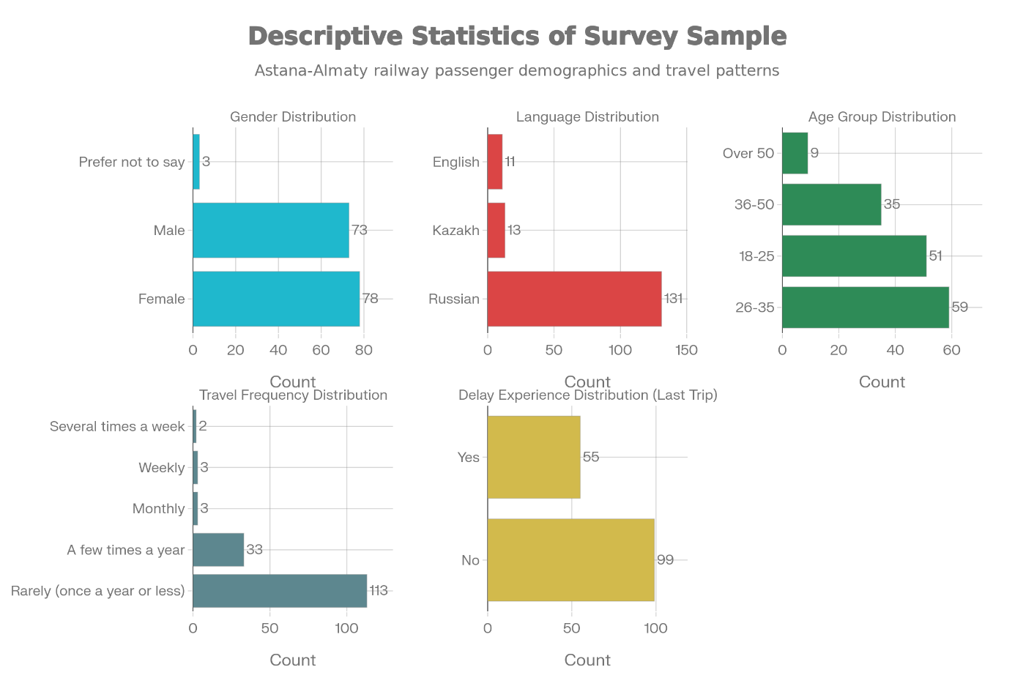
Figure 1. Descriptive statistics of the passenger survey sample

4.8.2 Delay experience and perceived causes
The survey results showed that most participants faced short to typical travel delays during their previous trip but they only experienced rare instances of prolonged service disruptions. The extended period of service delays makes customers doubt the dependability of their service. The detailed distribution of delay duration appears in Appendix B through Figure B1 which shows the average duration of passenger delays.
People who travel by train believe train delays result from major system problems instead of problems with individual system components. The main reason for delays stems from outdated infrastructure which includes both track conditions and signaling systems and technical problems with rolling stock and weather-related issues. The complete analysis of delay factors which passengers experience appears in Appendix B through Figure B2 (Perceived main causes of train delays on the Astana–Almaty route).

4.8.3 Impact of delays on passengers
The survey data indicates that train delays affect travelers most because they need to stay longer at the railway station while they also need to change their prearranged plans. Short delays in service create problems because they make passengers doubt that schedules will be followed and they must adjust their scheduled activities. Detailed evidence on the perceived impact of delays is reported in Appendix B, Figure B3 (Perceived impact of train delays on passengers).

4.8.4 Perceived frequency of delays
Passengers’ perceptions about the frequency of delays differ from one another. The majority of survey participants reported delays as infrequent events yet the occurrence of any delays shows that route reliability issues continue to affect the route. Service quality assessments from passengers become affected when train delays occur because these incidents create problems with their travel itineraries. Detailed results on perceived delay frequency are shown in Appendix B, Figure B4 (Perceived frequency of train delays).

4.8.5 Passenger priorities for service improvement
The survey results show that passengers have specific preferences about which improvements they want to see first. The main requirement for infrastructure modernization demands new railway tracks together with modernized control systems. Improved real-time communication during delays follows closely, reflecting strong demand for transparency and timely information. The worth of compensation programs together with onboard service availability during long delays surpasses the worth of increasing train service frequency. These priorities are illustrated in Appendix B, Figure B5 (Preferred improvements to railway services on the Astana–Almaty route).

4.8.6 Regression Analysis
The research used regression analysis to study how passenger characteristics along with their delay experiences affect their assessments of railway service quality and their predicted service improvements. Two types of models were applied depending on the nature of the dependent variable.
For Model 1, which examines whether a passenger experienced a delay during the most recent trip, a logistic regression model was used, as the outcome variable is binary (delay experienced or not). The results show that travel frequency is the main determinant of delay experience: passengers who travel more frequently have a significantly higher probability of encountering delays. In contrast, demographic characteristics such as age and gender do not have a statistically significant effect. Full results for Model 1 are reported in Appendix B, Table B1, with the corresponding coefficient plot shown in Appendix B, Figure B6.
For Models 2–6, which analyze passenger agreement with statements related to infrastructure modernization, climate-resilient investment, operational planning, real-time communication, and trust in future delay management, ordinary least squares (OLS) regression was applied. The models demonstrate that demographic variables fail to explain the behavior of participants. The length of train travel determines how passengers will view their complete journey from start to finish. The passengers who experienced long train delays support infrastructure modernization yet they remain dissatisfied with train communication methods. The number of times people travel leads to decreased trust in future delay management which becomes less reliable after each delay experience. Detailed estimation results for OLS Models 2–6 are presented in Appendix B, Tables B2–B6, while graphical summaries of coefficient estimates are shown in Appendix B, Figures B7–B11.
Overall, The regression results show that passenger dissatisfaction with delays stems from lived experiences instead of age or gender characteristics which supports that delays are perceived as a systemic issue affecting all users.

5. Discussion
The research studied the structural factors which create delays between Astana and Almaty while it studied their impact on railway operational performance and passenger comfort levels. The results show that route delays occur because of ongoing network infrastructure problems and operational issues which affect particular sections of the network.
The research shows that delay causes follow a strong Pareto-type distribution which shows significant imbalances. The total delay minutes stem mainly from infrastructure-related factors which include track condition and speed restrictions although rolling stock and energy and operational factors contribute to a lesser extent. The research shows that few critical system elements create most of the overall system breakdown. The average delay indicators fail to show the full extent of the problem because extended delays which occur rarely cause most of the total time losses and passenger dissatisfaction.
The system performance shows a distinct imbalance according to the results of directional analysis. Southbound services toward Almaty consistently experience longer and more frequent delays than northbound services. This imbalance points to localized infrastructure degradation and capacity constraints on the approach to Almaty, rather than uniform network-wide inefficiency. The fact that the same train types perform differently depending on direction strengthens the conclusion that physical track condition, rather than train characteristics or scheduling errors, is the primary driver of delays.
Passenger survey results confirm these findings. Although most passengers experience minor or moderate delays, their perception of service quality is largely influenced by prolonged service disruptions and the lack of timely and transparent information during such events. Regression analysis shows that demographic characteristics such as age and gender do not have a significant impact on attitudes toward infrastructure quality, operational planning, or communication. On the contrary, the key factor determining passenger support for infrastructure modernization and their dissatisfaction with current practices is their actual experience of delays. This suggests that delays are perceived as a systemic problem affecting all users, rather than a problem limited to specific groups of passengers.
The results of predictive modeling further confirm this interpretation. The limited effectiveness of regression and classification models indicates that the duration of delays is difficult to predict using only schedule and route variables. This supports the conclusion that delays are mainly caused by stochastic events related to infrastructure conditions and external factors, rather than predictable patterns embedded in schedules. At the same time, the analysis of the importance of characteristics confirms the role of seasonality, highlighting the interaction between infrastructure vulnerability and weather-related stress.
Overall, the discussion shows that targeted structural measures, rather than gradual operational adjustments, are needed to improve punctuality on the Astana–Almaty route. To restore reliability and trust in the system, critical infrastructure bottlenecks must be eliminated, schedules must be aligned with actual track capacity, and communication with passengers must be viewed as an indicator of operational efficiency

6. Conclusions

6.1 Research summary
This study analyzed passenger train delays on the Astana–Almaty railway corridor by combining data on operational delays with passenger survey data. The aim of the study was to identify the structural causes of delays, assess their impact on passenger perception, and develop policy-relevant recommendations for improving system reliability.
Empirical data show that delays on this corridor are mainly caused by infrastructure constraints rather than isolated operational failures. Track conditions and speed restrictions account for the majority of total delay time, confirming that physical infrastructure constraints play a decisive role in shaping system performance. An analysis of traffic directions reveals a clear asymmetry: trains traveling south toward Almaty are significantly less punctual than trains traveling north. This pattern indicates a local deterioration in infrastructure rather than uniform inefficiency across the entire network.
The results of the passenger survey complement these findings, showing that dissatisfaction is less determined by the average duration of delays and more by prolonged disruptions and inadequate communication during delays. Regression analysis confirms that actual delays are the main factor determining passenger attitudes toward infrastructure modernization, communication quality, and confidence in future improvements, while demographic characteristics have limited explanatory power. Taken together, the results show that delays are perceived as a systemic problem affecting all corridor users.

6.2 Key findings
The analysis allowed us to draw several key conclusions.
First, delays occur in a highly concentrated pattern. A small number of infrastructure bottlenecks account for a disproportionately large share of total delay time, which corresponds to a Pareto distribution. This means that minor improvements across the entire network are unlikely to be effective unless critical sections of track are addressed.
Second, the system's performance is directionally asymmetric. Trains traveling towards Almaty are at a significantly higher risk of delays than trains traveling in the opposite direction. This asymmetry highlights the importance of diagnosing specific corridors and calls into question the effectiveness of uniform measures across the entire network.
Third, passenger dissatisfaction is driven by their personal experiences rather than their characteristics. Frequent passengers experience delays more often and are less confident about future service improvements, indicating that repeated delays erode trust over time. At the same time, dissatisfaction with communication and operational planning is widespread among all passenger groups.
Fourth, predictive modeling confirms that the duration of delays is difficult to predict using schedule data alone. The limited accuracy of model predictions highlights the stochastic nature of delays and the importance of infrastructure conditions and seasonal factors. However, identifying seasonality as a key factor provides valuable recommendations for targeted preventive planning.

6.3 Policy Implications
The results of this study have a number of important implications for railway management and transport policy.
First, infrastructure investments should be prioritized based on the impact of delays rather than network coverage. Eliminating critical speed restrictions on the approach to Almaty from the south is likely to lead to a significant improvement in reliability than scattered maintenance measures.
Second, train schedules should match the actual capacity of the tracks. Operating high-speed or densely scheduled trains on infrastructure that cannot support planned speeds increases the likelihood of cascading delays and undermines confidence in the timetable.
Third, communication with passengers should be viewed as an indicator of operational efficiency rather than an ancillary service. Timely, transparent, and consistent information during disruptions can significantly reduce passenger dissatisfaction, even when delays are unavoidable.
Fourth, predictive analytics should be used as a supporting tool for proactive management, not for accurately predicting delays. While accurately predicting delays remains challenging, risk-based indicators can serve as a guide for planning maintenance, staffing, and advance passenger notification during periods of increased risk.
Overall, the results show that targeted measures focused on specific corridors are more effective than broad systemic reforms in addressing punctuality issues on high-demand routes.

6.4 Limitations of the Study
A number of limitations should be taken into account when interpreting the results.
The study focuses on a single railway corridor, which limits the ability to directly generalize the findings to other routes with different operational or infrastructure characteristics. However, the Astana–Almaty corridor serves as an important example illustrating broader structural problems in the system.
The classification of causes of delays is based on administrative data, which may oversimplify complex operational interactions and underestimate secondary factors. In addition, the passenger sample, while sufficient for statistical analysis, is biased toward regular users and may underestimate occasional passengers.
Finally, the predictive models are limited by the lack of detailed real-time weather data, maintenance schedules, and specific track technical parameters. Including these variables would likely improve the explanatory power and accuracy of the predictions.

6.5 Directions for Future Research
Future research should extend this analytical model to other major railway corridors in Kazakhstan to assess whether similar structural patterns and directional asymmetry exist. Integrating high-resolution infrastructure condition data, weather indicators, and maintenance planning information will enable the creation of a more reliable delay risk model.
Future work could also examine the long-term impact of infrastructure modernization and improved connectivity on passenger confidence and demand. Such analyses would help evaluate ongoing rail transport reforms and investment strategies based on factual data.
References:
A. D. Bolganbayev, K. Myrzabekkyzy, D.N. Kelesbayev, & S.T Baimaganbetov. (2021). The importance of logistics center application for development of goods transportation and research on Kazakhstan. Khoja Akhmet Yassawi International Kazakh-Turkish University, Kazakhstan. https://doi.org/10.31489/2021ec4/13-26
Avdakov, I. Y. (2018). Japan: experience in the construction of high-speed railways. History and Modernity Journal, 2(28). https://doi.org/10.30884/iis/2018.02.02
Baker, C. J., Chapman, L., Quinn, A., & Dobney, K. (2010). Climate change and the railway industry: A review. Proceedings of the Institution of Mechanical Engineers, Part C:
Journal of Mechanical Engineering Science, 224(3), 519-528. https://doi.org/10.1243/09544062JMES1558
Brazil, W., White, A., Nogal, M., Caulfield, B., O’Connor, A., & Morton, C. (2017). Weather and rail delays: Analysis of metropolitan rail in Dublin. Journal of Transport Geography, 59,
69–76. https://doi.org/10.1016/j.jtrangeo.2017.01.008
Budai, G., Huisman, D., & Dekker, R. (2006). Scheduling preventive railway maintenance activities. Journal of the Operational Research Society, 57(9), 1035-1044. https://doi.org/10.1057/palgrave.jors.2602085
Bubeck, P., Dillenardt, L., Alfieri, L., Feyen, L., Thieken, A. H., & Kellermann, P. (2019). Global warming to increase flood risk on European railways. Climatic Change, 155, 19–36. https://doi.org/10.1007/s10584-019-02434-5
Döscher, R. (2019). Climate extremes for Sweden – State of knowledge and implications for adaptation and mitigation. SMHI. https://doi.org/10.17200/climate_extremes_sweden https://www.diva-portal.org/smash/get/diva2:1368107/FULLTEXT01.pdf
Ferranti, E., Chapman, L., Lee, S., Jaroszweski, D., Lowe, C., McCulloch, S., & Quinn, A.
(2018). The hottest July day on the railway network: insights and thoughts for the future.
Meteorological Applications, 25(2), 195-208. https://doi.org/10.1002/met.1681
Grigoriev, A.V., & Lepov, V.V. (2012) Mechanisms for the accumulation of damage and destruction of the material of the rim of a railway wheel during operation in the North. Bulletin of the North-Eastern Federal University, 9(1). https://doi.org/10.2478/ttj-2021
Gov.kz. (2023). Speech by Chairman of the Supreme Audit Chamber Alikhan Smailov at the plenary session of the Mazhilis of the Parliament of the Republic of Kazakhstan. https://www.gov.kz/memleket/entities/esep/press/news/details/786200?lang=ru

Hansen, I., & Pachl, J. (2014). Railway timetabling and operations: Analysis, modelling, optimisation, simulation, performance, evaluation. Eurail press.

Kazinform, international news agency. Astana to start production of Stadler Kazakhstan passenger cars.(2024) https://en.inform.kz/news/astana-to-start-production-of-stadler-kazakhstan-passenger-cars-e73a41/

Koenigk, T., Barring, L., Matei, D., Nikulin, G., Strandberg, G., Tyrlis, E., Wang, S., & Wilcke, R. (2020). Tellus A: Dynamic Meteorology and Oceanography, 72(1). https://doi.org/10.1080/16000870.2020.1788901
Lidén, T. (2015).Railway Infrastructure Maintenance - A Survey of Planning Problems and Conducted Research. Transportation Research Procedia, 10, 574-583. https://doi.org/10.1016/j.trpro.2015.09.011
Mironova, L. (2024). Why trains have started running late in Kazakhstan: Ministry of Transport explains. Bizmedia.kz Почему в Казахстане стали опаздывать поезда, ответили в Минтранспорта
Ministry of Transport of the Republic of Kazakhstan.(2024). Delays of passenger trains ИТОГИ
КОМИТЕТА за 2024г 2.0
Ministry of Transport of the Republic of Kazakhstan.(2024). Implementation of a hub system and intermodal transportation in the Republic of Kazakhstan (GG po HUB,)
Ministry of Transport (2024). Spravka of train delays. Retrieved from https://transport.gov.kz
Ministry of Transport of the Republic of Kazakhstan.(2022). Reference on passenger train delays. (2022) СПРАВКА по опозданиям пассажирских поездов
Tengrinews (2024). When will there be normal trains in Kazakhstan? Interview with the Minister of the Transport. Retrieved from https://www.youtube.com/watch?v=x5-y4ikTJqA
Turkova, V., Arkhipova, A., Yusupova, G., & Zharkaya, G. (2022). Digitalization of railway service with the use of post-covid-19 events. Transportation Research Procedia, 63, 584-
590. https://doi.org/10.1016/j.trpro.2022.06.051
Van Zante-de Fokkert, J. I., den Hertog, D., van den Berg, F. J., & Verhoeven, J. H. M. (2007).
The Netherlands schedules track maintenance to improve track workers' safety. Interfaces,
37(2), 133-142. https://doi.org/10.1287/inte.1060.0246
Yerdavletova, F., Bolatkyzy, S., Mukhambetov, T., & Markhayeva, B. (2022). Analysis of
Financial and Investment Activities Based on Determination of Economic Value Added (on the
Example of “Kazakhstan Temirzholy” Joint Stock Company). Social Science
Research Network. http://dx.doi.org/10.2139/ssrn.4046077
Zakon.kz.2024. (2024). Smailov: KTZ is in the "red" credit risk zone. Retrieved from https://www.zakon.kz/obshestvo/6437793-smailov-ktzh-nakhoditsya-v-krasnoy-zone-kre ditnogo-riska.html
Zhelyupin, D. (2023). Endless train delays: how KTZ cultivates patience and self-control in its customers. Retrieved from
https://orda.kz/beskonechnye-zaderzhki-poezdov-kak-ktzh-vospityvaet-v-svoih-klientah-terpeliv ost-i-vyderzhku/
Mironova, L. (2024, June 12). Why trains have started running late in Kazakhstan: Ministry of Transport explains. Bizmedia.kz Почему в Казахстане стали опаздывать поезда, ответили в Минтранспорта

Appendix A
Analytical Report: Train Delay Performance

1. Executive Summary
Headline: Systemic infrastructure bottlenecks on the Southbound approach to Almaty are the primary driver of network delays.
Key Findings:
• Total Impact: The network suffered 11,643 minutes (approx. 194 hours) of delay across 358 recorded incidents.
• Primary Driver: 87% of all lost time is caused by Infrastructure (Track) issues, specifically speed restrictions ("огр скор"), rather than equipment failure or operational error.
• Critical Bottleneck: The Southbound route (Nurly Zhol → Almaty) is responsible for nearly half of all delays (4,950 minutes). The return trip (Northbound) performs significantly better, indicating an asymmetric infrastructure degradation.
• Worst Performing Service: Train #4 (Talgo) running from Nurly Zhol to Almaty is the single biggest point of failure, accounting for 26% of all delay minutes in the dataset (3,081 minutes).

1.2. Descriptive Overview
Overview of Delays This analysis focuses on the aggregate performance metrics to understand the scale of the issue.
• Total Incidents: 358 recorded delays.
• Total Time Lost: 11,643 minutes (approx. 194 hours).
• Average Delay: ~32.5 minutes per incident.
• Median Delay: 26.5 minutes.

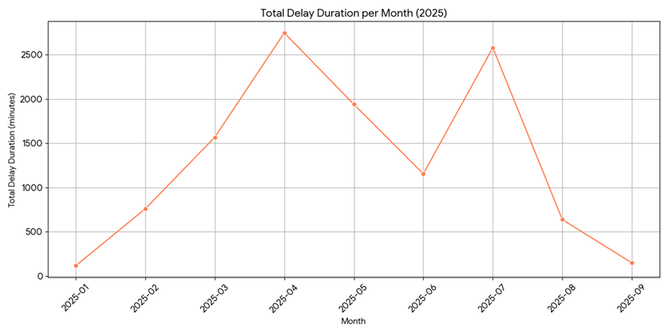
Figure A1.Total Delay Duration per Month

Trend Analysis:
• Seasonality: Delays are not uniform. The system experienced severe spikes in April and July, with monthly delays exceeding 2,500 minutes
• Recent Performance: A sharp improvement was observed in August and September, suggesting that seasonal factors (weather) or recent interventions have temporarily stabilized the system. However, this observation could also be influenced by a lack of data, making it not the most reliable information.
• Incident Profile: While the median delay is ~26 minutes, the average is higher (~32 minutes) due to a "long tail" of severe multi-hour delays.

1.3. Root Cause Analysis (The "Why")
The analysis categorized delay reasons into functional groups (Track, Locomotive, Energy,
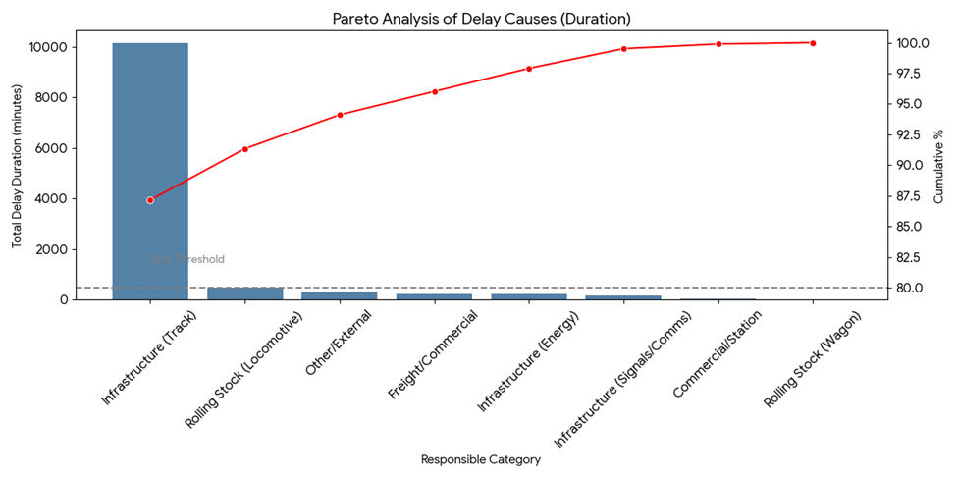
Figure A2. Pareto Analysis of Delay Causes (Duration)

etc.). The results show a massive Pareto imbalance:

Table A1. Pareto Analysis of Delay Causes (Duration)
Rank | Root Cause Category | Total Delay (Min) | % of Total | Impact Description
1 | Infrastructure (Track) | 10,147 | 87.2% | CRITICAL. Primarily caused by speed restrictions ("огр скор") due to track condition.
2 | Rolling Stock (Locomotive) | 488 | 4.2% | Mechanical failures (Department ТЧЭ).
3 | Energy / Signals | 407 | 3.5% | Contact network or signaling faults.
4 | Other / External | 322 | 2.8% | Weather, third-party issues.

Insight: The problem is not "random." It is a structural inability of the physical track to support the scheduled speeds.

1.4. Geographic & Directional Analysis (The "Where")
A directional split of the data reveals that the problem is highly concentrated on trains arriving in Almaty.
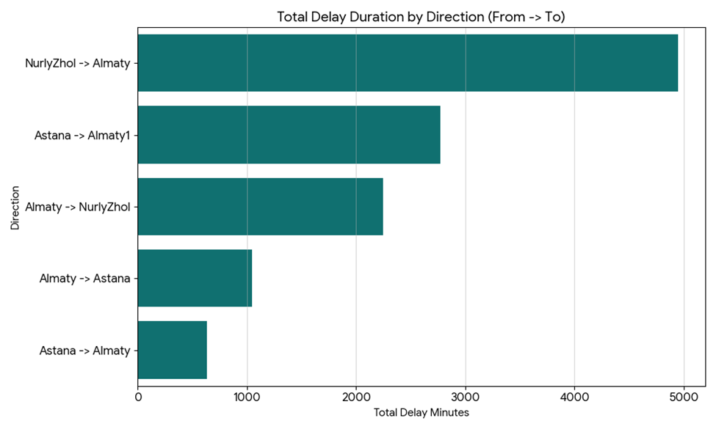
Figure A3.Total Delay Duration by Directions

Table A2. Total Delay Duration by Directions
Route Direction | Total Delay (Min) | Avg Delay (Min) | Notes
Nurly Zhol → Almaty (Southbound) | 4,950 | 36.4 | The most congested and problematic corridor.
Astana → Almaty-1 (Southbound) | 2,769 | 32.2 | Secondary Southbound flow; also highly delayed.
Almaty → Nurly Zhol (Northbound) | 2,245 | 29.2 | Significantly better performance than the return leg.
Almaty → Astana  (Northbound) | 1,048 | 23.8 | The most reliable major corridor.

Insight: Trains struggle significantly more returning to Almaty from the capital than they do leaving Almaty. This points to congestion or track degradation specifically on the southbound track (or the approach to Almaty).
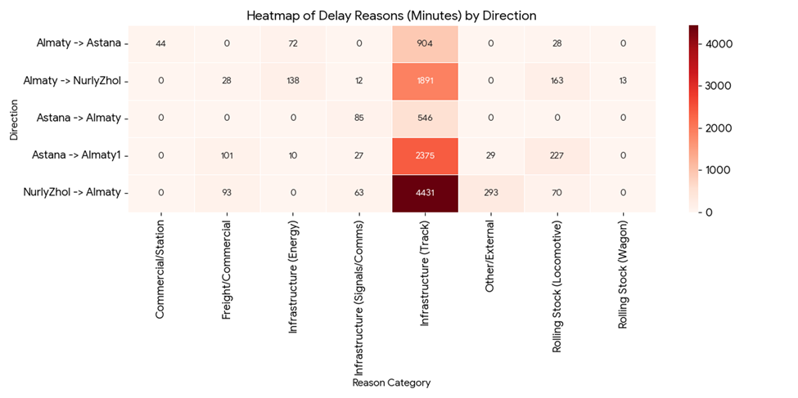
Figure A4. Heatmap of Delay Reasons (Minutes) by Direction

Conclusion: The Southbound track (or the approach path to Almaty) has significantly more unaddressed maintenance issues than the Northbound track.
Why? (Reasons by Direction)
• Nurly Zhol -> Almaty: 4,431 minutes due to Track (Infrastructure) vs only 70 minutes for Locomotives. This confirms the southbound track is in significantly worse physical condition.
• Astana -> Almaty-1: 2,375 minutes Track / 227 minutes Locomotive.
• Conclusion: The southbound track ("unpaired" or specific line) likely has more speed restrictions ("огр скор") than the northbound track.
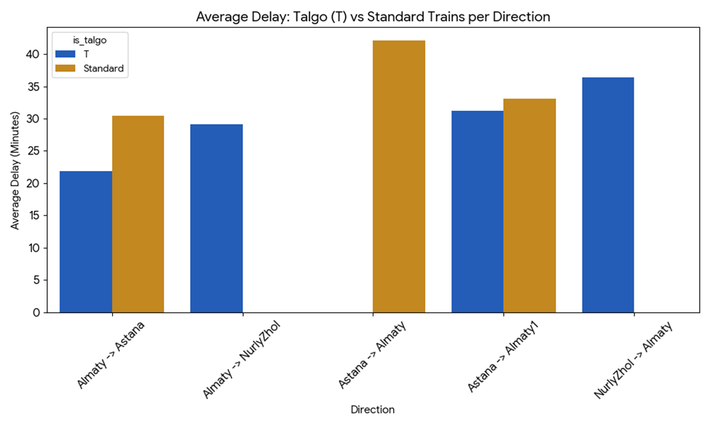
Figure A5. Talgo (T) vs Standard Trains per Direction

2. Train-Specific Performance (The "Who")
Two specific train services are disproportionately affecting the network's KPIs.

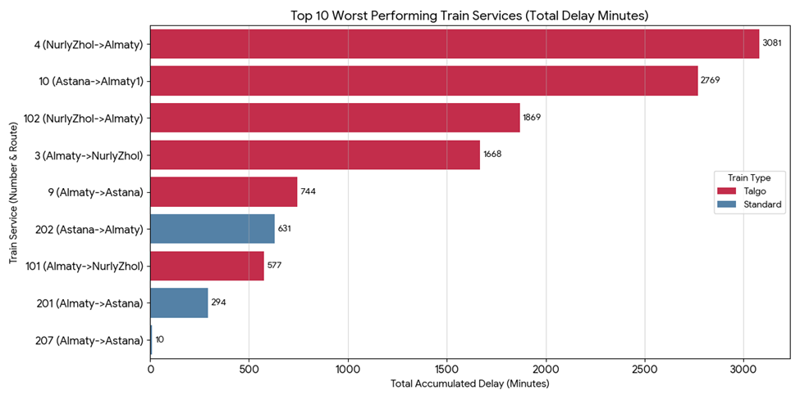Figure A6. Worst Performing Train Services

1. Train #4 (Talgo): Nurly Zhol → Almaty
• Total Delay: 3,081 minutes.
• Avg Delay: 35 minutes per incident.
• Diagnosis: High-speed Talgo trains are extremely sensitive to track speed restrictions. Train #4 is likely scheduled for a speed the current track cannot support.
2. Train #10 (Standard): Astana → Almaty-1
• Total Delay: 2,769 minutes.
• Avg Delay: 32 minutes.

3. Machine Learning Analysis Results
We tested two models to determine if we could predict delays based on schedule information (Train Number, Route, Date, etc.).
1. Regression Model (Predicting Exact Delay Duration)
• Performance: Poor (R2=0.19, MAE = 13.2 minutes).
• Interpretation: Our analysis indicates that the model cannot accurately predict the exact number of minutes a train will be late based on schedule data alone. This confirms that delays are primarily driven by random or external factors—such as specific track defects or sudden equipment failures—rather than by a predictable pattern inherent to the train number itself.
2. Classification Model (Predicting High Risk > 30 mins)
• Accuracy: 61% (marginally better than random chance).
• Insight: We found that predicting whether a specific trip will result in a "disaster" (>30 mins) versus a "minor" delay (<30 mins) is difficult using only this dataset.
• Feature Importance (The "Why"):
◦ The model identified Month and Day of Week as the most critical predictors, accounting for approximately 80% of the combined importance.
◦ This aligns with the seasonality findings in our descriptive report, specifically the spikes observed in April and July.
◦ Train Number and Route proved to be less significant predictors of risk level, likely because all routes are suffering somewhat equally from systemic track issues.
Conclusion on ML
While the machine learning models confirm that delays are largely stochastic (random) rather than strictly deterministic, the feature importance analysis validates our earlier finding: Seasonality (Month) is the strongest external driver of delay severity.

Reason Classification Logic
The following mapping was used to standardize the raw delay reasons:
Table A3. Reason Classification Logic
Code (Prefix) | Department / Entity | Assigned Category | Typical Keywords / Examples
ЦП | Dept. of Track & Structures | Infrastructure (Track) | огр.ск (speed limit), путь (track), ремонт (repair), окно (maintenance window)
ТЧЭ / ТЛ / ЦТ | Locomotive Economy | Rolling Stock (Locomotive) | неиспр (failure), порча лок (locomotive damage), обточка (turning/wheel)
ЦЭ | Electrification & Power | Infrastructure (Energy) | контактная сеть (contact network), напряжение (voltage)
ЦШ | Signaling & Comms | Infrastructure (Signals) | СЦБ (signaling), связь (comms), светофор (traffic light)
НОД | Regional Operations | Operations (Regional) | Often appears as a secondary code (e.g., "ЦП НОД-4"), indicating the region where the track issue occurred.
ВЧД / ГТВ | Wagon Economy | Rolling Stock (Wagon) | букса (axle box), тормоз (brakes)
ГП / ЦМ | Freight / Commercial | Commercial / Freight | погрузка (loading), клиент (client), таможня (customs)
ПП / ДС | Passenger / Station Ops | Station Operations | посадка (boarding), багаж (luggage)

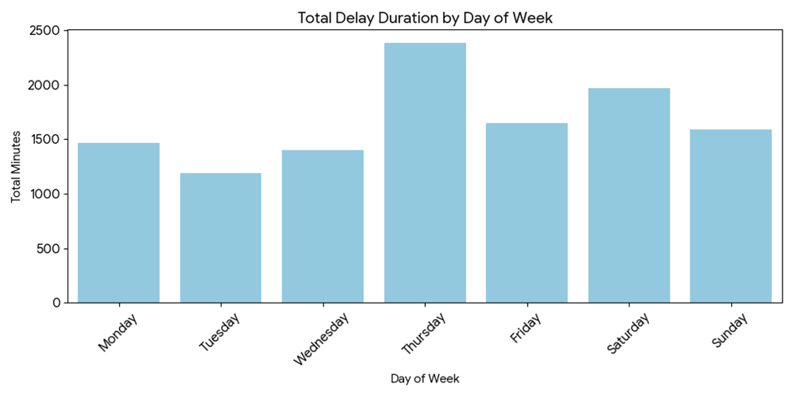
Figure A7. Total Delay Duration by Day of Week

Appendix B

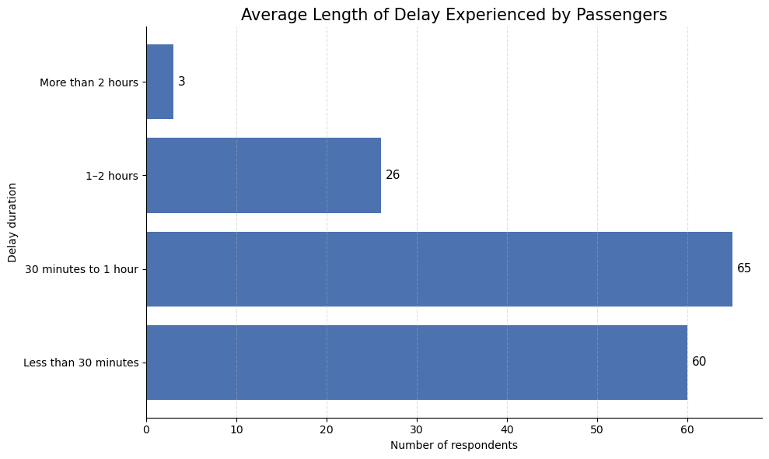
Figure B1. Average length of delays experienced by passengers

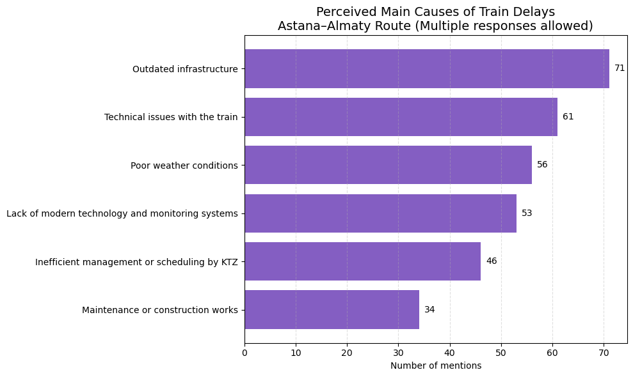

Figure B2. Perceived main causes of train delays on the Astana–Almaty route

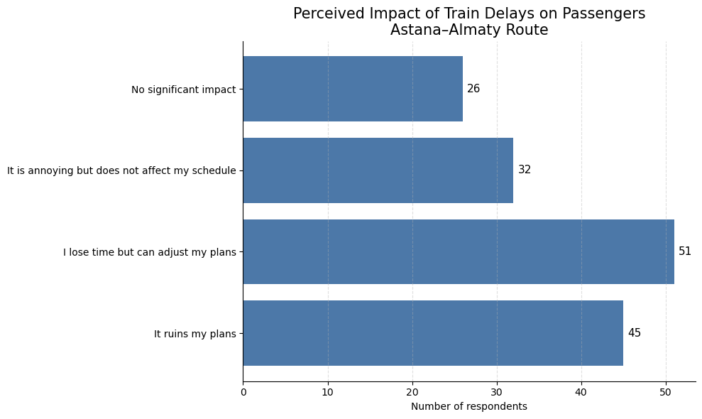
Figure B3. Perceived impact of train delays on passengers

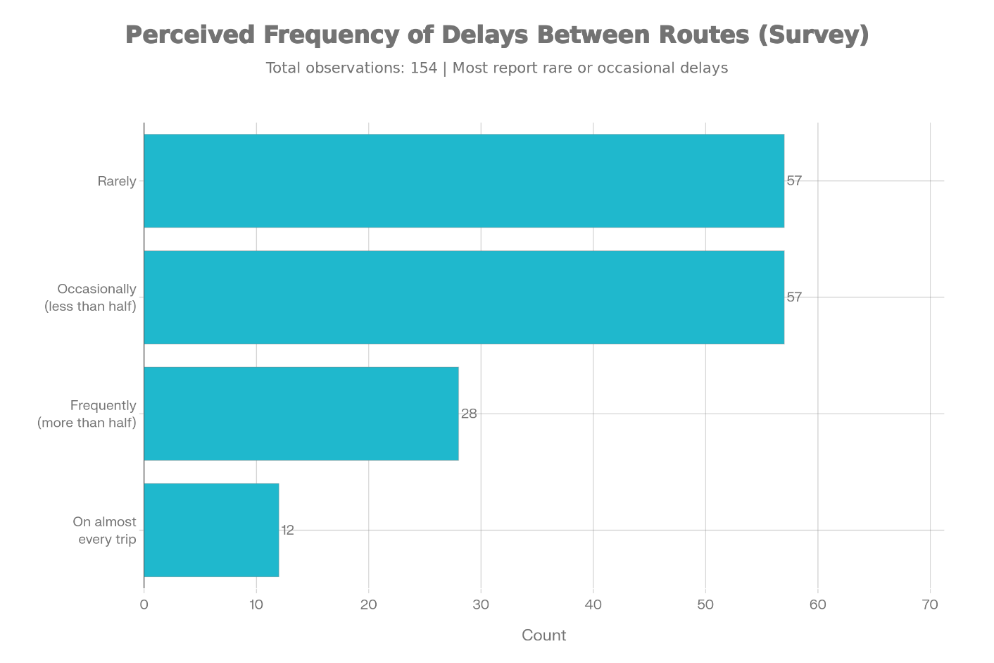
Figure B4. Perceived Frequency of Delays Between Routes

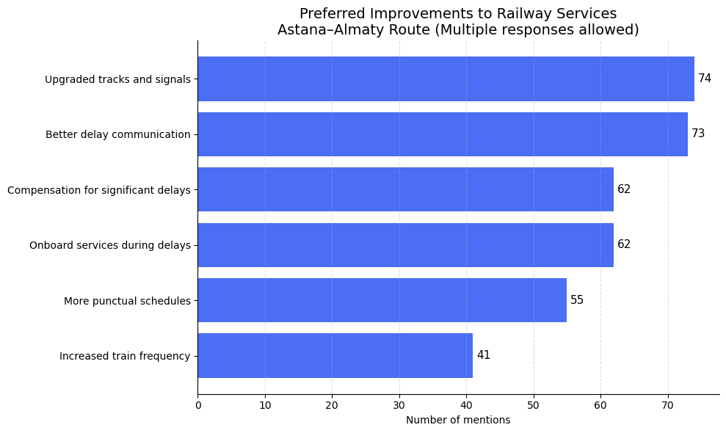
Figure B5. Preferred improvements to railway services on the Astana–Almaty route

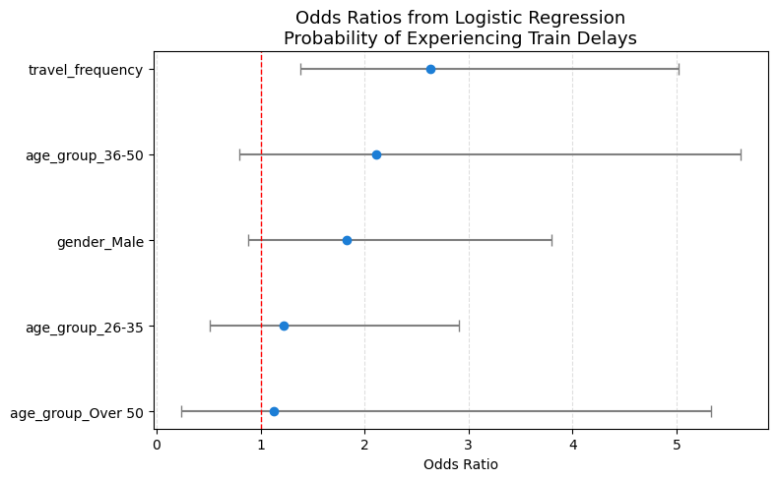
Figure B6. Odds ratios from logistic regression predicting the probability of experiencing train delays on the Astana–Almaty route.

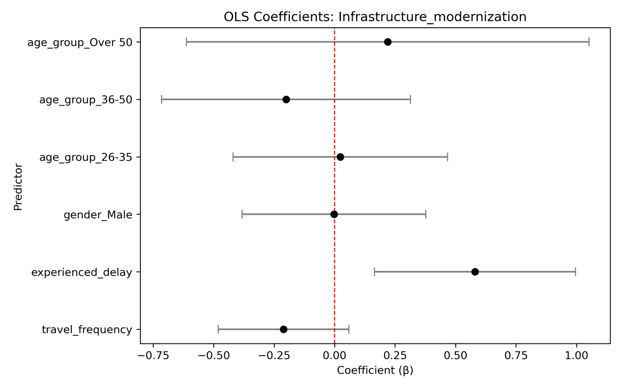
Figure B7. OLS Coefficients: Infrastructure Modernization

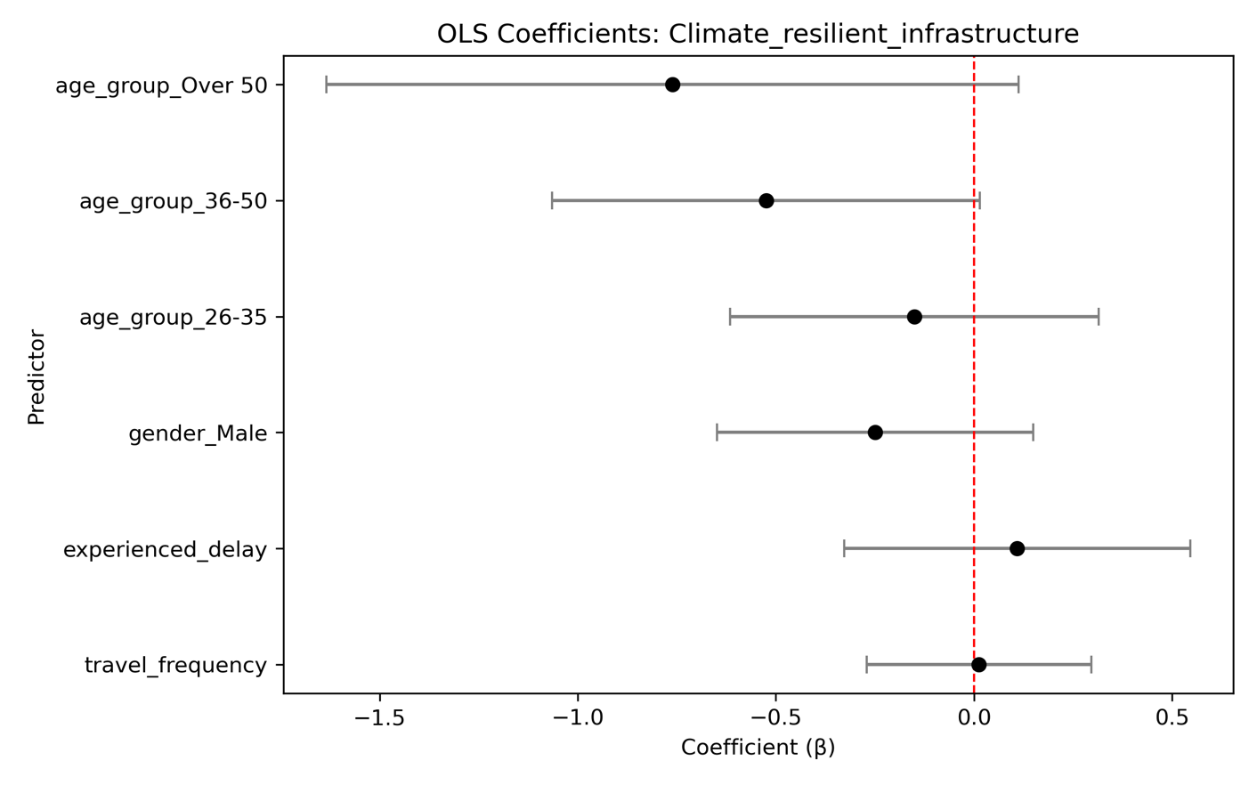Figure B8. OLS Coefficients: Climate Resilient Infrastructure

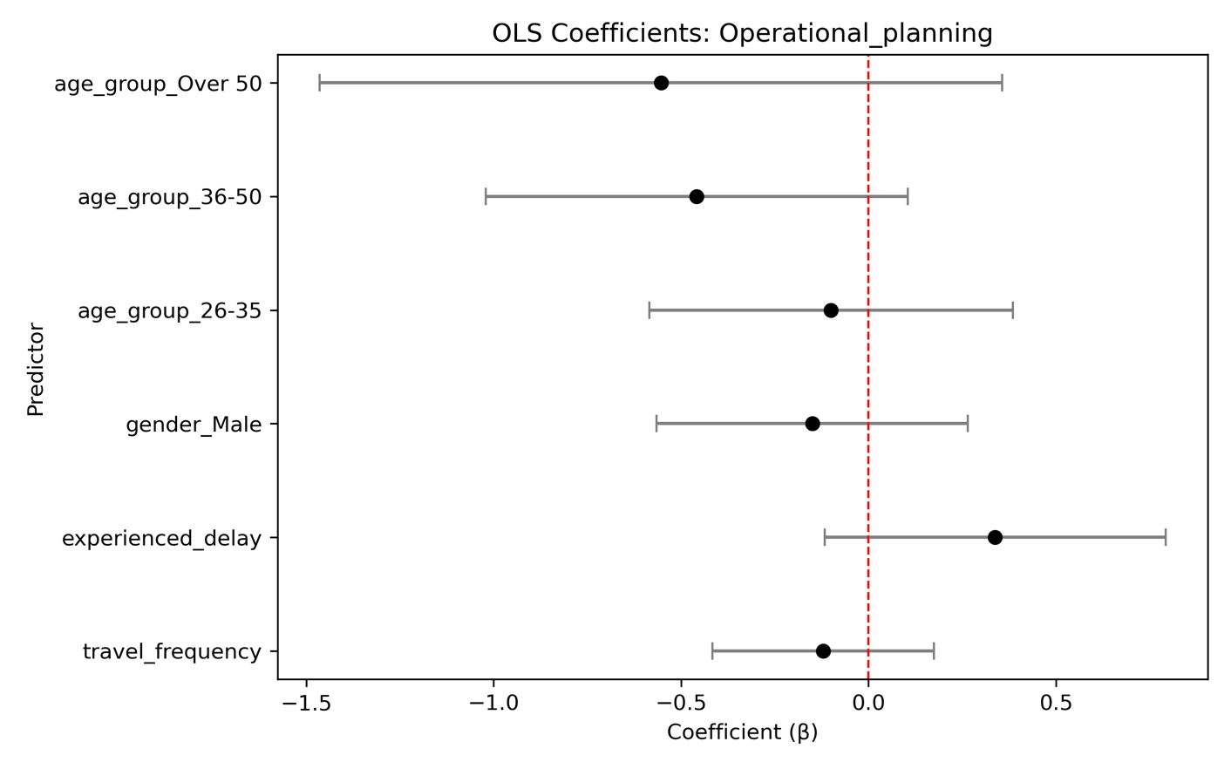
Figure B9. OLS Coefficients: Operational Planning

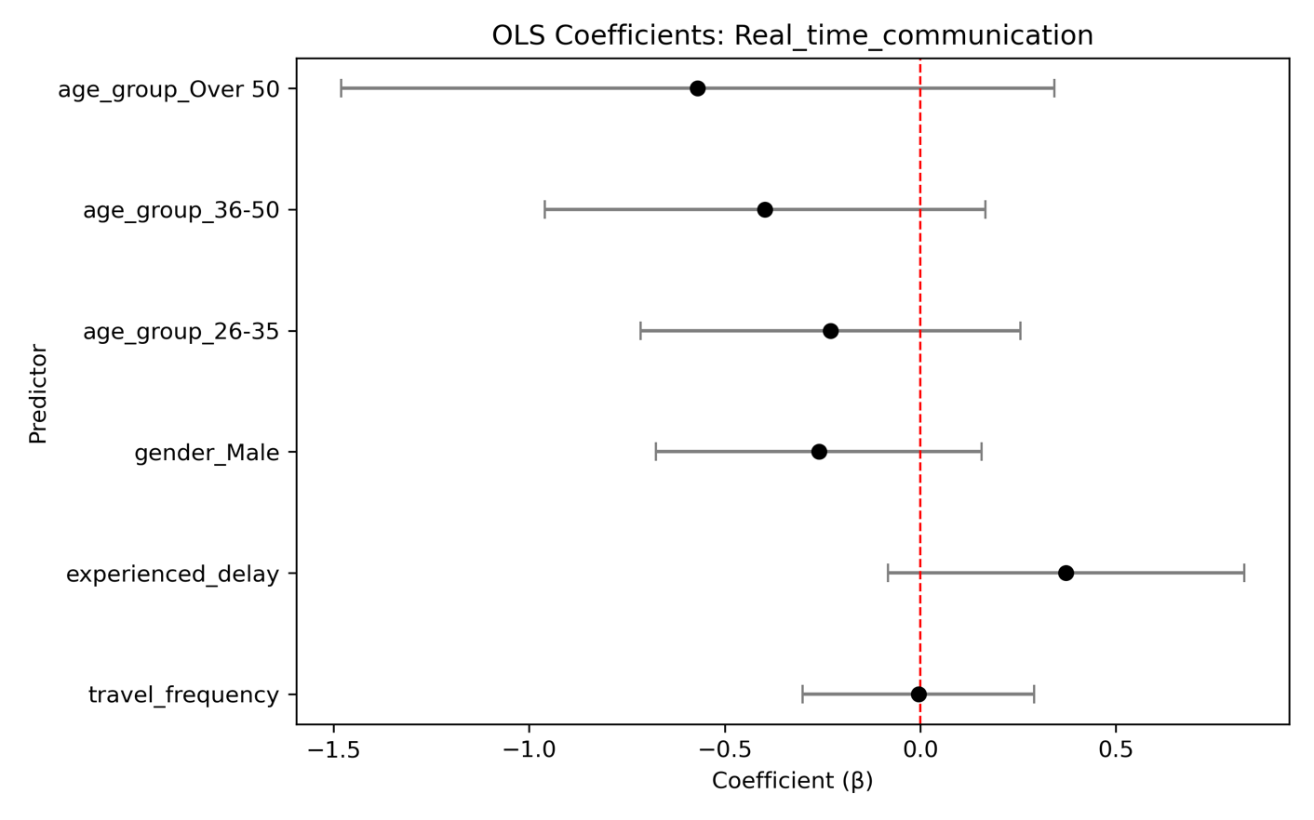
Figure B10. OLS Coefficients: Real Time Communication

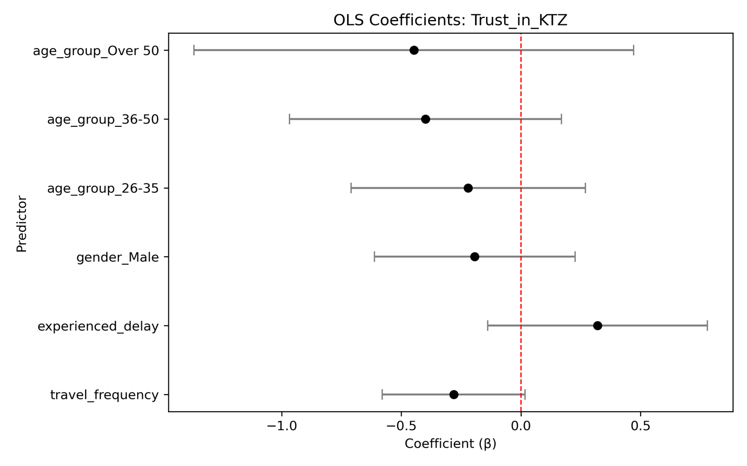
Figure B11. OLS Coefficients: Trust in KTZ

Table Regression Models
Table B1. Logistic Regression: Probability of Experiencing a Train Delay
Variable | Odds Ratio | Std. Error | Significance
Travel frequency | 2.63 | 0.33 | ***
Male | 1.83 | 0.37 | n.s.
Age 26–35 | 1.22 | 0.44 | n.s.
Age 36–50 | 2.11 | 0.50 | n.s.
Age over 50 | 1.13 | 0.79 | n.s.
Constant | 0.08 | 0.58 | ***
Observations: 154
Pseudo R²: 0.104

Table B2. OLS Regression: Agreement with Infrastructure Modernization
Variable | Coefficient (β) | Std. Error | Significance
Travel frequency | −0.21 | 0.14 | n.s.
Experienced delay | 0.58 | 0.21 | **
Male | −0.00 | 0.19 | n.s.
Age 26–35 | 0.02 | 0.22 | n.s.
Age 36–50 | −0.20 | 0.26 | n.s.
Age over 50 | 0.22 | 0.42 | n.s.
Constant | 4.09 | 0.25 | ***
Number of observations: 154
R²: 0.060

Table B3. OLS Regression: Agreement with Climate-Resilient Infrastructure Investment
Variable | Coefficient (β) | Std. Error | Significance
Travel frequency | 0.01 | 0.14 | n.s.
Experienced delay | 0.11 | 0.22 | n.s.
Male | −0.25 | 0.20 | n.s.
Age 26–35 | −0.15 | 0.24 | n.s.
Age 36–50 | −0.52 | 0.27 | *
Age over 50 | −0.76 | 0.44 | *
Constant | 4.18 | 0.26 | ***
Number of observations: 154
R²: 0.047

Table B4. OLS Regression: Agreement that Delays Are Due to Poor Operational Planning
Variable | Coefficient (β) | Std. Error | Significance
Travel frequency | −0.12 | 0.15 | n.s.
Experienced delay | 0.34 | 0.23 | n.s.
Male | −0.15 | 0.21 | n.s.
Age 26–35 | −0.10 | 0.25 | n.s.
Age 36–50 | −0.46 | 0.29 | n.s.
Age over 50 | −0.55 | 0.46 | n.s.
Constant | 3.80 | 0.27 | ***
Number of observations: 154
R²: 0.041

Table B5. OLS Regression: Agreement that Real-Time Communication Is Insufficient
Variable | Coefficient (β) | Std. Error | Significance
Travel frequency | −0.00 | 0.15 | n.s.
Experienced delay | 0.37 | 0.23 | n.s.
Male | −0.26 | 0.21 | n.s.
Age 26–35 | −0.23 | 0.25 | n.s.
Age 36–50 | −0.40 | 0.29 | n.s.
Age over 50 | −0.57 | 0.46 | n.s.
Constant | 3.93 | 0.27 | ***
Number of observations: 154
R²: 0.040

Table B6. OLS Regression: Trust in KTZ’s Future Delay Management
Variable | Coefficient (β) | Std. Error | Significance
Travel frequency | −0.28 | 0.15 | *
Experienced delay | 0.32 | 0.23 | n.s.
Male | −0.19 | 0.21 | n.s.
Age 26–35 | −0.22 | 0.25 | n.s.
Age 36–50 | −0.40 | 0.29 | n.s.
Age over 50 | −0.45 | 0.47 | n.s.
Constant | 4.60 | 0.28 | ***
Number of observations: 154
R²: 0.050
Notes for Appendix
- Reference categories: Female, Age 18–25
- *** p < 0.01, ** p < 0.05, * p < 0.10, n.s. = not significant
- Graphical coefficient plots are presented in the main text

