Medical informed consent in Kazakhstan and ethical considerations

Student: Iliyas Kozhantay
Supervisor: Dr Alessandra Clementi, MD, GP, Assistant Professor

Bachelor of Medical Sciences
Nazarbayev University School of Medicine

Astana, 2025

Abstract
Background: Informed consent is an integral part of healthcare provision. It is a process where doctors explain to the patient the diagnosis, treatment methods, alternatives and risks so that the patient can make an informed decision. Despite the importance of regulating the consent process, there is limited studies in Kazakhstan on how effectively this process is practiced. Methods: This paper analyzes the medical informed consent process in Kazakhstan, covering ethical protocols and governing legal & regulatory acts and aims at comparative analysis of the consent process in Kazakhstan with the UK. Results: The process of informed consent for medical intervention lacks provision of its principles and Kazakhstan's system does not provide for a multi-stage system of verification of consent and patient safety. The local practice needs a guideline document on informed consent for medical workers, which describes all the basic principles of action. Conclusion: Transformation and adaptation of local practices to international standards based on the experience of world leaders in medical ethics (UK) will be the key to success in achieving progress in the informed consent process in Kazakhstan.

Introduction
Historical background of medical ethics
Ethics and Medicine are two disciplines that encompass a set of moral norms of professional activity in the field of health care, providing for the relationship between medical staff and patients. The field of medicine in the 18th century covered only the treatment of the patient, and the patient fully trusted his life to doctors without unnecessary questions during invasive interventions. However, with the advancement of science and medicine in the 18th and 19th centuries, ethical issues began to resonate in society. The first possible documentation where a doctor warns about the risks to patients can be found in Europe in the eighteenth century: the practice of intentionally infecting a person with a weakened form of smallpox in order to develop a strong immunity to the disease (Kubar, 2018). At that time generally doctors limited themselves to verbal warnings, without fully explaining the treatment and possible alternatives. Only a century later, in 1847 the first document “the Code of Medical Ethics” that confirmed patients' consent to surgical interventions in written form appeared (Carmen & Joffe, 2005). As adopted by the young American Medical Association, the Code drew significantly on the work of the English physician-philosopher Thomas Percival, whose 1803 code of medical ethics set standards of conduct relative to hospitals and other charities (American Medical Association [AMA], 2017). However, this confirmation was used as a legal defense of doctors' rights rather than patients' rights. Only after the end of the “Second World War”, after the “Nuremberg Process”, “the Nuremberg Agreement” was formulated and this event was the beginning of the birth of the concept of informed consent (Annas, 1991). The main reason for this was the terrible experiments of Nazi doctors on human beings. The most famous were experiments’ of Prof Joseph Mengele in concentration camps, which highlighted the need to introduce ethical and legal rights in any medical interventions worldwide (Kerby, 2022). One of the most relevant principle of the ethical code is the informed consent, meaning the voluntary consent of any individual to participate in any research or experiment, with clear understanding of consequences.
Informed Consent Principles
Informed voluntary consent is a principle in medical ethics and medical law, according to which for a medical intervention, especially one involving risk, the patient's consent must be obtained (Shah et al., 2024). It is a legally enforceable document that informs the patient of all possible risks, alternative treatments and foreseeable complications. Many patients do not fully understand the importance of the informed consent process, mistakenly assuming that the consent process is limited to the formal signing of documents. Actually, incorrect or ineffective informed consent can have several consequences that affect both the patient and the healthcare system. Reduced effectiveness of treatment, increased litigation, loss of trust in the physician - these are just a few of the possible risks of improperly administered medical informed consent. In order to be valid the informed consent should comprise all of the following (Edgman-Levitan & Schoenbaum, 2021):
1. Voluntarism - free from coercion;
2. Capacity to consent;
3. Disclosure – properly informing the patient;
4. Patient understanding;
5. Decision;
Voluntarism requires that the patient be free from “coercion and from unfair persuasions and inducements”. Coercion refers to morally inappropriate pressures from individuals or institutions that constrain patients’ exercises of choice; serious illness by itself does not compromise voluntarism. The capacity to consent refers to a person’s ability to understand and voluntarily agree to consent. It can be affected by various factors like age, mental health and cognitive ability. Disclosure involves providing the patient with the information needed to understand a procedure: nature and purpose of the treatment, potential benefits, risks, alternatives, consequences. Patient understanding requires that the patient comprehend the information given and appreciate its relevance to her individual situation. Decision-making refers to the patient’s authorization allowing a physician to execute the proposed treatment (Professional Standards Authority [PSA], 2024). These all aspects of the informed consent process provide the patient with autonomy. This consent ensures the patient's right to make an informed choice about his/her own health, offering him/her all possible options in the course of treatment.
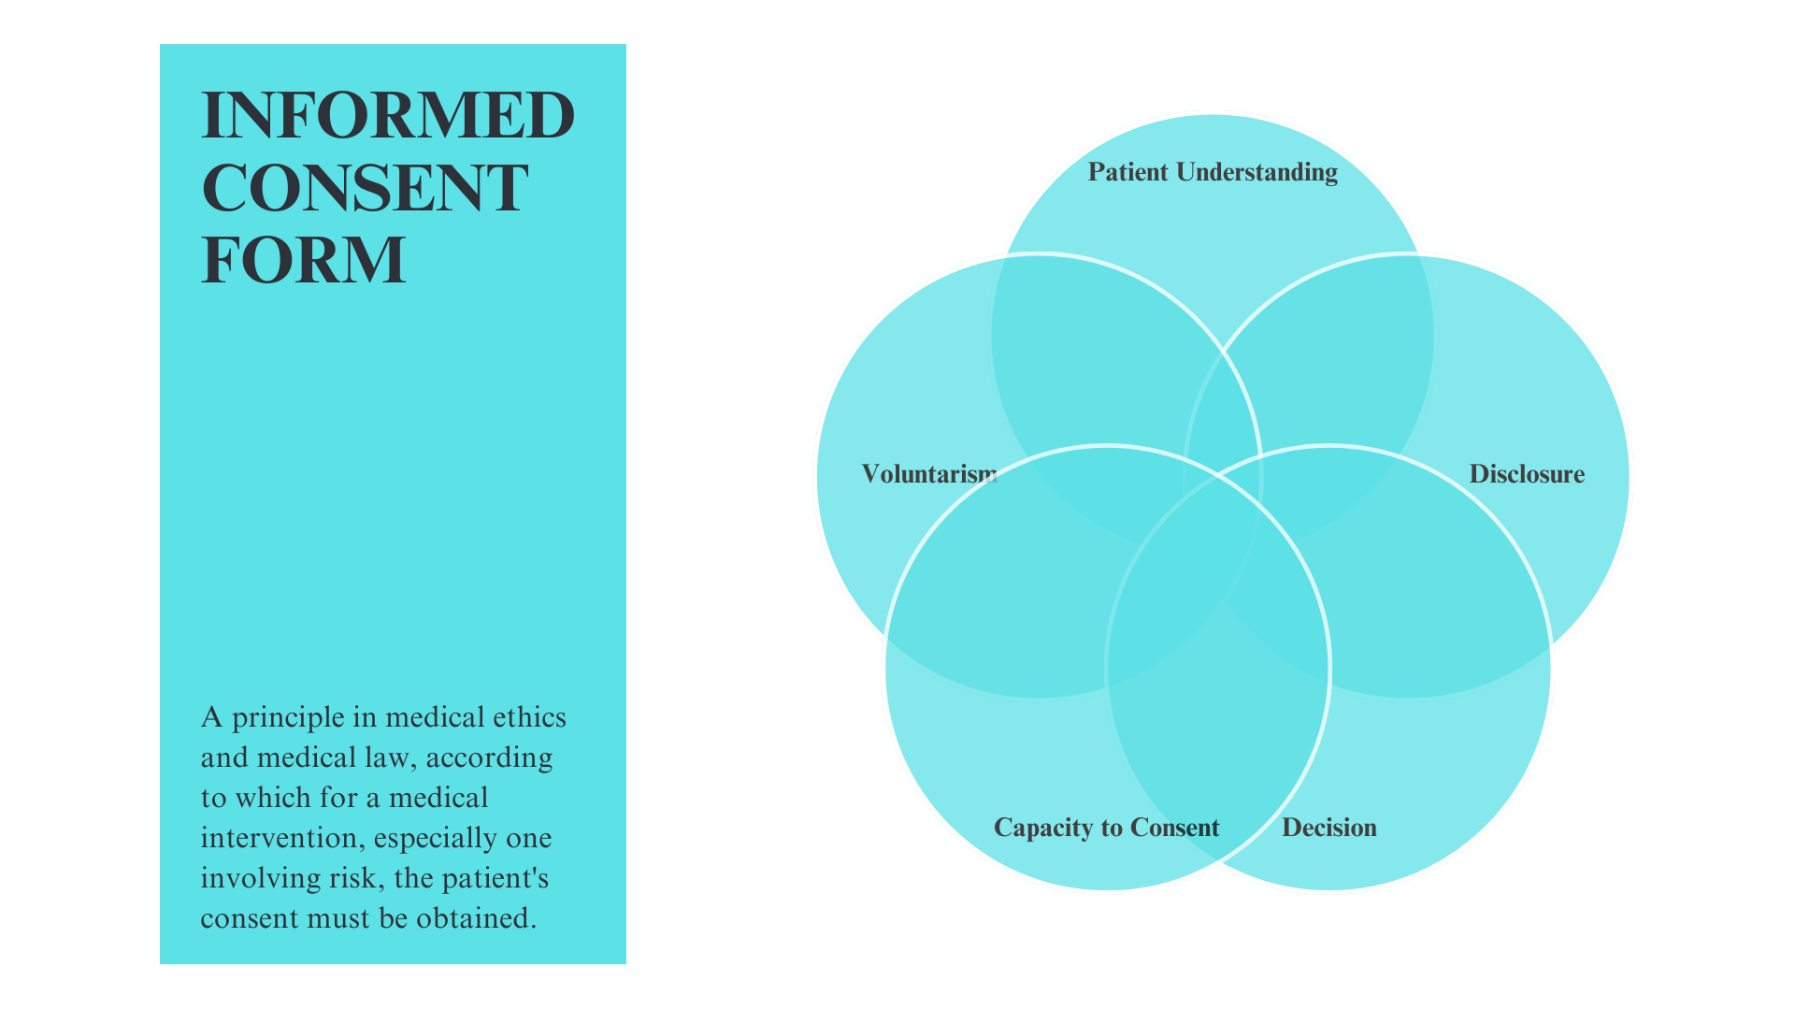
Figure 1. Schematic representation of the informed consent components
With the rapid development of the medical field and the annual introduction of modern technologies in treatment processes, informed consent is of particular importance, as it provides the patient with legal and ethical aspects, as well as transparency of medical procedures, protection of rights and effective achievement of awareness.
Today, every year the prevalence of morbidity among people is increasing, which leads to an increase in surgical interventions. According to the Ministry of Health of Kazakhstan (2024), 928,000 surgeries were performed in hospitals in the country, which is 3.8% more than in 2023, and 29.6% more than in 2018. The importance of effective communication between patients and physicians improved in the last decades and gained relevance. For many years, medical sciences have been trying to develop solutions that could lead to complete disclosure and full understanding of patients’ medical conditions. However, despite the importance of this stage, it appears that the process of signing an informed consent in Kazakhstan faces a number of difficulties that hinder treatment and reduce the effectiveness of this form: hard-to-access terminology, formal approach to signing and the possible difference of local practice from the international standard. Therefore, the relevance of this topic is determined by the fact that it is necessary to raise the level of awareness of patients about their rights, as well as to improve the process of interaction between the patient and the doctor, taking into account ethical norms.
Informed Consent and Communication
Treatment in medicine is not only to preserve human health, but also to promote its recovery. In the era of advanced technology, the relevance of doctor-patient communication and the establishment of a trusting relationship plays an extremely important role in improving the effectiveness of treatment. A study done by Sukhov & Karashuk (2022) involving more than 34,000 patients showed that patients who trust their physicians are much less likely to experience stress and depression, which has an impact on improving quality of life and reducing symptoms of illness. Therefore, the main distinctive aspect of today's medicine is the personalization with a patient-centered approach. A special feature of this approach is the doctor's focus on the patient's needs during treatment. This level of treatment can only be achieved if the patient is fully provided with the necessary information about his/her health, and is aware of the importance of each step of the therapies. Moreover, due to the lack of specific instructions during patient communication, the importance of the physician's ability to adapt to the needs of each individual, taking into account their emotional and social state, is growing.
These aspects of medicine emphasize the relevance of this topic, indicating that by obtaining a whole picture of the states of the informed voluntary consent process in Kazakhstan, it is possible to achieve patient-centered treatment with maximum effectiveness that can be adapted to international standards. However, the transition from Soviet-era medicine to modern standards of health care still faces practical problems. Conceptual perception of the historical doctor-centered approach is the main problem in the process of achieving a patient-centered approach in post-Soviet countries (Zhumadilova et al., 2018). Most patients and doctors prefer to make decisions oriented only to the physician, without colloquial discussion with the patient (Gotsadze & Zoidze, 2021). This tendency is explained by the fact that patients often value trust more than autonomy, which may reflect cultural values influenced by the post-Soviet legacy even after so many years (Shakhabov et al., 2020). In the doctor-centered approach, hierarchical norms are fully applied with the doctor's authority over the patient's autonomy. Because of this, the patient plays a passive role without active participation, resulting in reduced adherence and treatment efficacy. In contrast, the patient-centered approach focuses entirely on patient autonomy, taking into account individual needs/values and actively involving the patient in the decision-making process (Edgman-Levitan & Schoenbaum, 2021). In turn, the informed voluntary consent process strictly requires a patient-centered approach from the health care system. Freedom of choice is the key to success in the current state of medicine. The process of discussing with the patient about all risks, alternative treatments and possible consequences will not only improve the patient's understanding of their health, but will also have a positive impact on treatment. A trusting patient-doctor relationship strengthened by the required health information will start a new tendency in the field of health care, improving the final outcome of invasive interventions, taking into account legal and ethical aspects.
International Standards
International medical practice is a unified system of standards, methods and practices that are generally accepted in different countries and recognized internationally. The system helps to maintain transparency and quality, improving the overall level of health care in all countries. Aspects of international practices include advanced technologies, diagnostic and preventive methods that aim to optimize current medicine. Adapting to international practices and implementing their standards will allow Kazakhstan to achieve effective medicine in the process of informed consent. One of the most relevant guidelines available for ethical professional conduct are from the General Medical Council [GMC], the regulator body for doctors in the United Kingdom. The GMC UK developed the “Good Clinical Practice” guidelines, ensuring doctors compliance with ethical and legal norms towards the patient (General Medical Council, 2024). According to the Professional Standards Authority website, the GMC meets all 18 of the 18 standards of good regulation (PSA, 2024). It means that the historical primacy in shaping the principles of informed consent belongs to the UK. Moreover, one of the most important and large bodies regulating the informed consent process were created here. Therefore, when comparing local practices, the UK can be chosen as the representative of international standards.
Currently, the Informed consent process in Kazakhstan is regulated by a national legal act - the Code of the Republic of Kazakhstan (Code of the Republic of Kazakhstan, 2020). The country's healthcare system operates under the mandatory health insurance system “Social Health Insurance Fund”, introduced in 2020, which has brought new aspects to the process of obtaining informed consent. This system required additional measures in the consent process, especially concerning the coverage of and financial implications of medical interventions. Nevertheless, the level of realization of these norms in practice is still unclear and unexplored.
A comprehensive review of the existing literature in authoritative databases confirmed the research gaps. Multidisciplinary databases that contain studies covering multiple fields of life such as medicine, ethics and sociology were used to comprehensively review studies related to the main topic of the project. As a result, investigations from multidisciplinary databases such as Google Scholar, EBSCOhost, Scopus, Web of Science were limited to the study of international standards and specific regional issues of informed consent. Medical and ethical databases were used to study ethical challenges associated with the field of health care. Researches from PubMed, Cochrane Library, Medline Ultimate raised the problem of patient autonomy in surgical interventions and provided a current picture of the informed consent process as medical and ethical databases. However, even these databases did not include studies analyzing the process of informed consent for medical intervention in Kazakhstan. Therefore, we can identify a research gap as the lack of information and detailed analysis of the informed consent process in Kazakhstan, in terms of comparing its compliance with international standards, patient-centeredness, and legal and ethical aspects. A comprehensive analysis of the existing system would help to identify the weaknesses of the process itself and identify the main problems faced by the healthcare sector in Kazakhstan. It is important to note that doctor-patient communication plays as important a role in the informed consent process as the signing of the document by the patient when fully informed. Despite existing studies on informed consent in medical practice, there is still a lack of studies in Kazakhstan that analyze in detail the level of patient understanding of the content of this document and the process of doctor-patient interaction to ensure proper awareness. In some cases, a patient may have complete trust in a health care provider and not consider it necessary to understand the contents of this document comprehensively. However, true awareness in signing a consent form can only be achieved if the patient fully understands the content of the consent and knows his/her rights. Therefore, in international practice, more patient-centered treatment methods are used, including specialized (individual) ways to explain the information contained in the voluntary consent form to the patient in detail. On this point, a comprehensive analysis of the informed consent process will not only help to identify the limitations of the current system, but will also help to compare local practice with the international standard, suggesting solutions for its best adaptation to patient-centered medicine with high treatment efficacy.

Objectives:
To comprehensively analyze the process of informed consent form for medical intervention in Kazakhstan, considering international standards and local peculiarities, and identify problems and shortcomings existing in traditional methods of clinics:
- Conduct a detailed review of existing legislation governing informed consent in clinics of the Kazakhstan;
- Identify the main problems in understanding the consent form for different categories of patients;
- To check and compare local policies and practices with international standards and identify discrepancies or inconsistencies;
- To offer practical recommendations for improving the process of the informed consent form and achieving effectiveness in the patient's understanding;

Hypothesis:
The existing forms of informed consent for medical intervention in Kazakhstan may not be sufficiently adapted for patients, and current health system practices may differ from the international standards.

Materials and Methodology:
The methodology of this study aims to provide an in-depth and comparative analysis of the informed consent process for medical interventions in Kazakhstan. Qualitative research will be conducted as part of the methodology to provide a comprehensive picture of the consent process for further evaluation and to eventually propose recommendations for improving local practice. The research is a comparative-analytical study that covers legal and ethical aspects. It includes a study of legal and regulatory acts governing the consent process, identifying and comparing the features of the international standard (UK) with Kazakhstan medicine and analyzing the academic literature on this process.
Obtaining detailed information on the juridical aspects of the informed consent process requires an analysis of the regulatory and normative acts. The key regulatory documents in this matter for Kazakhstan are the “Order of the Ministry of Health and Social Development of Kazakhstan” and the “Code of the Republic of Kazakhstan”. The protection of patients' rights, the responsibilities of medical staff and the standard form of consent are fully provided by these legislative documents. A detailed qualitative analysis of these documents, especially the clauses and articles indicating the obligations and rights of medical personnel and the patient, will help to identify possible uncovered aspects of the process of voluntary consent in invasive interventions in Kazakhstan. The main regulatory documents for the UK to review are the "recommendations of the General Medical Council (GMC)" and "National safety standards for invasive procedures (NatSSIPS)". These normative documents describe in depth the process of voluntary consent in the UK, thus providing detailed information on the legal aspects for comparison with the legal acts of Kazakhstan. All four resources are used for comparative analysis to provide detailed information on the similarities and differences in the legal requirements for informed consent in the two countries. In addition, as well as analyzing the regulatory acts, it is important to compare the standardized forms of informed voluntary consent to medical intervention approved by the regulatory institutions for both country. The main purpose of this comparison is to examine the content of informed consent, to determine the level of information available to patients and to identify the distinctive features of the two consent standards.
Identifying tendencies, obtaining an overview of regional practices and proposing recommendations to improve the informed consent process in Kazakhstan requires a qualitative analysis of the academic literature. The analysis will review academic articles, studies and publications on the topic of informed consent to medical intervention from a variety of credible sources and databases. The rationale for the selection of specific databases was clarified in the introduction. All databases mentioned above were searched using the following keywords: informed consent, medical intervention, knowledge, patient, invasive procedure, Kazakhstan. No year restrictions were applied. To make the search as comprehensive as possible, Boolean operators “AND” and “OR” were used. Inclusion criteria were: studies evaluating the informed consent process; articles in three languages (Kazakh, Russian and English) in peer-reviewed academic and scientific journals; full-text articles available in electronic form. Exclusion criteria were: studies that included patients with mental/cognitive impairment, articles/journals evaluating informed consent used to participate in clinical trials, studies based only on interviews or surveys, studies that do not assess understanding of informed consent. A detailed review of the academic literature will also help to identify key issues related to the voluntary consent process for invasive interventions. The content analysis will provide detailed information on the worldwide medical tendency for comparison with local practice and will provide recommendations on how to overcome the problems found, based on the experience of other countries.

Results and Discussion:
The field of healthcare in the developed countries has historically been one of the most regulated areas of society. In particular, ethical and legal aspects prevail when assessing the current level of medical progress in a country. When assessing informed consent, it is important to analyse legal and normative standards, the perception of informed consent by patients and physicians, and the content of the consent form. Patient rights in healthcare are based on international human rights standards, many of which are reflected in regional international agreements and national constitutions. Therefore, the compatibility of regional legal norms with international standards should be constantly improved, striving for full adaptation of international practice to local medicine. Because of this, it is important to identify the main similarities and differences between Kazakhstan and the UK in a comparative analysis of the legal and regulatory norms of the consent process.
In Kazakhstan, the process is regulated by the Code of the Republic of Kazakhstan “On the Health of the People and the Healthcare System”. Citizen’s and patient’s rights are specified in “Section 2. Chapter 12. Rights and obligations of individuals in the field of the healthcare. Articles 76-78” (Appendix F). “Section 3. Chapter 16. Rights and duties in the field of healthcare and guarantees of their provision. Articles 134 – 138” (Appendix C). These articles cover the main 6 aspects to be regulated:
1. The rights of patients;
2. Right to information;
3. Informed consent;
4. Right to refuse medical care;
5. Provision of healthcare services without consent;
6. Standards of the medical care.
It is important to note that the Code of the Republic of Kazakhstan covers a wide range of patients' rights, ensuring their protection at various stages of receiving medical care. The Code also requires transparency from the medical institution in providing information to the patient, emphasising the need to respect the individual needs of each patient. This means that the legal-regulatory norms of Kazakhstan cover ethical aspects, obliging their observance. However, there are also many shortcomings that can be an obstacle to the informed consent process. Firstly, practical implementation may encounter difficulties due to resource constraints of medical institutions and insufficient patient awareness. The Code of the Republic of Kazakhstan ‘On Public Health and the Health Care System’ in Article 134, paragraph 1, subparagraph 5 states that services should be provided to the extent that the level of medical technology allows. Large differences in funding in different regions of Kazakhstan and differences in the level of provision of medical equipment create inequities in the provision of medical services. This also applies to the informed consent process, where only some medical centres can afford the latest medical technology for audio-visual delivery of information to the patient. Secondly, patients may have difficulties in understanding medical information (the content of informed consent), especially if it is presented in complex language or without taking into account individual perception peculiarities. The Code of the Republic of Kazakhstan does not provide for cases in which the patient does not fully understand the information. The subparagraphs that give the patient the right to be ‘treated with dignity’ and the ‘right to comprehensive information’ merely generalise the process of informing, without any obligation to convince medical staff of the patient's true awareness. This can be a serious threat to both the patient's health and the process of informed consent to medical intervention. Full awareness is one of the most important steps in the informed consent process. All other steps are directly related to the patient's level of understanding of the information in the consent. Patient misunderstanding of medical information or lack of awareness can lead to:
1) consenting to invasive interventions without realising all the risks and alternative treatment options;
2) the possibility of manipulation by medical staff when the patient consents to a procedure without understanding its consequences.
This weakness is even more significant in informed consent processes, where information is often provided in complex, inaccessible medical terms. Moreover, even if the information provided by the doctor is fully understood, there is no control over the completeness of the information provided. The reason for this is that there is no clear standard in any regulatory act as to what information should be provided to the patient. Sometimes there may be no information about alternative methods of treatment, sometimes about possible risks or foreseeable consequences. For example, the standard of voluntary informed consent for invasive interventions approved by the legislative bodies of Kazakhstan provides only general information about the treatment and lacks detailed information about diseases, treatment methods and alternatives (Appendix E). In comparison, the US or UK standards provide a detailed description of treatment methods, the meaning of medical terms with comprehensive explanations, information on post-surgical recovery and any risks or implications. Because of this, it is impossible to evaluate the informed consent process in Kazakhstan, as it will be up to the doctor to provide the remaining basic information. As mentioned earlier, international standards of international practice strive to establish a patient-centred approach, in which the autonomy of the patient comes before the authority of the doctor. However, this problem leads to the authority that is a feature of the doctor-centred approach, which allows major treatment decisions to be made according to the doctor's subjective preference rather than the patient's. Lack of information or lack of patient awareness may increase the number of dissatisfied patients, as they are deprived of autonomy by limiting their right to make treatment decisions. Thirdly, although the code provides for respectful treatment of cultural and personal values, patients' language barriers have been neglected. Language barriers generally cover a wide range of factors, including complex terminology, language accessibility to the patient and communication with the doctor. Kazakhstan is a multi-ethnic country with 130 ethnic groups. Although Kazakh is the state language and Russian has official status, a significant proportion of the population - particularly among ethnic minorities such as Uzbeks, Uighurs, Koreans and Dungans - may have limited fluency in both languages. Despite this linguistic diversity among the population, Kazakhstan's official legal framework does not provide for the use of medical interpreters in medical facilities to assist patients with limited knowledge of Kazakh or Russian. This is particularly important when it comes to building effective communication while receiving medical services in regional clinics. It is important to note that even if the patient and doctor speak the same language, medical terminology remains complex and may not be understood by the patient. The content of a fixed standard of informed consent for invasive interventions includes complex terms such as heredity, anaesthetic benefits, environmental and occupational factors, invasive intervention. However, only the meaning of one term (invasive intervention) has been elucidated in the notes of the form. As a result, these problems may lead to a lack of awareness of patients about their health and treatment.
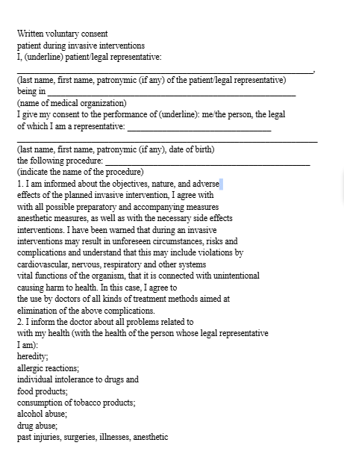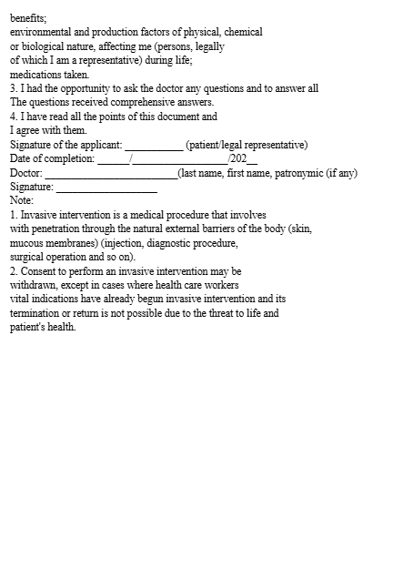
Figure 2. Standard of the patient's written voluntary consent form for invasive procedures in Kazakhstan
The main documents that guide doctors in the UK during the informed consent process in invasive interventions are ‘GMC: Decision making and Consent’ and ‘National Safety Standards for Invasive Procedures’. In the course of a detailed analysis of the British standards and their comparison with regulatory and legal acts in Kazakhstan, the main strengths of the British documents and what aspects should be focused on reformation of the informed consent process in Kazakhstan were identified. The comparative analysis of the two standards demonstrated high levels of coverage on both the legal and ethical sides, becoming a benchmark for local medicine.
The document ‘General Medical Council: Decision making and consent’ is a guide for UK doctors to ensure ethically correct and legally appropriate decision making in medicine. The standard covers all the important issues that can arise in the informed consent process, from ‘What doctor should tell a patient when talking about risks’ to ‘What doctor should record?’. A comprehensive treatment of all important topics related to the consent process is a key feature of this document. The document is 24 pages long and covers all the important steps, offering detailed steps to achieve a completely transparent patient-doctor relationship, as well as genuine patient information. The document is based on seven key principles that should be covered in the decision-making and consent process (Appendix A):
- All patients have right to be involved in decisions;
- The exchange of relevant information specific to the individual patient;
- Patients must be heard and informed;
- Doctors must consider the individual needs of the patient;
- All adult patients have capacity to make decisions, unless opposite is proven in line with legal requirements;
- Treatment of patients with limited capacity must be of overall benefit to them;
- Patients should be supported whether their right consent is affected by law or not;
All seven aspects aim to protect the rights of patients and improve the health services provided through the informed consent process. Furthermore, the document reports that this standard applies to every healthcare decision that is made about a patient. It includes decisions about treatments, procedures, interventions, investigations, screenings, examinations and referrals. Through adherence to these principles, not only in the consent process but in all areas of medicine where the patient makes decisions, the UK has achieved high standards of medical ethics and the protection of patients' rights. It is important to note that in addition to the basic principles that every health care professional should adhere to, the recommendations also include supplementary provisions. Unlike the Code of the Republic of Kazakhstan, which does not oblige doctors to check the patient's awareness, the GMC requires them to check whether the patient has understood the information provided by medical institutions, if necessary, to provide an explanation of every difficult to understand word and to adapt their communication style depending on the needs of the individual. One of the key aspects that has not been provided for in the legal and regulatory acts of Kazakhstan is the obligation to record. Every discussion of treatment, prognosis and alternative methods must be described in detail and recorded by the doctor in medical records, and decisions must be reviewed if necessary. Such regulation helps to conduct the dialogue as informative and objective as possible, without attaching the doctor's subjective point of view. Moreover, the standard takes into account the specifics of each case: the nature and severity of the patients' condition, how quickly a decision must be made, the level of risk and the degree of uncertainty. Therefore, the guideline proposes a ‘proportionality principle’ that is tailored to each case, taking into account all the factors influencing the decision-making process. The principle states that the amount of information required to be presented to the patient is correlated with the seriousness and complexity of the treatment. This approach not only gives the doctor the freedom to adapt his treatment method to each situation, but also becomes a reference point in emergency situations, when time for decision-making is short and the patient's condition is severe. It would seem that because of the relatively infrequent number of extremely severe cases, the main focus should be on the day-to-day normalities of the informed consent process. However, special attention to just such details becomes a basic foundation for the field of medical care, among them the informed consent process. Therefore, one of the key features of this standard is its broad scope, which envisages even the most undesirable scenarios and offers recommendations on how to deal with them. Considering all the above-mentioned strengths of one of the main documents on the informed consent process in the UK, key aspects of the GMC have been identified that are worth adapting to in the field of public health in Kazakhstan:
- Patient-centred approach which requires that all important medical decisions are made on the basis of the patient's individual needs, emotional state and life circumstances. All important aspects of the consent process including transparency, awareness and voluntarism are covered in this approach. In addition, the adaptation of medical terminology for the purpose of simplification is also included in the patient-centred approach. Compared to the standard voluntary consent form for medical interventions in Kazakhstan, the GMC standard requires the symplification of all hard-to-understand terms and words. If necessary, it is even recommended to use graphical resources. Checking patient understanding is also a key step in this approach. Medical staff should ask questions to check the patient's understanding and to ensure that the basic information has been fully assimilated. With all these options provided, the right to choose still remains with the patient. This trait emphasises the patient's autonomy by completely limiting any manipulation or pressure from the medical staff. Therefore, all these characteristics of the patient-centred approach aim to improve patient satisfaction and promote more effective treatment.
- Flexibility in the informed consent process with shared decision making. Every patient is a unique case. It means that the principle of ‘one size fits all’ does not work in the informed consent process. It is important to adapt to each patient and, based on individual needs, to tailor the dialogue to discuss the advantages and disadvantages of each option together. The flexibility of this principle is that the GMC allows verbal consent for simple procedures where the patient's life will not be in serious danger. However, in the case of complex invasive procedures, it is imperative that the patient is thoroughly informed of all possible risks, informed of alternative treatments and given written voluntary consent, with the ultimate right of choice given to the patient. Moreover, in all cases, medical staff should be prepared to review the decision and adapt to changes. The informed consent process is not only a discussion or signing of a document, but also a continuous interaction between the doctor and the patient, during which many things can change. Therefore, there should always be flexibility.
In the UK, unlike Kazakhstan, in addition to the document reuglising the process of informed consent during medical interventions, a second main document has been developed, which is aimed at improving patient safety during invasive procedures. The National Safety Standards for Invasive Procedures (NatSSIPs) document contains standards that serve as a benchmark for minimising medical errors and lethal cases while ensuring patient safety. As in the GMC document, in this standard the patient is the main subject of the process. Their active participation in decision making is an essential step in creating a culture of safety. In addition, the document outlines multi-stage, consistent safety standards aimed at standardising all procedures. It includes - The NatSSIPs Eight - eight key steps to ensure patient safety (Appendix B):
- Consent and Procedural verification;
- Team Brief;
- Sign In;
- Time Out;
- Implant use;
- Reconciliation of items;
- Sign Out;
- Debrief/Handover;
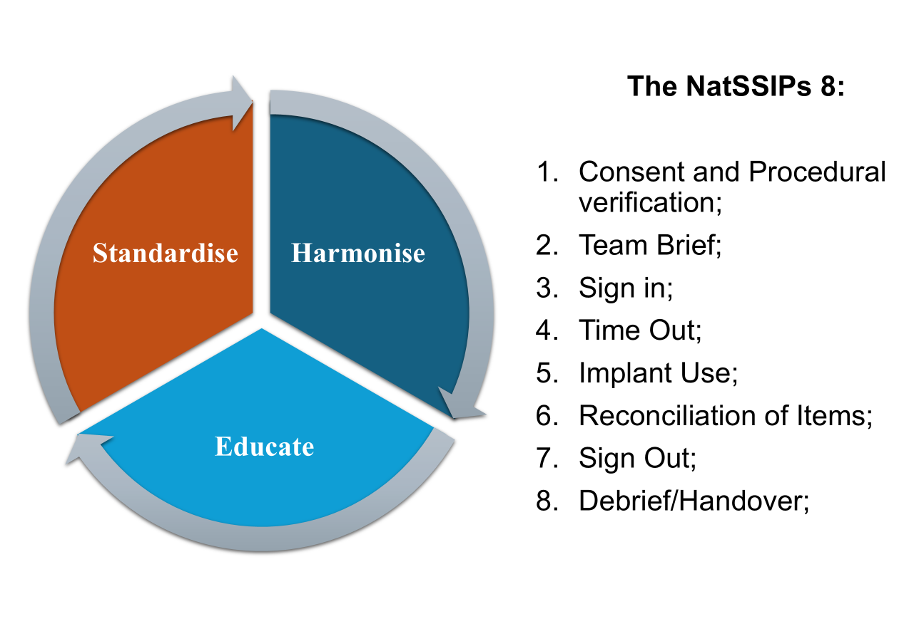
Figure 3. NatSSIPs 2 standard summary
As can be seen, the UK has adopted a systematic approach to patient safety, covering all stages of the procedure and reducing the likelihood of errors. Furthermore, the NatSSIPs require the setting of a common standard across the whole health system. This approach will help to achieve the same high levels across all UK hospitals and clinics, ensuring that medical procedures are safe without discriminating patients. Regardless of which medical centre a patient goes to, they will be assured that the level of care provided will be the same in all regions, which will also have an impact on trust in medical staff.
A full analysis of the NatSSIPs standard revealed the key strengths of the standard. The document focuses on teamwork of all medical staff and proposes to formalise this process. Unlike in Kazakhstan, a comprehensive briefing of medical teams is conducted every time before and after procedures. It is also important to note that patient check-ups are carried out at every stage of treatment, requiring multiple confirmations of the patient's identity and verifying the correctness of the chosen procedure. This multi-step verification of consent helps avoid future legal problems and improves the quality of care.
The standard goes beyond just regulating procedures. It obliges regular staff training, i.e. training courses on risk management and safe performance of procedures. Given the possible risks during operations, each member of the medical staff (doctors, nurses, allied health professionals) must be able to manage complications to ensure patient safety.
Moreover, the safety training of doctors is necessary in order to recognise errors and manage risks in time. One of the main features of the standard is the introduction of a culture of open discussion "Just Culture". Many doctors are afraid to make mistakes, especially when it comes to reporting them openly to their colleagues. It is important to remember that medicine is not an automatised system. It always has a human factor, where even the most experienced medical professional can make a blunder. However, for fear of being judged and suspended, many doctors choose not to speak openly about their lapses, which can lead to these outcomes in the future. Through a culture of open discussion, recurring errors can be significantly reduced when staff can freely discuss failures, this provides an opportunity to identify systemic errors, not just physician errors. Also, open discussion helps teamwork and builds trust, which will affect the effectiveness of the procedure. Doctors are human beings just like everyone else. To achieve complete equanimity during procedures, physicians need to be sure that reporting an error will not be punished or condemned by colleagues or administrators. In addition, promptly identifying errors and correcting them will help reduce a significant number of complications, thereby improving patient safety.
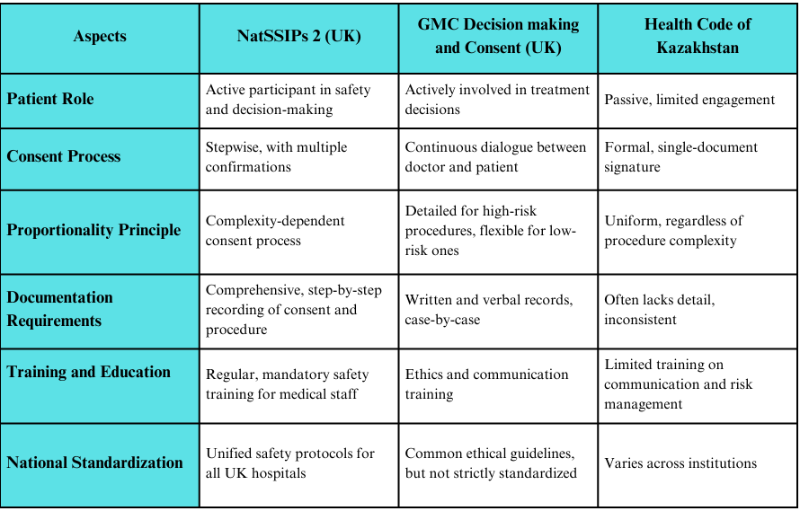
Figure 4. Comparison of Kazakhstan’s Health Code, GMC and NatSSIPs 2
To explore the informed consent process in Kazakhstan in more detail, another qualitative analysis was conducted by searching for all scientific articles, studies and publications on the topic of informed consent to medical intervention from various credible sources and databases. The study selection process is shown in Fig. 5. In total, 261 articles were retrieved from the databases, of which 1 was included in the review based on the inclusion/exclusion criteria. Such a small number of studies on this topic is due to the fact that the issue of informed consent has not yet gained the necessary importance in Kazakhstan. Unfortunately, the only study that met all the requirements was only aimed at studying the principle of informed consent in Kazakhstan, without a detailed analysis of the process. Moreover, it had many methodological gaps, sampling errors and poor links between the results and the existing literature. Due to the lack of a clearly stated purpose, conclusions had to be drawn from the content of the study itself. Therefore, it can be concluded that the topic of medically informed consent in Kazakhstan is under-researched and still requires recommendations to overcome the existing shortcomings.
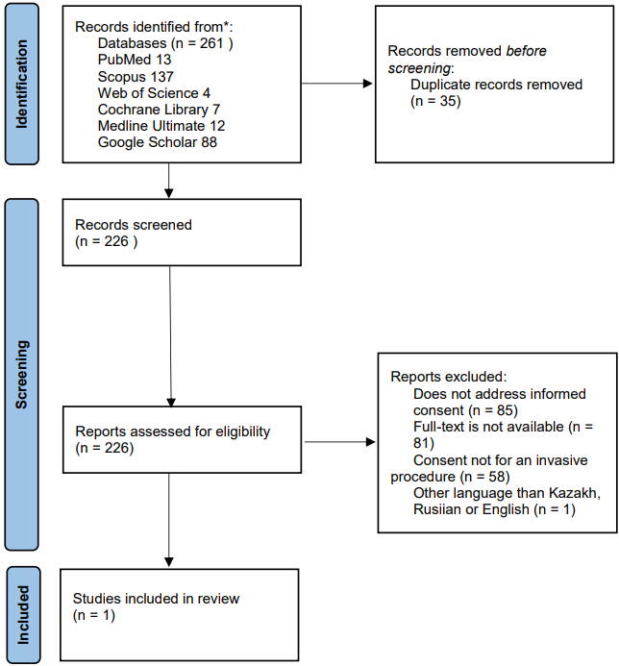
Figure 5. Results of literature searches to identify studies of medical informed consent in Kazakhstan

Recommendations:
- Formalisation of the medical informed consent process. The qualitative analysis of UK and Kazakhstani regulatory documents showed a difference in the standardised guidance documents that clearly spell out the ethical and legally valid actions to be taken during the informed consent process. The absence of such a document in Kazakhstan results in different levels of quality across all health care facilities. Medical staff do not have clear guidelines to follow or refer to depending on the nature of the complexity of situations. Because of this, all actions and decisions are made on the basis of doctors' own beliefs, which leads to different results and quality of medical care.
- Implementation of multi-stage validation of patient consent. Informed consent is a continuous process that is not limited to just signing the patient's consent. The main purpose of informed consent for medical intervention is to enable the patient to make the final decision when fully informed. However, there is no single system in place to accurately verify that patients are truly informed. It means that the system of consent verification in Kazakhstan is not sufficiently structured, which can lead to misinformation or undesirable litigation. Therefore, the introduction of multi-stage consent verification at each stage of medical intervention is the best solution. The use of digital technologies to both explain informed consent and to record the process of obtaining the patient's consent, dividing consent into several stages to avoid impulsive decisions are possible suggestions for the introduction of multi-stage consent verification.
- Developing a safety culture and introducing regular courses on medical ethics and safety issues. In local practice, mistakes made by medical staff during procedures often remain hidden for fear of being judged or excluded from healthcare. Such actions hinder the development of the patient safety system and negatively affect the formation of transparency in healthcare. A comparative analysis with the UK where a restorative safety culture ‘Just Culture’ has been introduced, whereby patients trust healthcare providers to investigate safety events in order to learn rather than blame them, has shown the need for such a system in Kazakhstan. Encouraging medical errors is important both to create honest reports of medical procedures and to recognise systematic errors. It is also important to hold regular training sessions to deal with erroneous cases and to organise simulation sessions on safety during procedures.
- Developing and increasing the number of observational studies aimed at quantitative and qualitative analysis of the informed consent process with active participation of both doctors and patients. One of the shortcomings of Kazakhstan's system of informed consent is the lack of studies in this field. As already mentioned, during the study only 1 paper was left matching the inclusion/exclusion criteria. The small number of research studies on this topic indicates that the informed consent process remains neglected. Moreover, researches in which both medical workers and patients openly express their opinions will help to assess the real dynamics of the consent process in local practice. The empirical data obtained on attitudes and understanding of informed consent through structured interviews or questionnaires will improve the analysis of legal awareness among patients and doctors. It is important to note, empirical research is not limited to a particular city or region, and can cover all parts of Kazakhstan. A comprehensive analysis in all regions of the country will help to build a current picture of the consent process in different areas and conduct a comparative analysis to identify regional differences. As a result, detailed information on informed consent in Kazakhstan can be obtained and specific gaps in this area can be identified.

Strengths
- The study fully analyzes the informed consent process focusing on local practice. In identifying the research gap, it was found that the number of researches examining the process of informed consent for medical intervention in Kazakhstan is limited. However, informed consent is a fundamental step in medical ethics and patient rights, which makes this topic highly relevant to Kazakhstan. Therefore, this study as a first mover may become the basis for future projects where empirical and quantitative data will be used.
- The research covers different disciplines of science including law, ethics and medicine. This helps to broaden the relevance and scope of the study, allowing to get conclusions that will be useful for several areas of society. This interdisciplinary approach enhances the degree of analysis by identifying key features and differences between local practices and international standards. Moreover, the practical significance of the study makes the results of the analysis extremely important for patients, affecting the healthcare system and the legislation of Kazakhstan.
- The social orientation of the research project has a direct impact on important aspects of national medicine - transparency, trust and freedom of choice. The aim of the project is to address the interaction between doctor and patient during the consent process by analyzing compliance with the basic principles of informed consent. In this way, the study is focused on improving patient welfare, contributing to the protection of patients' rights and achieving full trust in the healthcare system. On this basis, the results of the project will have social value for all citizens of Kazakhstan.

Limitations
Nevertheless, despite the results obtained and the in-depth and comparative analysis carried out, this study has several limitations which need to be considered. First, research lacks empirical data. One of the main objectives to be covered in the analysis is the examination of normative legal documents, standards, articles and their comparison with international standards. Because of this, the main focus of the research had to theoretically analyze the official documents of both countries. As a result, the study did not include patient or physician surveys, as well as lacks analysis of questionnaires and specific clinical cases in medical institutions in Kazakhstan. Such limitations narrow the possibilities of obtaining the real picture of current practice of informed consent. Secondly, the study includes a narrow sampling frame. Although the work aims to compare domestic practice with the international standard to identify weaknesses in the informed consent process in Kazakhstan, the analysis focuses primarily on the UK as a benchmark of ethical medicine, without covering the systems of other countries. Consequently, a comparative analysis of the informed consent process with the UK limits the scope of the ethical and legal analysis by providing data from only one country and preventing more extensive findings. A broader comparative analysis including other countries' healthcare systems would broaden the scope of the study and help to identify more recommendations for reforming the regulatory frameworks of the Republic of Kazakhstan. Third, the research lacks statistical and quantitative data. When it comes to assessing the effectiveness of any process in the field of healthcare, it necessarily requires quantitative characterization of aspects of this area. In particular, statistical data related to patient knowledge or satisfaction could improve the validity of the findings and reduce the degree of bias in evaluating the consent process. As a result, due to the lack of quantitative data, the study is limited in reliably assessment of the current system in Kazakhstan and in revealing the current situation of the consent process in local practices.

Conclusion
Medical informed consent is an ongoing process that consists of many important parts. Importantly, achieving long-term perspectives in this complex process requires a long time. An in-depth analysis has shown that in Kazakhstan the process of medical consent is only formally involved, ignoring the basic principles in practice. The reason for this was many factors, including the influence of historically established doctor-centered approach in post-Soviet countries, the lack of multi-stage verification of consent and patient safety, as well as the non-existence of a culture for open discussion of errors. Therefore, Kazakhstan's healthcare system needs to adopt key aspects of international standards, adjusting them to the necessary practices in local medical organizations. Most significantly, it is necessary to realize that in the modern world medicine cannot exist without ethics. The process of informed consent to medical intervention should not only formally protect the rights of the patient, but also reflect respect for individual preferences and choices. Based on this, it can be concluded that the transformation of the informed consent process in Kazakhstan requires a change in the current views on doctor-patient interactions, and should make a leap towards safe, ethical, and most importantly, patient-centered medicine.

References:
Annas, G. J. (1991). Mengele’s birthmark: The Nuremberg Code in United States Courts. The Journal of Contemporary Health Law and Policy, 7, 17–45.
Centre for Perioperative Care. (2023). National safety standards for invasive procedures (NatSSIPs 2). https://www.cpoc.org.uk/
Code of the Republic of Kazakhstan No. 360-VI. (2020, July 7). On public health and healthcare system. https://adilet.zan.kz/eng/docs/K2000000360
del Carmen, M. G., & Joffe, S. (2005). Informed consent for medical treatment and research: A review. The Oncologist, 10(8), 636–641. https://doi.org/10.1634/theoncologist.10-8-636
Edgman-Levitan, S., & Schoenbaum, S. C. (2021). Patient-centered care: Achieving higher quality by designing care through the patient’s eyes. Israel Journal of Health Policy Research, 10, Article 21. https://doi.org/10.1186/s13584-021-00459-9
General Medical Council. (2024). Decision making and consent: Professional standards for doctors. https://www.gmc-uk.org/guidance
Gotsadze, G., & Zoidze, A. (2021). Soviet legacy is still pervasive in health policy and systems research in the post-Soviet states. Public Health Research & Practice, 31(4), Article e3142121. https://doi.org/10.17061/phrp3142121
Kral'ko, A. A. (2009). Medical and legal aspects of obtaining informed consent for medical intervention. Medical News, 12, 41–45.
Kubar, O. I. (Ed.). (2018). Ethics of vaccination (criterion of scientific and humanitarian breakthrough). FBUN Pasteur Institute of Epidemiology and Microbiology.
Ministry of Healthcare of the Republic of Kazakhstan. (2024). Over 3.4 million patients received inpatient treatment in the country in 2024. https://ru.elordainfo.kz/zdoroviye/v-2024-godu-v-kazahstane-svyshe-3-4-mln-pacientov-poluchili-lechenie
Professional Standards Authority. (2024). General Medical Council (GMC).
Saiynov, M. S., Kulniyazova, A. B., & Sisenbaeva, A. T. (2021). Informed voluntary consent of the patient [Информированное добровольное согласие пациента]. Journal of Health Development, 2(42), 69–75. https://doi.org/10.32921/2225-9929-2021-2-42-69-75
Shah, P., Thornton, I., Kopitnik, N. L., & Hipskind, J. E. (2024). Informed consent. In StatPearls. StatPearls Publishing. https://www.ncbi.nlm.nih.gov/books/NBK430827/
Shakhabov, I. V., Melnikov, Y. Y., & Smyshlyaev, A. V. (2020). Key aspects of patient-oriented management model in medical organizations. Science Review: Medical Sciences, 3, 34–38. https://doi.org/10.17513/srms.1112
Sukhov, A., & Karashuk, L. (2022). Social and psychological aspects of trust in medical patients [Социально-психологические аспекты доверия у медицинских пациентов]. Психолого-педагогический Поиск, 2(62), 138–147. https://doi.org/10.37724/rsu.2022.62.2.015
Zhumadilova, A., Craig, B., & Bobák, M. (2018). Patient-centered beliefs among patients and providers in Kazakhstan. https://www.semanticscholar.org/paper/Patient-Centered-Beliefs-Among-Patients-and-in-Zhumadilova-Craig/fe5c3f13f9fa007f3c543df3b89f1280b4a07b33

Appendix
Appendix A - The seven principles of GMC with explanation
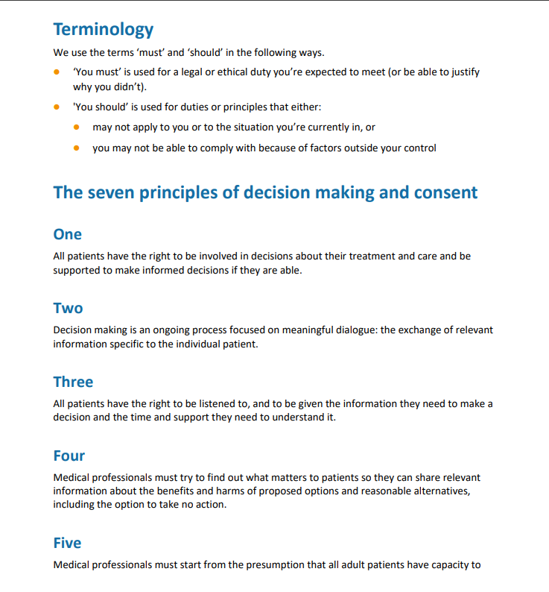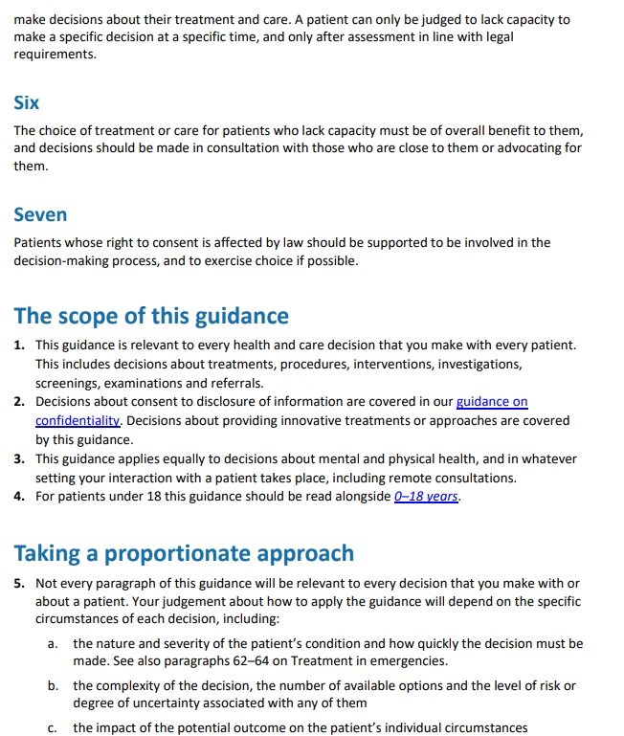
Appendix B – “The NatSSIPs Eight” Sequential Step and Organisational Standards
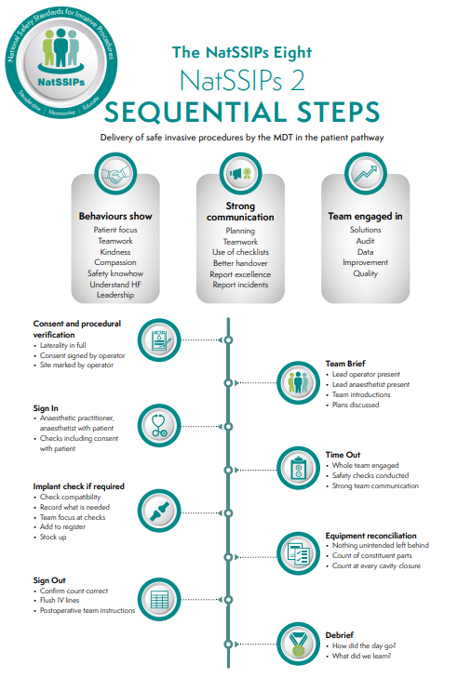
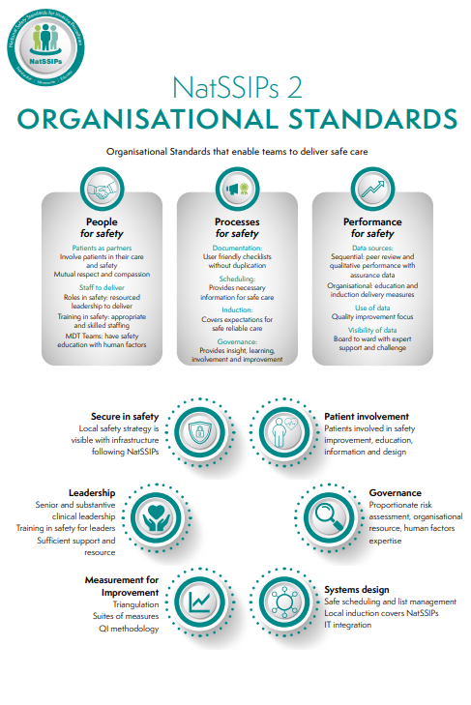
Appendix C – The Code of Republic of Kazakhstan. “On Public Health and the Healthcare System”, Section 3. Chapter 16. Articles 134, 135, 136, 137 and 138. Patient’s right and obligations (original version)
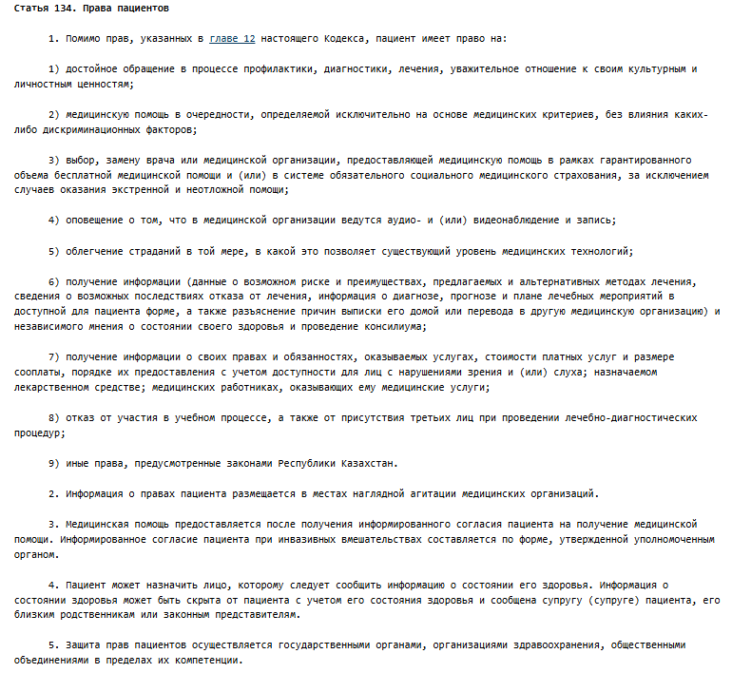
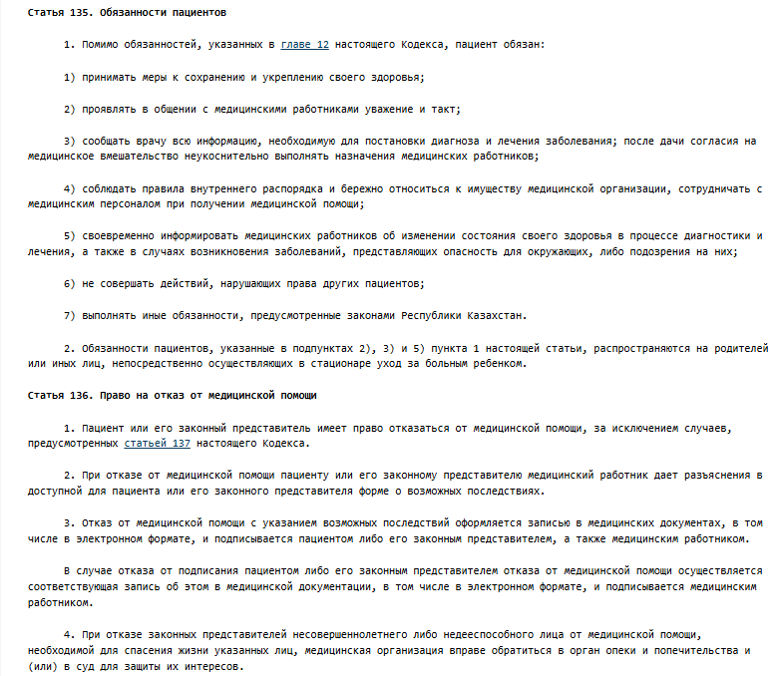
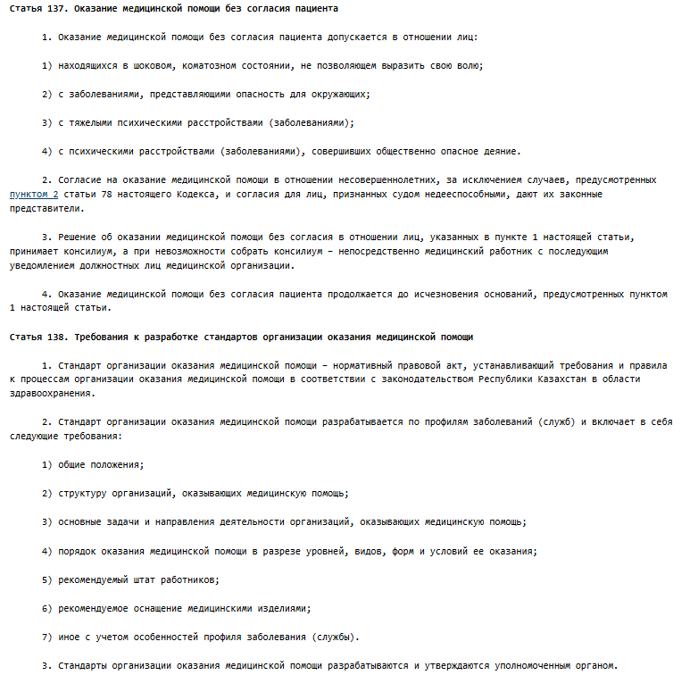
Appendix D – The Code of Republic of Kazakhstan. “On Public Health and the Healthcare System”, Section 3. Chapter 16. Articles 134, 135, 136, 137 and 138. Patient’s right and obligations (translated version)
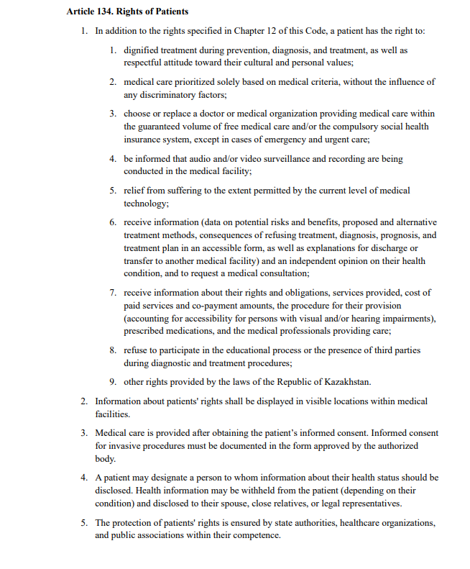
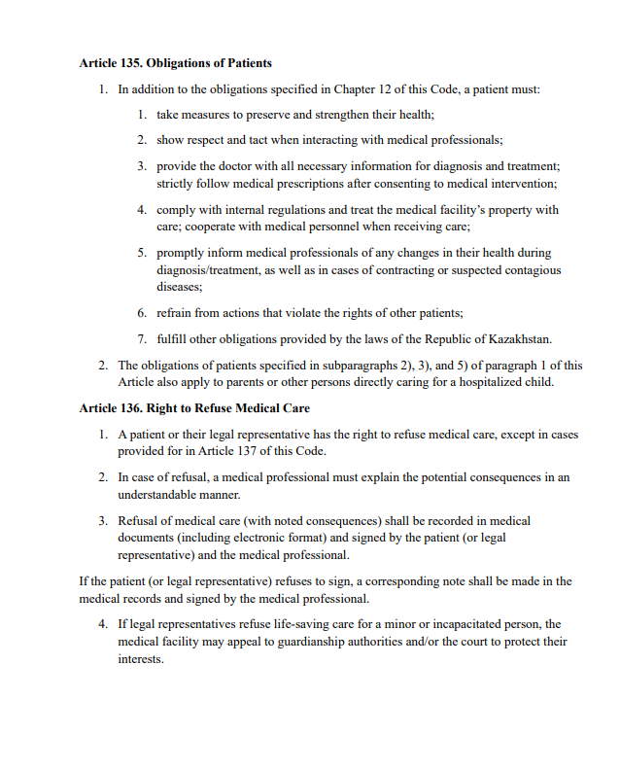
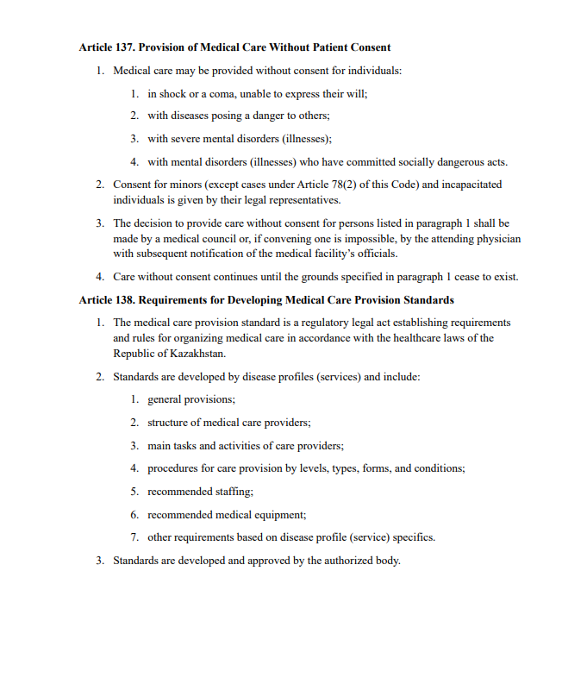
Appendix E – Standard of the patient's written voluntary consent form for invasive procedures in Kazakhstan (original version)
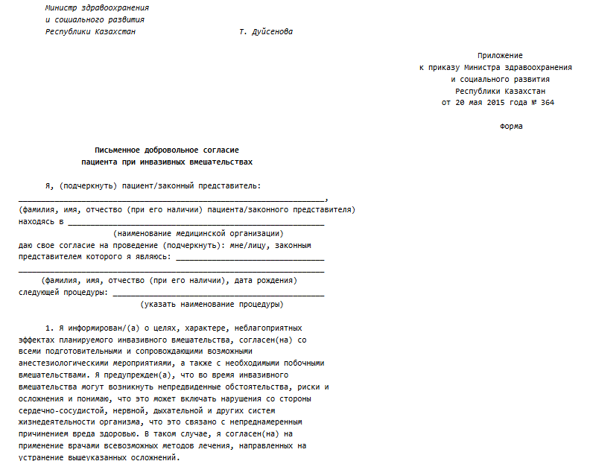
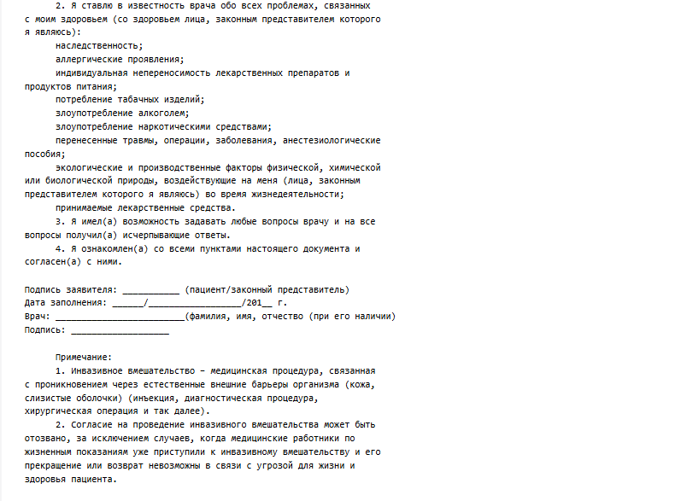
Appendix F – The Code of Republic of Kazakhstan. “On Public Health and the Healthcare System”, Section 2. Chapter 12. Articles 76, 77 and 78. Patient’s right and obligations (original version)
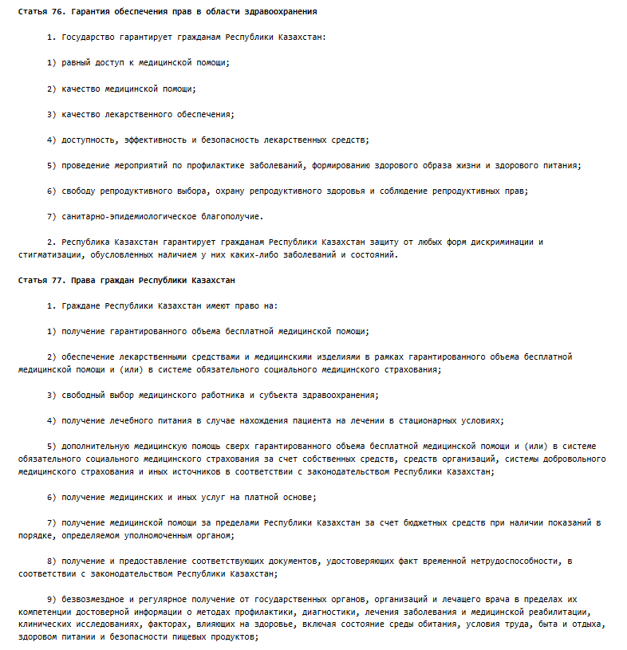

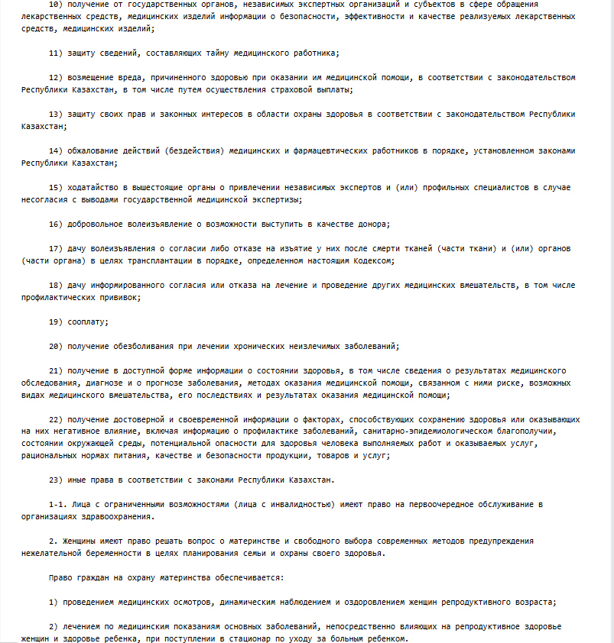
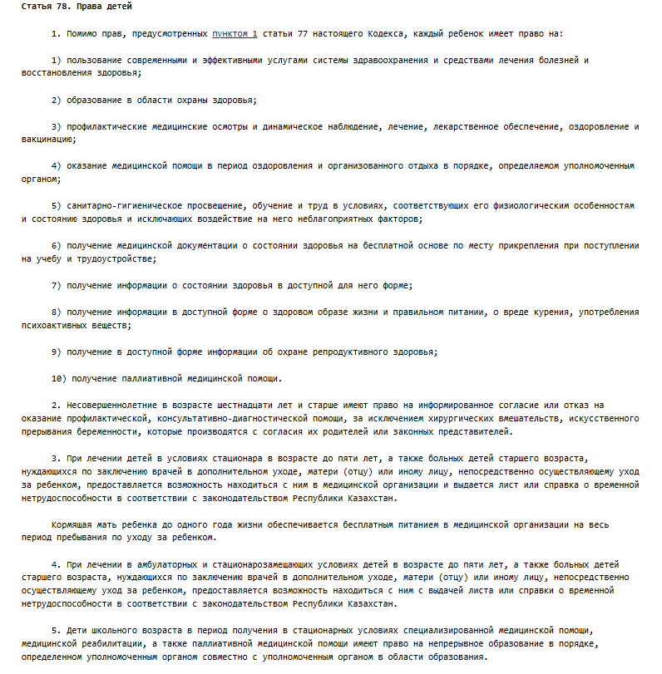
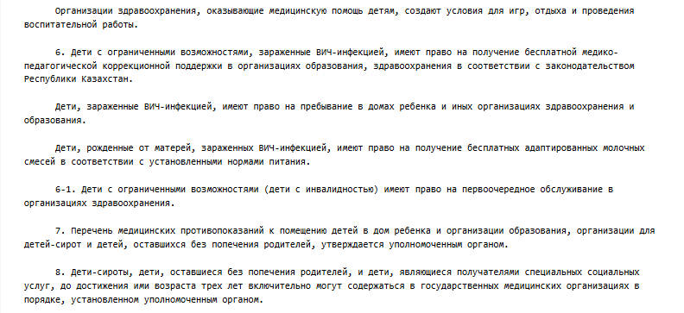

Appendix G – The Code of Republic of Kazakhstan. “On Public Health and the Healthcare System”, Section 2. Chapter 12. Articles 76, 77 and 78. Patient’s right and obligations (translated version)
