Screening for inhibitors of Zeb1, a key regulator of Epithelial to Mesenchymal Transition (EMT) in breast cancer cells
Student: Rustam Alimkulov
PI: Nickolai Barlev
Co-Pi: Eugene Tulchinsky
01.03.2026

Abstract
Breast cancer is a global healthcare burden. This type of malignancy accounts for approximately 670,000 deaths annually. The primary cause of mortality is metastasis. Metastasis is dissemination of cancer cells from primary tumor to other parts of the body. The molecular mechanism that promotes dissemination of cancer cells is mediated by Epithelial-to-Mesenchymal Transition (EMT) enabling cellular motility. Several transcription factors, including Zeb1, regulate the initiation of EMT. This project aimed to screen for small-molecule inhibitors targeting Zeb1 activity. We utilized a Zeb1-negative epithelial MCF-7 breast cancer cell line with Tetracycline-inducible Zeb1 expression. Western Blot analysis confirmed the validity of the model. The protein profile demonstrated that Zeb1 induction inversely correlates with E-cadherin expression. Downregulation of E-cadherin is a fundamental hallmark of the transition into a motile state. We evaluated candidate small-molecule compounds for their impact on Zeb1-driven apoptosis and cell cycle arrest using Flow Cytometry. However, preliminary results indicated limited efficacy of the selected compounds. We attempted to build a rescue model by stably transfecting Zeb1-knockout MDA-MB-231 cells. While control GFP transfection was successful, stable integration of Zeb1 plasmids via lipofection proved inefficient under antibiotic selection. We plan to employ viral transduction to generate more robust, stable lines.
Introduction
Metastatic breast cancer (MBC) is a critical global healthcare burden. MBC accounts for approximately 90% of breast cancer-related mortality, despite advances in early detection (Afifi et al., 2020). The progression towards metastasis relies heavily on epithelial-mesenchymal transition (EMT). EMT is a natural developmental program that transforms rigidly adherent epithelial cells into a migratory mesenchymal phenotype.
Several transcription factors regulate EMT. They are Slug, Snail, Twist, and Zeb. Zeb1 has emerged as a master regulator of EMT. Recent studies indicate that Zeb1 is uniquely critical for maintaining the mesenchymal phenotype. Zeb1 depletion alone is often sufficient to reverse EMT (Addison et al., 2021). Besides conferring enhanced metastatic and invasive potential, Zeb1 promotes resistance to multiple drugs. The resistance is mediated by utilizing several mechanisms: tamoxifen resistance via estrogen receptor-alpha hypermethylation (Zhang et al., 2017), doxorubicin resistance via Akt/GSK3β/β-catenin (Wang et al., 2016), trastuzumab resistance via the Zeb1/mir-200 axis (Bai et al., 2014), and enhanced repair of DNA damage via ATM pathway (Zhang et al., 2018). Recent evidence suggests that Zeb1 not only helps breast cancer stem cells bypass apoptosis (Shivhare et al., 2023) but also triggers autophagy to repair the very genotoxic damage meant to kill them (Fedorova et al., 2022).
Despite its obvious value as a therapeutic target, direct and clinically approved Zeb1 inhibitors do not yet exist. While researchers are mapping natural suppression mechanisms, such as the NOTCH3/miR-223 axis (Chen et al., 2024), current translational efforts mostly rely on indirect targeting. For instance, the kinase inhibitor UCN-01 has been shown to suppress Zeb1 activity (Sayan et al., 2019). Crucially, Song et al. (2018) demonstrated that suppressing Zeb1 sensitizes cancer cells to the ATR inhibitor VE-821, leading to lethal accumulation of DNA damage.
In order to leverage this finding, we aim to identify specific Zeb1 inhibitors by screening a library of 2,330 FDA-approved drugs for use in a combinational strategy with VE-821. We hypothesize that identifying agents that disrupt Zeb1 activity will restore E-cadherin expression and synergize with ATR inhibition to overcome chemoresistance. To quantify inhibition, we are using a Zeb-1 negative MCF-7 model engineered to express Tetracycline-inducible Zeb1 system and a luciferase reporter driven by the E-cadherin promoter. Because this strategy relies on repurposing existing drugs, it may provide a significantly shorter path for clinical translation should such drugs be identified.
Methods
Cell culture
Two breast cancer cell lines were used: MCF-7 (luminal type), carrying a Tetracycline-inducible Zeb1 expression system, and MDA-MB-231 (basal type), including Wild Type (WT) and Zeb1 Knockout (KO). Cells were cultured in DMEM supplemented with 10% fetal bovine serum (FBS) and penicillin-streptomycin. Cells were maintained at 37°C with 5% CO2. Cell passaging was performed using Trypsin-EDTA when confluence reached approximately 80-90%.
Chemical reagents and treatments
To induce Epithelial-Mesenchymal Transition (EMT), doxycycline was dissolved in sterile water and added to the culture medium at a final concentration of 0.5 µM. Cells were treated for 96h to ensure complete phenotypic transition. Cell lysates were then collected to perform Western Blot.
For drug screening assays, candidate small-molecule inhibitors were dissolved in DMEM (+FBS -penicillin-streptomycin). MCF-7 cells were seeded and allowed to adhere for 24 hours. Induction was initiated with 0.5 µg/ml doxycycline for the '72h' experimental groups, while '0h' control groups received fresh standard media. Following 24 hours of induction, inhibitors (A8, A10, G5) or DMSO vehicle control were added to both induced and non-induced populations. Cells were harvested 48 hours post-inhibitor treatment (corresponding to 72 hours post-induction) and fixed in 70% ethanol for cell cycle analysis via flow cytometry.
Western Blot
Cell lysates were collected using Laemmli buffer. Protein concentration was determined via Bradford assay. Samples were separated by SDS-PAGE and transferred to nitrocellulose membranes. Membranes were blocked in milk/PBST and incubated with primary antibodies: anti-Zeb1 (Rabbit) and anti-E-cadherin (Mouse). Following incubation with secondary antibodies, protein bands were visualized using ECL reagents on a ChemiDoc system.
Densinometric analysis
ImageJ software was used to quantify protein expression levels from Western blot images.
Analysis steps:
- Image Processing: Digital images were split channeled. The channel with highest resolution and least noise was chosen.
- ROI Selection: A rectangular region of interest (ROI) was used to define the area around each protein band (Zeb1, E-cadherin, and Beta-tubulin).
- Normalization: Target protein values were normalized against the Beta-tubulin loading control using the following formula:
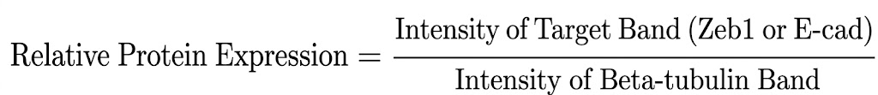
Flow Cytometry (cell cycle analysis using Attune NxT Thermo Fisher Flow Cytometer)
Cells treated with inhibitors were harvested using Trypsin, washed with PBS, and fixed in 70% ethanol. Fixed cells were washed to remove ethanol and stained with a solution of Propidium Iodide (PI) and RNase A. Samples were analyzed on a Flow Cytometer to assess cell cycle distribution (G1, S, G2/M) and the presence of apoptotic cells (sub-G1 population). Gates were applied to exclude debris and doublets.
Bacterial transformation, plasmid preparation
Plasmids (Zeb1-KO rescue vector, pcDNA5 empty vector, and GFP control) were amplified to generate stable MDA-MB-231 cell lines. DH5α competent bacteria were transformed via heat shock. Bacteria were grown on LB agar plates with Ampicillin selection. Colonies were picked, expanded in liquid LB, and plasmids were isolated using Midiprep kits. DNA concentration and purity were verified using a NanoDrop spectrophotometer.
Transfection and antibiotic selection
MDA-MB-231 (KO and WT) cells were seeded in 6-well plates. Transfection was performed using Lipofectamine reagent according to the manufacturer's protocol.
Conditions: Zeb1 KO + Zeb1 plasmid; Zeb1 KO + GFP plasmid; WT + pcDNA5; WT + GFP. Selection: 48 hours post-transfection, cells were treated with selective antibiotics: Hygromycin (for Zeb1 plasmid) and G418 (for pcDNA5). Selection was maintained for up to 7 days.
Results
Validation of the Zeb1 inducible system
We used Western blotting to confirm the functionality of the MCF-7 Tetracycline-inducible system. The cells showed no baseline Zeb1 expression in the absence of doxycycline at 0 hours. However, after induction, Zeb1 protein levels increased (Figure 1). E-cadherin expression was significantly downregulated, whereas Zeb1 accumulation was increased (Figure 1). Our model demonstrates that upregulating Zeb1 is sufficient to trigger the core molecular shifts of the epithelial-mesenchymal transition (EMT).
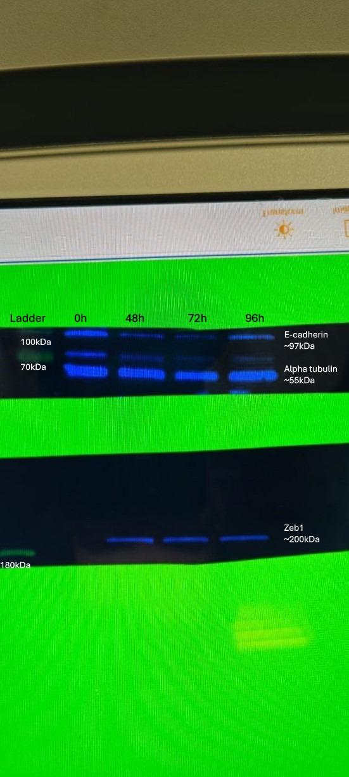
Figure 1. Visualization of Zeb1 and E-cadherin expression in MCF-7 cells by Western blotting. Concentrations of E-cadherin, Beta-tubulin, Zeb1, with their respective molecular weight, are described. Protein expression was determined by relative fluorescence of the respective bands with specific antibodies using the ChemiDoc 2.0 software.
Densitometric analysis using ImageJ software
Table 1 shows densities of the bands: E-cadherin, beta-tubulin, and Zeb1. The densities of E-cadherin and Zeb1 were normalized to beta-tubulin density. At 0-hour baseline, Zeb1 was entirely undetectable. This confirms a stable epithelial state and that our cell line lacks endogenous Zeb1. After induction, Zeb1 expression rose sharply by the 48-hour mark (Normalized: 1.34) and reached its maximal expression at 72 hours (Normalized: 1.58). At the same time, E-cadherin expression decreased to 0.69 and reached its minimal value of 0.45 at 72 hours. At 96 hours, Zeb1 levels remained high (Normalized: 1.20), though they showed a slight decrease compared to the 72-hour peak. This decrease in Zeb1 is mirrored by an increase in E-cadherin (from 0.45 to 1). Also, the highest Zeb1 density corresponds to the lowest E-cadherin density. The data suggest quantitative evidence of an inverse relation between Zeb1 and E-cadherin.
 | 0h | 48h | 72h | 96h
E-cadherin | 36344.309 | 14494.945 | 7670.338 | 20044.279
% | 46.267 | 18.452 | 9.764 | 25.517
Normalized | 1.738641915 | 0.6930068354 | 0.4586406125 | 1.001687996
Beta-tubulin | 36656.48 | 36678.016 | 29326.309 | 35091.087
% | 26.611 | 26.626 | 21.289 | 25.474
Zeb1 | 0 | 42933.957 | 40601.421 | 36817.472
% | 0 | 35.673 | 33.735 | 30.591
Normalized | 0 | 1.339780666 | 1.584621166 | 1.200871477
Table 1. ImageJ analysis of Western Blot
Evaluation of cell cycle progression
We used flow cytometry to evaluate the impact of the inhibitors on cell survival and growth. Figure 2 shows cell groups after treatment for before and after induction. Flow cytometry analysis included cell groups of non-induced(0h) and induced (72h), using the native software of the Attune NxT Flow Cytometer. Cell cycle analysis was successfully quantified for 0h and 72h timepoints.
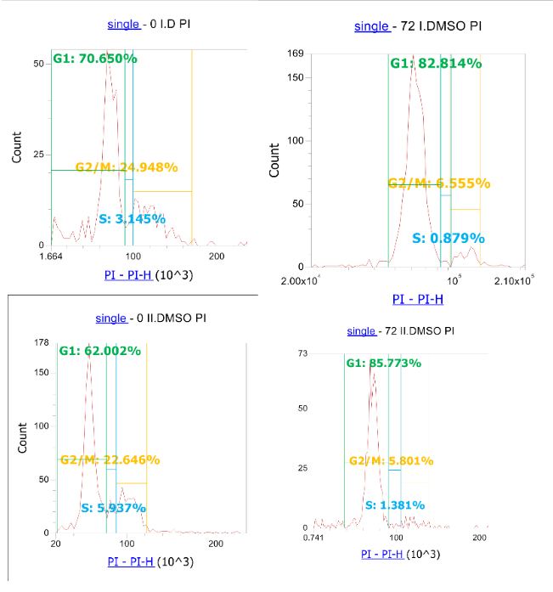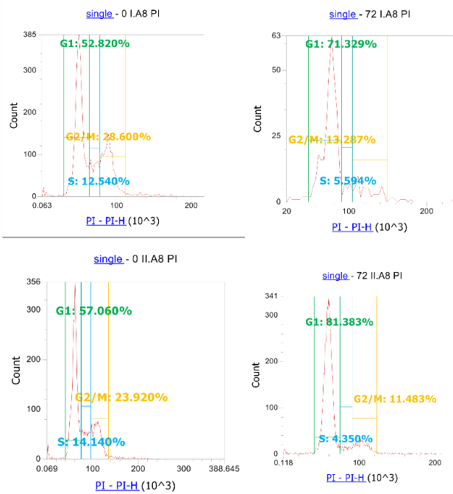
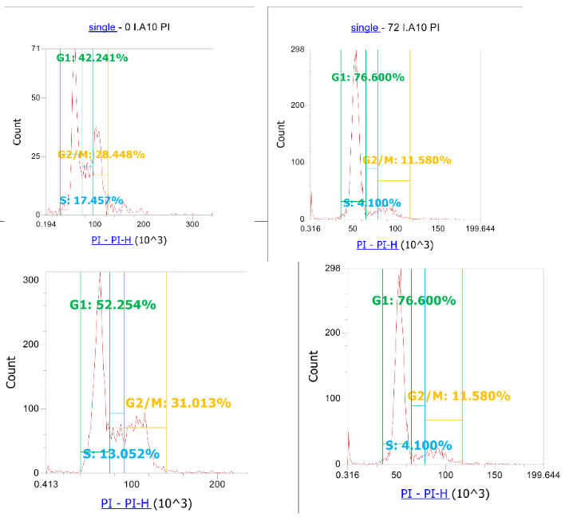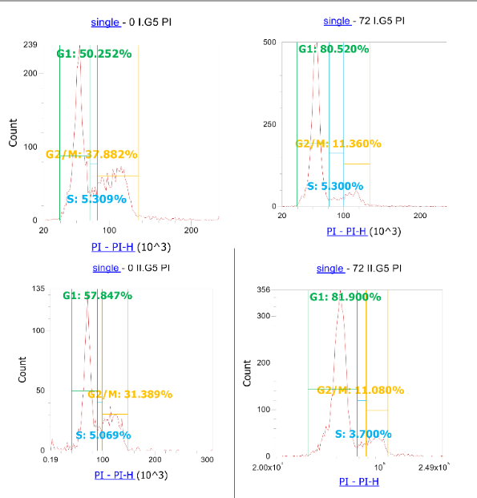
Figure 2. Flow cytometric analysis of cell cycle distribution in MCF-7 cells.
Table 2 shows organized raw flow cytometric data.
Non-induced | DMSO-1 | DMSO-2 | A8-1 | A8-2 | A10-1 | A10-2 | G5-1 | G5-2
G1 | 70.1 | 62 | 52.8 | 57.1 | 42.4 | 52.3 | 50 | 57.8
G2 | 25 | 22.6 | 28.6 | 23.9 | 28.4 | 31 | 37.8 | 31.4
S | 3.1 | 5.9 | 12.5 | 14.1 | 17.5 | 13 | 5.3 | 5.1
induced | DMSO-1 | DMSO-2 | A8-1 | A8-2 | A10-1 | A10-2 | G5-1 | G5-2
G1 | 82.4 | 85.8 | 71.3 | 81.4 | 76.6 | 78.2 | 80.5 | 82
G2 | 6.6 | 5.8 | 13.3 | 11.5 | 11.6 | 10.2 | 11.4 | 11.2
S | 0.9 | 1.3 | 5.6 | 4.4 | 4.1 | 7.9 | 5.3 | 3.6
Table 2. Raw flow cytometric data. “1” and “2” represent sample numbers - duplicates.
Table 3 represents average values of duplicates. This data was used to generate histograms to visualize results before and after treatment as shown in Figure 3.

Non-induced | DMSO | A8 | A10 | G5
G1 | 66.05 | 54.95 | 47.35 | 53.9
G2 | 23.8 | 26.25 | 29.7 | 34.6
S | 4.5 | 13.3 | 15.25 | 5.2
Induced | DMSO | A8 | A10 | G5
G1 | 84.1 | 76.35 | 77.4 | 81.25
G2 | 6.2 | 12.4 | 10.9 | 11.3
S | 1.1 | 5 | 6 | 4.45
Table 3. Average values of flow cytometric data.
Figure 3 shows that induction of Zeb1 in MCF-7 cells using 0.5 µg/ml doxycycline significantly alters the cell cycle. Zeb1 expression in the DMSO control group resulted in a cell accumulation in the G1 phase. It increased from 66.05% to 84.10%. This was accompanied by a severe depletion of the S-phase population, which dropped from 4.50% to 1.10%.
Inhibitor effects on non-induced cells
Inhibitors fenretinide (formerly A8), midostaurin (formerly A10), and auranofin (formerly G5) failed to revert the cells to an epithelial state. In the non-induced 0 h control group, fenretinide and midostaurin tripled the S-phase population, while auranofin induced a severe G2/M-phase arrest (34.60%). Zeb1-induced population exhibited marked resistance to these disruptions. Midostaurin increased the S-phase by 10.75% in non-induced cells, but only by 4.9% in induced cells.
Inhibitor effects on induced cells
Treatment with fenretinide, midostaurin, and auranofin resulted in a slight reduction in G1-phase accumulation compared to the induced DMSO control. The G1 population decreased from 84.10% to a range of 76.35% (fenretinide) to 81.25% (auranofin). However, these cells did not exhibit the baseline distribution. Instead, they showed concurrent increases in the G2 and S-phase populations.

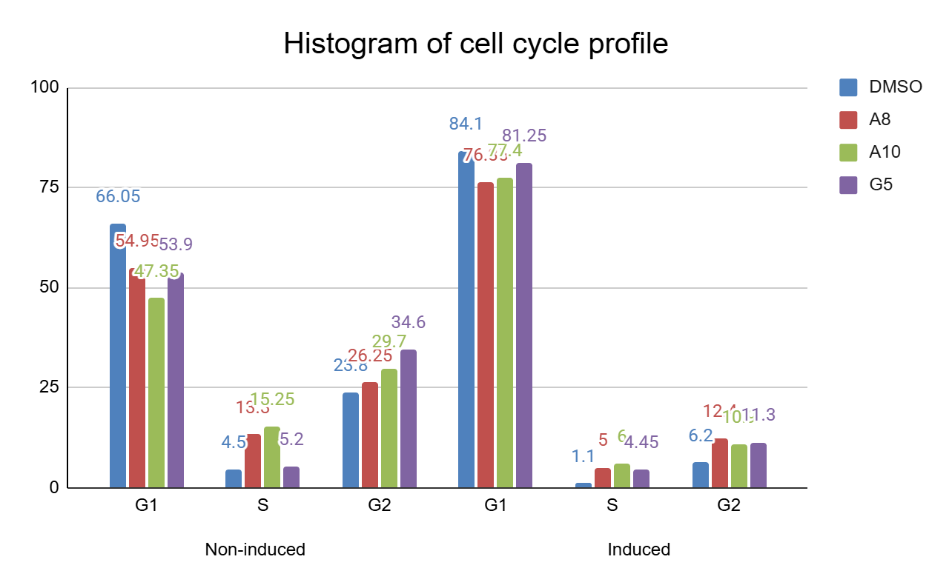
Figure 3. Histogram of the cell cycle profile for the non-induced and induced groups.
Discussion
The induction of Epithelial-Mesenchymal Transition (EMT) is a critical mechanism driving metastasis and therapeutic resistance in breast cancer. We used a Tetracycline-inducible Zeb1-negative MCF-7 model to simulate Zeb1-driven EMT to evaluate the efficacy of candidate small-molecule inhibitors.
Validation of the Zeb1-driven EMT model
Our Western blot analysis confirmed the functionality of our model: doxycycline treatment induces Zeb1 expression, leading to E-cadherin repression. At baseline 0h Zeb1 is absent, whereas at 72h Zeb1 exhibits the highest concentration (normalized 1.58, Table 1). On the contrary, at 72h, E-cadherin expression was at the lowest (normalized 0.46, Table 1). The inverse correlation aligns with seminal findings that Zeb1 functions as a transcriptional repressor of E-cadherin by binding to E-box sequences in the CDH1 (E-cadherin) promoter (Eger et al., 2005). The loss of E-cadherin is a hallmark of EMT, which leads to the disassembly of adherens junctions and increased migratory potential. The successful recapitulation of this molecular switch confirms that the MCF-7 Tet-on system is a working model for studying EMT kinetics and serves as a valid platform for screening anti-metastatic compounds (Mock et al., 2015). There is a slight recovery of E-cadherin at 96h (normalized to 1.00, Table 1), with a corresponding decrease in Zeb1 (normalized to 1.20, Table 1). This finding can be explained by cell overconfluence or a phenomenon called partial EMT. Partial EMT is a hallmark of circulating tumor cell clusters (CTC clusters). A CTC cluster is a group of tumor cells that maintains E-cadherin expression to maintain adherens junctions and survive as a multicellular unit. At the same time, the cells express Zeb1 to employ migratory plasticity (Chen et al., 2022). A partial EMT phenotype is of great significance, as it confers tumor cells with the highest level of chemoresistance and metastatic potential (Caruso et al., 2024).
Proliferation-migration dichotomy
The flow cytometry results demonstrate a sharp increase in the G1 population (66.05% to 84.10%). This finding indicates a robust G1 cell cycle arrest. It is a characteristic of the "proliferation-migration dichotomy" in cancer cells. As Zeb1 induces EMT, cells exit the active cell cycle (S-phase) to conserve energy for structural remodeling and invasive behaviors necessary for metastasis (Alfahed A., 2024).
Cell cycle and cytotoxic drug action
Normal cell cycle. In proliferating epithelial cells, the cycle progresses through four distinct phases controlled by cyclins and cyclin-dependent kinases (CDKs) (Visconti et al., 2016).
- G1 Phase: The cell grows and prepares the necessary proteins for DNA replication.
- S Phase (Synthesis): The cell replicates its entire genome.
- G2 Phase: The cell undergoes a final growth spurt and a critical DNA damage checkpoint before division.
- M Phase (Mitosis): The cell divides into two daughter cells.
Cytotoxic Drug Action. Most conventional chemotherapies and small-molecule inhibitors are "cytotoxic". They target vulnerabilities in rapidly dividing cells (Anand U., 2022).
- When a drug interferes with DNA synthesis (e.g., antimetabolites), cells become trapped in the S-phase, unable to finish replicating (Helleday et al., 2008).
- When a drug damages the mitotic spindle or causes severe DNA damage, the cells are arrested at the G2/M checkpoint to prevent the division of a mutated cell (Yam et al., 2022).
- If the damage is too severe, the cell undergoes apoptosis, which appears in flow cytometry as a fragmented Sub-G1 population (Costigan et al., 2023).
Analysis of inhibitors activity
Analysis of the results of non-induced groups revealed off-target effects. The compounds severely disrupted specific checkpoints, rather than maintaining a normal epithelial cell cycle. The drugs act as generalized cytotoxic agents.
We primarily analyzed the non-induced group to understand the inhibitors’ effect on cell cycle of MCF-7 cells. Because Zeb1 causes massive G1 cell cycle arrest (84.1%), which can blunt the cycle-dependent effect of the inhibitors.
- Fenretinide(A8) causes an S-phase arrest. S-phase triples from 4.5% to 13.3%. Also, it is accompanied by a drop in G1. This indicates that the cells are entering the DNA synthesis phase but are stalling out, unable to complete replication.
- Midostaurin (A10) causes accumulation in S- and G2-phases. This drug severely depletes the G1 phase (dropping it to 47.35%), pushing the cells into the later stages of the cycle. The S-phase more than triples (to 15.25%), and the G2-phase increases (to 29.7%). This suggests widespread replication stress and failure to progress into mitosis.
- Auranofin(G5) causes a profound G2/M-phase arrest. While the S-phase remains relatively normal (5.2%), the G2 population jumps dramatically from 23.8% to 34.6%. This is a classic hallmark of a drug that triggers the G2/M DNA damage checkpoint, preventing cells from dividing.
Short review of the drugs in the global literature in Table 4.
Compound | Mechanism of Action | Cell Cycle Effects & Arrests | Breast Cancer Cell Lines (MCF-7 Focus)
Fenretinide (4-HPR) | A synthetic retinoid that triggers apoptosis through both RAR-dependent and independent pathways (Salazar et al., 2011). It uniquely drives cytotoxicity by elevating ceramide levels and generating reactive oxygen species (Cazzaniga et al., 2012; Rehman et al., 2004). | Primarily induces G2/M phase arrest and subsequent apoptosis across various signal transduction pathways (Gomez-Larrauri et al., 2021; Salazar et al., 2011). | Shows synergistic growth inhibition in MCF-7 when paired with tamoxifen (Cazzaniga et al., 2012). It increases C18 and C24-ceramide levels (Kim et al., 2026) and can re-sensitize antiestrogen-resistant cells to treatment (Moyer et al., 2023; Li et al., 2021).
Midostaurin (PKC412) | A multi-target kinase inhibitor (targeting PKC, FLT3, and VEGFR). Specifically in TNBC, it has been shown to inhibit the Aurora kinase family (Kawai et al., 2015; Silnitsky et al., 2023). | Induces G2/M arrest characterized by significant 4N and 8N DNA accumulation, indicating mitotic interference (Kawai et al., 2015). | Effectively attenuates proliferation in a broad spectrum of lines, including ER+ (MCF-7, HCC1428), HER2+, and various TNBC models (Kawai et al., 2015). It is also noted for reversing ABCB1-mediated multidrug resistance (Ji et al., 2019).
Auranofin | A gold-based compound that inhibits Thioredoxin Reductase (TrxR), leading to a lethal surge in oxidative stress (Abdalbari et al., 2021; Zhang et al., 2019). It also blocks proteasome-associated deubiquitinases and inhibits STAT3 phosphorylation (Galassi et al., 2022; Kim et al., 2013). | Causes phase-specific arrest at G0/G1 or S-phase depending on the metabolic context of the cell line (Chen et al., 2021; Zhao et al., 2020). | Demonstrates higher apoptotic potential in MCF-7 than cisplatin (Ryu et al., 2020). While it generally suppresses growth, it can show context-dependent pro-proliferative effects under specific nitrosothiol conditions (Cañas et al., 2012). Synergizes well with Trametinib and selenocystine (Joo et al., 2020; Liu et al., 2013).
Table 4. Review of the drugs
Table 5 compares Table 4 with our experimental results.
Compound | Literature cell cyle arrest | Experimental cell cycle arrest | Interpreting the gap
Fenretinide (A8) | G2/M Phase | S-Phase (13.3%) | Literature notes G2/M arrest via metabolites, but the S-phase spike suggests replication stress. High ROS/Ceramide levels may stall DNA polymerase during DNA synthesis before the cell even reaches G2.
Midostaurin (A10) | G2/M Phase (4N/8N accumulation) | S-Phase (15.25%) & G2 (29.7%) | In the literature, the "4N" population is the G2 population. High S-phase suggests that many cells are trying to reach the 4N state.
Auranofin (G5) | G0/G1 or S-Phase | G2/M Phase (34.6%) | Literature suggests G0/G1 arrest, whereas our MCF-7 cells are triggering G2/M checkpoint. This finding may indicate that the TrxR-induced oxidative stress was severe enough to trigger a mandatory DNA-repair halt before mitosis.
Table 5. Comparison of literature data and experimental results with possible interpretations.
The inhibitors cause the alterations of the cell cycle, not resembling epithelial cell cycle profile; they can not be considered specific Zeb1 inhibitors.
Upon Zeb1 induction, the MCF-7 cell cycle architecture is reorganized into a dominant G1-arrested state (84.1%). Our analysis shows that this G1-heavy profile acts as a pharmacological shield. For the multi-target kinase inhibitor Midostaurin (A10), the literature suggests that its primary mechanism of action is inhibition of Aurora kinases, leading to 4N DNA accumulation (Kawai et al., 2015). Epithelial cells showed a robust increase in G2/M; the Zeb1-induced cells showed a significantly blunted response (G2: 6.2% to 10.9%). Similarly, the lethal surge in oxidative stress typically induced by Auranofin (G5) (Abdalbari et al., 2021) was largely neutralized. The G2/M checkpoint spike reduced by more than 60% compared to the epithelial baseline.
The result aligns with established paradigms: EMT equips cells with cancer stem cell traits. These include heightened efflux pump activity, metabolic flexibility, and superior DNA repair (Singh & Settleman, 2010). Mesenchymal cells generally resist conventional treatments that target rapidly dividing populations (Shibue & Weinberg, 2017).
On the other hand, Fenretinide (A8) remained the most active in the induced group, tripling the S-phase population and doubling the G2-phase population. This suggests that the generation of ceramides and reactive oxygen species (Cazzaniga et al., 2012) can bypass the Zeb1-mediated G1 block more effectively than kinase-specific inhibition, although the overall population remains largely sequestered in G1.

Conclusion
The transition from epithelial to mesenchymal states in MCF-7 cells is characterized by an 84.1% G1-phase sequestration, which functions as a form of kinetic resistance. While the tested inhibitors (Fenretinide, Midostaurin, Auranofin) exert distinct phase-specific arrests in proliferative cells, targeting DNA replication (S-phase) and mitotic machinery (G2/M), the Zeb1-induced population evades these effects by remaining outside the active cycle. Therefore, the failure of these inhibitors to reverse EMT is likely due to the cells' dormant metabolic state, suggesting that future therapies must first 'awaken' these cells or target G1-specific vulnerabilities to be effective.
Methodology and strategy improvement
The inducible system proved effective, however our attempts to generate a stable Zeb1 rescue model in MDA-MB-231 KO cells using liposomal transfection were unsuccessful. Although adequate efficacy of transient expression was confirmed by measuring GFP fluorescence of transfected cells, the antibiotic selection of Zeb1-expressing cell populations resulted in complete cell lethality. This failure is likely attributed to the low genomic integration efficiency of plasmid-based chemical transfection in mesenchymal triple-negative breast cancer lines (Karra & Vemula, 2010). These results support the conclusion that transient methods are ill-suited for generating stable cell lines in hard-to-transfect mesenchymal variants.
In the future experiments, lentiviral transduction will be used. Viral vectors utilize active integration mechanisms into the host genome via single-stranded Long Terminal Repeats of lentivirus. This mechanism ensures stable incorporation of the transgene into the host genome, significantly improving the yield of viable, antibiotic-resistant colonies for long-term functional assays (Lino et al., 2018).
Future directions
A single drug that can kill these cells directly has proven insufficient. Zeb1-driven mesenchymal state is intrinsically resistant. To bypass this barrier, our next phase scales up the discovery process by evaluating a comprehensive library of 2,330 FDA-approved compounds. Repurposing existing compounds provides a fast track to clinical use. Their safety and tolerability are well documented (Pushpakom et al., 2019; Corsello et al., 2020).
We will utilize our E-cadherin luciferase reporter to identify compounds that actively disrupt Zeb1 signaling and force epithelial reversion. The ultimate clinical application of the drug screening is to find a "two-punch" strategy. We aim to identify an agent that successfully breaks the mesenchymal state and restores E-cadherin expression. Also, cdk inhibitors might be good candidates to start with as they target G1 checkpoint failures. Later, we could pair it with the ATR inhibitor VE-821. When Zeb1 is inhibited, the cell’s internal repair machinery essentially collapses. We expect this failure to trigger a massive, fatal accumulation of DNA damage (Song et al., 2018). Finally, this strategy aims to strip metastatic breast cancer cells of their EMT-derived chemoresistance, rendering them fatally vulnerable to targeted therapies.
Reference list
- Abdalbari, F. H., & Telleria, C. M. (2021). The gold complex auranofin: new perspectives for cancer therapy. Discover oncology, 12(1), 42. https://doi.org/10.1007/s12672-021-00439-0
- Addison, J. B., Voronkova, M. A., Fugett, J. H., Lin, C. C., Linville, N. C., Trinh, B., Livengood, R. H., Smolkin, M. B., Schaller, M. D., Ruppert, J. M., Pugacheva, E. N., Creighton, C. J., & Ivanov, A. V. (2021). Functional hierarchy and cooperation of EMT master transcription factors in breast cancer metastasis. Molecular Cancer Research, 19(5), 784–798. https://doi.org/10.1158/1541-7786.MCR-20-0532
- Afifi, A. M., Saad, A. M., Al-Husseini, M. J., Elmehrath, A. O., Northfelt, D. W., & Sonbol, M. B. (2020). Causes of death after breast cancer diagnosis: A US population-based analysis. Cancer, 126(7), 1559–1567. https://doi.org/10.1002/cncr.32648
- Alfahed, A. (2024). Cell Migration–Proliferation Dichotomy in Cancer: Biological Fact or Experimental Artefact? Biology, 13(10), 753. https://doi.org/10.3390/biology13100753
- Bai, W. D., Ye, X. M., Zhang, M. Y., Zhu, H. Y., Xi, W. J., Huang, X., Zhao, J., Gu, B., Zheng, G. X., Yang, A. G., & Jia, L. T. (2014). MiR-200c suppresses TGF-β signaling and counteracts trastuzumab resistance and metastasis by targeting ZNF217 and ZEB1 in breast cancer. International journal of cancer, 135(6), 1356–1368. https://doi.org/10.1002/ijc.28782
- Bassani, B., Bartolini, D., Pagani, A., Principi, E., Zollo, M., Noonan, D. M., & Albini, A. (2016). Fenretinide (4-HPR) targets caspase-9, ERK 1/2 and the Wnt3a/β-catenin pathway in medulloblastoma cells and medulloblastoma cell spheroids. PLoS One, 11(7), e0154111.
- Cañas, A., López-Sánchez, L. M., Valverde-Estepa, A., Hernández, V., Fuentes, E., Muñoz-Castañeda, J. R., López-Pedrera, C., De La Haba-Rodríguez, J. R., Aranda, E., & Rodríguez-Ariza, A. (2012). Maintenance of S-nitrosothiol homeostasis plays an important role in growth suppression of estrogen receptor-positive breast tumors. Breast cancer research : BCR, 14(6), R153. https://doi.org/10.1186/bcr3366
- Caruso, J.A., Chen-Tanyolac, C. & Tlsty, T.D. A hybrid epithelial-mesenchymal transition program enables basal epithelial cells to bypass stress-induced stasis and contributes to a metaplastic breast cancer progenitor state. Breast Cancer Res 26, 184 (2024). https://doi.org/10.1186/s13058-024-01920-8
- Cazzaniga, M., Varricchio, C., Montefrancesco, C., Feroce, I., & Guerrieri-Gonzaga, A. (2012). Fenretinide (4-HPR): a preventive chance for women at genetic and familial risk?. Journal of biomedicine & biotechnology, 2012, 172897. https://doi.org/10.1155/2012/172897
- Chen, Q., Zou, J., He, Y., Pan, Y., Yang, G., Zhao, H., Huang, Y., Zhao, Y., Wang, A., Chen, W., & Lu, Y. (2022). A narrative review of circulating tumor cells clusters: A key morphology of cancer cells in circulation promote hematogenous metastasis. Frontiers in oncology, 12, 944487. https://doi.org/10.3389/fonc.2022.944487
- Chen, S. Y., Chao, C. N., Huang, H. Y., & Fang, C. Y. (2022). Auranofin induces urothelial carcinoma cell death via reactive oxygen species production and synergy with cisplatin. Oncology letters, 23(2), 61. https://doi.org/10.3892/ol.2021.13179
- Chen, W. J., Zhong, H. T., Wu, H. T., Hou, Y. Y., Wu, Z., Fang, Z. X., & Liu, J. (2024). NOTCH3 inhibits transcription factor ZEB1 expression and metastasis of breast cancer cells via transcriptionally upregulating miR-223. Journal of Cancer, 15(1), 192–203. https://doi.org/10.7150/jca.89034
- Corsello, S. M., Nagari, R. T., Spangler, R. D., Rossen, J., Kocak, M., Bryan, J. G., Humeidi, R., Peck, D., Wu, X., Tang, A. A., Wang, V. M., ... & Golub, T. R. (2020). Discovering the anti-cancer potential of non-oncology drugs by systematic viability profiling. Nature Cancer, 1(3), 235–248. https://doi.org/10.1038/s43018-019-0018-6
- Costigan, A., Hollville, E., & Martin, S. J. (2023). Discriminating between apoptosis, necrosis, necroptosis, and ferroptosis by microscopy and flow cytometry. Current Protocols, 3, e951. doi: 10.1002/cpz1.951
- Eger, A., Aigner, K., Sonderegger, S., Dampier, B., Oehler, S., Schreiber, M., Berx, G., Cano, A., Beug, H., & Foisner, R. (2005). DeltaEF1 is a transcriptional repressor of E-cadherin and regulates epithelial plasticity in breast cancer cells. Oncogene, 24(14), 2375–2385. https://doi.org/10.1038/sj.onc.1208429
- Fedorova, O., Daks, A., Parfenyev, S., Shuvalov, O., Netsvetay, S., Vasileva, J., Gudovich, A., Golotin, V., Semenov, O., Petukhov, A., Baiduik, E., Berdigaliyev, N., Tulchinsky, E. M., & Barlev, N. A. (2022). Zeb1-mediated autophagy enhances resistance of breast cancer cells to genotoxic drugs. Biochemical and Biophysical Research Communications, 589, 29–34. https://doi.org/10.1016/j.bbrc.2021.11.088
- Galassi, R., Luciani, L., Wang, J., Vincenzetti, S., Cui, L., Amici, A., Pucciarelli, S., & Marchini, C. (2022). Breast Cancer Treatment: The Case of Gold(I)-Based Compounds as a Promising Class of Bioactive Molecules. Biomolecules, 12(1), 80. https://doi.org/10.3390/biom12010080
- Gomez-Larrauri, A., Das Adhikari, U., Aramburu-Nuñez, M., Custodia, A., & Ouro, A. (2021). Ceramide Metabolism Enzymes-Therapeutic Targets against Cancer. Medicina (Kaunas, Lithuania), 57(7), 729. https://doi.org/10.3390/medicina57070729
- Helleday, T., Petermann, E., Lundin, C. et al. DNA repair pathways as targets for cancer therapy. Nat Rev Cancer 8, 193–204 (2008). https://doi.org/10.1038/nrc2342
- Ji, N., Yang, Y., Cai, C. Y., Wang, J. Q., Lei, Z. N., Wu, Z. X., Cui, Q., Yang, D. H., Chen, Z. S., & Kong, D. (2019). Midostaurin Reverses ABCB1-Mediated Multidrug Resistance, an in vitro Study. Frontiers in oncology, 9, 514. https://doi.org/10.3389/fonc.2019.00514
- Joo, M. K., Shin, S., Ye, D. J., An, H. G., Kwon, T. U., Baek, H. S., Kwon, Y. J., & Chun, Y. J. (2021). Combined treatment with auranofin and trametinib induces synergistic apoptosis in breast cancer cells. Journal of toxicology and environmental health. Part A, 84(2), 84–94. https://doi.org/10.1080/15287394.2020.1835762
- Kawai, M., Nakashima, A., Kamada, S., & Kikkawa, U. (2015). Midostaurin preferentially attenuates proliferation of triple-negative breast cancer cell lines through inhibition of Aurora kinase family. Journal of biomedical science, 22(1), 48. https://doi.org/10.1186/s12929-015-0150-2
- Kim, M. H., Huh, B., Park, J. W., & Park, W. J. (2026). Targeting Sphingolipids in Breast Cancer: From Tumor Biology to Therapeutic Strategies. Oncology research, 34(2), 6. https://doi.org/10.32604/or.2025.071523
- Kim, N. H., Park, H. J., Oh, M. K., & Kim, I. S. (2013). Antiproliferative effect of gold(I) compound auranofin through inhibition of STAT3 and telomerase activity in MDA-MB 231 human breast cancer cells. BMB reports, 46(1), 59–64. https://doi.org/10.5483/bmbrep.2013.46.1.123
- Li, Y., Cook, K. L., Yu, W., Jin, L., Bouker, K. B., Clarke, R., & Hilakivi-Clarke, L. (2021). Inhibition of Antiestrogen-Promoted Pro-Survival Autophagy and Tamoxifen Resistance in Breast Cancer through Vitamin D Receptor. Nutrients, 13(5), 1715. https://doi.org/10.3390/nu13051715
- Lino, C. A., Harper, J. C., MacDonald, J. P., & Brougham, R. V. (2018). Delivering CRISPR: A review of the challenges and approaches. Drug Delivery, 25(1), 1234–1257. https://doi.org/10.1080/10717544.2018.1474964
- Liu, C., Liu, Z., Li, M., Li, X., Wong, Y. S., Ngai, S. M., Zheng, W., Zhang, Y., & Chen, T. (2013). Enhancement of auranofin-induced apoptosis in MCF-7 human breast cells by selenocystine, a synergistic inhibitor of thioredoxin reductase. PloS one, 8(1), e53945. https://doi.org/10.1371/journal.pone.0053945
- Mock, K., Preca, B. T., Brummer, T., Brabletz, S., Stemmler, M. P., & Brabletz, T. (2015). The EMT-activator ZEB1 induces bone metastasis associated genes including BMP-inhibitors. Oncotarget, 6(16), 14399–14412. https://doi.org/10.18632/oncotarget.3882
- Moyer, C. L., & Brown, P. H. (2023). Targeting nuclear hormone receptors for the prevention of breast cancer. Frontiers in medicine, 10, 1200947. https://doi.org/10.3389/fmed.2023.1200947
- Pushpakom, S., Iorio, F., Eyers, P. A., Escientia, K. J., Andrews, S., Kelland, L. R., ... & Pirmohamed, M. (2019). Drug repurposing: Progress, challenges and recommendations. Nature Reviews Drug Discovery, 18(1), 41–58. https://doi.org/10.1038/nrd.2018.168
- Rehman, F., Shanmugasundaram, P., & Schrey, M. P. (2004). Fenretinide stimulates redox-sensitive ceramide production in breast cancer cells: potential role in drug-induced cytotoxicity. British journal of cancer, 91(10), 1821–1828. https://doi.org/10.1038/sj.bjc.6602212
- Ryu, Y. S., Shin, S., An, H. G., Kwon, T. U., Baek, H. S., Kwon, Y. J., & Chun, Y. J. (2020). Synergistic Induction of Apoptosis by the Combination of an Axl Inhibitor and Auranofin in Human Breast Cancer Cells. Biomolecules & therapeutics, 28(5), 473–481. https://doi.org/10.4062/biomolther.2020.051
- Salazar, M. D., Ratnam, M., Patki, M., Kisovic, I., Trumbly, R., Iman, M., & Ratnam, M. (2011). During hormone depletion or tamoxifen treatment of breast cancer cells the estrogen receptor apoprotein supports cell cycling through the retinoic acid receptor α1 apoprotein. Breast cancer research : BCR, 13(1), R18. https://doi.org/10.1186/bcr2827
- Shibue, T., & Weinberg, R. A. (2017). EMT, CSCs, and drug resistance: The mechanistic link and clinical implications. Nature Reviews Clinical Oncology, 14(10), 611–629. https://doi.org/10.1038/nrclinonc.2017.44
- Shivhare, S., Choudhury, S., Singh, D., & Das, A. (2023). ZEB1 potentiates chemoresistance in breast cancer stem cells by evading apoptosis. Biochimica et biophysica acta. Molecular cell research, 1870(7), 119528. https://doi.org/10.1016/j.bbamcr.2023.119528
- Silnitsky, S., Rubin, S. J. S., Zerihun, M., & Qvit, N. (2023). An Update on Protein Kinases as Therapeutic Targets-Part I: Protein Kinase C Activation and Its Role in Cancer and Cardiovascular Diseases. International journal of molecular sciences, 24(24), 17600. https://doi.org/10.3390/ijms242417600
- Song, N., Jing, W., Li, C., Bai, M., Cheng, Y., Li, H., Hou, K., Li, Y., Wang, K., Li, Z., Liu, Y., Qu, X., & Che, X. (2018). ZEB1 inhibition sensitizes cells to the ATR inhibitor VE-821 by abrogating epithelial-mesenchymal transition and enhancing DNA damage. Cell Cycle, 17(5), 595–604. https://doi.org/10.1080/15384101.2017.1404206
- Sreekumar, R., Emaduddin, M., Al-Saihati, H., & et al. (2019). Protein kinase C inhibitors override ZEB1-induced chemoresistance in HCC. Cell Death & Disease, 10, Article 703. https://doi.org/10.1038/s41419-019-1885-6
- Sulaiman, N.B., Mohan, C.D., Basappa, S., Pandey, V., Rangappa, S., Bharathkumar, H. ... Rangappa, K.S. (2016). An azaspirane derivative suppresses growth and induces apoptosis of ER-positive and ER-negative breast cancer cells through the modulation of JAK2/STAT3 signaling pathway. International Journal of Oncology, 49, 1221-1229. https://doi.org/10.3892/ijo.2016.3615
- Visconti, R., Della Monica, R. & Grieco, D. Cell cycle checkpoint in cancer: a therapeutically targetable double-edged sword. J Exp Clin Cancer Res 35, 153 (2016). https://doi.org/10.1186/s13046-016-0433-9
- Wang, C., Jin, H., Wang, N., Fan, S., Wang, Y., Zhang, Y., Wei, L., Tao, X., Gu, D., Zhao, F., Fang, J., Yao, M., & Qin, W. (2016). Gas6/Axl axis contributes to chemoresistance and metastasis in breast cancer through Akt/GSK-3β/β-catenin signaling. Theranostics, 6(8), 1205–1219. https://doi.org/10.7150/thno.15083
- Yam, C. Q. X., Lim, H. H., & Surana, U. (2022). DNA damage checkpoint execution and the rules of its disengagement. Frontiers in cell and developmental biology, 10, 1020643. https://doi.org/10.3389/fcell.2022.1020643
- Zhang, J., Zhou, C., Jiang, H., Chen, L., Meng, H., Hou, T., ... & Wang, X. (2017). ZEB1 induces ER-α promoter hypermethylation and confers antiestrogen resistance in breast cancer. Cell Death & Disease, 8, e2732. https://doi.org/10.1038/cddis.2017.154
- Zhang, X., Selvaraju, K., Saei, A. A., D'Arcy, P., Zubarev, R. A., Arnér, E. S., & Linder, S. (2019). Repurposing of auranofin: Thioredoxin reductase remains a primary target of the drug. Biochimie, 162, 46–54. https://doi.org/10.1016/j.biochi.2019.03.015
- Zhang, X., Zhang, Z., Zhang, Q., Zhang, Q., Sun, P., Xiang, R., Ren, G., & Yang, S. (2018). ZEB1 confers chemotherapeutic resistance to breast cancer by activating ATM. Cell Death & Disease, 9(2), Article 57. https://doi.org/10.1038/s41419-017-0087-3

