Access to Drinking Water in Akmola Oblast Rural Settlements

by
Mirat Akshalov
Nursulu Kurshida
Zhuldyz Nurpan

Supervisor
Dr. Aliya Assubayeva

Master’s Project
Paper submitted in partial fulfillment of the Degree of Master in Public Administration

Graduate School of Public Policy
Nazarbayev University

Astana Kazakhstan
December 28, 2025
TABLE OF CONTENTS
CHAPTER 1. INTRODUCTION 1
1.1. Background and problem statement 1
1.2. Research objectives and questions 2
1.3. Structure of MP project 2
CHAPTER 2. LITERATURE REVIEW 3
2.2. Challenges to Water Access in Akmola Oblast 3
2.3. Impact on Quality of Life 5
2.4. Addressing Gaps in the Literature 7
CHAPTER 3. RESEARCH METHODOLOGY 8
3.1. Data collection and analysis 8
3.4. Ethics of the study 10
CHAPTER 4. FINDINGS 11
4.1. RESULTS FROM THE INTERVIEW with the representative from the Committee on Water Management of The Ministry of Water Resources and Irrigation of the Republic of Kazakhstan 11
4.2 RESULTS FROM THE INTERVIEW with representatives from Akmola oblast 12
4.3. RESULTS FROM THE RESIDENTS SURVEY (conducted in Damsinkiy selskiy okrug village (Shortandy region) and Talapker village (Tselinograd region). 15
23
CHAPTER 5. DISCUSSION 24
Limitations of the study 26
CHAPTER 6. CONCLUSIONS 27
6.1. Research summary 27
REFERENCES 30
Appendix 2 39
Appendix 3 41

LIST OF FIGURES/TABLES
Figure 1. Source of drinking water for households (p. 16)
Figure 2. Household Member Who Brings Drinking Water Home (p. 16)
Figure 3. Time Required for a Water Collection Trip (p. 17)
Figure 4: Reliability of water supply for households (p. 18)
Figure 5: Household Responses to Drinking Water Unavailability (p. 18)
Figure 6: Problems Reported with Water Supply Infrastructure (p. 20)
Figure 7: Perceived Views on Causes of Drinking Water Problems (p. 20)
Figure 8. Prioritizing drinking water in relation to other needs (p. 21)
Picture 1. Water distribution point in Talapker village (p. 22)
Picture 2. Water distribution point schedule (p. 22)

ABSTRACT
Access to drinking water remains one of the main social and infrastructural problems in the rural settlements of Kazakhstan, despite the continuous implementation of state policies and official high indicators of water availability in Kazakhstan regions. This study is dedicated to the analysis of real access to drinking water by households in rural settlements of Akmola Oblast based on the example of such villages as Damsa and Talapker. The goal of the research was an effort to reveal whether there are any gaps between the official and household understanding of the concept of "access to drinking water".
The research methodology is based on the qualitative exploratory case study design. The qualitative approach is based on triangulation of three different data collection methods, including surveys of 70 village households. The approach included semi-structured interviews with the representatives of state and regional government authorities, and field observation in Talaker and Damsa villages. The study included descriptive statistics for analysis of survey data and thematic analysis for interpretation of interviews and field observation.
The results of the research indicate that the majority of the households rate drinking water as the most important basic need, however real access to drinking water often is supplied via alternative and paid sources (water distribution points/modules, bottled water). It was revealed that there is a big gap between the official understanding of access to water as the presence of water infrastructure and the public perspective, linking access to water with quality, reliability and household convenient access to water. The research concludes that there is a necessity for systematic evaluation of water supply programs, taking into account household practices and local conditions.

CHAPTER 1. INTRODUCTION

Background and problem statement
Access to clean and safe water is one of the basic needs of people and is considered a main condition for sustainable socio-economic development. Despite the fact there has been much progress in terms of water infrastructure on global level, the problem of unequal drinking water access still persists, especially in rural and suburban places. According to the World Health Organization data, millions of people in the entire world still do not have reliable access to safe drinking water, which directly negatively affects the health of the population, including living standards and community stability (Ritchie et al., 2019).
Rural settlements, especially remain vulnerable in this context, which are sometimes not among the priorities of state infrastructure funding. As Omarova et al. (2019) indicate the implementation of the "leave no one behind" principles requires special attention to rural settlements, where problems of access to clean drinking water are usually systemic and long term in nature. Research shows that local communities in villages, as a rule, are confronted with worse economic conditions, and are forced to use unsafe sources of water compared to the urban population (Tussupova et al., 2019).
In Kazakhstan, the problem with access to drinking water has its historical and institutional specific characteristics. In Soviet times, a large-scale water supply system was built, however its development and quality varied substantially by region. After the collapse of the Soviet Union in 1991 many elements of water infrastructure have deteriorated significantly, especially in rural settlements. The switch to market economy was accompanied by the reduced financing in the public utilities sector, which led to the deterioration of the technical condition of water supply systems as well as the water filtration systems (Sagyndyk & Zeynoldanova, 2016).
Nevertheless, according to the SDG 6.1.1 indicator (JMP, 2024), about 92% of Kazakhstan’s population uses safely managed drinking water services, and rural coverage reaches nearly 98%. In Akmola Oblast, approximately 93% of the population is connected to centralized water supply systems, 6.9% rely on decentralized sources, and 17 rural settlements depend on truck-supplied water. Modern Kazakhstan, despite the implementation of major public policies, such as "Ak-bulak", "Nurly Zher" and National Project on Development of the Regions, still face serious issues with the gap between official water availability figures and people' actual experience.
The problems with drinking water access are especially seen in villages such as Talapker, Damsa, Egindikol (Tselinograd and Shortandy regions of the Akmola Oblast) where long-term water supply challenges remain, including in areas close to the capital. Based on media reports, Master Project researchers of this study doubted the official statistics on water coverage of rural areas and conducted a study to verify the reality.

1.2. Research objectives and questions
The main objective of this study was to analyze the access to clean drinking water in rural settlements of Akmola Oblast, analyze how households are dealing with existing constraints and eventually compare it with the official interpretation and implementation of state water policy.
As part of research, the following research questions were formulated:
1) What is the current state of household access to drinking water in rural Akmola Oblast settlements?
2) What are the main barriers and enabling factors that affect household access to drinking water in the studied villages, according to households, officials and observation reports?
3) How do government officials and households define "access to drinking water," and how does this difference affect policy implementation and perceived outcomes?

1.3. Structure of MP project
This MP paper consists of several sections. The first section provides an introduction that substantiates research relevance, formulates research goals and questions. The second section of the paper addresses literature review and theoretical approaches to the problem with access to water. The third section of the paper is dedicated to the methodology of the research and describes what data collection tools were used including survey of households from Damsa and Talapker villages, field observation, and semi- structured interviews with central and regional government representatives. Fourth section points to research findings. The fifth section contains discussion of the research findings and field observation and comparison of those findings. The final section consists of conclusions and practical recommendations to the issues described in the paper.

CHAPTER 2. LITERATURE REVIEW

2.2. Challenges to Water Access in Akmola Oblast
2.2.1. Geographic and Environmental Challenges
The rural population of Akmola Oblast often uses wells and small local reservoirs for drinking water and household needs. The fact that the area has a hot and dry climate, cold winters and hot summers which affect the availability of water directly affects the reliability of such sources and results in a high level of seasonal and interannual variability (Akhmetova et al., 2023). When the water levels are low, the sources used in refilling and the stored water are used by the households and the water content is unknown which highlights why the settlements with little or no centralized infrastructure are vulnerable. Even the pressure of the environment complicates these things: the ground water is frequently chemically/microbially contaminated, as well as it is highly mineralized, sedimented, and exhibits taste issues (Azat et al., 2024; Beisenova et al., 2024). The lowered provision of water and water infrastructure in a degraded state contributes to the further reduction of the stability of water supply and water quality and poses a perpetual risk to the health and usability.
Climate change exacerbates these weaknesses by varying the volume of precipitation, aquifers recharge, and increasing the rate of evaporation to further strain the surface and groundwater reserves (Wang, 2022). Shortage of water, pollution and infrastructure limitation present a dual threat to the rural families, since it renders access to sufficient water an issue and usage of unhealthy water sources another health risk to the rural families. Such conditions suggest that adaptive management practices that would be necessary that would ensure the safety and reliability of drinking water to rural citizens in Akmola would include continuous water-quality monitoring, infrastructure improvements, and measures associated with community-level treatment (Akhmetova et al., 2023; Azat et al., 2024).
The geographic dispersion of rural settlements is one of the most often mentioned geographic constraints. Long distances between settlements greatly increase the cost and technical complexity of water supply infrastructure according to studies from nations with large territories and sparsely populated rural areas. For instance, it has been demonstrated that remote settlements and mountainous terrain in Nepal hinder the development and upkeep of infrastructure leading to unequal access to drinking water in rural areas (Pandey et al., 2018). Similar geographic features can be seen in Kazakhstan where the development and sustainability of centralized water supply systems are complicated by the widely dispersed rural settlements in Akmola Oblast.
2.2.2. Infrastructure and Technological Challenges
The main risk to providing the population with reliable drinking water in rural areas of the Akmola region is associated with outdated and non-existent water supply infrastructure. Small towns and villages have a wide network of pipelines and networks that are decades old and have a high probability of leakages, ruptures, and frequent failures, leading to irregular supply and outages among households (OECD, 2016; Government of the Republic of Kazakhstan, 2023a). As of 2022, roughly 89.8% of rural settlements in Akmola were connected to centralized water supply, which means that much of the villages rely on decentralized or other types, including wells, boreholes, or standpipes (Government of the Republic of Kazakhstan, 2023a, 2023b). In certain regions such as the Shortandy district, the piped water is considered to be technical instead of drinking, thus depicting why there is the urgent consideration of the infrastructure improvements (Liter.kz, 2022). Although the networks are available, intermittency of supply, low pressure, shorter service hours, and water quality issues can still force residents to use personal wells or standpipes, which points to the fact that nominal coverage does not imply safe and reliable supply in spite of the fact that the network is present (Rakhmatullaev et al., 2019).
Realizing these problems, the authorities of the region and the country have been working since 2010 to modernize, in particular, group water supply systems and block-modular sewage treatment plants, in order to expand centralized coverage and increase reliability (Government of the Republic of Kazakhstan, 2023a; New Times, 2024). Nonetheless, infrastructural improvements are not enough. To guarantee safe drinking water in the long term, it is necessary to ensure that the water systems are maintained, water-quality monitored on a regular basis, and that the local operation capacity is increased to handle the networks efficiently. In the absence of these institutional support systems, pit lines, however modernized, still risk becoming corroded very quickly or leaking or contaminated, which continuously threatens the rural water security of Akmola Oblast (OECD, 2016; Rakhmatullaev et al., 2019).
2.2.3. Governance and Policy Challenge
A key issue to understand the water access in rural Kazakhstan is governance and policy concerns. The local government is weak, and the policy implementation is lacking in Akmola Oblast, which raises the level of inequalities and, in turn, the inability of national programs like “Ak Bulak” and “Nurly Zher” to be effective (Beisenova et al., 2024). Even though these programs are expected to enhance rural water infrastructure, many gaps in the local implementation of these programs mean that many communities are deprived of the reliable water facilities despite the existence of the infrastructure. It is not infrastructure per se but governance: poor translations of national intentions into local service delivery, slowness, and insufficient oversight continue to hamper the concept of rural water security. A further issue is the discrepancy between official statistics and household circumstances. Although the government claims that more than 94 out of 100 rural areas in Akmola currently have centralized access to drinking water (Government of Kazakhstan 2023). However, field research shows that many locals still rely on wells, delivered water or a combination of these sources because they believe it to be safer, higher-quality and less prone to disruptions (Beisenova et al. 2024; Omarova et al., 2019). Institutional limitations also exist: local water agencies frequently struggle with technical ineptitude and lack the financial stability required to avoid malfunctions and guarantee dependable service which results in system failures and insufficient repairs (OECD, 2015; OECD, 2021). These inconsistencies highlight the need for governance changes that go beyond infrastructure spending emphasizing the significance of improved monitoring, transparent reporting and institutional capacity to guarantee rural communities dependable safe water services.

2.3. Impact on Quality of Life
2.3.1. Discrepancy Between Official Coverage and Actual Water Access
The majority of households in Kazakhstan still lack dependable and safe access to water despite reports of high rural water coverage based on official statistics. In 2024 over 97% of rural residents would have access to clean drinking water according to government reports (Enbekshiqazaq, 2024). However, the household-level research reveals the opposite situation: of the 1369 households surveyed in four central Kazakhstani villages a sizable percentage of households officially connected to piped water continued to use alternative water sources like wells boreholes or tankers because of mistrust of tap water quality (Omarova et al. 2019). Moreover, Bolatova et al. (2025) found that only 58. 1% of respondents in 86 rural villages had access to tap water at home indicating a discrepancy between the purported coverage and actual household access. Since it demonstrates that households that are counted as receiving water services may still experience water insecurity this disparity is sometimes referred to as hidden water poverty. In the rural areas of Akmola Oblast the lack of dependable access lowers living standards and jeopardizes household chores hygiene and quality of life (Omarova et al., 2019; Bolatova et al., 2025).
2.3.2. Water Quality and Health Risks
The availability of safe water is as important as the availability itself. The research conducted by Beisenova et al. (2024) reveals that non-centralized water sources (wells or boreholes) are frequently higher than the levels of chemical or microbiological safety. People living in such houses often complain of taste, odor, and turbidity in relation to consumers of the central tap water. Poor or unpredictable water supply poses the threat of water-borne diseases and also prevents the capacity of households to be hygienically maintained. Moreover, higher rates of gastrointestinal infections, diarrheal illnesses and associated morbidity have been closely associated with inadequate water treatment and monitoring infrastructure in rural developing nations (Ali & Ghareeb, 2023). Even the methods of boiling or filtering water are costly and labor-intensive and do not remove all the dangers, directly endangering health and the general quality of life (Beisenova et al., 2024). The environmental situation and the lack of equal monitoring capacities do not help to govern water-quality in Akmola Oblast. Ecological studies point to insufficient correspondence between the chemical parameters of the surface and groundwater, which often exceed the safety threshold, undermining the governmental promises of the stable water-quality rates (Zhartybaeva et al., 2022; Government of Kazakhstan, 2023). Most of the rural pipelines depend on groundwater in the immediate surroundings, so there is no robust checking, and hence citizens are directly subjected to unhealthy water. It is also observed that assessments show a high mineralization, hardness, and sensory-quality complaints, such as taste, odor, and turbidity, which prompt households not to use piped water at all (Beisenova et al., 2024). These results highlight the existence of a governance gap between formal water-quality reporting and the fact of inconsistent testing, under-invested laboratories and outdated infrastructures, creating a necessity of better monitoring, control and interventions on the local level.
2.3.3. Implications for Quality of Life and Well‑being
Households are burdened directly and indirectly by limited access and poor water quality. According to Omarova et al. (2019) households that rely on alternative sources typically use less water per person which is insufficient for household and hygiene needs. Since women and children are usually in charge of collecting water, water insecurity disproportionately impacts marginalized households and exacerbates gender inequality (Bolatova et al., 2025). Moreover, economic well-being is also closely linked to access to water. According to international research, inadequate water services increase household costs because people have to purchase bottled water, invest in filtration or storage systems or pay for medical care for waterborne illnesses (Hutton & Varughese 2016). In rural areas where household incomes are typically lower and job opportunities are limited these additional costs can significantly reduce disposable income and overall quality of life. Similar problems have been noted in rural Kazakhstan where households may have to rely on other sources or pay more for clean drinking water. Furthermore, access to drinking water has significant effects on social stability and psychological health, in addition to economic and physical ones. Research shows that rural residents experience stress, anxiety, and a diminished sense of security as a result of uncertainty about the availability and quality of water (Wutich & Ragsdale, 2008). Subjective well-being can be further impacted by persistent worries about water safety, which can weaken confidence in public services and have a detrimental effect on opinions of local governments. In general poor access to water in rural Kazakhstan is a major factor in social justice, economic stability and well-being rather than just an infrastructure issue.

2.4. Addressing Gaps in the Literature
There are still research gaps especially when it comes to household experiences in Akmola Oblast even though previous studies have highlighted Kazakhstan's rural water access issues. The majority of research concentrates on water quality infrastructure performance and the effectiveness of centralized versus non-centralized systems (Omarova et al., 2019). Few studies look at how locals feel about the affordability, dependability and quality of water services or whether local needs are met by government initiatives. Despite being formally covered by national programs many rural settlements still experience inconsistent supply subpar service or a reliance on wells and delivered water (Beisenova et al., 2024).

CHAPTER 3. RESEARCH METHODOLOGY

3.1. Data collection and analysis
The study was conducted in two villages of the Akmola Oblast, Kazakhstan. Their locations are: Damsa, and Talapker. Damsa is 70 kilometers away from Astana city, in the north direction and Talapker is only 40 kilometers away in the west direction. The selection of these two villages turned out to be for practical and relevant reasons. The first village Damsa was selected because it was close and one of the MP researchers knew the area well, which made it easier to collect data. The second village “Talapker” was chosen because of consistent reports in local news highlighting social issues relevant to the study.
The respondents were composed of the two groups:
Households living in these selected villages. 70 households overall participated in the Qualtrics survey conducted online from July to September 2025. The survey was disseminated via several methods: the research team's personal contacts in local communities as well as via online link shared with respondents via instant messaging apps (including WhatsApp and Telegram). This approach was selected given the population's assumed limited trust in formal surveys. To increase response numbers, the research team sent 4 reminders during the data collection period. The Qualtrics survey included questions on people’s perception of water quality, demographic questions and also priority ranking of basic needs. The actual survey questions with results are provided in the Appendix 1.
Government officials. Researchers planned to conduct interviews with local akims of these villages but due to delayed responses from local akims the interviews did not happen. Instead, 2 Zoom interviews were conducted with senior officials: from the Committee of Water Management of the Ministry of Water Resources and Irrigation of the Republic of Kazakhstan (25.10.2025); and representatives of the Akimat of the Akmola oblast responsible for Housing and Utilities, as well as with the deputy akim of the Shortandy region (Damsa is part of it), the deputy akim of the Tselinograd region (Talapker is part of it) at the same time (07.11.2025). Another short informal (offline) interview was conducted with the deputy director of the regional water management branch within the Ministry of Water Resources. The open ended question focused on current water management issues in Akmola Oblast, the state of infrastructure, budget issues and overall trends in water management in regions. The interview questions are provided in the Appendix 2. In addition, official administrative data related to central water supply in Akmola oblast was collected from Akmola oblast Akimat, the Ministry of Healthcare of the Republic of Kazakhstan, the Ministry of Water Resources and Irrigation of the Republic of Kazakhstan via e-Otinish electronic request.
Descriptive statistics was used to summarize the survey results into meaningful information, including the percentage of households with reliable water access and average time spent on fetching water in the villages. Descriptive statistics was mainly utilized to interpret findings. Interview responses were designed to help MP researchers see the bigger picture of the water management in the regions. Interviews identified some common themes such as budget issues and water infrastructure inherited from Soviet times and also budget limitations. On site observation at Talapker and Damsa village was conducted to document visible water infrastructure and a general assessment of the situation by interviewing local people. The observation report to Talapker village is included in the Appendix 3.
3.2. Research Design
This exploratory qualitative study draws on three sources of evidence: semi-structured interviews with government officials, a household questionnaire for descriptive support, and field observations in Talapker. The study uses triangulation to compare perspectives across data sources, identifying convergences and contradictions regarding access to drinking water. The research is also inductive and descriptive, insights and conclusions emerged directly from the data collected, rather than being tested against predefined hypotheses. On site visit was also documented in an observation report.
The study had operationalized the key concepts as the following:
- Access to water: this is measured by the frequency of water availability, efforts or distance required to fetch water.
- Time and effort: survey measures this by asking the amount of time or number of trips needed to obtain water
- Water quality: this is measured by people’s perception of safety, cleanliness, and taste of drinking water
- Governance and infrastructure: this is measured by the types of water systems, the frequency of maintenance, funding sources and local policy priorities.

3.4. Ethics of the study
The study follows ethical guidelines from the CITI Program that MP researchers took as a basic training course in the CITI online certification program on Human Subjects Research prior to the data collection period. Nazarbayev University Graduate School of Public Policy Committee reviewed the MP research plan and approved it.
Ethical considerations were a key part of this research. Before the participation all participants were informed about why the study was being done, and how data would be collected and what rights they had. The researchers ensured that participants of the survey and interviews gave electronic and written consent respectively. The researchers did not collect any personal information and responses were confidential and anonymous.

CHAPTER 4. FINDINGS

4.1. RESULTS FROM THE INTERVIEW with the representative from the Committee on Water Management of The Ministry of Water Resources and Irrigation of the Republic of Kazakhstan
Our first interview with the representative from the Committee on Water Management of the Ministry of Water Resources and Irrigation of the Republic of Kazakhstan reflects a primarily macro-level, top-down perspective on the water supply situation in rural areas of the Akmola Oblast. According to the representative, the level of water provision of rural areas of Akmola Oblast in 2022 was 89.3% and in 2024 it was already 96.6%. After the follow-up clarification, it was noted that official statistics define access to water as the presence of a centralized pipeline to the village or the availability of water distribution points.
It was also noted in the interview that the water supply system in Kazakhstan is organized as a hierarchical system of responsibility. The Ministry of Water Resources and Irrigation is responsible for connecting water supply to rural settlements, whereas the Ministry of Industry and Construction and local executive authorities (akimats) are responsible for water distribution within those rural settlements. The representative from the Ministry of Water Resources highlighted the significant amount of water investments in the public water supply sector. As reported by the government official from the ministry the budget of the Committee for Water Resources for 2025 is 70 billion tenge. Large scale water infrastructure projects are being implemented in the regions including construction and modernization of group water pipelines, the cost of which is estimated in billions of tenge.
At the same time, the government official from the ministry acknowledged the existence of serious problems at the local level in prior years. Specifically, the absence of timely planning was indicated as well as the lack of initiatives from the local executive authorities. All these factors led to the shortage of required infrastructure in fast growing rural settlements such as Talapker village.
The main systemic problem highlighted at the national level according to the official was the operations and technical servicing of central water infrastructure, in other words operations and maintenance. It was also noted by the official that low water tariffs, shortage of qualified specialists and engineers in the regions as well as economical inefficiencies of public utility makes sustainable servicing of water infrastructure almost impossible after the construction of pipelines are completed.

4.2 RESULTS FROM THE INTERVIEW with representatives from Akmola oblast
The interview that followed up the interview with the top official from the ministry was the interview with representatives from Aknola Oblast akimat and representatives from raion (district) akimats. The interview with representatives of the Akimat of the Akmola oblast and relevant raions (districts) revealed the official position of regional authorities regarding access to drinking water, the state of infrastructure and the implementation of state policy in the field of water supply. The interview was attended by the representatives of the Department of Energy and Housing and Communal Services of the Akmola region, a representative of the construction department in Akmola Oblast akimat, as well as the representative from the Shortandy region and Tselinograd region.
1. Water-Access definition.
One of the main findings from the interview was an understanding of how regional authorities interpret the term "access to drinking water". According to representatives of the Akmola oblast akimat, the state provides water supply up to the border of the house property (fence) of each household. Further connection of the water system inside the house is considered as the responsibility of the residents themselves and is carried out at their own expense.
Therefore, the official statistics on access to drinking water covers situations when:
- There is a centralized water supply network in the village
- Central water connection reaches to the border of the households (fence)
- Water Distribution Points are installed, from where residents of the village independently collect water.
This approach creates a formally high level of water supply/availability, regardless of the actual convenience, regularity and quality of water supply inside households of any settlement.
2. A policy on water supply in small and large rural settlements
The interview also revealed the separation of approaches to water supply in rural areas depending on the population which was clearly outlined as below:
- Villages with a population of 200 people and more have centralized water supply
- Villages with a population below 200 people are supplied with water by the means of water distribution points.
It was also revealed during the interview that 41 projects on installing water distribution points were being implemented in Akmola Oblast at the time, of which 16 had already been constructed and the remaining ones were scheduled to be completed by the end of 2025. Akimat representatives also expressed the confidence that the established deadlines would be met.
3. Condition and depreciation of water supply system
A major outcome from the interview was also the acknowledgement from the interviewees that there was a high level of deterioration of the water supply system and sewerage networks. Specifically, it was revealed that: the average level of deterioration of the water supply networks amounts to 50%; the level of deterioration of sewerage networks amounts to 56%; the aggregate length of water supply networks across the Akmola oblast surpasses 6000 km. The interview revealed that most of the water infrastructure was built in the ’80s and ’90s and requires step by step reconstruction. In addition, the Akmola Oblast representatives highlighted that each year there are dozens of projects implemented on repair and reconstruction. However, the full modernization of all networks is not possible within a short timeframe.
4. Financing of the water supply projects
The interview helped researchers to reveal that the total amount of funding for water supply projects in Akmola Oblast is approximately 36 billion tenge for the year 2025, including: construction of new water facilities, reconstruction of current water networks/pipelines, project and design documentation, current construction, and procurement of water filtration modules.
5.Quality Control and Supervision of Projects.
Researchers also brought up the issues of quality and who monitors it. The interview showed that control over the construction and reconstruction of water supply networks is implemented through a multi-level system: 1) technical inspection, 2) architectural supervision, 3) client supervision (akimat), and 4) involvement of community advisory boards and elected regional deputies. All stages of construction of pipelines are accompanied by signing the certificates of completed work, and projects are coordinated with the participation of local communities if necessary to project proposals.
6.Drinking water quality issues in Akmola oblast villages (An example is Damsa village)
During the interview researchers specifically asked the Shortandy district representative about the quality of drinking water in Damsa village because based on the survey among the residents the results were not satisfactory and that quality water is one of the main problems indicated by the residents. The survey response from the village Damsa, where the source for drinking water is open surface reservoir, particularly indicated the deterioration of water quality during spring seasons. Shortandy akimat representative replied that they are aware of the issue and to solve the problem here what they are doing on a regular basis by filtering components are replaced two to four times a year. In just the year 2024 alone additional filtration systems were installed. And subsequently greater volumes of treated water had been produced.
7. Workforce shortage as a systemic problem
One of the main findings in the interview was the reveal that there is an acute shortage of qualified specialists in the field of water supply, housing and communal services. Akimat officials emphasized the shortage of engineers, qualified financiers, and technical specialists on the regional scale. The key items mentioned during the interview were: 1) young workforce are hesitant to work in this water management sector, 2) the wages paid are not attractive to the young specialists, 3) education and training are more theory based and provide no practical skills. And there was mutual agreement that this factor alone is seen as a long term risk for sustainable functioning of the water supply infrastructure.
8. An approach to sustainable management and future developments
There were also questions from the researchers about the future and sustainability, the interviewed respondents were in general positive. Akmola oblast representative indicated that a good solution to improve the overall situation is integration of digital management systems. He brought the example of GIS and SCADA which is a system for monitoring water leaks, pipeline breakdowns, and repair planning. There were also discussions in the interview about the issues on flood water retention and a rational use of water resources, however, it was noted by the Akimat official that the implementation of such projects requires the involvement of highly specialized specialists and additional scientific analysis.

4.3. RESULTS FROM THE RESIDENTS SURVEY (conducted in Damsinkiy selskiy okrug village (Shortandy region) and Talapker village (Tselinograd region).
General profile of the sample. The total number of respondents that took part in the survey was 70, all of which gave voluntary consent to participate in the survey. The majority of the respondents were from Damsinkiy (Damsa) rural settlement and 6 respondents were from Talapker village. This corresponds to the goals of the study which is focused on the analysis of the access to drinking water of people in rural Akmola Oblast. The majority of the respondents fall within the age range of 30-49 years and 9 respondents were 50 years and older. Slightly more than half of the respondents were male about 65 % and women made up 35%..
In terms of education there was a bigger representation of the people with higher education with around 62%.. Another group from the sample is people with secondary education making up 23 %, and 16 % representing people with vocational or specialized training.
The results of the survey also showed that almost all the sample, which is 80 %, are working full time and get monthly salaries.. None of the people are engaged in freelance work. four people indicated that they are retired and get monthly pension, one person indicated that he is self-employed.
The survey included a question regarding monthly income of respondents. Slightly more than half of the people in the sample, 52 %, have a total monthly income ranging from 100 000 to 300 000 tenge. 25 % of the respondents indicated the salary ranging from 300 000 tenge to 500 000 tenge. One person indicated his/her salary as more than 500 000 tenge and one person indicated that his/her salary was less than 100 000 tenge. Some respondents opted not to respond to the question.
Source of drinking water inside households. Results of the survey indicate that access to drinking water in the studied villages is obtained through various sources, which points to the lack of uniformity in the system of the central water supply system. 50 respondents responded to the question on the source of drinking water and 38 % responded that their source of water is a centralized water supply inside their households. However, a significant proportion of respondents, 32 % indicated that they used bottled water for drinking purposes. 6 % indicated that they use public water taps, three people indicated they use public wells to collect water, and three people (6 percent) indicated that they use water delivered by the "akimat truck".

Figure 1. Source of drinking water for households
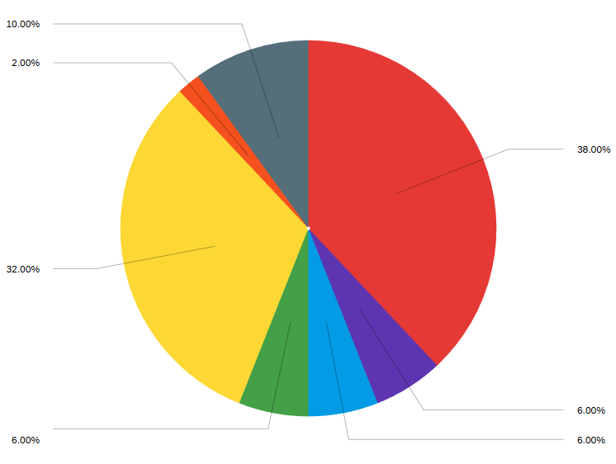
Red: Piped water (to home)
Purple: Public standpipe or communal tap
Blue: Private or shared well (groundwater)
Green:: Water delivered by tanker truck
Yellow: Bottled water
Orange: Surface water (e.g., river, lake, pond)
Grey: Other

Results of the survey also indicated that in the households that rely on manual fetching of drinking water, the main burden most often falls on adult men, indicated by 51 % in the figure 2, adult women represent 22%. 3 households indicated that drinking water is fetched by the children younger than 18 years old. Four households in the survey say that water collecting responsibility is shared among family members.
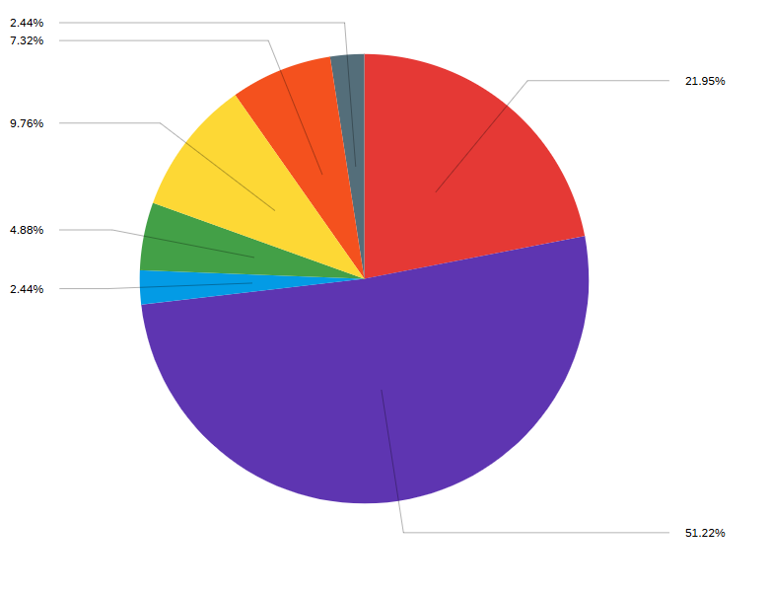
Figure 2. Household Member Who Brings Drinking Water Home
Red: Adult woman ( mother, wife, grandmother)
Purple: Adult man (father, husband, grandfather)
Blue: Female child (under 18)
Green: Male child (under 18)
Yellow: Shared responsibility among household members
Grey: Not applicable (water is piped or delivered to the home)

In terms of time that is needed to fetch water the time cost of water delivery is significant. 49 % of respondents indicated that a two way trip takes more than 30 minutes, and 19 % of respondents said that it takes more than an hour to collect drinking water.

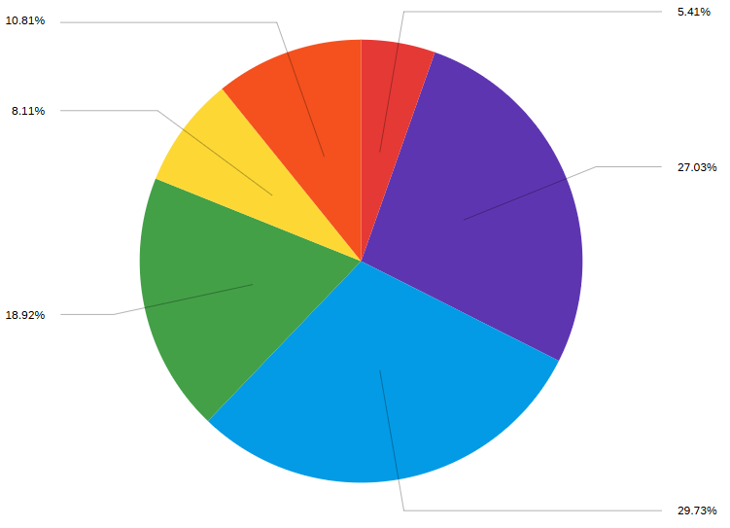
Figure 3. Time Required for a Water Collection Trip

Red: Less than 10 minutes
Purple: 10–30 minutes
Blue: 31–60 minutes
Green: More than 1 hour
Yellow: Varies by season
Orange: Not applicable (water is piped or delivered)

Water supply reliability. More than half of respondents indicated that there were disruptions in the supply of drinking water within the last six months. At the same time respondents indicated that these disruptions can last from anywhere between a few days per month and significantly longer periods. Seasonal factors also play a major role, and each season has its own problems. In winter time 42 % of respondents indicated that supply of tap water is worse in winter due to the breakdown or frozen pipes. 35 % of the respondents indicated that the situation is worse in the summer season due to increased demand in tap water for different purposes presumably for watering gardens as was mentioned verbally by some respondents. 23 % percent of the respondents indicated that there were no changes in water access across different seasons.

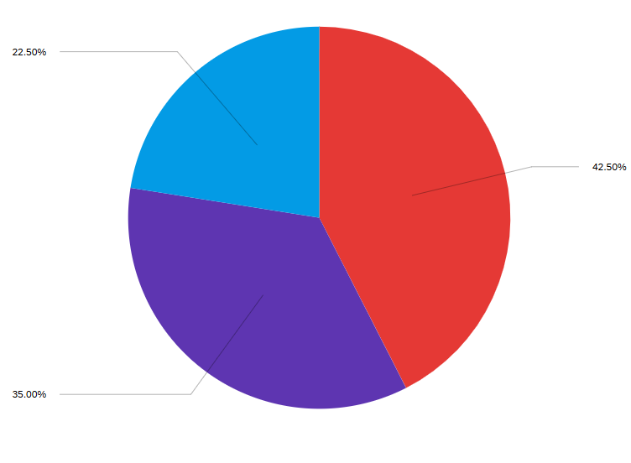
Figure 4: Reliability of water supply for households
Red: Yes, worse in winter (e.g., frozen pipes, delivery issues)
Purple:Yes, worse in summer (e.g., lower supply, increased demand)
Blue: No major seasonal change

The question that asked about what households do when access to drinking water is restricted each day, received a significantly higher response rate with 70 responses. Of seventy responses, 38 % of the sample responded that they store water in containers. 35% indicated that they buy bottled water, 12 % indicated that they wait until “akimat truck” delivers water to the center of the village, and 17 % indicated that they reduce the overall use of water.
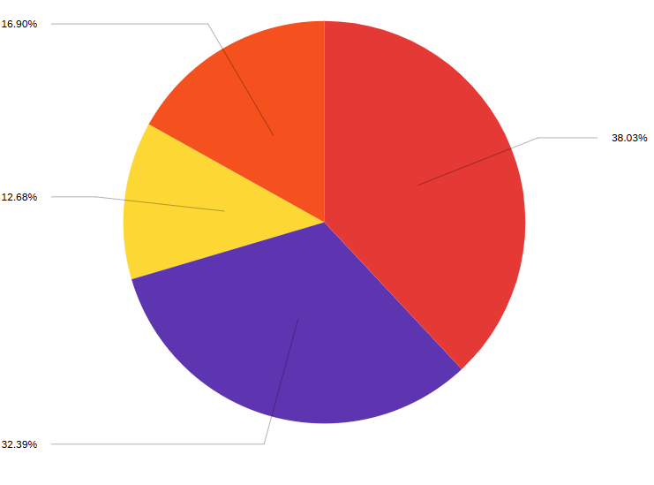
Figure 5: Household Responses to Drinking Water Unavailability
Red: Store water in containers (buckets, tanks, barrels)
Purple: Buy bottled or filtered water
Yellow: Wait for water delivery (e.g., by tanker or municipal truck)
Orange: Reduce water use or skip some activities

Quality of drinking water. The overall assessment of drinking water quality is low. More than half of the respondents described the water as bad according to the following five parameters:
Table 1: Tap water negative perception and evaluation in percentages
Parameters | Percentage of sample
Bad water clarity | 58
Bad water color | 53
Bad water smell | 63
Bad water taste | 52
Perceived safety for health | 57

The results of the follow up survey question (with response number of 60) about what households do to make tap water more safe for drinking was 28 % of the respondents say that they boil tap water, 18 % indicated that install water filters, 5 % indicated that they let the water settle in containers, 43 % indicated that they buy bottled water from stores.
Local water supply infrastructure problems and assessment of the state policies/actions. Respondents in the questionnaire most often complained and indicated the following systemic problems: 22 % indicated that the water pressure was too weak and 22 % of respondents indicated the lack of its purification. 19 % of respondents indicated that the pipes in the villages are old and leaky. Around 15 % of surveyed people indicated the problem with drinking water as the pollution near the sources of drinking water, the surface water (reservoir). Less often people complained about breakdown and freezing of water systems and other issues. Overall, water problems in the village settlements, as survey results showed, are related to quality of the water itself and the deterioration of the pipelines system built many years ago during Soviet times.
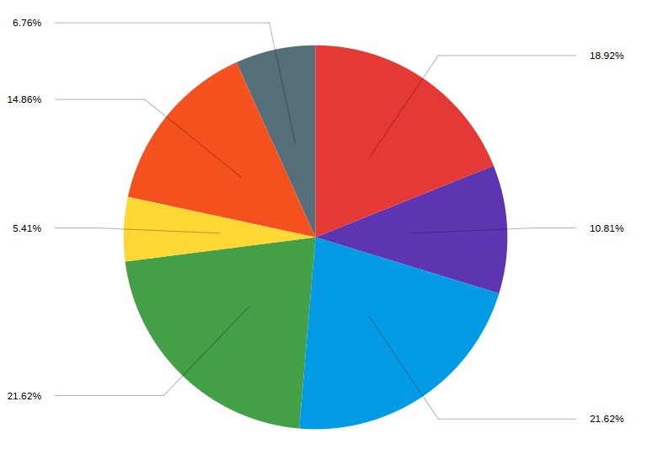
Figure 6: Problems Reported with Water Supply Infrastructure
Red: Old or leaking pipes
Purple: Water often not delivered or arrives late
Blue:Water pressure is too low
Green: No water treatment ( not cleaned or disinfected)
Yellow: Pipes or tanks freeze in winter
Orange: Nearby pollution or waste near water sources

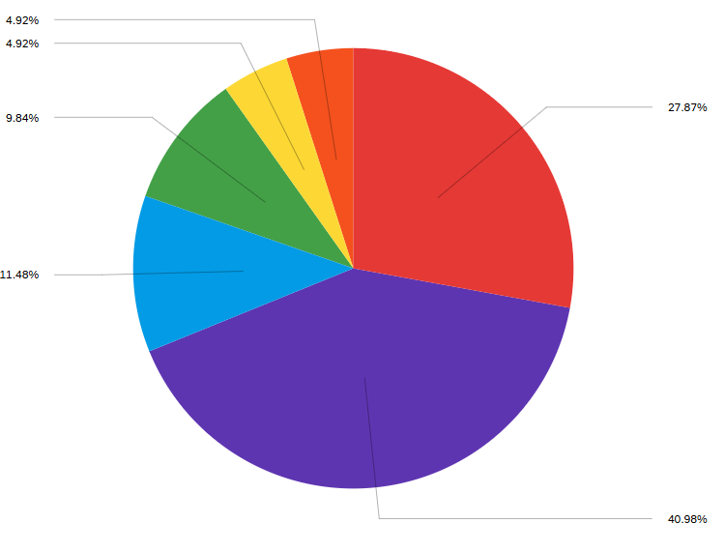
The survey also asked the respondents about their perception of what they thought the main reasons are with drinking water issues. There were sixty responses to the question, and 41 % of respondents indicated that they think there is insufficient support or investment from local and state authorities. 28 % of survey respondents indicated that they think deteriorated water infrastructure is the main reason for occurring water problems. When respondents were asked about how they would assess the efforts of the state and local authorities on improving the situation, 59 % of respondents indicated that the efforts are inefficient, and 20 % indicated that they didn't observe any efforts from the state. Only 18 % of surveyed assessed the measures taken by the state authorities as quite effective.
Figure 7: Perceived Views on Causes of Drinking Water Problems
Red:Old or poorly maintained water infrastructure
Purple: Not enough support or investment from local authorities/ government
Blue Natural water shortages (e.g., limited groundwater or dry seasons)
Green:Contamination from nearby farms, or industry
Yellow:: People don’t know how to keep water safe
Prioritizing water by households. There was a question that was one of the main questions of the study on priority that local people give to clean drinking water. Specifically researchers wanted to understand how important clean drinking water is in relation to heating, nutrition (food) and sanitation. And the results of the survey indicated that 78 % of the people rated clean drinking as the most prioritized need in their daily lives. The second rated need selected by respondents was nutrition with 11 % responses, sanitation was third ranked need.
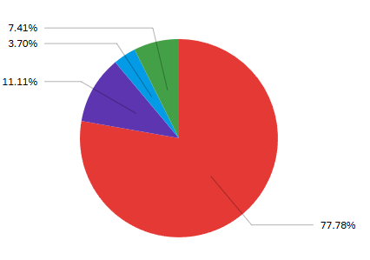

Figure 8. Prioritizing drinking water in relation to other needs
Red: Clean drinking water
Purple: Food
Blue: Energy (heating)
Green: Sanitation

Talapker village field observation.
The field observation conducted by the research group in Talapker village on 21 September, 2025 allowed for a deeper interpretation of the results of the survey and interviews with State and regional authorities. There are four distribution points in the village, one of which the team closely monitored and which the locals call the water supply module (Picture 1). The group made an effort to speak with locals in order to understand the issues they have with drinking water access. The majority of locals, however, declined to take part in the survey, explaining that officials and reporters regularly come to observe the situation, but no real progress is made.
The observation report demonstrated the gap between formal water coverage statistics and the daily experience of Talapker residents. Observation conducted in the village confirms the survey findings that the presence of technical infrastructure does not mean real access to drinking water. Despite the presence of water distribution points, residents are forced to travel to collect drinking water by car, stay in line and physically carry water inside their houses at certain times of the week (Picture 2). This is consistent with the survey data, where a significant percentage of respondents indicated the use of truck delivered water or bottled water as well as the time spent to collect water by doing a two-way trip to public water taps.
An observation report of the researchers also indicated that water in the public wells is salty and unsuitable for drinking, which fully coincides with the survey data, where majority of the respondents assessed the taste, smell, and safety of local water as “bad”. As a result, Talapker residents are forced to buy bottled water, keep water in the containers, and use water from the wells or pipes only for technical purposes.

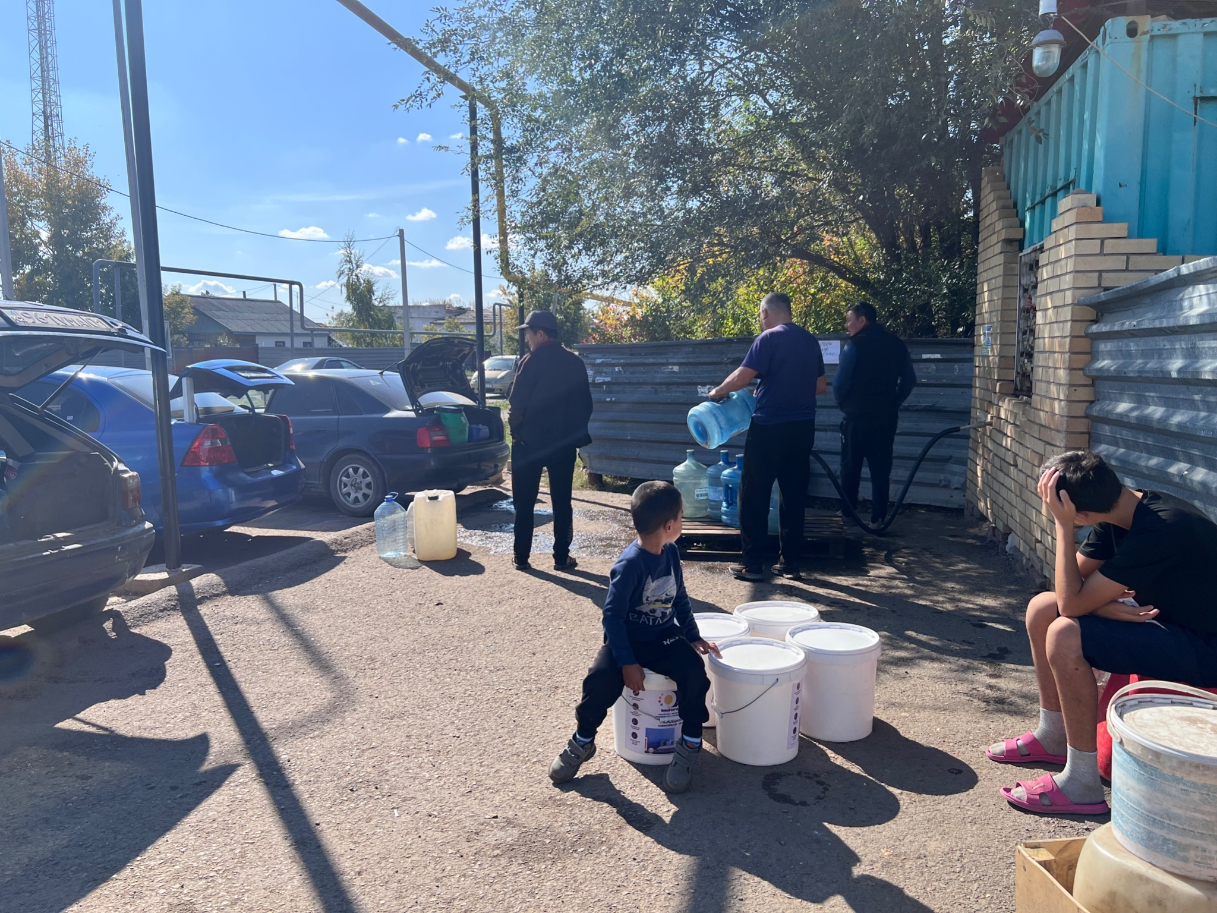
Picture 1. Water distribution point in Talapker village Picture 2. Water distribution point schedule
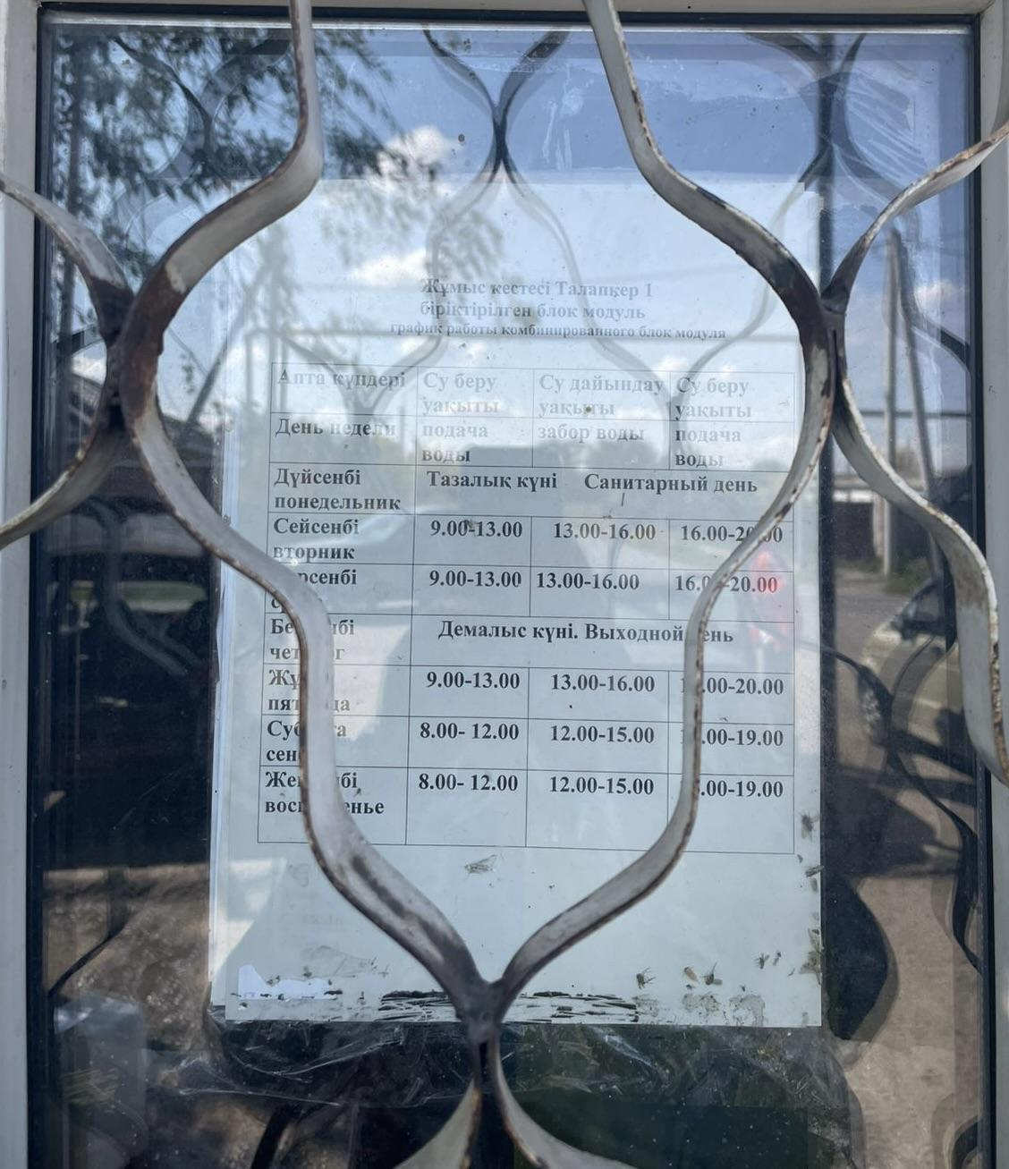

The main takeaway for the researchers during the field observation to Talapker was the confirmation that Akmola oblast village water issues are not mainly about the absence of water, but the absence of quality drinking water in the pipes.

CHAPTER 5. DISCUSSION
The results from the survey in the 2 Akmola oblast villages, interviews with the representatives of the Ministry of Water Resources and Irrigation, Akmola oblast akimat, and also field observations helped researchers reveal both common ground and major differences in the assessment of the situation with the access to drinking water. The key finding of this case study is the existence of systemic gaps between the official understanding of access to water and the actual experiences of Akmola oblast village households.
Gap 1: infrastructure as "access" vs water as a service. The first and most significant gap concerns differences in the interpretation of the very concept of "access to drinking water". According to the official position presented in interviews with state and Akmola oblast authorities, the level of drinking water coverage to the rural population of the Akmola oblast is assessed as high, 96.6 %. At the same time, access to water from the state and akimats is primarily understood as the availability of the water infrastructure, connection of central pipes to the border of the settlements, installation of water collection points and support in technical feasibility of connection.
At the same time, the survey results show that the formal availability of infrastructure does not automatically translate into actual access to water for rural households. Only 38 % of the respondents indicated that they use tap water in their homes as their primary source of drinking water, while 32 % buy bottled water on regular basis. This demonstrates that for the households, access to water is not determined by the presence of a pipe or water collection point, but the ability to use water daily and safely for drinking and household needs. Thus, the study reveals a structural gap between "access as infrastructure" and "access as a service".
Gap 2: water availability vs water quality and reliability. The second gap is associated with the difference between physical presence of water and its quality characteristics, such as safety, stability and reliability of supply. Government officials noted in the interviews that the problem of water supply in the regions gradually shifts from the absence of water as such to questions of its quality. In particular, it was emphasized that in a number of rural settlements water is technically supplied, but does not always comply with sanitary norms, especially in the spring season.
Survey data support this observation and demonstrate that water quality problems are systemic. More than half of the survey respondents assessed transparency, smell, taste and safety of water as "bad". As a result, households are forced to apply individual adaptation strategies, such as boiling water, use of filters, and purchase of bottled water. These practices not only increase the financial burden of households, but also effectively shift responsibility for ensuring water security from the state to the households.
In addition, a significant number of respondents reported regular interruptions in water supply. More than 50 % of households experienced water outages in the last 6 months, and about 75 % noted deterioration in access to water in the summer and winter season. This demonstrates the low reliability of the water supply system and indicates that the seasonal sustainability of the infrastructure remains a serious problem, despite the formal presence of water supply pipes.
Gap 3: responsibility and awareness. The third key gap is associated with the issue of responsibility for the level of water access and the lack of clear mechanisms for supporting households. During interviews representatives of the ministry and Akmola oblast akimat indicated that responsibility for water supply is divided between different levels of government. In practice, however, such "division of responsibility" leads to its blurring. In particular, it is assumed that connecting water from the boundary of the house (fence) is the responsibility of the households themselves, however, state programs for systemic support of households in this process are either absent or poorly communicated to the households.
The survey results reflect the consequences of this institutional gap. 59% of the survey respondents assessed state and Akmola oblast akimat efforts as ineffective, and 24 % reported, that they did not observe any actions to improve access to water at all. Open-ended survey question responses reveal that there is weak quality control of work, use of low-quality pipes, lack of qualified specialists and a low level of accountability of water program executors.
Field observations and trust issues. Field observation to Talapker and Damsa villages complement survey data and help researchers understand the reasons for negative assessment from the households. Distrust towards "outsiders", government officials or researchers, manifested itself in refusals to participate in the survey and a suspicious attitude towards the research team. This points to a broader crisis of trust between the population and state institutions which directly impacts the perception and effectiveness of state water supply policies.
Field observations also showed that local households are forced to spend their time and resources daily to deliver water to their homes using personal transport and adjusting to the limited operating hours of water distribution points. This type of water access cannot be considered sustainable or consistent with the concept of safe and manageable water supply.
Final thoughts. All things considered, the results of the research show that high national SDG 6 data and high levels of formal water access in rural settlements mask deep problems at the household level. The gap between the state's infrastructure approach and the service-oriented perception of the population, as well as the lack of clear responsibility for the quality and reliability of the service, significantly reduce the real effectiveness of state policy in the water utility sector. To reduce this gap, it is necessary to move the "constructed/connected" assessment to the assessment of actual water use, its quality, reliability and accessibility for rural households of Akmola oblast.

Limitations of the study
The conducted research had several limitations. One of the main limitations was the reluctance of local village residents to participate in the survey, which is largely due to significant distrust towards external researchers and related fears that researchers might be represented by the state agencies. This was particularly evident in the field observation in the Talapker village. Additional limitation of the study was the uneasy interaction with the local raion akimats, including long wait for responses from those akimats to the official letters and requests from researchers. This restricted the opportunity for expansion of the survey sample and the conduct of additional interviews. Also, it must be noted that the results of the survey is based on around 70 respondents with varied response numbers to some survey questions. This posed some challenges during generalization of the responses to the entire rural population of Akmola Oblast.

CHAPTER 6. CONCLUSIONS

6.1. Research summary
The main objective of this Master's Project was to analyze the access to drinking water in rural settlements of Akmola Oblast and analyze how households are dealing with existing constraints. By using the survey responses of Damsa and Talapker villages, interviews with the representatives of central and regional government officials, as well as the field observation in Talapker and Damsa village, the conducted research helped to answer the research questions.
In the context of the research question 1, the results of the research show a contradictory and problematic picture. On one hand, survey data confirm that drinking water is one the main basic needs for rural households. On the other hand, results show that households choose not to use tap water for drinking purposes because of its perceived low quality and unreliability. As a result, households have to buy bottled water, deliver water to homes by car and choose other alternative decentralized methods.
Responding to research question 2, a conducted study showed that in spite of the presence of state programs and budget investments, village residents perceive the measures taken by the authorities as insufficient or ineffective. Delivery of water to households, installation of water distribution points, replacement of water filters in reservoirs partially solves the problem but does not provide reliable and convenient access to water for local households. Households most often point to the need for upgrading water infrastructure, the need to improve the quality of water treatment, and the need to reinforce technical oversight.
In the context of research question 3, it was revealed that there is a significant gap between official and household level understanding of the concept “access to drinking water”. Representatives of state and regional governments believe that the water access is provided to households when central water pipes reach villages and households fences respectively or there public water distribution points are installed. At the same time, for households, water access means the opportunity to receive safe quality tap water at home daily without additional expenditure on time and financial resources. This gap has a profound impact on public trust in public policy and the perception of its outcomes.
6.2. Practical Implications
Practical relevance of the research is that research findings can inform local and regional akimats for updating the approaches they take in providing water to rural settlements. First, when assessing water availability, it’s important to consider not only the presence of the water infrastructure, but also the quality of water, water supply reliability and physical connection of households to water pipes. Second, the research findings point to the necessity of stronger interaction with the public, including policy announcements, consideration of local conditions and public feedback. Reinforcing technical oversight, increasing the transparency of water project implementation and commitment to long term solutions should increase the effectiveness of public policies and trust of village residents.
6.3 Suggestions for further research/policy recommendations
Future research can expand the geography of the study, by including more regions in Kazakhstan, and also by conducting comparison analysis between different regional data. Additional research can also include the questions of public trust towards state institutions and mechanisms of participatory governance in water issues by the local communities.
From the perspective of the state policies, researchers recommend:
- To guarantee a clear and consistent understanding, it is advised to redefine the term "access to drinking water". While "drinking water" can refer to water that is generally safe to drink but may need filtration or treatment, the term "clean drinking water" should be used officially to denote water that is totally safe and of excellent quality. Standardizing these definitions will increase public comprehension, promote efficient communication, and direct decisions about infrastructure and policy in rural communities.
- The government should actively seek out highly qualified water resources specialists. Currently, experts like engineers are paid inadequately; for that reason, many young people choose easier jobs with higher incomes. Because of this, it is challenging to obtain and use contemporary water management technologies efficiently due to a lack of highly qualified specialists. Therefore, the government funding should be set aside for the education and training of technical personnel qualified to oversee and manage water systems at the local and regional levels in order to address these issues.
- State, regional, and rural authorities should enhance their coordination of management. Interviews with representatives of different authorities revealed that although each organization addresses issues within its own, it is often unaware of the situation in other authorities. There is still a gap because no single organization is in charge of coordinating between the various government agencies. To avoid urgent issues arising out of the blue, all parties involved must be aware of each other's procedures and ready to assist when needed. Therefore, strengthening both vertical and horizontal governance structures can guarantee clear responsibilities, effective communication, and coordinated oversight at all levels of water management.
- The state must conduct a systematic and independent review of public programs in the water supply sector. State program evaluation must be carried out not only at the final stage of completion but also during the implementation process. Even if significant financial resources are allotted and water supply projects are finished, this does not guarantee that the issue is resolved. Maintenance is more crucial than construction. Inadequate maintenance can cause water facilities to rapidly deteriorate and require reconstruction. Water infrastructure is kept in excellent condition for a long time by nations like Singapore and Germany that regularly monitor, maintain, and evaluate their systems. This long-term strategy should be Kazakhstan's goal. Moreover, criteria for program effectiveness must include not only official water coverage indicators but also the actual level of water use by local households, its quality, water supply reliability, and water pipe connection affordability.

REFERENCES
Akhmetova, G., Mukhamedzhanov, K., & Sarsembayeva, A. (2023). Assessment of the groundwater for household and drinking purposes in central Kazakhstan. Groundwater for Sustainable Development, 23, 100907. https://doi.org/10.1016/j.gsd.2023.100907
Ali, Q. A., & Ghareeb, O. A. (2023). Drinking water quality and its impact on public health: Review. Web of Scientist: International Scientific Research Journal, 4(9). https://wos.academiascience.org/index.php/wos/article/view/4348
Azat, S., Kuldeyev, E., Khalkhabay, B., Baikadamova, A., Sultakhan, S., & Berndtsson, R. (2024). Pathogen contamination of groundwater affecting drinking water quality with potential health effects in Pavlodar region, Kazakhstan. Water, 16(20), 2970. https://www.mdpi.com/2073-4441/16/20/2970
Beisenova, R., Tussupova, K., Tazitdinova, R., et al. (2024). Perceived and physical quality of drinking water in Pavlodar and Akmola rural regions of Kazakhstan. Sustainability, 16, 7625. https://www.mdpi.com/2071-1050/16/17/7625
Bolatova, Z., Sharapatova, R., Kanagat, K., Kabiyev, Y., Berndtsson, R., & Tussupova, K. (2025). Household Satisfaction and Drinking Water Quality in Rural Areas: A Comparison with Official Access Data. Sustainability, 17(15), 7107. https://doi.org/10.3390/su17157107
Enbekshiqazaq. (2024). 98.9% of Kazakhstan’s population has universal access. https://www.enbekshiqazaq.kz/en/news/324933-989-of-kazakhstans-population-has-universal-access.html
Government of Kazakhstan. (2023, May 2). Citizens of all Kazakhstan cities and villages to be provided with clean drinking water by 2025. https://primeminister.kz/en/news/citizens-of-all-kazakhstan-cities-and-villages-to-be-provided-with-clean-drinking-water-by-2025-23951
Government of the Republic of Kazakhstan. (2023a). Citizens of all Kazakhstan cities and villages to be provided with clean drinking water by 2025. https://primeminister.kz/en/news/citizens-of-all-kazakhstan-cities-and-villages-to-be-provided-with-clean-drinking-water-by-2025-23951
Government of the Republic of Kazakhstan. (2023b). People left without water for months because of regular ruptures — report on rural water-supply infrastructure issues in Akmola Oblast. https://primeminister.kz/en/news/people-left-without-water-for-months-because-of-regular-ruptures-alikhan-smailov-critical-of-drinking-water-supply-long-construction-work-24149
Hutton, G., & Varughese, M. (2016). The costs of meeting the 2030 sustainable development goal targets on drinking water, sanitation, and hygiene. World Bank. https://openknowledge.worldbank.org/handle/10986/23681
Liter.kz. (2022). Dark brown in color and smells bad: 70 km from the capital, residents live without clean water. Retrieved November 25, 2024, from https://liter.kz/temno-korichnevogo-tsveta-i-voniaet-v-70-km-ot-stolitsy-zhiteli-zhivut-bez-chistoi-vody-1647513847/
New Times. (2024). Projects to provide drinking water to rural residents are being implemented in Akmola Oblast. https://newtimes.kz/obshchestvo/196188-kakie-proekty-po-obespecheniiu-pitevoi-vodoi-realizuiut-v-akmolinskoi-oblasti
OECD. (2016). Sustainable business models for water supply and sanitation in small towns and rural settlements in Kazakhstan. OECD Publishing. https://doi.org/10.1787/9789264249400-en
OECD. (2021). Water safety and public health: Epidemiological risks from unsafe water supply — Country case: Kazakhstan. OECD Working Papers. https://one.oecd.org/document/ENV/WKP%282021%299/en/pdf
Omarova, A., Tussupova, K., Hjorth, P., Kalishev, M., & Dosmagambetova, R. (2019). Water supply challenges in rural areas: A case study from central Kazakhstan. International Journal of Environmental Research and Public Health, 16(5), 688. https://doi.org/10.3390/ijerph16050688
Pandey, V., et al. (2018). Geographical heterogeneity and inequality of access to improved drinking-water supply and sanitation in Nepal. International Journal for Equity in Health, 17, 75. https://equityhealthj.biomedcentral.com/articles/10.1186/s12939-018-0754-8
Rakhmatullaev, I., Saparov, T., & Beisenova, R. (2019). Water supply challenges in rural areas: A case study from central Kazakhstan. International Journal of Environmental Research and Public Health, 16(5), 688. https://www.mdpi.com/1660-4601/16/5/688
Ritchie, H., Spooner, F., & Roser, M. (2019). Clean water. Our World in Data. Retrieved from https://ourworldindata.org/clean-water
Sagyndyk М., & Zeynoldanova F. (2016). Problems of water use in the Republic of Kazakhstan. Рroblems of Engineering and Professional Education, 38(5), 45–54. https://doi.org/10.32523/2220-685X-2016-38-5-45-54
SDG 6 Data. (n.d.). Kazakhstan — SDG 6 data (Indicator 6.1.1). Sustainable Development Goal 6 Data Portal. https://www.sdg6data.org/en/country-or-area/kazakhstan#anchor_6.1.1
Tussupova, K., Hjorth, P., & Berndtsson, R. (2016). Access to Drinking Water and Sanitation in Rural Kazakhstan. International Journal of Environmental Research and Public Health, 13(11), 1115. https://doi.org/10.3390/ijerph13111115
Wang, Y. (2022). Climate change and water resources in semi-arid regions: Impacts on water availability and quality. Environmental Research, 212, 113394. https://doi.org/10.1016/j.envres.2022.113394
Wutich, A., & Ragsdale, K. (2008). Water insecurity and emotional distress: Coping with supply, access, and seasonal variability of water in a Bolivian squatter settlement. Social Science & Medicine, 67(12), 2116–2125. https://doi.org/10.1016/j.socscimed.2008.09.042
Zhartybaeva, M., Tulegenova, S., & Muntaev, N. (2022). Water quality of aquatic ecosystems of Akmola region. Fundamental and Experimental Biology, 108(4), 34–38. https://feb.buketov.edu.kz/bmg-vestnik/article/view/357

Appendix 1
Survey on Access to Clean Drinking Water in Akmola Oblast
Dear residents of the Akmola region,
We are conducting a research project on the challenges of accessing clean drinking water in rural areas of Akmola Oblast as a part of our master project.
This short survey will take approximately 5–8 minutes to complete. It is available in both Kazakh and Russian — please select the language that is most convenient for you.
Your participation is voluntary, and all responses are anonymous and confidential. Your insights and suggestions are very important and will help us better understand the water access issues faced by your community
If you have any questions or would like more information about the study, feel free to contact us at: email address.
Thank you for your time and valuable contribution.
Mirat Akshalov, Nursulu Kurshida and Zhuldyz Nurpan
Master’s students in Public Administration, Nazarbayev University

Section 1: Water Access and Use
1. What is the main source of drinking water for your household? (Multiple choice)
- Piped water (to home)
- Public standpipe or communal tap
- Private or shared well (groundwater)
- Water delivered by tanker truck
- Bottled water
- Surface water (e.g., river, lake, pond)
- Other (please specify): _______________
2. If your household needs to fetch or collect drinking water, who usually does it? (Multiple choice)
- Adult woman (e.g., mother, wife, grandmother)
- Adult man (e.g., father, husband, grandfather)
- Female child (under 18)
- Male child (under 18)
- Shared responsibility among household members
- Not applicable (water is piped or delivered to the home)
- Other (please specify): _______________
3. If your household collects water, do you use any transport (e.g., car, bicycle, etc) to bring it home?
- Yes
- No
- Not applicable (water is piped or delivered)
4. If your household collects water, how long does one round trip usually take (including travel, waiting, and returning)?
(Select all that apply if it varies by season or water source)
- Less than 10 minutes
- 10–30 minutes
- 31–60 minutes
- More than 1 hour
- Varies by season
- Not applicable (water is piped or delivered)
5. How much water does your household use (for all purposes)?
(Choose the option that best describes your situation)
- Small amount (e.g., only for drinking and cooking, less than 100 liters per day)
- Moderate amount (e.g., also used for washing, 100–300 liters per day)
- Large amount (e.g., includes bathing, cleaning, possibly gardening, more than 300 liters per day)
- Don’t know / Not sure
6. Approximately how much does your household spend per month specifically on drinking water? (Select one)
- 0 Tenge (e.g., from own well or untreated source)
- Less than 4 999 Tenge
- 5 000 – 9 999 Tenge
- 10,000 Tenge or more
- Don’t know / Water is paid together with total household use
- Not sure / No separate spending on drinking water
7. Does your household's access to drinking water change with the seasons? (Multiple choice)
  - Yes, worse in winter (e.g., frozen pipes, delivery issues)
  - Yes, worse in summer (e.g., lower supply, increased demand)
  - No major seasonal change
  - I’m not sure
8. In the past 6 months, did your household experience any interruptions in drinking water supply from your main source? (For example, due to frozen pipes, low pressure, delivery delays, or maintenance)
- Yes
- No
- Not sure
If yes: Approximately how many days in total was water unavailable? ______ days
9. If drinking water is not available every day, what does your household do to manage the situation? (Multiple choice)
- Store water in containers (buckets, tanks, barrels)
- Buy bottled or filtered water
- Collect water from a natural source (e.g., river, lake, snowmelt)
- Ask neighbors or relatives for water
- Wait for water delivery (e.g., by tanker or municipal truck)
- Reduce water use or skip some activities
- Other (please specify): ____________
10. How would you rate the following aspects of your current drinking water? (1 = Good, 2 = Acceptable, 3 = Poor)
 | 1 = Good | 2 = Acceptable | 3 = Poor
Clarity (water is clear (no dirt or particles)
Colour
Smell
Taste
Healthiness
Stability of supply
Convenience (easy to access)

11. What does your household do to make drinking water safer? (Multiple choice)
- Boil the water
- Add bleach or chlorine
- Use a water filter (e.g., ceramic, sand, or household filter)
- Let the water stand and settle
- Buy bottled or purified water instead
- We do not treat our water
- Other (please specify): _______________
12. What problems have you noticed with the water supply infrastructure in your area? (Multiple choice)
- Old or leaking pipes
- Water often not delivered or arrives late
- Water pressure is too low
- No water treatment (e.g., not cleaned or disinfected)
- Pipes or tanks freeze in winter
- Nearby pollution or waste near water sources
- Other (please specify): _______________
13. In your opinion, what is the main reason why clean drinking water is still a problem in your area? (Multiple choice)
- Old or poorly maintained water infrastructure
- Not enough support or investment from local authorities/ government
- Natural water shortages (e.g., limited groundwater or dry seasons)
- Contamination from nearby waste, farms, or industry
- People don’t know how to keep water safe
- Other (please specify): _______________
14. What actions, if any, have you seen the government or local authorities take to improve water access? (Multiple choice)
- Repaired or upgraded water pipes or infrastructure
- Delivered water by truck or installed public taps
- Built or improved water treatment facilities
- Provided public education or advice on safe water use
- No actions observed
- Other (please specify): _______________
15. How would you rate the efforts of the government or local authorities to improve access to clean drinking water in your area? (Select one)
- Very effective
- Somewhat effective
- Not effective
- I haven’t seen any efforts
16. Do you have any suggestions for how to solve drinking water problems in your area? (Multiple choice)
- Repair or replace old water pipes and systems
- Build or improve water treatment facilities
- Increase water deliveries to households
- Provide water filters or purification tablets
- Raise awareness about safe water storage and use
- Improve protection of natural water sources from pollution
- Other (please specify): _______________
17. Please rank the following needs in your household from most to least important (1 = most important, 4 = least important)
- Clean drinking water
- Nutritious food
- Energy (electricity, gas, firewood, coal)
- Sanitation and hygiene (toilets, washing, cleaning)
18. If your household has very limited money, which of these are you most likely to cut back on first? (Select one)
- Drinking water
- Food
- Energy
- Sanitation supplies
- Other (please specify): _______________
19. Please estimate how your household budget is usually spent across these needs: (Total should add up to 100% — you can give approximate numbers)
- Drinking water: ______%
- Food: ______%
- Energy (electricity, gas, coal, etc.): ______%
- Sanitation and hygiene: ______%
- Other: ______%
Section 2: Demographic Questions
20. What is your age?
- Under 18 years
- 18–29 years
- 30–49 years
- 50 years or older
- Prefer not to say
21. What is your gender?
- Male
- Female
- Prefer not to say
22. What is the highest level of education?
- No formal education
- Primary education
- Secondary education
- Technical/vocational
- University education
- Prefer not to say
23. What is your household’s main source of income?
- Agriculture or livestock
- Salary or wage (public or private job)
- Small business or informal trade
- Daily or seasonal labor
- Pensions, remittances, or social support
- Prefer not to say
- Other (please specify): _______________
24. What is your household’s total monthly income (in Tenge)?
- Less than 100 000 Tenge
- 100 000 – 300 000 Tenge
- 300 001 - 500 000 Tenge
- More than 500 000 Tenge
- Prefer not to say
25. How many people live in your household (including yourself)?
- 1–2 people
- 3–5 people
- 6 or more people
- Prefer not to say
26. How many children under the age of 18 live in your household?
- None
- 1–2 children
- 3–4 children
- 5 or more children
- Prefer not to say
27. What is the name of your village or settlement?
- Damsa
- Talapker
- Egindigol
- Other (please specify): _______________

Appendix 2
Interview Questions
Interviewer’s Introduction: Good morning! Thank you for agreeing to take part in this interview.
Our research is focused on the issues and prospects of water supply in the Akmola region.
The goal is to understand the current situation, systemic difficulties, and plans for overcoming them.
Allow me to ask you a few questions on this topic.
Block 1: General Situation and Current Problems: Let me begin with a general question.
- How would you assess the current situation regarding access to drinking water for the population in the Akmola region?
— How complete is the official data? Are there discrepancies between the data and the actual situation?
Now let's talk about the geographic distribution of the issues.
2. Can you name specific districts or settlements where access to clean water is particularly limited?
— What is the cause — technical, natural, or administrative reasons?
- In your opinion, what are the main causes of drinking water shortages in the region?
— Is it primarily due to deteriorated infrastructure, lack of water sources, or management issues?
Block 2: Infrastructure Condition and Projects
We’d like to discuss in more detail the technical condition of water supply systems.
4. What is the current level of wear and tear in the water supply and drainage networks in the region?
- Which areas would you identify as the most problematic in terms of technical condition?
Now, regarding ongoing efforts.
6. What water supply modernization projects are currently being implemented or planned for the near future in the Akmola region?
- Which areas are covered by these projects, and what are their priorities — reconstruction, new network construction, or local solutions?
- What is the scale of funding for these projects?
— Where do the funds come from — the republican, regional budgets, or international programs?
- Who oversees the implementation of these projects?
— How is the quality of work and adherence to deadlines ensured?
Block 3: Future, Sustainability, and Ecology
Given climate change and the increasing load on infrastructure, we’d like to move on to long-term issues.
10. What measures are being taken to ensure sustainable water supply in the region under climate change conditions?
- How is the water supply issue being addressed in remote and sparsely populated villages where building main pipelines is difficult?
- What modern technologies and innovations are already being used or considered in the field of water supply?
— Are block-modules, digital monitoring systems, or alternative sources being utilized?
Block 4: Governance and Government Measures
We’d also like to touch on administrative and regulatory aspects.
13. Which authorities are responsible for monitoring drinking water quality and ensuring uninterrupted water supply for the population?
- Is there coordination between the Committee on Water Resources, local governments (akimats), and other agencies? How effective is this coordination?
- What measures is the national government taking to address water supply problems in the regions?
— Is there a unified state program or roadmap?
Block 5: Social and Humanitarian Dimension
We are also interested in the human factor — the public’s response and consequences.
16. How does the state respond to complaints from residents about poor water quality or lack of access to it? Are there mechanisms for quick feedback?
- How are the sanitary and social consequences of drinking water shortages in rural areas assessed?
- Are there any informational or educational campaigns being conducted to promote responsible water use among the population?
Conclusion
Thank you for your detailed and informative answers. This interview will be an important part of our thesis research and will help us gain deeper insights into how water policy is formed in Kazakhstan’s regions. Thank you again for your participation!

Appendix 3

Field Observation Report: Visit to Talapker Village
Date: September 21, 2025
Location: Talapker village, Akmola Oblast (approximately 40 minutes from Astana)
Observers: MP Project Team Members (Nursulu, Zhuldyz)
Purpose: Field observation and informal data collection related to access to drinking water
1. Visit Background
On September 21, 2024, at approximately 11:00 AM, members of the MPA research project team visited Talapker village in the Tselinograd district of Akmola region, Kazakhstan. The visit was part of the research on access to drinking water in rural and suburban areas. Talapker is located approximately 40 minutes from Astana. The trip was calm, and the group reached the village without difficulty, as there was no traffic congestion along the route and the access road was completely paved.
2. First Contacts in the Village
Initial Contacts in the Village After arriving in the village, we first stopped at a store to find local residents. The shopkeepers said they didn't live in the village. Upon leaving the store, we met some local men. During the conversation, it became clear that some of the people working in Talapker don't actually live there. They come from other regions or nearby villages to earn money.
During the visit, we noted that the locals were reserved and unwilling to communicate or participate with the researchers. However, one man agreed to help and showed the team where the residents collect drinking water. The team learned that most households have their own wells and boreholes, which the residents dug themselves. According to locals, the water from these wells is salty and dirty and not suitable for drinking. Residents use this water only for technical purposes; for drinking, they buy or bring water from the city.
3. Observation at the Water Distribution Point
The team approached a water collection point, known locally as a water distribution point. The area was crowded with vehicles and people. Most of the people collecting water were men; one woman was also observed. Residents typically arrive by car and fill jerrycans and other containers with water.
A work schedule was posted at the site. The schedule was not entirely convenient for residents, as water is sold at specific times, which is inconvenient for people, and every Monday is designated as a cleanup day. The price of water was 10 tenge per jerrycan. According to residents, there are five such water supply modules in the village of Talapker.
4. Reactions from Residents
When the team attempted to speak with people at the water collection point, many residents reacted with suspicion, distrust, and anger. Some assumed the team represented government agencies or official authorities. Because of this, the team had to explain several times that they were researchers from Nazarbayev University and that the visit was purely academic. After lengthy explanations, one man agreed to participate in the survey. He said he had a legal background and therefore trusted the researchers. He completed the questionnaire and also persuaded a friend to participate. Most of the other people declined to participate, although many were present. Residents who collected water from the module were willing to share their observations and opinions about water supply issues but expressed reluctance to participate in our survey.
5. Observations in the Commercial Area
Later, when the water supply module was closed for a break, the team visited the nearby shopping district, including the Magnum supermarket and the small shops inside. Many people again declined to speak, stating that they did not live in Talapker.
Finally, two women agreed to speak with the researchers. They said they had lived in Talapker for about 35 years and purchased their home many years ago.
6. Residents’ Views on Land and Water
One resident shared important information about purchasing land in Talapker. He explained that when purchasing land in the village, people were informed in advance of the lack of basic infrastructure, including drinking water. Because of these conditions, the land was sold at a lower price, and many agreed to buy it despite the lack of utilities.
At the same time, residents expressed mixed feelings. On the one hand, they resigned themselves to the situation because they had been informed in advance. On the other hand, they believed the government had already allocated funds for water supply projects, raising hopes that the water problem would be resolved.
7. Reflections from the Field Visit
The visit revealed serious problems with access to safe drinking water in the village of Talapker. It also revealed a strong mistrust of the residents in the authorities and external organizations. This mistrust made it difficult to conduct surveys and communicate openly with people. We observed that residents were cautious in their communication and reluctant to participate in the survey, although they were willing to share their observations about water supply problems.
During and after the visit, team members discussed the issue of responsibility. They believed that responsibility for water supply was divided between the central government and local government (akimat).

